 |  |  |  |  |  |  | E  TG/PINEAP(proj.10)  ORIGINAL: English  DATE: 2012-07-06
INTERNATIONAL UNION FOR THE PROTECTION OF NEW VARIETIES OF PLANTS
Geneva
 |  |  | DRAFT
 |  | PINEAPPLE  UPOV Code: ANANA_COM  Ananas comosus (L.) Merr. |  |  | *

GUIDELINES

FOR THE CONDUCT OF TESTS

FOR DISTINCTNESS, UNIFORMITY AND STABILITY

prepared by an expert from France

to be considered by the
Technical Working Party for Fruit Crops at its forty-third session,
to be held in Beijing, from July 30 to August 3, 2012

Alternative Names:*

Botanical name | English | French | German | Spanish
Ananas comosus (L.) Merr. | Pineapple | Ananas | Ananas | Piña

The purpose of these guidelines (“Test Guidelines”) is to elaborate the principles contained in the General Introduction (document TG/1/3), and its associated TGP documents, into detailed practical guidance for the harmonized examination of distinctness, uniformity and stability (DUS) and, in particular, to identify appropriate characteristics for the examination of DUS and production of harmonized variety descriptions.

ASSOCIATED DOCUMENTS
These Test Guidelines should be read in conjunction with the General Introduction and its associated TGP documents.
TABLE OF CONTENTS PAGE

1. Subject of these Test Guidelines 3
2. Material Required 3
3. Method of Examination 3
3.1 Number of Growing Cycles 3
3.2 Testing Place 3
3.3 Conditions for Conducting the Examination 3
3.4 Test Design 3
3.5 Additional Tests 4
4. Assessment of Distinctness, Uniformity and Stability 4
4.1 Distinctness 4
4.2 Uniformity 5
4.3 Stability 5
5. Grouping of Varieties and Organization of the Growing Trial 5
6. Introduction to the Table of Characteristics 6
6.1 Categories of Characteristics 6
6.2 States of Expression and Corresponding Notes 6
6.3 Types of Expression 6
6.4 Example Varieties 6
6.5 Legend 7
7. Table of Characteristics/Tableau des caractères/Merkmalstabelle/Tabla de caracteres 8
8. Explanations on the Table of Characteristics 18
8.1 Explanations covering several characteristics 18
8.2 Explanations for individual characteristics 18
9. Literature 23
10. Technical Questionnaire 24

ANNEX OPTIONS FOR AD. 11 “ONLY VARIETIES WITH SPINES VISIBLE: LEAF: POSITION OF SPINES AT MARGIN”

Subject of these Test Guidelines

These Test Guidelines apply to all varieties of Ananas comosus (L.) Merr. The characteristics in these Test Guidelines have been developed to distinguish between edible varieties and additional characteristics may be needed in order to examine ornamental varieties.

Material Required

2.1 The competent authorities decide on the quantity and quality of the plant material required for testing the variety and when and where it is to be delivered. Applicants submitting material from a State other than that in which the testing takes place must ensure that all customs formalities and phytosanitary requirements are complied with.

2.2 The material is to be supplied in the form of aerial suckers, crowns, slips or young plants as specified by the authority.

2.3 The minimum quantity of plant material, to be supplied by the applicant, should be:

10 aerial suckers, crowns, slips or young plants.

2.4 The plant material supplied should be visibly healthy, not lacking in vigor, nor affected by any important pest or disease.

2.5 The plant material should not have undergone any treatment which would affect the expression of the characteristics of the variety, unless the competent authorities allow or request such treatment. If it has been treated, full details of the treatment must be given.

Method of Examination

3.1 Number of Growing Cycles

3.3.1 The minimum duration of tests should normally be two independent growing cycles.

3.1.2 The growing cycle is considered to be the period ranging from the beginning of active vegetative growth continuing through active vegetative growth and fruit development and concluding with the harvesting of fruit.

3.2 Testing Place

Tests are normally conducted at one place. In the case of tests conducted at more than one place, guidance is provided in TGP/9 “Examining Distinctness”.

3.3 Conditions for Conducting the Examination

3.3.1 The tests should be carried out under conditions ensuring satisfactory growth for the expression of the relevant characteristics of the variety and for the conduct of the examination.

3.3.2 The optimum stage of development for the assessment of each characteristic is indicated by a number in the second column of the Table of Characteristics. The stages of development denoted by each number are described in Chapter 8.3.

3.4 Test Design

3.4.1 Each test should be designed to result in a total of at least 10 plants.

3.4.2 The design of the tests should be such that plants or parts of plants may be removed for measurement or counting without prejudice to the observations which must be made up to the end of the growing cycle.

3.5 Additional Tests

Additional tests, for examining relevant characteristics, may be established.

Assessment of Distinctness, Uniformity and Stability

4.1 Distinctness

4.1.1 General Recommendations

It is of particular importance for users of these Test Guidelines to consult the General Introduction prior to making decisions regarding distinctness. However, the following points are provided for elaboration or emphasis in these Test Guidelines.

4.1.2 Consistent Differences

The differences observed between varieties may be so clear that more than one growing cycle is not necessary. In addition, in some circumstances, the influence of the environment is not such that more than a single growing cycle is required to provide assurance that the differences observed between varieties are sufficiently consistent. One means of ensuring that a difference in a characteristic, observed in a growing trial, is sufficiently consistent is to examine the characteristic in at least two independent growing cycles.

4.1.3 Clear Differences

Determining whether a difference between two varieties is clear depends on many factors, and should consider, in particular, the type of expression of the characteristic being examined, i.e. whether it is expressed in a qualitative, quantitative, or pseudo-qualitative manner. Therefore, it is important that users of these Test Guidelines are familiar with the recommendations contained in the General Introduction prior to making decisions regarding distinctness.

4.1.4 Number of Plants / Parts of Plants to be Examined

Unless otherwise indicated, for the purposes of distinctness, all observations on single plants should be made on 10 plants or parts taken from each of 10 plants and any other observations made on all plants in the test, disregarding any off-type plants. In the case of observations of parts taken from single plants, the number of parts to be taken from each of the plants should be 2.

4.1.5 Method of Observation

The recommended method of observing the characteristic for the purposes of distinctness is indicated by the following key in the second column of the Table of Characteristics (see document TGP/9 “Examining Distinctness”, Section 4 “Observation of characteristics”):

MG: single measurement of a group of plants or parts of plants
MS: measurement of a number of individual plants or parts of plants
VG: visual assessment by a single observation of a group of plants or parts of plants
VS: visual assessment by observation of individual plants or parts of plants

Type of observation: visual (V) or measurement (M)

“Visual” observation (V) is an observation made on the basis of the expert’s judgment. For the purposes of this document, “visual” observation refers to the sensory observations of the experts and, therefore, also includes smell, taste and touch. Visual observation includes observations where the expert uses reference points (e.g. diagrams, example varieties, side-by-side comparison) or non-linear charts (e.g. color charts). Measurement (M) is an objective observation against a calibrated, linear scale e.g. using a ruler, weighing scales, colorimeter, dates, counts, etc.

Type of record: for a group of plants (G) or for single, individual plants (S)

For the purposes of distinctness, observations may be recorded as a single record for a group of plants or parts of plants (G), or may be recorded as records for a number of single, individual plants or parts of plants (S). In most cases, “G” provides a single record per variety and it is not possible or necessary to apply statistical methods in a plant-by-plant analysis for the assessment of distinctness.

In cases where more than one method of observing the characteristic is indicated in the Table of Characteristics (e.g. VG/MG), guidance on selecting an appropriate method is provided in document TGP/9, Section 4.2.

4.2 Uniformity

4.2.1 It is of particular importance for users of these Test Guidelines to consult the General Introduction prior to making decisions regarding uniformity. However, the following points are provided for elaboration or emphasis in these Test Guidelines:

4.2.2 For the assessment of uniformity, a population standard of 1% and an acceptance probability of at least 95% should be applied. In the case of a sample size of 20 plants, 1 off-type is allowed.

4.3 Stability

4.3.1 In practice, it is not usual to perform tests of stability that produce results as certain as those of the testing of distinctness and uniformity. However, experience has demonstrated that, for many types of variety, when a variety has been shown to be uniform, it can also be considered to be stable.

4.3.2 Where appropriate, or in cases of doubt, stability may be further examined by testing a new plant stock to ensure that it exhibits the same characteristics as those shown by the initial material supplied.

Grouping of Varieties and Organization of the Growing Trial

5.1 The selection of varieties of common knowledge to be grown in the trial with the candidate varieties and the way in which these varieties are divided into groups to facilitate the assessment of distinctness are aided by the use of grouping characteristics.

5.2 Grouping characteristics are those in which the documented states of expression, even where produced at different locations, can be used, either individually or in combination with other such characteristics: (a) to select varieties of common knowledge that can be excluded from the growing trial used for examination of distinctness; and (b) to organize the growing trial so that similar varieties are grouped together.

5.3 The following have been agreed as useful grouping characteristics:

(a) Plant: growth habit (characteristic 1)
(b) Leaf: anthocyanin coloration (characteristic 6)
(c) Leaf: raised margin (characteristic 8)
(d) Leaf: spines (characteristic 9)
(e) Fruit: shape (characteristic 31)
(f) Fruit: predominant color (characteristic 34)
(g) Fruit: color of flesh (characteristic 39)

5.4 Guidance for the use of grouping characteristics, in the process of examining distinctness, is provided through the General Introduction and document TGP/9 “Examining Distinctness”.

Introduction to the Table of Characteristics

6.1 Categories of Characteristics

6.1.1 Standard Test Guidelines Characteristics

Standard Test Guidelines characteristics are those which are approved by UPOV for examination of DUS and from which members of the Union can select those suitable for their particular circumstances.

6.1.2 Asterisked Characteristics

Asterisked characteristics (denoted by *) are those included in the Test Guidelines which are important for the international harmonization of variety descriptions and should always be examined for DUS and included in the variety description by all members of the Union, except when the state of expression of a preceding characteristic or regional environmental conditions render this inappropriate.

6.2 States of Expression and Corresponding Notes

6.2.1 States of expression are given for each characteristic to define the characteristic and to harmonize descriptions. Each state of expression is allocated a corresponding numerical note for ease of recording of data and for the production and exchange of the description.

6.2.2 In the case of qualitative and pseudo-qualitative characteristics (see Chapter 6.3), all relevant states of expression are presented in the characteristic. However, in the case of quantitative characteristics with 5 or more states, an abbreviated scale may be used to minimize the size of the Table of Characteristics. For example, in the case of a quantitative characteristic with 9 states, the presentation of states of expression in the Test Guidelines may be abbreviated as follows:

State | Note
small | 3
medium | 5
large | 7

However, it should be noted that all of the following 9 states of expression exist to describe varieties and should be used as appropriate:

State | Note
very small | 1
very small to small | 2
small | 3
small to medium | 4
medium | 5
medium to large | 6
large | 7
large to very large | 8
very large | 9

6.2.3 Further explanation of the presentation of states of expression and notes is provided in document TGP/7 “Development of Test Guidelines”.

6.3 Types of Expression

An explanation of the types of expression of characteristics (qualitative, quantitative and pseudo-qualitative) is provided in the General Introduction.

6.4 Example Varieties

Where appropriate, example varieties are provided to clarify the states of expression of each characteristic.

6.5 Legend

(*) Asterisked characteristic – see Chapter 6.1.2

QL Qualitative characteristic – see Chapter 6.3
QN Quantitative characteristic – see Chapter 6.3
PQ Pseudo-qualitative characteristic – see Chapter 6.3

MG, MS, VG, VS – see Chapter 4.1.5

- 1-T: At fully vegetative growth stage, immediately before flower emergence
- 2-A: Anthesis stage
- 3-I: Immature fruit stage, before physiologically ripe
- 4-M: Maturity stage, when physiologically ripe

(a)-(e) See Explanations on the Table of Characteristics in Chapter 8.1
(+) See Explanations on the Table of Characteristics in Chapter 8.2

Table of Characteristics/Tableau des caractères/Merkmalstabelle/Tabla de caracteres

 |  | English | français | deutsch | español | Example Varieties  Exemples  Beispielssorten  Variedades ejemplo | Note/  Nota
1  (*)  (+) | VG  1-T | Plant: growth habit | Plante : port | Pflanze: Wuchstyp | Planta: porte
QN | (a) | upright | dressé | aufrecht | erecto | Perola | 1
 |  | semi upright | demi-dressé | halbaufrecht | semierecto | Smooth Cayenne | 3
 |  | spreading | étalé | breitwüchsig | rastrero | Perolera | 5
2  (*)  (+) | VG/MS  1-T | Plant: number of leaves | Plante : nombre de feuilles | Pflanze: Anzahl der Blätter | Planta: número de hojas
QN | (a) | few | rares | gering | bajo | Perola | 3
 |  | medium | moyen | mittel | medio | BRS Imperial, Gold,  Smooth Cayenne | 5
 |  | many | nombreuses | groß | alto | Gomo de Mel | 7
3  (*) | VG/MS  1-T | Reference leaf: length | Feuille de référence : longueur | Referenzblatt: Länge | Hoja de referencia: longitud
QN | (a) | short | petit | kurz | corta | Queen | 3
 | (b) | medium | moyen | mittel | media | Smooth Cayenne | 5
 |  | long | grand | lang | larga | Aus-Carnival, Perola | 7
4  (*) | VG/  MS  1-T | Reference leaf: width | Feuille de référence : largeur | Referenzblatt: Breite | Hoja de referencia: anchura
QN | (a) | narrow | étroite | schmal | estrecha | Queen | 3
 | (b) | medium | moyenne | mittel | media | Smooth Cayenne | 5
 |  | broad | large | breit | ancha | Perola | 7
5  (*) | VG  1-T | Leaf: green color of upper side | Feuille : couleur verte de la face supérieure | Blatt: Grünfärbung der Oberseite | Hoja: verde color del haz
QN | (a) | light | claire | hell | claro | BRS Vitoria | 3
 |  | medium | moyen | mittel | medio | Smooth Cayenne | 5
 |  | dark | foncée | dunkel | oscuro | Jupi, MD-2, Perola | 7
6  (*) | VG  1-T | Leaf: anthocyanin coloration | Feuille : pigmentation anthocyanique | Blatt: Anthocyanfärbung | Hoja: pigmentación antociánica
QN | (a) | absent or very weak | absente ou très faible | fehlend oder sehr gering | ausente o muy débil | Aus-Jubilee,  BRS Vitoria, MD-2, Selangor Green | 1
 |  | weak | faible | gering | débil | Pot à eau | 3
 |  | medium | moyenne | mittel | media | Smooth Cayenne | 5
 |  | strong | forte | stark | fuerte | Rondon | 7
 |  | very strong | très forte | sehr stark | muy fuerte | Roxo de Tefe, 73-50 | 9
7  (+) | VG  1-T | Leaf: density of trichomes on lower side | Feuille : densité de trichomes sur la face inférieure | Blatt: Dichte der Trichome auf Unterseite | Hoja: densidad de tricomas en el envés
QN |  | absent or very sparse | absente ou peu dense | fehlend oder gering | ausentes o muy escasos |  | 1
 |  | intermediate | intermédiaire | mittel | medios | Smooth Cayenne | 2
 |  | dense | dense | hoch | densos | Queen | 3
8  (*)  (+) | VG  1-T | Leaf: raised margin | Feuille: bord élevé | Blatt: hochgezogener Rand | Hoja: borde elevado
QL | (a) | absent | absent | fehlend | ausente | Queen, Samba | 1
 |  | present | présent | vorhanden | presente | Perolera,  Singapore Canning | 9
9  (+) | VG  1-T | Leaf: spines | Feuille : épines | Blatt: Stacheln | Hoja: espinas
QL | (a) | absent | absentes | fehlend | ausentes | BRS Imperial, Perolera, Samba, Singapore Canning | 1
 |  | present | présentes | vorhanden | presentes | Queen | 9
10 | VG  1-T | Only varieties with spines : Leaf: density of spines | Seulement variétés avec des épines : Feuille : densité des épines | Nur Sorten mit Stacheln: Blatt: Dichte der Stacheln | Sólo variedades con espinas: Hoja: densidad de espinas
QN | (a) | sparse | peu dense | gering | dispersas | MD-2,  Smooth Cayenne | 1
 |  | medium | moyenne | mittel | medias | Red Spanish,  Tainon 17 | 2
 |  | dense | dense | hoch | densas | Abacaxi special amarelo, Perola, Queen, Tainon 4 | 3
11  (+) | VG  1-T | Only varieties with spines: Leaf: position of spines at margin | Seulement variétés avec des épines : Feuille : position des épines au bord | Nur Sorten mit Stacheln: Blatt: Position der Stacheln am Rand | Sólo variedades con visibles: Hoja: posición de las espinas en el borde
PQ | (a) | at base only | à la base seulement | nur an der Basis | sólo en la base |  | 1
 |  | at apex only | au sommet seulement | nur an der Spitze | sólo en el ápice | Smooth Cayenne | 2
 |  | at base and apex | à la base et au sommet | an Basis und Spitze | en la base y en el ápice | MD-2 | 3
 |  | along all margins | le long de tous les bords | entlang aller Ränder | en todos los bordes | Queen | 4
12 | VG  1-T | Only varieties with spines: Leaf: color of spine | Seulement variétés avec des épines: Feuille : couleur de l’épine | Nur Sorten mit Stacheln: Blatt: Farbe des Stachels | Sólo variedades con espinas: Hoja: color de las espinas
PQ | (a) | yellowish green | vert jaunâtre | gelblich grün | verde amarillento | Gold, MD-2 | 1
 |  | orange | orange | orange | anaranjado |  | 2
 |  | red | rouge | rot | rojo | Gomo de Mel | 3
 |  | purple | violet | purpur | púrpura |  | 4
13  (*) | VG  1-T | Only varieties with spines : Leaf : size of the spine | Seulement variétés avec des épines: Feuille : taille de l’épine | Nur Sorten mit Stacheln: Blatt: Größe des Stachels | Sólo variedades con espinas: Hoja : tamaño de la espina
QN | (a) | small | petite | klein | pequeño | Gold, MD-2, Perola, Smooth Cayenne | 1
 |  | medium | moyenne | mittel | media | Singapore Canning | 3
 |  | large | grande | groß | grande | Gomo de Mel, Queen | 5
14  (*)  (+) | VG  2-A | Inflorescence: floral bract size | Inflorescence : taille de la bractée florale | Blütenstand: Größe des Blütendeckblatts | Inflorescencia: tamaño de la bráctea floral
QN | (c) | small | petite | klein | pequeño | Perola | 1
 |  | medium | moyenne | mittel | medio | Queen,  Smooth Cayenne | 2
 |  | large | grande | groß | grande | Singapore Canning | 3
15 | VG  2-A | Petal : color of apex | Pétale : couleur du sommet | Blütenblatt: Farbe der Spitze | Pétalo: color del ápice
QL | (c) | blue purple | violet bleu | blaupurpurn | púrpura azulado | Perola | 1
 |  | red purple | violet rouge | rotpurpurn | púrpura rojizo | Smooth Cayenne | 2
16 | VG/  MS  2-A | Petal length | Pétale : longueur | Blütenblatt: Länge | Pétalo longitud
QN | (c) | short | courte | kurz | corto | Singapore Canning | 1
 |  | medium | moyenne | mittel | medio | Smooth Cayenne | 2
 |  | long | longue | lang | largo | Rondon | 3
17 | VG  2-A | Stamen: length | Étamines : longueur | Staubblatt: Länge | Estambre: longitud
QN | (c) | short | courte | kurz | corto | Smooth Cayenne | 1
 |  | medium | moyenne | mittel | medio | Rondon | 2
 |  | long | longue | lang | largo | Perolera | 3
18 | VG  2-A | Style: length | Style : longueur | Griffel: Länge | Estilo: longitud
QN | (c) | short | courte | kurz | corto | Singapore Canning | 1
 |  | medium | moyenne | mittel | medio | Red Spanish | 2
 |  | long | longue | lang | largo | Perolera | 3
19  (+) | VG  3-I | Immature fruit: color | Fruit immature : couleur | Unreife Frucht: Farbe | Fruto no maduro: color
PQ | (d) | grey | gris | grau | gris | Perola | 1
 |  | medium green | vert moyen | mittelgrün | verde medio | Smooth Cayenne | 2
 |  | dark green | vert foncé | dunkelgrün | verde oscuro | MD-2 | 3
 |  | pink | rose | rosa | rosa |  | 4
 |  | red | rouge | rot | rojo |  | 5
 |  | purple | pourpre | purpur | púrpura |  | 6
 |  | brownish purple | pourpre brunâtre | bräunlichpurpur | púrpura amarronado | Roxo de Tefe | 7
 |  | dark brown | brun foncé | dunkelbraun | marrón oscuro |  | 8
20 | VG  4-M | Plant: height to fruit base | Plante : hauteur jusqu’au pied du fruit | Pflanze: Höhe bis zur Fruchtbasis | Planta: altura hasta la base del fruto
QN | (e) | short | courte | kurz | corta | Queen, Rondon | 3
 |  | medium | moyenne | mittel | media | BRS Imperial, Perolera,  Smooth Cayenne | 5
 |  | tall | haute | hoch | alta |  | 7
21  (*)  (+) | VG/  MS  4-M | Peduncle: length | Pédoncule : longueur | Blütenstandstiel: Länge | Pedúnculo: longitud
QN | (e) | short | court | kurz | corto | BRS Victoria,  Smooth Cayenne | 1
 |  | medium | moyen | mittel | medio | BRS Imperial,  Singapore Canning | 2
 |  | long | long | lang | largo | Perola | 3
22  (+) | VG/  MS  4-M | Peduncle: diameter | Pédoncule : diamètre | Blütenstandstiel: Durchmesser | Pedúnculo: diámetro
QN | (e) | small | petite | klein | pequeño | Singapore Canning | 1
 |  | medium | moyenne | mittel | medio | Perola | 2
 |  | large | grande | groß | grande | Smooth Cayenne | 3
23  (*) | VG  4-M | Plant: number of underground suckers | Plante : présence de rejets souterrains | Pflanze: Anzahl unterirdischer Schößlinge | Planta: número de bulbillos de raíz
QN | (e) | none or very few | aucun ou très peu | keine oder sehr gering | ninguno o muy pocos | Perola | 1
 |  | few | très peu | gering | pocos | Perolera | 2
 |  | medium | moyen | mittel | medio | Aus-Jubilee, MD-2,  Red Spanish,  Smooth Cayenne | 3
 |  | many | nombreux | groß | muchos | Queen,  Singapore Canning | 4
24  (+) | VG  4-M | Plant: number of aerial suckers on stem | Plante : nombre de rejets aériens sur la tige | Pflanze: Anzahl der oberirdischen Schößlinge am Trieb | Planta: número de brotes laterales en el tallo
QN | (e) | none or very few | aucun ou très peu | keine oder sehr gering | ninguno o muy pocos | Perola,  Smooth Cayenne | 1
 |  | few | très peu | gering | pocos |  | 2
 |  | medium | moyen | mittel | medio | Aus-Carnival,  Smooth Cayenne | 3
 |  | many | nombreux | groß | muchos | Queen | 4
25 | VG  4-M | Plant: size of aerial suckers on stem | Plante : taille des rejets aériens sur la tige | Pflanze: Größe der oberirdischen Schößlinge am Trieb | Planta: tamaño de los brotes laterales en el tallo
QN | (e) | small | petite | gering | pequeño |  | 1
 |  | medium | moyenne | mittel | medio | Smooth Cayenne | 2
 |  | large | grande | groß | grande | Aus-Carnival,  Fils de Chalvet | 3
26  (*) | VG/MS  4-M | Plant: number of slips | Plante : nombre de bulbilles | Pflanze: Anzahl Schößlinge am Fruchtstiel | Planta: número de bulbillos
QN | (e) | none or very few | aucun ou très peu | keine oder sehr gering | ninguno o muy bajo | Smooth Cayenne | 1
 |  | few | peu | gering | bajo | Aus-Carnival, MD-2 | 3
 |  | medium | moyen | mittel | medio | Queen, Red Spanish | 5
 |  | many | nombreux | groß | alto | BRS Imperial, Perola, Perolera | 7
27  (+) | VG/  MS | Plant: size of slips | Plante : taille des bulbilles | Pflanze: Größe der Schößlinge am Fruchtstiel | Planta: tamaño de los bulbillos
QN | (e) | small | petite | klein | pequeño |  | 3
 |  | medium | moyenne | mittel | medio | Queen | 5
 |  | large | large | groß | grande | Smooth Cayenne | 7
28 | VG | Crown: number | Couronne : nombre | Krone: Anzahl | Corona: número
QL |  | one | un | eine | one | Smooth Cayenne | 1
 |  | more than one | plus d’un | mehr als eine | más de uno | Queen, Red Spanish | 2
29  (+) | VG  4-M | Crown: attitude | Couronne : port | Krone: Stellung | Corona: porte
QN | (e) | upright | dressé | aufrecht | erecto | Perola | 1
 |  | semi upright | demi dressé | halbaufrecht | semierecto | BRS-Imperial, MD-2,  Smooth Cayenne | 2
 |  | spreading | étalé | breitwüchsig | rastrero | BRS Vitoria, Perolera | 3
30 | VG  4-M | Crown: size | Couronne : taille | Krone: Größe | Corona: tamaño
QN | (e) | small | petite | klein | pequeña | Rondon | 3
 |  | medium | moyenne | mittel | media | Perola, Queen | 5
 |  | large | grande | groß | grande | Smooth Cayenne | 7
31  (*)  (+) | VG  4-M | Fruit: shape | Fruit : forme | Frucht: Form | Fruto: forma
PQ | (e) | narrow ovate | ovale étroite | schmal eiförmig | oval estrecho | Gomo de Mel, Perola | 1
 |  | medium ovate | ovale moyenne | mittel eiförmig | oval medio | BRS Imperial, BRS Vitoria | 2
 |  | oblong | oblongue | rechteckig | oblongo | MD-2, Perolera | 3
 |  | elliptic | elliptique | elliptisch | elíptico | Smooth Cayenne | 4
 |  | circular | circulaire | kreisförmig | circular | Red Spanish | 5
32  (*)  (+) | VG/  MS  4-M | Fruit: length | Fruit : longueur | Frucht: Länge | Fruto: longitud
QN | (e) | short | court | kurz | corto | Singapore Canning | 3
 |  | medium | moyen | mittel | medio | BRS Imperial, Perolera, Smooth Cayenne | 5
 |  | long | long | lang | largo | Perola | 7
33  (*) | VG/  MS  4-M | Fruit: diameter | Fruit : diamètre | Frucht: Durchmesser | Fruto: diámetro
QN | (e) | narrow | étroit | klein | estrecho | Perola | 1
 |  | medium | moyen | mittel | medio | BRS Imperial, Singapore Canning | 3
 |  | broad | large | groß | ancho | Perolera, Smooth Cayenne | 5
34  (*) | VG  4-M | Fruit: predominant color | Fruit : couleur prédominante | Frucht: dominierende Farbe | Fruto: color predominante
PQ | (e) | white cream | blanc crème | weiß cremefarben | crema blanco |  | 1
 |  | yellow green | vert jaune | gelbgrün | verde amarillento |  | 2
 |  | green | vert | grün | verde | Perola | 3
 |  | grey green | vert clair | graugrün | verde grisáceo |  | 4
 |  | light yellow | jaune clair | hellgelb | amarillo claro | BRS Vitoria | 5
 |  | medium yellow | jaune moyen | mittelgelb | amarillo medio | Smooth Cayenne | 6
 |  | orange | orange | orange | anaranjado | MD-2 | 7
 |  | orange red | rouge orangé | orangerot | rojo anaranjado | Manzana,  Roxo de Tefe | 8
 |  | red | rouge | rot | rojo |  | 9
 |  | brown | brun | braun | marrón |  | 10
35  (*) | MS/  VG  4-M | Fruit: size | Fruit : taille | Frucht: Größe | Fruto: tamaño
QN | (e) | very small | très petit | sehr klein | muy pequeño | Victoria | 1
 |  | small | petit | klein | pequeño | Aus-Jubilee,  Singapore Canning | 3
 |  | medium | moyen | mittel | medio | Aus-Carnival,  Red Spanish | 5
 |  | large | large | groß | grande | Smooth Cayenne | 7
 |  | very large | très large | sehr groß | muy grande | Cabeza de Onca, Pouco conhecida, Sugiro Cabezona | 9
36  (*) | VG  4-M | Fruit: size of eye | Fruit: taille de l’œil | Frucht: Größe des Auges | Fruto: tamaño del ojo
QN | (e) | small | petite | klein | pequeño | Black Antigua | 3
 |  | medium | moyenne | mittel | medio | Perola,  Smooth Cayenne | 5
 |  | large | grande | groß | grande | Red Spanish | 7
37  (*)  (+) | VG  4-M | Fruit: eye profile | Fruit : forme de l’œil | Frucht: Augenprofil | Fruto: perfil de ojo
QN | (e) | sunken | légèrement en creux | eingesunken | hundido | Singapore Canning | 1
 |  | flat | plat | flach | plano | Perola,  Smooth Cayenne | 2
 |  | slightly prominent | légèrement proéminent | leicht hervortretend | ligeramente prominente | Rondon | 3
 |  | prominent | proéminent | hervortretend | prominente | BRS Imperial, Queen | 4
38  (+) | VG  4-M | Fruit: evenness of color of eyes | Fruit : uniformité de la couleur des yeux | Frucht: Gleichmäßigkeit der Farbe der Augen | Fruto: uniformidad del color de los ojos
QN | (e) | even or slightly uneven | uniforme ou très légèrement irrégulière | gleichmäßig oder leicht ungleichmäßig | uniforme o ligeramente irregular | Queen | 1
 |  | moderately uneven | modérément irrégulière | mäßig ungleichmäßig | moderadamente irregular | MD-2 | 2
 |  | strongly uneven | fortement irrégulière | stark ungleichmäßig | muy irregular | BRS Imperial, Perola, Smooth Cayenne | 3
39  (*) | VG  4-M | Fruit: color of flesh | Fruit : couleur de la chair | Frucht: Farbe des Fleisches | Fruto: color de la pulpa
PQ | (e) | whitish yellow | jaune blanchâtre | weißlich gelb | amarillo blanquecino | Perola | 1
 |  | light yellow | jaune clair | hellgelb | amarillo claro | Smooth Cayenne | 2
 |  | medium yellow | jaune moyen | mittelgelb | amarillo medio | Perolera | 3
 |  | yellowish orange | orange jaunâtre | gelblich orange | anaranjado amarillento | Queen | 4
40 | VG/  MS  4-M | Fruit: diameter of core | Fruit : diamètre du cœur | Frucht: Durchmesser in der Mitte | Fruto: diámetro del corazón
QN | (e) | small | petit | klein | pequeño | BRS Victoria, Singapore Canning | 3
 |  | medium | moyen | mittel | medio | Queen | 5
 |  | large | grand | groß | grande | Smooth Cayenne | 7
41 | VG  4-M | Flesh: evenness of color | Chair : uniformité de la chair | Fleisch: Gleichmäßigkeit der Farbe | Pulpa: uniformidad del color
QN | (e) | even or slightly uneven | uniforme ou très légèrement irrégulière | gleichmäßig oder leicht ungleichmäßig | uniforme o ligeramente irregular | MD-2, Queen | 1
 |  | moderately uneven | modérément irrégulière | mäßig ungleichmäßig | moderadamente irregular | Smooth Cayenne | 2
 |  | strongly uneven | fortement irrégulière | stark ungleichmäßig | muy irregular | 73-50 | 3
42  (*) | VG  4-M | Flesh: density | Chair : densité | Fleisch: Dichte | Pulpa: densidad
QN | (e) | loose | lâche | gering | laxa | Queen | 1
 |  | medium | moyenne | mittel | media | Smooth Cayenne | 2
 |  | dense | dense | hoch | densa | Perolera | 3
43  (+) | MS  4-M | Flesh: firmness | Chair : fermeté | Fleisch: Festigkeit | Pulpa: firmeza
QN | (e) | soft | tendre | weich | blanda | Perola, Rondon | 3
 |  | medium | moyenne | mittel | media | Smooth Cayenne | 5
 |  | firm | ferme | fest | firme | BRS Imperial, Perolera | 7
44  (+) | VG  4-M | Flesh: fibrousness | Chair : fibrosité | Fleisch: Fasrigkeit | Pulpa: fibrosidad
QN | (e) | low | faible | gering | baja | Perola | 1
 |  | medium | moyenne | mittel | media | Smooth Cayenne | 2
 |  | high | forte | hoch | alta | BRS Imperial, MD-2,  Singapore Canning | 3
45 | VG  4-M | Flesh: aroma | Chair : arôme | Fleisch: Aroma | Pulpa: aroma
QN | (e) | weak | faible | schwach | débil |  | 1
 |  | medium | moyen | mittel | medio | Perola,  Smooth Cayenne | 2
 |  | strong | fort | stark | fuerte | MD-2, Queen | 3
46  (*) | VG  4-M | Flesh: juiciness | Chair : succulence | Fleisch: Saftgehalt | Pulpa: suculencia
QN | (e) | low | basse | niedrig | baja | BRS Imperial, Pomare | 1
 |  | medium | moyenne | mittel | media | Queen, Smooth Cayenne | 2
 |  | high | élevée | hoch | alta | Perola | 3
47  (+) | MS  4-M | Flesh: acidity | Chair : acidité | Fleisch: Säure | Pulpa: acidez
QN | (e) | low | faible | niedrig | baja | Perola, Queen | 3
 |  | medium | moyenne | mittel | media | Rondon | 5
 |  | high | élevée | hoch | alta | Red Spanish, Smooth Cayenne | 7
48  (*)  (+) | MS  4-M | Flesh: sweetness | Chair : goût sucré | Fleisch: Süße | Pulpa: dulzura
QN | (e) | low | faible | niedrig | baja | Singapore Canning | 3
 |  | medium | moyen | mittel | media | Perolera,  Smooth Cayenne | 5
 |  | high | élevé | hoch | alto | BRS Imperial, Queen | 7

Explanations on the Table of Characteristics

8.1 Explanations covering several characteristics

Characteristics containing the following key in the second column of the Table of Characteristics should be examined as indicated below:

(a) (Characteristics 1 to 13) Floral emergence is obtained from provoked artificially floral induction. Floral induction should be invoked artificially about 36 to 54 weeks after planting depending on location and varieties.
(b) (Characteristics 3 to 4) The reference leaf is the longest at the time floral induction is provoked. Measurements to be taken on 20 leaves.
For reference leaf length (Characteristic 3), proceed with the longer leaf.
(c) (Characteristics 14 to 19) Observations related to flowering, inflorescence and flowers should be made on 10 inflorescences, at the time of anthesis (stage 2-A). Measurements of floral parts to be taken on 10 flowers removed at mid-anthesis.
(d) (Characteristics 20 and 21) Observations of fruits before maturity should be made on 10 fruits, 4-6 months after floral induction is provoked (immature fruit—stage 3-I), at maximum size before the fruits starts to mature.
(e) (Characteristics 22 to 54) Qualitative observations related to plant and fruit at harvest should be made in the plot on 10 plants and 10 fruits. It is considered that harvest time is the stage at which the fruit is ready for consumption (actual maturity—stage 4-M). Measures to be made on 10 fruits.

8.2 Explanations for individual characteristics

Example varieties: Through over the world common knowledge varieties have several varietal denominations. The list below gives the synonyms.

Example variety | Synonyms
Queen | Mc Gregor
Smooth Cayenne | Champaka, Cayenne, F 200, Mc Gregor, Ripley Queen, Alexande, Kew, Giant Kew, Sarawak
MD-2 | Golden Ripe, Extra sweet, Gold
Manzana | Burmenguesa
Singapore Canning | Singapore Spanish, Ruby, Red Pine, Nanas merah, Nangka, Gandul, Betek, Masmerah
Red Spanish | Española Roja, Black Spanish, Key Largo, Havannah, Habanna, Cubana, Cowboy, Bull Head, Cumanesa, Native Philipinne

From Bartholomew, D. P., Paul, R. E., and Rohrbach, K. G., eds. (2002) : The Pineapple: Botany, Production and Uses; editors., University of Hawaii, Manoa, Honolulu, USA. 320 p.

Ad. 1: Plant: growth habit

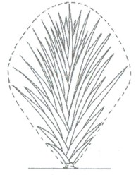 | 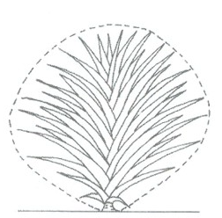 | 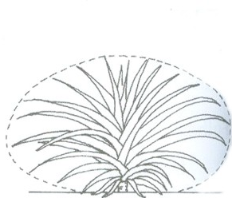
1 | 3 | 5
upright | semi upright | spreading

Ad. 2: Plant: number of leaves

Leaves produced between planting and floral emergence.
Ad. 7: Leaf: density of trichomes on lower side

Trichomes are to be observed including hairs. They are located on the lower side of the leaf.

Ad. 8: Leaf: raised margin

“Piping” as named by Collins and Kerns (1946). The meaning is that the lower epidermis is folded over the leaf edge and extended over the upper surface, to produce a narrow silvery stripe.

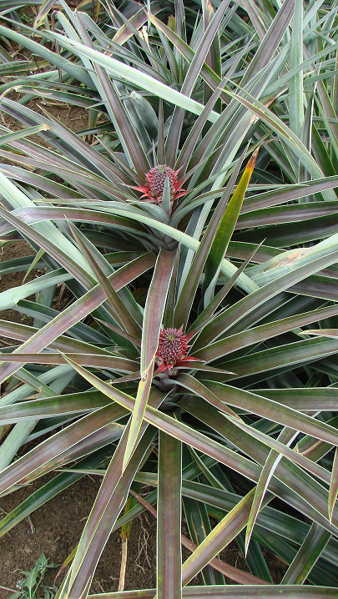 | 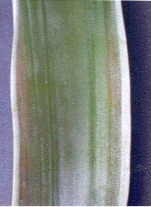

Ad. 11: Only varieties with spines: Leaf: position of spines at margin

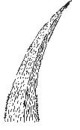 | 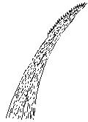 | 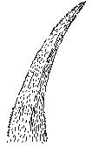 | 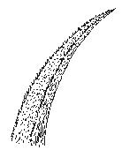
1 | 2 | 3 | 4
at base only | at apex only | at base and apex | along all margins

[To be improved: see Annex to this document]

Ad. 14: Inflorescence: floral bract size

To be observed, before total fruit development. Floral bracts are borne on the fruit at the base of each fruitlet (eye).

Ad. 21: Peduncle: length
Ad. 24: Plant: number of aerial suckers on stem
Ad. 27: Plant: size of slips
Ad. 29: Crown: attitude

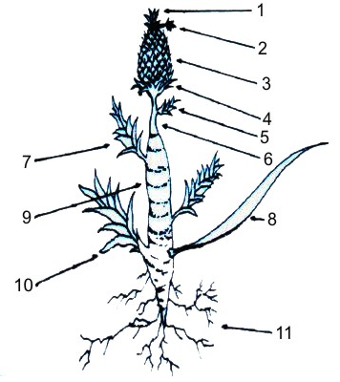 | - Crown
 | - Crownlet
 | - Fruit
 | - Basal fruit slip
 | - Peduncle slip
 | - Peduncle
 | - Aerial sucker (cloves)
 | - Leaf
 | - Stem
 | - Ground Sucker
 | - Root

Ad. 22: Peduncle: diameter

To be observed, before fruit development, at middle.

Ad. 25: Plant: size of aerial suckers on stem

To be observed at fruit harvest.

Ad 31: Fuit: shape

To be observed excluding neck.

 |  | < broadest part >
 |  | (below middle) | at middle | (above middle)
< lateral outline in apical half > | flat parallel sides |  | 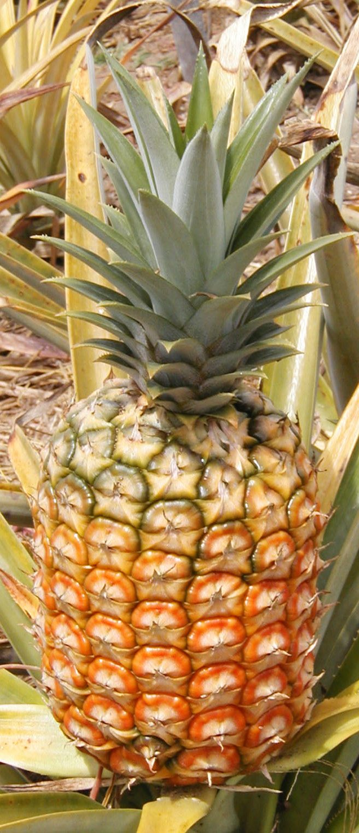  3  oblong
< lateral outline in apical half > | rounded | 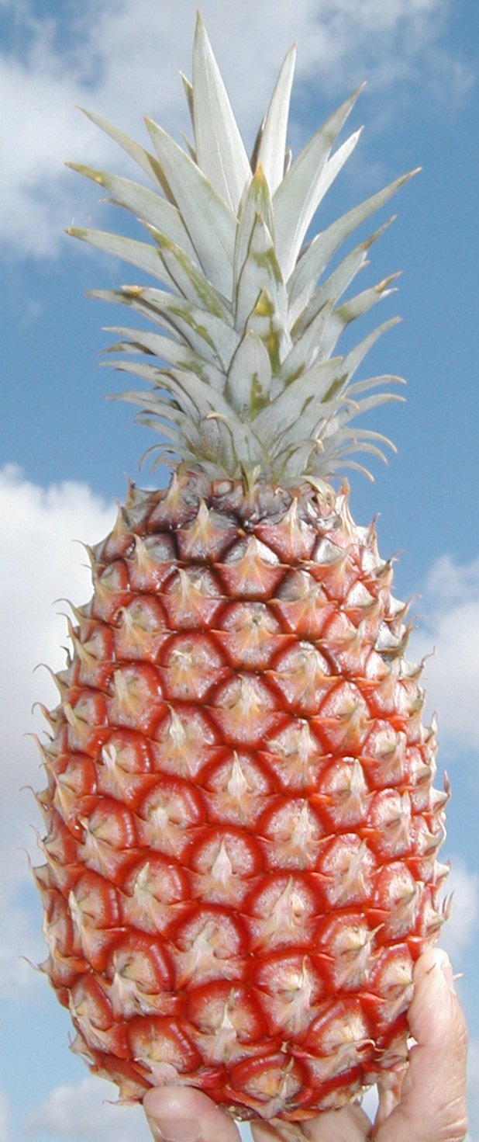  2  medium ovate | 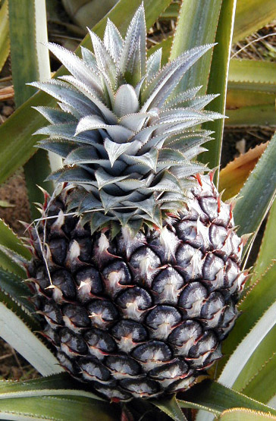  4  elliptic  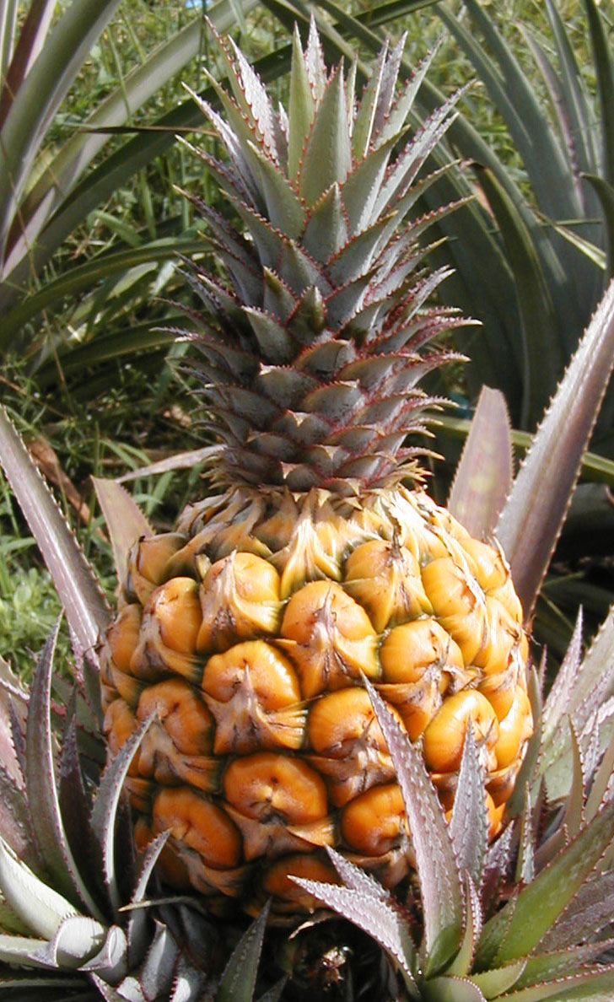  5  circular
< lateral outline in apical half > | pointed | 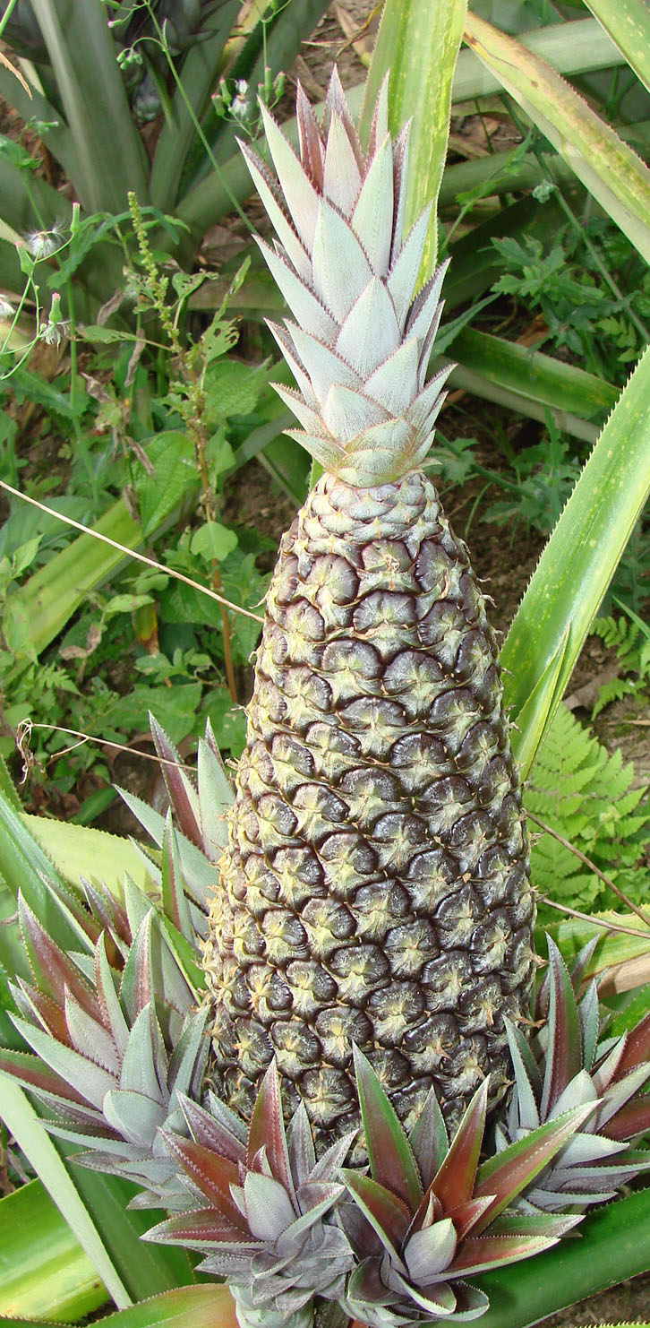  1  narrow ovate

Ad 32: Fruit: length

To be observed excluding crown.

Ad. 37: Fruit: eye profile
Ad. 38: Fruit: evenness of color of eyes

To assess the regularity of the eye color from the basal to the upper part of the fruit.
fruitlet

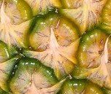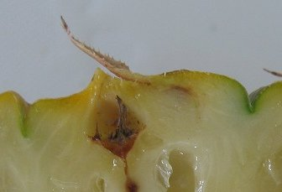

floral bract
eye

Ad. 43: Flesh: firmness

To be assessed using a penetrometer.

Ad. 44: Flesh: fibrousness

While eating, evaluate the amount of fiber and flesh (after removal of the skin and eyes).

Ad. 47: Flesh: acidity

Free acid content is determined by titration of 10 ml filtered juice with 0.1 NaOH with phenolphtaleine as indicator. The result is given in meq per 100 ml of juice (meq/100ml).

Ad. 48: Flesh: sweetness

Sugar content (Brix value) is recorded with a refractometer.

Literature

Bartholomew, D. P., Paul, R. E., and Rohrbach, K. G., eds., 2002: The Pineapple: Botany, Production and Uses; editors., University of Hawaii, Manoa, Honolulu, USA. 320 p.

Collins, J.J., Kerns, K.R., 1946 : Inheritance of three leaf types in the pineapple. Journal of Heridity, Vol. 37, Issue 4. American Research Association. US, pp. 123-128

CNPMF (CUNHA, G. A. P. da; CABRAL, J. R. S; SOUZA, L. F. da S. (Organizadores). O abacaxizeiro – cultivo, agroindústria e economia. Brasília: Embrapa Comunicação para Transferência de Tecnologia, 1999. P. 17-51

Py, C., Lacoeuilhe, J.J., Teisson, C. (1984) : L’ananas, sa culture, ses produits. Collection techniques agricoles et productions tropicales. Éditions Maisonneuve et Larose, Paris, 562 p.

Technical Questionnaire

TECHNICAL QUESTIONNAIRE |  |  |  | Page {x} of {y} |  | Reference Number:
 |  |  |  |  |  | Application date:
 |  |  |  |  |  | (not to be filled in by the applicant)
TECHNICAL QUESTIONNAIRE
to be completed in connection with an application for plant breeders’ rights

1. Subject of the Technical Questionnaire
1.1 Botanical name |  |  | Ananas comosus (L.) Merr.
1.2 Common name |  |  | Pineapple
2. Applicant
Name
Address
Telephone No.
Fax No.
E-mail address
Breeder (if different from applicant)
3. Proposed denomination and breeder’s reference
Proposed denomination
(if available)

Breeder’s reference
#4. Information on the breeding scheme and propagation of the variety

4.1 Breeding scheme

Variety resulting from:

4.1.1 Crossing

(a) controlled cross [ ]
(please state parent varieties)

(…………………..……………..…) x (……………..…………………..…)
female parent male parent

(b) partially known cross [ ]
(please state known parent variety(ies))

(…………………..……………..…) x (……………..…………………..…)
female parent male parent

(c) unknown cross [ ]

4.1.2 Mutation [ ]
(please state parent variety)

4.1.3 Discovery and development [ ]
(please state where and when discovered and how developed)

4.1.4 Other [ ]
(please provide details)

4.2 Method of propagating the variety

4.2.1 Vegetative propagation

(a) cuttings [ ]

(b) in vitro propagation [ ]

(c) other (state method) [ ]

4.2.2 Seed [ ]

4.2.3 Other [ ]
(please provide details)

5. Characteristics of the variety to be indicated (the number in brackets refers to the corresponding characteristic in Test Guidelines; please mark the note which best corresponds).

 | Characteristics |  |  |  |  |  | Example Varieties |  |  | Note
5.1  (1) | Plant: growth habit
 | upright |  |  |  |  |  | Perola |  |  | 1[ ]
 | upright to semi upright |  |  |  |  |  |  |  |  | 2[ ]
 | semi upright |  |  |  |  |  | Smooth Cayenne |  |  | 3[ ]
 | semi upright to spreading |  |  |  |  |  |  |  |  | 4[ ]
 | spreading |  |  |  |  |  | Perolera |  |  | 5[ ]
5.2  (6) | Leaf: anthocyanin coloration
 | absent or very weak |  |  |  |  |  | Aus-Jubilee, BRS Vitoria, MD-2, Selangor Green |  |  | 1[ ]
 | very weak to weak |  |  |  |  |  |  |  |  | 2[ ]
 | weak |  |  |  |  |  | Pot à eau |  |  | 3[ ]
 | weak to medium |  |  |  |  |  |  |  |  | 4[ ]
 | medium |  |  |  |  |  | Smooth Cayenne |  |  | 5[ ]
 | medium to strong |  |  |  |  |  |  |  |  | 6[ ]
 | strong |  |  |  |  |  | Rondon |  |  | 7[ ]
 | strong to very strong |  |  |  |  |  |  |  |  | 8[ ]
 | very strong |  |  |  |  |  | Roxo de Tefe, 73-50 |  |  | 9[ ]
5.3  (8) | Leaf: raised margin
 | absent |  |  |  |  |  | Queen, Samba |  |  | 1[ ]
 | present |  |  |  |  |  | Perolera, Singapore Canning |  |  | 9[ ]
5.4  (9) | Leaf: spines
 | absent |  |  |  |  |  | BRS Imperial, Perolera, Samba, Singapore Canning |  |  | 1[ ]
 | present |  |  |  |  |  | Queen |  |  | 9[ ]
 | Characteristics |  |  |  |  |  | Example Varieties |  |  | Note
5.5  (31) | Fruit: shape
 | narrow ovate |  |  |  |  |  | Gomo de Mel, Perola |  |  | 1[ ]
 | medium ovate |  |  |  |  |  | BRS Imperial, BRS Vitoria |  |  | 2[ ]
 | oblong |  |  |  |  |  | MD-2, Perolera |  |  | 3[ ]
 | elliptic |  |  |  |  |  | Smooth Cayenne |  |  | 4[ ]
 | circular |  |  |  |  |  | Red Spanish |  |  | 5[ ]
5.6  (34) | Fruit: predominant color
 | white cream |  |  |  |  |  |  |  |  | 1[ ]
 | yellow green |  |  |  |  |  |  |  |  | 2[ ]
 | green |  |  |  |  |  | Perola |  |  | 3[ ]
 | grey green |  |  |  |  |  |  |  |  | 4[ ]
 | light yellow |  |  |  |  |  | BRS Vitoria |  |  | 5[ ]
 | medium yellow |  |  |  |  |  | Smooth Cayenne |  |  | 6[ ]
 | orange |  |  |  |  |  | MD-2 |  |  | 7[ ]
 | orange red |  |  |  |  |  | Manzana, Roxo de Tefe |  |  | 8[ ]
 | red |  |  |  |  |  |  |  |  | 9[ ]
 | brown |  |  |  |  |  |  |  |  | 10[ ]
5.7  (39) | Fruit: color of flesh
 | whitish yellow |  |  |  |  |  | Perola |  |  | 1[ ]
 | light yellow |  |  |  |  |  | Smooth Cayenne |  |  | 2[ ]
 | medium yellow |  |  |  |  |  | Perolera |  |  | 3[ ]
 | yellowish orange |  |  |  |  |  | Queen |  |  | 4[ ]
6. Similar varieties and differences from these varieties

Please use the following table and box for comments to provide information on how your candidate variety differs from the variety (or varieties) which, to the best of your knowledge, is (or are) most similar. This information may help the examination authority to conduct its examination of distinctness in a more efficient way.

Denomination(s) of variety(ies) similar to your candidate variety |  | Characteristic(s) in which your candidate variety differs from the similar variety(ies) |  |  | Describe the expression of the characteristic(s) for the similar variety(ies) |  |  | Describe the expression of the characteristic(s) for your candidate variety
Example |  | Leaf: anthocyanin coloration |  |  | absent or very weak |  |  | medium
Comments:

#7. Additional information which may help in the examination of the variety

7.1 In addition to the information provided in sections 5 and 6, please provide information concerning ploidy:

diploid [ ]
tetraploid [ ]

7.2 Are there any special conditions for growing the variety or conducting the examination?

Yes [ ] No [ ]

(If yes, please provide details)

7.3 Other information

A representative color image of the variety should accompany the Technical Questionnaire.

8. Authorization for release

(a) Does the variety require prior authorization for release under legislation concerning the protection of the environment, human and animal health?

Yes [ ] No [ ]

(b) Has such authorization been obtained?

Yes [ ] No [ ]

If the answer to (b) is yes, please attach a copy of the authorization.

9. Information on plant material to be examined or submitted for examination.

9.1 The expression of a characteristic or several characteristics of a variety may be affected by factors, such as pests and disease, chemical treatment (e.g. growth retardants or pesticides), effects of tissue culture, different rootstocks, scions taken from different growth phases of a tree, etc.

9.2 The plant material should not have undergone any treatment which would affect the expression of the characteristics of the variety, unless the competent authorities allow or request such treatment. If the plant material has undergone such treatment, full details of the treatment must be given. In this respect, please indicate below, to the best of your knowledge, if the plant material to be examined has been subjected to:

(a) Microorganisms (e.g. virus, bacteria, phytoplasma) Yes [ ] No [ ]

(b) Chemical treatment (e.g. growth retardant, pesticide) Yes [ ] No [ ]

(c) Tissue culture Yes [ ] No [ ]

(d) Other factors Yes [ ] No [ ]

Please provide details for where you have indicated “yes”.

……………………………………………………………

9.3 Has the plant material to be examined been tested for the presence of virus or other pathogens?

Yes [ ]
(please provide details as specified by the Authority)

No [ ]

10. I hereby declare that, to the best of my knowledge, the information provided in this form is correct:

Applicant’s name

Signature Date

[Annex follows]
OPTIONS FOR AD. 11 “ONLY VARIETIES WITH SPINES VISIBLE: LEAF:
POSITION OF SPINES AT MARGIN”

Option 1

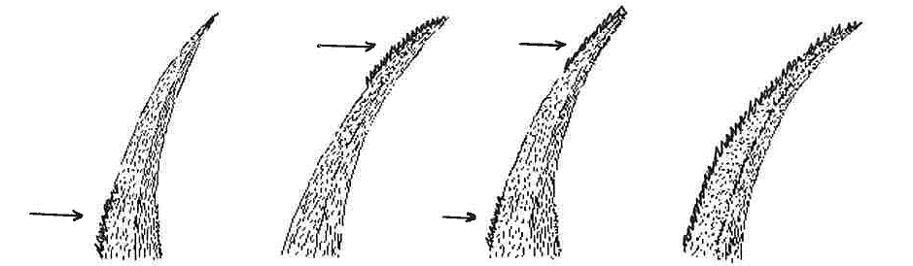
1 | 2 | 3 | 4
at base only | at apex only | at base and apex | along all margins

Option 2

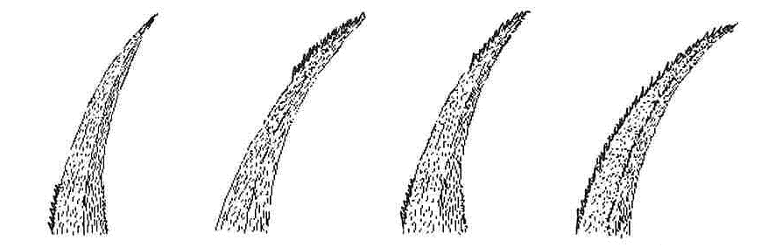
1 | 2 | 3 | 4
at base only | at apex only | at base and apex | along all margins

[End of Annex and of document]

* These names were correct at the time of the introduction of these Test Guidelines but may be revised or updated. [Readers are advised to consult the UPOV Code, which can be found on the UPOV Website (www.upov.int), for the latest information.]
# Authorities may allow certain of this information to be provided in a confidential section of the Technical Questionnaire.
# Authorities may allow certain of this information to be provided in a confidential section of the Technical Questionnaire.

