 |  |  |  |  |  |  | E  TG/187/2 (proj 1)  ORIGINAL: TG/187/1  DATE: 2012-06-22
INTERNATIONAL UNION FOR THE PROTECTION OF NEW VARIETIES OF PLANTS
Geneva
 |  |  | DRAFT
 |  | PRUNUS-ROOTSTOCKS  UPOV Code: PRUNU  (Prunus L.) |  |  | *

GUIDELINES

FOR THE CONDUCT OF TESTS

FOR DISTINCTNESS, UNIFORMITY AND STABILITY

prepared by experts from Germany

to be considered by the
Technical Working Party for Fruit Crops at its forty-third session,
to be held in Beijing, from July 30 to August 3, 2012

Alternative Names:*

Botanical name | English | French | German | Spanish
Prunus L. | Prunus rootstocks

The purpose of these guidelines (“Test Guidelines”) is to elaborate the principles contained in the General Introduction (document TG/1/3), and its associated TGP documents, into detailed practical guidance for the harmonized examination of distinctness, uniformity and stability (DUS) and, in particular, to identify appropriate characteristics for the examination of DUS and production of harmonized variety descriptions.

ASSOCIATED DOCUMENTS
These Test Guidelines should be read in conjunction with the General Introduction and its associated TGP documents.

Other associated UPOV documents:
TABLE OF CONTENTS PAGE

1. Subject of these Test Guidelines 3
2. Material Required 3
3. Method of Examination 3
3.1 Number of Growing Cycles 3
3.2 Testing Place 3
3.3 Conditions for Conducting the Examination 3
3.4 Test Design 3
3.5 Additional Tests 3
4. Assessment of Distinctness, Uniformity and Stability 4
4.1 Distinctness 4
4.2 Uniformity 5
4.3 Stability 5
5. Grouping of Varieties and Organization of the Growing Trial 5
6. Introduction to the Table of Characteristics 5
6.1 Categories of Characteristics 5
6.2 States of Expression and Corresponding Notes 6
6.3 Types of Expression 6
6.4 Example Varieties 6
6.5 Legend 6
7. Table of Characteristics/Tableau des caractères/Merkmalstabelle/Tabla de caracteres 8
8. Explanations on the Table of Characteristics 15
8.1 Explanations covering several characteristics 15
8.2 Explanations for individual characteristics 15
9. Literature 21
10. Technical Questionnaire 22

Subject of these Test Guidelines

These Test Guidelines apply to all varieties of These Test Guidelines apply to all varieties used as rootstocks of all species of Prunus L. If characteristics of the flower, the fruit or the seed are necessary to examine the varieties, the Test Guidelines for Almond TG/56, Apricot TG/70, Cherry TG/35, European Plum TG/41, Japanese Plum TG/84, Mume (Japanese Apricot) TG/160 or Peach, Nectarine TG/53 should be used for those characteristics, as appropriate.

Material Required

2.1 The competent authorities decide on the quantity and quality of the plant material required for testing the variety and when and where it is to be delivered. Applicants submitting material from a State other than that in which the testing takes place must ensure that all customs formalities and phytosanitary requirements are complied with.

2.2 The material is to be supplied in the form of plants on their own roots.

2.3 The minimum quantity of plant material, to be supplied by the applicant, should be:

(a) 5 plants, for vegetatively propagated varieties, or
(b) 40 one-year-old seedlings for seed propagated varieties.

2.4 The plant material supplied should be visibly healthy, not lacking in vigor, nor affected by any important pest or disease.

2.5 The plant material should not have undergone any treatment which would affect the expression of the characteristics of the variety, unless the competent authorities allow or request such treatment. If it has been treated, full details of the treatment must be given.

Method of Examination

3.1 Number of Growing Cycles

The minimum duration of tests should normally be two independent growing cycles.

3.2 Testing Place

Tests are normally conducted at one place. In the case of tests conducted at more than one place, guidance is provided in TGP/9 “Examining Distinctness”.

3.3 Conditions for Conducting the Examination

3.3.1 The tests should be carried out under conditions ensuring satisfactory growth for the expression of the relevant characteristics of the variety and for the conduct of the examination.

3.4 Test Design

3.4.1 Each test should be designed to result in a total of at least 5 plants.

3.5 Additional Tests

Additional tests, for examining relevant characteristics, may be established.

Assessment of Distinctness, Uniformity and Stability

4.1 Distinctness

4.1.1 General Recommendations

It is of particular importance for users of these Test Guidelines to consult the General Introduction prior to making decisions regarding distinctness. However, the following points are provided for elaboration or emphasis in these Test Guidelines.

4.1.2 Consistent Differences

The differences observed between varieties may be so clear that more than one growing cycle is not necessary. In addition, in some circumstances, the influence of the environment is not such that more than a single growing cycle is required to provide assurance that the differences observed between varieties are sufficiently consistent. One means of ensuring that a difference in a characteristic, observed in a growing trial, is sufficiently consistent is to examine the characteristic in at least two independent growing cycles.

4.1.3 Clear Differences

Determining whether a difference between two varieties is clear depends on many factors, and should consider, in particular, the type of expression of the characteristic being examined, i.e. whether it is expressed in a qualitative, quantitative, or pseudo-qualitative manner. Therefore, it is important that users of these Test Guidelines are familiar with the recommendations contained in the General Introduction prior to making decisions regarding distinctness.

4.1.4 Number of Plants / Parts of Plants to be examined

Unless otherwise indicated, for the purposes of distinctness, all observations on single plants should be made on 5 plants or parts taken from each of 5 plants and any other observations made on all plants in the test, disregarding any off-type plants. In the case of observations of parts taken from single plants, the number of parts to be taken from each of the plants should be 2.

4.1.5 Method of Observation

The recommended method of observing the characteristic for the purposes of distinctness is indicated by the following key in the second column of the Table of Characteristics (see document TGP/9 “Examining Distinctness”, Section 4 “Observation of characteristics”):

MG: single measurement of a group of plants or parts of plants
MS: measurement of a number of individual plants or parts of plants
VG: visual assessment by a single observation of a group of plants or parts of plants
VS: visual assessment by observation of individual plants or parts of plants

Type of observation: visual (V) or measurement (M)

“Visual” observation (V) is an observation made on the basis of the expert’s judgment. For the purposes of this document, “visual” observation refers to the sensory observations of the experts and, therefore, also includes smell, taste and touch. Visual observation includes observations where the expert uses reference points (e.g. diagrams, example varieties, side-by-side comparison) or non-linear charts (e.g. color charts). Measurement (M) is an objective observation against a calibrated, linear scale e.g. using a ruler, weighing scales, colorimeter, dates, counts, etc.

Type of record: for a group of plants (G) or for single, individual plants (S)

For the purposes of distinctness, observations may be recorded as a single record for a group of plants or parts of plants (G), or may be recorded as records for a number of single, individual plants or parts of plants (S). In most cases, “G” provides a single record per variety and it is not possible or necessary to apply statistical methods in a plant-by-plant analysis for the assessment of distinctness.”

In cases where more than one method of observing the characteristic is indicated in the Table of Characteristics (e.g. VG/MG), guidance on selecting an appropriate method is provided in document TGP/9, Section 4.2.

4.2 Uniformity

4.2.1 It is of particular importance for users of these Test Guidelines to consult the General Introduction prior to making decisions regarding uniformity. However, the following points are provided for elaboration or emphasis in these Test Guidelines:

4.2.1 For the assessment of uniformity, a population standard of 1% and an acceptance probability of at least 95% should be applied. In the case of a sample size of 5 plants, no off-type is allowed. In case of a sample size of 40 plants, 2 off-types are allowed.

4.3 Stability

4.3.1 In practice, it is not usual to perform tests of stability that produce results as certain as those of the testing of distinctness and uniformity. However, experience has demonstrated that, for many types of variety, when a variety has been shown to be uniform, it can also be considered to be stable.

4.3.2 Where appropriate, or in cases of doubt, stability may be further examined by testing a new plant stock to ensure that it exhibits the same characteristics as those shown by the initial material supplied.

Grouping of Varieties and Organization of the Growing Trial

5.1 The selection of varieties of common knowledge to be grown in the trial with the candidate varieties and the way in which these varieties are divided into groups to facilitate the assessment of distinctness are aided by the use of grouping characteristics.

5.2 Grouping characteristics are those in which the documented states of expression, even where produced at different locations, can be used, either individually or in combination with other such characteristics: (a) to select varieties of common knowledge that can be excluded from the growing trial used for examination of distinctness; and (b) to organize the growing trial so that similar varieties are grouped together.

5.3 The following have been agreed as useful grouping characteristics:

(a) Plant: vigor (characteristic 1)
(b) Leaf blade: length (characteristic 15)
(c) Leaf blade: shape (characteristic 18)
(d) Plant: flowers (characteristic 39)

5.4 Guidance for the use of grouping characteristics, in the process of examining distinctness, is provided through the General Introduction and document TGP/9 “Examining Distinctness”.

Introduction to the Table of Characteristics

6.1 Categories of Characteristics

6.1.1 Standard Test Guidelines Characteristics

Standard Test Guidelines characteristics are those which are approved by UPOV for examination of DUS and from which members of the Union can select those suitable for their particular circumstances.

6.1.2 Asterisked Characteristics

Asterisked characteristics (denoted by *) are those included in the Test Guidelines which are important for the international harmonization of variety descriptions and should always be examined for DUS and included in the variety description by all members of the Union, except when the state of expression of a preceding characteristic or regional environmental conditions render this inappropriate.

6.2 States of Expression and Corresponding Notes

6.2.1 States of expression are given for each characteristic to define the characteristic and to harmonize descriptions. Each state of expression is allocated a corresponding numerical note for ease of recording of data and for the production and exchange of the description.

6.2.2 In the case of qualitative and pseudo-qualitative characteristics (see Chapter 6.3), all relevant states of expression are presented in the characteristic. However, in the case of quantitative characteristics with 5 or more states, an abbreviated scale may be used to minimize the size of the Table of Characteristics. For example, in the case of a quantitative characteristic with 9 states, the presentation of states of expression in the Test Guidelines may be abbreviated as follows:

State | Note
small | 3
medium | 5
large | 7

However, it should be noted that all of the following 9 states of expression exist to describe varieties and should be used as appropriate:

State | Note
very small | 1
very small to small | 2
small | 3
small to medium | 4
medium | 5
medium to large | 6
large | 7
large to very large | 8
very large | 9

6.2.3 Further explanation of the presentation of states of expression and notes is provided in document TGP/7 “Development of Test Guidelines”.

6.3 Types of Expression

An explanation of the types of expression of characteristics (qualitative, quantitative and pseudo-qualitative) is provided in the General Introduction.

6.4 Example Varieties

Where appropriate, example varieties are provided to clarify the states of expression of each characteristic.

6.5 Legend

(*) Asterisked characteristic – see Chapter 6.1.2

QL Qualitative characteristic – see Chapter 6.3
QN Quantitative characteristic – see Chapter 6.3
PQ Pseudo-qualitative characteristic – see Chapter 6.3

MG, MS, VG, VS – see Chapter 4.1.5

(a)-(d) See Explanations on the Table of Characteristics in Chapter 8.1”

(+) See Explanations on the Table of Characteristics in Chapter 8.2.

Table of Characteristics/Tableau des caractères/Merkmalstabelle/Tabla de caracteres

 |  | English | français | deutsch | español | Example Varieties  Exemples  Beispielssorten  Variedades ejemplo | Note/  Nota
1  (*)  (+) | VG | Plant: vigor
QN | (a) | weak |  |  |  | Edabriz, Ferlenain | 3
 |  | medium |  |  |  | Brokforest, GM 61/1 | 5
 |  | strong |  |  |  | Alkavo, F 12/1 | 7
2 | VG | Plant habit
QN | (a) | upright |  |  |  | Colt | 1
 |  | spreading |  |  |  | Gisela 5 | 3
 |  | drooping |  |  |  | Prunus besseyi | 5
3 | VG | Plant: branching
QN | (a) | weak |  |  |  | F 12/1, Ferciana | 3
 |  | medium |  |  |  | Pixy | 5
 |  | strong |  |  |  | Gisela 5 | 7
4 | VG | One-year-old shoot: thickness
QN | (a) | thin |  |  |  | Edabriz, Gisela 5 | 3
 |  | medium |  |  |  | Colt, Pixy | 5
 |  | thick |  |  |  | Brooks-60, F 12/1 | 7
5 | VG/MS | One-year-old shoot: length of internode (middle third of shoot)
QN | (a) | short |  |  |  | SL 64 | 1
 |  | medium |  |  |  | Colt | 3
 |  | long |  |  |  | F 12/1 | 5
6 | VG | One-year-old shoot: pubescence (upper third)
QL | (a) | absent |  |  |  | Pixy | 1
 |  | present |  |  |  | SL 64 | 9
7 | VG | One-year-old shoot: number of lenticels
QN | (a) | few |  |  |  | Colt, Fereley | 3
 |  | medium |  |  |  | Gisela 4, Pixy | 5
 |  | many |  |  |  | SL 64 | 7
8 | VG | One-year-old shoot: anthocyanin coloration of apex
QN | (a) | absent or very weak |  |  |  | F 12/1 | 1
 |  | weak |  |  |  | Fereley | 2
 |  | medium |  |  |  | Pixy | 3
 |  | strong |  |  |  | Hamyra | 4
 |  | very strong |  |  |  | Ferciana | 5
9  (+) | VG | One-year-old shoot: position of vegetative bud in relation to shoot
QN | (a) | adpressed |  |  |  | Hamyra | 1
 |  | slightly held out |  |  |  | Gisela 5 | 3
 |  | markedly held out |  |  |  | F 12/1 | 5
10 | VG | One-year-old shoot:  size of vegetative bud
QN |  | small |  |  |  | SL 64 | 1
 |  | medium |  |  |  | F 12/1 | 3
 |  | large |  |  |  | Piku 1 | 5
11  (*)  (+) | VG | One-year-old shoot: shape of apex of vegetative bud
PQ | (a) | acute |  |  |  | Hamyra, Pixy | 1
 |  | obtuse |  |  |  | Gisela 5 | 2
 |  | rounded |  |  |  | F 12/1 | 3
12  (+) | VG | One-year-old shoot: size of vegetative bud support
QN | (a) | small |  |  |  | Hamyra | 1
 |  | medium |  |  |  | F 12/1 | 3
 |  | large |  |  |  |  | 5
13  (*) | VG | One-year-old shoot: branching (at the end of summer)
QN | (a) | weak |  |  |  | Felinem, Mayor | 1
 |  | medium |  |  |  | Adafuel | 3
 |  | strong |  |  |  | GF 677 | 5
14 | VG | Young shoot: intensity of anthocyanin coloration of young leaf (during rapid growth)
QN |  | weak |  |  |  | Edabriz, Fereley, Hamyra | 1
 |  | medium |  |  |  | F 12/1 | 3
 |  | strong |  |  |  | Colt | 5
15  (*) | VG/MS | Leaf blade: length
QN | (b) | very short |  |  |  | Myrobalan B | 1
 |  | short |  |  |  | Edabriz, Weito T6 | 3
 |  | medium |  |  |  | Piku 1 | 5
 |  | long |  |  |  | F 12/1 | 7
 |  | very long |  |  |  | GF 677 | 9
16 | VG/MS | Leaf blade: width
QN | (b) | very narrow |  |  |  | GF 677 | 1
 |  | narrow |  |  |  | Myrobalan B | 3
 |  | medium |  |  |  | Fereley | 5
 |  | broad |  |  |  | Brooks-60, F 12/1 | 7
 |  | very broad |  |  |  | Colt | 9
17 | VG/MS | Leaf blade: ratio length/width
QN | (b) | very small |  |  |  | GM 61/1 | 1
 |  | small |  |  |  | Gisela 5 | 3
 |  | medium |  |  |  | F 12/1, Pixy | 5
 |  | large |  |  |  | Piku 3 | 7
 |  | very large |  |  |  | GF 677 | 9
18  (*)  (+) | VG | Leaf blade: shape
PQ | (b) | narrow elliptic |  |  |  | GF 677 | 1
 |  | elliptic |  |  |  | Colt, Fereley, Pixy | 2
 |  | circular |  |  |  | Adara, SL 64 | 3
 |  | ovate |  |  |  | Edabriz, Gisela 5 | 4
 |  | obovate |  |  |  |  | 5
19  (+) | VG | Leaf blade: angle at apex (excluding tip)
QN | (b) | acute |  |  |  | GF 677, Pixy | 1
 |  | right-angled |  |  |  | Edabriz | 3
 |  | obtuse |  |  |  | Colt, Fereley | 5
20  (*)  (+) | VG | Leaf blade: length of tip
QN | (b) | short |  |  |  | Fereley | 1
 |  | medium |  |  |  | GM 61/1 | 3
 |  | long |  |  |  | Colt, Ferlenain | 5
21  (*)  (+) | VG | Leaf blade: shape of base
PQ | (b) | acute |  |  |  | Colt | 1
 |  | obtuse |  |  |  | F 12/1, Ferlenain | 2
 |  | truncate |  |  |  | SL 64 | 3
22 | VG | Leaf blade: color of upper side
PQ | (b) | light green |  |  |  | Gisela 5, Pixy | 1
 |  | dark green |  |  |  | Colt | 2
 |  | red |  |  |  | Citation | 3
 |  | reddish brown |  |  |  | Rubira | 4
23 | VG | Leaf blade: glossiness of upper side
QN | (b) | weak |  |  |  | Hamyra | 1
 |  | medium |  |  |  | Fereley, Gisela 5 | 3
 |  | strong |  |  |  | Colt | 5
24 | VG | Leaf blade: pubescence of lower side at apex
QN | (b) | weak |  |  |  | Hamyra | 1
 |  | medium |  |  |  | Pixy | 3
 |  | strong |  |  |  | Weito T6 | 5
25  (*)  (+) | VG | Leaf blade: incisions of margin
QL | (b) | only crenate |  |  |  | Pixy | 1
 |  | both crenate and serrate |  |  |  | Adesoto, GF 1869 | 2
 |  | only serrate |  |  |  | Gisela 5 | 3
26 | VG | Leaf blade: depth of incisions of margin
QN | (b) | shallow |  |  |  | Edabriz | 1
 |  | medium |  |  |  | Piku 3 | 3
 |  | deep |  |  |  | Colt | 5
27  (*) | VG/MS | Petiole: length
QN | (b) | short |  |  |  | Piku 3 | 1
 |  | medium |  |  |  | Pixy | 3
 |  | long |  |  |  | GF 677 | 5
28  QL | VG | Petiole: presence of pubescence of upper side
 | (b) | absent |  |  |  | F 12/1 | 1
 |  | present |  |  |  | Weito T6 | 9
29 | VG | Petiole: intensity of pubescence of upper side
QN | (b) | weak |  |  |  | Colt | 1
 |  | medium |  |  |  | Hamyra | 3
 |  | strong |  |  |  | Weito T6 | 5
30  (+) | VG | Petiole: depth of groove
QN | (b) | shallow |  |  |  | F 12/1 | 1
 |  | medium |  |  |  | Gisela 5 | 3
 |  | deep |  |  |  | Myrobalan B | 5
31 | VG/MS | Leaf: ratio length of leaf blade/length of petiole
QN | (b) | small |  |  |  | Piku 1 | 3
 |  | medium |  |  |  | Colt | 5
 |  | large |  |  |  | Fereley, GF 677 | 7
32 | VG | Leaf: presence of stipules
QL | (b) | absent |  |  |  | Hamyra | 1
 |  | present |  |  |  | F 12/1, Weito T6 | 9
33 | VG/MS | Stipule: length
QN | (b) | short |  |  |  | Weito T6 | 1
 |  | medium |  |  |  | Gisela 5, Pixy | 3
 |  | long |  |  |  | F 12/1 | 5
34  (*) | VG | Leaf: presence of nectaries
QL | (b) | absent |  |  |  | Ferlenain, Hamyra | 1
 |  | present |  |  |  | GF 677, Pixy, St. Julien A | 9
35  (*) | VG | Varieties with nectaries only:  Leaf: predominant number of nectaries
QL | (b) | one |  |  |  | Weiroot 158 | 1
 |  | two |  |  |  | Gisela 5, Pixy | 2
 |  | more than two |  |  |  | Weito T6 | 3
36 | VG | Leaf: position of nectaries
QN | (b) | predominantly on base of blade |  |  |  | Gisela 5 | 1
 |  | equally distributed on base of blade and petiole |  |  |  | Colt | 2
 |  | predominantly on petiole |  |  |  | F 12/1 | 3
37  (*) | VG | Nectary: color
PQ | (b) | green |  |  |  | Pixy | 1
 |  | yellow |  |  |  | Weito T6 | 2
 |  | red |  |  |  | Weiroot 158 | 3
 |  | violet |  |  |  | Colt | 4
38  (*) | VG | Nectary: shape
QL | (b) | round |  |  |  | Gisela 5 | 1
 |  | reniform |  |  |  | Colt | 2
39  (*) | VG | Plant: flowers
QL | (c) | absent |  |  |  | Brokforest | 1
 |  | present |  |  |  | Colt | 9

Explanations on the Table of Characteristics

8.1 Explanations covering several characteristics

Characteristics containing the following key in the second column of the Table of Characteristics should be examined as indicated below:

(a) All observations on the plant should be made in the dormant season.
(b) All observations on the leaf should be made at the stage of fully developed leaves on the upper third of typical one-year-old shoots.

8.2 Explanations for individual characteristics

Ad. 1: Plant: vigor

The vigor of the plant should be considered as the overall abundance of vegetative growth.

Ad. 9: One-year-old shoot: position of vegetative bud in relation to shoot

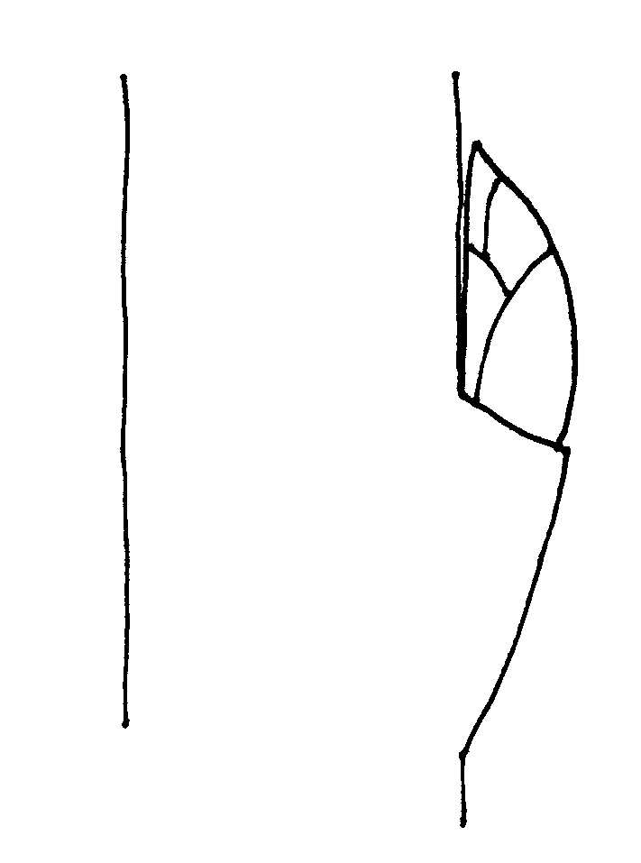 | 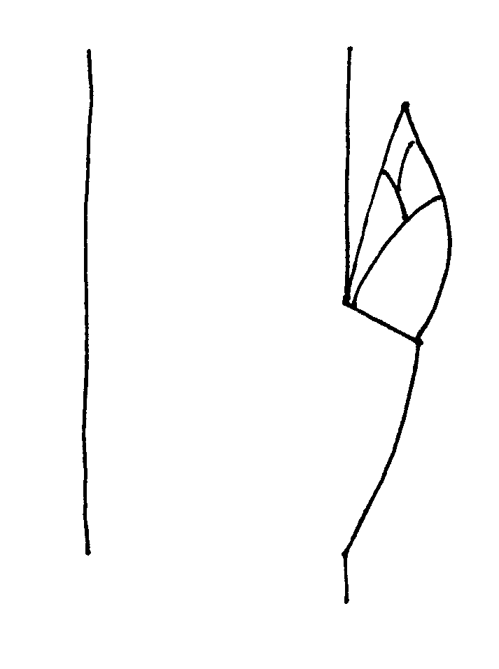 | 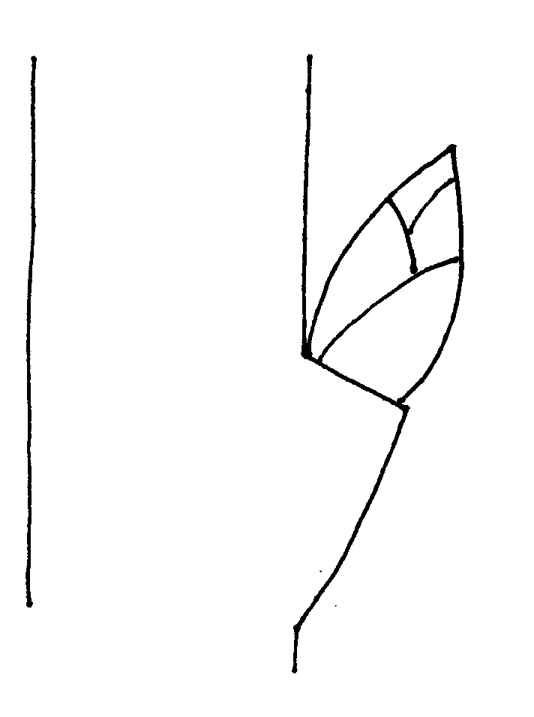
1 | 3 | 5
adpressed | slightly held out | markedly held out

Ad. 11: One-year-old shoot: shape of apex of vegetative bud

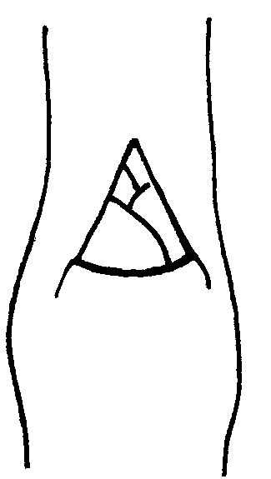 | 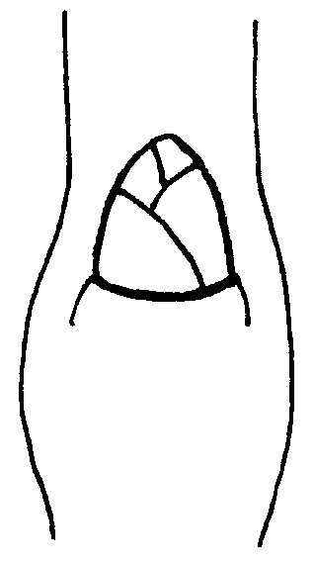 | 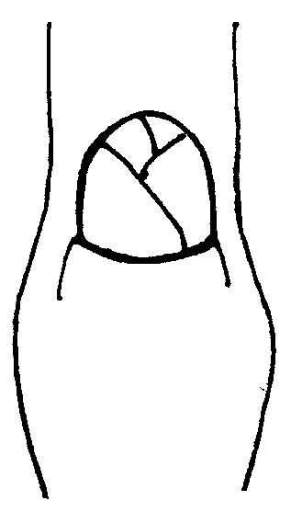

1 | 2 | 3
acute | obtuse | rounded

Ad. 12: One-year-old shoot: size of vegetative bud support

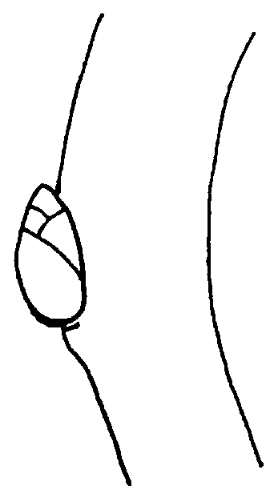 | 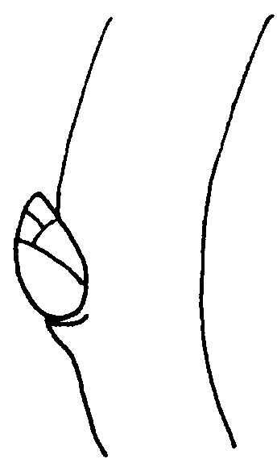 | 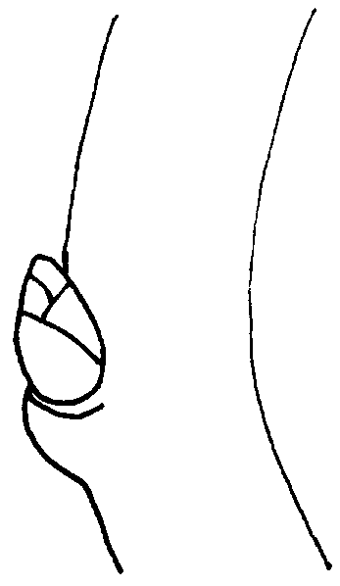

1 | 3 | 5
small | medium | large

Ad. 18: Leaf blade: shape

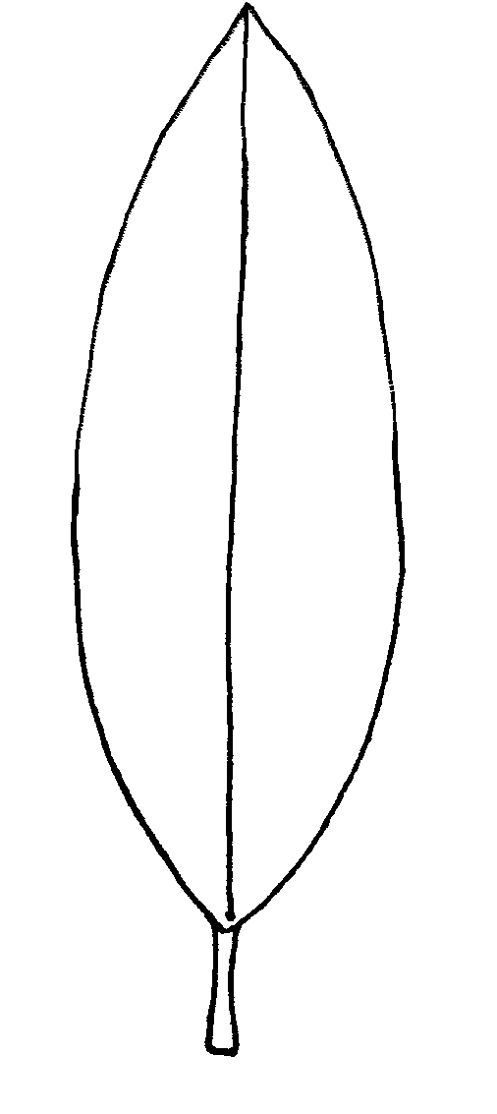 | 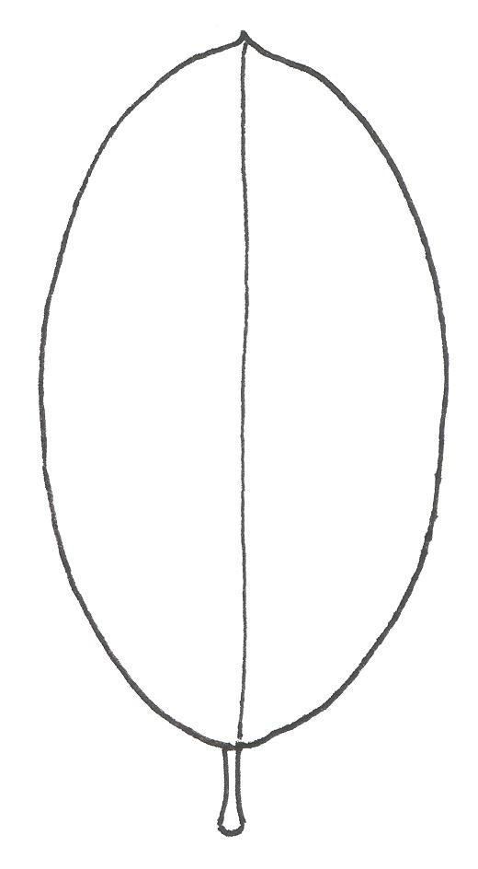 | 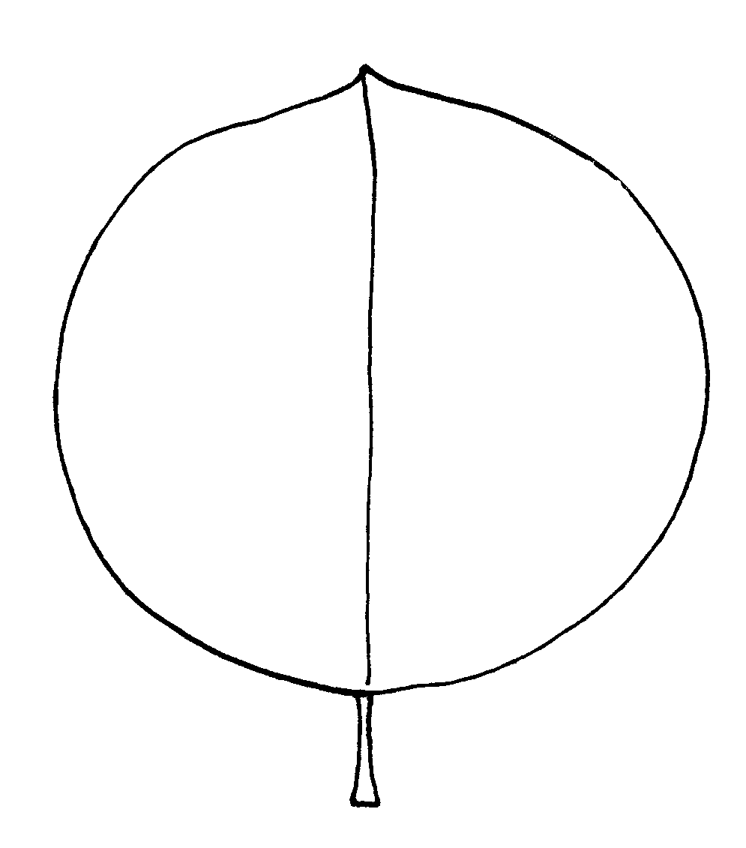

1 | 2 | 3
narrow elliptic | elliptic | circular

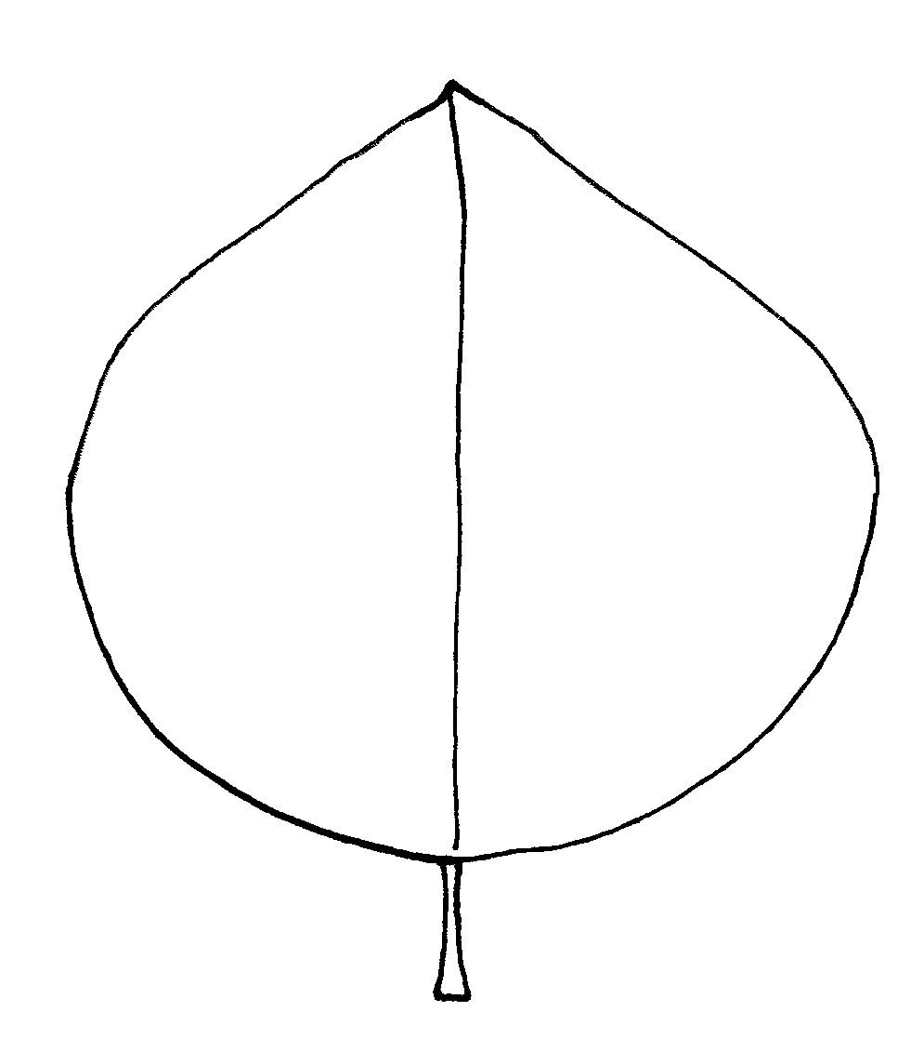 | 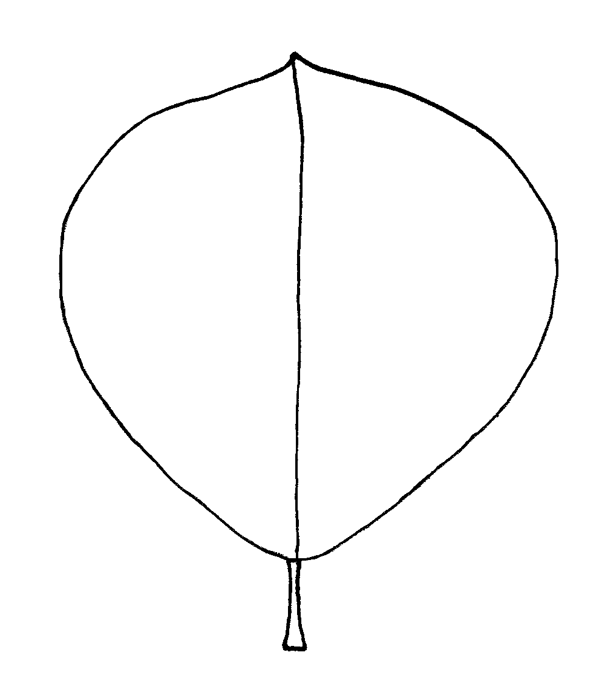

4 | 5
ovate | obovate
Ad. 19: Leaf blade: angle of apex (excluding tip)

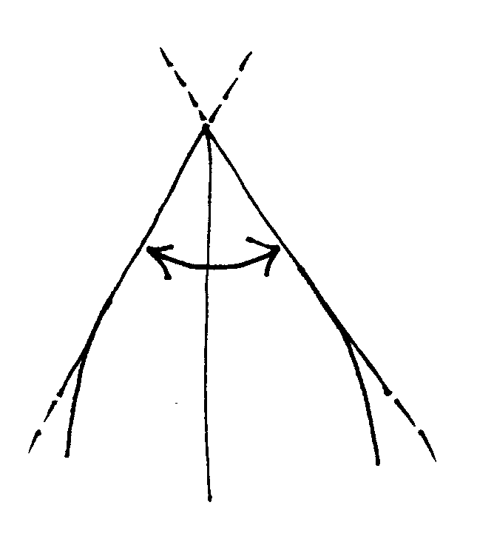 | 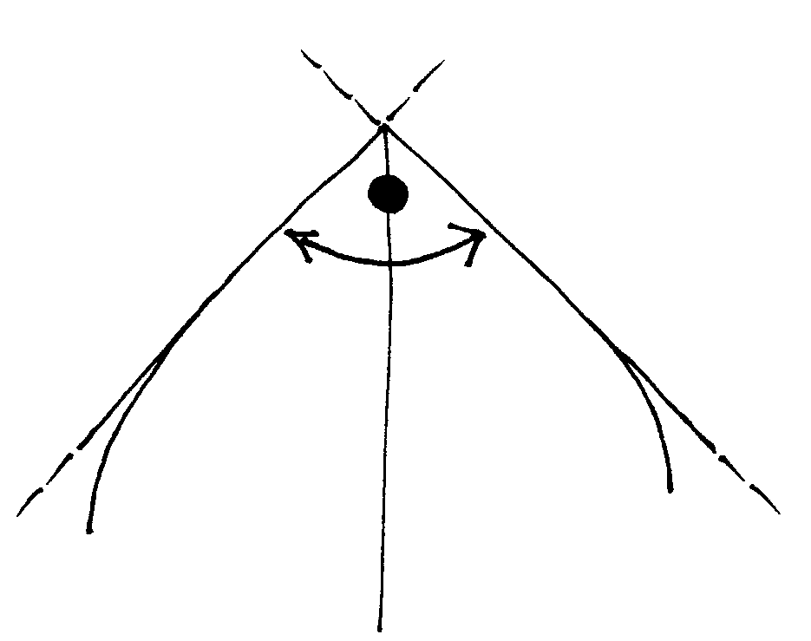 | 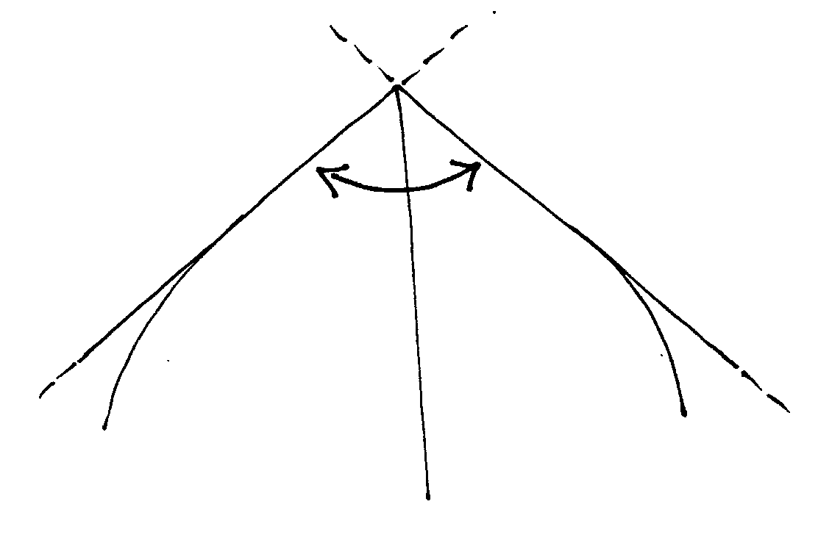
1 | 3 | 5
acute | right-angled | obtuse

Ad. 20: Leaf blade: length of tip

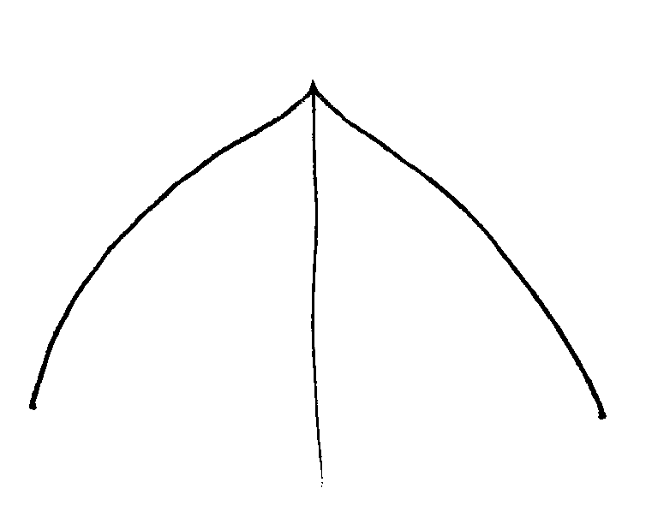 | 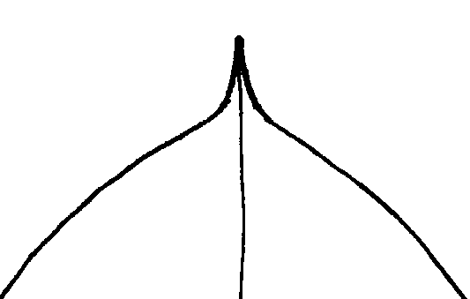 | 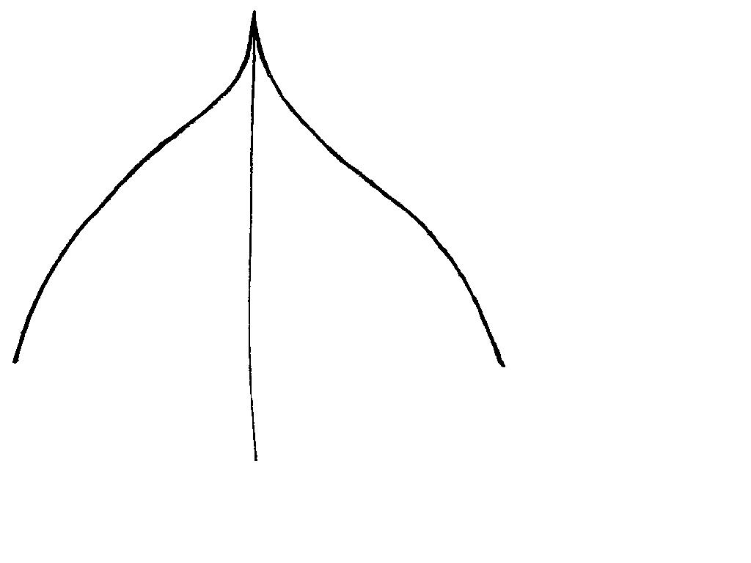

1 | 3 | 5
short | medium | long

Ad. 21: Leaf blade: shape of base

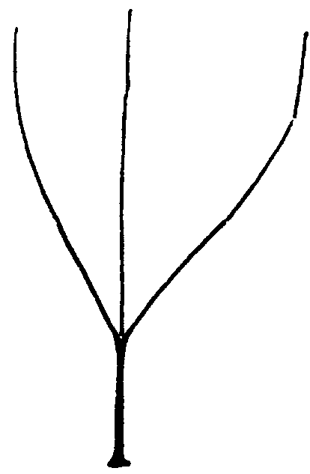 | 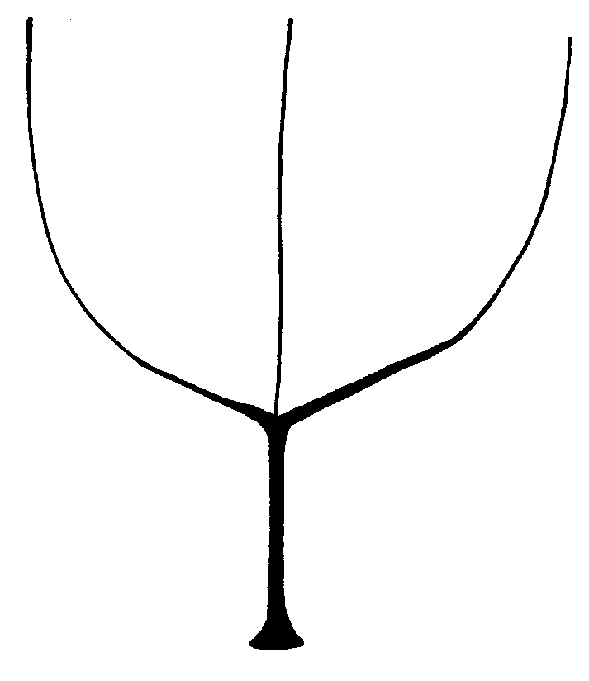 | 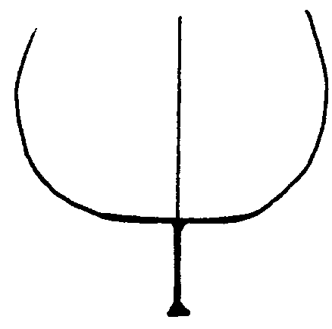

1 | 2 | 3
acute | obtuse | truncate

Ad. 25: Leaf blade: incisions of margin

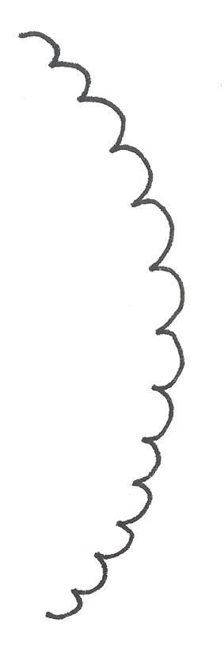 | 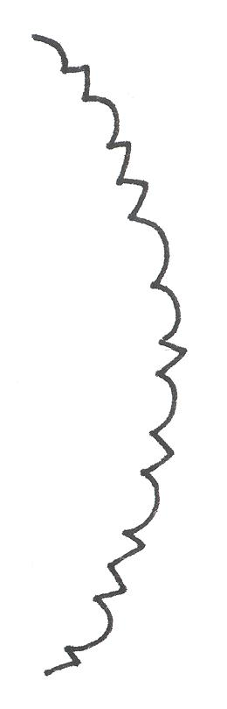 | 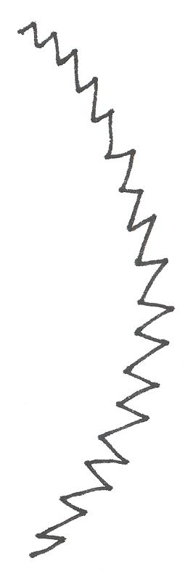

1 | 2 | 3
only crenate | both crenate and serrate | only serrate

Ad. 30: Petiole: depth of groove
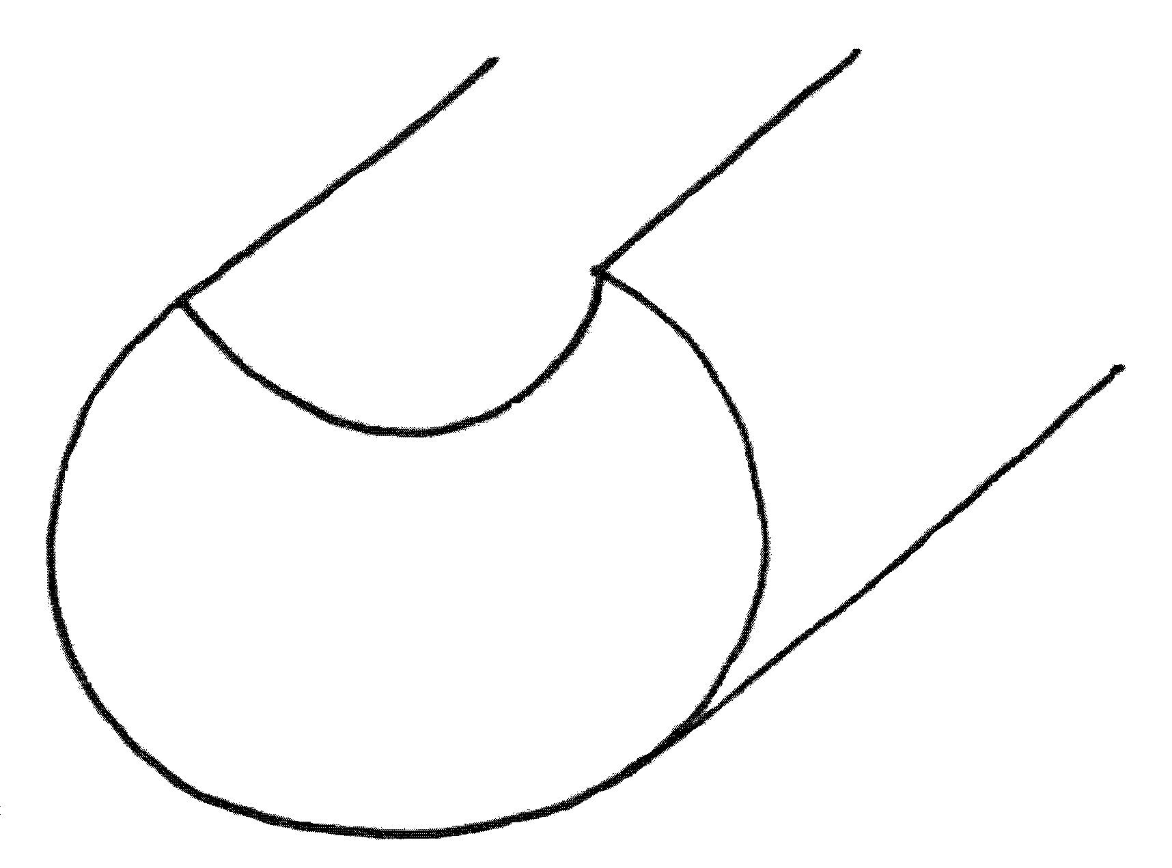
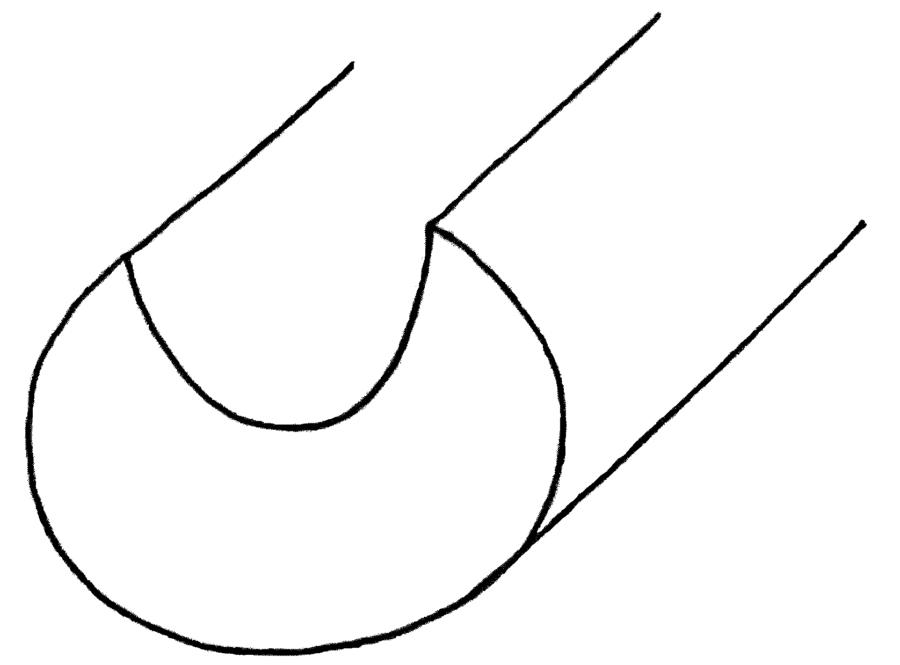
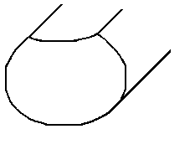

1 | 3 | 5
shallow | medium | deep

Explanations on the Example Varieties

Variety denomination |  | Species
Adafuel | Prunus dulcis (Mill.) D.A. Webb x P. persica (L.) Batsch.
Adara | Prunus cerasifera Ehrh., open pollinated
Adesoto | Prunus domestica L. ssp. insititia (L.) Schneid
Alkavo | (syn. Altenweddinger Kaukasische Vogelkirsche) Prunus avium (L.) L.
Brokforest | (syn. M x M14) Prunus mahaleb L. x Prunus avium (L.) L.
Brooks-60 | (syn. Broksec, M x M60) Prunus mahaleb L. x Prunus avium (L.) L.
Citation | Prunus domestica L. x P. persica (L.) Batsch.
Colt | Prunus avium (L.) L. x P. pseudocerasus Lindl.
Edabriz | Prunus cerasus L.
F 12/1 | Prunus avium (L.) L.
Felinem | Prunus persica (L.) Batsch. x P. dulcis (Mill.) D.A. Webb
Ferciana | (Prunus cerasifera Ehrh. x P. salicina Lindl.) x (P. domestica L. x P. persica (L.) Batsch.)
Fereley | (Prunus salicina Lindl. x P. cerasifera Ehrh.) x P. spinosa L.
Ferlenain | Prunus besseyi L.H. Bailey x P. cerasifera Ehrh.
GF 677 | Prunus persica (L.) Batsch. x P. dulcis (Mill.) D.A. Webb
GF 1869 | Prunus domestica (L.) x P. persica (L.) Batsch.
Gisela 4 | (syn. 473/10) Prunus avium (L.) L. x P. fruticosa Pall.
Gisela 5 | (syn. 148/2) Prunus cerasus L. x P. canescens Bois
GM 61/1 | Prunus dawyckensis Sealy
Hamyra | Prunus cerasifera Ehrh.
Mayor | Prunus persica (L.) Batsch. x P. dulcis (Mill.) D.A. Webb
Myrobalan B | Prunus cerasifera Ehrh.
Piku 1 | (syn. Pi-Ku 4,20) Prunus avium (L.) L. x (P. canescens Bois x P. tomentosa Thunb. ex Murr.)
Piku 3 | (syn. Pi-Ku 4,83) Prunus. pseudocerasus Lindl. x (P. canescens Bois x P. incisa Thunb. ex Murr.)
Pixy | Prunus domestica L. ssp. insititia (L.) Schneid.
Rubira | Prunus persica (L.) Batsch.
SL 64 | (syn. ‘Saint Lucie 64’) Prunus mahaleb L.
St. Julien A | Prunus domestica L. ssp. insititia (L.) Schneid.
Weiroot 158 | Prunus cerasus L.
Weito T6 | Prunus tomentosa Thunb. ex Murr.

Literature

Anonymous (1997): The Brooks and Olmo Register of Fruit & Nut Varieties. ASHS Press, 3rd edition, Alexandria VA, US, 744 p..

De Haas, P.G. (1976): Die Unterlagen- und Baumformen des Kern- und Steinobstes. Stuttgart: Ulmer Verlag, DE.

Friedrich, G. (1993): Handbuch des Obstbaus. Radebeul: Neumann Verlag, DE.

Kester, D. E. and C. Grasselly (1987): Almond rootstocks, in: Roy C. Rom and Robert F. Carlson: Rootstocks for Fruit Crops. J. Wiley and Sons, pp. 265-293.

Layne, R. E. C. (1987): Peach rootstocks, in: Roy C. Rom and Robert F. Carlson: Rootstocks for Fruit Crops. J. Wiley and Sons, pp. 185-216.

Maurer, E. (1939): Die Unterlagen der Obstgehölze. Berlin: Parey Verlag, DE.

Okie, W. R. (1987): Plum rootstocks, in: Roy C. Rom and Robert F. Carlson: Rootstocks for Fruit Crops. J. Wiley and Sons, pp. 321-360.

Perry, R. L. (1987): Cherry rootstocks, in: Roy C. Rom and Robert F. Carlson: Rootstocks for Fruit Crops. J. Wiley and Sons, pp. 217-264.

Raynaud, P. C. and J.M. Audergon (1987): Apricot rootstocks, in: Roy C. Rom and Robert F. Carlson: Rootstocks for Fruit Crops. J. Wiley and Sons, pp. 295-320.

Salesses, G., Grasselly, C., Renaud, R., Claverie, J. (1992): Les porte greffe des espèces fruitières à noyau du genre Prunus. “Amélioration des espèces végétales cultivées. Objectifs et critères de sélection”, pp. 768, A. Gallais, H. Bannerot I.N.R.A. Paris, FR, pp. 605-619.

Wertheim, S.J. (1998): Rootstock Guide. Publication no. 25, Fruit Research Station Wilhelminadorp, NL.

Technical Questionnaire

TECHNICAL QUESTIONNAIRE |  |  | Page {x} of {y} | Reference Number:
 |  |  |  | Application date:
 |  |  |  | (not to be filled in by the applicant)
TECHNICAL QUESTIONNAIRE
to be completed in connection with an application for plant breeders’ rights

1. Subject of the Technical Questionnaire
1.1 Botanical name |  | Prunus L.
1.2 Common name |  | Prunus rootstock
1.2. Species  6 [ ] |  | P. armeniaca L. 1 [ ]  P. avium (L.) L. 2 [ ]  P. cerasifera Ehrh. 3 [ ]  P. cerasus L. 4 [ ]  P. domestica L. 5 [ ]  P. dulcis (Mill.) D.A. Webb (P. amygdalus Batsch) 6 [ ]  P. mahaleb L. 7 [ ]  P. persica (L.) Batsch 8 [ ]  P. salicina Lindl. 9 [ ]  other species (please specify) 10 [ ]  interspecific hybrid (please specify) 11 [ ]
2. Applicant
Name
Address
Telephone No.
Fax No.
E-mail address
Breeder (if different from applicant)
3. Proposed denomination and breeder’s reference
Proposed denomination
(if available)

Breeder’s reference
4. Information on the breeding scheme and propagation of the variety

4.1 Breeding scheme

Variety resulting from:

4.1.1 Crossing

(a) controlled cross [ ]
(please state parent varieties)

(…………………..……………..…) x (……………..…………………..…)
female parent male parent

(b) partially known cross [ ]
(please state known parent variety(ies))

(…………………..……………..…) x (……………..…………………..…)
female parent male parent

(c) unknown cross [ ]

4.1.2 Mutation [ ]
(please state parent variety)

4.1.3 Discovery and development [ ]
(please state where and when discovered and how developed)

4.1.4 Other [ ]
(please provide details)”

4.2 Method of propagating the variety

4.2.1 Vegetative propagation

(a) cuttings [ ]

(b) in vitro propagation [ ]

(c) other (state method) [ ]

4.2.2 Seed [ ]

4.2.3 Other [ ]”
(please provide details)”

5. Characteristics of the variety to be indicated (the number in brackets refers to the corresponding characteristic in Test Guidelines; please mark the note which best corresponds).

 | Characteristics |  |  |  | Example Varieties |  | Note
5.1  (1) | Plant: vigor
 | very weak |  |  |  |  |  | 1[ ]
 | weak to very weak |  |  |  |  |  | 2[ ]
 | weak |  |  |  | Edabriz, Ferlenain |  | 3[ ]
 | weak to medium |  |  |  |  |  | 4[ ]
 | medium |  |  |  | Brokforest, GM 61/1 |  | 5[ ]
 | medium to strong |  |  |  |  |  | 6[ ]
 | strong |  |  |  | Alkavo, F 12/1 |  | 7[ ]
 | strong to very strong |  |  |  |  |  | 8[ ]
 | very strong |  |  |  |  |  | 9[ ]
5.2  (15) | Leaf blade: length
 | very short |  |  |  | Myrobalan B |  | 1[ ]
 | very short to short |  |  |  |  |  | 2[ ]
 | short |  |  |  | Edabriz, Weito T6 |  | 3[ ]
 | short to medium |  |  |  |  |  | 4[ ]
 | medium |  |  |  | Piku 1 |  | 5[ ]
 | medium to long |  |  |  |  |  | 6[ ]
 | long |  |  |  | F 12/1 |  | 7[ ]
 | long to very long |  |  |  |  |  | 8[ ]
 | very long |  |  |  | GF 677 |  | 9[ ]
5.3  (18) | Leaf blade: shape
 | narrow elliptic |  |  |  | GF 677 |  | 1[ ]
 | elliptic |  |  |  | Colt, Fereley, Pixy |  | 2[ ]
 | circular |  |  |  | Adara, SL 64 |  | 3[ ]
 | ovate |  |  |  | Edabriz, Gisela 5 |  | 4[ ]
 | obovate |  |  |  |  |  | 5[ ]
 | Characteristics |  |  |  | Example Varieties |  | Note
5.4  (39) | Plant: flowers
 | absent |  |  |  | Brokforest |  | 1[ ]
 | present |  |  |  | Colt |  | 9[ ]

Denomination(s) of variety(ies) similar to your candidate variety | Characteristic(s) in which your candidate variety differs from the similar variety(ies) | Describe the expression of the characteristic(s) for the similar variety(ies) | Describe the expression of the characteristic(s) for your candidate variety
Example | Plant: flowers | absent | present
Comments:

7. Additional information which may help in the examination of the variety

7.1 In addition to the information provided in sections 5 and 6, are there any additional characteristics which may help to distinguish the variety?

Yes [ ] No [ ]

(If yes, please provide details)

7.2 Are there any special conditions for growing the variety or conducting the examination?

Yes [ ] No [ ]

(If yes, please provide details)

7.3 Utilization as rootstock for

P. armeniaca L. 1 [ ]
P. avium (L.) L. 2 [ ]
P. cerasifera Ehrh. 3 [ ]
P. cerasus L. 4 [ ]
P. domestica L. 5 [ ]
P. dulcis (Mill.) D.A. Webb (P. amygdalus Batsch) 6 [ ]
P. mahaleb L. 7 [ ]
P. persica (L.) Batsch 8 [ ]
P. salicina Lindl. 9 [ ]

other species 10 [ ]
(please specify)

7.3 Other information

A representative color image of the variety should accompany the Technical Questionnaire.

8. Authorization for release

(a) Does the variety require prior authorization for release under legislation concerning the protection of the environment, human and animal health?

Yes [ ] No [ ]

(b) Has such authorization been obtained?

Yes [ ] No [ ]

If the answer to (b) is yes, please attach a copy of the authorization.

9. Information on plant material to be examined or submitted for examination.

9.1 The expression of a characteristic or several characteristics of a variety may be affected by factors, such as pests and disease, chemical treatment (e.g. growth retardants or pesticides), effects of tissue culture, different rootstocks, scions taken from different growth phases of a tree, etc.

9.2 The plant material should not have undergone any treatment which would affect the expression of the characteristics of the variety, unless the competent authorities allow or request such treatment. If the plant material has undergone such treatment, full details of the treatment must be given. In this respect, please indicate below, to the best of your knowledge, if the plant material to be examined has been subjected to:

(a) Microorganisms (e.g. virus, bacteria, phytoplasma) Yes [ ] No [ ]

(b) Chemical treatment (e.g. growth retardant, pesticide) Yes [ ] No [ ]

(c) Tissue culture Yes [ ] No [ ]

(d) Other factors Yes [ ] No [ ]

Please provide details for where you have indicated “yes”.

……………………………………………………………

9.3 Has the plant material to be examined been tested for the presence of virus or other pathogens?

Yes [ ]
(please provide details as specified by the Authority)

No [ ]

10. I hereby declare that, to the best of my knowledge, the information provided in this form is correct:

Applicant’s name

Signature Date

[Annex follows]

Observations and Comments to document TG/187/2(proj.1)

Char. 3 | ZA: Does it correspond with 13. one year old shoot branching? If a plant has the tendency for branching then the one year old shoot will also have the tendency of feathering/branching. Considering deleting 13.
Char. 5 | ZA: To move middle third of shoot to explanations.
Char. 6 | DE: to check whether truly QL.  ZA: To move upper third to explanations.  QZ: To read "presence of".
Char. 8 | DE: to check whether to prefer absent or weak (1), medium (3), and strong (5); further to consider deleting, as it corresponds closely with char. 14.  ZA: To delete “of apex” and including on sunny side; observing the characteristic on the one year old shoot on the sunny side.
Char. 13 | DE: to consider the term "feathering" instead of "branching".  ZA: Consider changing to Young shoot: anthocyanin coloration with the states 1 absent or very weak, 2 weak, 3 medium, 4 strong, 5 very strong; to have anthocyanin coloration the characteristic is observed for both the amount and the intensity of the anthocyanin coloration.
Char. 15 | QZ: To delete the asterisk.
Char. 17 | ZA: Change the notes from very slightly elongated to very strongly elongated; proposing new characteristic Leaf blade: attitude in relation to shoot 1 upwards, 3 outwards, 5 downwards
Car. 18 | ZA: Considering the deletion of narrow elliptic it is been covered in the ratio. Change the order of the shapes according to tgp14.
Char. 19 | ZA: Change the wording to Leaf blade: angle of apex. Move excluding tip to explanations.
Char. 22 | ZA: Propose to change red to medium red and to insert dark red.
Char. 23 | ZA: Propose to have state 1 absent or very weak.
Char. 24 | QZ: To read "intensity of".
Char. 25 | ZA: To delete “only”.
Char. 28 | DE: Consider to delete "presence of".
Char. 29 | ZA: Considering changing intensity to density.
Char. 31 | ZA: Consider changing to Leaf: length of petiole relative to blade length.
Char. 32 | ZA: Explanation of when the observation should be made. Perhaps it should be early in the leaf development, because later the stipule is not that easy to observe.
Char. 35 | ZA: Propose to delete. Not consistent. Do you consider both the nectaries of the petiole and the base of the leaf?
Char. 39 | ZA: Plant: flowers Explanation at Ad. 39.
8.1 | DE: for (c) to add explanation for flower or to do so under 8.2, Ad. 39. Alternatively: to read  (a) All observations on the plant should be made in the dormant season;  (b) All observations on the one-year-old shoot should be made on well-developed shoots at midlength, in the dormant season;  (c) All observations on the young shoots should be made during rapid growth;  (d) All observations on the leaf should be made at the stage of fully developed leaves on the upper third of typical one-year-old shoots.  ZA: All observations on the leaf should be made on the middle third of typical one-year -old shoot
Explanations on the example varieties | QZ: In case particular hybrids may be given a species name of their own (e.g. Prunus ×persicoides (Ser.) M. Vilm. & Bois instead of: Prunus persica (L.) Batsch. x P. dulcis (Mill.) D.A. Webb), this one should be indicated, with its parentage added in brackets.

[End of Annex and of document]

* These names were correct at the time of the introduction of these Test Guidelines but may be revised or updated. [Readers are advised to consult the UPOV Code, which can be found on the UPOV Website (www.upov.int), for the latest information.]

