 |  |  |  |  |  |  | E  TG/163/4(proj.2)  ORIGINAL: English  DATE: 2012-06-20
INTERNATIONAL UNION FOR THE PROTECTION OF NEW VARIETIES OF PLANTS
Geneva
 |  |  | DRAFT
 |  | APPLE ROOTSTOCK  UPOV Code: MALUS  Malus Mill. |  |  | *

GUIDELINES

FOR THE CONDUCT OF TESTS

FOR DISTINCTNESS, UNIFORMITY AND STABILITY

prepared by an expert from South Africa

to be considered by the
Technical Working Party for Fruit Crops, at its forty-third session,
to be held in Beijing, from July 30 to August 3, 2012

Alternative Names:*

Botanical name | English | French | German | Spanish
Malus Mill. | Apple Rootstock | Porte-Greffes De Pommier | Apfel-Unterlagen | Portainjertos De Manzano

The purpose of these guidelines (“Test Guidelines”) is to elaborate the principles contained in the General Introduction (document TG/1/3), and its associated TGP documents, into detailed practical guidance for the harmonized examination of distinctness, uniformity and stability (DUS) and, in particular, to identify appropriate characteristics for the examination of DUS and production of harmonized variety descriptions.

ASSOCIATED DOCUMENTS
These Test Guidelines should be read in conjunction with the General Introduction and its associated TGP documents.
TABLE OF CONTENTS PAGE

1. Subject of these Test Guidelines 3
2. Material Required 3
3. Method of Examination 3
3.1 Number of Growing Cycles 3
3.2 Testing Place 3
3.3 Conditions for Conducting the Examination 3
3.4 Test Design 3
3.5 Additional Tests 3
4. Assessment of Distinctness, Uniformity and Stability 4
4.1 Distinctness 4
4.2 Uniformity 5
4.3 Stability 5
5. Grouping of Varieties and Organization of the Growing Trial 5
6. Introduction to the Table of Characteristics 5
6.1 Categories of Characteristics 5
6.2 States of Expression and Corresponding Notes 6
6.3 Types of Expression 6
6.4 Example Varieties 6
6.5 Legend 7
7. Table of Characteristics/Tableau des caractères/Merkmalstabelle/Tabla de caracteres 8
8. Explanations on the Table of Characteristics 19
8.1 Explanations covering several characteristics 19
8.2 Explanations for individual characteristics 19
9. Literature 27
10. Technical Questionnaire 28

ANNEX OBSERVATIONS AND COMMENTS TO DOCUMENT TG/163/4(PROJ.2)

Subject of these Test Guidelines

These Test Guidelines apply to all vegetatively propagated rootstock varieties of Malus Mill.

Material Required

2.1 The competent authorities decide on the quantity and quality of the plant material required for testing the variety and when and where it is to be delivered. Applicants submitting material from a State other than that in which the testing takes place must ensure that all customs formalities and phytosanitary requirements are complied with.

2.2 The material is to be supplied in the form of 5 one-year-old rooted trees, or in the form of one year old rooted plants (for stoolbeds).

2.3 The minimum quantity of plant material, to be supplied by the applicant, should be:

5 one-year-old rooted trees or
10 one-year-old rooted plants for stoolbeds

2.4 The plant material supplied should be visibly healthy, not lacking in vigor, nor affected by any important pest or disease. It should preferably not be obtained from in vitro propagation.

2.5 The plant material should not have undergone any treatment which would affect the expression of the characteristics of the variety, unless the competent authorities allow or request such treatment. If it has been treated, full details of the treatment must be given.

Method of Examination

3.1 Number of Growing Cycles

The minimum duration of tests should normally be two independent growing cycles.

3.2 Testing Place

Tests are normally conducted at one place. In the case of tests conducted at more than one place, guidance is provided in TGP/9 “Examining Distinctness”.

3.3 Conditions for Conducting the Examination

The tests should be carried out under conditions ensuring satisfactory growth for the expression of the relevant characteristics of the variety and for the conduct of the examination.

3.4 Test Design

3.4.1 Each test should be designed to result in a total of at least 5 plants.

3.4.2 The design of the tests should be such that plants or parts of plants may be removed for measurement or counting without prejudice to the observations which must be made up to the end of the growing cycle.

3.5 Additional Tests

Additional tests, for examining relevant characteristics, may be established.

Assessment of Distinctness, Uniformity and Stability

4.1 Distinctness

4.1.1 General Recommendations

It is of particular importance for users of these Test Guidelines to consult the General Introduction prior to making decisions regarding distinctness. However, the following points are provided for elaboration or emphasis in these Test Guidelines.

4.1.2 Consistent Differences

The differences observed between varieties may be so clear that more than one growing cycle is not necessary. In addition, in some circumstances, the influence of the environment is not such that more than a single growing cycle is required to provide assurance that the differences observed between varieties are sufficiently consistent. One means of ensuring that a difference in a characteristic, observed in a growing trial, is sufficiently consistent is to examine the characteristic in at least two independent growing cycles.

4.1.3 Clear Differences

Determining whether a difference between two varieties is clear depends on many factors, and should consider, in particular, the type of expression of the characteristic being examined, i.e. whether it is expressed in a qualitative, quantitative, or pseudo-qualitative manner. Therefore, it is important that users of these Test Guidelines are familiar with the recommendations contained in the General Introduction prior to making decisions regarding distinctness.

4.1.4 Number of Plants / Parts of Plants to be Examined

Unless otherwise indicated, all observations for the purposes of distinctness should be made on 5 plants or parts taken from each of 5 plants, disregarding any off-type plants. In the case of observations of parts of plants, the number of parts to be taken from each of the plants should be 5.

4.1.5 Method of Observation

The recommended method of observing the characteristic for the purposes of distinctness is indicated by the following key in the second column of the Table of Characteristics (see document TGP/9 “Examining Distinctness”, Section 4 “Observation of characteristics”):

MG: single measurement of a group of plants or parts of plants
MS: measurement of a number of individual plants or parts of plants
VG: visual assessment by a single observation of a group of plants or parts of plants
VS: visual assessment by observation of individual plants or parts of plants

Type of observation: visual (V) or measurement (M)

“Visual” observation (V) is an observation made on the basis of the expert’s judgment. For the purposes of this document, “visual” observation refers to the sensory observations of the experts and, therefore, also includes smell, taste and touch. Visual observation includes observations where the expert uses reference points (e.g. diagrams, example varieties, side-by-side comparison) or non-linear charts (e.g. color charts). Measurement (M) is an objective observation against a calibrated, linear scale e.g. using a ruler, weighing scales, colorimeter, dates, counts, etc.

Type of record: for a group of plants (G) or for single, individual plants (S)

For the purposes of distinctness, observations may be recorded as a single record for a group of plants or parts of plants (G), or may be recorded as records for a number of single, individual plants or parts of plants (S). In most cases, “G” provides a single record per variety and it is not possible or necessary to apply statistical methods in a plant-by plant analysis for the assessment of distinctness.”

In cases where more than one method of observing the characteristic is indicated in the Table of Characteristics (e.g. VG/MG), guidance on selecting an appropriate method is provided in document TGP/9, Section 4.2.

4.2 Uniformity

4.2.1 It is of particular importance for users of these Test Guidelines to consult the General Introduction prior to making decisions regarding uniformity. However, the following points are provided for elaboration or emphasis in these Test Guidelines:

4.2.2 For the assessment of uniformity, a population standard of 1% and an acceptance probability of at least 95 % should be applied. In the case of a sample size of 5 plants, no off-type are allowed. In the case of a sample size of 10 plants 1 off type is allowed.

4.3 Stability

4.3.1 In practice, it is not usual to perform tests of stability that produce results as certain as those of the testing of distinctness and uniformity. However, experience has demonstrated that, for many types of variety, when a variety has been shown to be uniform, it can also be considered to be stable.

4.3.2 Where appropriate, or in cases of doubt, stability may be further examined by testing a new plant stock to ensure that it exhibits the same characteristics as those shown by the initial material supplied.

Grouping of Varieties and Organization of the Growing Trial

5.1 The selection of varieties of common knowledge to be grown in the trial with the candidate varieties and the way in which these varieties are divided into groups to facilitate the assessment of distinctness are aided by the use of grouping characteristics.

5.2 Grouping characteristics are those in which the documented states of expression, even where produced at different locations, can be used, either individually or in combination with other such characteristics: (a) to select varieties of common knowledge that can be excluded from the growing trial used for examination of distinctness; and (b) to organize the growing trial so that similar varieties are grouped together.

  - The following have been agreed as useful grouping characteristics:

Will be provided

5.4 Guidance for the use of grouping characteristics, in the process of examining distinctness, is provided through the General Introduction and document TGP/9 “Examining Distinctness”.

Introduction to the Table of Characteristics

6.1 Categories of Characteristics

6.1.1 Standard Test Guidelines Characteristics

Standard Test Guidelines characteristics are those which are approved by UPOV for examination of DUS and from which members of the Union can select those suitable for their particular circumstances.

6.1.2 Asterisked Characteristics

Asterisked characteristics (denoted by *) are those included in the Test Guidelines which are important for the international harmonization of variety descriptions and should always be examined for DUS and included in the variety description by all members of the Union, except when the state of expression of a preceding characteristic or regional environmental conditions render this inappropriate.

6.2 States of Expression and Corresponding Notes

6.2.1 States of expression are given for each characteristic to define the characteristic and to harmonize descriptions. Each state of expression is allocated a corresponding numerical note for ease of recording of data and for the production and exchange of the description.

6.2.2 In the case of qualitative and pseudo-qualitative characteristics (see Chapter 6.3), all relevant states of expression are presented in the characteristic. However, in the case of quantitative characteristics with 5 or more states, an abbreviated scale may be used to minimize the size of the Table of Characteristics. For example, in the case of a quantitative characteristic with 9 states, the presentation of states of expression in the Test Guidelines may be abbreviated as follows:

State | Note
small | 3
medium | 5
large | 7

However, it should be noted that all of the following 9 states of expression exist to describe varieties and should be used as appropriate:

State | Note
very small | 1
very small-small | 2
small | 3
small-medium | 4
medium | 5
medium-large | 6
large | 7
large-very large | 8
very large | 9

6.2.3 Further explanation of the presentation of states of expression and notes is provided in document TGP/7 “Development of Test Guidelines”.

6.3 Types of Expression

An explanation of the types of expression of characteristics (qualitative, quantitative and pseudo qualitative) is provided in the General Introduction.

6.4 Example Varieties

Where appropriate, example varieties are provided to clarify the states of expression of each characteristic.

Example varieties are marked according to regions: South Africa ¹, China (Asia)², Germany (Europe)³ New Zealand⁴
When marked in bold two or more regions have the same example variety for the same state of expression

6.5 Legend

(*) Asterisked characteristic – see Chapter 6.1.2

QL Qualitative characteristic – see Chapter 6.3
QN Quantitative characteristic – see Chapter 6.3
PQ Pseudo-qualitative characteristic – see Chapter 6.3

MG, MS, VG, VS – see Chapter 4.1.5

A - Applies only for stoolbeds

B - Applies only for fully grown trees

(a)-(f) See Explanations on the Table of Characteristics in Chapter 8.1

(+) See Explanations on the Table of Characteristics in Chapter 8.2

Table of Characteristics/Tableau des caractères/Merkmalstabelle/Tabla de caracteres

 |  | English | français | deutsch | español | Example Varieties  Exemples  Beispielssorten  Variedades ejemplo | Note/  Nota
1.  (*)  (+) | VG | Plant: vigor
QN | (a) | very weak |  |  |  | CG 222¹ | 1
 |  | weak |  |  |  | M 26¹^{4,} M 9⁴,M 27⁴ | 3
 |  | medium |  |  |  | M 7¹, M 26⁴, JM7⁴,CG202⁴ | 5
 |  | strong |  |  |  | M 793¹, MM 106⁴ | 7
 |  | very strong |  |  |  | CG 934¹ | 9
2. | VG  B | Plant: number of branches
QN | (a) | very few |  |  |  | G 222¹ M 27⁴ | 1
 |  | few |  |  |  | M 9¹⁴ | 3
 |  | medium |  |  |  | M 26¹⁴, JM7 | 5
 |  | many |  |  |  | MM 111, G 707¹, CG202⁴, MM 106⁴ | 7
 |  | very many |  |  |  | M 25⁴ | 9
3. | VG  A | Plant: number of shoots
QN | (a) | very few |  |  |  | M 27 | 1
 |  | few |  |  |  | M 9 | 3
 |  | medium |  |  |  | M 26 | 5
 |  | many |  |  |  | MM 106, MM 111 | 7
 |  | very many |  |  |  | M 25 | 9
4.  (*)  (+) | VG | Plant: habit
PQ | (a) | upright |  |  |  | M 4, M 7¹ CG202⁴,M116⁴ | 1
 |  | upright-spreading |  |  |  | CG707¹ | 2
 |  | spreading |  |  |  | M 9, CG 222¹, Cepiland⁴, M116⁴ | 3
 |  | drooping |  |  |  | Marubakaido¹ | 4
 |  | weeping |  |  |  |  | 5
5.  (*) | VG | One-year-old shoot: growth
QN | (a) | straight |  |  |  | M 9¹⁴ | 1
 |  | moderately wavy |  |  |  | M 793¹, CG202⁴ | 3
 |  | strongly wavy |  |  |  | M 2, M 25¹ | 5
6.  (*)  (+) | VG | One-year-old shoot: pubescence
QN | (b) | absent or very weak |  |  |  |  | 1
 |  | weak |  |  |  | B 9, M 26 | 2
 |  | medium |  |  |  | M 27 | 3
 |  | strong |  |  |  | M 9⁴ | 4
 |  | very strong |  |  |  | Crab C | 5
7.  (*) | VG | One-year-old shoot: glossiness of bark
QN | (b) | weak |  |  |  | M 26,JM7⁴ | 1
 |  | medium |  |  |  | M 9, CG202⁴ | 3
 |  | strong |  |  |  | M 27⁴ | 5
8.  (*) | VG/MG | One-year-old shoot: thickness
QN | (b) | thin |  |  |  | M 7, M 27 | 3
 |  | medium |  |  |  | MM 111 | 5
 |  | thick |  |  |  | MM 106 | 7
9.  (*) | VG/MG | One-year-old shoot: length of internodes
QN | b | short |  |  |  | M 25¹, M27⁴ | 3
 |  | medium |  |  |  | M 26¹,M116⁴ | 5
 |  | long |  |  |  | M 7, CG 707¹ | 7
10.  (*) | VG | One-year-old shoot: number of lenticels
QN | (b) | very few |  |  |  |  | 1
 |  | few |  |  |  | M 9⁴ | 3
 |  | medium |  |  |  | M 26 | 5
 |  | many |  |  |  | M 2, MM 111 | 7
 |  | very many |  |  |  | MM 104 | 9
11. | VG | One-year-old shoot: size of lenticels
QN | (b) | small |  |  |  | CG 6210 | 1
 |  | medium |  |  |  | M 9, M 26, CG202⁴ | 3
 |  | large |  |  |  | M 2 | 5
12.  (*) | VG | One-year-old shoot: predominant color on sunny side
PQ | (b) | greenish brown |  |  |  | M9⁴ | 1
 |  | reddish brown |  |  |  | M 9, M 27⁴, JM7⁴ | 2
 |  | medium brown |  |  |  | M 25, M 27 | 3
13.  (*) | VG | One-year-old shoot: size of bud
QN | (b) | small |  |  |  | M 25, MM 111, MM106⁴ | 1
 |  | medium |  |  |  | MM 106, M27⁴, CG202⁴ | 3
 |  | large |  |  |  | M 2, M 9⁴, M 27 | 5
14.  (+) | VG | One-year-old shoot: shape of tip of bud
PQ | (b) | acute |  |  |  | M 9, M 27, JM7⁴ | 1
 |  | obtuse |  |  |  |  | 2
 |  | rounded |  |  |  | Bemali, MM 111, MM116⁴ | 3
15.  (+) | VG | One-year-old shoot: position of bud relative to axis
QN | (b) | adpressed |  |  |  | MM 106⁴, JM7⁴ | 1
 |  | slightly held out |  |  |  | M 9⁴, M 26 | 2
 |  | markedly held out |  |  |  |  | 3
16.  (+) | VG | One-year-old shoot: size of bud support
QN | (b) | small |  |  |  | M 9^{4,},JM7⁴ | 1
 |  | medium |  |  |  | M 7, M 27 | 3
 |  | large |  |  |  | M 2, MM106⁴ | 5
17.  (*)  (+) | VG | One-year old shoot: color of upper part
PQ | (b) | whitish |  |  |  | M 25, M116⁴ | 1
 |  | greenish |  |  |  | M 2, M 27, MM 106⁴ | 2
 |  | reddish |  |  |  | M 9⁴ | 3
 |  | blackish |  |  |  | B 9, M 10, M 26 | 4
18. | VG | One-year-old shoot: spines
QN | (b) | few |  |  |  |  | 1
 |  | medium |  |  |  |  | 2
 |  | many |  |  |  | CG 202 | 3
19.  (*) | VG | Young leaf: anthocyanin coloration
QN | (c) | absent or very weak |  |  |  | M 27 | 1
 |  | weak |  |  |  |  | 2
 |  | medium |  |  |  |  | 3
 |  | strong |  |  |  |  | 4
 |  | very strong |  |  |  | B 9 | 5
20.  (*) | VG | Young leaf: hue of anthocyanin coloration
PQ | (c) | reddish brown |  |  |  | P 22 | 1
 |  | brownish red |  |  |  |  | 2
 |  | purple |  |  |  | B 9 | 3
21.  (+) | VG | Leaf blade: attitude in relation to shoot
QN | (d) | upwards |  |  |  | M 111, M 793¹,M116⁴ | 1
 |  | outwards |  |  |  | M 7¹, MM 106⁴, CG 707¹, CG202⁴ | 3
 |  | downwards |  |  |  | CG 778¹, JM7⁴ | 5
22.  (*) | VG/MS | Leaf blade: length
QN | (d) | short |  |  |  | M 26¹, M 27 | 3
 |  | medium |  |  |  | M 111, M 793¹ | 5
 |  | long |  |  |  | M 9, P 16, CG 778¹ | 7
23.  (*) | VG/MS | Leaf blade: width
QN | (d) | narrow |  |  |  | M 26¹ | 3
 |  | medium |  |  |  | M 9¹, M 27 | 5
 |  | broad |  |  |  | P 14, CG 778¹ | 7
24.  (*) | VG/MS | Leaf blade: ratio length/width
QN | (d) | very strongly elongated |  |  |  |  | 1
 |  | strongly elongated |  |  |  | M 7, CG 222¹ | 2
 |  | moderately elongated |  |  |  | M 26 | 3
 |  | slightly elongated |  |  |  | P 16, CG 778¹ | 4
 |  | very slightly elongated |  |  |  |  | 5
25.  (*) | VG | Leaf blade: profile in cross section
QN | (d) | concave |  |  |  | M 27, M 111, CG778¹, M116⁴ | 1
 |  | straight |  |  |  | M 9¹⁴, M 7¹, CG 707¹ | 2
 |  | convex |  |  |  | M 25 | 3
26. | VG | Leaf blade: length of tip
QN | (d) | short |  |  |  | M 26¹, M 27,M116⁴ | 1
 |  | medium |  |  |  | M 9¹, CG202⁴ | 3
 |  | long |  |  |  | CG 4214¹, P 16 | 5
27.  (*)  (+) | VG | Leaf blade: incisions of margin
PQ | (d) | crenate |  |  |  | CG 707¹, J 9³, JM7⁴ | 1
 |  | bicrenate |  |  |  | M 7, CG 222¹, M 793¹, J-TE-G³ | 2
 |  | serrate type 1 |  |  |  | MM 109¹, M 9³, J-TE-H³,M 27⁴ | 3
 |  | serrate type 2 |  |  |  | J-TE-A³ | 4
 |  | biserrate |  |  |  | CG 778¹, MM 106¹, MM 112³, MM 114³ | 5
28. | VG | Leaf blade: depth of incisions of margin
QN | (d) | very shallow |  |  |  | M 26¹ | 1
 |  | shallow |  |  |  | CG 4204¹ | 2
 |  | medium |  |  |  | M 7, CG 707¹ | 3
 |  | deep |  |  |  | CG 778¹ | 4
 |  | very deep |  |  |  |  | 5
29. | VG | Leaf blade: undulation of margin
QN | (d) | absent or very weak |  |  |  | CG 778¹², Pi 80³, MM 105³, CG 222² | 1
 |  | weak |  |  |  | M 9¹², MM 106¹³, MM 110³ | 2
 |  | medium |  |  |  | M 26¹², M 7¹², Cepiland¹³, J-TE-H³ | 3
 |  | strong |  |  |  | CG 6210¹², CG 24³, M 18³ | 5
30. | VG | Leaf blade: pubescence on lower side
QN | (d) | weak |  |  |  | M 9¹, CG202⁴ | 1
 |  | medium |  |  |  | M 27¹ | 3
 |  | strong |  |  |  | MM 106¹ | 5
31. | VG | Leaf blade: glossiness
QN | (d) | absent or very weak |  |  |  | M 26¹²,CG 707², M 16³, MM 114³, P 60³ | 1
 |  | weak |  |  |  | MM 106¹², MM 111³ | 2
 |  | medium |  |  |  | M 9¹², M 14³, M 17³, MM 106³ | 3
 |  | strong |  |  |  | CG 4202¹², Marubakaido¹², M 9³, MM 102³, MM 110³,MM 112³, Pi-AU 9-24³ | 5
32. | VG | Leaf blade: intensity of green color
QN | (d) | light |  |  |  | M 7¹², CG 778¹², J-TE-G³ | 1
 |  | medium |  |  |  | M 9¹²³, CG 707¹², CG 24³ | 3
 |  | dark |  |  |  | M 26¹²³, MM 109¹², CG 10³, P 60³ | 5
33.  (*) | VG/MS | Petiole: length
QN | (d) | short |  |  |  | M 26¹, M 27 | 3
 |  | medium |  |  |  | M 9¹, JM7⁴ | 5
 |  | long |  |  |  | MM 106, MM 111 CG 707¹ | 7
34.  (*)  (+) | VG/MG | Leaf: length of petiole relative to blade
QN | (d) | small |  |  |  | M 7¹ | 1
 |  | medium |  |  |  | CG 202¹⁴,B 9, M 9, | 3
 |  | large |  |  |  | P 2, P 16, CG 778¹ | 5
35.  (+) | VG | Petiole: extent of anthocyanin coloration from base
QN |  | small |  |  |  | CG 222¹, M 9, J-TE-F³ | 1
 |  | medium |  |  |  | CG 778¹, M 9³,M 14³ | 3
 |  | large |  |  |  | Marubakaido¹, B-9², CG 10³ | 5
36.  (*) | VG | Stipule: size
QN |  | small |  |  |  | M 27¹ | 1
 |  | medium |  |  |  | M 9¹, M 26 | 3
 |  | large |  |  |  | MM 106¹ | 5
37.  (+) | VG  B | Flower: predominant color at balloon stage
PQ | (e) | white |  |  |  |  | 1
 |  | white yellow |  |  |  |  | 2
 |  | light pink |  |  |  | M 7¹², M 27², CG 80³, JM7⁴ | 3
 |  | medium pink |  |  |  | M 9¹², J-TE-F³ | 4
 |  | medium red |  |  |  | CG 707¹, Supporter 1³ | 5
 |  | dark red |  |  |  | CG 228¹, B 9³ | 6
 |  | purple |  |  |  | B 9², J 9³ | 7
38.  (+) | VG  B | Flower: arrangement of petals
QN | (e) | free |  |  |  | M 9¹², Cepiland¹³ | 1
 |  | intermediate |  |  |  | M 7¹² | 2
 |  | overlapping |  |  |  | M 27², CG 222¹,J-TE-B³,JM7⁴ | 3
39.  (+) | VG  B | Flower: diameter
QN | (e) | very small |  |  |  | CG 228¹ | 1
 |  | small |  |  |  | M 793¹ | 3
 |  | medium |  |  |  | CG 707¹ | 5
 |  | large |  |  |  | M 27¹ | 7
40.  (+) | VG  B | Flower: position of stigmas relative to anthers
QN | (e) | below |  |  |  |  | 1
 |  | same level |  |  |  | M 25¹,P 92³ | 2
 |  | above |  |  |  | CG 228¹, J-TE-B³ | 3
41. | VG  B | Fruit: size
QN | (f) | very small |  |  |  | JM7⁴ | 1
 |  | small |  |  |  | CG 222¹, J-TE-F³,CG202⁴ | 3
 |  | medium |  |  |  | M 793¹, M 7¹ J-TE-H³ | 5
 |  | large |  |  |  | MM 109¹, M 9³ | 7
 |  | very large |  |  |  | MM106⁴ | 9
42.  (+) | VG  B | Fruit ratio length/ width
QN | (f) | compressed |  |  |  | M 793¹ | 1
 |  | moderately compressed |  |  |  | M 26¹ | 2
 |  | medium |  |  |  | M 7¹ | 3
 |  | moderately elongated |  |  |  | CG 222¹ | 4
43.  (+) | VG  B | Fruit: general shape
PQ | (f) | cylindrical waisted |  |  |  |  | 1
 |  | conic |  |  |  |  | 2
 |  | ovate |  |  |  | Last minute³ | 3
 |  | elliptic |  |  |  | M 11³ | 4
 |  | circular |  |  |  | Bemali³,JM7⁴ | 5
 |  | oblate |  |  |  | M 793¹ | 6
 |  | cylindric |  |  |  |  | 7
44. | VG  B | Fruit: ribbing
QN | (f) | absent or very weak |  |  |  | CG 778¹, Bemali³ | 1
 |  | weak |  |  |  | CG 228¹, CG 24³ | 2
 |  | medium |  |  |  | CG 80³ | 3
 |  | strong |  |  |  | CG 222¹, Lancep³ | 5
45. | VG  B | Fruit: crowning at calyx end
QN | (f) | absent or very weak |  |  |  | CG 707¹, M 3³ | 1
 |  | weak |  |  |  | G 228¹, J-TE-A³ | 2
 |  | medium |  |  |  | MM 106¹, Joha³ | 3
 |  | strong |  |  |  | CG 222¹, CG 80³ | 5
46. | VG  B | Fruit: ground color
PQ | (f) | not visible |  |  |  |  | 1
 |  | whitish yellow |  |  |  | CG 778¹, M 8³ | 2
 |  | yellow |  |  |  | M 9¹⁴, P 92³,CG202⁴, M26⁴, MM106⁴ | 3
 |  | whitish green |  |  |  | CG 228¹, CG 24³ | 4
 |  | yellow green |  |  |  | M 793¹, M 1³ | 5
 |  | green |  |  |  | M 5³ | 6
47. | VG  B | Fruit: hue of over color
PQ | (f) | orange red |  |  |  | M 26³ | 1
 |  | pink red |  |  |  | CG 228¹, P 47³, P 60³ | 2
 |  | red |  |  |  | CG 222¹, CG 707¹ | 3
 |  | purple red |  |  |  | MM 102³ | 4
 |  | brown red |  |  |  | Mark³ | 5
48. | VG  B | Fruit: relative area of over color
QN | (f) | absent or very small |  |  |  | MM 109¹, MM 115³ JM7⁴ | 1
 |  | small |  |  |  | CG 228¹, MM 105³ ,MM116⁴ | 3
 |  | medium |  |  |  | CG 707¹, MM 104³ | 5
 |  | large |  |  |  | M 793¹, M 26³ | 7
 |  | very large |  |  |  | B 6³ | 9
49. | VG  B | Fruit: length of stalk
QN | (f) | very short |  |  |  | M 793¹, Last Minute³ | 1
 |  | short |  |  |  | CG 778¹, P 92³ | 3
 |  | medium |  |  |  | MM 109¹, P 1³ | 5
 |  | long |  |  |  | CG 228¹, SU57233³,JM7⁴ | 7
 |  | very long |  |  |  | CG 707¹, Supporter 1³ | 9
50.  (+) | VG  B | Fruit: aperture of locules
QN | (f) | closed or slightly open |  |  |  | M 7¹, M 5³ | 1
 |  | moderately open |  |  |  | G 228¹, Last Minute³ | 2
 |  | fully open |  |  |  | MM 109¹, J-TE-F³ | 3
51.  (*)  (+) | VG/MG | Time of beginning of bud burst
QN |  | very early |  |  |  | P 16, CG202⁴ | 1
 |  | early |  |  |  | M 9, MM 106 | 3
 |  | medium |  |  |  | M 25 | 5
 |  | late |  |  |  | MM 111 | 7
 |  | very late |  |  |  | M 26 | 9
52.  (+) | VG | Flower: presence
QN | (e) | absent or few |  |  |  |  | 1
 |  | medium |  |  |  |  | 3
 |  | many |  |  |  |  | 5
53.  (+) | VG  B | Time of beginning of flowering
QN |  | very early |  |  |  |  | 1
 |  | early |  |  |  |  | 3
 |  | medium |  |  |  |  | 5
 |  | late |  |  |  |  | 7
 |  | very late |  |  |  |  | 9
54. | VG | Plant: rooting ability of hardwood cuttings
QN |  | weak |  |  |  |  | 3
 |  | medium |  |  |  |  | 5
 |  | strong |  |  |  |  | 7

Explanations on the Table of Characteristics

8.1 Explanations covering several characteristics

Characteristics containing the following key in the second column of the Table of Characteristics should be examined as indicated below:

(a) Plant: All observations on the plant should be made in the dormant season.
(b) One-year-old shoot: All observations of the shoot should be made on the middle third of the one-year-old shoot in the dormant season.

(c) Young leaf: All observation on the young leave should be done on the first opened young leaf.

(d) Leaf: All observations on the leave should be made on fully developed leaves from the middle third of vigorous current season shoots.

(e) Flower: All observations on the flower should be done on fully grown trees. Observations on the flower should be made on the second or subsequent flowers, at the start of dehiscence.

(f) Fruit: All observations on the fruit should be done on fully grown trees. All observations of the fruit should be made on 10 typical fruits taken from a minimum sample of 20 fruits, at time of visual ripeness.

8.2 Explanations for individual characteristics

Ad 1 Plant: vigor

The vigor of the plant should be considered as the overall abundance of vegetative growth.

Ad 4 Plant: habit

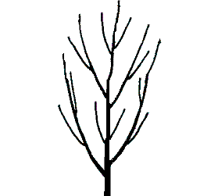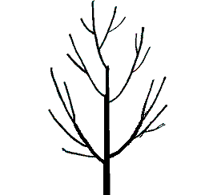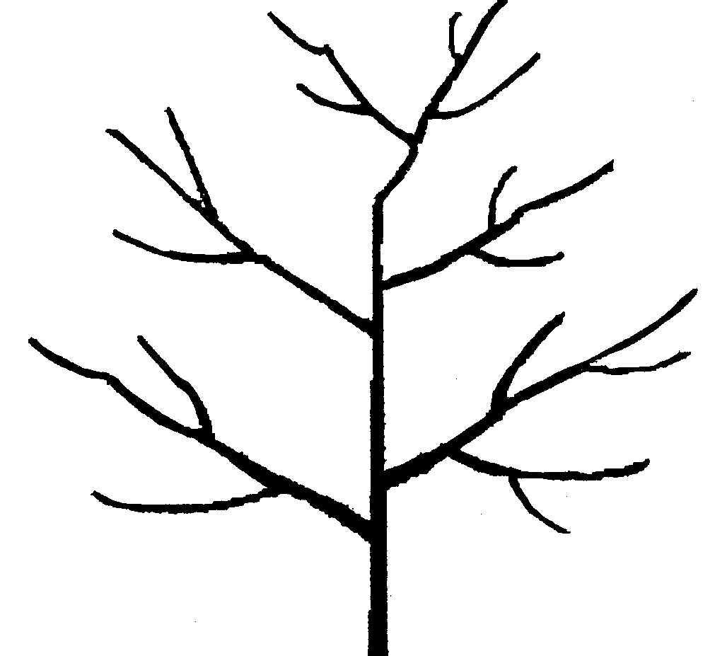

1 2 3
upright upright-spreading spreading

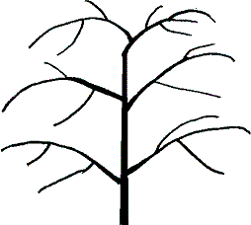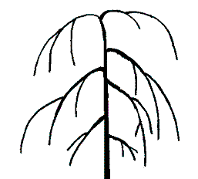

4 5
drooping weeping

Ad 6 One-year-old shoot: pubescence

The pubescence should be observed on the distal half of the shoot.

Ad 14 One-year-old shoot: shape of tip of bud

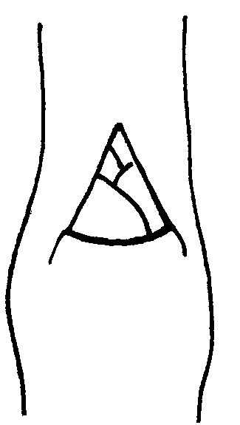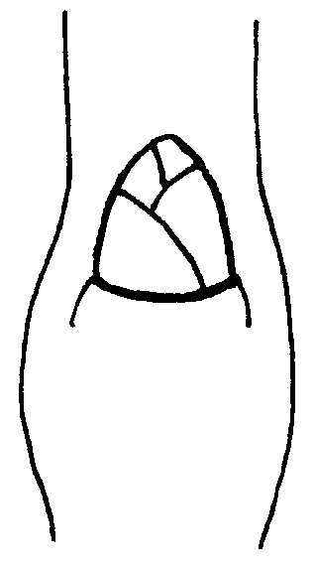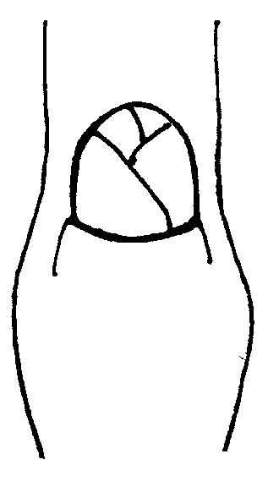
1 2 3
acute obtuse rounded

Ad 15 One-year-old shoot: position of bud relative to axis

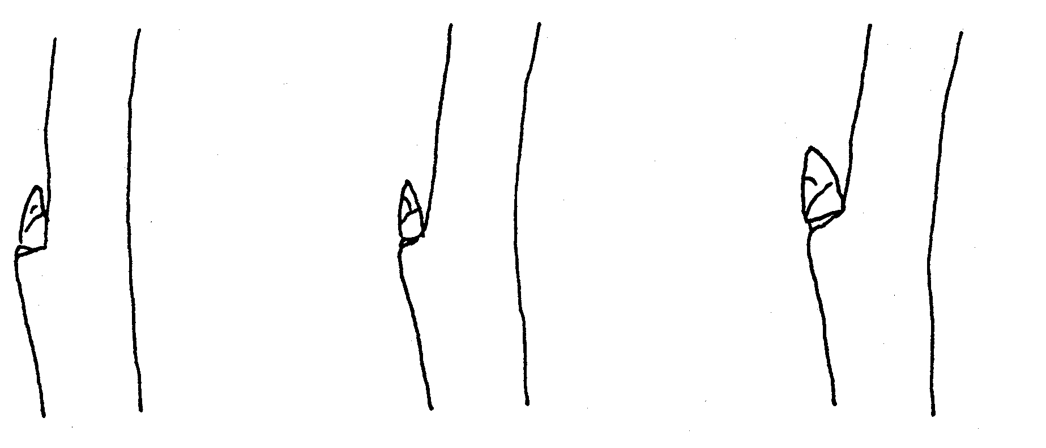

1 | 2 | 3
adpressed | slightly held out | markedly held out

Ad 16 One-year-old shoot: size of bud support

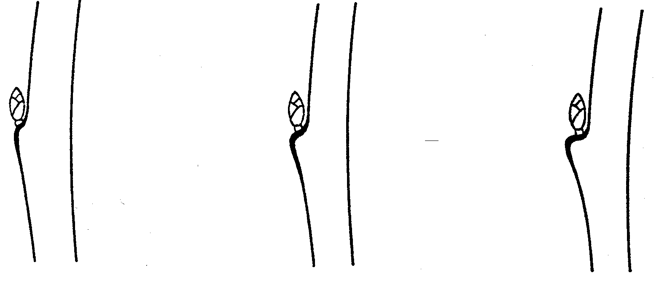

3 | 5 | 7
small | medium | large

Ad 17 One year old shoot: color of upper part

All observations should be made on the upper 100mm of the shoot during full growth. The color observed should be of the underlying skin underneath the pubescence.

Ad 21 Leaf blade: attitude in relation to shoot

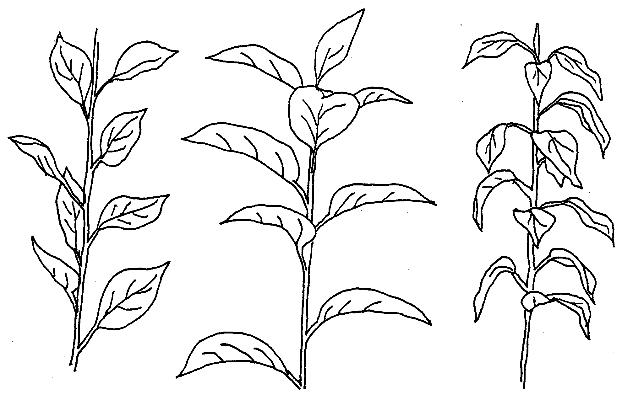

1 | 3 | 5
upwards | outwards | downwards

Ad 27 Leaf blade: incisions of margin

Observations should be done on the upper half of the leaf blade

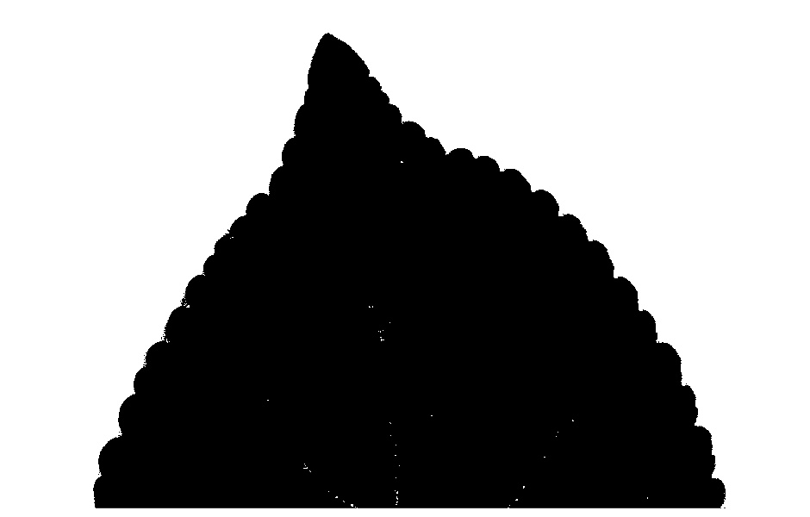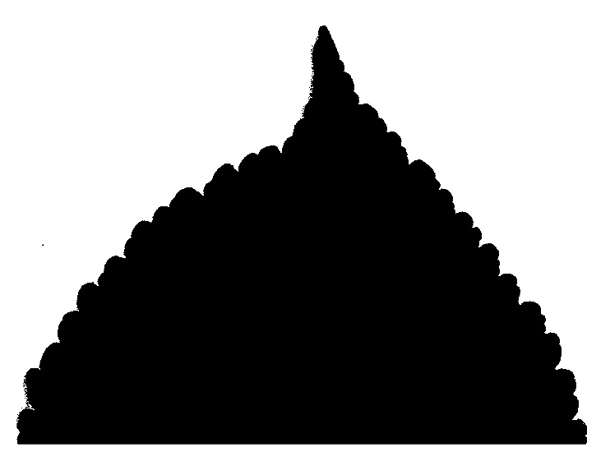
1 2
crenate bicrenate
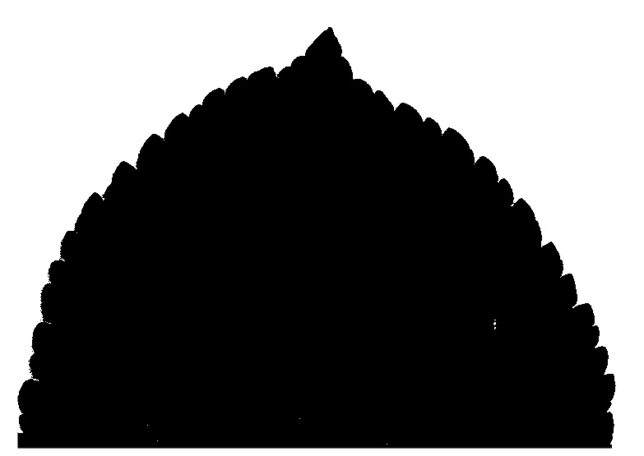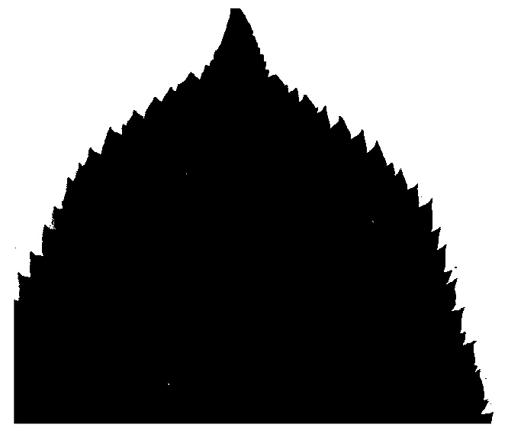
3 4
serrate type 1 serrate type 2
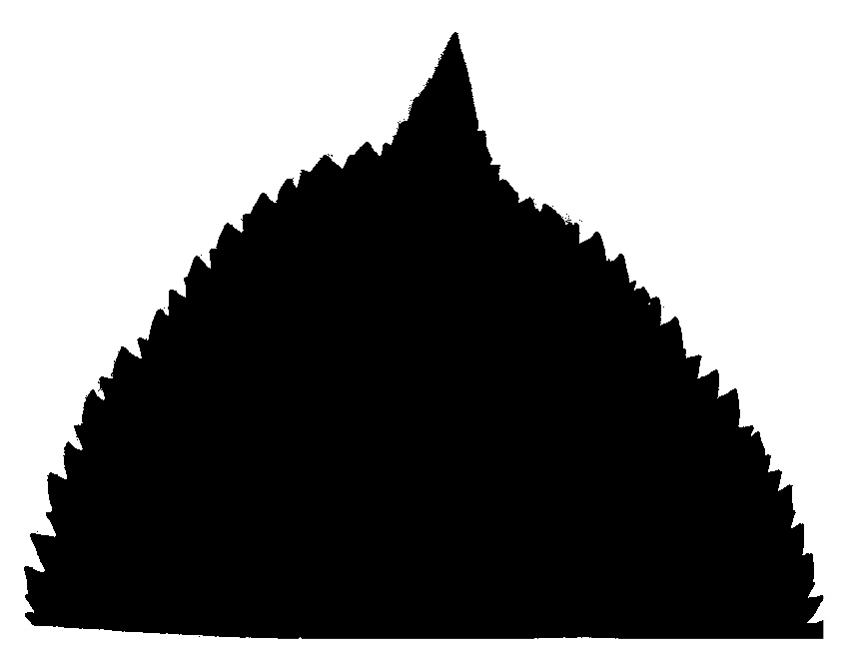
5
biserrate

Ad 34 Leaf: length of petiole relative to blade

Length of the petiole compared to the length of the middle vein of the leaf

Ad 35 Petiole: extent of anthocyanin coloration from base

Degree to which the amount of anthocyanin coloration extend from the petiole base towards the base of the leaf

Ad 37 Flower: predominant color at balloon stage

Balloon stage is the phenological stage in the course of the flower development when the calyx is fully expanded and the petals are recognizable, having partially expanded and inflated but are closed, covering the internal organs. Balloon stage is usually 1-2 days before the petals unfold.

Ad 38 Flower arrangement of petals

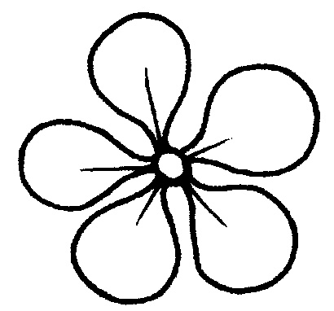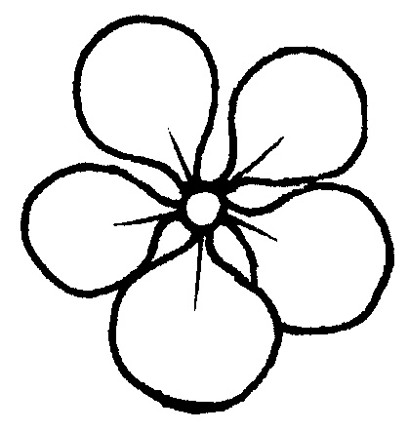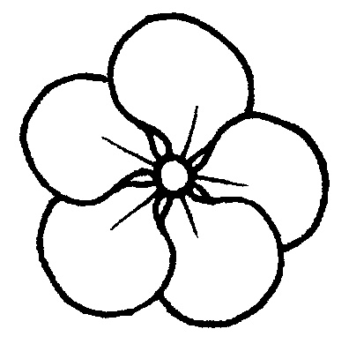
1 2 3
free intermediate overlapping

Ad 39 Flower: diameter

The observation on the flower should be done with the petals pressed into a horizontal position

Ad 40 Flower: position of stigmas relative to anthers
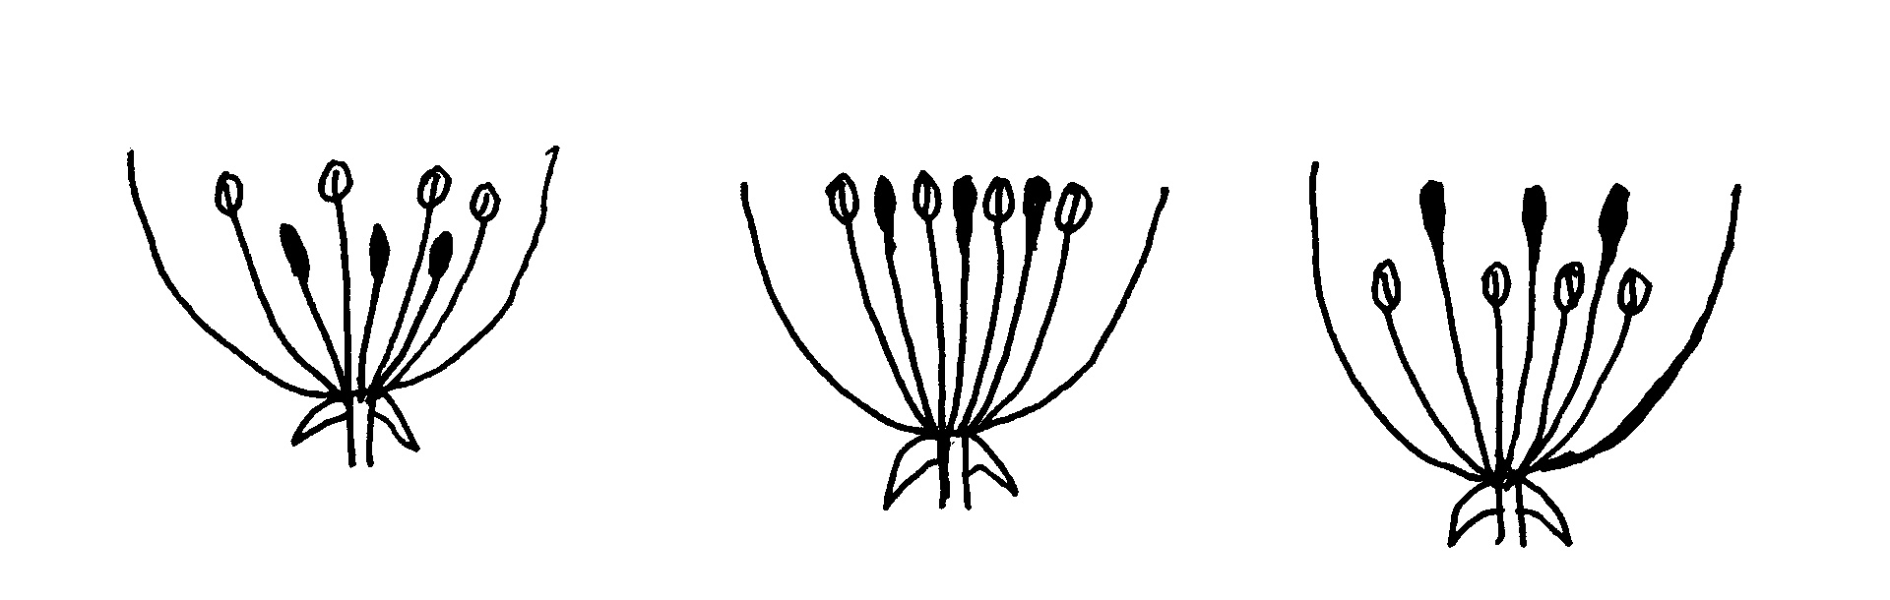
1 2 3
below same level above

Ad 42 Fruit: ratio height/diameter
Ad 43 Fruit: shape

 |  | ← lateral outline in apical half →
 |  | concave | flat tapering | rounded | flat parallel sides
at base ← position of broadest part → at middle |  |  |  | 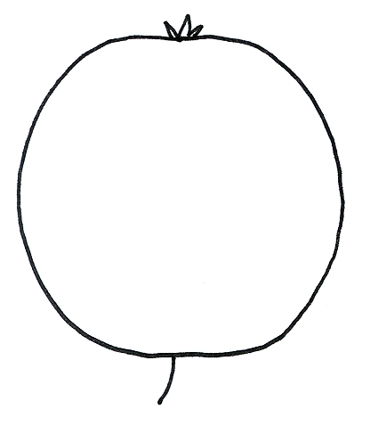  3  ovate
at base ← position of broadest part → at middle |  | 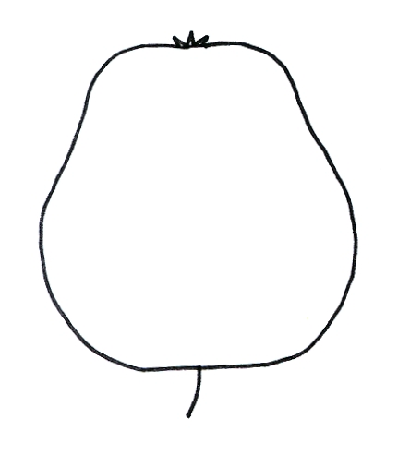 | 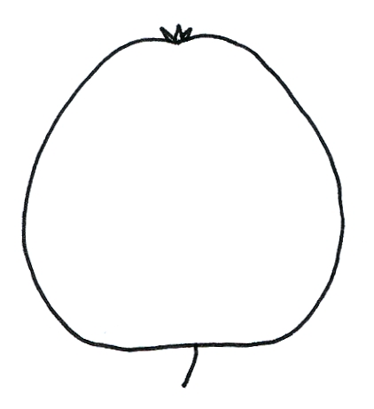 |  | 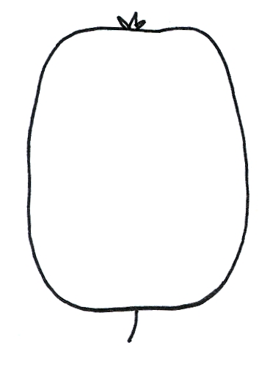
at base ← position of broadest part → at middle |  | 1  cylindrical waisted | 2  conic | 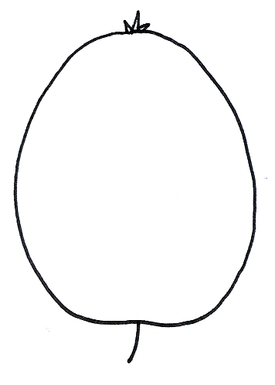  4,5,6  elliptic  (includes circular and oblate) | 7  cylindric

Ad 47: Fruit: hue of over color

All observation should be done with the bloom removed

Ad 50 Fruit: aperture of locules in transverse section
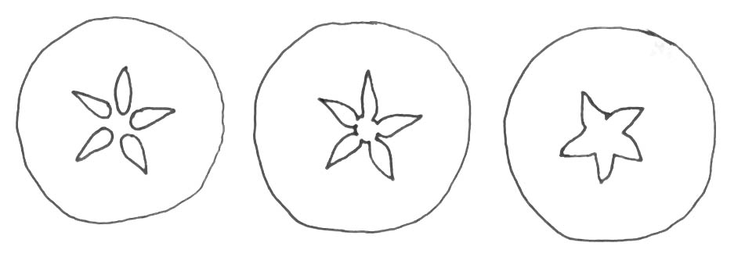
1 2 3
closed or slightly open moderately open fully open

Ad 51: time of beginning of bud burst

To be assessed when10% of the buds show green point

Ad 52 Flower: presence

Amount of flowers present during the flowering period

Ad 53: Time of beginning of flowering

When 10% of the flowers on the tree are fully open

Literature

Embree, C.G. 1995: “A Photographic Description of the Fruit of Certain Apple Rootstocks,” Fruit Varieties Journal, 49 (1):59-64, USA

Ferree, David C., Carlson, Robert F., 1987: “Apple Rootstocks” in Rootstocks for Fruit Crops, Ed. Rom, Roy C. and Carlson, Robert F., Wiley, 107-143, USA

Krümmel, H., 1956: “Die vegetativ vermehrbaren Unterlagen des Kern- und Steinobstes,” Berlin: Deutscher Bauernverlag, Germany

Maurer, Erich.,1939: “Die Unterlagen der Obstgehölze,” Berlin: Parey Verlag, Germany

Simons, Roy K., 1986: “Leaf Characteristics of Apple Dwarfing Rootstocks,” Fruit Varieties Journal, 40 (3): 71-79, USA

Tydeman, H.M., 1953: “A Description of Classification of the Malling-Herton and Malling XXV Apple Rootstocks,” Report East Malling Research Station for 1952, pp. 53-63, United Kingdom

Tydeman, H.M., 1954: “A Description of Certain MIX Crosses,” Report East Malling Research Station for 1953, United Kingdom

Tydeman, H.M., 1955: “Descriptions of the Malling Apple Rootstocks,” Report East Malling Research Station for 1954, pp. 64-66, United Kingdom

Technical Questionnaire

The TQ will be amended when there is agreement on the table of characteristics.

TECHNICAL QUESTIONNAIRE |  |  |  | Page {x} of {y} |  | Reference Number:
 |  |  |  |  |  | Application date:
 |  |  |  |  |  | (not to be filled in by the applicant)
TECHNICAL QUESTIONNAIRE
to be completed in connection with an application for plant breeders’ rights

1. Subject of the Technical Questionnaire
1.1 Botanical name |  |  | Malus Mill.
1.2 Common name |  |  | Apple Rootstocks
2. Applicant
Name
Address
Telephone No.
Fax No.
E-mail address
Breeder (if different from applicant)
3. Proposed denomination and breeder’s reference
Proposed denomination
(if available)

Breeder’s reference
#4. Information on the breeding scheme and propagation of the variety

4.1 Origin

(a) Seedling of unknown parentage [ ]

(b) Produced by controlled pollination [ ]
(indicate parent varieties)

− Seed bearing parent (indicate parent)

................................................................................................

− Pollen parent (indicate parent)

................................................................................................

(c) Produced by open pollination of [ ]
(indicate seed bearing parent plant)
................................................................................................

(d) Mutation or sport from (indicate original parent variety)

................................................................................................ [ ]

(e) Discovery (indicate where and when)

................................................................................................ [ ]

4.2 In vitro propagation

The plant material of the candidate variety has been obtained
by in vitro propagation yes [ ]
no [ ]

4.3 Virus status

- The variety is free from all known viruses as follows: [ ]
(indicate from which viruses)
...................................................................................................
- The plant material is virus tested [ ]
(indicate against which viruses)
...................................................................................................
- The virus status is unknown [ ]
  - Other information

5. Characteristics of the variety to be indicated (the number in brackets refers to the corresponding characteristic in Test Guidelines; please mark the note which best corresponds).

 | Characteristics |  |  |  |  |  | Example Varieties |  |  | Note
5.1  (4) | Plant: habit
 | upright |  |  |  |  |  | M 4, M 7¹ CG202⁴,M116⁴ |  |  | 1[ ]
 | upright-spreading |  |  |  |  |  | CG707¹ |  |  | 2[ ]
 | spreading |  |  |  |  |  | M 9, CG 222¹, Cepiland⁴, M116⁴ |  |  | 3[ ]
 | drooping |  |  |  |  |  | Marubakaido |  |  | 4[ ]
 | weeping |  |  |  |  |  |  |  |  | 5[ ]
5.2  (5) | One-year-old- shoot: growth
 | straight |  |  |  |  |  | M 9¹⁴ |  |  | 1[ ]
 | Straight to moderately wavy |  |  |  |  |  |  |  |  | 2[ ]
 | moderately wavy |  |  |  |  |  | M 793¹, CG202⁴ |  |  | 3[ ]
 | Moderately wavy to strongly wavy |  |  |  |  |  |  |  |  | 4[ ]
 | Strongly wavy |  |  |  |  |  | M 2, M 25¹ |  |  | 5[ ]
5.3  (19) | Young leaf: anthocyanin coloration
 | absent or very weak |  |  |  |  |  | M 27 |  |  | 1[ ]
 | weak |  |  |  |  |  |  |  |  | 2[ ]
 | medium |  |  |  |  |  |  |  |  | 3[ ]
 | strong |  |  |  |  |  |  |  |  | 4[ ]
 | very strong |  |  |  |  |  | B 9 |  |  | 5[ ]
 | Characteristics |  |  |  |  |  | Example Varieties |  |  | Note
5.4  (51) | Time of beginning of bud burst
 | very early |  |  |  |  |  | P 16 |  |  | 1[ ]
 | very early to early |  |  |  |  |  |  |  |  | 2[ ]
 | early |  |  |  |  |  | M 9, MM 106 |  |  | 3[ ]
 | early to medium |  |  |  |  |  |  |  |  | 4[ ]
 | medium |  |  |  |  |  | M 25 |  |  | 5[ ]
 | medium to late |  |  |  |  |  |  |  |  | 6[ ]
 | late |  |  |  |  |  | MM 111 |  |  | 7[ ]
 | late to very late |  |  |  |  |  |  |  |  | 8[ ]
 | very late |  |  |  |  |  | M 26 |  |  | 9[ ]
6. Similar varieties and differences from these varieties

Please use the following table and box for comments to provide information on how your candidate variety differs from the variety (or varieties) which, to the best of your knowledge, is (or are) most similar. This information may help the examination authority to conduct its examination of distinctness in a more efficient way.

Denomination(s) of variety(ies) similar to your candidate variety |  | Characteristic(s) in which your candidate variety differs from the similar variety(ies) |  |  | Describe the expression of the characteristic(s) for the similar variety(ies) |  |  | Describe the expression of the characteristic(s) for your candidate variety
Example
Comments:
In the case of identical states of expressions of both varieties, please indicate the size of the difference.

#7. Additional information which may help in the examination of the variety

7.1 Resistance to pests and diseases

7.2 Special conditions for the examination of the variety

7.3 Other information

A representative color image of the variety should accompany the Technical Questionnaire.

8. Authorization for release

(a) Does the variety require prior authorization for release under legislation concerning the protection of the environment, human and animal health?

Yes [ ] No [ ]

(b) Has such authorization been obtained?

Yes [ ] No [ ]

If the answer to (b) is yes, please attach a copy of the authorization.

9. Information on plant material to be examined or submitted for examination.

9.1 The expression of a characteristic or several characteristics of a variety may be affected by factors, such as pests and disease, chemical treatment (e.g. growth retardants or pesticides), effects of tissue culture, different rootstocks, scions taken from different growth phases of a tree, etc.

9.2 The plant material should not have undergone any treatment which would affect the expression of the characteristics of the variety, unless the competent authorities allow or request such treatment. If the plant material has undergone such treatment, full details of the treatment must be given. In this respect, please indicate below, to the best of your knowledge, if the plant material to be examined has been subjected to:

(a) Microorganisms (e.g. virus, bacteria, phytoplasma) Yes [ ] No [ ]

(b) Chemical treatment (e.g. growth retardant, pesticide) Yes [ ] No [ ]

(c) Tissue culture Yes [ ] No [ ]

(d) Other factors Yes [ ] No [ ]

Please provide details for where you have indicated “yes”.

……………………………………………………………

{ ASW 17 (Chapter 10: TQ 9.3) – tests for the presence of virus or other pathogens }

“9.3 Has the plant material to be examined been tested for the presence of virus or other pathogens?

Yes [ ]
(please provide details as specified by the Authority)

No [ ]”

10. I hereby declare that, to the best of my knowledge, the information provided in this form is correct:

Applicant’s name

Signature Date

[Annex follows]

Observations and Comments to document TG/163/4(proj.2)

3.1 | NZ Request that a single independent growing cycle be considered as a minimum. If there is clear D and U in the cycle, what is the actual purpose of the second season? A second season really only adds information if there is doubt or questions in the first. Do we need to confirm a positive first season?  ZA In 4.1.2 states that differences observed between varieties may be so clear that more than one growing cycle is not necessary.
4.2.2 | DE in a sample size of 10 plants 1 off type is allowed
Table of characteristics
4 | ZA to insert upright-spreading for note 2
5 | DE: Propose to have the states 1, 3, 5 in order to improve the discrimination value. To read "strongly …" in state 5.
7 | DE: Propose to have the states 1, 3, 5 in order to improve the discrimination value.
9 | NZ Generally easier to see in stoolbeds as a single shoot.
11 | DE: Propose to have the states 1, 3, 5 in order to improve the discrimination value.
13 | DE: Propose to have the states 1, 3, 5 in order to improve the discrimination value.
16 | DE: Propose to have the states 1, 3, 5 in order to improve the discrimination value.
17 | NZ Pubescence can obscure the colour. Note about “colour of underlying skin”
21 | NZ notes 1, 2, 3
24 | NZ Currently there are 5 states, including the in between states are not so easy to determine. Consider altering the scale range to make the states clearer  1 very slightly elongated 2 slightly elongated 3 moderately elongated 4 strongly elongated 5 very strongly
26 | ZA to delete pointed
28 | NZ Consider deleting. There is correlation with 26 and questionable whether it adds any new information for distinctness.
30 | DE: Propose to have the states 1, 3, 5 in order to improve the discrimination value.
34 | ZA Change wording to length of petiole relative to blade, delete ratio length of blade/ length of petiole. Harmonized with other guidelines
36 | NZ Similar comment for 23. Five states OK but improve clarity  ZA Very small object to observe, suggest keep as is.
37 | NZ state 4 needs to be medium pink or dark pink. Suggest medium pink
General | NZ Fruit characters: do we need so many? Size, shape and colour are the keys, much as in ornamental apples. Considering deleting 42, 44, 45, 48, 50, 51
41 | NZ Insert note 1 and 9
42 | ZA change order from compressed to elongated
 | ZA propose to delete fruit: thickness of stalk
53 | DE: To move before 36. I still question whether we need all these flower and fruit characteristics in rootstock guidelines. May this char. be indicated as A,B? Propose to have the states 1, 3, 5 in order to improve the discrimination value.  ZA Decided in Japan to move after time of beginning of bud burst.
54 | NZ A is not necessary. An entirely separate test.  DE: Do not consider this to be a suitable DUS characteristic, but more a characteristic for VCU.
New | NZ Consider One year old shoots: spines 1 few 2 medium 3 many  Some varieties such as CG202 have spiny shoots. We have not looked into this character closely

[End of Annex and of document]

* These names were correct at the time of the introduction of these Test Guidelines but may be revised or updated. [Readers are advised to consult the UPOV Code, which can be found on the UPOV Website (www.upov.int), for the latest information.]
# Authorities may allow certain of this information to be provided in a confidential section of the Technical Questionnaire.
# Authorities may allow certain of this information to be provided in a confidential section of the Technical Questionnaire.

