E
International Union for the Protection of New Varieties of Plants

Technical Working Party on Automation and Computer Programs  Thirty-Seventh Session  Hangzhou, China, October 14 to 16, 2019 | TWC/37/5  Original: English  Date: September 30, 2019
Risks associated with assessment of uniformity by off-types on the basis of more than one growing cycle
Document prepared by experts from the United Kingdom
Disclaimer: this document does not represent UPOV policies or guidance

Introduction

The report of the Technical Working Party on Automation and Computer Programs (TWC) at its thirty-sixth session (see document TWC/36/15 “Report”) concluded:

“54. The TWC considered document TWC/36/7 ‘Risks associated with assessment of uniformity by off-types on the basis of more than one growing cycle’ and received a presentation by experts from Germany and the United Kingdom, a copy of which would be provided as document TWC/36/7 Add..
“55. The TWC agreed to invite the experts from Germany and the United Kingdom to develop examples demonstrating the risks and consequences for decisions on uniformity to be presented at its next session.
“56. The TWC noted the importance of considering the risks associated with assessment of uniformity by off-types on the basis of more than one growing cycle and agreed that it would not be practical to develop tables with the allowed number of off-types for such cases. The TWC noted that, in future, software might be needed to calculate such risks.”

A calculator based in Excel is presented. This enables the calculation of both appropriate thresholds in terms maximum allowable numbers of off-types as well as statistical risks. It works for both single and two-cycle systems for off-type assessment. At this stage it does not work for sequential approaches based on sub-samples within a single test or trial.

3. The text below and the software assumes that there is only one submission of plant material, even when uniformity is assessed over two cycles.

The importance of considering risks when assessing uniformity by off-types

4 Population standards for off-types are given in Test Guidelines, defining the maximum allowable proportions of off-types.

5 The population standard is the maximum level of off-types in all individuals of variety. This is a hypothetical concept since we cannot assess all individuals. Instead, we examine a sample of individuals, with the number depending on circumstances and indicated in the Test Guidelines.

6. As we only look at a relatively small number of individuals, the proportion of off-types we see may not reflect perfectly the proportion in the variety.

7. For example, if the proportion of off-types in the variety is 5% and the sample size is 500 plants, we might find the following numbers of off-types on different occasions (random simulation): 29, 19, 21, 27, 30, 29, 32, 28, 21 or 22.

8. Some of these numbers are more than 5% of 500 plants, others less. If we were to set the maximum number of off-types to 25 (5% of 500), approximately half the time we would expect a variety with 5% off-types to fail this uniformity criterion.

9. We should allow for this natural sampling variability in the way that we assess varieties for off-types. We can do this by understanding the risks associated with the decisions.

Type of risks to consider

10. From a statistical viewpoint, we should consider two types of risks in particular:

Type I error: The conclusion based on the test statistic, i.e. from the DUS trial, is that a variety is not uniform, when it would be uniform if the trial could be repeated indefinitely.

Type II error: The conclusion based on the test statistic, i.e. from the DUS trial, is that a variety is uniform, when it would be non-uniform if the trial could be repeated indefinitely.

11. We can alter the chances of these two types of errors by the way we assess off-types. For a single cycle assessment, we can do this by changing the maximum number of off-types that is acceptable or by changing the sample size. The probabilities of these types of errors can be calculated using mathematical formulae.

12. In general, the maximum number of off-types is set to ensure that chance of type I errors is sufficiently low. In most cases, we aim to have the chance of type I errors being less than 5%. As the chance of type I errors is 1 minus the acceptance probability, this equates to an acceptance probability of 95%.

13. Given the sample size, the population standard and the acceptance probability, for a single cycle assessment we can identify the maximum number of off-types. These can be found in tables in document TGP/8/3 “Trial Design and Techniques used in the Examination of Distinctness, Uniformity and Stability” Part II Section 8. For example, the maximum number of off-types with a sample size of 500, a population standard of 5% and an acceptance probability of 95% is 33. Note that 33 off-types in 500 plants is 6.6%, a proportion that is larger than the population standard. So the approach gives a margin of safety for the candidate variety according to the sample size.

14. If the test is set up this way, increasing the sample size tends to reduce the chance of type II errors. For example, with a sample size of 500, a population standard of 5% and an acceptance probability of 95%, the chance of a variety with 10% off-types having an acceptable number of off-types (type II error rate) is just 0.5%. However if the sample size is reduced to 50 plants so that the maximum acceptable number is now 5, then the type II error rate increases to 63%.

15. Guidance on sample sizes can be found in Test Guidelines. General guidance can be found in TGP/8/3 on statistical aspects of assessment of uniformity by off-types.

Considering risks when uniformity by off-types is assessed on basis of more than one growing cycle

16. When examining off-types over two or more cycles, it is necessary to consider which risks are most important when setting thresholds in each cycle. This is particularly true for approaches 1 and 2 as set out in Annex I of document TWP/1/17 Rev.. There are two key choices:

a) To consider risks in each cycle separately;
b) To consider risks for the complete decision process over multiple cycles.

17. The advantage of following a) is that it is easier to work out the maximum number of off-types required for each cycle to achieve the required acceptance probability; tables in TGP/8/3 will give these. For b), tables have not yet been produced.

18. However, b) has the advantage that the selected acceptance probability will be achieved for the whole test, which will have the effect of reducing the chance of type II errors. The choice should lead to greater harmonisation in standards of off-types testing across member states. This would be irrespective of whether off-types are assessed in one cycle or more than one cycle, and is independent of approach. This is because risks are balanced appropriately for the overall decision on uniformity.

19. For example, let consider approach 1 with 50 plants in each cycle, a 1% population standard with acceptable probability of 95%. [In approach 1, the two cycles are assessed separately. If there is inconsistency in the verdicts for the two cycles, a third cycle is assessed]. If the risks are considered separately for each cycle then the maximum number of off-types in each cycle would be set at 2. If the overall risks are considered, the maximum number is 1. The overall chance of declaring a variety with 5% off-types as uniform is 56% when the maximum number is 2 and 19% when it is 1. So setting the number of off-types allowed based on the acceptance probability for a single cycle results in a much higher overall chance of type II errors.

20. Software has now been developed in Excel that enables examination of risks as provided in the Annex II to this document.

PROPOSAL

21. Whichever approach is used, when uniformity is assessed over two or more cycles, it is proposed that the thresholds for the acceptable number of off-types should be chosen to give the required overall acceptance probability (or equivalently, the required type I error over all cycles as this is 1 minus the acceptance probability). This will lead to greater harmonisation of standards, whatever approach is used.

SOFTWARE

22. Software has been developed in Excel. The Excel workbook uses no macros so should be easy to distribute with low security concerns.

23. The software can calculate the two types of statistical risk for either a one-cycle or a two-cycle situation. For this, it requires the acceptance probability, the population standard, the sample size (number of individuals examined) in each cycle, and the maximum allowable numbers of off-types (for two-cycles, this is per cycle and possibly for the combined sample depending on the approach).

24. The software can also suggest the thresholds in terms of maximum allowable numbers of off-types. This requires the acceptance probability, the population standard and the sample size in each cycle. In the case of two-cycles, the thresholds are calculated to achieve either the overall acceptance probability or the acceptance probability for individual cycles.

25. The software is meant to facilitate discussion on setting up of off-type tests, either using overall cycles or individual cycle acceptance probabilities. It should also be a useful tool for crop experts.

26. The authors would be happy for the software to be freely distributed. However, it would be prudent for it to be tested by an independent party.

27. A demonstration of the software will be presented at the thirty-seventh session of the TWC.

28. The TWC is invited to:

(a) note that a software was developed in Excel that enables examination of risks, as provided in Annex II to this document; and

(b) consider the proposal that the thresholds for the acceptable number of off-types should be chosen to give the required overall acceptance probability, when uniformity is assessed over two or more cycles, as set out in paragraph 21 of this document.

Adrian Roberts, BioSS, United Kingdom
Sally Watson, AFBI, United Kingdom

[Annex I follows]

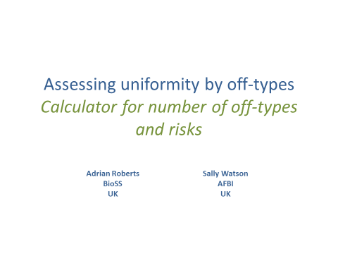

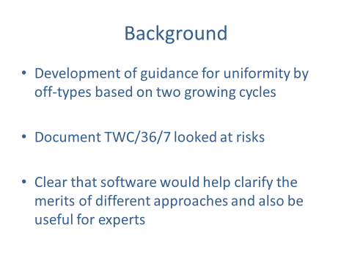

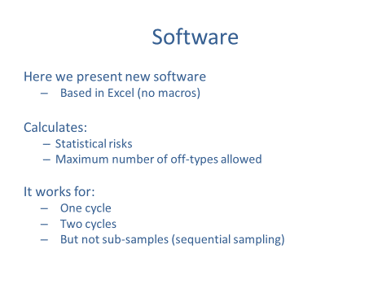

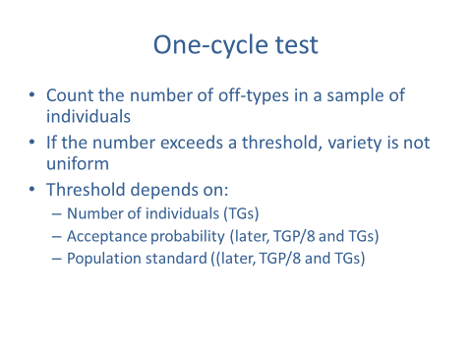

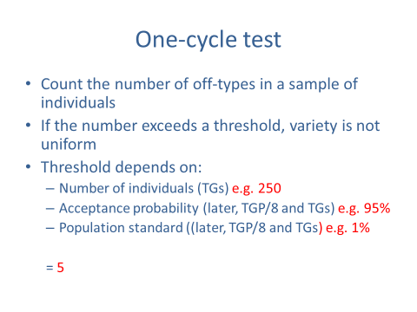

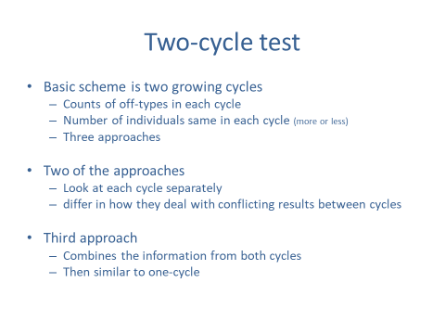

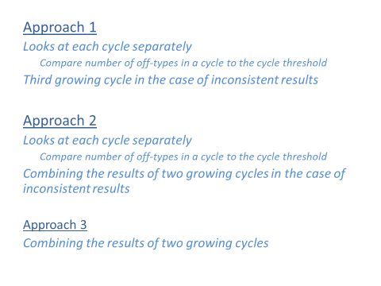

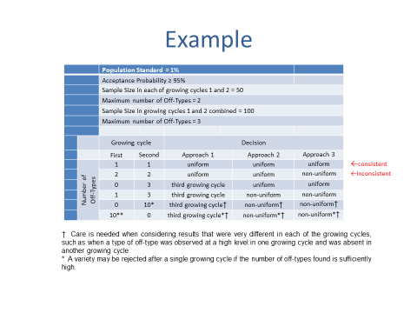

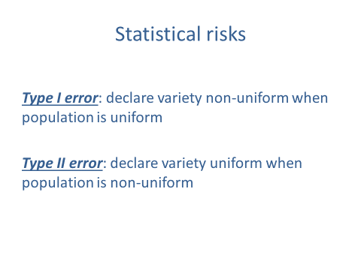

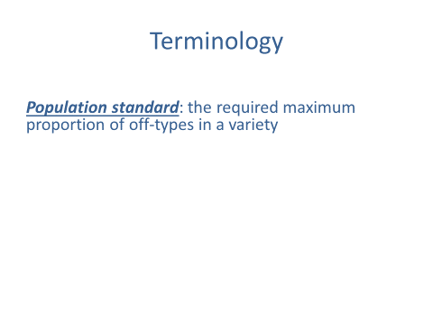

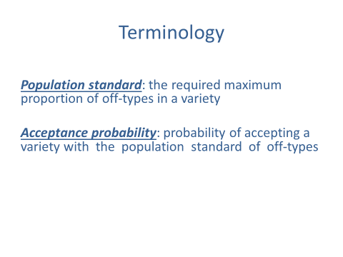

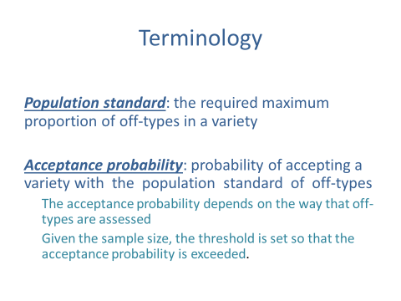

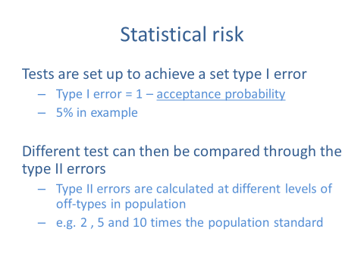

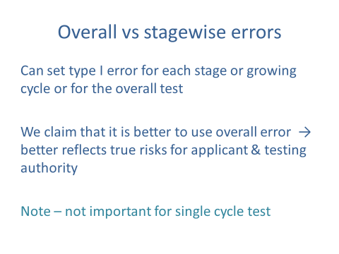

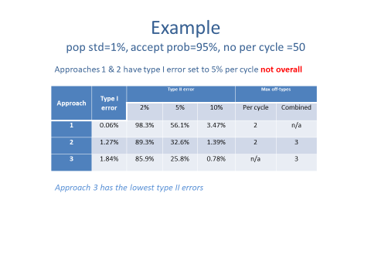

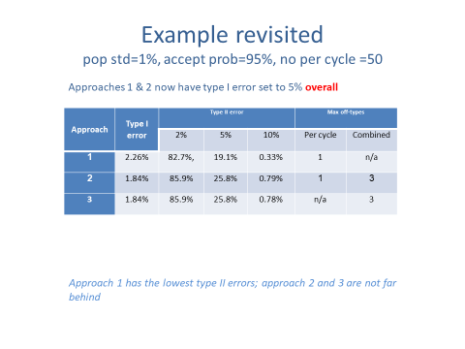

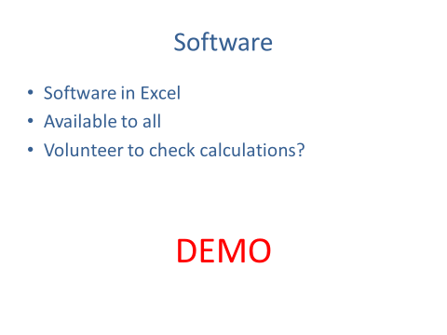

[Annex II follows]

Please see the Excel file

[End of Annex II and of document]

