E
International Union for the Protection of New Varieties of Plants

Technical Working Party on Automation and Computer Programs  Thirty-Seventh Session  Hangzhou, China, October 14 to 16, 2019 | TWC/37/4  Original: English  Date: September 26, 2019
Web services provided by UPOV
Document prepared by the Office of the Union
Disclaimer: this document does not represent UPOV policies or guidance

EXECUTIVE SUMMARY

The purpose of this document is to report on developments concerning web services provided by UPOV and, in particular, to report on the implementation of system-to-system communication for the UPOV PRISMA PBR Application Tool in order to exchange application data with relevant PVP offices.

The TWC is invited to note the future developments in relation to GENIE DB

The structure of this document is as follows:
EXECUTIVE SUMMARY 1
BACKGROUND 1
UPOV PRISMA 1
GENIE DATABASE 2

BACKGROUND

The Technical Working Party on Automation and Computer Programs (TWC), at its thirty-sixth session, held in Hanover, Germany, from July 2 to 6, 2019, considered document TWC/36/8 “Web services provided by UPOV and members of the Union” and received a presentation by the Office of the Union, a copy of which was provided as document TWC/36/8 Add..

The TWC noted the progress in the development of a new WIPO standard designed to guide Web Application Programming Interface (API) implementation.

UPOV PRISMA

If a PVP office already has an online PBR application system, it is possible to:
- transmit application data from UPOV PRISMA to the PVP Office;
- allow applicants using the PVP Office filing system to import existing application data into UPOV PRISMA

Therefore, UPOV has made available two web services:
- ExportWS: allows transmission of application data from UPOV PRISMA to PVP Office system.
- ImportWS: allows transmission of application data from PVP Office system to UPOV PRISMA.

- XML: It is recommended to use this option in order to get benefit of the structured data. However, the PVP office system should support this specific data format described in the PVP-XML schemas. For more information about PVP-XML, please visit http://www.upov.int/upovprisma/pvpxml.html
- PDF: It is recommended to use this option if the PVP office system does not support PVP-XML. It is important to note that the data at UPOV PRISMA side is stored in XML and can be retrieved whenever the PVP office is ready to accept the PVP-XML format.
- Both

Since UPOV PRISMA Version 2.0 was released in February 2018, it is possible for the CPVO online system to retrieve application data submitted through UPOV PRISMA.

Other PVP offices have contacted the office of the Union in order to set up machine-to-machine communication with UPOV PRISMA, namely: Georgia; Japan; Kenya and the United States of America.

GENIE DATABASE

Currently, it is possible to retrieve all the UPOV codes in JSON format using https://webaccess/genie/upovcode/UpovCodeList.

Output (IN JSON Format):

{
"upovCodeList":
[
{
"upovCode":"COPRI",
"principalBotanicalName":"Coprinus",
"otherBotanicalName":"Coprinus",
"commonNameEN":"",
"commonNameFR":"",
"commonNameDE":"",
"commonNameES":"",
"commonNameZH":"",
"commonNameJA":"",
"commonNameKO":"",
"commonNameVI":"",
"commonNameTR":"",
"hasTqForm":"",
},
{
"upovCode":"COPRI_COM",
"principalBotanicalName":"Coprinus comatus mull ex fv",
"otherBotanicalName":"Coprinus comatus mull ex fv",
"commonNameEN":"",
"commonNameFR":"",
"commonNameDE":"",
"commonNameES":"",
"commonNameZH":"",
"commonNameJA":"",
"commonNameKO":"먹물버섯",
"commonNameVI":"",
"commonNameTR":"",
"hasTqForm":"",
},
{
"upovCode":"COPRO_REP",
"principalBotanicalName":"Coprosma repens A. Rich.",
"otherBotanicalName":"Coprosma repens A. Rich.",
"commonNameEN":"",
"commonNameFR":"",
"commonNameDE":"",
"commonNameES":"",
"commonNameZH":"",
"commonNameJA":"",
"commonNameKO":"",
"commonNameVI":"",
"commonNameTR":"",
"hasTqForm":"",
},
"responseCode":"1",
"responseMsg":"SUCCESS"
}

It is now possible to get the same list in XML format using: https://webaccess.wipo.int/genie/upovcode/xmlupovcodes

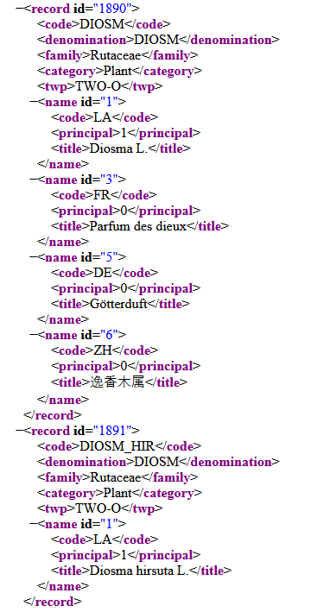

It is planned to make these web services available under www.upov.int, as follows:
- https://www.upov.int/geniews/upovcode/UpovCodeList
- https://www.upov.int/geniews/upovcode/xmlupovcodes

In order to facilitate the integration with PLUTO DB, a new web service will be available to obtain the list of all UPOV codes covered by UPOV Test Guidelines.

Output (IN JSON Format) :

{
DIOSP_KAK: true,
DIPLO_TEN: true,
DNDRB: true,
HORDE_VUL: true,
HOSTA: true,
HOSTA_FOR: true,
HOSTA_PLA: true,
HOSTA_SIE: true,
HOSTA_TAR: true,
HUMUL_LUP: true,
ALLIU_CEP_AGG: true,
ALLIU_CEP_CEP: true,
ALLIU_FIS: true,
CASTA_SAT: true,
CASTA_SAT: true,
CATHA_ROS: true,
CELOS: true,
CELOS_ARG: true,
CELOS_ARG_CRI: true,
LEUCD_LAU: true,
LEUCD_SAL: true,
LEUCD_SPI: true,
LEUCD_UDI: true,
LEUCS: true,
LEUCS_COR: true,
LEUCS_CPA: true,
LEUCS_CUN: true,
LEUCS_ECU: true,
LEUCS_ERU: true,
LEUCS_PAT: true,
LILIU: true,
…
}

In order to facilitate the integration with TG Template Web Based application, a new web service will be available to update GENIE DB in relation the coverage of Test Guidelines when its status becomes adopted in the TG Template Web Based application.

The TWC is invited to note the availability of web services to transmit application data between PVP offices and UPOV PRISMA and the future developments in relation to GENIE DB.

[End of document]

