E
International Union for the Protection of New Varieties of Plants

Technical Working Party on Automation and Computer Programs  Thirty-Sixth Session  Hanover, Germany, July 2 to 6, 2018 | TWC/36/6 Add.  Original: English  Date: June 29, 2018
addendum to
IMPACT OF THE NUMBER OF GROWING CYCLES ON VARIETY DESCRIPTIONS
AND DISCRIMINATION POWER
Document prepared by an expert from Germany
Disclaimer: this document does not represent UPOV policies or guidance
The Annex to this document contains a copy of a presentation on “Impact of the number of growing cycles on variety descriptions and discrimination power”, to be made at the thirty-sixth session of the Technical Working Party on Automation and Computer Programs (TWC).

[Annex follows]

IMPACT OF THE NUMBER OF GROWING CYCLES ON VARIETY DESCRIPTIONS AND DISCRIMINATION POWER

Presentation prepared by an expert from Germany

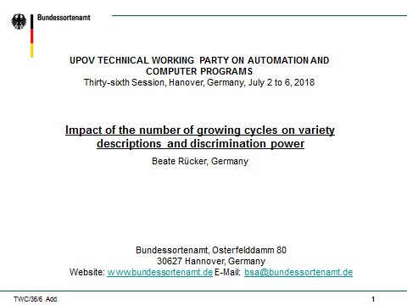

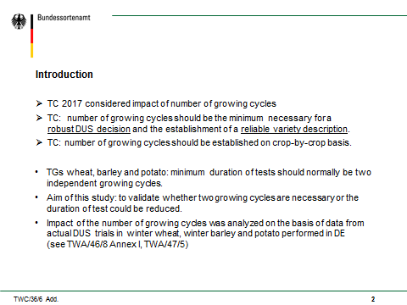

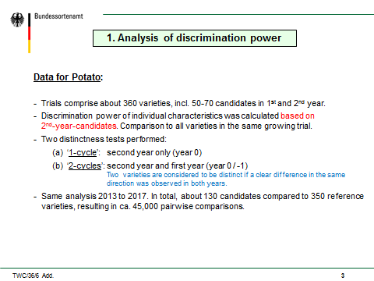

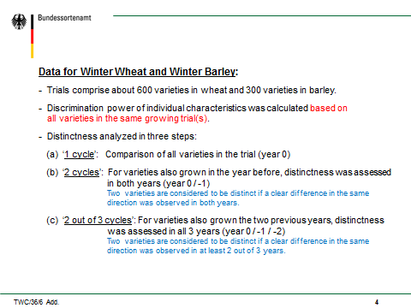

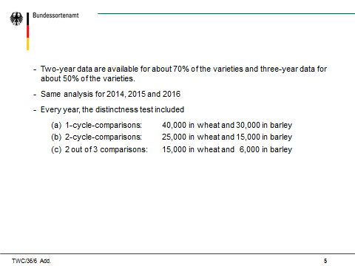

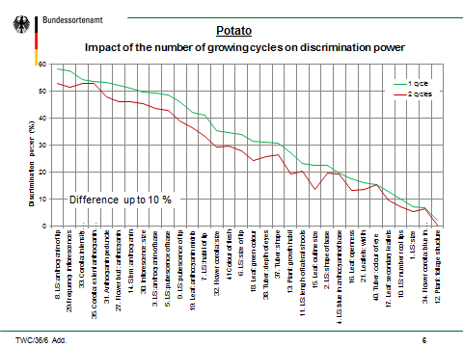

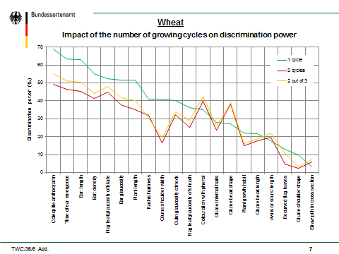

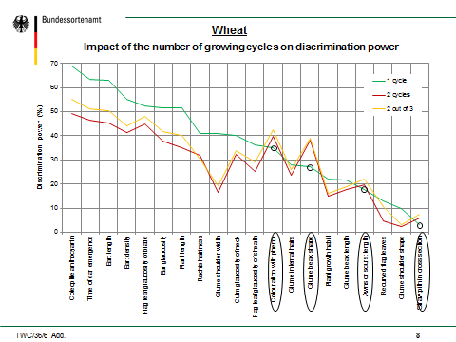

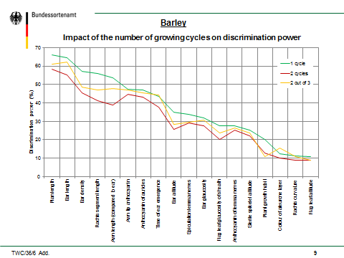

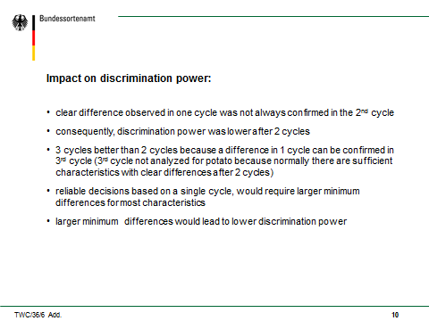

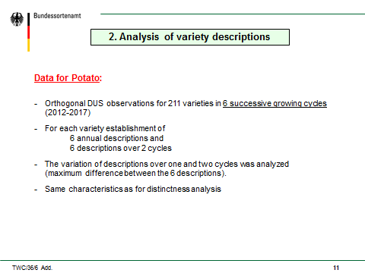

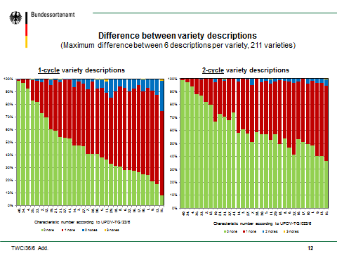

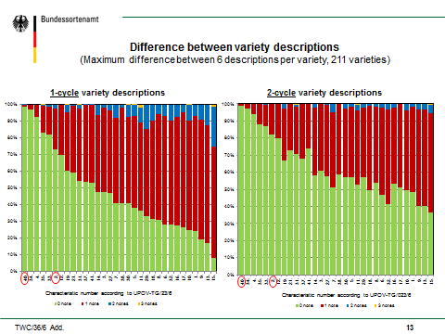

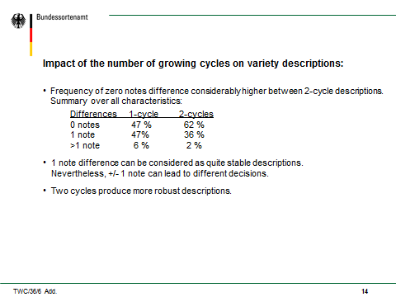

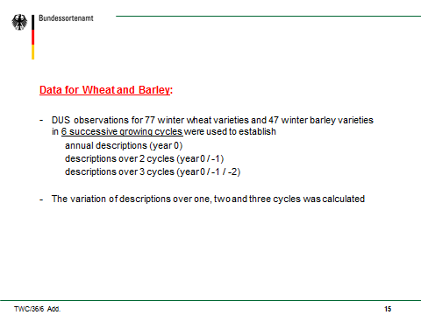

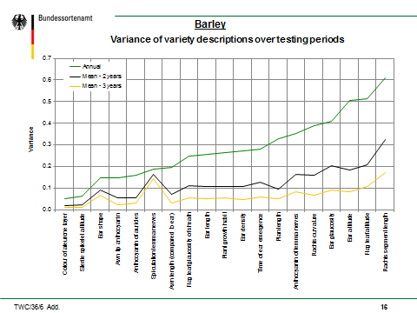

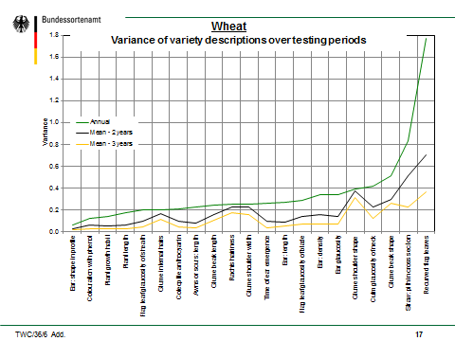

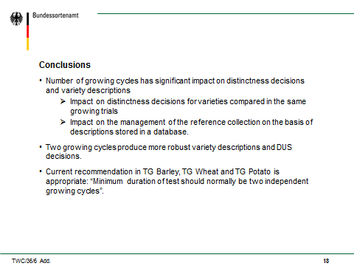

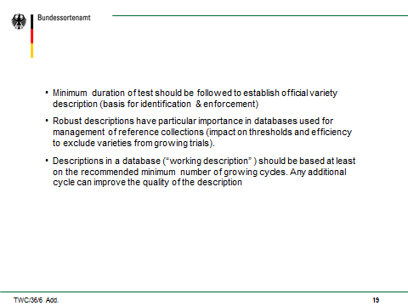

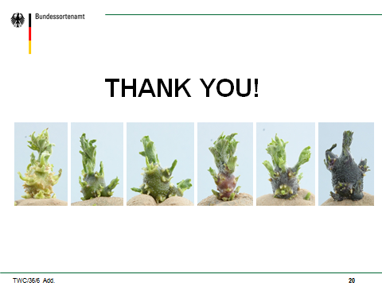

[End of Annex and of document]

