E
International Union for the Protection of New Varieties of Plants

Technical Working Party on Automation and Computer Programs  Thirty-Sixth Session  Hanover, Germany, July 2 to 6, 2018 | TWC/36/2  Original: English  Date: June 18, 2018
Compilation of explanations on methods for producing varietIES descriptions for measured characteristics, and clarification of differences
prepared by an expert from the United Kingdom
Disclaimer: this document does not represent UPOV policies or guidance

Background

The purpose of this document is to progress the possible development of new guidance for document TGP/8 on “Data Processing for the Assessment of Distinctness and for Producing Variety Descriptions” describing different methods used by UPOV members for measured quantitative characteristics.

At its thirty-fifth session, the TWC considered explanations of methods to transform measurements into notes for quantitative characteristics. These were from:

- TWP/1/15, Annex III “Short explanation on the French methods for producing variety descriptions for measured characteristics”,
- TWC/35/12 “Short explanation on the Japanese methods for assessment table for producing variety descriptions”.
- TWC/35/15 “Short explanation on some United Kingdom methods for data processing for the assessment of distinctness and for producing variety descriptions for quantitative characteristics”, and

The methods explained were among those compared in TWC/35/9 “Comparison of Methods Used For Producing Variety Descriptions: Results of the Practical Exercise”.

The TWC noted that explanations provided by the participants in the practical exercise presented information in different ways, and requested a document compiling all explanations received using the same format and clarifying the differences. The TWC requested that this document also took into consideration relevant information from TWC/35/5 “Characteristics, genotype by environment interaction (GEI) and DUS trials”.

This document provides a compilation of explanations on methods for producing variety descriptions for measured characteristics, and a clarification of differences.

Introduction

For crops with measured quantitative characteristics that vary within varieties, distinctness is determined in general by comparison of variety means through statistical analysis, and based on data from trials in a number of years or growing cycles. Because the data on the characteristics are quantitative, the variety means also are quantitative, e.g. measured in millimeters, and so are not on a 0 to 9 scale. To produce a variety description for a variety, the variety means for these characteristics are converted or transformed to notes.

This document describes the different methods used by some member states to transform variety means into notes for measured quantitative characteristics. It also clarifies the differences between the methods.

The explanations of methods received from member states to transform measurements into notes for measured quantitative characteristics are compiled in Annex I-III of this document. A summary of these methods is included in the table below.

COUNTRY |  | Method : description | Example varieties | Crop expert judgment | Equal-spaced state
France | Method 1 | Combined use of example varieties and reference collection | X | X
 | Method 2 | Adjusted means from COY program + linear regression method calibrated with example varieties | X | X
Italy# |  | Average range of historical means + median used as "reference point" + partitioning into equal spaced states + calibration with crop expert judgment and example varieties | X | X | X
Germany* |  | Adjusted mean from COY program + partitioning based on example varieties and crop expert judgment | X | X
Japan |  | Adjusted Full Assessment Table (FAT) : states determined with historical data of example varieties | X |  | X
United Kingdom | Method 1 | Range of expression of the over-year means for the reference collection varieties (for the past 10 years) divided into equal spaced states |  |  | X
 | Method 2 | Crop experts define delineating varieties, in conjunction with example varieties, whose over-year means are used to delineate each state | X | X

* method not considered here as explanation of method not yet received
# method not considered here as method under development

With all methods, the objective is to transform candidate variety means for a characteristic to notes. This is effectively done by:

- Calculation of the range of expression of the characteristic. This is then divided into states, each state relating to a note. To do this, characteristic values equivalent to the limits of the states/notes are calculated.
- Comparison of each candidate variety’s mean with these limits in order to decide the candidate variety’s note.

The methods differ according to:

- The numbers of varieties and years used in the calculations and when subdividing the range of expression
- How the characteristic values equivalent to the limits of the states/notes are calculated.

These are summarized in the table below. An equation for the characteristic value equivalent to the upper limit of state/note i is given for each method.

In all methods, the aim is to produce notes for a candidate variety that are unchanging over time relative to the notes of other varieties. This is needed because these methods are used on crops and characteristics where varieties produce different values over years and locations due to genotype by environment interaction (GEI). The use of one permanent location for DUS trials as the official testing location helps mitigate this effect, as does the use of means over several years – the more years used, the less the influence of GEI effect on the description. This applies both to the means used to calculate the range of expression and divide it into states, and also to the candidate means. The more years used to calculate and divide the range of expression, and the more years contributing to the candidate variety’s mean, the less likely the candidate variety’s note is to change over time relative to the notes of other varieties. Further, the calculation of a candidate variety’s mean over years allows it to be adjusted for year effects, and so make it more comparable with other varieties’ means.

COUNTRY |  | Method : description | Calculations (range of expression of the characteristic, and the characteristic values equivalent to the limits of the states/notes) are based on | Equation for the characteristic value U_{i} equivalent to the upper limit of state/note i | Number of years the candidate variety’s mean is based on
France | Method 1 | Combined use of example varieties and reference collection | Range and limits based on current-year means of all reference varieties given each note in the previous year | $$U_{i}=\frac{{\overline{x}}_{i,n-1}}{2}+\frac{{\overline{x}}_{i+1,n-1}}{2}$$  Where ${\overline{x}}_{i,n-1}$is the current-year mean of all reference varieties given note i the previous year | current year
 | Method 2 | Adjusted means from COY program + linear regression method calibrated with example varieties | Range based on 5-year means for a set of example varieties. Limits based on coefficients of regression of their notes on these. | $$U_{i}=\frac{i+\frac{1}{2}-\hat{a}}{\hat{b}}$$Where $\hat{a}$ is the intercept from the regression of notes for a set of example varieties on their 5-year means  And $\hat{b}$ is the slope from the regression of notes for a set of example varieties on their 5-year means | 2 (3?) years
Japan |  | Adjusted Full Assessment Table (FAT) : states determined with historical data of example varieties | Range based on 10-year means of example varieties. Limits adjusted proportional to the current year mean of an example variety relative to its 10 year mean | $$U_{i}=U_{i.}×\frac{{\overline{x}}_{A,n}}{{\overset{̿}{x}}_{A}}$$  Where $U_{i.}$ is the characteristic value equivalent to the upper limit of state/note i in the fundamental assessment table (FAT)  And ${\overline{x}}_{A,n}$ is the current year mean of example variety A  And ${\overset{̿}{x}}_{A}$ is the 10 year mean of example variety A | current year
United Kingdom | Method 1 | Range of expression of the over-year means for the reference collection varieties (for the past 10 years) divided into equal spaced states | Range and limits based on means over any years where reference varieties have been tested | $$U_{i}={\overline{x}}_{min}+\frac{i×({\overline{x}}_{max}-{\overline{x}}_{min})}{N}$$  Where ${\overline{x}}_{max}$ is the maximum over year reference variety mean  And ${\overline{x}}_{min}$ is the minimum over year reference variety mean  And $N$ is the number of notes | 2 (3?) years
 | Method 2 | Crop experts define delineating varieties whose over-year means are used to delineate each state | Range and limits based on 10-year means of (delineating) reference varieties | $$U_{i}={\overline{x}}_{i}$$  Where ${\overline{x}}_{i}$ is the 10-year mean of the delineating reference variety for note i | 2 or 3 years

[Annex I follows]

SHORT EXPLANATION ON THE FRENCH METHODS FOR PRODUCING VARIETIES DESCRIPTIONS FOR MEASURED CHARACTERISTICS

Document prepared by an expert from France

In France, two main methods have been developed to produce varieties descriptions from measurements. The first one is used mainly on agricultural and vegetable crops and the second one mainly on herbage and some other agricultural crops. A third method can be used only on very stable characteristics observed under controlled conditions: variety description produced according to a fixed scale.

Method 1

Method 1 is based on experience on reference collection varieties and on example varieties. It can only be used for species with a living reference collection.

The first step is to determine the range of notes of the year. To do that, for example for note 5, we calculate the mean of year n of all the reference varieties which were noted 5 the year n-1. This mean becomes the middle of note 5 for year n. Then we determine the limits of notes by this simple formula:

Max (Note 5) = Middle note 5 + [Middle note 6 – Middle note 5] / 2

The main interest of this method is the fact that more reference varieties than only example varieties are taken into account. It increases the power of the transformation of measures into notes. It also takes into account the environmental effect of the considered year. This method is used in France on several species such as maize, oilseed rape or flax.

Method 2

Method 2 is based on a regression calculation from a set of example varieties to determine the notes of candidate varieties.

Means of example varieties are used to set the following regression model:

Y = a + Bx

Y is the note of the example variety

X is the mean of the measurement for this example variety (depending on the specie, the mean can be the arithmetic mean or the adjusted mean using COY analysis).

An equation is then obtained for each measured characteristic, which allows to calculate the notes of each candidate variety.

The choice of example varieties is crucial in this method and it can be difficult to find good example varieties for all the notes. However it is a reliable method which shows a good stability of descriptions and notes and takes into account the environmental conditions of the year.

This method is used in France mainly on herbage and sunflower.

Example for the characteristic flowering time of sunflower:

Example varieties

In any methods, the crop expert judgment is fundamental to validate the transformation each year and he/she can perform adjustments if needed.

[Annex II follows]

SHORT EXPLANATION ON THE JAPANESE METHODS FOR ASSESSMENT TABLE FOR PRODUCING VARIETY DESCRIPTIONS

Document prepared by an expert from Japan
- The measured data for QN characteristics in DUS growing trial are transformed to numerical notes based on the assessment table. The assessment table are developed by the measurement data of respective example variety which are allocated in the specific notes, are precisely defined each range of notes. In case of major crops as we have accumulated measured data from long standing DUS growing trials which have been carried out under the same places, similar circumstances and same condition for the crops growing.
- Under these circumstances, the fundamental assessment table (FAT) are developed by these accumulated measured data of the example variety. The FAT is corrected by the growing degree calculated by the comparison with current years measured data of example variety.

[Appendix follows]

INTRODUCTION TO USING FUNDAMENTAL ASSESSMENT TABLE SYSTEM FOR QUANTITATIVE CHARACTERISTICS IN JAPAN

- Assessment Table

Assessment Table had been working to transform measured data into numerical note in DUS test. Each note was allocated “Range” by their measured data of example varieties.

Table 1: Example of Assessment Table for characteristic ‘Length of leaf blade’
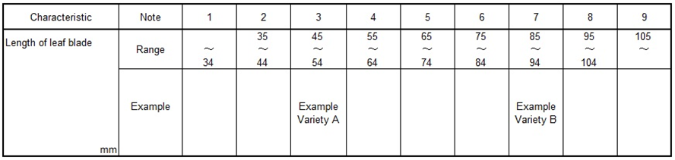

As growing of these example varieties have been affected by the yearly climatic situation or other environmental elements, their actual measured data for QN characteristics have tendency of fluctuation in some extent. Usually registered varieties have been used as similar varieties for DUS growing trials, in the case of registered variety as note 3, registered variety doesn’t always keep their original states when the variety registered by applying above Assessment Table because of fluctuating for the distance of measured data between example variety A and B.

To keep the evaluation unchangeably, The Assessment Table had been improved based on the accumulated measured data of example varieties.

- Fundamental Assessment Table (FAT) System
2.1. FUNDAMENTAL ASSESSMENT TABLE (FAT)
FAT is developed by more than 10 years’ average as “Trial Mean” of data of example varieties which are allocated “Median” of the Range of Note.

Following table is set by 10 years’ average of example varieties.

Table 2: Example FAT for characteristic ‘Length of leaf blade’
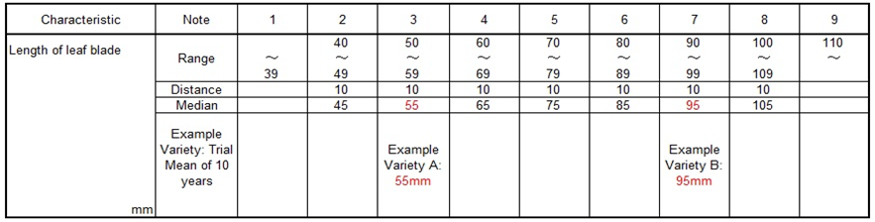

FAT is the assessment table which involved 10 years’ error as principle table, usually FAT is converted by current year’s data of example varieties before the evaluation of the note for QN characteristics.

Current trial data should always be assessed by transforming FUNDAMENTAL ASSESSMENT TABLE (FAT) to CURRENT ASSESSMENT TABLE (CAT).
2.2. Transforming CURRENT ASSESSMENT TABLE (CAT)
To transform from FAT to CAT, it is used “Growth Score” as followings.
2.2.1. Growth Score
Example
10 years’ average as “Trial Mean” of leaf length is 55mm with example variety A
“Current years’ Mean” of leaf length is 52mm with example variety A.
Current Mean of 52mm / Trial Mean of 55mm = 0.95 =“Growth Score”
2.2.2. Multiplying “Growth Score”
CAT is developed by multiplying “Growth Score” to FAT for adjustment to the current growth level.

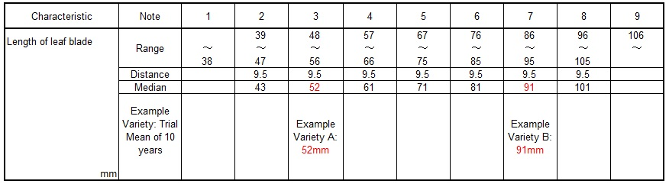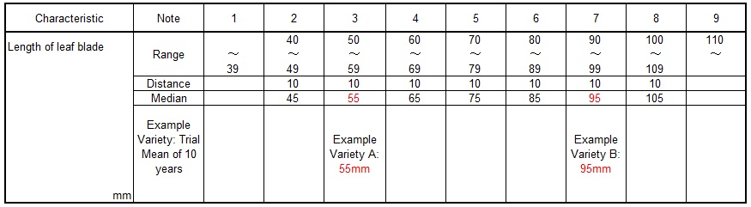
FAT is multiplied Growth Score 0.95
CAT is produced with reflected growth level of the trial (0.95)

2.3 Relevance of FAT and CAT
Following graph explains relation between FAT and CAT. FAT is always retained 1.00 Growth Score. Current trial Growth Score to be scored year by year.

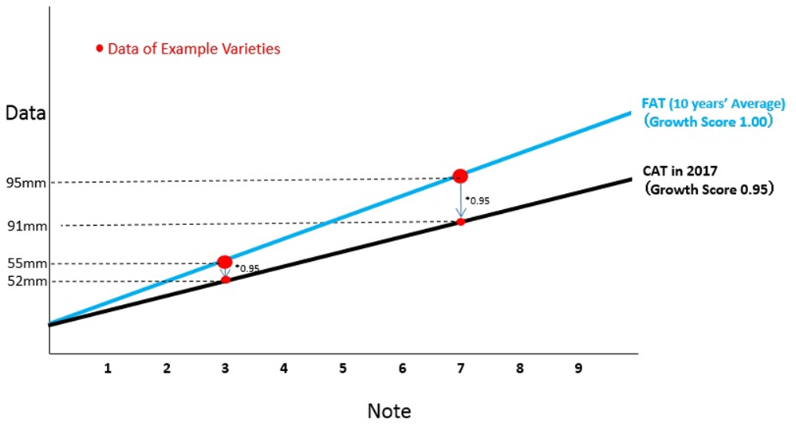

[Annex III follows]

Short explanation on some United Kingdom methods for Data Processing for the Assessment of Distinctness and for Producing Variety Descriptions for measured quantitative characters

Document prepared by experts from the United Kingdom

These two methods are only for characteristics which are measured and quantitative.

Method 1: The equal spaced notes method using field peas as an example:

Over-year variety means are calculated from the yearly trial means. Trial means from all years where the reference collection varieties have been tested are used for peas. The over-year means are calculated using a fitted constants analysis; this allows for varieties not being present in every year. Finally, the over-year means are converted to notes. For peas this is done so that the states are equally spaced.

Method 2: The delineating varieties method using herbage as an example:

Over-year variety means are calculated from the yearly trial means. Trial means from the past 10 years’ trials are used for herbage crops. The over-year means are calculated using a fitted constants analysis; this allows for varieties not being present in every year. Finally, the over-year means are converted to notes. For herbage crops this is done by use of delineating varieties chosen by crop expert judgement and are based on the notes for example varieties. Delineating varieties differ from example varieties. A delineating variety defines each upper (or lower) intervening limit of the states within the range of expression. By contrast, an example variety usually represents the typical or mid-interval expression of each state within the range of expression.

Both methods use over-year means to minimise any observed variation in varieties due to differences in years. In effect, reference varieties (including example varieties) remain the same note year on year.

For greater detail of these two methods and worked examples, see TWC/30/32. Please note that the worked examples are based on an artificial data set in order to illustrate the method.

[End of Annex III and of document]

