E
International Union for the Protection of New Varieties of Plants

Technical Working Party on Automation and Computer Programs  Thirty-Sixth Session  Hanover, Germany, July 2 to 6, 2018 | TWC/36/12 Rev.  Original: English  Date: October 5, 2018
Statistical methods and software tools for molecular techniques in DUS examination
Document prepared by an expert from France
Disclaimer: this document does not represent UPOV policies or guidance
The Annex to this document contains a copy of a presentation on “Statistical methods and software tools for molecular techniques in DUS examination”, made at the thirty-sixth session of the Technical Working Party on Automation and Computer Programs (TWC).

[Annex follows]

STATISTICAL METHODS AND SOFTWARE TOOLS FOR MOLECULAR TECHNIQUES IN DUS EXAMINATION

Presentation prepared by an expert from France

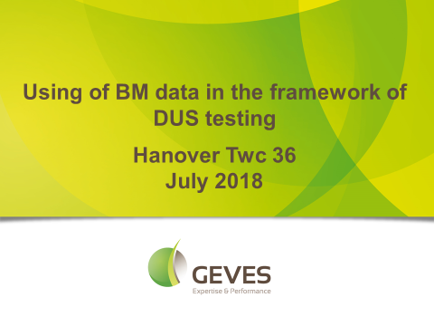

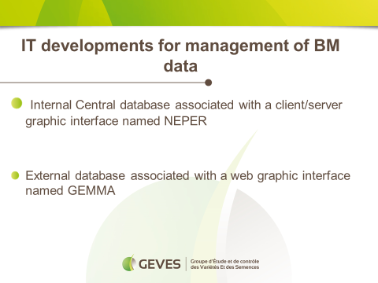

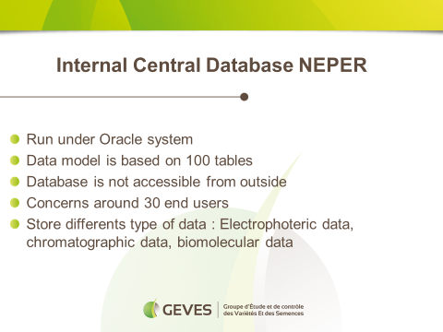

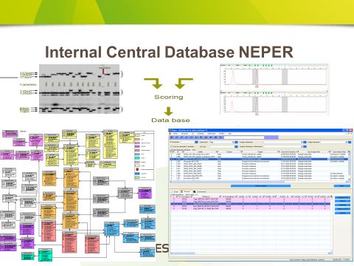

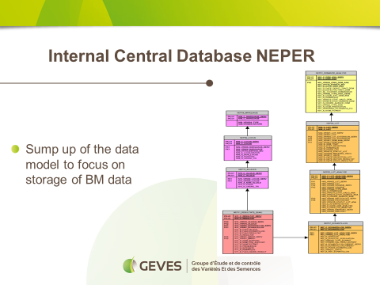

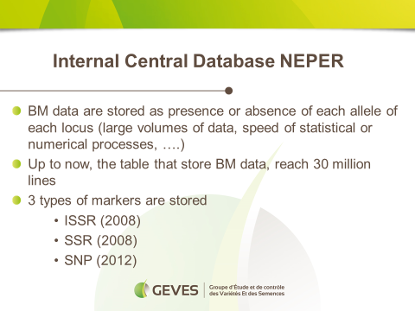

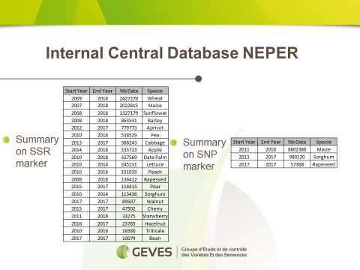

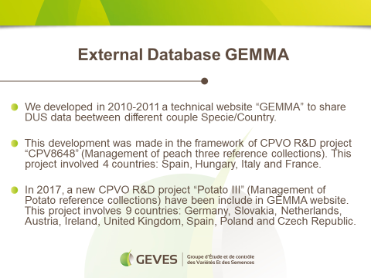

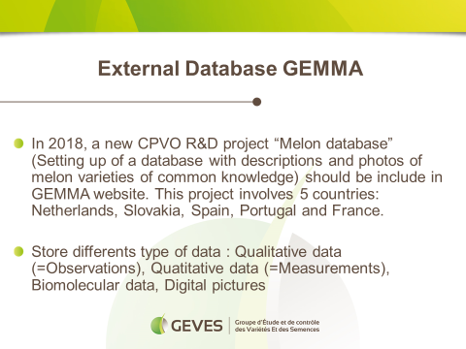

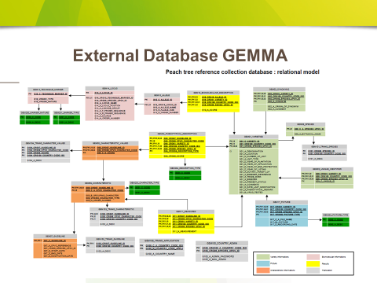

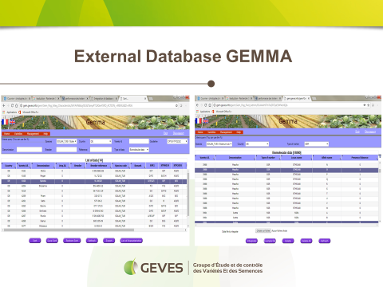

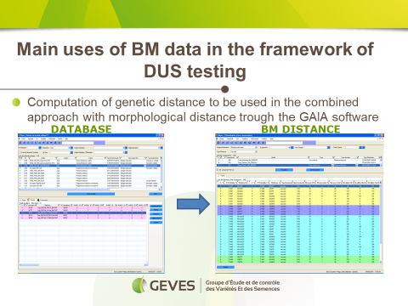

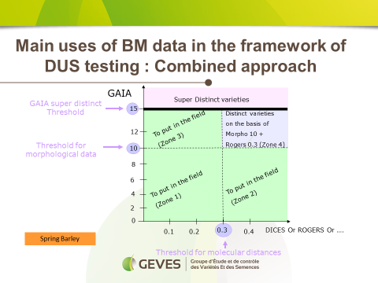

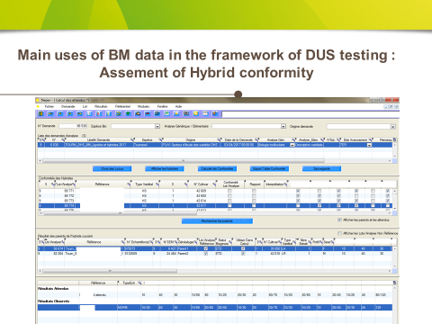

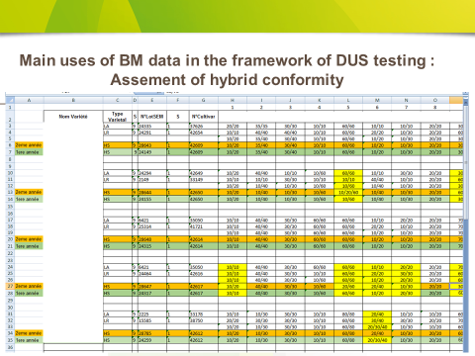

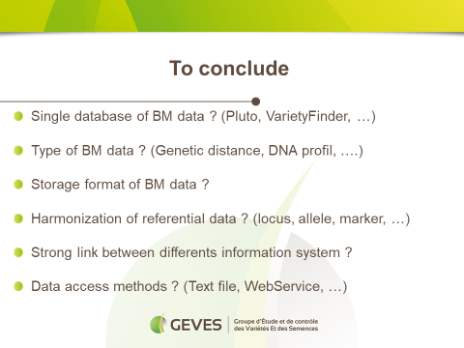

[End of annex and of document]

