E
International Union for the Protection of New Varieties of Plants

Technical Working Party on Automation and Computer Programs  Thirty-Fifth Session  Buenos Aires, Argentina, November 14 to 17, 2017 | TWC/35/8  Original: English  Date: October 23, 2017
Assessing Uniformity by Offtypes on the Basis of More than One Growing Cycle: examples from NL
Document prepared by an expert from the Netherlands
Disclaimer: this document does not represent UPOV policies or guidance

The Annex to this document contains a copy of a presentation “Assessing Uniformity by Offtypes on the Basis of More than One Growing Cycle: examples from NL” to be made at its thirty-fifth session of the Technical Working Party on Automation and Computer Programs (TWC).

Lysbeth Hof, Researcher / Specialist Agricultural Crops, Variety Research Department, Naktuinbouw, Netherlands

[Annex follows]

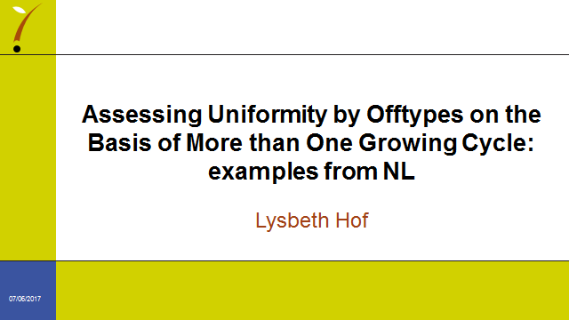

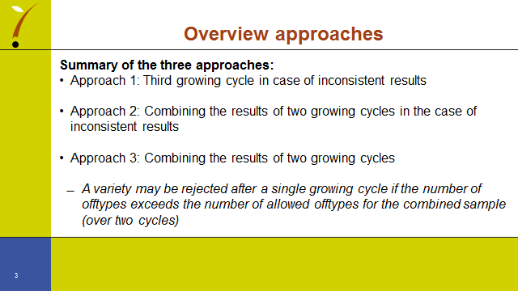

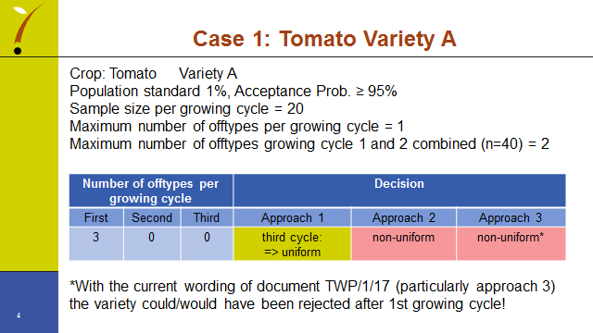

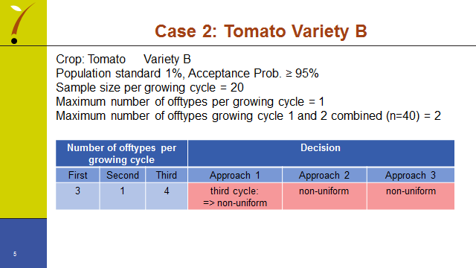

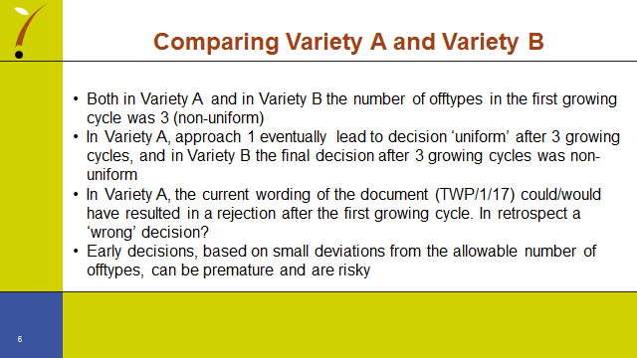

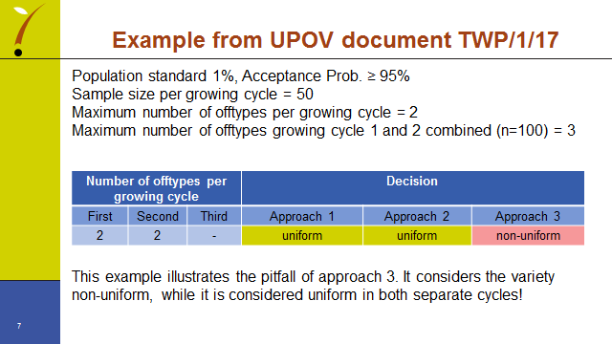

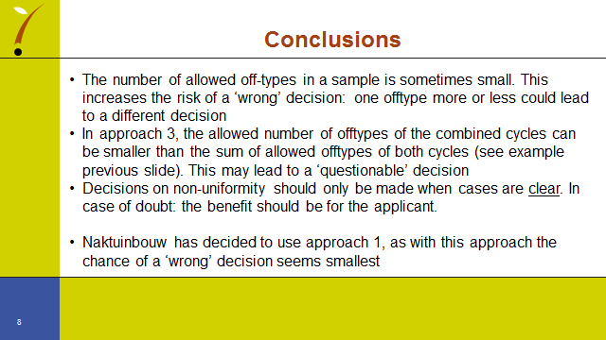

[End of Annex and of document]

