E
International Union for the Protection of New Varieties of Plants

Technical Working Party on Automation and Computer Programs  Thirty-Fifth Session  Buenos Aires, Argentina, November 14 to 17, 2017 | TWC/35/6 Add.  Original: English  Date: November 7, 2017
addendum to
METHOD OF CALCULATION OF COYU: PRACTICAL EXERCISE, PROBABILITY LEVELS, EXTRAPOLATION & SOFTWARE
Document prepared by an expert from the United Kingdom
Disclaimer: this document does not represent UPOV policies or guidance
The Annex to this document contains a copy of a presentation on “Method of calculation of COYU: practical exercise, probability levels, extrapolation & software”, prepared by an expert from the United Kingdom, to be made at the thirty-fifth session of the Technical Working Party on Automation and Computer Programs (TWC).

[Annex follows]

METHOD OF CALCULATION OF COYU: PRACTICAL EXERCISE, PROBABILITY LEVELS, EXTRAPOLATION & SOFTWARE

Presentation prepared by an expert from the United Kingdom

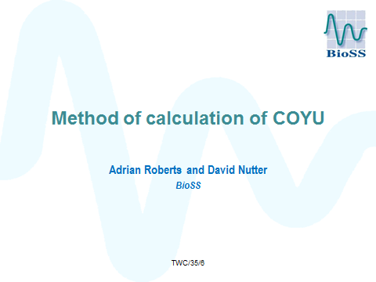

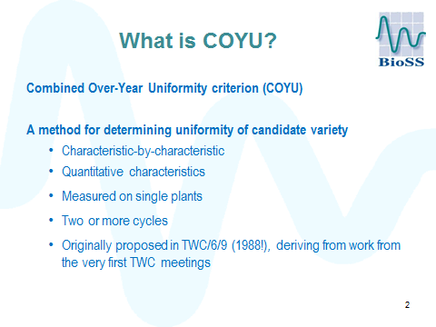

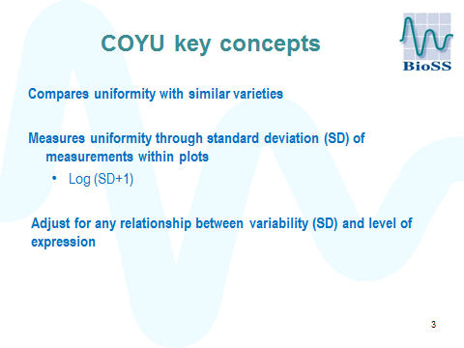

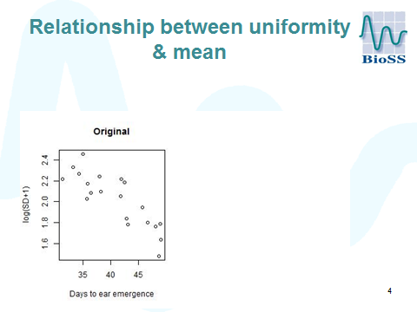

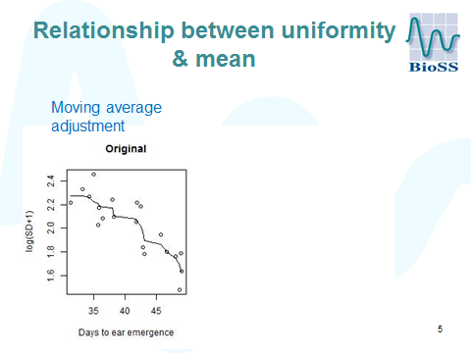

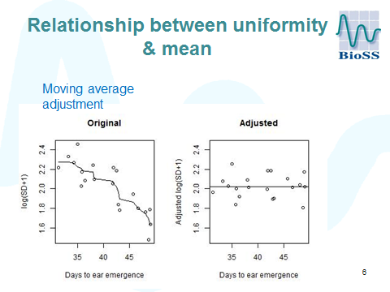

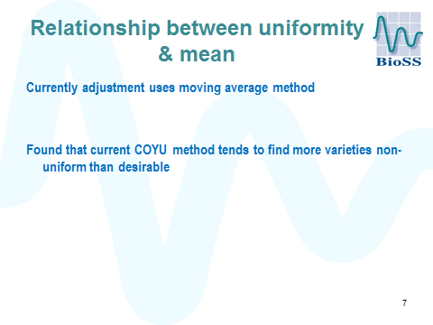

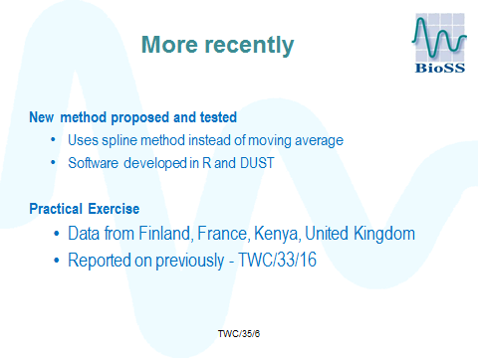

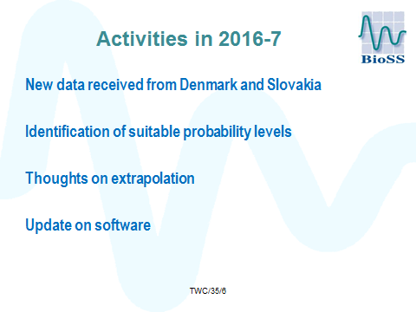

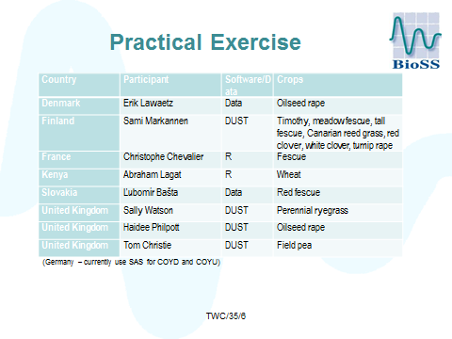

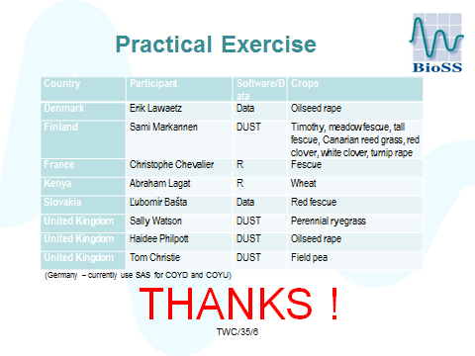

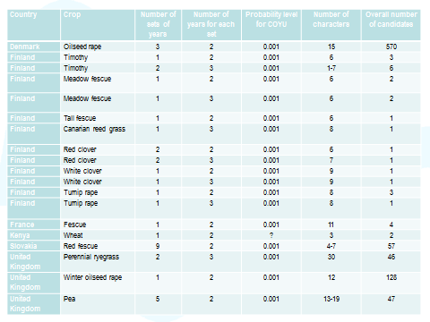

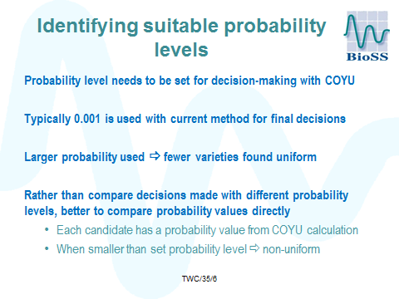

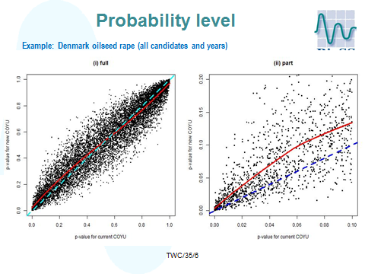

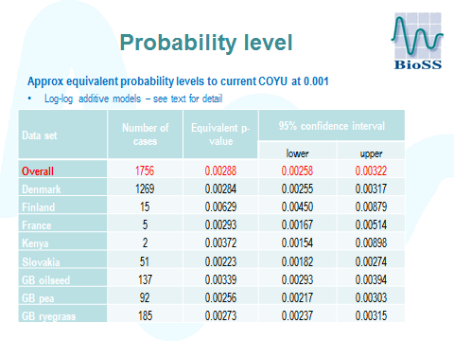

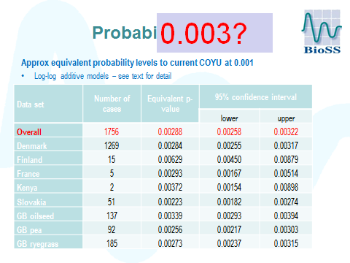

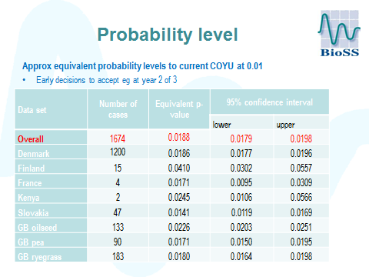

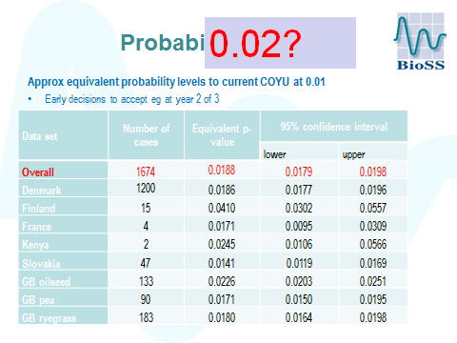

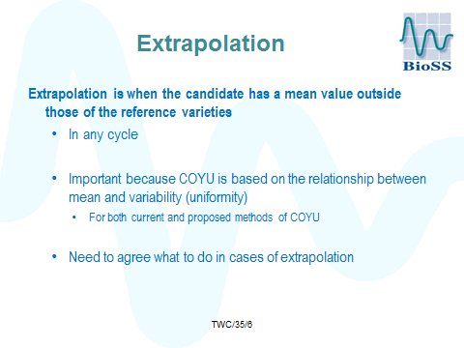

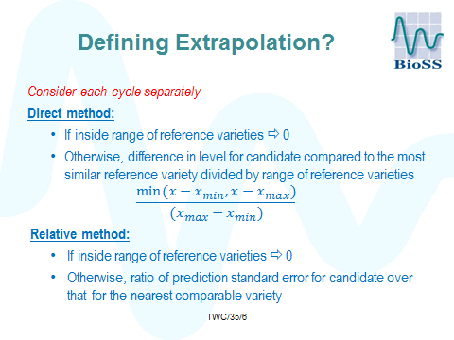

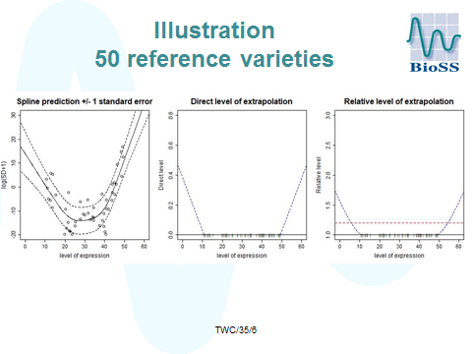

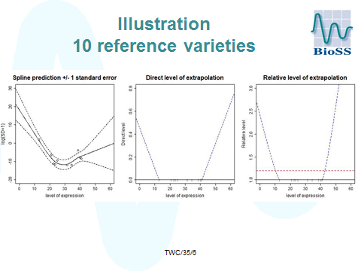

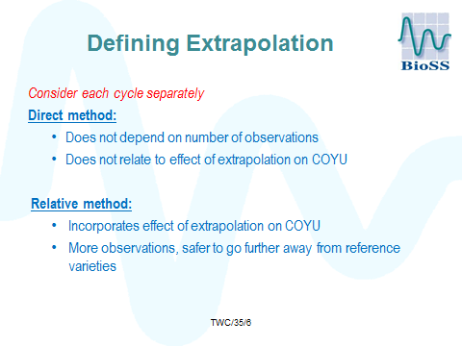

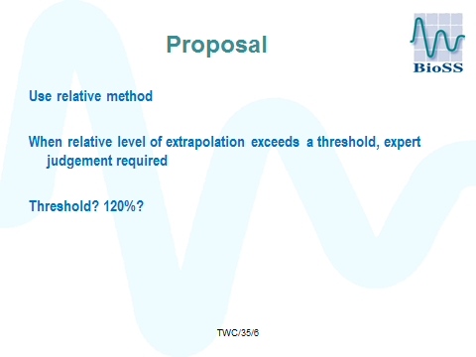

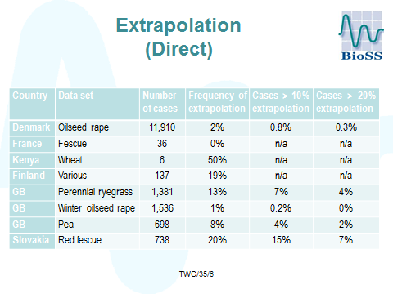

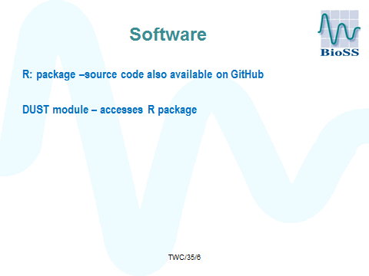

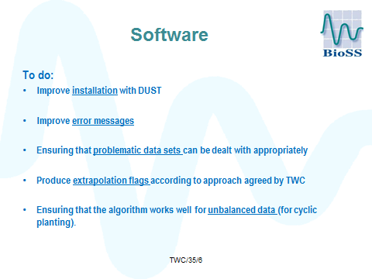

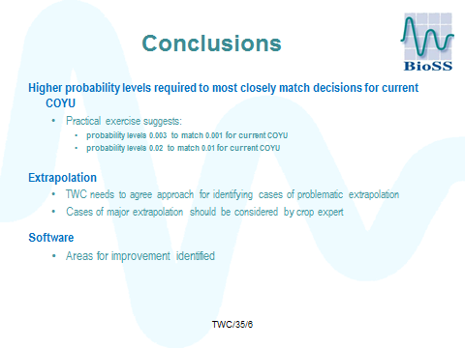

[End of Annex and of document]

