E
International Union for the Protection of New Varieties of Plants

Technical Working Party on Automation and Computer Programs  Thirty-Fifth Session  Buenos Aires, Argentina, November 14 to 17, 2017 | TWC/35/13 Add.  Original: English  Date: November 7, 2017
addendum to
Thresholds for Excluding Varieties of Common Knowledge from the Second Growing Cycle when COYD is Used
Document prepared by experts from the United Kingdom
Disclaimer: this document does not represent UPOV policies or guidance
The Annex to this document contains a copy of a presentation on “Thresholds for Excluding Varieties of Common Knowledge from the Second Growing Cycle when COYD is Used”, prepared by experts from the United Kingdom, to be made at the thirty-fifth session of the Technical Working Party on Automation and Computer Programs (TWC).

[Annex follows]

THRESHOLDS FOR EXCLUDING VARIETIES OF COMMON KNOWLEDGE FROM THE SECOND GROWING CYCLE WHEN COYD IS USED

Presentation prepared by experts from the United Kingdom

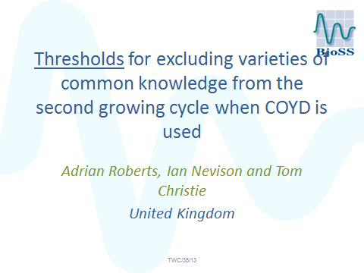

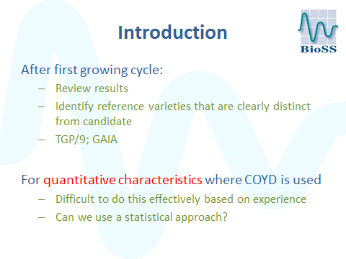

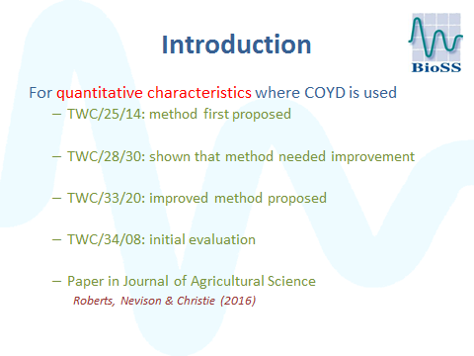

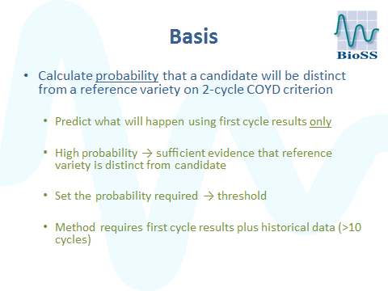

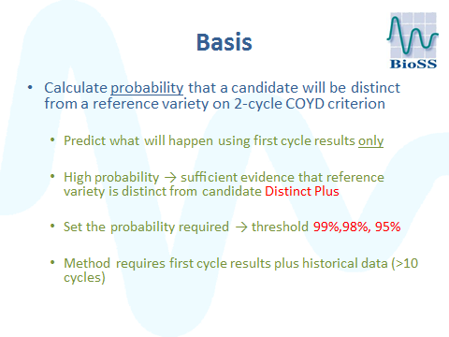

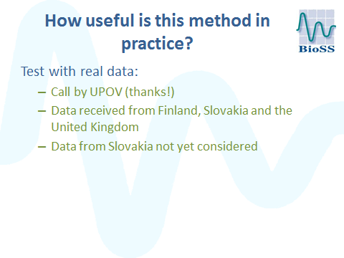

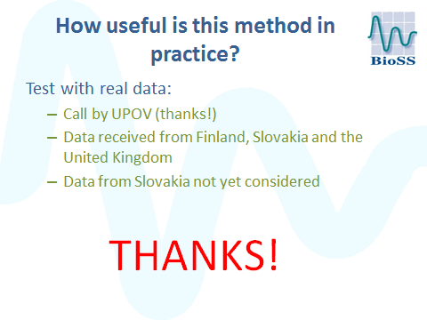

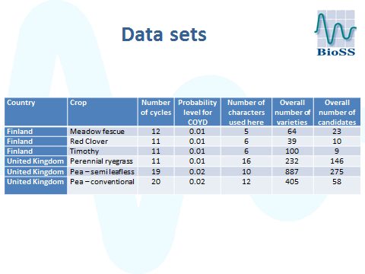

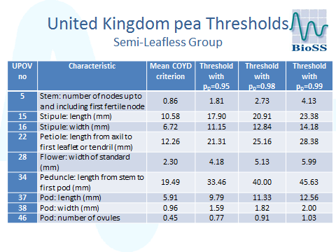

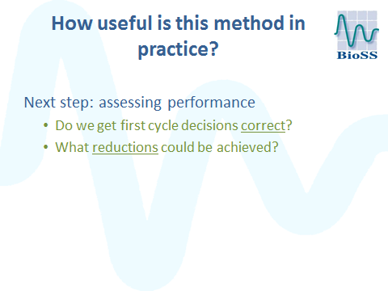

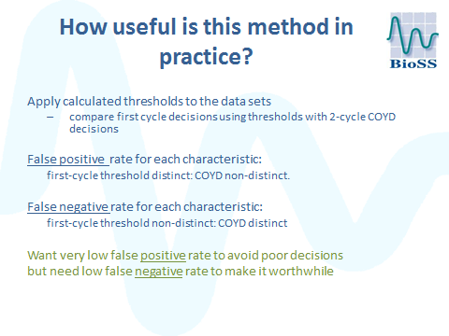

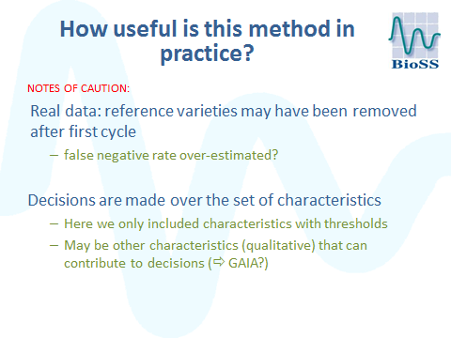

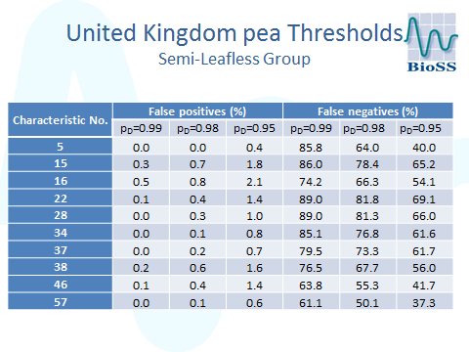

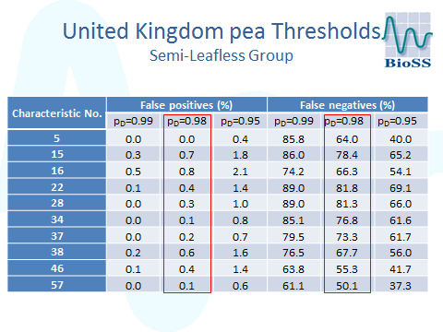

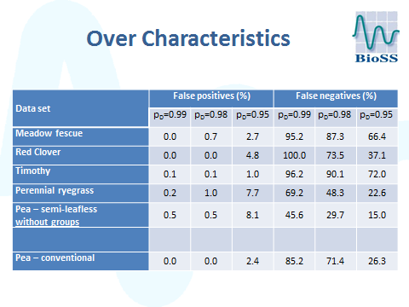

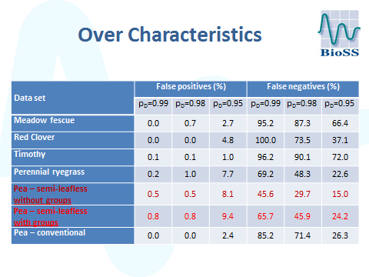

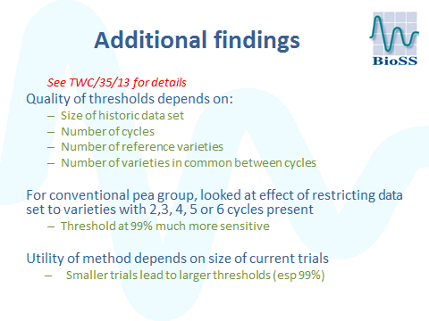

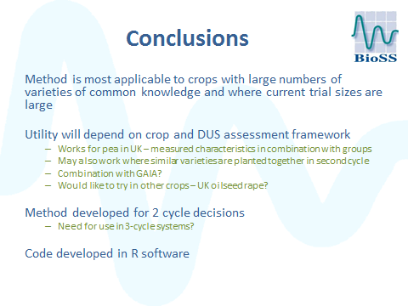

[End of Annex and of document]

