E
TWC/34/8 Add.
ORIGINAL: English
DATE: May 31, 2016
INTERNATIONAL UNION FOR THE PROTECTION OF NEW VARIETIES OF PLANTS
Geneva
Technical working party on automation and computer programs
Thirty-Fourth Session
Shanghai, China, June 7 to 10, 2016
Addendum to
CALCULATED THRESHOLDS FOR EXCLUDING VARIETIES OF COMMON KNOWLEDGE FROM THE SECOND GROWING CYCLE WHEN COYD IS USED
Document prepared by experts from the United Kingdom
Disclaimer: this document does not represent UPOV policies or guidance
The Annex to this document contains a copy of a presentation on “Calculated Thresholds for Excluding Varieties of Common Knowledge from the Second Growing Cycle when COYD is used”, which will to be made at the thirty-fourth session of the Technical Working Party on Automation and Computer Programs (TWC).

Adrian Roberts (Biomathematics and Statistics Scotland (BioSS)), Ian Nevison (BioSS) & Tom Christie (SASA)

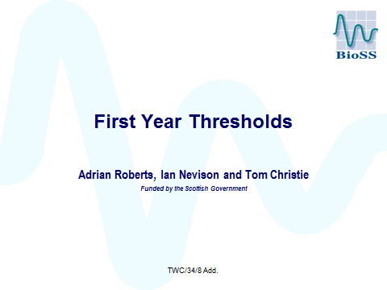

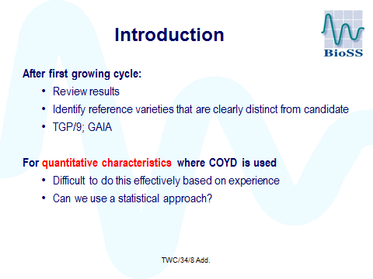

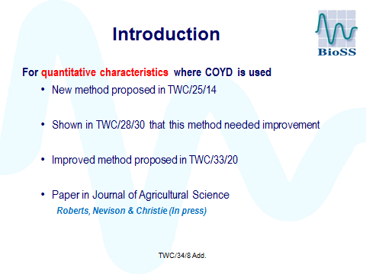

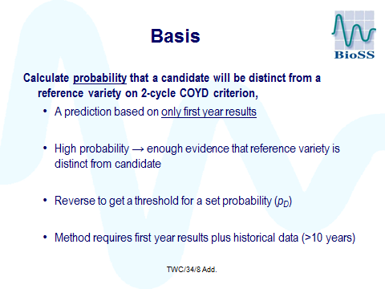

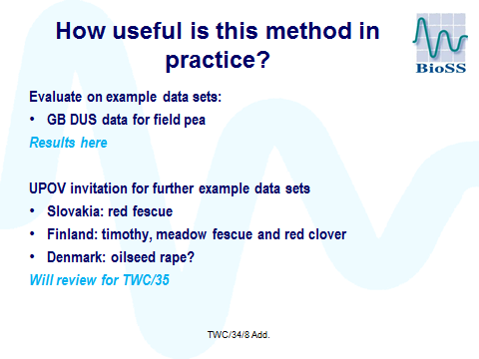

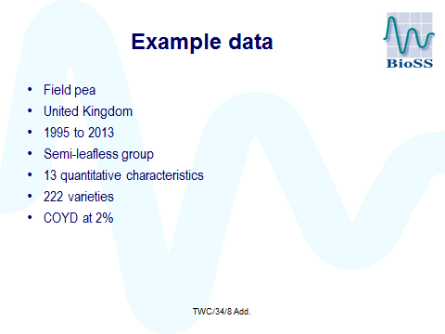

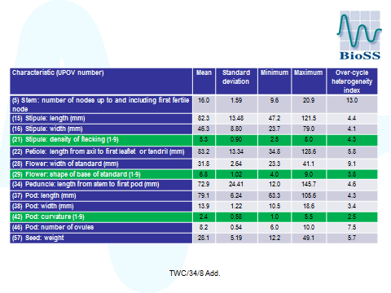

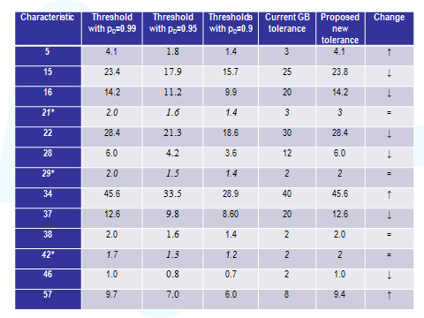

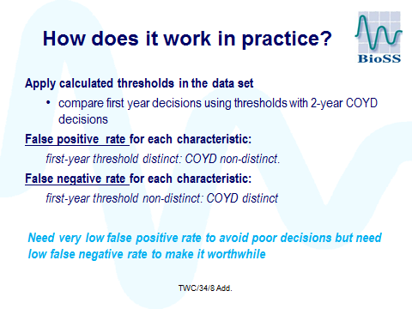

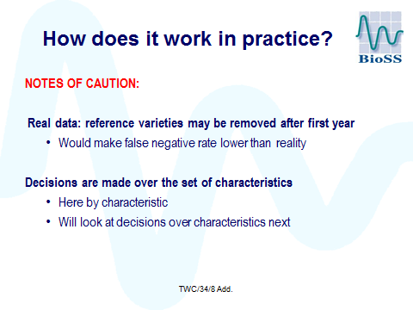

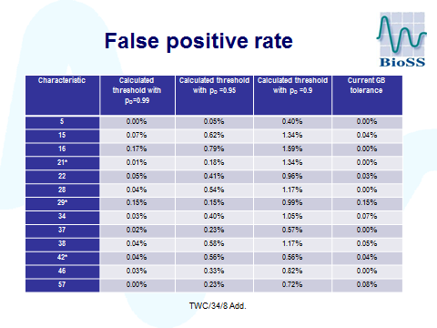

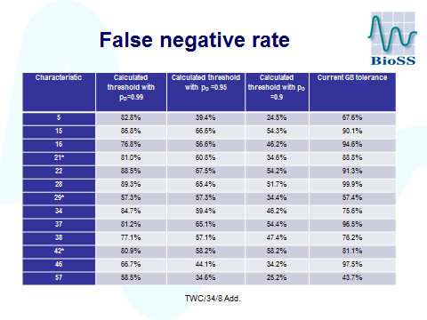

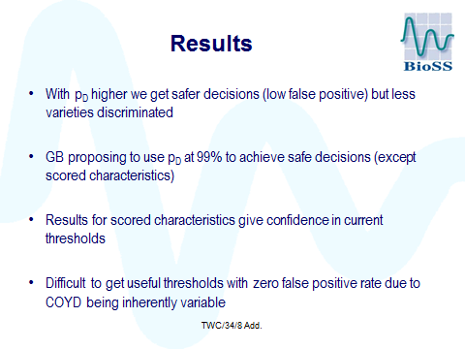

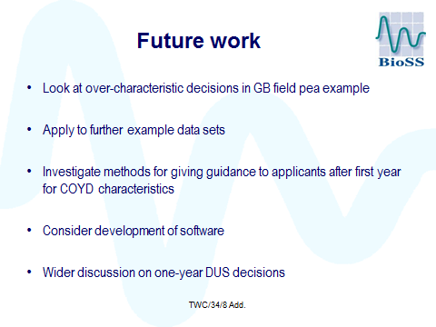

[End of document]

