E
TWC/34/27
ORIGINAL: English
DATE: May 31, 2016
INTERNATIONAL UNION FOR THE PROTECTION OF NEW VARIETIES OF PLANTS
Geneva
Technical working party on automation and computer programs
Thirty-Fourth Session
Shanghai, China, June 7 to 10, 2016
Practical experience of assessing uniformity by off-types on oilseed rape and cauliflower
Document prepared by an expert from France
Disclaimer: this document does not represent UPOV policies or guidance
The Annex to this document contains a copy of a presentation on “Practical experience of assessing uniformity by off-types on oilseed rape and cauliflower” that will be made at the thirty-forth session of the Technical Working Party on Automation and Computer Programs (TWC).

Abbreviations:
CPVO Community Plant Variety Office of the European Union
GEVES Variety and Seed Study and Control Group
OSR Oilseed rape

Anne-Lise Corbel, DUS head of oilseed rape, crucifers, flax and hemp, Groupe d'étude et de contrôle des variétés et des semences (GEVES)

[Annex follows]

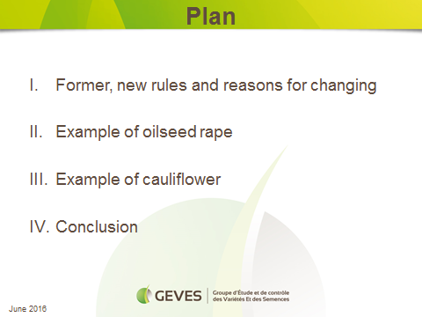

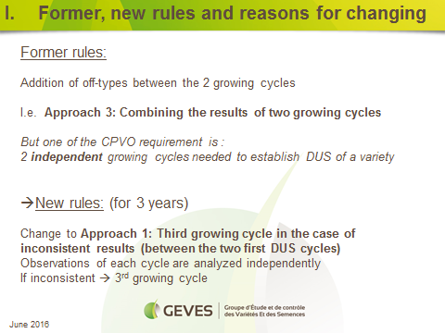

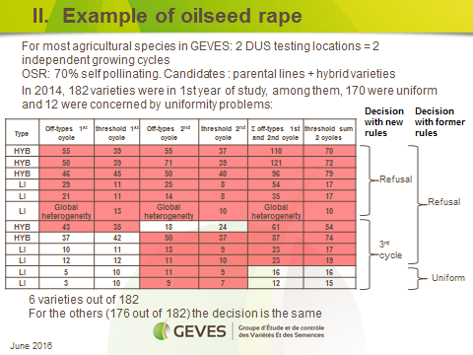

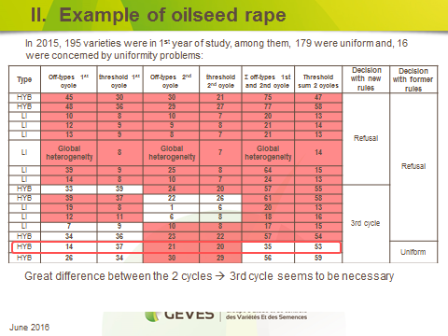

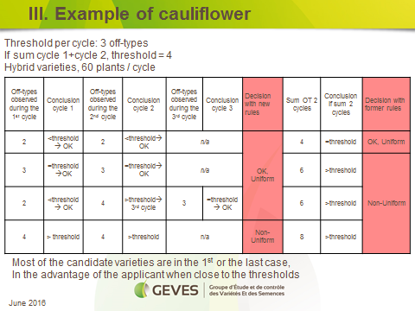

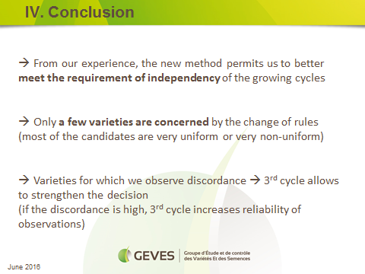

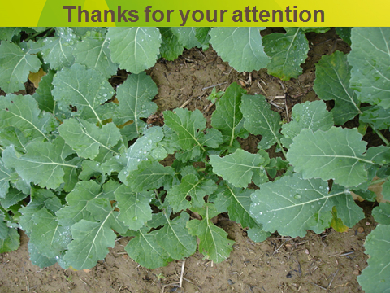

[End of Annex and of document]

