E
TWC/34/22
ORIGINAL: English
DATE: May 19, 2016
INTERNATIONAL UNION FOR THE PROTECTION OF NEW VARIETIES OF PLANTS
Geneva
Technical working party on automation and computer programs
Thirty-Fourth Session
Shanghai, China, June 7 to 10, 2016
Naktuinbouw application and information database: Integrated IT-tool to manage applications, requests, trials, reports and variety collections
Document prepared by an expert from the Netherlands
Disclaimer: this document does not represent UPOV policies or guidance
The Annex to this document contains a copy of a presentation on “Naktuinbouw application and information database: Integrated IT-tool to manage applications, requests, trials, reports and variety collections” that will be made at the thirty-fourth session of the Technical Working Party on Automation and Computer Programs (TWC).

Abbreviations:
CPVO Community Plant Variety Office of the European Union
GEVES Variety and Seed Study and Control Group
ISTA International Seed Testing Association
NAK Dutch General Inspection Service for Agricultural Seed and Seed Potatoes
VCU Value for Cultivation and Use

Kees van Ettekoven, Head, Variety Registration Department, Naktuinbouw

[Annex follows]

NAKTUINBOUW APPLICATION AND INFORMATION DATABASE: INTEGRATED IT-TOOL TO MANAGE APPLICATIONS, REQUESTS, TRIALS, REPORTS AND VARIETY COLLECTIONS

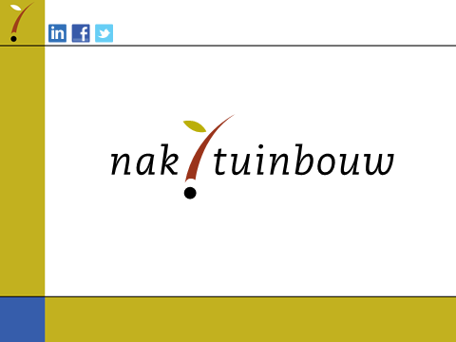

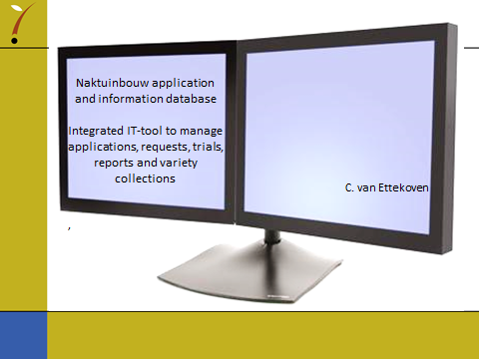

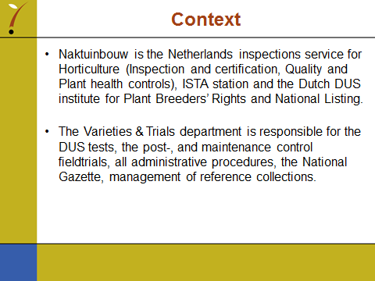

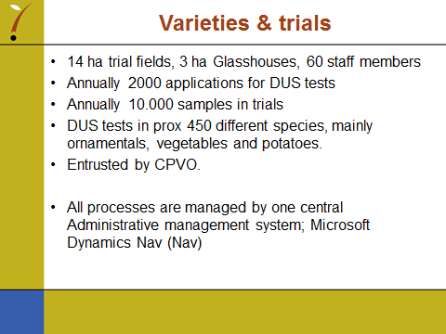

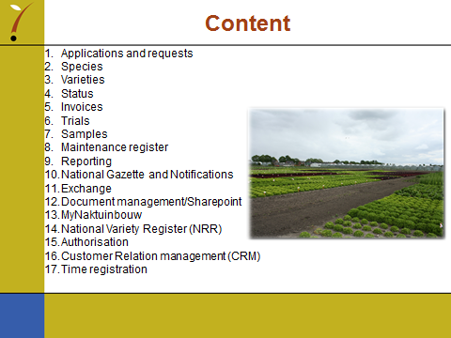

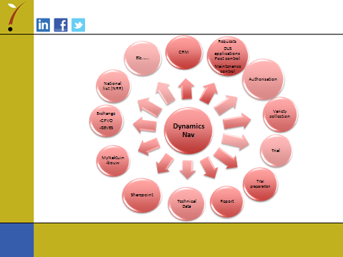

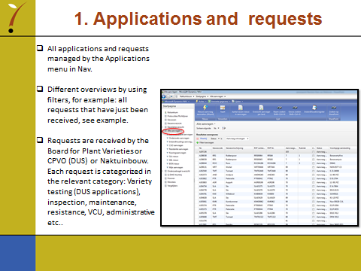

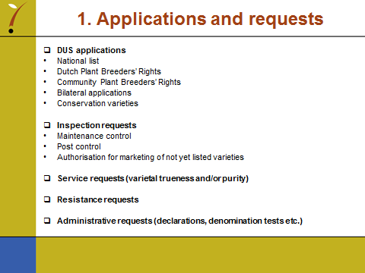

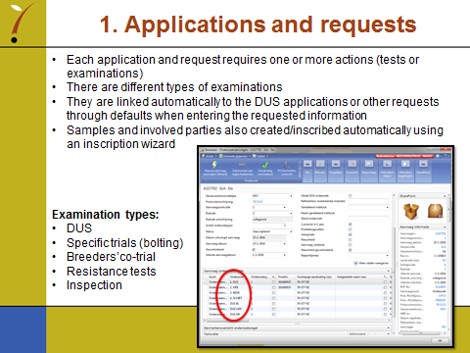

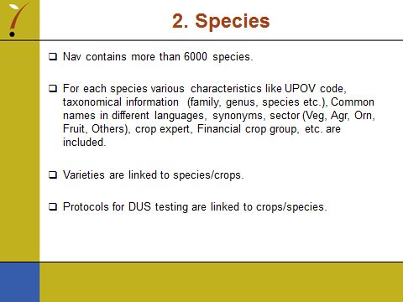

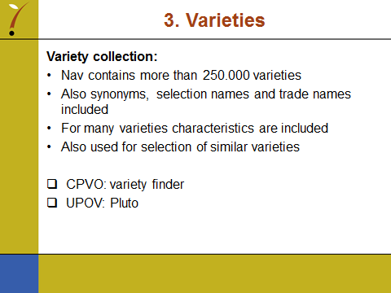

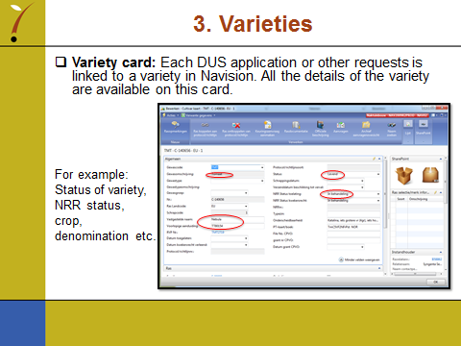

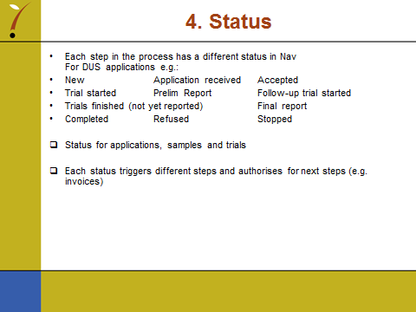

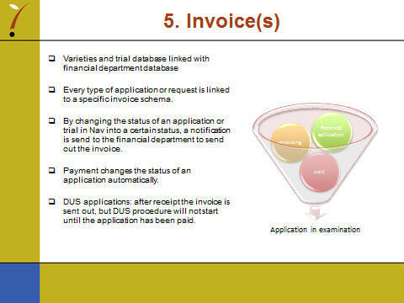

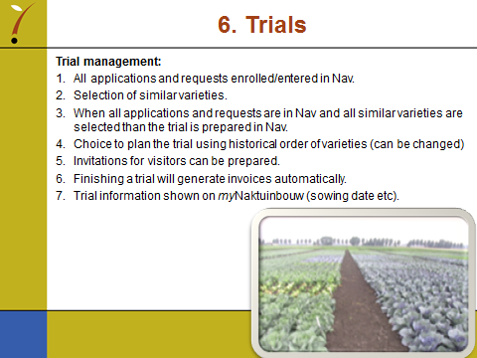

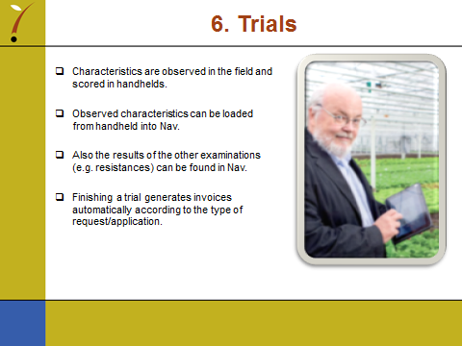

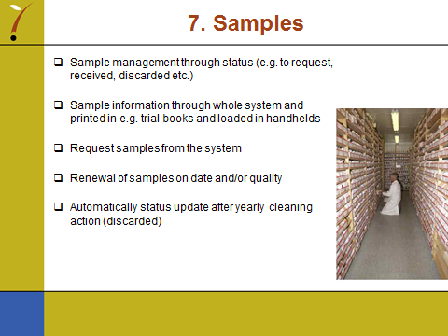

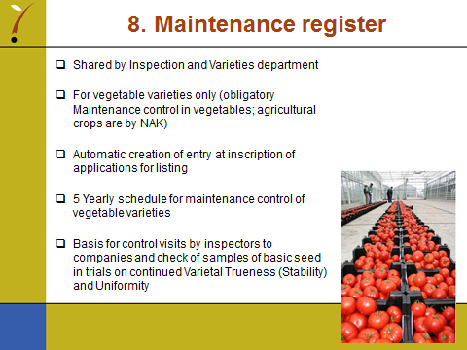

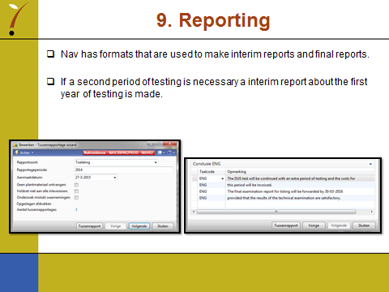

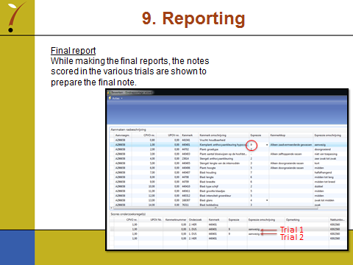

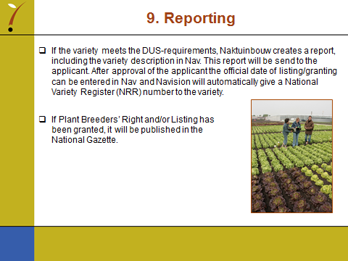

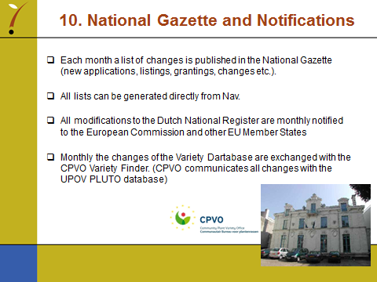

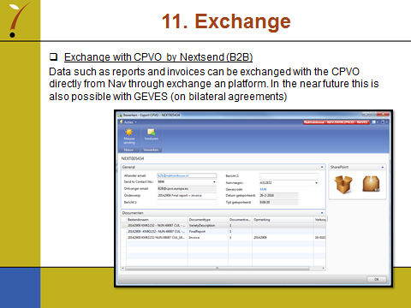

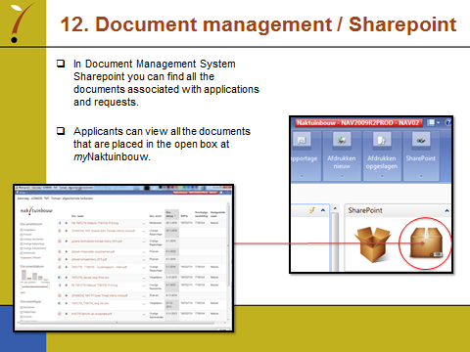

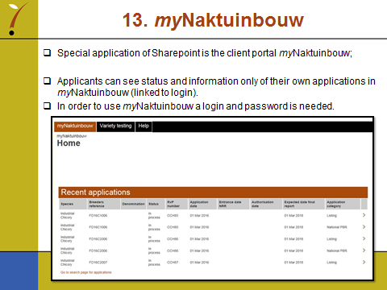

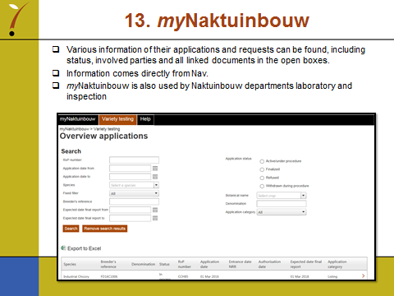

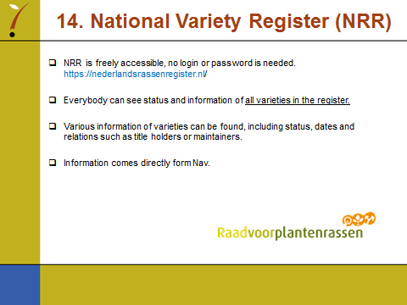

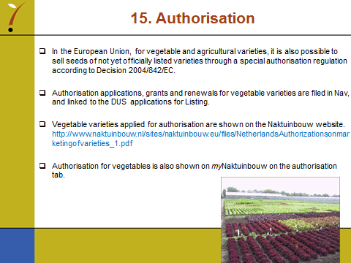

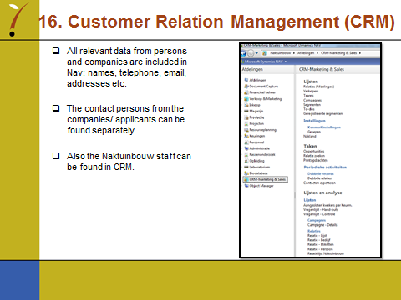

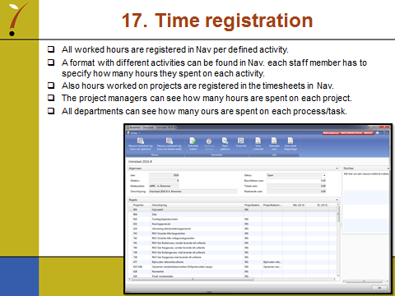

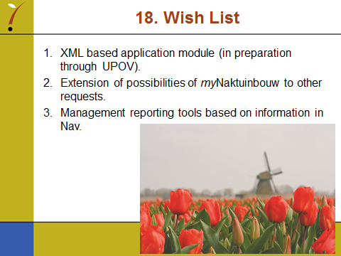

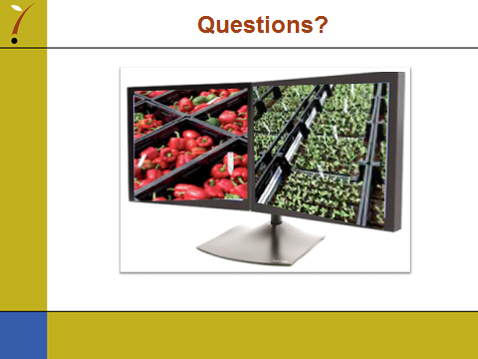

[End of Annex and of document]

