E
TWC/34/19
ORIGINAL: English
DATE: May 18, 2016
INTERNATIONAL UNION FOR THE PROTECTION OF NEW VARIETIES OF PLANTS
Geneva
Technical working party on automation and computer programs
Thirty-Fourth Session
Shanghai, China, June 7 to 10, 2016
Minimizing variation between observers – practical example from Finland
Document prepared by an expert from Finland
Disclaimer: this document does not represent UPOV policies or guidance
The Annex to this document contains a copy of a presentation on “Minimizing variation between observers – practical example from Finland” that will be made at the thirty-fourth session of the Technical Working Party on Automation and Computer Programs (TWC).

Sami Markkanen, Senior Officer, Control Department, Finnish Food Safety Authority (EVIRA), Tampereentie 51, P.O. Box 111, FI-32201 Loimaa, Finland

[Annex follows]

MINIMIZING VARIATION BETWEEN OBSERVERS – PRACTICAL EXAMPLE FROM FINLAND

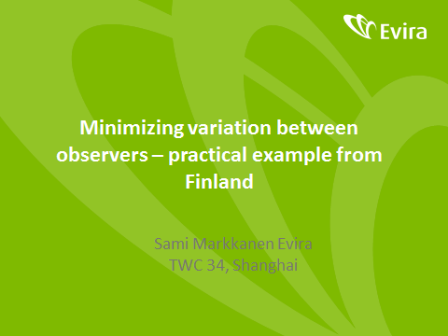

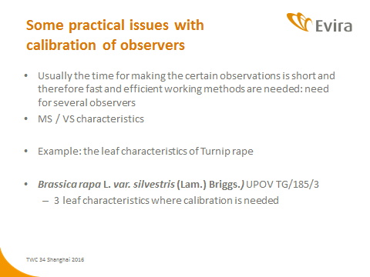

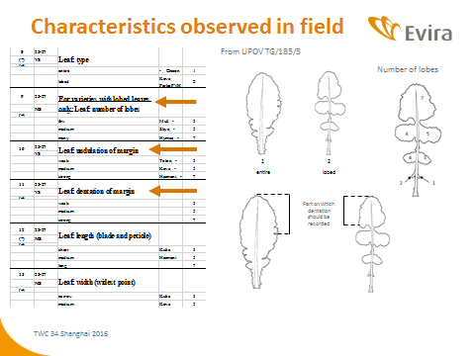

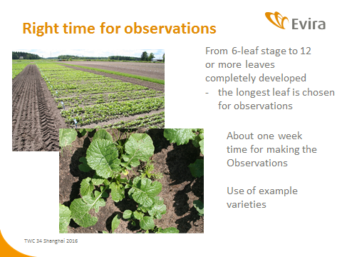

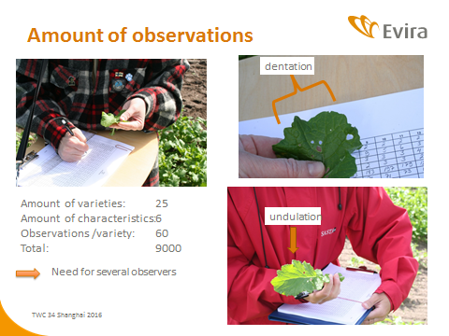

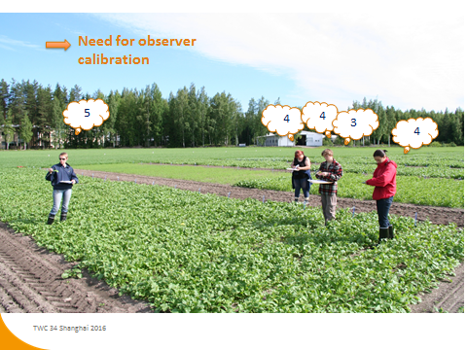

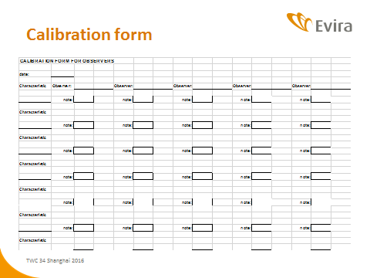

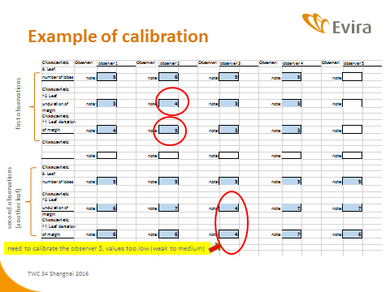

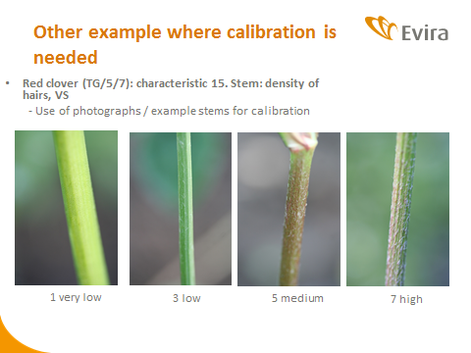

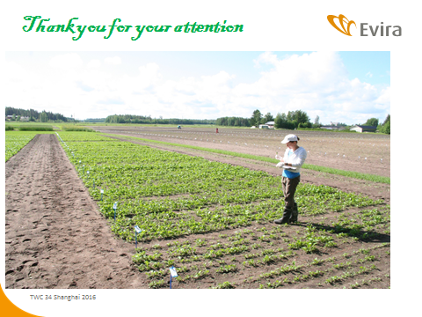

[End of Annex and of document]

