E
TWC/34/15 Add.
ORIGINAL: English
DATE: January 27, 2017
INTERNATIONAL UNION FOR THE PROTECTION OF NEW VARIETIES OF PLANTS
Geneva
Technical working party ON AUTOMATION AND COMPUTER PROGRAMS
Thirty-Fourth Session
Shanghai, China, June 7 to 10, 2016
ADDENDUM TO number of growing cycles in dus examination
Document prepared by an expert from Finland
Disclaimer: this document does not represent UPOV policies or guidance
The Annex to this document contains a copy of a presentation on “Number of growing cycles in DUS examination -simulation of impact on DUS decisions”, which was made at the thirty-fourth session of the Technical Working Party on Automation and Computer Programs (TWC).

Sami Markkanen Sami MARKKANEN, Senior Officer, Control Department, Finnish Food Safety Authority (EVIRA)

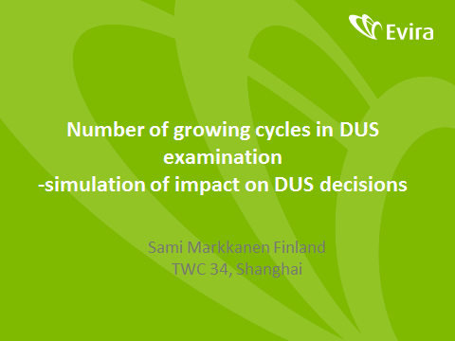

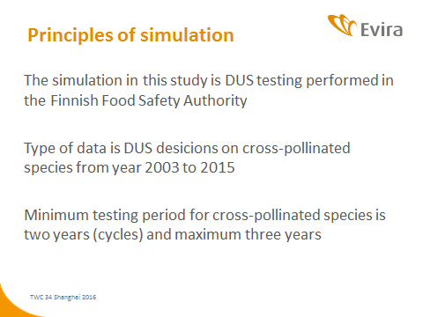

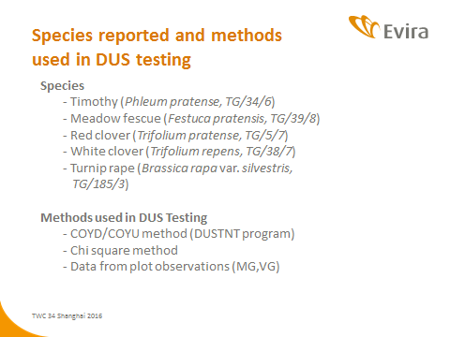

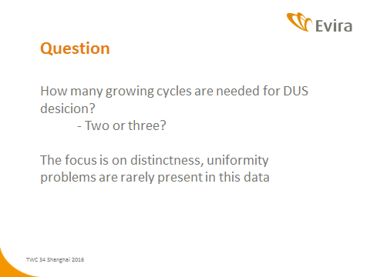

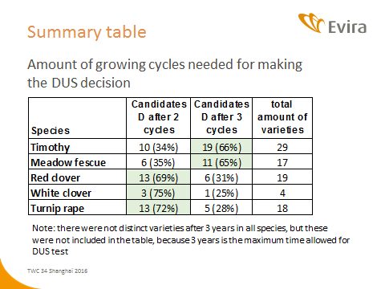

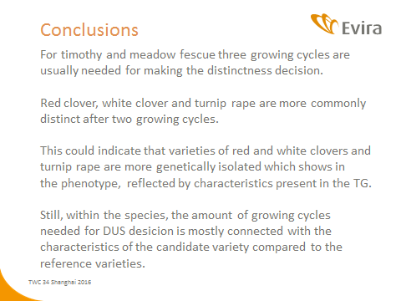

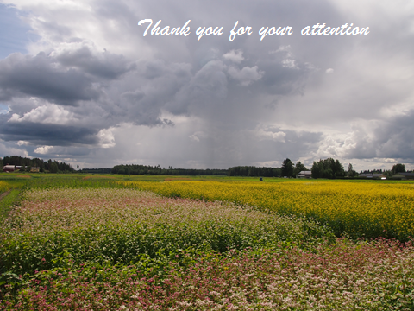

[End of Annex and of document]

