E
TWC/33/30
ORIGINAL: English
DATE: July 13, 2015
INTERNATIONAL UNION FOR THE PROTECTION OF NEW VARIETIES OF PLANTS
Geneva
Technical working party ON AUTOMATION AND COMPUTER PROGRAMS
Thirty-Third Session
Natal, Brazil, June 30 to July 3, 2015
Report
Document prepared by the Office of the Union
Disclaimer: this document does not represent UPOV policies or guidance
Opening of the session

The Technical Working Party on Automation and Computer Programs (TWC) held its thirty-third session in Natal, Brazil, from June 30 to July 3, 2015. The list of participants is reproduced in Annex I to this report.

The TWC was welcomed by Mr. Roberto Papa, Deputy Superintendent of Agriculture in the State of Rio Grande do Norte, Brazil.

The TWC received a presentation from Mr. Fabricio Santana Santos, Federal Agricultural Inspector, Coordinator of the National Plant Variety Protection Office (SNPC), Ministry of Agriculture, Livestock and Food Supply (MAPA) on “Plant Variety Protection in Brazil”, a copy of which is provided in Annex II to this report.

The session was opened by Mr. Adrian Roberts (United Kingdom), Chairman of the TWC, who welcomed the participants and thanked Brazil for hosting the TWC session.

Adoption of the agenda

The TWC adopted the agenda as presented in document TWC/33/1.

Short reports on developments in plant variety protection

- Reports on developments in plant variety protection from members and observers

The TWC noted the information on developments in plant variety protection from members and observers provided in document TWC/33/22 Prov. The TWC noted that reports submitted to the Office of the Union after June 22, 2015, would be included in the final version of document TWC/33/22.

- Reports on developments within UPOV

The TWC received a presentation from the Office of the Union on the latest developments within UPOV, a copy of which is provided in document TWC/33/21. The TWC noted in particular that the designated contact person to the Technical Committee (TC) had been copied in the circular requesting information for document C/48/5 “Cooperation in examination”.

The TWC noted that the meeting documents from previous sessions of the TWC had been scanned by the UPOV Office and would be made available online on the UPOV website, where they could be searched. The TWC thanked the experts from Germany for having organized database of documents with search function and agreed on the importance of the documents with search functions.

TGP documents

The TWC considered the TGP documents below on the basis of document TWC/33/3.

Matters for adoption by the Council in 2015

The TWC noted the revisions to documents TGP/0, TGP/5, TGP/9 and TGP/14 to be put forward for adoption by the Council at its forty-ninth ordinary session, as set out in paragraphs 6 to 18 of document TWC/33/3.

Future revision of TGP documents

The TWC noted that the proposals for future revisions of TGP documents to be discussed by the TWPs at their sessions in 2015 would be dealt with under separate documents.

Matters agreed by the TC concerning future revisions

The TWC noted that the TC had agreed that it was not necessary to develop further guidance to address issues relating to plant material submitted for examination beyond that already provided in documents TG/1/3, TGP/7 and TGP/9.

The TWC noted that the TC had agreed that authorities should provide guidance on the requirements of material submitted for DUS examination to avoid possible effects of the method of propagation (e.g. micropropagation) in the expression of DUS characteristics.

The TWC noted that the TC had agreed to add new standard wording in the TG template, Chapter 4.2 “Uniformity”, and amend ASW 8 (c) to provide guidance for Test Guidelines that are developed on the basis of varieties with one type of propagation when varieties may be developed in the future with other types of propagation, for future revision of document TGP/7, as set out in paragraph 24 of document TWC/33/3.

The TWC noted that the TC had agreed that the existing guidance in documents TGP/8: Part I: “DUS trial design and data analysis” and TGP/9 “Examining distinctness” was sufficient to address guidance for blind randomized trials.

The TWC noted that the TC had agreed to include guidance on “Examining characteristics using image analysis”, for future revision of document TGP/8, as presented in paragraphs 26 and 27 of document TWC/33/3.

Program for the development of TGP documents

The TWC noted the program for the development of TGP documents, as set out in the Annex to document TWC/33/3.

TGP/8: Trial Design and Techniques Used in the Examination of Distinctness, Uniformity and Stability

Revision of document TGP/8: Part I: DUS Trial Design and Data Analysis, New Section: Minimizing the Variation due to Different Observers

The TWC considered document TWC/33/15.

The TWC considered the draft guidance in the Annex to document TWC/33/15, and agreed that it should be included in a future revision of document TGP/8 on minimizing the variation due to different observers.

The TWC agreed that further information should be provided on variation between observers for PQ characteristics before guidance could be drafted on the use of non-parametric methods, such as frequency of deviations.

The TWC agreed to invite the experts from Argentina and Brazil to make a presentation at its thirty-fourth session on their experiences in training for minimizing variation between observers on PQ characteristics.

Revision of document TGP/8: Part II: Selected Techniques Used in DUS Examination, Section 9: the Combined-Over-Years Uniformity Criterion (COYU)

The TWC considered document TWC/33/16 and TWC/33/16 Add.

The TWC noted that the experts from Finland, France, Germany, Kenya and the United Kingdom had participated in the exercise to test the new software on COYU.

The TWC considered the report on the practical exercise as presented by an expert from the United Kingdom in the Annex to document TWC/33/16.

The TWC received a presentation on the “Method of calculation of COYU” from an expert from the United Kingdom, a copy of which is provided in an addendum to document TWC/33/16. The TWC agreed that the new method worked well in practice and requested that the expert from the United Kingdom provide guidance on extrapolation when the candidate had a level of expression outside that seen in the reference varieties.

The TWC noted the need for larger data sets to be tested in order to develop probability levels for the new method. Such data sets should include at least 100 candidate varieties, with a possibility that data for those 100 varieties could be derived from several years.

The TWC agreed to invite the experts from China and France to join in the next steps of the practical exercise and to provide their data sets for use in the testing. The TWC also agreed to invite the TWA to provide large data sets from field crops.

Revision of document TGP/8: Part II: Selected Techniques used in DUS Examination, New Section: Examining DUS in Bulk Samples

The TWC considered document TWC/33/17.

The TWC considered further information provided by an expert from the Netherlands on the example of a bulk characteristic in the Netherlands: Content of Glycoraphanin, as reproduced in Annex II to document TWC/33/17.

The TWC noted that the TC, at its fifty-first session, had agreed that further information on fulfilling the requirements of a DUS characteristic should be provided in the example of a characteristic examined on the basis of a bulk sample and, in that regard, considered a discussion paper provided by an expert from the Netherlands on uniformity requirements in bulk characteristics, as reproduced Annex I to document TWC/33/17.

The TWC noted that the TC, at its fifty-first session, had agreed to consider further whether the analysis of individual plants to validate characteristics examined on the basis of bulk samples was necessary, and the possible cost implications, and had invited proposals for alternative approaches for the examination of uniformity.

The TWC agreed that the elements (a) Control of the characteristic before it is accepted in the relevant guideline; (d) Subplots; (g) DNA analysis; and (i) Plant number in document TWC/33/17, Annex I might be further developed as a basis for guidance on the analysis of characteristics examined on the basis of bulk samples

The TWC considered whether characteristics examined on the basis of bulk samples should be assessed on the basis of the number of plants recommended in the Test Guidelines under Chapter 4.1.4. It agreed that this approach would be preferable from a statistical perspective but noted that such an approach was not feasible for the example provided because of the cost of analysis of glycoraphanin content for individual plants.

The TWC noted that the TC, at its fifty-first session, had agreed that the determination of states of expression should be based on existing variation between varieties and considering environmental influence.

The TWC noted the offer of France to provide other examples of characteristics based on bulk samples and invited other members to provide examples.

Revision of document TGP/8: Part II: Selected Techniques Used in DUS Examination, New Section: Data Processing for the Assessment of Distinctness and for Producing Variety Descriptions

The TWC considered document TWC/33/18.

The TWC noted that the TWC and the TWA had agreed that the guidance on “Different forms that variety descriptions could take and the relevance of scale levels”, as reproduced in Annex I to document TWC/33/18, should be used as an introduction to future guidance to be developed on data processing for the assessment of distinctness and for producing variety descriptions.

The TWC considered the information in document TWC/33/18, Annex III with regard to the steps used in the methods provided by the participants in the practical exercise. The TWC agreed that the methods to assign a note to the candidate varieties were based on a combination of division into equal-spaced states, use of the results of examples varieties and/or crop expert judgment.

The TWC considered the differences in the results of the practical exercise presented by the different participants as a basis for understanding the differences in the methodologies provided by an expert from France, as presented in Annex III to document TWC/33/18.

The TWC agreed that an “X” should be added to the United Kingdom “Method 2” in the column “example varieties” of document TWC/33/18 Annex III, page 1. On that basis, the TWC agreed that the different methods to assign notes to candidate varieties could be briefly summarized in the table below (see document TWC/33/18 Annex III, page 1).

COUNTRY |  | Method : description | Example varieties | Crop expert judgment | Equal-spaced state
France | Method 1 | Combined use of example varieties and reference collection | X
 | Method 2 | Adjusted means from COY program + linear regression method calibrated with example varieties | X
Italy |  | Average range of historical means + median used as "reference point" + partitioning into equal spaced states + calibration with crop expert judgment and example varieties | X | X | X
Germany |  | Adjusted mean from COY program + partitioning based on example varieties and crop expert judgment | X | X
Japan |  | Adjusted Full Assessment Table (FAT) : states determined with historical data of example varieties | X |  | X
United Kingdom | Method 1 | Range of expression of the over-year means for the reference collection varieties (for the past 10 years) divided into equal spaced states |  |  | X
 | Method 2 | Crop experts define delineating varieties whose over-year means are used to delineate each state | X | X

The TWC noted that information on the methods used for data processing for the assessment of distinctness and for producing variety descriptions in China would be considered under agenda item 10 “Information on the methods used for data processing for the assessment of distinctness and for producing variety descriptions in China” of the agenda (see document TWC/33/23 “Application Management System (AMS) and Variety Description Database (VDD) in China”).

The TWC noted that the European Union had reported to the Technical Committee that the project on a ring-test on Apple for the management of variety description to be launched in 2015 had been suspended.

TGP/7: Development of Test Guidelines

Revision of document TGP/7: Drafter’s Kit for Test Guidelines

The TWC considered document TWC/33/12.

The TWC agreed that a proposal for the revision of document TGP/7 reflecting the introduction of the web-based TG Template be presented to the TWPs and the TC in 2016, after Version 1 was finalized.

The TWC agreed with the proposal to standardize the format of the Table of Characteristics in all Test Guidelines with a structure as set out in paragraph 15 of document TWC/33/12.

The TWC noted that all Leading Experts had prepared the draft Test Guidelines for discussion during the TWPs at their sessions in 2015 using the web-based TG Template.

The TWC noted that all Interested Experts had been required to provide their comments on draft Test Guidelines for discussion during the TWPs at their sessions in 2015 using the web-based TG Template.

The TWC noted the issues being addressed in response to the comments by Leading and Interested Experts that participated in the testing of the 2015 prototype of the web-based TG Template, as set out in paragraphs 13 and 14 of document TWC/33/12.

The TWC received a demonstration of the planned resolution of the issues being addressed in the 2015 prototype of the web-based TG Template, as set out in paragraphs 13 and 14 of document TWC/33/12.

The TWC noted the timetable for the development of the web-based TG Template, as set out in paragraphs 17 to 19 of document TWC/33/12.

Revision of document TGP/7: Use of Proprietary Photographs and Illustrations in Test Guidelines

The TWC considered document TWC/33/13.

The TWC agreed with the proposed guidance in relation to text, photographs or illustrations that could be subject to third party rights, for inclusion in a future revision of document TGP/7, as follows:

“In the case of text, photographs, illustrations or other material that are subject to third party rights, it is the responsibility of the author of the document, including Test Guidelines, to obtain the necessary permission of the third party. Material must not be included in documents where such permission is required but has not been obtained.”

The TWC agreed that drafters of UPOV documents should also be requested to ensure that they had obtained the necessary authorization, as appropriate, for the use of text, photographs, illustrations or other materials in those documents.

Revision of document TGP/7: Regional Sets of Example Varieties

The TWC considered document TWC/33/14.

The TWC agreed to include guidance in document TGP/7 that a “region” should be comprised of more than one country in order to justify a regional set of example varieties in Test Guidelines.

The TWC agreed to include guidance in document TGP/7 that the TWP should determine the basis on which the region would establish an agreed regional set of example varieties (e.g. by an exchange of information, or by a ring-test).

Revision of document TGP/10: Assessing uniformity by off-types on basis of more than one growing cycle or on the basis of sub-samples

The TWC considered document TWC/33/9.

The TWC considered the draft guidance in document TWC/33/9, Annex I, and agreed to propose amending the title of Approach 2 to read “Combining the results of two growing cycles in the case of inconsistent results”.

The TWC received a presentation by the experts from Germany and the United Kingdom, as reproduced in document TWC/33/25, and agreed to propose the addition of the third approach to the draft guidance as follows:

“Approach 3: Combining the results of two growing cycles

“A variety is considered uniform if the total number of off-types at the end of the two growing cycles does not exceed the number of allowed off-types for the combined sample.

“A variety is considered non-uniform if the total number of off-types at the end of the two growing cycles exceeds the number of allowed off-types for the combined sample.

“A variety may be rejected after a single growing cycle, if the number of off-types exceeds the number of allowed off-types for the combined sample (over two cycles).

“Care is needed when considering results that are very different in each of the growing cycles, such as when a type of off-type is observed at a high level in one growing cycle and is absent in another growing cycle. A statistical test for consistency is possible.”

The TWC noted that the approach presented by the experts from Germany and the United Kingdom was used in the United Kingdom and always combined the results of two growing cycles. The TWC noted the explanation that this approach allowed an early decision on uniformity to be taken when the number of off-types was greater in a sub-sample than the allowed number for the combined sample. The TWC also noted the explanation that this approach reduced the type 2 error (to accept a non-uniform variety), when compared with the other two approaches presented in the draft guidance, by considering the overall risk of the combined samples instead of the risks for each stage of evaluation separately.

The TWC agreed that the presentation made by the experts from Germany and the United Kingdom should be made available to the other TWPs.

Matters concerning variety descriptions

The TWC considered document TWC/33/10.

Verifying the maintenance of the variety

The TWC considered the use of Test Guidelines for verifying the maintenance of the variety that were different from the Test Guidelines used for the examination of DUS. The TWC noted that not all UPOV members required the maintenance of varieties to be verified. The TWC noted that China used the original trial data to generate a new variety description in the case of changes to the Test Guidelines.

The TWC considered the experiences presented by experts with regard to the use of information, documents or material provided by the breeder for verifying the maintenance of the variety and noted that some authorities grew the standard sample beside new plant material provided to verify the maintenance of the variety.

Matters concerning variety descriptions

The TWC considered the experiences presented by experts with regard to how variety descriptions are generated in DUS examination and noted that in some UPOV members the variety descriptions were generated by the authority while in others the variety descriptions were generated by the breeders.

The TWC considered the experiences presented by experts with regard to how variety descriptions are used after the granting of a breeders’ right and noted that Brazil used the variety descriptions to verify the maintenance of varieties, in particular for QL and PQ characteristics. The TWC noted that in many countries additional information could be added to databases of variety descriptions to complement information on a variety. The TWC noted that in Germany the variety description had been stored as a file. There were possibilities to transform the data of the variety description into a new scale in the database in the case of a change of Technical Guidelines. The TWC also noted that in Germany when characteristics could not be transformed, a new characteristic could be added to the database.

The TWC considered the experiences presented by experts with regard to the role of the plant material used as the basis for the DUS examination and noted that in some members, such as the Netherlands, the plant material was considered to represent the variety while its description had only limited value. The TWC noted that in some members the variety description could change and that other descriptions of the same variety could be added to the database without changing the original variety description. The TWC also noted that in Argentina the variety description could only be changed if the variety was not commercialized and that in Brazil it could not be changed after the title had been granted.

Statistical Methods for Visually Observed Characteristics

The TWC considered document TWC/33/26.

The TWC noted the presentations by members of the Union on how they intended to use the new statistical method for visually observed characteristics in DUS examination, as set out in Annex I to document TWC/33/26.

The TWC noted that the TC, at its fifty-first session, had agreed to remove the document “Statistical methods for visually observed characteristics” from the program for the revision of document TGP/8, and to consider the matter under a separate agenda item.

The TWC received a presentation by an expert from China on “Analysis of visually observed characteristics using the DUST China (DUSTC) software package” using the data set for growth habit in meadow fescue provided by Finland. A copy of the presentation is provided in document TWC/33/26 Add.1.

The TWC agreed to invite China to make a presentation at the thirty-fourth session of the TWC to describe the statistical methods used in the DUSTC software package for the analysis of distinctness and uniformity.

The TWC received a presentation on “Ways in which members of the Union intend to use the new statistical method for visually observed characteristics in DUS examination” by an expert from Finland. A copy of the presentation is provided as document TWC/33/26 Add.2.

The TWC noted that Finland intended to use the new statistical method for the analysis of seven visually observed ordinal characteristics in Timothy, Meadow Fescue and Tall Fescue, White Clover and Red Clover.

The TWC agreed that the naming of the different methods should be clarified to avoid confusion with other methods widely used in UPOV, such as COYD.

The TWC welcomed the offer by an expert from France to study the development of software to implement the method developed by experts from Denmark and Poland (see document TWC/30/19), in collaboration with experts from Finland and the United Kingdom.

A rationale for excluding varieties of common knowledge from the second growing cycle when COYD is used

The TWC considered the information provided in documents TWC/33/20.

The TWC received a presentation on “Calculated Thresholds for Excluding Varieties of Common Knowledge from the Second Growing Cycle when COYD is used” by an expert from the United Kingdom. A copy of the presentation is provided in document TWC/33/20 Add.

The TWC noted the request by the expert from the United Kingdom for further data to be tested for developing the proposed methodology, preferably with 10 or more growing cycles.

Application management system (AMS) and variety description database (VDD) in China

The TWC received a presentation by an expert from China on Application Management System (AMS) and Variety Description Database (VDD) in China. A copy of the presentation is provided in document TWC/33/23.

Image analysis system in China

The TWC received a presentation by an expert from China on the new plant variety protection image analysis system in China. The TWC noted that the presentation had been amended from the version in document TWC/33/28 and would be provided as document TWC/33/28 Rev..

Information and databases

(a) UPOV information databases

The TWC considered document TWC/33/5.

GENIE database

The TWC noted the information on allocation of crop type(s) for UPOV codes used in the PLUTO database as of June 26, 2014.

The TWC noted that information on crop type(s) had been introduced in the GENIE database and the GENIE database had been modified to show the crop type(s) for each UPOV Code.

The TWC noted that a standard report for TWP allocations for UPOV codes was introduced on the GENIE webpage.

The TWC noted that allocation of crop type(s) for further UPOV codes would occur when UPOV codes were used in the PLUTO database for the first time.

The TWC noted the developments concerning the UPOV code system.

The TWC noted the summary of contributions to the PLUTO database from 2012 to 2014 and the current situation of members of the Union on data contribution, as presented in Annex II to document TWC/33/5.

The TWC noted that an additional column in the PLUTO search screen, showing the date on which the information was provided, had been introduced.

The TWC noted that both the “Denomination” and “Breeder’s Ref” fields had been made searchable, independently or in combination, by denomination search tools on the “Denomination Search” page of the PLUTO database.

The TWC noted the information concerning the training course “Contributing data to the PLUTO database”, held in Geneva in December 2014 and the plans to organize three further courses, in English, French and Spanish.

(b) Variety description databases

The TWC considered document TWC/33/6.

The TWC considered a presentation by an expert from China on the analysis of variance for the interaction “variety x location” (environment) of the QN characteristics. A copy of the presentation is provided in document TWC/33/27.

The TWC noted that the TC had agreed to include a discussion item on facilitating the development of databases at its fifty-second session.

The TWC noted the demonstration of the DUSTC software, made by an expert from China.

(c) Exchange and use of software and equipment

The TWC considered document TWC/33/7.

The TWC noted that the Council, at its forty-eighth ordinary session, had adopted the revision of document UPOV/INF/16/4 “Exchangeable Software”.

The TWC agreed that discussions on the inclusion of the SISNAVA software in document UPOV/INF/16 should be continued in the TWC, subject to the conclusion on discussions on the variation of variety descriptions over years in different locations.

The TWC noted that the TC, at its fifty-first session, and the CAJ, at its seventy-first session, had agreed the proposed revision of document UPOV/INF/16/4 concerning the inclusion of information on the use of software by members of the Union in conjunction with the comments of the TC, as set out in Annex I to document TWC/33/7 and that a draft of document UPOV/INF/16/5 “Exchangeable Software” would be presented for adoption by the Council at its forty-ninth ordinary session.

The TWC noted that the Council, at its forty-eighth ordinary session, had adopted document UPOV/INF/22/1 “Software and equipment used by members of the Union”.

The TWC noted that the TC, at its fifty-first session, and the CAJ, at its seventy-first session, had agreed the proposed revision of document UPOV/INF/22/1 concerning software and equipment used by members of the Union in conjunction with the comments of the TC, as set out in Annex II to document TWC/33/7, and that a draft of document UPOV/INF/22 would be presented for adoption by the Council at its forty-ninth ordinary session.

(d) Electronic application systems

The TWC noted the information provided in document TWC/33/8 and the developments concerning the development of a prototype electronic form.

Molecular techniques

Developments in UPOV

The TWC considered document TWC/33/2.

The TWC noted the report on developments in the BMT, as set out in paragraphs 7 to 10 of document TWC/33/2.

The TWC noted that the TC, at its fifty-first session, had agreed to develop a joint document explaining the principal features of the systems of Organization for Economic Co-operation and Development (OECD), UPOV and International Seed Testing Association (ISTA), subject to the approval of the Council and in coordination with the OECD and ISTA, as set out in paragraph 18 of document TWC/33/2.

The TWC noted that the TC, at its fifty-first session, had agreed to develop an inventory on the use of molecular marker techniques, by crop, with a view to developing a joint OECD/UPOV/ISTA document containing that information, in a similar format to UPOV document UPOV/INF/16 “Exchangeable Software”, subject to the approval of the Council and in coordination with the OECD and ISTA, as set out in paragraph 20 of document TWC/33/2.

The TWC noted that the TC, at its fifty-first session, had agreed the proposal for the BMT, at its fifteenth session, to develop lists of possible joint initiatives with OECD and ISTA in relation to molecular techniques for consideration by the TC, as set out in paragraph 21 of document TWC/33/2.

The TWC noted that the OECD/UPOV/ISTA Joint Workshop on Molecular Techniques had agreed that it would be useful to repeat the joint workshop at relevant meetings of the OECD and ISTA, as set out in paragraph 19 of document TWC/33/2, and, in that regard, that the Technical Working Group Meeting of the OECD Seed Schemes, had agreed that another OECD/UPOV/ISTA Joint Workshop on Molecular Techniques should be organized either back-to-back with the Annual Meeting of the OECD Seed Schemes or in conjunction with the OECD Technical Working Group Meeting.

The TWC agreed with the initial draft question and answer concerning the information on the situation in UPOV with regard to the use of molecular techniques for a wider audience, including the public in general, discussed during the TC, at its fifty-first session, as reproduced in paragraph 32 of document TWC/33/2.

The TWC noted an oral report by Mr. Kees van Ettekoven, Chairman of the BMT, highlighting the developments on molecular techniques presented at the fourteenth session of the BMT, in particular: a presentation by the Republic of Korea (see document BMT/14/16 Rev. 2 “Use of Molecular Marker Techniques for Selection of ‘Similar Variety’ about ‘Candidate Variety”); the United States of America (see documents BMT/14/5 and BMT/14/5 Add. “The Use of Reference Varieties in Varietal Distinctness: An Approach under Investigation in the United States of America for Potential Application in Plant Variety Protection”); the Netherlands (see Document BMT/14/11 “Ownership and Use of DUS Samples and of DNA and DNA Data During and After the DUS Tests”) and on cooperation between UPOV, OECD and ISTA on molecular techniques.

Hand-held data capture systems in France and Germany

The TWC considered the information provided in document TWC/33/24, introduced by the experts from France and Germany. The TWC noted the properties of the systems used in France and Germany for data capture in DUS. The TWC noted the small differences in size, weight, screen size, keyboard, water- and dust-resistance and battery life of the data logger models used. Both systems were available in English versions.

Weighting matrix in the GAIA software for soybean

The TWC received a presentation on the weighting matrix in the GAIA software for soybean by an expert from Brazil. A copy of the presentation is provided as an Addendum to document TWC/33/29. The TWC agreed that the presentation should be made available to the TWA and noted that Brazil planned to provide information on the use of GAIA for inclusion in document UPOV/INF/16.

The TWC agreed to invite Brazil to make a presentation at its thirty-fourth session on the statistical methods used for defining the definition of the weighing matrix for the GAIA software

Experiences with new types and species

The TWC noted that applications had been filed for the following new types and species: in Argentina, Trichloris crinite; in Brazil, Baccharis trimera and Achyrocline satureioides; and in the Netherlands, seed-propagated potato, medicinal hemp and seaweed.

Variety denominations

The TWC considered document TWC/33/4.

The TWC noted that the TC, at its fifty-first session, and the Administrative and Legal Committee (CAJ), at its seventy-first session, had noted the work on the possible development of a UPOV similarity search tool for variety denomination purposes by the Working Group for the Development of a UPOV Denomination Similarity Search Tool (WG-DST), including the test study, and that the TC had also noted that the result of the test study would be reported to the second meeting of the WG-DST and the most effective search tool would be described and documented, as set out in paragraphs 6 to 13 of document TWC/33/4.

The TWC noted that the TC, at its fifty-first session, and the CAJ, at its seventy-first session, had noted the proposed revision of document UPOV/INF/12 in relation to changes of registered variety denominations, as set out in paragraph 18 of document TWC/33/4, and the CAJ approved the presentation of that guidance for adoption by the Council at its forty-ninth ordinary session.

The TWC noted that the CAJ, at its seventy-first session, had agreed to invite the WG-DST to consider the comments by the Administrative and Legal Committee Advisory Group (CAJ-AG), at its ninth session, on the proposals in document UPOV/INF/12/5 Draft 2 concerning Sections 2.2.2 (b), 2.3.1 (c) and (d), and 2.3.3, in conjunction with the development of an effective UPOV similarity search tool, and any conclusions by the WG-DST to revise document UPOV/INF/12, if appropriate, as set out in paragraph 24 of document TWC/33/4.

The TWC noted that the CAJ, at its seventy-first session, had agreed to consider the proposals of the CAJ-AG under Sections 2.2.2 (c), 4(a) and 4(e)(i) at its seventy-second session, as set out in paragraph 25 of document TWC/33/4.

Definition of color groups from RHS Colour Charts

The TWC considered document TWC/33/19.

The TWC agreed with the possibility to use RHS Colour Chart references as a basis for defining color groups for the purposes of grouping of varieties and organization of the growing trial. The TWC was of the opinion that the applicants should be made aware that reallocation of the material to another color group during the trial could lead to another growing cycle with comparing varieties from that otheer color group.

Guidance for drafters of Test Guidelines

The TWC considered document TWC/33/11.

The TWC supported the plan to update the TG drafters’ webpage to provide the information as set out in paragraph 11 of document TWC/33/11.

Date and Place of the Next Session

At the invitation of China, the TWC agreed to hold its thirty-fourth session in Shanghai, China, from June 7 to 10, 2016, with the preparatory workshop on June 6, 2016. It noted that China planned to organize a training course on data processing and sharing, from June 3 to 5, 2016, in conjunction with the TWC session.

Future program

The TWC agreed to propose to invite WIPO to make a presentation during the thirty fourth session of the TWC on the management of databases in general and of large databases, such as the Global Brand Database. In order to face the future challanges of the creation of large joint databases containing variety descriptions from different sources, using different guidelines, but possibly also containing other type of data such as DNA-profiles, alternative database management systems might be required. To be prepared for discussions on the subject, the input from a wide perspective would be helpful.

The TWC proposed to discuss the following items at its next session:

1. Opening of the session
2. Adoption of the agenda
3. Short reports on developments in plant variety protection
(a) Reports from members and observers (written reports to be prepared by members and observers)
(b) Reports on developments within UPOV (document to be prepared by the Office of the Union)
4. Molecular techniques (document to be prepared by the Office of the Union and documents invited)
5. TGP documents
6. Information and databases
(a) UPOV information databases (document to be prepared by the Office of the Union, the Netherlands and documents invited)
(b) Variety description databases (document to be prepared by the Office of the Union and documents invited)
(c) Exchangeable software (document to be prepared by the Office of the Union and documents invited)
(d) Electronic application systems (document to be prepared by the Office of the Union, Germany and documents invited)
(e) Management of large databases (presentation of WIPO to be invited)
(f) Bio-informatics (presentation to be made by the Netherlands)
7. Variety denominations (document to be prepared by the Office of the Union)
8. Experience with new types and species (oral reports invited)
9. Uniformity assessment by off-types
(a) Uniformity assessment by off-types (document to be prepared by the Office of the Union)
(b) Practical experience of uniformity by off-types on oilseed rape, wheat, maize and sunflower (document to be prepared by France)
10. Statistical methods
(a) Method of calculation of COYU (document to be prepared by the United Kingdom)
(b) Statistical methods used in the DUSTC software package (document to be prepared by China)
(c) Excluding varieties of common knowledge from the second growing cycle (document to be prepared by the United Kingdom)
11. Software for DUS examination
(a) Software for ordinal, nominal and binomial data (document to be prepared by France, with cooperation of Finland and the United Kingdom)
(b) Software to define reference collections (document to be prepared by France)
(c) Weighting matrix for the GAIA software on soybean (document to be prepared by Brazil)
(d) Integration of GAIA, COYU and COYD processes with the same interface (document to be prepared by France)
(e) A ring-test comparing three different software packages for COYD (document to be prepared by China, with cooperation of Finland, Germany and others invited)
12. Image analysis
(a) Demonstration of Chinese software on image analysis (document to be prepared by China)
(b) Search for reference varieties in a photo database (document to be prepared by the Netherlands)
13. Minimizing variation between observers (documents to be prepared by Argentina, Brazil and Finland and documents invited)
14. Genotype-by-environment interaction, DUS tests and data transformation into notes (document to be prepared by Italy and Finland and documents invited)
15. Date and place of the next session
16. Future program
17. Report on the session (if time permits)
18. Closing of the session

Software demonstrations

On the afternoon of July 1, 2015, the TWC received demonstrations of the followings: “Electronic application, current situation in Brazil” from Ms. Daniela Aviani, Federal Inspector, SNPC, MAPA; “SNPC Management System Database” from Ms. Stefania Palma Araujo, Federal Inspector, SNPC, MAPA, on the electronic system for the management of applications and for providing information to applicants and the public; and “Seed analysis system” from Dr. Joel Yutaka Sugano, Professor of Innovation Management, Department of Management and Economy, Federal University of Lavras, on an image analysis system intended to be used by the Plant Variety Protection Office in Brazil and its possible uses.

[Annex I follows]

LIST OF PARTICIPANTS
 | I. MEMBERS
 | ARGENTINA
Alberto BALLESTEROS, Examiner for Cereal, Cotton, Rice and Forage Crops, Registro de Variedades, Secretaría de Agricultura, Ganadaría y Pesca, Instituto Nacional de Semillas (INASE), Ministerio de Agricultura, Ganadería, Pesca, Venezuela 162, 3 piso, of. 347, 1095 Buenos Aires
(tel.: +54 11 3220 5424 fax: +54 11 4349 2444 e-mail: aballesteros@inase.gov.ar)
 | BRAZIL
 | 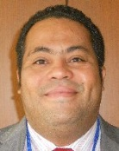 | Fabrício SANTANA SANTOS, Coordinator, National Plant Variety Protection Office (SNPC), Ministry of Agriculture, Livestock and Food Supply, Esplanada dos Ministerios, Bloco 'D' Anexo A, Sala 252, CEP 70043-900 Brasilia D.F.  (tel.: +55 61 3218 2923 fax: +55 61 3224 2842 email: fabricio.santos@agricultura.gov.br)
 | 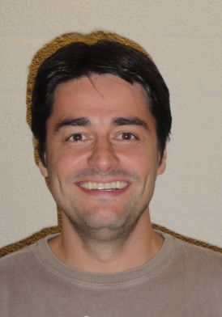 | Ricardo ZANATTA MACHADO, Federal Agricultural Inspector, National Plant Variety Protection Service (SNPC), Ministry of Agriculture, Livestock and Food Supply, Esplanada dos Ministérios, Bloco 'D', Anexo A, 2o andar, Sala 248, 70043-900 BRASILIA D.F.  (tel.: +55 61 321 825 49 e-mail: ricardo.machado@agricultura.gov.br)
Daniela de MORAES AVIANI (Ms.), Federal Inspector, National Plant Variety Protection Service (SNPC), Ministry of Agriculture, Livestock and Food Supply, Esplanada dos Ministérios, Bloco 'D', Anexo A, Sala 247, Brasilia D.F. 70043-900
(tel.: +55 61 3218 2805/9976 8552 e-mail:daniela.aviani@agricultura.gov.br)
 | 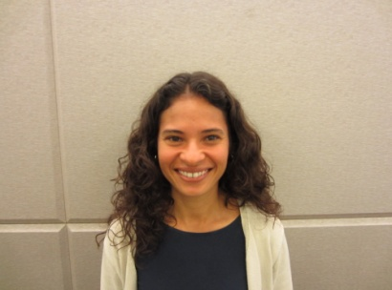 | Stefânia PALMA ARAUJO (Ms.), Federal Agricultural Inspector, National Plant Variety Protection Service (SNPC), Ministry of Agriculture, Livestock and Food Supply, Esplanada dos Ministérios, Bloco 'D', Anexo A, Sala 247, Brasilia D.F. 70043-900  (tel.: +55 61 3218 2547 fax: +55 61 3224 2842 e-mail: stefania.araujo@agricultura.gov.br)
 | 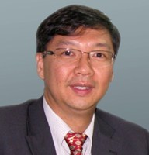 | Joel YUTAKA SUGANO, Associate Professor, Federal University of Lavras TBIT S/A, Rua Desembargador Edesio Fernandes, 525, Monte Líbano  (tel.: +55 35 9143 3068/35 8852 0261 e-mail: joel@tbit.com.br)
 | CHINA
Zhicheng HUANG, Research Associate, Shanghai Academy of Agricultural Sciences, No. 888 Yezhuang Road, Fengxian, Shanghai
(tel.: +86 21 5746 0009 fax: +86 21 + 5746 0009 e-mail: hzauhzhch@126.com
 | 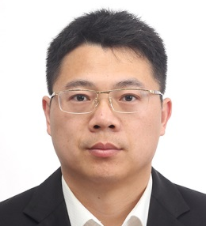 |  | Yang KUN, Senior Agronomist, DUS Testing Division, Development Centre for Science and Technology, Ministry of Agriculture, Room 707, Nonfeng Building, No. 96 Dong San Huan Nan Lu, Chaoyang District, Beijing  (tel.: +86 10 591 993 60 fax: +86 10 591 993 61 e-mail: yangkunmail@foxmail.com)
Xiangsheng WANG, Research Associate, Institute of Food Crops, Jiangsu Academy of Agricultural Sciences, Ministry of Agriculture, Nanjing Station for DUS Testing, 50 Zhongling Str., Xuanwu District, Nanjing City, 210014
(tel.: +86 25 84391966 fax: +86 25 84391966 e-mail: wangxiansheng80@126.com)
 | FINLAND
Sami MARKKANEN, Senior Officer, Control Department, Finnish Food Safety Authority (EVIRA), Tampereentie 51, P.O. Box 111, FI-32201 Loimaa
(tel.: +358 40 8294543 fax: +358 29 530 5318 e-mail: sami.markkanen@evira.fi)
 | france
Christophe CHEVALIER, Manager, IT Department, Groupe d’étude et de contrôle des variétés et des semences (GEVES), rue Georges Morel, BP 90024, 49071 Beaucouzé
(tel. : +33 2 41 22 86 36 fax : +33 2 41 22 86 02 e-mail : christophe.chevalier@geves.fr)
 | 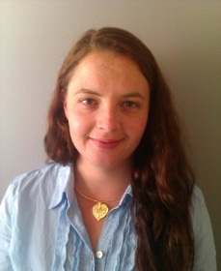 | Anne-Lise CORBEL (Ms.), Responsable DHS colza, crucifères, lin et chanvre, Groupe d'étude et de contrôle des variétés et des semences (GEVES), Domaine de l'Anjouère, 49370 La Poueze  (tel.: +33 24 122 8705 fax: +33 24 122 8660 e-mail: anne-lise.corbel@geves.fr)
 | GERMANY
Uwe MEYER, Referatsleiter Informationstechnologie, Referat 111, Bundessortenamt, Osterfelddamm 80, D-30627 Hannover
(tel.: +49 511 9566 5689 fax: +49 511 9566 9689
email: uwe.meyer@bundessortenamt.de)
Thomas DROBEK, Referat 111,Bundessortenamt, Osterfelddamm 80, D-30627 Hannover
(tel.: +49 511 9566 5688 fax: +49 511 9566 9600
e-mail: thomas.drobek@bundessortenamt.de)
 | Italy
Maurizio GIOLO, Senior Scientist, Council for Agricultural Research CRA SCS, Experimentation and seed certification Center, Via Ca' Nova Zampieri, 37, S.G., Lupatoto (Verona) 37057
(tel.: +39 45 545164 fax: +39 45 545 250 e-mail: maurizio.giolo@entecra.it)
 | japan
 | 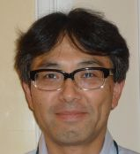 | Hiroshi UCHIZAWA, Senior Examiner, Plant Variety Protection Office, New Business & Intellectual Property Division, Ministry of Agriculture, Forestry and Fisheries, 1-2-1 Kasumigaseki, Chiyoda-ku, Tokyo 100-8950  (tel.: +81 3 6738 6466 fax: +81 3 3502 6572 e-mail: hiroshi_uchizawa@nm.maff.go.jp)
 | NETHERLANDS
Kees VAN ETTEKOVEN, Head of Variety Testing Department, Naktuinbouw NL, Sotaweg 22, Postbus 40, NL-2370 AA Roelofarendsveen
(tel.: +31 71 332 6128 fax: +31 71 332 6565 e-mail: c.v.ettekoven@naktuinbouw.nl)
 | UNITED KINGDOM
Adrian M. I. ROBERTS, , External Development Manager, Biomathematics & Statistics Scotland (BioSS), James Clerk Maxwell Building, The King's Buildings, Edinburgh EH9 3JZ Scotland
(tel.: +44 131 650 4893 fax: +44 131 650 4900 e-mail: adrian@bioss.ac.uk)
 | II. OFFICER
 |  |  | Adrian M.I. Roberts, Chair
 | III. OFFICE OF UPOV
 | 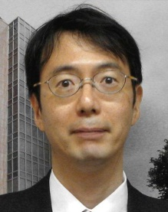 |  | Jun KOIDE, Technical/Regional Officer (Asia), International Union for the Protection of New Varieties of Plants (UPOV), Geneva 1211, Switzerland  (tel.: +41 22 338 7442 fax: +41 22 733 0336 e-mail: jun.koide@upov.int)
 | 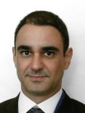 |  | Leontino TAVEIRA, Technical/Regional Officer (Latin America, Caribbean), International Union for the Protection of New Varieties of Plants (UPOV), Geneva 1211, Switzerland  (tel.: +41 22 338 9565 fax: +41 22 733 0336 e-mail: leontino.taveira@upov.int)

[Annex II follows]

PLANT VARIETY PROTECTION IN BRAZIL

Presentation by Mr. Fabricio Santana Santos, Coordinator, National Plant Variety Protection Office (SNPC), Ministry of Agriculture, Livestock and Food Supply

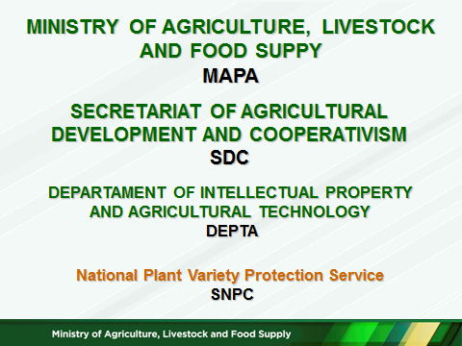

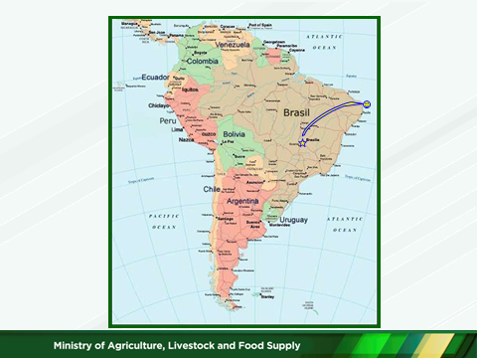

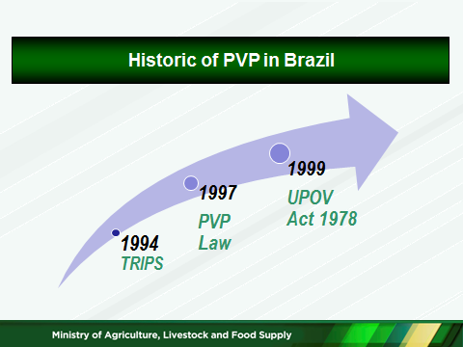

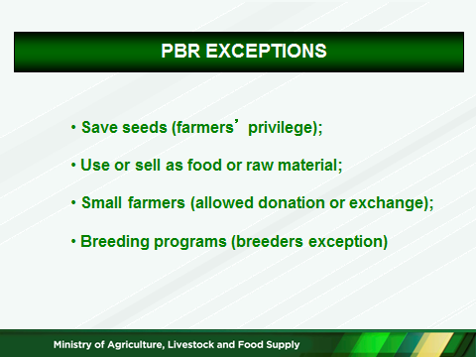

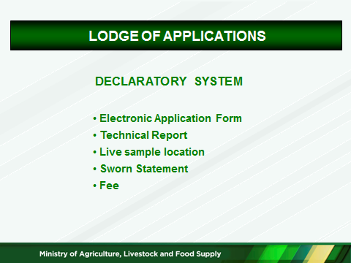

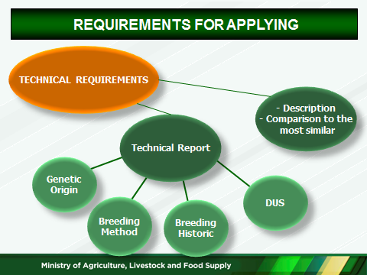

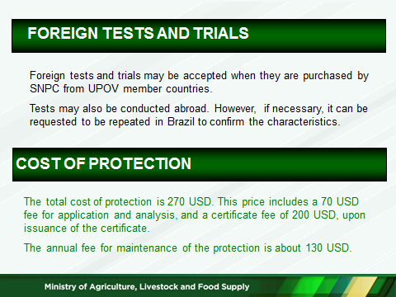

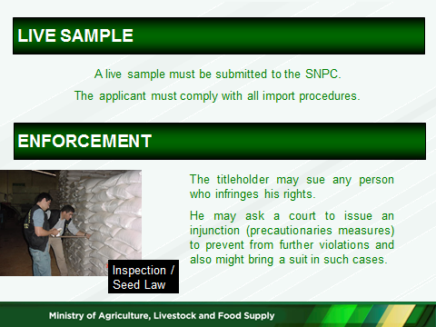

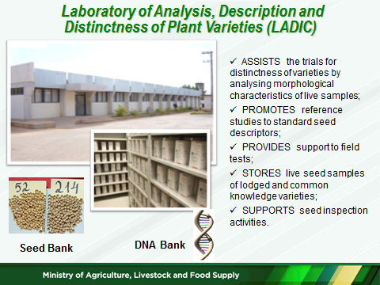

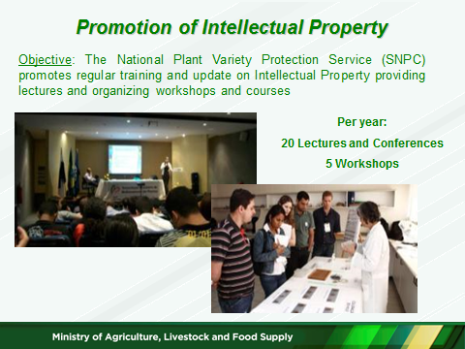

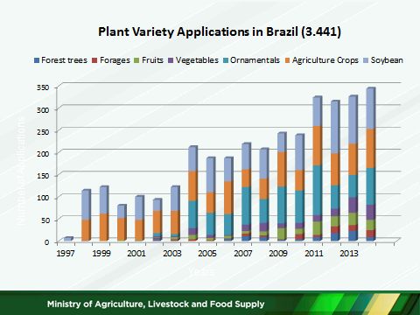

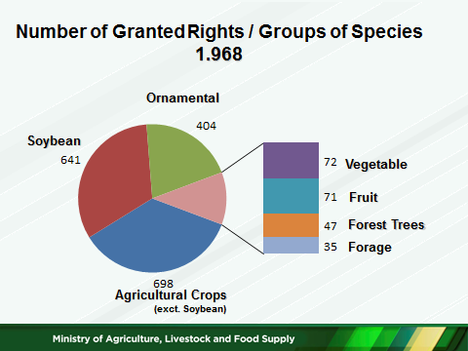

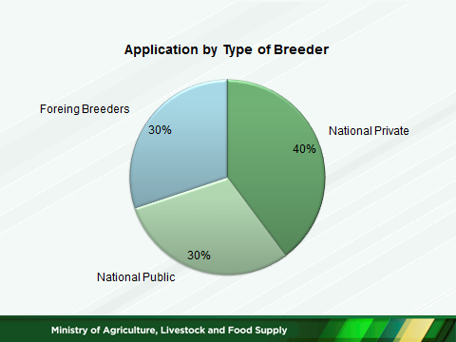

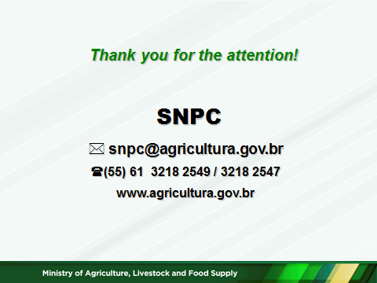

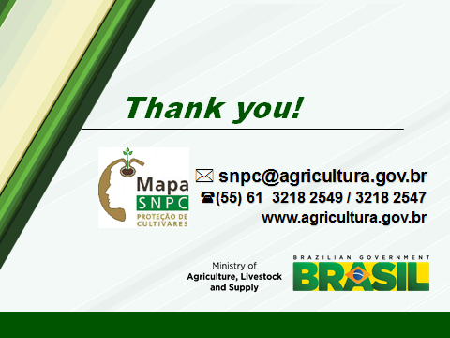

[End of Annexes and of document]

