E
TWC/33/29 Add.
ORIGINAL: English
DATE: July 13, 2015
INTERNATIONAL UNION FOR THE PROTECTION OF NEW VARIETIES OF PLANTS
Geneva
Technical working party on automation and computer programs
Thirty-Third Session
Natal, Brazil, June 30 to July 3, 2015
addendum to
Weighting matrix in the GAIA software for soybean
Document prepared by the Office of the Union
Disclaimer: this document does not represent UPOV policies or guidance
The Annex to this document contains a copy of a presentation that was made by an expert from Brazil on “Weighting matrix in the GAIA software for soybean” at the thirty-third session of the Technical Working Party on Automation and Computer Programs (TWC).

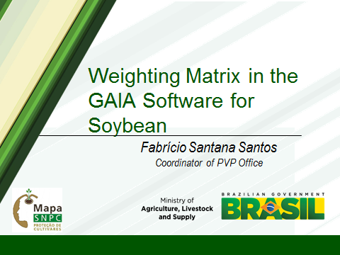

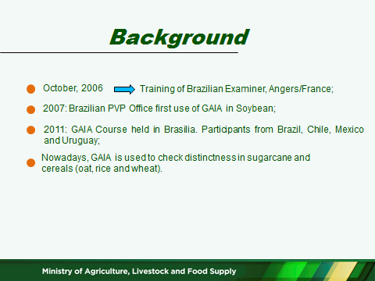

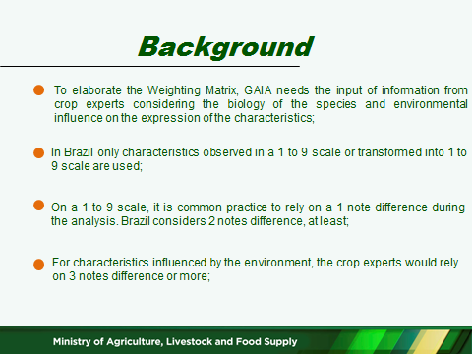

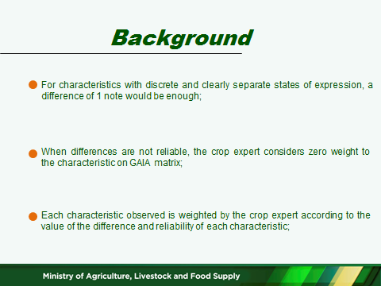

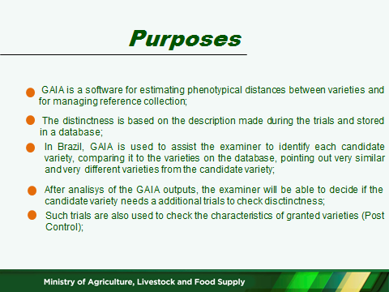

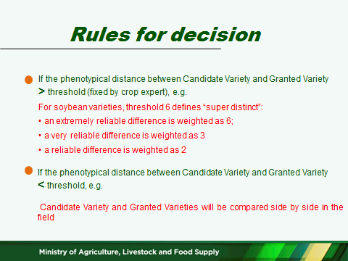

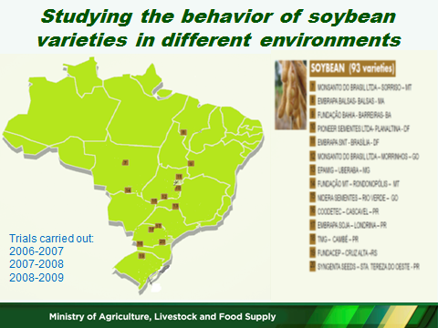

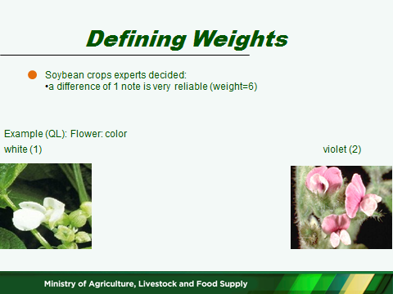

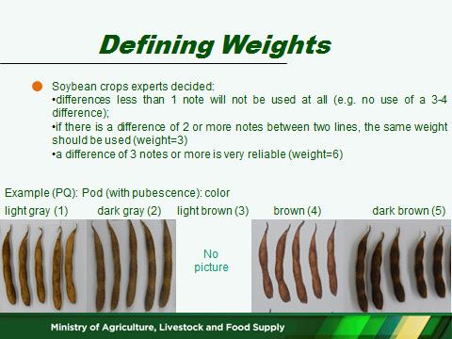

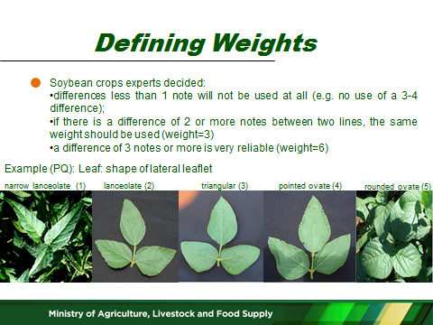

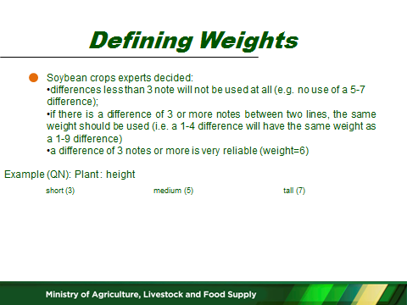

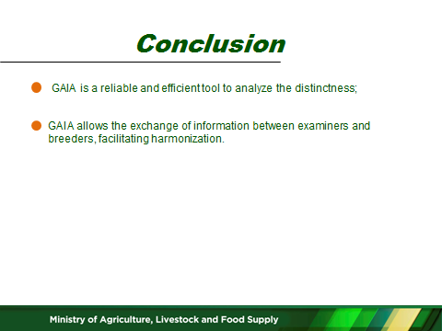

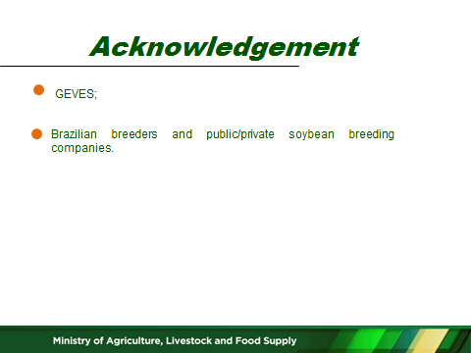

[End of annex and of document]

