E
TWC/33/26 Add. 1 Rev.
ORIGINAL: English
DATE: July 13, 2015
INTERNATIONAL UNION FOR THE PROTECTION OF NEW VARIETIES OF PLANTS
Geneva
Technical working party on automation and computer programs
Thirty-Third Session
Natal, Brazil, June 30 to July 3, 2015
ADDENDUM to
Statistical methods for visually observed characteristics
Document prepared by the Office of the Union
Disclaimer: this document does not represent UPOV policies or guidance
The Annex to this document contains a copy of a presentation that was made by an expert from China on “Analysis of visually observed characteristics using the DUST China (DUSTC) software package using the data set of meadow fescue provided by Finland” at the thirty-third session of the Technical Working Party on Automation and Computer Programs (TWC).

[Annex follows]

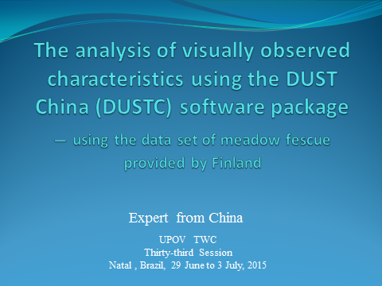

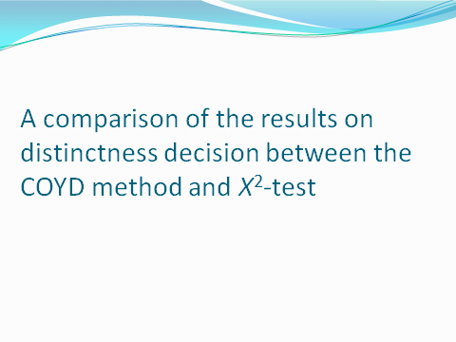

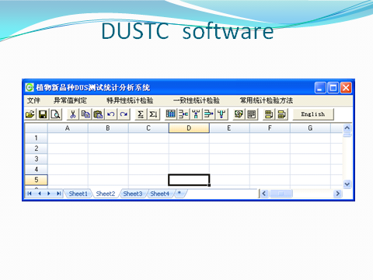

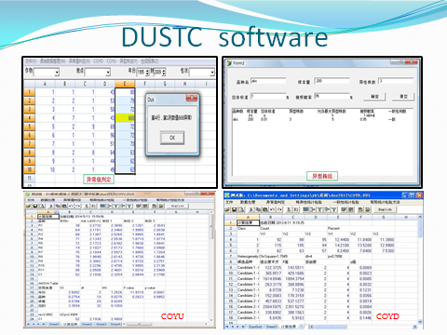

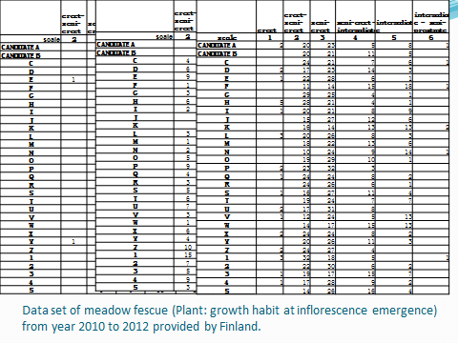

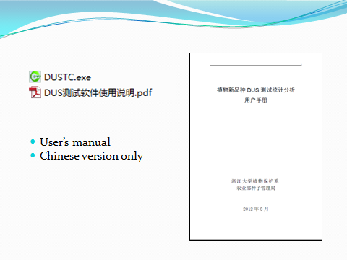

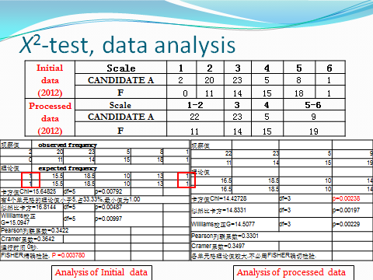

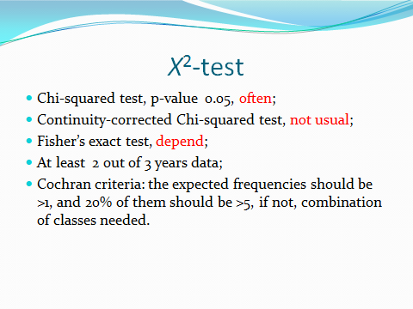

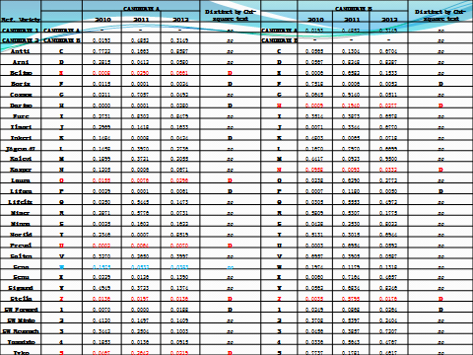

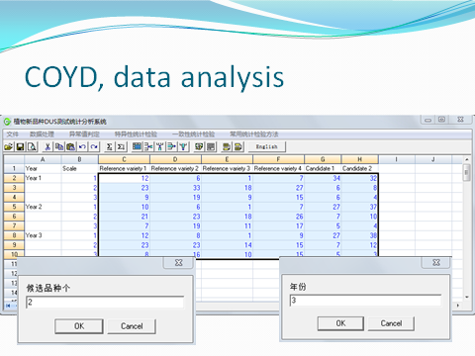

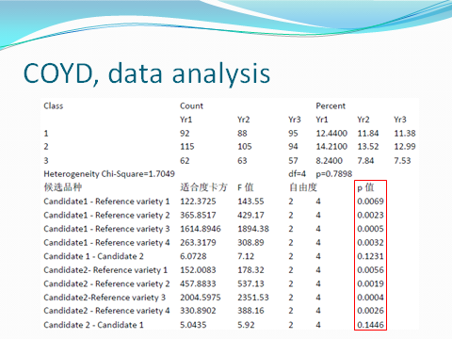

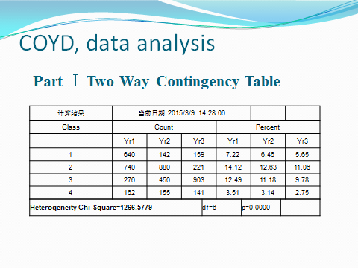

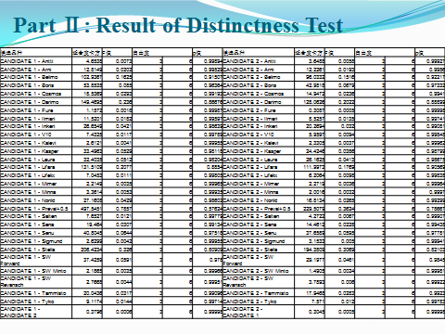

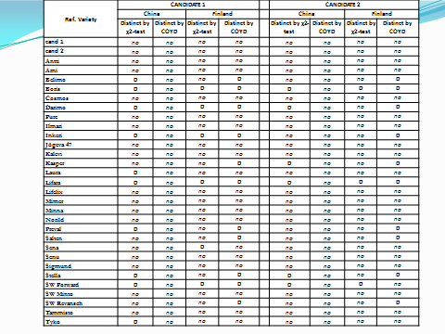

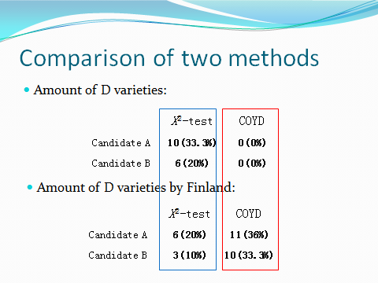

[End of Annex and of document]

