|  |  |  |
| --- | --- | --- |
|  |  | E  TWC/33/26  **ORIGINAL:**  English  DATE:  June 23, 2015 |
| INTERNATIONAL UNION FOR THE PROTECTION OF NEW VARIETIES OF PLANTS | | |
| Geneva | | |

Technical working party on automation and computer programs

Thirty-Third Session  
Natal, Brazil, June 30 to July 3, 2015

Statistical methods for visually observed characteristics

Document prepared by the Office of the Union  
  
Disclaimer: this document does not represent UPOV policies or guidance

EXECUTIVE SUMMARY

The purpose of this document is to report on developments concerning a new statistical method for visually observed characteristics in DUS examination with multinomial distributed data.

The TWC is invited to:

(a) consider the presentations by members of the Union on how they intend to use the new statistical method for visually observed characteristics in DUS examination, as set out in Annex I to this document;

(b) note that the TC, at its fifty-first session, agreed to remove the document “Statistical methods for visually observed characteristics” from the program for the revision of document TGP/8, and to consider the matter under a separate agenda item; and

(c) consider the presentation by China on the analysis of visually observed characteristics using the DUST China (DUSTC) software package using the data set of meadow fescue provided by Finland.

The structure of this document is as follows:

BACKGROUND 2

DEVELOPMENTS IN 2014 2

Technical Working Parties 2

DEVELOPMENTS IN 2015 3

Enlarged Editorial Committee 3

Technical Committee 3

Invitation for presentations 3

Comparison of results on distinctness decisions between the new COYD method for visually observed characteristics and the Chi-square test 3

Annex I New statistical method for visually observed characteristics with multinomial distributed data

Annex II Consequences of decisions for examination of distinctness, uniformity and stability

Annex III A comparison of the results on distinctness decision between the COYD method for ordinal characteristics and Chi-square test

The following abbreviations are used in this document:

CAJ: Administrative and Legal Committee

TC: Technical Committee

TC-EDC: Enlarged Editorial Committee

TWA: Technical Working Party for Agricultural Crops

TWC: Technical Working Party on Automation and Computer Programs

TWF: Technical Working Party for Fruit Crops

TWO: Technical Working Party for Ornamental Plants and Forest Trees

TWV: Technical Working Party for Vegetables

TWPs: Technical Working Parties

# BACKGROUND

The background to this matter is provided in documents TWC/32/21, TC/49/32 and TC/50/28 “Revision of document TGP/8: Part II: Selected Techniques Used in DUS Examination, New Section: Statistical Methods for Visually Observed Characteristics”.

Annex I to this document contains an explanation on the method proposed Mr. Kristian Kristensen (Denmark), as presented to the Technical Committee at its forty-ninth session, held in Geneva, from March 18 to 20, 2013 (see document TC/49/32 “Revision of document TGP/8: Part II: Selected Techniques Used in DUS Examination, New Section: Statistical Methods for Visually Observed Characteristics”).

Annex II to this document presents a copy of supplementary information concerning consequences of the decisions for DUS examination as background information for consideration when document TWC/30/29 “Revision of document TGP/8: Part II: Selected Techniques Used in DUS Examination, New Section: Statistical Methods for Visually Observed Characteristics” was discussed by the TWC, at its thirtieth session, held in Chisinau, Republic of Moldova, from June 26 to 29, 2012 (see document TWC/30/19 “Consequences of Decisions for Examination of Distinctness, Uniformity and Stability”).

Annex III to this document presents a comparison of the results on distinctness decision between the new statistical method (COYD method for ordinal characteristics) and Chi-square test, prepared by Mr. Sami Markkanen (Finland) and considered by the TWC at its thirty-second session, held in Helsinki, Finland, from June 3 to 6, 2014.

# DEVELOPMENTS IN 2014

## Technical Working Parties

At their sessions in 2014, the TWO, TWF, TWV, TWC and TWA considered documents TWO/47/21, TWF/45/21, TWV/48/21, TWC/32/21, TWC/32/21 Add. and TWA/43/21 “Revision of Document TGP/8: Part II: Selected Techniques Used in DUS Examination, New Section: Statistical Methods for Visually Observed Characteristics”, respectively.

The TWO, TWF, TWC, TWV and TWA noted the developments concerning a possible New Section: “Statistical Methods for Visually Observed Characteristics” to be introduced in document TGP/8: Part II: Techniques Used in DUS Examination, in a future revision of document TGP/8 (see document TWO/47/28 “Report”, paragraph 47, TWF/45/32 “Report”, paragraph 48, TWC/32/28 “Report”, paragraph 45, TWV/48/43 “Report”, paragraph 61 and TWA/43/27 “Report”, paragraph 53, respectively).

The TWO, TWF and TWV agreed that it should be clarified that the new proposed method was used for the visual observation of individual plants or parts of plants (VS) (see document TWO/47/28, paragraph 48, TWF/45/32, paragraph 49 and TWV/48/43, paragraph 62, respectively).

The TWC considered a comparison of the results on distinctness decisions between the new COYD method for visually observed characteristics and the Chi-square test, which was presented by an expert from Finland, as set out in the Annex to document TWC/32/21 Add. (see document TWC/32/28, paragraph 46).

The TWC agreed that the new method was tailored for the analysis of visually observed characteristics and had a better fundamental basis when compared to the Chi-square test. The TWC noted that the new method allowed for distinctness to be established between more pairs of varieties than the Chi-square test in the example of meadow fescue “growth habit” considered (see document TWC/32/28, paragraph 47).

The TWC agreed that software should be developed using the new method for the software packages available and noted that the code was currently available for SAS. The TWC noted the information that the United Kingdom was currently assessing how GenStat could be used for this method (see document TWC/32/28, paragraph 48).

The TWC agreed to invite an expert from China to make a presentation on the analysis of visually observed characteristics using the DUST China (DUSTC) software package using the same data set of meadow fescue provided by Finland to be presented at the next session of the TWC (see document TWC/32/28, paragraph 49).

The TWA noted the comparison of results of the COYD method for ordinal characteristics and Chi‑square test on distinctness decisions made using meadow fescue growth habit data from Finland. The TWA agreed to request the TWC to clarify whether the COYD method for ordinal characteristics was recommended for any ordinal data or other conditions should also be considered when selecting the appropriate analysis method (see document TWA/43/27, paragraph 54).

# DEVELOPMENTS IN 2015

## Enlarged Editorial Committee

The TC-EDC, at its meeting held in Geneva, on January 7 and 8, 2015, considered document TC‑EDC/Jan 15/12 “Revision of document TGP/8: Part II: Selected Techniques Used in DUS Examination, New Section: Statistical Methods for Visually Observed Characteristics”.

In order to achieve a better understanding of the new proposed method, the TC-EDC recommended that the members of the Union be invited to present to the TWPs how they intend to use the new method in DUS examination. In addition, the TC-EDC proposed to remove the document “Statistical methods for visually observed characteristics” from the program for the revision of document TGP/8, and the document to be presented under a separate agenda item, pending clarification on the possible use of the method.

## Technical Committee

The TC, at its fifty-first session, held in Geneva, from January 23 to 25, 2015, encouraged members of the Union to present to the TWPs the ways in which they intended to use the new statistical method for visually observed characteristics in DUS examination.

The TC agreed to remove the document “Statistical methods for visually observed characteristics” from the program for the revision of document TGP/8 for the time being, and to consider the matter under a separate agenda item.

The TC noted that an expert from China had been invited to make a presentation at the next session of the TWC on the analysis of visually observed characteristics using the DUST China (DUSTC) software package using the data set of meadow fescue provided by Finland.

## Invitation for presentations

On May 5, 2015, the Office of the Union issued a circular inviting members to submit the ways in which members of the Union intend to use the new statistical method for visually observed characteristics in DUS examination, as set out in Annex I to this document (see UPOV Circular E-15/108 “Invitation to make presentations to the TWPs at their sessions in 2015”).

Presentations made at the thirty-third session of the TWC will be provided as an addendum to this document.

## Comparison of results on distinctness decisions between the new COYD method for visually observed characteristics and the Chi-square test

In response to the invitation by the TWC at its thirty-second session, an expert from China has submitted to the Office of the Union a presentation on “the analysis of visually observed characteristics using the DUST China (DUSTC) software package using the data set of meadow fescue provided by Finland”. The presentation will be provided as an addendum to this document.

The TWC is invited to:

(a) consider the presentations by members of the Union on how they intend to use the new statistical method for visually observed characteristics in DUS examination, as set out in Annex I to this document;

(b) note that the TC, at its fifty-first session, agreed to remove the document “Statistical methods for visually observed characteristics” from the program for the revision of document TGP/8, and to consider the matter under a separate agenda item; and

(c) consider the presentation by China on the analysis of visually observed characteristics using the DUST China (DUSTC) software package using the data set of meadow fescue provided by Finland.

[Annexes follow]

NEW STATISTICAL METHOD FOR VISUALLY OBSERVED CHARACTERISTICS WITH MULTINOMIAL DISTRIBUTED DATA

THE COMBINED OVER-YEARS METHOD FOR ORDINAL CHARACTERISTICS

Summary of requirements for application of the method

* + The method is appropriate to use for assessing distinctness of varieties where:
  + The characteristic is ordinal and recorded for individual plants (usually recorded visually)
  + There are some differences between plants
  + The observations are made over at least two years or growing cycles on a single location
  + There should be at least 20 degrees of freedom for estimating the random variety-by-year interaction term.
  + The distribution of the characteristic should be unimodal, i.e. notes with large number of plants should occur next to each other, zeros at one or both ends of the scale should not cause problems as long as most varieties have plants that fall in different notes
  + The total number of plants for each variety should not be too low, at least 5 times the number of notes the variety covers

Summary

The method can be considered as an alternative to the χ2-test for independence in a contingency table. The χ2-test only takes the variation caused by random sampling into account and may thus be too liberal if additional sources of variation are present. Also the χ2-test does not take the ordering of the notes into account. The combined over-years method for ordinal characteristics takes other sources of variation into account by including a random variety-by-year interaction term (as for the COYD method described in TGP/8/1 Part II: 3).It takes the ordering of notes into account by using a cumulative function over the ordered notes. The inclusion of the random effect is expected to decrease the number of distinct pairs of varieties compared to the χ2-test for independence, but to better ensure that the decisions are consistent over coming years. Taking the ordering of notes into account is expected to increase the power of the test and thus to increase the number of distinct pairs.

The method is based on a generalisation of the traditional analyses of variance and regression methods for normally distributed data, which are called “generalized linear mixed models”. A general description of the method may be found in Agresti (2002) and a more specific description – using other examples of data may be found in Kristensen (2011).

The combined over-years method for ordinal characteristics involves

* Calculating the number of plants for each note for each variety in each of the two or three years of trials, which results in a 3-way table (see the example)
* Analyse the data using appropriate software
* Compare each candidate to the reference varieties and the other candidates at the appropriate level of significance to see which varieties the candidate is distinct from
* Check if the variety-by-year interaction term for distinct pairs is considerably larger than the average for all variety pairs

Example

For demonstration a subset of varieties from a DUS experiment with Meadow fescue (*Festuca pratensis*) in Finland was chosen. The notes for Plant: growth habit at inflorescence emergence (Characteristic 9 of TG/39/8) in 2010, 2011 and 2012 were analysed (Table 4). In most cases 40-60 plants were recorded in each year. This characteristic is rather sensitive to the growing conditions. This is apparent from table 4 where it is seen that the note 1 was recorded only in 2012 while note 7 was recorded only in 2010. Also it is seen that the most common note (over all varieties) in the three years was note, 5, 3 and 3, respectively in 2010, 2011 and 2012. The applied analysis method takes this into account by calculating an additive effect of each year (as for the COYD method for normal distributed data).

The estimated percent of plants in each note for each variety are shown in Table 2.

Table 1. Number of individual plants with each note for each variety and year for the characteristic Plant: growth habit at inflorescence emergence in Meadow fescue *(Festuca pratensis)*

|  |  |  |  |  |  |  |  |  |  |  |  |  |  |  |  |  |  |  |  |  |  |
| --- | --- | --- | --- | --- | --- | --- | --- | --- | --- | --- | --- | --- | --- | --- | --- | --- | --- | --- | --- | --- | --- |
| Variety | Note | | | | | | | | | | | | | | | | | | | | |
| 1 | | | 2 | | | 3 | | | 4 | | | 5 | | | 6 | | | 7 | | |
| 2010 | 2011 | 2012 | 2010 | 2011 | 2012 | 2010 | 2011 | 2012 | 2010 | 2011 | 2012 | 2010 | 2011 | 2012 | 2010 | 2011 | 2012 | 2010 | 2011 | 2012 |
| A | 0 | 0 | 2 | 0 | 2 | 20 | 4 | 27 | 23 | 1 | 23 | 5 | 32 | 2 | 8 | 4 | 0 | 1 | 0 | 0 | 0 |
| B | 0 | 0 | 0 | 0 | 1 | 20 | 1 | 12 | 21 | 9 | 5 | 11 | 29 | 0 | 5 | 8 | 0 | 0 | 0 | 0 | 0 |
| C | 0 | 0 | 0 | 0 | 4 | 24 | 3 | 21 | 21 | 1 | 21 | 7 | 30 | 7 | 6 | 8 | 1 | 1 | 0 | 0 | 0 |
| D | 0 | 0 | 2 | 0 | 6 | 17 | 7 | 35 | 23 | 6 | 11 | 14 | 31 | 1 | 3 | 3 | 0 | 0 | 0 | 0 | 0 |
| E | 0 | 0 | 1 | 1 | 9 | 22 | 9 | 30 | 28 | 13 | 12 | 6 | 31 | 1 | 1 | 0 | 0 | 0 | 0 | 0 | 0 |
| F | 0 | 0 | 0 | 0 | 1 | 11 | 0 | 13 | 14 | 6 | 22 | 15 | 27 | 14 | 18 | 10 | 4 | 1 | 0 | 0 | 0 |
| G | 0 | 0 | 0 | 0 | 3 | 29 | 8 | 34 | 25 | 10 | 18 | 4 | 25 | 3 | 1 | 4 | 0 | 0 | 0 | 0 | 0 |
| H | 0 | 0 | 5 | 0 | 6 | 28 | 7 | 48 | 21 | 19 | 6 | 4 | 19 | 0 | 1 | 1 | 0 | 0 | 0 | 0 | 0 |
| I | 0 | 0 | 1 | 0 | 2 | 20 | 5 | 29 | 21 | 6 | 23 | 8 | 29 | 5 | 9 | 6 | 0 | 0 | 0 | 0 | 0 |
| J | 0 | 0 | 0 | 0 | 0 | 15 | 1 | 35 | 27 | 0 | 16 | 12 | 35 | 5 | 6 | 4 | 0 | 0 | 2 | 0 | 0 |
| K | 0 | 0 | 0 | 0 | 0 | 16 | 2 | 24 | 14 | 4 | 17 | 13 | 29 | 17 | 13 | 9 | 0 | 2 | 2 | 0 | 0 |
| L | 0 | 0 | 3 | 0 | 3 | 20 | 4 | 34 | 26 | 7 | 17 | 8 | 28 | 5 | 3 | 2 | 0 | 0 | 0 | 0 | 0 |
| M | 0 | 0 | 0 | 0 | 1 | 18 | 5 | 24 | 22 | 7 | 27 | 13 | 30 | 7 | 6 | 5 | 0 | 0 | 2 | 0 | 0 |
| N | 0 | 0 | 0 | 0 | 2 | 10 | 3 | 18 | 24 | 2 | 15 | 9 | 25 | 16 | 14 | 11 | 1 | 1 | 1 | 0 | 0 |
| O | 0 | 0 | 0 | 0 | 5 | 19 | 9 | 39 | 29 | 9 | 8 | 10 | 23 | 2 | 1 | 3 | 0 | 0 | 0 | 0 | 0 |
| P | 0 | 0 | 2 | 0 | 9 | 23 | 13 | 30 | 32 | 7 | 4 | 3 | 19 | 0 | 0 | 2 | 0 | 0 | 0 | 0 | 0 |
| Q | 0 | 0 | 1 | 0 | 4 | 24 | 9 | 27 | 24 | 10 | 19 | 8 | 28 | 5 | 2 | 3 | 0 | 0 | 0 | 0 | 0 |
| R | 0 | 0 | 0 | 0 | 3 | 24 | 2 | 30 | 26 | 6 | 21 | 6 | 35 | 6 | 1 | 5 | 0 | 0 | 0 | 0 | 0 |
| S | 0 | 0 | 1 | 0 | 5 | 16 | 6 | 25 | 27 | 14 | 19 | 11 | 26 | 8 | 4 | 2 | 0 | 0 | 0 | 0 | 0 |
| T | 0 | 0 | 0 | 0 | 6 | 19 | 3 | 36 | 24 | 4 | 5 | 7 | 18 | 3 | 7 | 5 | 0 | 0 | 0 | 0 | 0 |
| U | 0 | 0 | 2 | 0 | 7 | 17 | 11 | 41 | 31 | 15 | 11 | 8 | 30 | 0 | 0 | 0 | 0 | 0 | 0 | 0 | 0 |
| V | 0 | 0 | 3 | 0 | 15 | 32 | 11 | 33 | 18 | 13 | 6 | 5 | 30 | 3 | 0 | 4 | 0 | 1 | 0 | 0 | 0 |
| W | 0 | 0 | 0 | 0 | 7 | 22 | 4 | 28 | 30 | 6 | 16 | 6 | 37 | 5 | 2 | 6 | 0 | 0 | 1 | 0 | 0 |
| X | 0 | 0 | 1 | 0 | 5 | 19 | 2 | 24 | 17 | 4 | 17 | 15 | 40 | 6 | 7 | 2 | 0 | 0 | 0 | 0 | 0 |
| Y | 0 | 0 | 1 | 0 | 3 | 12 | 2 | 8 | 24 | 4 | 6 | 5 | 24 | 0 | 13 | 6 | 0 | 0 | 0 | 0 | 0 |
| Z | 0 | 0 | 0 | 0 | 1 | 14 | 1 | 25 | 17 | 2 | 16 | 15 | 26 | 10 | 13 | 10 | 0 | 0 | 0 | 0 | 0 |
| 1 | 0 | 0 | 2 | 0 | 6 | 24 | 5 | 38 | 24 | 8 | 9 | 8 | 34 | 2 | 2 | 0 | 0 | 0 | 0 | 0 | 0 |
| 2 | 0 | 0 | 0 | 1 | 4 | 20 | 5 | 29 | 26 | 5 | 16 | 11 | 37 | 5 | 3 | 3 | 0 | 0 | 0 | 0 | 0 |
| 3 | 0 | 0 | 2 | 0 | 10 | 24 | 7 | 28 | 27 | 8 | 12 | 4 | 30 | 1 | 0 | 0 | 0 | 0 | 0 | 0 | 0 |
| 4 | 0 | 0 | 1 | 0 | 9 | 17 | 7 | 31 | 28 | 6 | 10 | 9 | 30 | 2 | 2 | 2 | 0 | 0 | 0 | 0 | 0 |
| 5 | 0 | 0 | 0 | 0 | 3 | 14 | 1 | 24 | 26 | 9 | 22 | 16 | 36 | 8 | 4 | 5 | 0 | 0 | 0 | 0 | 0 |

Table 2. Estimated percent of plants for each note of each variety

|  |  |  |  |  |  |  |  |
| --- | --- | --- | --- | --- | --- | --- | --- |
| Variety | Note | | | | | | |
| 1  erect | 2  erect –  semi erect | 3  semi erect | 4  semi erect – intermediate | 5 intermediate | 6 intermediate –  semi prostrate | 7  semi prostate |
| A | 0.2 | 5.7 | 34.8 | 33.7 | 24.5 | 1.1 | 0.1 |
| B | 0.2 | 5.9 | 35.4 | 33.5 | 23.9 | 1.0 | 0.0 |
| C | 0.1 | 4.8 | 31.2 | 34.4 | 28.1 | 1.3 | 0.1 |
| D | 0.2 | 8.2 | 41.8 | 30.8 | 18.2 | 0.7 | 0.0 |
| E | 0.4 | 12.4 | 48.7 | 25.7 | 12.4 | 0.5 | 0.0 |
| F | 0.0 | 1.7 | 14.6 | 28.9 | 51.0 | 3.6 | 0.2 |
| G | 0.3 | 10.3 | 45.8 | 28.2 | 14.9 | 0.6 | 0.0 |
| H | 0.6 | 17.0 | 52.3 | 20.9 | 8.9 | 0.3 | 0.0 |
| I | 0.2 | 5.6 | 34.1 | 33.9 | 25.1 | 1.1 | 0.1 |
| J | 0.1 | 4.3 | 29.2 | 34.6 | 30.3 | 1.4 | 0.1 |
| K | 0.1 | 2.5 | 19.6 | 32.5 | 42.8 | 2.5 | 0.1 |
| L | 0.2 | 7.8 | 40.8 | 31.4 | 19.1 | 0.8 | 0.0 |
| M | 0.1 | 4.6 | 30.2 | 34.5 | 29.1 | 1.3 | 0.1 |
| N | 0.1 | 2.2 | 18.1 | 31.6 | 45.1 | 2.8 | 0.1 |
| O | 0.3 | 10.1 | 45.5 | 28.4 | 15.1 | 0.6 | 0.0 |
| P | 0.5 | 16.0 | 51.8 | 21.8 | 9.5 | 0.3 | 0.0 |
| Q | 0.3 | 8.8 | 43.1 | 30.0 | 17.1 | 0.7 | 0.0 |
| R | 0.2 | 6.7 | 37.8 | 32.7 | 21.7 | 0.9 | 0.0 |
| S | 0.2 | 7.0 | 38.8 | 32.3 | 20.8 | 0.8 | 0.0 |
| T | 0.2 | 7.9 | 41.0 | 31.2 | 18.8 | 0.7 | 0.0 |
| U | 0.4 | 12.1 | 48.4 | 25.9 | 12.7 | 0.5 | 0.0 |
| V | 0.5 | 16.5 | 52.1 | 21.4 | 9.2 | 0.3 | 0.0 |
| W | 0.2 | 7.1 | 38.9 | 32.2 | 20.7 | 0.8 | 0.0 |
| X | 0.1 | 5.2 | 32.6 | 34.2 | 26.6 | 1.2 | 0.1 |
| Y | 0.1 | 4.4 | 29.7 | 34.6 | 29.7 | 1.4 | 0.1 |
| Z | 0.1 | 2.7 | 21.3 | 33.3 | 40.3 | 2.2 | 0.1 |
| 1 | 0.3 | 10.6 | 46.2 | 27.8 | 14.5 | 0.5 | 0.0 |
| 2 | 0.2 | 6.7 | 37.8 | 32.7 | 21.7 | 0.9 | 0.0 |
| 3 | 0.4 | 12.6 | 49.0 | 25.4 | 12.2 | 0.4 | 0.0 |
| 4 | 0.3 | 9.3 | 44.1 | 29.4 | 16.3 | 0.6 | 0.0 |
| 5 | 0.1 | 4.4 | 29.7 | 34.6 | 29.7 | 1.4 | 0.1 |

The candidates were variety *A* and *B* and the remaining varieties *C, D,…, 5* were reference varieties, a measure of the differences and the P-values for testing the hypothesis of no difference between candidate and reference varieties were calculated. The differences and the *P*-values are shown in Table 6. An *F3*-value is calculated in a similar way as for COY-D for normally distributed characteristics and is used in order to ensure that the pair did not became distinct because of a very large difference in only of the years without being different in other years (TGP/8/1 Draft 13 Section 3.6.3). Therefore, a significant difference between two varieties with a high *F3*-value should be examined carefully before the final decision is taken. The *F3*‑values and their significances are also shown in Table 6.

For the data shown here candidate *A* could be separated from 11 of the reference varieties when using a 1% level of significance while candidate B could be separated form 10 of the reference varieties. The two candidates could not be separated from each other. The largest *F3-value,* 5.43, was found for variety pair *B-S* (the approximate threshold for the *F4* values to be significant is 4.98). This means that the interaction for this pair should have been considered if this pair had been distinct on this characteristic.

Table 3. Differences and F3 values together with P-values for relevant pairs of varieties

|  |  |  |  |  |  |  |  |  |
| --- | --- | --- | --- | --- | --- | --- | --- | --- |
| Variety | Candidate A | | | | Candidate B | | | |
|  | Difference | PDifference | F3 | PF3 | Difference | PDifference | F3 | PF3 |
| A | - | - | - | - | 0.03 | 0.9011 | 0.22 | 0.4051 |
| B | -0.03 | 0.9011 | 0.21 | 0.6566 | - | - | - | - |
| C | 0.19 | 0.4507 | 0.02 | 0.8782 | 0.22 | 0.4051 | 0.09 | 0.7694 |
| D | -0.39 | 0.1243 | 0.04 | 0.8522 | -0.35 | 0.1856 | 0.07 | 0.7947 |
| E | -0.84 | 0.0011 | 0.73 | 0.4154 | -0.81 | 0.0030 | 1.73 | 0.2215 |
| F | 1.26 | <.0001 | 0.56 | 0.4743 | 1.29 | <.0001 | 1.46 | 0.2584 |
| G | -0.63 | 0.0125 | 1.66 | 0.2298 | -0.60 | 0.0255 | 3.06 | 0.1144 |
| H | -1.22 | <.0001 | 1.17 | 0.3080 | -1.19 | <.0001 | 2.37 | 0.1579 |
| I | 0.03 | 0.8922 | 0.29 | 0.6041 | 0.07 | 0.8004 | 0.99 | 0.3448 |
| J | 0.30 | 0.2267 | 1.13 | 0.3146 | 0.34 | 0.2081 | 0.37 | 0.5600 |
| K | 0.88 | 0.0007 | 0.00 | 0.9669 | 0.91 | 0.0010 | 0.25 | 0.6274 |
| L | -0.33 | 0.1879 | 0.52 | 0.4895 | -0.30 | 0.2651 | 1.39 | 0.2681 |
| M | 0.24 | 0.3255 | 0.82 | 0.3878 | 0.28 | 0.2949 | 1.87 | 0.2047 |
| N | 0.99 | 0.0002 | 0.00 | 0.9734 | 1.02 | 0.0003 | 0.18 | 0.6805 |
| O | -0.61 | 0.0162 | 0.27 | 0.6151 | -0.58 | 0.0317 | 0.96 | 0.3525 |
| P | -1.15 | <.0001 | 0.24 | 0.6350 | -1.11 | 0.0001 | 0.90 | 0.3664 |
| Q | -0.47 | 0.0630 | 2.59 | 0.1421 | -0.43 | 0.1039 | 4.28 | 0.0685 |
| R | -0.17 | 0.5056 | 0.06 | 0.8115 | -0.13 | 0.6174 | 0.50 | 0.4984 |
| S | -0.22 | 0.3813 | 3.50 | 0.0943 | -0.18 | 0.4858 | 5.43 | 0.0448 |
| T | -0.34 | 0.1848 | 0.82 | 0.3879 | -0.31 | 0.2578 | 0.20 | 0.6650 |
| U | -0.82 | 0.0013 | 1.04 | 0.3352 | -0.79 | 0.0035 | 2.18 | 0.1735 |
| V | -1.18 | <.0001 | 0.03 | 0.8674 | -1.15 | <.0001 | 0.08 | 0.7799 |
| W | -0.23 | 0.3621 | 0.17 | 0.6870 | -0.19 | 0.4653 | 0.00 | 0.9662 |
| X | 0.12 | 0.6441 | 0.00 | 0.9863 | 0.15 | 0.5764 | 0.23 | 0.6444 |
| Y | 0.27 | 0.3246 | 0.19 | 0.6753 | 0.30 | 0.2936 | 0.00 | 0.9791 |
| Z | 0.77 | 0.0032 | 0.64 | 0.4435 | 0.80 | 0.0038 | 0.12 | 0.7404 |
| 1 | -0.66 | 0.0093 | 0.00 | 0.9861 | -0.63 | 0.0196 | 0.23 | 0.6443 |
| 2 | -0.17 | 0.5049 | 0.15 | 0.7116 | -0.13 | 0.6165 | 0.71 | 0.4219 |
| 3 | -0.87 | 0.0009 | 0.07 | 0.8017 | -0.83 | 0.0026 | 0.52 | 0.4907 |
| 4 | -0.53 | 0.0393 | 0.03 | 0.8714 | -0.49 | 0.0684 | 0.09 | 0.7760 |
| 5 | 0.27 | 0.2712 | 0.31 | 0.5938 | 0.31 | 0.2471 | 1.03 | 0.3376 |

In order to examine whether one or more varieties have a different variety by year interaction than the main part of the varieties, the actual contribution to the interaction was calculated for each variety and compared to the average contribution from all varieties. This was done using an *F*- value, *F4.*

The *F4* values for each variety in the analysis are shown in Figure 2. The largest *F4-*value*,* 2.78, was found for variety *S* (the approximate threshold for the *F4-*values to be significant is 4.98)*.* This value was not significantly larger than 1. The *F4*-value is calculated as the quotients between the each varieties contribution to the overall interaction and the average interaction over all varieties. As the contribution for the actual variety enters in both the numerator and denominator of the *F4*-valuethis test is approximate.

It is also seen that some varieties, e.g. *I, K, N, X, 1, 2, 3* and *5* have a very low interaction with year indicating that their response to year is very close to the mean reaction for all varieties.

|  |
| --- |
|  |
| **Figure 1. *F4*-values for each variety’s contribution to the interaction for ordinal characteristic growth habit** |

THE COMBINED OVER-YEARS METHOD FOR NOMINAL CHARACTERISTICS

Summary of requirements for application of the method

The method is appropriate to use for assessing distinctness of varieties where:

* The characteristic is nominal and recorded for individual plants (usually recorded visually)
* There are some differences between plants
* The observations are made over at least two years or growing cycles on a single location
* There should be at least 20 degrees of freedom for estimating the random variety-by-year interaction term.
* The expected number of plants for each combination of variety and note should be at least one – and for most of the combinations the number should be at least 5.

Summary

The method can be considered as an alternative to the χ2-test for independence in a contingency table. The χ2-test only takes the variation caused by random sampling into account and may thus be too liberal if additional sources of variation are present. The combined over-years method for nominal characteristics takes other sources of variation into account by including a random variety-by-year interaction term (as for the COYD method described in TGP/8/1 Part II: 3). The inclusion of the random effect is expected to decrease the number of distinct pairs of varieties compared to the χ2-test for independence, but to better ensure that the decisions are consistent over coming years. The method is based on a generalisation of the traditional analyses of variance and regression methods for normally distributed data, which are called “generalized linear mixed models”. A detailed description of the method – using other examples of data may be found in Agresti (2002) or Kristensen (2011).

The combined over-years method for nominal characteristics involves

* Calculating the number of plants for each note for each variety in each of the two or three years of trials, which results in a 3-way table (see the example)
* Analyse the data using appropriate software
* Compare each candidate to the reference varieties and the other candidates at the appropriate level of significance to see which varieties the candidate is distinct from
* Check if the variety-by-year interaction term for distinct pairs is considerably larger than the average for all variety pairs

Example

No example shown at present.

THE COMBINED OVER-YEARS METHOD FOR BINOMIAL CHARACTERISTICS

Summary of requirements for application of the method

The method is appropriate to use for assessing distinctness of varieties where:

* The characteristic is recorded for individual plants (usually recorded visually) using a scale with only 2 levels (such as present/absent or similar)
* There are some differences between plants
* The observations are made over at least two years or growing cycles on a single location
* There should be at least 20 degrees of freedom for estimating the random variety-by-year interaction term.
* The expected number of plants for each combination of variety and note should be at least one – and for most of the combinations the number should be at least 5.

Summary

The method can be considered as an alternative to the χ2-test for independence in a contingency table. The χ2-test only takes the variation caused by random sampling into account and may thus be too liberal if additional sources of variation are present. The combined over-years method for binomial characteristics take other sources of variation into account by including a random variety-by-year interaction term (as for the COYD method described in TGP/8/1 Part II: 3). The inclusion of the random effect is expected to decrease the number of distinct pairs of varieties compared to the χ2-test for independence, but to better ensure that the decisions are consistent over coming years.

The method is based on generalisation of the traditional analyses of variance and regression methods for normally distributed data, which are called “generalized linear mixed models”.

The combined over-years method for binomial characteristics involves

* Calculating the number of plants for each note for each variety in each of the two or three years of trials, which results in a 3-way table
* Analyse the data using appropriate software
* Compare each candidate to the reference varieties and the other candidates at the appropriate level of significance to see which varieties the candidate is distinct from
* Check if the variety-by-year interaction term for distinct pairs is considerably larger than the average for all variety pairs

Example

The proportion of plants with cyanid glucoside (Characteristic 4 in TG/38/7) was measured for some white clover varieties in Northern Ireland in each of 3 years. The variable was recorded as absent or present. In this example only 20 varieties are used and variety 1 and 2 are considered as candidates, while the remaining varieties are considered as references. The data are shown in Table 7.

**Table 4. Number of plants without and with cyanid glucoside in 20 white clover varieties in each of 3 years**

|  |  |  |  |  |  |  |
| --- | --- | --- | --- | --- | --- | --- |
|  | Year 1 | | Year 2 | | Year 3 | |
| Variety | Absent | Present | Absent | Present | Absent | Present |
| 1 | 31 | 29 | 22 | 38 | 17 | 43 |
| 2 | 40 | 20 | 42 | 18 | 41 | 19 |
| 3 | 50 | 10 | 52 | 8 | 55 | 5 |
| 4 | 42 | 18 | 40 | 20 | 34 | 26 |
| 5 | 37 | 23 | 42 | 18 | 37 | 23 |
| 6 | 51 | 9 | 49 | 11 | 52 | 8 |
| 7 | 30 | 30 | 25 | 35 | 26 | 34 |
| 8 | 37 | 23 | 31 | 29 | 30 | 30 |
| 9 | 27 | 33 | 27 | 33 | 25 | 35 |
| 10 | 48 | 12 | 47 | 13 | 43 | 17 |
| 11 | 40 | 20 | 40 | 20 | 32 | 28 |
| 12 | 18 | 42 | 13 | 47 | 12 | 48 |
| 13 | 10 | 50 | 12 | 48 | 5 | 55 |
| 14 | 41 | 19 | 46 | 14 | 45 | 15 |
| 15 | 58 | 2 | 55 | 5 | 58 | 2 |
| 16 | 7 | 53 | 10 | 50 | 11 | 49 |
| 17 | 25 | 35 | 22 | 38 | 20 | 40 |
| 18 | 48 | 12 | 54 | 6 | 52 | 8 |
| 19 | 20 | 40 | 20 | 40 | 23 | 37 |
| 20 | 57 | 3 | 54 | 6 | 55 | 5 |

The analysis showed that for these data there was no interaction between variety and year, which means that the variance component for year by variety was estimated to be zero and thus all variation in the data could be explained by sampling variation. The F-test for comparing the varieties was 36.67 with a P-value less than 0.01%, so there were clearly some differences among the varieties.

More specifically the analysis showed that candidate variety 1 was significantly different from 12 of the reference varieties at the 1% level (Table 8) whereas candidate variety 2 was significantly different from 11 of the reference varieties. Also the two candidate varieties were significantly different at the 1% level (Table 8).

As there was no interaction between variety and year, all *F3* and *F4* values are estimated to be zero for these data. Therefore, they are not shown here.**Table 5. Estimated percent of plants with cyanid glucoside for each variety and comparison of each variety with the candidate varieties 1 and 2 using F-tests**

|  |  |  |  |  |  |
| --- | --- | --- | --- | --- | --- |
|  | Estimated percent | Candidate 1 | | Candidate 2 | |
| Variety | F | P | F | P |
| 1 | 61.1 |  |  | 30.45 | <.0001 |
| 2 | 31.6 | 30.45 | <.0001 |  |  |
| 3 | 12.7 | 77.01 | <.0001 | 17.58 | 0.0002 |
| 4 | 35.5 | 23.05 | <.0001 | 0.61 | 0.4395 |
| 5 | 35.5 | 23.05 | <.0001 | 0.61 | 0.4395 |
| 6 | 15.5 | 70.09 | <.0001 | 12.54 | 0.0011 |
| 7 | 55.0 | 1.38 | 0.2473 | 19.58 | <.0001 |
| 8 | 45.5 | 8.69 | 0.0054 | 7.27 | 0.0104 |
| 9 | 56.1 | 0.93 | 0.3414 | 21.39 | <.0001 |
| 10 | 23.3 | 49.59 | <.0001 | 3.12 | 0.0853 |
| 11 | 37.8 | 19.27 | <.0001 | 1.48 | 0.2309 |
| 12 | 76.1 | 9.28 | 0.0042 | 66.21 | <.0001 |
| 13 | 85.0 | 24.61 | <.0001 | 90.68 | <.0001 |
| 14 | 26.6 | 41.43 | <.0001 | 1.09 | 0.3034 |
| 15 | 5.0 | 82.34 | <.0001 | 33.21 | <.0001 |
| 16 | 84.5 | 23.44 | <.0001 | 89.25 | <.0001 |
| 17 | 62.8 | 0.11 | 0.7463 | 33.81 | <.0001 |
| 18 | 14.4 | 72.95 | <.0001 | 14.45 | 0.0005 |
| 19 | 65.0 | 0.58 | 0.4492 | 38.53 | <.0001 |
| 20 | 7.8 | 84.99 | <.0001 | 28.18 | <.0001 |

COMMON TO ALL THREE METHODS

Software

The procedure *GLIMMIX* of *SAS* (SAS Institute Inc., 2010) can be used to estimate the parameters of the generalised linear mixed model, and the data-step facilities (and/or the procedure *IML*) of the same package can be used for the remaining calculations. However, similar facilities may be found in other statistical packages, thus the *glmer*() function of the package *lme4* of R can do the binomial analysis provided that there are more than one observation for each combination of variety and year.

Final note

In the case where there are only two notes, the methods for nominal and ordinal scaled characteristics both become identical as they reduce to the same binomial method: meaning that both methods can be applied to binomially distributed data.

References and literature

Agresti, A., 2002, Categorical data analysis, 2nd edition. Wiley & Sons, Inc. 710 pp.

Kristensen, K. 2011 Analyses of visually accessed data from DUS trials using a combined over years analysis for testing distinctness. Biuletyn Oceny Odmian (Cultivar Testing Bulletin) 33, 49-62.

SAS Institute Inc. 2010, SAS/STAT® 9.22 User’s Guide. Cary, NC: SAS Institute Inc.8460 pp. (online access: <http://support.sas.com/documentation/cdl/en/statug/63347/PDF/default/statug.pdf>, accessed 15th November 2010)

[Annex II follows]

Consequences of Decisions for Examination of Distinctness, Uniformity and Stability

INTRODUCTION

1. The methods that have been suggested for testing for distinctness in visually observed characteristics are based on the distribution of the data. This applies to methods that are based on the multinomial distribution, i.e:

* The generalized linear mixed model for nominal characteristics using the generalised logit as link function
* The generalised linear mixed model for ordinal characteristics using the cumulative logit as link function
* The χ2-test used for both nominal and ordinal characteristics
* The analysis of each characteristic using the generalized linear mixed model using the logit as link and assuming each characteristic to be binomial distributed
* The analysis of each characteristic using the present COY-D method for each note after an appropriate transformation

PROBLEMS

Uniformity

2. As an example we consider some artificial data for a characteristic such as intensity of anthocyanin coloration on coleoptiles for varieties in winter wheat are recorded on an ordinal scale (table 1).

Table 1. True percentage of individual plants with each note for a hypothetical characteristic recorded on the ordinal scale

|  |  |  |  |  |  |  |
| --- | --- | --- | --- | --- | --- | --- |
| Variety | Note | | | | | |
|  | 1  very weak | 2  weak | 3 medium | 4  strong | 5  very strong | Total |
| 1 | 80.0 | 16.0 | 3.8 | 0.1 | 0.1 | 100 |
| 2 | 2.0 | 8.0 | 80.0 | 8.0 | 2.0 | 100 |
| 3 | 0.1 | 1.9 | 8.0 | 80.0 | 10.0 | 100 |
| 4 | 60.0 | 20.0 | 14.0 | 5.9 | 0.1 | 100 |
| 5 | 5.0 | 15.0 | 60.0 | 15.0 | 5.0 | 100 |
| 6 | 3.0 | 7.0 | 10.0 | 60.0 | 20.0 | 100 |

3. In the example here the data are constructed such that variety 1, 2 and 3 are more uniform than variety 4, 5 and 6. From the data is seen that variety 1, 2 and 3 are expected to be judged uniform and distinct. Variety 1 may be considered to be not distinct from variety 4, and that variety 4 to be less uniform than variety 1. Similarly, variety 2 and 5 may be considered to be not distinct and variety 5 to be less uniform than variety 2 and similarly variety 3 and 6 may be considered to be non distinct and variety 6 to be less uniform than variety 3.

4. If 100 observations were sampled from each of these varieties in two years (with some interaction between variety and year) and the data were analysed using a generalised mixed model varieties 1-3 are expected to be distinct from each other whereas the variety pairs 1-4, 2-5, 3-6 should not be considered distinct, but may very well be so. A simulation study (1000 simulations) and the analysis of each simulation (6 varieties × 2 years × 100 plants) showed that the variety pair 1-4 became significant in more than 50% of the cases (table 2). Variety pair 2-5 and 3-6 was only significant in a few cases which both were less than the expected number. However, if the same distribution was assumed for a nominal characteristic all three pairs (1-4, 2-5 and 3-6) became significant in about 70 % of the cases. Using a χ2-test, which are the same for both ordinal and nominal scaled characteristics those three pairs (1-4, 2-5 and 3-6) became significant in about 95 % of the cases. Also the methods of analysing each note separately are identically for both ordinal and nominal scaled characteristics. When each note was analysed separately (either assuming Binomial distributed data or normal distributed data (after arc-sinus-sqrt transformation) characteristics those three pairs (1-4, 2-5 and 3-6) became significant in about 80-90 % of the cases. If the tests were corrected for multiple tests (here 5 tests using Bonferroni’s method) the relative number of significant pairs was reduced to about 50-70 percent (table 2).

Table 2 Percent of significant (α=0.05) differences between selected variety pairs for 1000 simulations

|  |  |  |  |  |  |  |
| --- | --- | --- | --- | --- | --- | --- |
| Analysis method | Variety pairs | | | | | |
| 1-2 | 1-3 | 2-3 | 1-4 | 2-5 | 3-6 |
| GLIMM ordinal | 100.0 | 100.0 | 99.9 | 54.6 | 1.4 | 3.8 |
| GLIMM nominal | 99.2 | 99.6 | 99.0 | 72.0 | 70.1 | 65.7 |
| χ2 test for independence | 100.0 | 100.0 | 100.0 | 94.6 | 94.4 | 95.9 |
| Binomial Uncorrected | 99.2 | 97.6 | 100.0 | 83.1 | 87.7 | 90.7 |
| Binomial Corrected2 | 98.6 | 91.6 | 100,0 | 50.1 | 61.9 | 69.5 |
| Normal Uncorrected1 | 100.0 | 100.0 | 100.0 | 89.0 | 89.3 | 88.4 |
| Normal Corrected12 | 100.0 | 100.0 | 100.0 | 64.0 | 57.9 | 57.7 |

1)  After that transformation of relative figures using the arc-sin-square-root transformation

2) Corrected for multiple tests (one test for each of five notes using Bonferroni’s method)

Distribution “variability” depends on where the variety are located on the scale and how the characteristic is constructed

5. Assume that the notes (ordinal) can be regarded to be the result of an underlying unknown continuous variable and that the recorded notes depend on some borders (threshold) on the unknown continuous variable. Assume that the unknown continuous variable runs from about 1 to about 100 and that the notes 1-5 are recorded as follows:

* The note 1 is recorded if the value is less than 10
* The note 2 is recorded if the value is between 10 and 20
* The note 3 is recorded if the value is between 20 and 35
* The note 4 is recorded if the value is between 35 and 60
* The note 5 is recorded if the value is larger than 60

6. In practice we do not know the thresholds, but they are defined indirectly by the definition of the notes.

7. The value on this unknown continuous variable is assumed to be normally distributed with a variety specific mean, μv and a variety specific standard deviation, σv. As an example we consider 7 varieties with different means and standard deviations (table 3).

Table 3 Assumed means and standard deviation on the continuous scale for 6 varieties

|  |  |  |  |  |  |  |  |
| --- | --- | --- | --- | --- | --- | --- | --- |
| Variety | A | B | C | D | E | F | G |
| mean, μv | 5 | 20 | 27.5 | 80 | 5 | 20 | 80 |
| standard deviation, σv | 4 | 4 | 4 | 4 | 8 | 8 | 8 |

8. From this we can calculate the distribution of notes for each of the 7 varieties (table 4). The table shows that the apparent distribution over the notes depends not just on the standard deviation on the unknown continuous variable. Additionally in table 4 another measure of variation (in form of the so-called coefficient of concentration) is given. More details about it are given in APPENDIX 1. As an example variety A and C seems to be more uniform than variety B. The reason for that is mainly that the mean value of variety B is located just at the border between two notes and therefore most of the observations fall in the two notes on each side of the border whereas the mean value variety A and C is located half way between two borders and therefore most of the observations fall in the note defined by those two borders. Variety D, seem to be much more uniform than variety A and both are located about half way between two borders. The reason that variety D looks more uniform than variety A is mainly that variety D belongs to a note that covers a larger range on the unknown continuous variable than variety A”.

Table 4 True percentage of individual plants with each note

|  |  |  |  |  |  |  |  |  |
| --- | --- | --- | --- | --- | --- | --- | --- | --- |
| Variety | Note | | | | | | Std. Dev. on Notea | Coefficient of concentration, hb |
|  | 1 | 2 | 3 | 4 | 5 | Total |
| A | 89.44 | 10.56 | 0.01 | 0.00 | 0.00 | 100 | 0.31 | 0.24 |
| B | 0.62 | 49.38 | 49.99 | 0.01 | 0.00 | 100 | 0.52 | 0.63 |
| C | 0.00 | 3.04 | 93.92 | 3.04 | 0.00 | 100 | 0.25 | 0.15 |
| D | 0.00 | 0.00 | 0.00 | 0.00 | 100.00 | 100 | 0.00 | 0.00 |
| E | 73.40 | 23.56 | 3.03 | 0.01 | 0.00 | 100 | 0.52 | 0.51 |
| F | 10.56 | 39.44 | 46.96 | 3.04 | 0.00 | 100 | 0.72 | 0.77 |
| G | 0.00 | 0.00 | 0.00 | 0.62 | 99.38 | 100 | 0.08 | 0.02 |

a) Approximate as it assume interval scaled. Based on 100 observations per variety

b) For calculation see Appendix 1

9. Variety A, B and D all seem more uniform than E, F and G, respectively. This is as expected as they have the comparable mean value on the unknown continuous variable but different standard deviation.

10. It should be noted that variety G seems more uniform than variety A, B and C even variety G has a larger standard deviation on the unknown continuous variable than variety A, B and C. The reason is mainly that variety G is located in the centre of a note that covers a larger range on the unknown continuous variable whereas the varieties A, B and C are located in notes that have a shorter range on the unknown continuous variable – an for variety B also at the border between two notes.

11. The two measures of uniformity ranked the varieties the same way except that variety B and E had the same value when using standard deviation while variety B were judged to be more uniform than variety E when using the coefficient of concentration.

12. In order to further illustrate this dependence between standard deviation and mean of the notes, the expected value of mean note and mean standard deviation was calculated for the each whole number on the continuous underlying (latent) variable. This is done here – even the condition for calculation both mean and standard deviation are not fulfilled – as approximate way to show that a measure of homogeneity will depend not just on the variety, but also where it is located on this continuous scale. Both the expected mean value and the standard deviation were calculated under the assumption that 100 plants were recorded (visually accessed). The results are shown in figure 1.

13. The results clearly show that standard deviation under the assumption clearly depends on the mean value of the note and especially how far the mean value is from a threshold value and the width of the note on the underlying continuous variable, meaning that the standard deviation is expected to depend indirectly on how the notes are defined. The standard deviation on the note also depends on the standard deviation on the underlying scale – especially where the threshold on the underlying scale is relatively close.

14. In order to see if such relationship exists for real data the same measurements of standard deviation, coefficient of concentration and mean scores were calculated for some characteristics for wheat (Table 5).

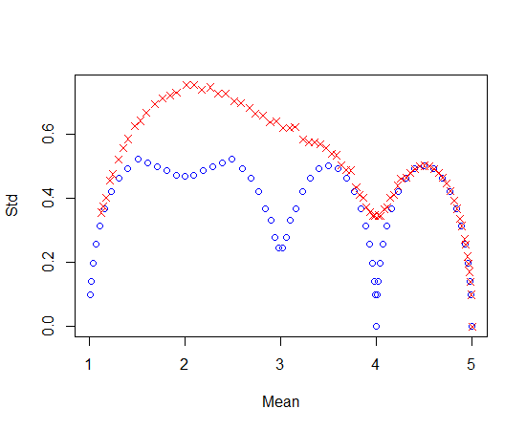

Figure 1 Relation between the standard deviation and mean of notes using the threshold stated above (Red crosses: Std. on the underlying continuous variable is 8. Blue circles: Std. on the underlying continuous variable is 4.)

Table 5 List of characteristics shown in figure 2 together with applied symbol and average standard deviation within varieties

|  |  |  |  |  |  |
| --- | --- | --- | --- | --- | --- |
| UPOV no | Description | Symbol in figure 2 to 4 | Average standard deviationa | Average coefficient of concentration | Applied notes |
| 12 | Ear: Density |  | 0.33 | 0.18 | 2, 3, 4 ,5 ,6 ,7 ,8 |
| 15 | Awns of scours at tip of ear: Length |  | 0.26 | 0.20 | 3, 4 ,5 ,6 ,7 |
| 17 | Apical rachis segment: Hairiness of convex surface |  | 076 | 0.61 | 1, 2, 3, 4 ,5 ,6 ,7, 8, 9 |
| 18 | Lower glume: Shoulder width |  | 0.41 | 0.26 | 3, 4, 5, 6, 7 |
| 19 | Lower glume: Shoulder shape |  | 0.59 | 0.35 | 3, 4, 5, 6, 7 |
| 20 | Lower glume: Beak length |  | 0.35 | 0.20 | 1, 2, 3, 4, 5, 6, 7 |
| 21 | Lower glume: Beak shape |  | 0.56 | 0.25 | 1, 3, 5, 7 |
| 23 | Lower lemma: Beak shape |  | 1.25 | 0.64 | 1, 3, 5, 7, 9 |

a) Approximate as it assume interval scaled. Based on 100 observations per variety

15. Figure 2 shows that such relationship exists although the relationship is not clear for all characteristics. The clearest relations were seen for 12, 15, 18, 20 and 21 while the least clear relations were seen for characteristic 17 and 23. There seem to be a tendency that the clearest relations were found for the characteristics where the variation within variety was small (Table 5) while the least relations were found for characteristics where the variation within variety was large. For the characteristics where a clear relationship was found the smallest standard deviations was found when the mean note for the variety was close to one of the recorded values.

16. Similar results are found when using the coefficient of concentration (Figure 3), although the two measures are not strongly correlated for all characteristics (Figure 4).

17. The measure of heterogeneity for a variety depends much on the mean note (APPENDIX 2). A possible method for heterogeneity for such characteristics could be to judge if any of the plants are considered as an off-type – either directly when accessing the characteristic or based on figures such as those in appendix 2.

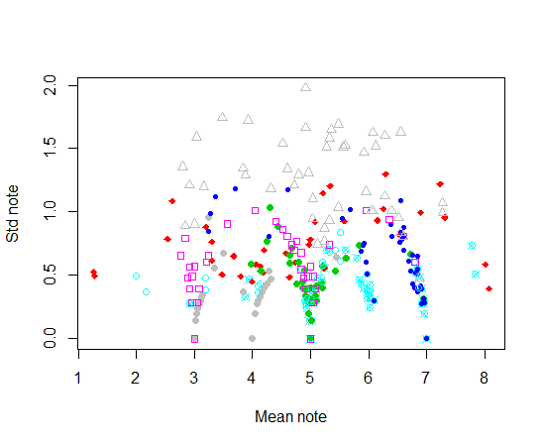

Figure 2 Relation between standard deviations and means for 8 characteristics of wheat (see Table 5 for a list of the characteristics)

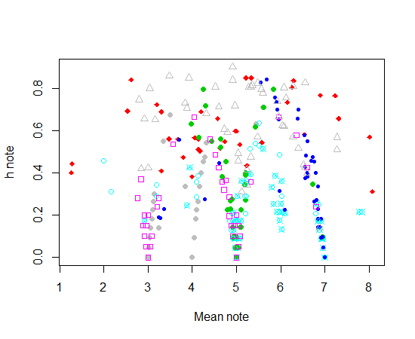

Figure 3 Relation between the coefficients of concentration, h, and means for 8 characteristics of wheat (see Table 5 for a list of the characteristics)

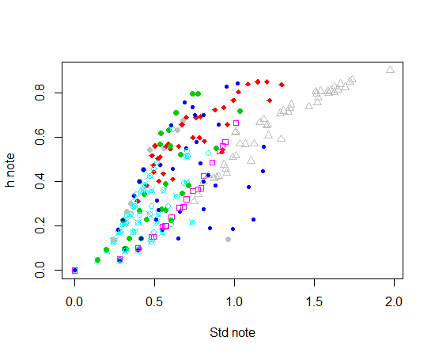

Figure 4 Relation between the coefficients of concentration, h, and means for 8 characteristics of wheat (see Table 5 for a list of the characteristics)

Discussion

18. The above examples clearly show that the uniformity for visually accessed characteristics in these examples depended on the mean or more correctly on where it is located on the underlying scale and where the thresholds are located. However, the results depend very much the assumption that the notes are formed as a result of an underlying continuous variable.

19. For ordered data it is expected that the standard deviation or the coefficient on the underlying variable will be a good measure of heterogeneity, but this is unknown. Unfortunately, the standard deviation (or the coefficient of concentration) on the note is not directly related to the standard deviation on the underlying variable, because the standard deviation and other measures of heterogeneity depend much on where the mean of the variety on the underlying variable is located relative to how the notes are defined. The two measures of uniformity used here showed similar relation with the mean note.

20. The most unfavourable (for variety) situation when the variety mean value is very close to the note threshold can be partly overcome by amalgamation of two categories with the largest observations before calculation any measure of variation such as for example coefficient of concentration. After amalgamation, two varieties with the same dispersion but with different location (with respect to the threshold) of the mean value will receive approximately the same measure of uniformity. As an example this has been done for the data in Table 4. The results are shown in Table 6. Variety *B* had large values for both the standard deviation and the coefficient of concentrations because its mean value was located right at the border between to notes. After merging, this variety had smaller values and thus could not be rejected as non-uniform just because it happened to be close to the border between two notes. However, variety *C*, which measure of uniformity should be comparable to that of variety A, seemed to be much more heterogenic than variety *A* after merging.

Table 6 Measures of uniformity for artificial varieties with notes based on the parameters shown in Table 3 and distribution of notes shown in Table 4 before and after merging the two most frequent notes

|  |  |  |  |  |  |
| --- | --- | --- | --- | --- | --- |
| Variety | True Std. Dev. on continuous variable | Std. Dev. on Note.  Recorded | Coefficient of concentration, h. Recorded | Std. Dev. on Note.  Originala | Coefficient of concentration, h. Merged |
| A | 4 | 0.31 | 0.24 | 0.010 | 0.0003 |
| B | 4 | 0.52 | 0.63 | 0.080 | 0.0167 |
| C | 4 | 0.25 | 0.15 | 0.173 | 0.0786 |
| D | 4 | 0.00 | 0.00 | 0.000 | 0.0000 |
| E | 8 | 0.52 | 0.51 | 0.173 | 0.0786 |
| F | 8 | 0.72 | 0.77 | 0.363 | 0.3219 |
| G | 8 | 0.08 | 0.02 | 0.000 | 0.0000 |

a) After merging the notes were renumbered (1, 2, 3,…) before calculating the standard deviation.

21. For nominal scaled characteristics it is expected that the uniformity of the varieties also will depend on the note and on how the note are defined.

22. As we do not know the underlying scale and where the thresholds are defined indirectly the above examples show that it may be difficult to decide how to define uniformity for visually accessed characteristics.

Appendix 1 Coefficient of concentration

23. The - so called - coefficient of concentration hi (probably the better name for it is the coefficient of diffuseness) is calculated according to the formula (1) and can be treated as an alternative measure of uniformity, see also TWC/13/3

hi =  (1)

where k stands for the number of “effective” categories, xij is the observation (fraction, number of plants) for i-th variety in j-th note (category). The term “effective category” denotes category with at least one observation different from zero for at least one variety.

24. The main advantage of this coefficient is that it takes values from the range from 0 (perfect uniformity – all observations received the same note) to 1 (the same numbers (fractions) of observations in all notes). As crop experts know from their experience which variety is more uniform than the other, so – at least within the same trial – they can compare coefficient of concentration of new variety with those of known varieties to have some information on degree of uniformity of new variety.

Appendix 2 Distribution of notes for each characteristic

25. In the figures to follow the length of the lines indicates the relative number of observation (out of 50) for each plot that had the actual note. The colour of the line indicates the variety (so if two neighbouring lines have the same colour they belong to the same variety).

26. So as an example the bottom 2 lines of the figure for characteristic 12 shows that these two plots come from the same variety – as they both have the same colour (grey). In both plots most plants had note 7, but a few plants had note 5. The next two lines also belong to the same variety (red lines) and most of the plants had note 6 with a few plants in both replicates had note 5 and 7 and in one of the replicates a single plant had note 4. This single plant with note 4 may be considered as an off-type.

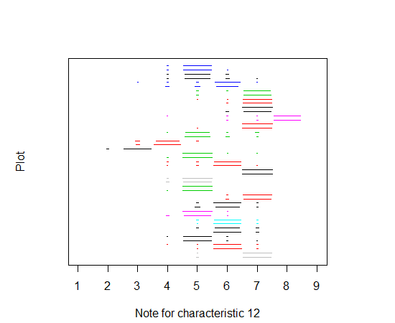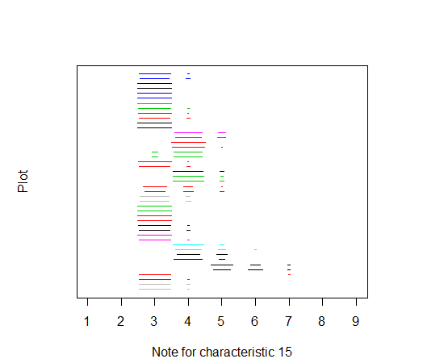

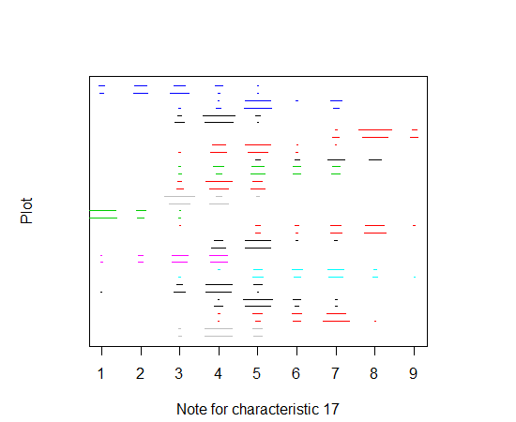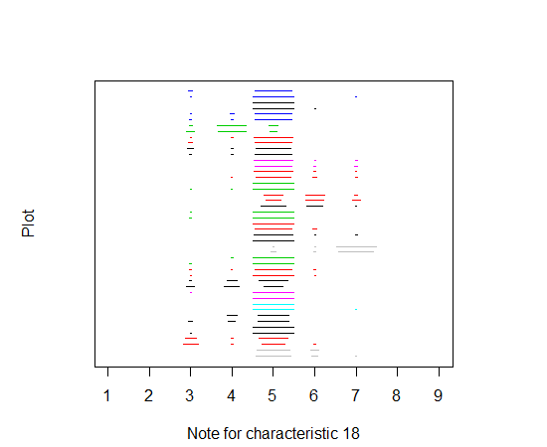

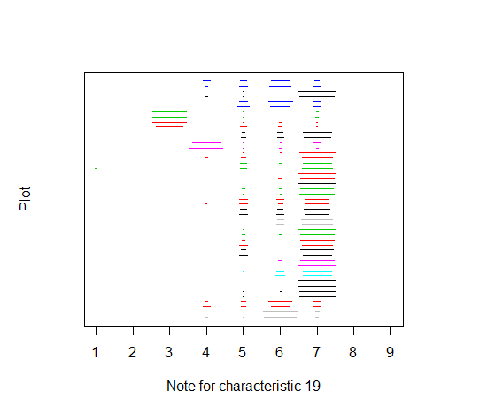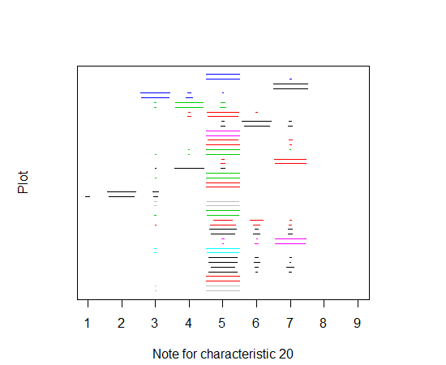

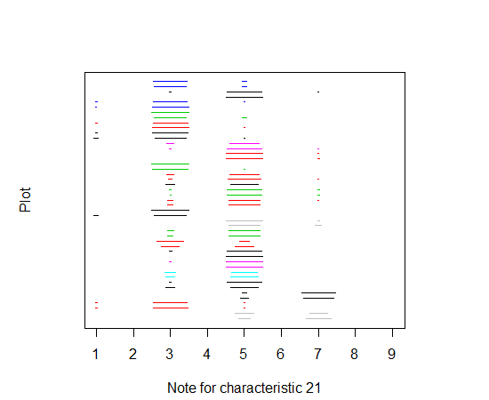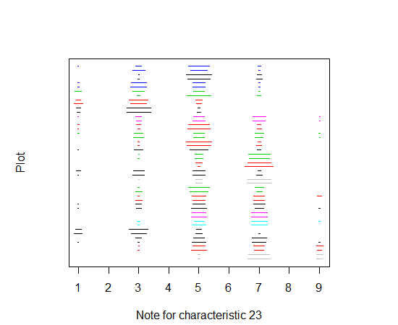

[Annex III follows]

A COMPARISON OF THE RESULTS ON DISTINCTNESS DECISION BETWEEN THE COYD METHOD FOR ORDINAL CHARACTERISTICS AND CHI-SQUARE TEST

**Introduction**

1. During its 31st meeting in 2013, the TWC agreed that it would be beneficial to further develop the method for multinomial data and to compare the decisions made using the two methods Chi-square test and COYD method for multinominal characteristics,based on real data from Finland and the United Kingdom (Timothy, Red Clover and Meadow Fescue: growth habit). (See report TWC/31/32 page 7.)
2. A Comparison of the results of the COYD method for ordinal characteristics and Chi-square test on distinctness decision was made using the same Meadow fescue growth habit data from Finland. The idea of the comparison is to consider if the COYD for ordinal characteristics separates more variety pairs than the Chi-square test. As an expert from Denmark stated in the Memorandum (TC/50/28, Annex, page 2.) ‘The Chi-square test does not depend on the scale of measurements, so data recorded on the nominal scale and ordinal scale are treated the same way and because the Chi-square test ignores the ordering of notes on the ordinal scale. The proposed new method for characteristics recorded on the ordinal scale takes this ordering into account. The proposed method is therefore expected to be more effective if the data are recorded on the ordinal scale than if they are recorded on the nominal scale.’
3. Introduction to different types of data and scale levels, including ordinal scaled quantitative data, can be found in the revision document for TGP/8 ‘Data to be recorded’ (latest version TC/50/5 Annex II). Detailed analysis of COYD method for ordinal characteristics by expert from Denmark in TC/49/32 Annex II, pages 4 to 10). Pearson’s chi-square test is explained in TGP/8/1 Part II, page 85.
4. The characteristic ‘Plant: growth habit at inflorescence emergence’ (TG/39/8 Meadow fescue (*Festuca pratensis* Huds and Tall fescue *F.arundinacea* Schreb.) is a visually observed characteristic TG/39/8 explains the characteristic ‘The growth habit should be assessed visually from the attitude of the leaves of the plant as a whole. The angle formed by the imaginary line through the region of greatest leaf density and the vertical should be used.’ . The observations for this data were done from single plants and the observer gave each one a note.

**Criteria for distinctness in the Chi-square test**

1. The p-value used in the Chi-square test was 0,05. Yates correction was not used, because the amount of classes in the comparison was always over two.
2. The order of direction of the data was checked before distinctness decision, i.e. the growth habit of the candidate has to be constantly more erect or more prostrate than the compared reference in at least two of the three years used in the analysis. If the data compared between variety pair had different directions in different years, the result was not distinct even though the calculated p-values were under 0,05 in both of the years.
3. The recommended criteria for Chi-square test was used (Ranta et al. 1994). Therefore 20% of the calculated expected frequencies shouldn’t go under 5 and the expected frequencies should be over 1. Due to this, some of the classes had to be fused together. It was usual to have four to three classes in the analysis, because otherwise these criteria would not have met. Especially more extreme classes 1 to 3 and 6 to 9 had only few observations (see TC/49/32, Annex II, page 8).
4. The analyses for Chi-square test were done using Excel software for Windows.

**Results and conclusions**

1. Candidate A could be separated from 6 reference varieties with Chi-square test (varieties F,H,K,P,W and 1). Candidate B was separated from 3 reference varieties (F,P and 1). COYD method for ordinal characteristics separated respectively 11 reference varieties from Candidate A (varieties E,F,H,K,N,P,U,V,Z,1 and 3) and 10 reference varieties from Candidate B (varieties E,F,H,K,N,P,U,V,Z and 3). In average, the COYD method separated 20% more reference varieties than the Chi-square test. For Candidate A, all the reference varieties separated by Chi-square test except one (candidate W) were separated also by COYD method. For Candidate B there was also one reference variety (candidate 1) separated only by Chi-square test.
2. Problem of the analysis of growth habit data with Chi-square test is the low number of individuals in some of the classes. In 14 cases the p-values in comparisons with Candidate A were under 0,05, but the expected frequencies didn’t fulfill the requirements (either over 20% of the expected frequencies were under 5 or some of the values were under 1). Comparisons with Candidate B showed 5 similar situations (marked as (* in the Table 1. in the Annex). This low number of observations in some classes can lead into situation where the candidate variety can’t be stated as distinct, because the requirements of the statistical analysis are not fulfilled, though the compared varieties could be distinct.
3. The comparison of the results of COYD method for ordinal characteristics and Chi-square test for meadow fescue growth habit data showed that COYD method for ordinal characteristics can separate more varieties and therefore the use of COYD method with ordinal characteristic would enhance decisions on distinctness.
4. It would be useful to have same type of comparison between COYD method for multinomial characteristics and Chi-square test with other species and characteristics.

**References**

Ranta, E., Rita, H. & Kouki J. 1994. Biometria. Tilastotiedettä ekologeille. Yliopistopaino, Helsinki.

UPOV. TGP/8/1. Trial Design and Techniques Used in the Examination of Distinctness, Uniformity and Stability. 2010

UPOV TG/39/8 Guidelines for the conduct of tests for distinctness, uniformity and stability. Meadow fescue (*Festuca pratensis* Huds.), Tall fescue (*Festuca arundinacea* Schreb.). Geneva 2002.

TC/50/28 REVISION OF DOCUMENT TGP/8: PART II: SELECTED TECHNIQUES USED IN DUS EXAMINATION, NEW SECTION: STATISTICAL METHODS FOR VISUALLY OBSERVED CHARACTERISTICS, January 30, 2014.

TC/49/32 REVISION OF DOCUMENT TGP/8: PART II: SELECTED TECHNIQUES USED IN DUS EXAMINATION, NEW SECTION: STATISTICAL METHODS FOR VISUALLY OBSERVED CHARACTERISTICS, February 4, 2013.

**Annex. Table 1.** P-values for variety pair comparisons and information of distinctness by Chi-square test and COYD for ordinal characteristics.

|  |  |  |  |  |  |  |  |  |  |  |
| --- | --- | --- | --- | --- | --- | --- | --- | --- | --- | --- |
| Ref. Variety | **CANDIDATE A** | |  | **Distinct by Chi-square test** | **Distinct by COYD** | **CANDIDATE B** | |  | **Distinct by Chi-square test** | **Distinct by COYD** |
| **2010** | **2011** | **2012** | **2010** | **2011** | **2012** |
| cand A | - | - | - | *no* | *no* | 0,02(* | 0,38 | 0,31 | *no* | *no* |
| cand B | 0,02(* | 0,53 | 0,31 | *no* | *no* | - | - | - | *no* | *no* |
| C | 0,68 | 0,16 | 0,86 | *no* | *no* | 0,31 | 0,12 | 0,67 | *no* | *no* |
| D | 0,24 | 0,04(* | 0,06 | *no* | *no* | 0,25 | 0,74 | 0,88 | *no* | *no* |
| E | 0,003 | 0,07 | 0,07 | *no* | **D** | 0,0003 | 0,46 | 0,09 | *no* | **D** |
| F | 0,04(* | **0,0001** | **0,002** | **D** | **D** | 0,74 | 0,002 | 0,005 | **D** | **D** |
| G | 0,01 | 0,64 | 0,06 | *no* | *no* | 0,14 | 0,80 | 0,02 | *no* | *no* |
| H | **0,00002** | 0,0003(* | **0,03** | **D** | **D** | 0,0006(* | 0,16 | 0,01 | *no* | **D** |
| I | 0,40 | 0,77 | 0,85 | *no* | *no* | 0,01 | 0,33 | 0,66 | *no* | *no* |
| J | 0,34 | 0,21 | 0,16 | *no* | *no* | 0,01 | 0,17 | 0,68 | *no* | *no* |
| K | 0,13 | **0,001** | **0,04** | **D** | **D** | 0,43 | 0,09 | 0,07 | *no* | **D** |
| L | 0,14 | 0,40 | 0,27 | *no* | *no* | 0,15 | 0,76 | 0,65 | *no* | *no* |
| M | 0,18 | 0,33 | 0,21 | *no* | *no* | 0,39 | 0,07 | 0,95 | *no* | *no* |
| N | 0,09 | 0,0005 | 0,07 | *no* | **D** | 0,28 | 0,04(* | 0,03 | *no* | **D** |
| O | 0,007 D | 0,005(* | 0,02 D | *no* | *no* | 0,02 | 0,65 | 0,26 | *no* | *no* |
| P | 0,001(* | **0,0004** | **0,01** | **D** | **D** | 0,001 | 0,09 | 0,002 | **D** | **D** |
| Q | 0,01 | 0,51 | 0,15 | *no* | *no* | 0,03 | 0,42 | 0,48 | *no* | *no* |
| R | 0,26 | 0,54 | 0,08 | *no* | *no* | 0,53 | 0,42 | 0,17 | *no* | *no* |
| S | 0,007(* | 0,15 | 0,16 | *no* | *no* | 0,03 | 0,24 | 0,78 | *no* | *no* |
| T | 0,22 | 0,001 | 0,85 | *no* | *no* | 0,46 | 0,46 | 0,69 | *no* | *no* |
| U | 0,0008 | 0,01(* | 0,08 | *no* | **D** | 0,007 | 0,58 | 0,18 | *no* | **D** |
| V | 0,30 | 0,004(* | 0,40 | *no* | **D** | 0,66 | 0,39 | 0,06 | *no* | **D** |
| W | 0,15 | **0,03** | **0,04** | **D** | *no* | 0,24 | 0,22 | 0,13 | *no* | *no* |
| X | 0,02(* | 0,009 (* | 0,13 | *no* | *no* | 0,01(* | 0,67 | 0,45 | *no* | *no* |
| Y | 0,47 | 0,35 | 0,14 | *no* | *no* | 0,20 | 0,63 | 0,82 | *no* | *no* |
| Z | 0,04(* | 0,02(* | 0,04 | *no* | **D** | 0,01(* | 0,37 | 0,01 | *no* | **D** |
| 1 | **0,004** | **0,0001** | **0,02** | **D** | **D** | 0,02 | 0,14 | 0,03 | **D** | *no* |
| 2 | 0,39 | 0,15 | 0,14 | *no* | *no* | 0,39 | 0,43 | 0,22 | *no* | *no* |
| 3 | 0,32 | 0,22 | 0,10 | *no* | **D** | 0,04 | 0,32 | 0,72 | *no* | **D** |
| 4 | 0,17 | 0,01 | 0,09 | *no* | *no* | 0,13 | 0,47 | 0,46 | *no* | *no* |
| 5 | 0,05(* | 0,27 | 0,02 | *no* | *no* | 0,73 | 0,17 | 0,47 | *no* | *no* |
|  | **Explanations for the table** | | | |  |  |  |  |  |  |
|  | **(\*** p-values which were under 0,05, but over 20 % of the the expected frequencies | | | | | | | | |  |
|  | were under 5 or one or more of the expected frequencies were below 1 | | | | | | | |  |  |
|  | **d**  the direction of the difference between varieties was not constant between years | | | | | | | | |  |
|  | **highlighted** p-values in shaded cells are p-values which separated varieties, **D** is for distinct | | | | | | |  |  |  |

[End of Annex III and of document]