E
TWC/33/24
ORIGINAL: English
DATE: June 12, 2015
INTERNATIONAL UNION FOR THE PROTECTION OF NEW VARIETIES OF PLANTS
Geneva
Technical working party on automation and computer programs
Thirty-Third Session
Natal, Brazil, June 30 to July 3, 2015
HAND-HELD DATA CAPTURE SYSTEMS IN FRANCE AND GERMANY
Document prepared by experts from Germany and France
Disclaimer: this document does not represent UPOV policies or guidance

Introduction

From time to time hard and software components of hand-held data capture systems have to be upgraded. There is an UPOV document which describes the actual situation in different member states (see document TWC/32/27 “Updated Survey on Hand-Held Data Capture Device”).

The aim of this document is to inform participants of TWC meeting about new developments in Germany regarding to hand-held data capture systems, to compare the French and the German system and to offer an English version of the software.

The French system: SIRIUS

The hand-held data capture system of French colleagues “SIRIUS“ was described in document TWC/27/17 “Hand-Held Data Capture System: SIRIUS”. It is a highly developed system and is in use in many countries. There are a lot of useful functions and a user-friendly interface. The system was developed by using “WINDEV” as programming language and a relational database “HYPERFILE”. The software works on all windows platforms. The contact person is Christophe Chevalier, a member of the TWC.

The German system

Up to 2012 German colleagues worked with hand-held data loggers which had proprietary operating systems. In 2013 there was for the first time a data logger on the market comparable with the old ones but using a windows mobile operating system. In the past the Bundessortenamt developed an application program for these data loggers in co-operation with a private company based on programming language “C-Easy”. There is an interface to exchange data with the German DUS program which can use to import and to export different types of data.

German DUS experts wanted to transfer the same application program on the new platform in order to minimize their training time and costs. So IT experts of the Bundessortenamt rewrote the program using programming language Visual Studio 2008 (.NET).

Starting in 2013, we have been using a first version successfully and we developed a second version which has a user interface in English in 2015. The contact person is Thomas Drobek, a member of the TWC.

Comparison of French and German system

In the following table the French and the German system are compared.

Category | French system | German system | Remarks
Programming language | WINDEV | .NET Compact
Windows compatible | Yes | Yes
English version | Yes | Yes
Changing order of characteristics on display | Yes | Yes | The order is defined by the selection (click-order)
Definition of data format for each characteristic | Yes | Yes
Definition of lower and upper limit of expressions | Yes | Yes
Definition of input type of each characteristic | Yes | Yes | No input,  Not displayed,  Day of month,  Reference value
Definition of filter | Yes | No | To define accessible cells
Parameter update in the office and/or in the field | Yes | Yes
User friendly interface to handle many notes | Up to 250,000 | Yes  1000*5*3*20=300.000 (plot-no.* No. of characteristics * No. of repl. * No. of single plants)
Rules-processing | Yes | Yes | Dependence between two characteristics
Note-mode | Yes | Yes | fast typing without enter key (only press one key)
Hardware | Panasonic  Toughbook CF 19  Toughbook CF U1 | ACD  M210 Pocket-PC
Screen | 10,1” | 3,5”
Pixel |  | 240 x 320
Weight | CF-U1: 1060g | 550g
Resistance | IP65 | IP54
Application area | DUS, VCU | DUS
Contact person | Christophe Chevalier | Thomas Drobek

Screenshots German System

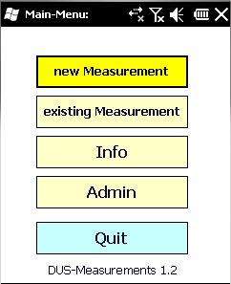 | 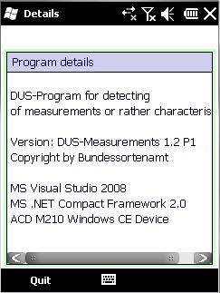
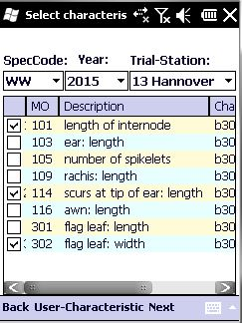 | 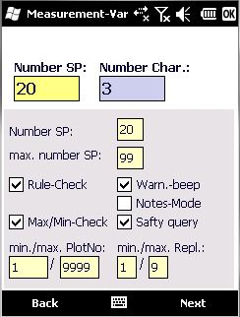
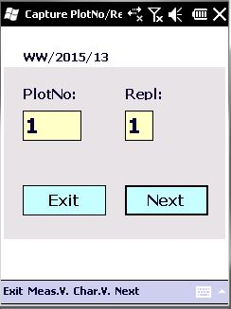 | 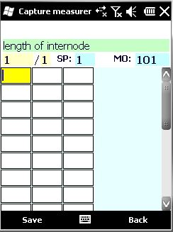
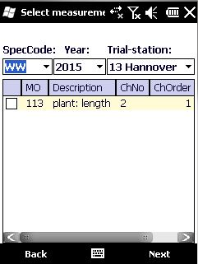 | 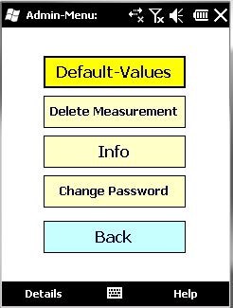

Database-Model German System
A table with all database table and column names is included in Annex.

Images of data loggers in use

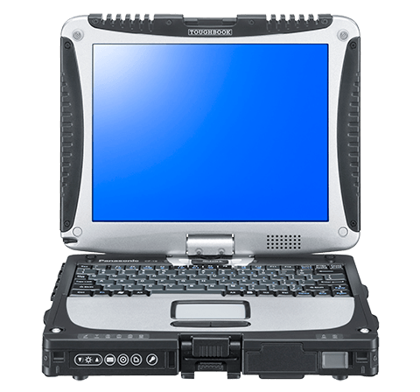 Panasonic Toughbook 19 using in France

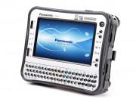 Panasonic Toughbook CF-U1 using in France

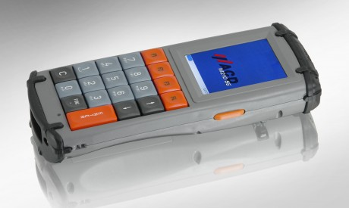 ACD M210 Pocket-PC using in Germany

TABLE OF DATABASE STRUCTURE

database | table | column name | datatype | length | description
masterdata | duschar | speccode | nchar | 3 | species code
masterdata | duschar | charact | nchar | 4 | character
masterdata | duschar | measobj | int | 4 | object of measurement
masterdata | duschar | charno | int | 4 | number of character
masterdata | duschar | mrule | nchar | 20 | rule of measurement
masterdata | duschar | mob_min | int | 4 | minimum value
masterdata | duschar | mob_max | int | 4 | maximum value
masterdata | duschar | descript | int | 4 | description
masterdata | standard | minmaxflag | nchar | 1 | minimum/maximum flag
masterdata | standard | mruleflag | nchar | 1 | rule of measurement flag
masterdata | standard | warnflag | nchar | 1 | warning flag
masterdata | standard | safeflag | nchar | 1 | safe flag
masterdata | standard | nosp | int | 4 | number of single plants
masterdata | standard | maxsp | int | 4 | maximal number of single plants
masterdata | standard | noteflag | nchar | 1 | note flag
masterdata | standard | minpltno | int | 4 | minimal plot number
masterdata | standard | maxpltno | int | 4 | maximal plot number
masterdata | standard | minreplno | int | 4 | minimal replication number
masterdata | standard | maxreplno | int | 4 | maximal replication number
masterdata | standard | zoom | int | 4 | zoom
masterdata | measurements | measno | int | 4 | measurement number
masterdata | measurements | speccode | nchar | 3 | species code
masterdata | measurements | year | int | 4 | year
masterdata | measurements | trialst | int | 4 | trialstation
masterdata | measurements | nosp | int | 4 | number of single plants
masterdata | measurements | no_sp | int | 4 | number of single plants exception
masterdata | measurements | maxsp | int | 4 | maximal number of single plants
masterdata | measurements | minmaxflag | nchar | 1 | minimum/maximum flag
masterdata | measurements | minpltno | int | 4 | minimal plot number
masterdata | measurements | maxpltno | int | 4 | maximal plot number
masterdata | measurements | minrepl | int | 4 | minimal replication number
masterdata | measurements | maxrepl | int | 4 | maximal replication number
masterdata | measurements | mruleflag | nchar | 1 | rule of measurement flag
masterdata | measurements | noteflag | nchar | 1 | note flag
masterdata | measurements | safeflag | nchar | 1 | safe flag
masterdata | measurements | warnflag | nchar | 1 | warning flag
masterdata | measurements | no_char | int | 4 | number of characters
masterdata | trialstnam | trialstno | int | 4 | number of trial station
masterdata | trialstnam | trialstname | nchar | 20 | name of trial station
masterdata | measchar | measno | int | 4 | measurement number
masterdata | measchar | charorder | int | 4 | character order
masterdata | measchar | measobj | int | 4 | object of measurement
masterdata | measchar | charno | int | 4 | number of character
masterdata | measchar | descript | nchar | 75 | description
masterdata | measchar | mob_min | int | 4 | minimum value
masterdata | measchar | mob_max | int | 4 | maximum value
masterdata | measchar | mrule | nchar | 20 | rule of measurement
masterdata | measchar | charact | nchar | 4 | character
m-measurement | measurement | measno | int | 4 | measurement number
m-measurement | measurement | plotno | int | 4 | plot number
m-measurement | measurement | repl | int | 4 | replication number
m-measurement | measurement | sp | int | 4 | single plot
m-measurement | measurement | m001 | nchar | 4 | measurement 1
m-measurement | measurement | m002 | nchar | 4 | measurement 2
m-measurement | measurement | m003 | nchar | 4 | measurement 3
m-measurement | measurement | m004 | nchar | 4 | measurement 4
m-measurement | measurement | m005 | nchar | 4 | measurement 5
m-measurement | measurement | m006 | nchar | 4 | measurement 6
m-measurement | measurement | m007 | nchar | 4 | measurement 7
m-measurement | measurement | m008 | nchar | 4 | measurement 8
m-measurement | measurement | m009 | nchar | 4 | measurement 9
m-measurement | measurement | m010 | nchar | 4 | measurement 10
m-measurement | measurement | m011 | nchar | 4 | measurement 11
m-measurement | measurement | m012 | nchar | 4 | measurement 12
m-measurement | measorder | measno | int | 4 | measurement number
m-measurement | measorder | order | int | 4 | order
m-measurement | measorder | plotno | int | 4 | plot number
m-measurement | measorder | repl | int | 4 | replication number
archivflag | archivflag | measno | int | 4 | measurement number
archivflag | archivflag | archivflag | char | 1 | archive flag

[End of Annex and of document]

