|  |  |  |
| --- | --- | --- |
|  |  | E  TWC/32/7  **ORIGINAL:** English  DATE: May 30, 2014 |
| INTERNATIONAL UNION FOR THE PROTECTION OF NEW VARIETIES OF PLANTS | | |
| Geneva | | |

Technical working party ON AUTOMATION AND COMPUTER PROGRAMS

Thirty-Second Session  
Helsinki, Finland, June 3 to 6, 2014

Exchangeable software

Document prepared by the Office of the Union  
  
Disclaimer: this document does not represent UPOV policies or guidance

The purpose of this document is to report on developments concerning exchangeable software and to present a proposal concerning the development of a new information document.

The following abbreviations are used in this document:

CAJ: Administrative and Legal Committee

TC: Technical Committee

TWC: Technical Working Party on Automation and Computer Programs

TWPs: Technical Working Parties

The structure of this document is as follows:

i. Proposal to develop a new information document 1

II. Review of document UPOV/INF/16 “Exchangeable Software” 3

Software proposed for inclusion in document UPOV/INF/16 “Exchangeable software” 3

SIVAVE software 3

SISNAVA software 3

Information on use by members 4

iII. Translation of SOFTWARE IN document UPOV/INF/16/3 4

AIM software 4

Information System (IS) used for Test and Protection of Plant Varieties in the Russian Federation 4

i. new information document

The CAJ, at its sixty-eighth session, held in Geneva on October 21, 2013, agreed with the conclusions of the TC, at its forty-ninth session, that the title of document UPOV/INF/16 “Exchangeable Software” and the text of Section 1 “Requirements for exchangeable software” should remain unchanged on the basis that the document concerns software that had been developed or customized by a member of the Union for UPOV purposes; and that it would be useful for the TC to seek to develop a separate information document that would allow members of the Union to provide information on the use of non-customized software and equipment (e.g. data loggers) that was used by members of the Union (see document CAJ/68/10 “Report on the Conclusions”, paragraph 30).

The TC at its fiftieth session, held in Geneva, April 7 to 9, 2014, and the CAJ, at its sixty-ninth session, held in Geneva, April 10, 2014, agreed to propose new information document (UPOV/INF/22 “Software and equipment used by members of the Union”) for adoption by the Council at its forty-eighth ordinary session, to be held in Geneva on October 16, 2014, on the following basis (see document TC/50/8, paragraph 6, TC/50/36 “Report on Conclusions”, paragraph 110, and CAJ/69/12 “Report on Conclusions”, paragraph 39).

|  |  |
| --- | --- |
| Title | “Software and equipment used by members of the Union” (document UPOV/INF/22) |
| 1. Requirements | * 1. Members of the Union are invited to provide information on software/equipment for inclusion on the basis that it has been used for the purposes of plant variety protection.   2. Information on the following should be provided by any member of the Union proposing software/equipment for inclusion in this document:   Title of software/equipment  Function (brief summary)  Source and contact details  Category(ies) of use (see section 3, below) |
| 2. Procedure for inclusion of software/equipment | 2.1 Software/equipment proposed for inclusion in this document by members of the Union is, in the first instance, presented to the TC.    2.2 The TC will decide whether to:   1. propose to include the information in the document; 2. request further guidance from other relevant bodies (e.g. CAJ and TWPs); or 3. propose not to include the information in the document.   2.3 In the case of a positive recommendation by the TC and, subsequently by the CAJ, the software/equipment will be listed in a draft of the document, to be considered for adoption by the Council. |
| 3. Categories of software/equipment | To assist users, information on software/equipment is provided in the following categories:  Administration of applications  On-line application systems  Variety denomination checking  DUS trial design and data analysis  Data recording and transfer  Image analysis  Biochemical and molecular data |
| 4. Information on use by members of the Union | * 1. A circular is issued to members of the Union on an annual basis, inviting them to provide information on their use of the software/equipment included in this document.   2. The information on software/equipment use by members of the Union is indicated in the columns “Member(s) of the Union using the software/equipment” and “Application by user(s)”. With regard to the indication of “Application by user(s)”, members of the Union can indicate, for example, crops or types of crop for which the software/equipment is used. |

Subject to adoption of document UPOV/INF/22 by the Council, the Office of the Union will issue a circular to the designated persons of the members of the Union in the TC, inviting them to provide information regarding non-customized software and equipment used by members of the Union for inclusion in the document.

*The TWC is invited to note that:*

*(a) document UPOV/INF/22 “Software and equipment used by members of the Union” will be presented for adoption by the Council at its forty-eighth ordinary session, to be held in* *Geneva on October 16, 2014, as set out in paragraph 5; and*

*(b) subject to adoption of document UPOV/INF/22 by the Council at its forty-eighth ordinary session, a circular will be issued to the designated persons of the members of the Union in the TC, inviting them to provide information regarding non-customized software and equipment used by members of the Union, as appropriate.*

# II. Review of document UPOV/INF/16 “Exchangeable Software”

## Software proposed for inclusion in document UPOV/INF/16 “Exchangeable software”

### SIVAVE software

The TWC, at its thirty-first session, held in Seoul, June 4 to 7, 2013, considered the SIVAVE software proposed by Mexico, which allows for the real-time dissemination of the status of proceedings concerning applications for breeders’ rights. It agreed that the SIVAVE software was suitable for inclusion in document UPOV/INF/16 (see document TWC/31/30, Annex page 7, and TWC/31/32 “Report”, paragraph 72).

The TC, at its fiftieth session, and the CAJ, at its sixty-ninth session, agreed that a draft revision of document UPOV/INF/16/3 concerning the inclusion of the SIVAVE software should be presented for adoption by the Council, at its forty-eighth ordinary session, to be held in Geneva on October 16, 2014, as reproduced in Annex I to this document (see document TC/50/36, paragraph 114, CAJ69/12, paragraph 41 and 42).

### 

### SISNAVA software

The TWC, at its thirty-first session, considered the SISNAVA software developed by Mexico, which computes difference in characteristics between varieties. It requested Mexico to provide further information on the SISNAVA software to clarify the method of determination for the crop specific limits of acceptance (sum of differences), including the role of the crop experts in this process, to be presented to the TWC at its thirty-second session (see document TWC/31/30, Annex page 1, and TWC/31/32 “Report”, paragraph 73).

Annex V to this document presents further information on the SISNAVA software “SISNAVA as an exchangeable software proposed by SNICS, from Mexico”, prepared by an expert from Mexico.

*The TWC is invited to:*

*(a) note that a revision of document UPOV/INF/16/3 concerning the inclusion of the SIVAVE software will be presented for adoption by the Council at its forty-eighth ordinary session, to be held on October 16, 2014, as prepared in Annex I of this document; and*

*(b) consider the presentation to be made by Mexico on the SISNAVA software, as presented in Annex V to this document.*

## Information on use by members

The TC approved the revision of document UPOV/INF/16 concerning the inclusion of information on the use of software by members of the Union to include the information received by the Office of the Union (see document TC/50/36 paragraph 116, and TC/50/8 Annex III as reproduced in Annex II to this document).

The CAJ agreed the proposed revision of document UPOV/INF/16 concerning the inclusion of information on the use of software by members of the Union as a basis for its adoption by the Council at its forty‑eighth ordinary session, to be held on October 16, 2014 (see document CAJ/69/12 paragraph 44).

*The TWC is invited to note that* the TC and CAJ agreed with the proposed revision of document UPOV/INF/16 concerning the inclusion of information on the use of software by members of the Union, as presented in Annex II to this document.

# iII. Translation of SOFTWARE IN document UPOV/INF/16/3

## AIM software

The user interfaces and user manual of the AIM software have been translated into English by the Office of the Union and have been verified by the expert from France.

The TC, at its fiftieth session, and the CAJ, at its sixty-ninth session, noted that an expert from France would make a presentation on the AIM software at the thirty‑second session of the TWC, based on the English translation of the software requirements (see document TC/50/36 “Report on the Conclusions”, paragraph 118, and CAJ/69/12 “Report on the Conclusions”, paragraph 45).

It is recalled that an expert from France presented the AIM software at the thirtieth session of the TWC (see document TWC/30/31). Annex III to this document contains the cover page, preface and the contents of the user manual of the AIM software in English. A complete copy of the user manual is available from the UPOV website at: <http://upov.int/meetings/en/details.jsp?meeting_id=31703>.

## Information System (IS) used for Test and Protection of Plant Varieties in the Russian Federation

With regard to the possible translation of the “Information System (IS) used for Test and Protection of Plant Varieties in the Russian Federation”, it was agreed by the CAJ, at its sixty-eighth session, held on October 21, 2013, that the Office of the Union should arrange a telephone meeting in Russian with the IT expert of the Russian Federation in order to clarify translation requirements (see document CAJ/68/10 “Report on the Conclusions”, paragraph 32).

A telephone meeting in Russian with an IT expert of the Russian Federation was organized by the Office of the Union on December 3, 2013, in order to clarify translation requirements for the “Information System (IS) used for Test and Protection of Plant Varieties in the Russian Federation” software. It was concluded from the meeting that the translation of the user interfaces of the software would be technically very difficult as the software is designed only to deal with data written in Russian language and, therefore, it would be necessary to rewrite the entire program of the software in order to create an English version of the user interfaces. It was also reported that a user manual that would be suitable for translation did not exist. However, it was proposed by the IT expert from the Russian Federation that some English screenshots be created for presentation to the TWC at its thirty-second session, in order to explain how the software works.

The TC, at its fiftieth session, agreed that selected screenshots in English of the software “Information System (IS) used for Test and Protection of Plant Varieties in the Russian Federation” be presented to the TWC at its thirty‑second session, in order to explain how the software worked requirements (see document TC/50/36 “Report on the Conclusions”, paragraph 120, and CAJ/69/12 “Report on the Conclusions”, paragraph 46). The selected screenshots in English of the software “Information System (IS) used for Test and Protection of Plant Varieties in the Russian Federation” prepared by an expert from the Russian Federation are attached as Annex V of this document.

*The TWC is invited to note:*

(a) the availability of the AIM User Guide in English; and

(b) the explanation of the software “Information System (IS) used for Test and Protection of Plant Varieties in the Russian Federation”, as provided in Annex IV of this document.

[Annexes follow]

**DRAFT**

SOFTWARE PROPOSED FOR INCLUSION IN DOCUMENT UPOV/INF/16 “EXCHANGEABLE SOFTWARE”

(Information provided by Mexico on February 25, 2013)

1. Administration of applications

|  |  |  |  |  |  |  |
| --- | --- | --- | --- | --- | --- | --- |
| Program name | Programming language | Function (brief summary) | Source & contact details | Condition for supply | Member(s) of the Union using the software | Application by user(s) |
| SIVAVE | Database:  Mysql 5.1  PHP  Version 2.5.9  Ajax.  Javascript.  Routines are integrated with Java Applets and several Java Archives (JARS).  Complements:  Zend Optimizer 3.3  Compilers:  Zend Studio  ScriptCase | Allows for the real-time dissemination of the status of proceedings concerning applications for breeders’ rights in Mexico. | Mexico:  E-mail: [enriqueta.molina@snics.gob.mx/](mailto:enriqueta.molina@snics.gob.mx/)  [eduardo.padilla@snics.gob.mx](mailto:eduardo.padilla@snics.gob.mx) | Written application and justification of need for use. | MX | All crops |

[Annex II follows]

PROPOSED Revision to document UPOV/INF/16 “EXCHANGEABLE SOFTWARE”

(Information regarding the use of the software provided by Croatia and Kenya in reply to Circular E-14/014: appears highlighted)

(a) Administration of applications

|  |  |  |  |  |  |  |  |
| --- | --- | --- | --- | --- | --- | --- | --- |
| Date added | Program name | Programming language | Function (brief summary) | Source & contact details | Condition for supply | Member(s) of the Union using the software | Application by user(s) |
|  | ZAJVKA | SQL Windows | Information on applications (name and address of applicants, proposed denomination, date of application etc) and registration (denomination, date of registration) | Russian Federation: State Commission of the Russian Federation for Selection Achievements Test and Protection, Valentin Sherbina, Chief of IT Department  E-mail: [gossort@gossort.com](mailto:gossort@gossort.com) | Only available in Russian | RU | all crops |

(b) On-line application systems

(c) Variety denomination checking

(d) DUS trial design and data analysis

|  |  |  |  |  |  |  |  |  |  |  |  |
| --- | --- | --- | --- | --- | --- | --- | --- | --- | --- | --- | --- |
| Date added | | Program name | Programming language | | | Function (brief summary) | Source & contact details | Condition for supply | Member(s) of the Union using the software | Application by user(s) | |
|  | DUSTNT | | | FORTRAN 90 | General program for analysis of data from DUS trials. Includes facilities for COY analysis and a wide range of multivariate analysis techniques | | United Kingdom: Dr. Sally Watson  Email: [sally.watson@afbini.gov.uk](mailto:sally.watson@afbini.gov.uk) |  | GB | | Herbage,  Pea (Field & Veg), Parsnip, Swede, Onion, Brussels Sprout, Winter Oilseed Rape, Sugar Beet, Faba Beans, Spring Oilseed Rape, Kale, Linseed |
| CZ | | Oilseed Rape, Grasses and Luzerne |
| EE | | Grasses and Legumes |
| VN | | Maize, Flowers, Rice, Tomato, Potato, Soybean, Vegetables, and other species |
| KE | | Maize |
|  | GAIA | | | Windev | Computes comparisons of varieties for management of reference collections | | France: Email:  [christophe.chevalier@geves.fr](mailto:christophe.chevalier@geves.fr) |  | FR | | Sorghum, Sugar Beet, Maize, Wheat, Barley, Oat, Rape, Sunflower, Triticale, Pea |
| HR | | Barley, Maize, Wheat, Soybean |
| CZ | | Maize, Wheat, Barley, Oat, and Pea |

(e) Data recording and transfer

|  |  |  |  |  |  |  |  |
| --- | --- | --- | --- | --- | --- | --- | --- |
| Date added | Program name | Programming language | Function (brief summary) | Source & contact details | Condition for supply | Member(s) of the Union using the software | Application by user(s) |
|  | SIRIUS | Windev | Hand-Held Data Capture Software | France: Email:  [christophe.chevalier@geves.fr](mailto:christophe.chevalier@geves.fr) |  | FR | Sorghum, Sugar Beet, Maize, Wheat, Barley, Oat, Rape, Sunflower, Triticale, Pea, Herbage |

(f) Image analysis

|  |  |  |  |  |  |  |  |  |  |  |
| --- | --- | --- | --- | --- | --- | --- | --- | --- | --- | --- |
| Date added | | Program name | Programming language | | Function (brief summary) | Source & contact details | | Condition for supply | Member(s) of the Union using the software | Application by user(s) |
|  | AIM | | | Windows | Image processing software | | France: E-mail: [christophe.chevalier@geves.fr](mailto:christophe.chevalier@geves.fr) |  | FR | rapeseed, sunflower, hydrangea, flax, peas, carrot, maize, winter wheat, orchids |

(g) Biochemical and molecular data

[Annex III follows]

## AIM USER GUIDE



**A.I.M.**

**User Guide**

Image Analysis

**j0305493Preface**

***AIM* facilitates** the processing of images, using third-party software (ImageJ).

***AIM* enables** you to: establish a framework for your studies (date, client, species, device);

carry out processing operations and obtain results (in one click);

archive the following in a database:

your series of images;

your processing operations (ImageJ macros);

your results files;

your individual measurements;

your clustered measurements (grouped by variety, image, etc.).

calculate new measurements (for example: convert pixels to

millimeters);

cluster results (by variety, image, series) and to present them (filtered,

in table format, in the form of a graph, for export into Excel,…).

***AIM* simplifies** processing operations for users by encapsulating them (automatic execution, one click) through the integration of history functions (traceability), rights management (user or super user), color management (UPOV, RHS, …..) and by displaying results in the form of a graph (curve, histogram).

***AIM* facilitates** multi-user, multi-workstation usage of the same project (study), as well as the sharing of processing operations (ImageJ macros) or results between partners (bodies, companies,).

The field of imaging is becoming an increasingly integral part of our studies and professional projects on a daily basis. The tools available on the market are frequently expensive and too specialized.

AIM will facilitate the processing of images, performed using ImageJ software, while offering significant flexibility with regard to the subjects studied (plant, medical, spatial, industrial,…).

Some examples of image processing performed using series of GEVES images:

*- Surface measurements, height and width of grains.*

*(back-lit table, corn, 2009)*

*- Surface spread of fungus on leaves.*

*(scanner, wheat, 2010)*

*- Surface measurements, height and width of leaves.*

*(scanner, rape seed cotyledons, 2010)*

*- Surface measurements, height and width of flower petals.*

*(scanner, flax, 2010)*

*- Ground coverage of plants.*

*(camera in field, peas, 2011)*

*- Kinetics of seed imbibition and germination.*

*(Jacobsen table, multiple species, 2011)*

*- Surface and perimeter measurements to define the thickness of leaves.*

*(scanner, carrot tops, 2011)*

*- Quantification, labeling of colors on leaves and flowers.*

*(back-lit table, peas and orchids, 2012)*

**j0305493CONTENT**

***Preface*** *Error! Bookmark not defined.*

***CONTENTS 3***

***1 – Software installation (GEVES) 6***

**1.1 – Initial installation 6**

**1.2 – Automatic updates (GEVES) 7**

***2 – Connection to AIM (GEVES) 8***

***3 – General overview 9***

**3.1 – Main menu 9**

3.1.1 – Title bar 9

3.1.2 – Toolbar 9

3.1.3 – Status bar 10

3.1.4 – Menu bar 10

**3.2 – Functions available in different windows 11**

3.2.1 – Exporting a table 11

3.2.2 – Sorting and searching 11

3.2.3 – Layout of columns in a table 12

3.2.4 – Managing windows and tables 12

3.2.5 – List of values 13

***4 – “File” Menu 14***

**4.1 – Send a message 14**

**4.2 – Application (GEVES) 15**

**4.3 – Switch database (GEVES) 16**

**4.4 – Change password (GEVES) 16**

**4.5 – Screen shots 16**

**4.6 – Quit 16**

***5 – “Referential” Menu 17***

**5.1 – List of values 17**

5.1.1 – Condition 18

5.1.2 – Result variables 18

5.1.3 – Type - Image, Object, Study and File 20

5.1.4 – Statistical parameters 21

**5.2 – Experimental condition 21**

5.2.1 – Consult 22

5.2.2 – Create / Modify 22

5.2.3 – Delete 24

**5.3 – Medium and Source 25**

5.3.1 – Consult 25

5.3.2 – Create / Modify 25

5.3.3 – Delete 26

**5.4 – Zone layout 27**

5.4.1 – Consultation 27

5.4.2 – The concept of ZONES 27

5.4.3 – Create / Modify 28

5.4.4 – Delete 29

5.4.5 – Example 30

**5.5 – List of Colors 31**

5.5.1 – Consultation 31

5.5.2 – Color Functions 31

5.5.3 – Coloring the rows (RGB, HSL) 32

5.5.4 – Color Group Labels 33

**5.6 – Species – Individual - Company (Non GEVES) 34**

5.6.1 – Consultation 34

5.6.2 – Create / Modify 34

5.6.3 – Delete 34

***6 – “Processing Software” Menu 35***

**6.1 – Open 35**

**6.2 – Application path 35**

**6.3 – Define 35**

**6.4 – Default 35**

**6.5 – Download 35**

**6.6 – Online support 35**

**6.7 – Close automatically 36**

***7 – “Quick processing” Menu***  ***37***

**7.1 – Quick processing 37**

7.1.1 – How to use this feature 37

7.1.2 – Study 38

7.1.3 – Images 38

7.1.4 – Macros 39

7.1.5 – Analysis 40

***8 – “Macro” Menu 41***

**8.1 – Management of “Macros” 41**

8.1.1 – Consulting a macro 42

8.1.2 – Create / Modify a macro 42

8.1.3 – Deletion 45

8.1.4 – Import / Export 45

***9 “Study” Menu 47***

**9.1 – Study declaration 47**

9.1.1 – Consultation 48

9.1.2 – Create/ Modify 48

9.1.3 – Deletion 49

9.1.4 – Materials 50

9.1.5 – Acquisition 51

9.1.6 – Macro 53

**9.2 – Analysis 54**

9.2.1 – How to use this feature 54

9.2.2 – Macros 55

9.2.3 – Images 56

9.2.3.a – How to use this feature 56

9.2.3.b – Loading images 57

9.2.4 – Files 58

9.2.5 – Analyses 59

**9.3 – Integration 60**

9.3.1 – Processing history and results files 60

9.3.2 – Display 61

9.3.3 – Options 62

9.3.4 – Integrate 64

**9.4 – Calculations 65**

9.4.1 – How to use this feature 65

**9.5 – Results 68**

9.5.1 – Display 68

9.5.2 – Type of result 69

9.5.3 –Clustering 69

9.5.4 – Deletion 73

9.5.5 – Graph 73

***10 – “Windows” Menu 76***

**10.1 – How to use this feature 76**

***11 – “Help” Menu 77***

**11.1 – How to use this feature 77**

***12 – Frequently-asked questions 79***

[Annex IV follows]

INFORMATION SYSTEM (IS) USED FOR TEST AND PROTECTION OF SELECTION ACHIEVEMENTS IN THE RUSSIAN FEDERATION

(Information provided by Russian Federation on April 25, 2014)

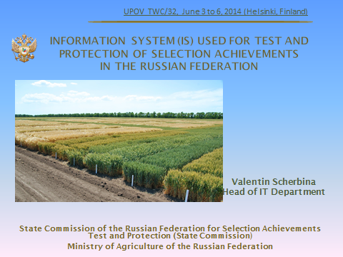

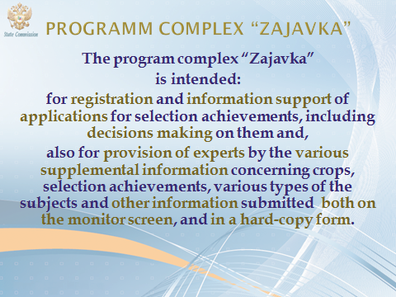

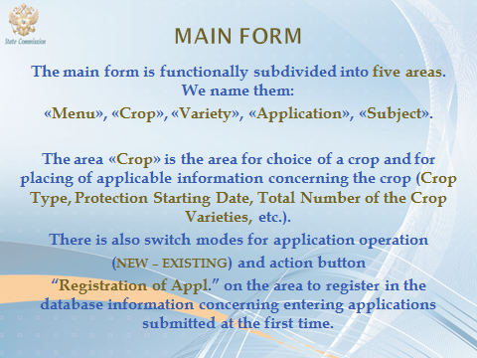

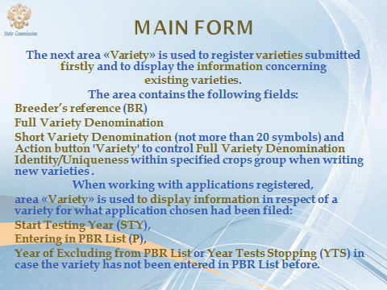

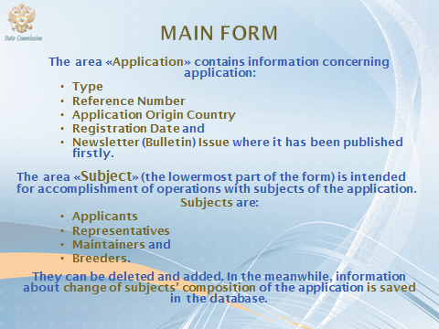

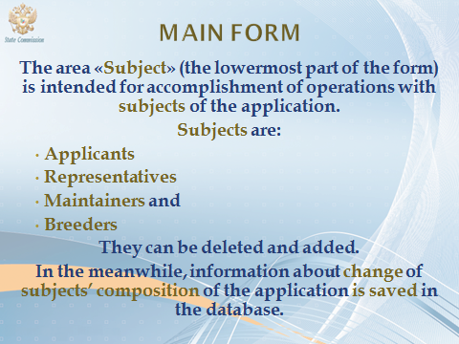

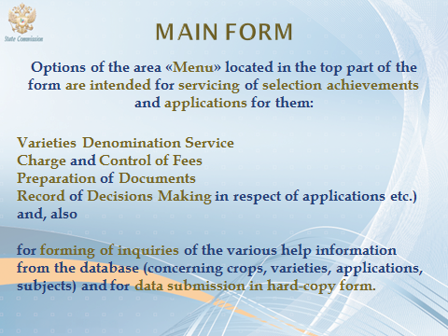

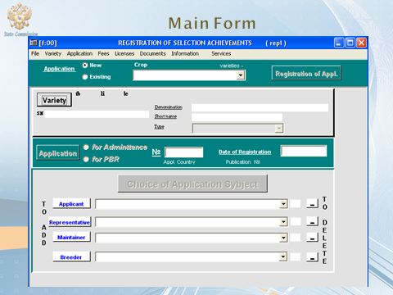

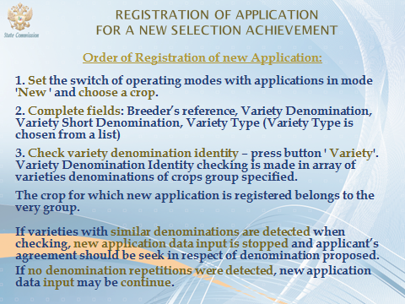

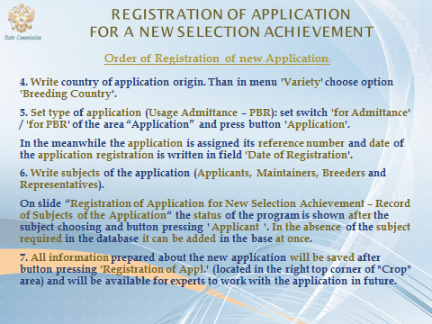

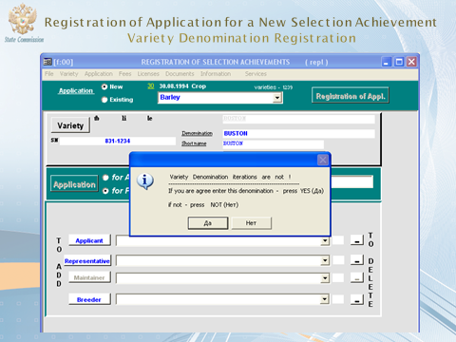

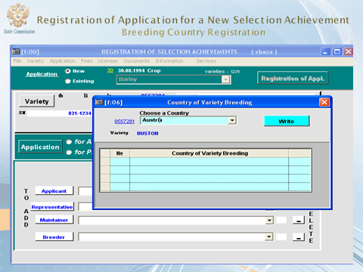

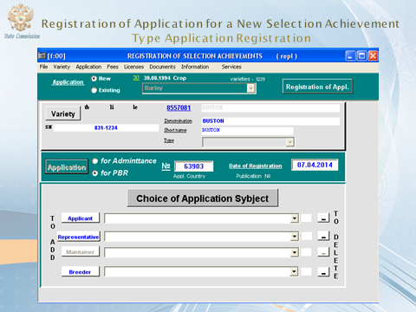

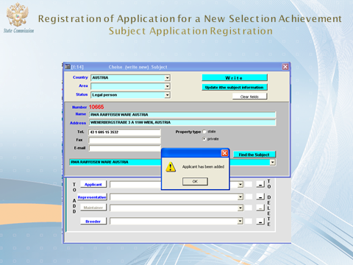

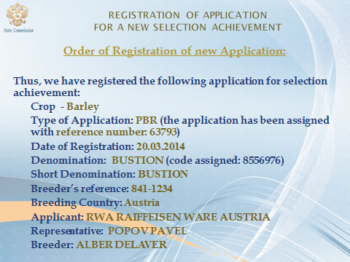

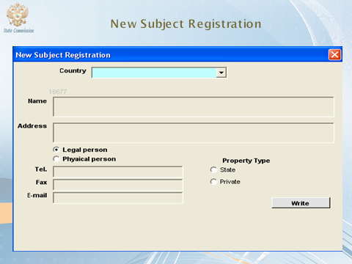

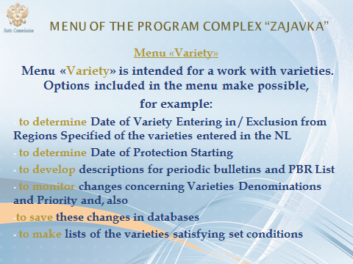

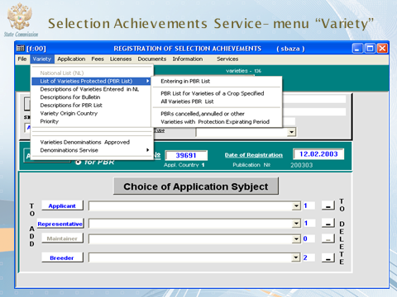

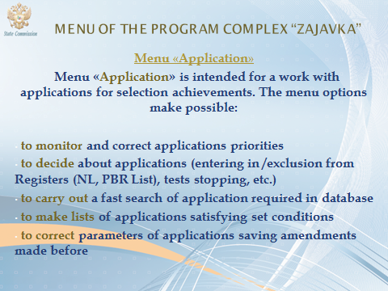

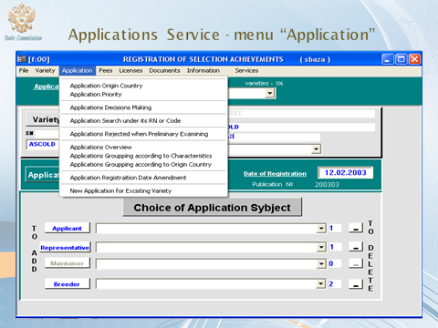

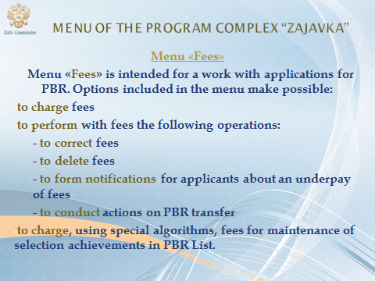

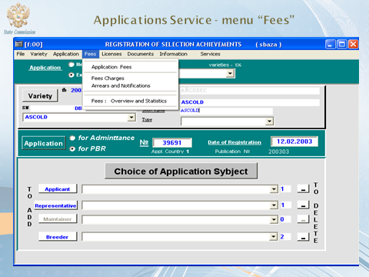

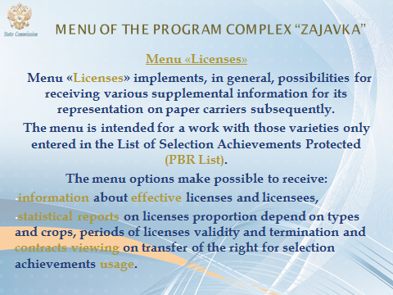

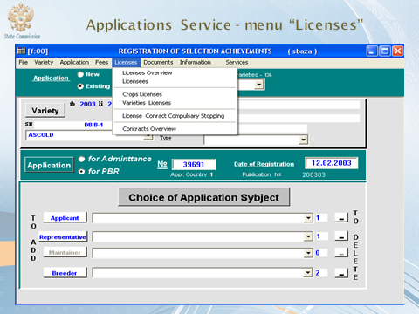

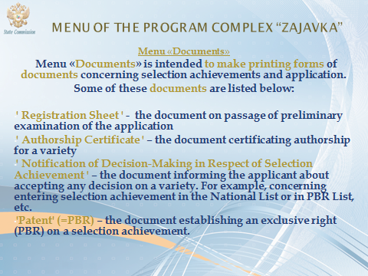

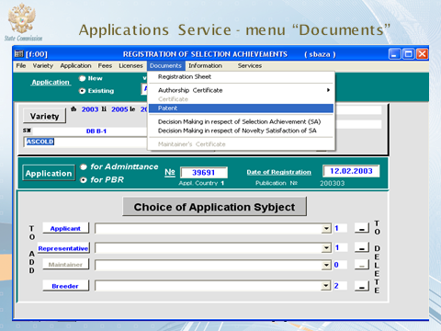

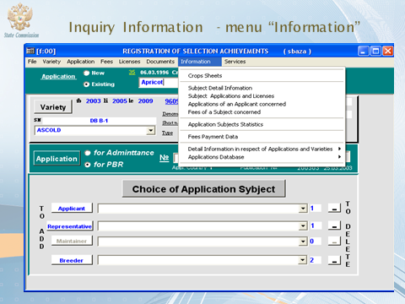

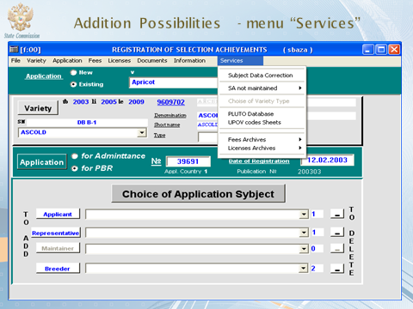



[Annex V follows]

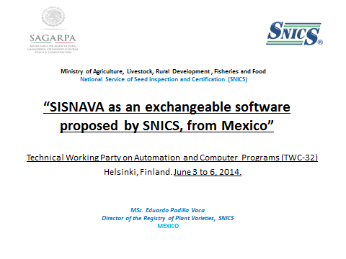

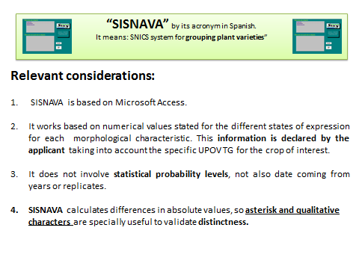

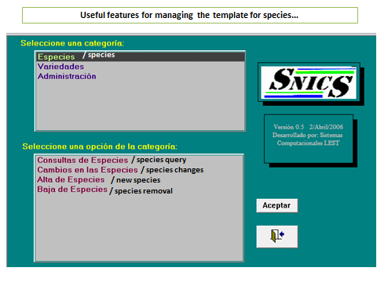

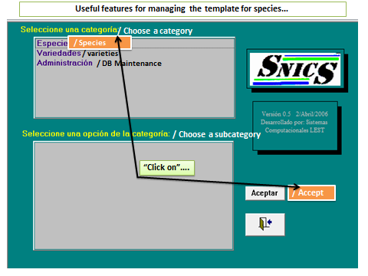

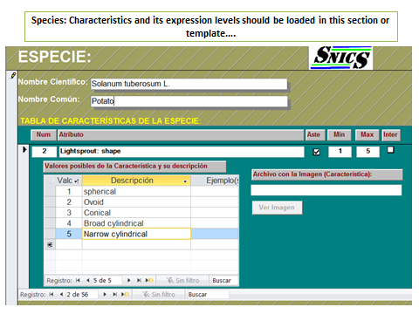

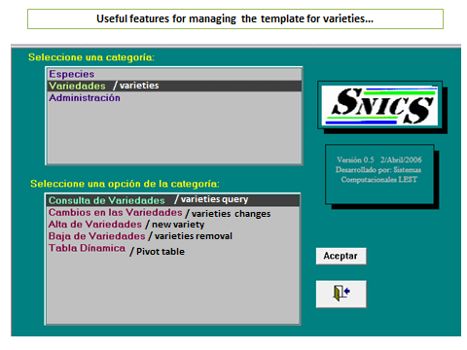

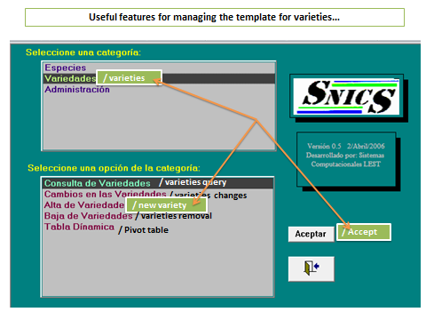

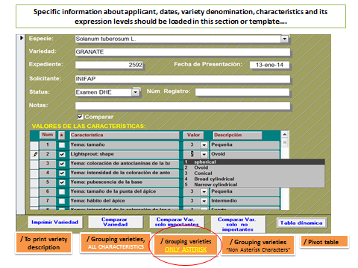

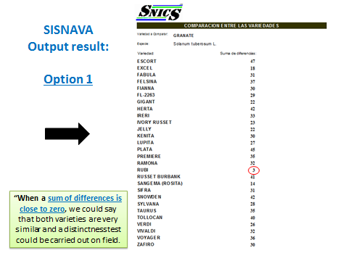

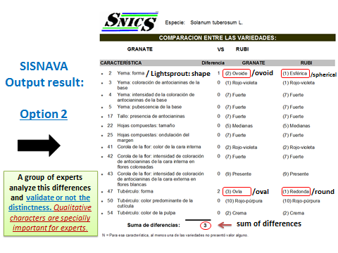

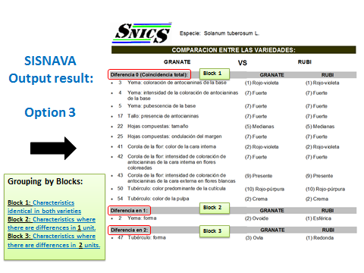

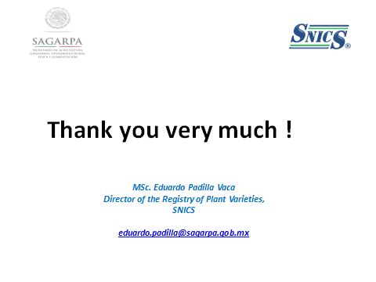

[End of Annexes and of document]