E
TWC/32/28
ORIGINAL: English
DATE: June 6, 2014
INTERNATIONAL UNION FOR THE PROTECTION OF NEW VARIETIES OF PLANTS
Geneva
Technical working party on automation and computer programs
Thirty-Second Session
Helsinki, June 3 to 6, 2014
REPORT
adopted by the
Technical Working Party on Automation and Computer Programs
Opening of the Session

The Technical Working Party on Automation and Computer Programs (TWC) held its thirty-second session in Helsinki, from June 3 to 6, 2014. The list of participants is reproduced in Annex I to this report.

The TWC was welcomed Mrs. Riitta Heinonen, Deputy Director General, Ministry of Agriculture and Forestry of Finland. A copy of the welcome address is attached in Annex II to this report. The TWC was also welcomed by Mrs. Marja Savonmaki, Senior Specialist, Ministry of Agriculture and Forestry.

The TWC received a presentation on plant variety protection (PVP) in Finland by Mrs. Tarja Hietaranta, Senior Officer, Seed Certification Unit, Finnish Food and Safety Authority. A copy of the presentation is provided in Annex III to this report.

The session was opened by Mr. Sami Markkanen (Finland), Chairperson of the TWC, who welcomed participants.

Adoption of the agenda

The TWC adopted the agenda as reproduced in document TWC/32/1 Rev.

Short reports on developments in Plant Variety Protection

- Reports on developments in plant variety protection from members and observers

The TWC noted the information on developments in plant variety protection from members of the Union provided in document TWC/32/26 Prov..

The TWC noted that reports submitted to the Office of the Union during or after the session would be included in the final version of document TWC/32/26.

(b) Reports on developments within UPOV

The TWC received a presentation from the Office of the Union on the latest developments within UPOV, a copy of which is provided in document TWC/32/24. The TWC noted that the designated contact person to the Technical Committee had been copied in the Circular requesting information for document C/48/5 “Cooperation in examination”.

TGP documents

The TWC considered document TWC/32/3.

Matters for adoption by the Council in 2014

The TWC noted the agreement of the TC and the CAJ to submit revisions to document TGP/0/7 “List of TGP Documents and Latest Issue Dates”, TGP/2 “List of Test Guidelines Adopted by UPOV”, TGP/5 “Experience and Cooperation in DUS Testing: Section 10: Notification of Additional Characteristics”, TGP/7 “Development of Test Guidelines” and TGP/8 “Trial Design and Techniques Used in the Examination of Distinctness, Uniformity and Stability” for adoption by the Council, at its forty-eighth ordinary session, to be held on October 26, 2014, as set out in document TWC/32/3, paragraphs 5 to 21.

Program for the development of TGP documents

The TWC noted the program for the development of TGP documents, as set out in Annex II to document TWC/32/3.

Revision of Document TGP/8: Part II: Selected Techniques Used in DUS Examination, Section 3: Method of Calculation of COYU

The TWC considered document TWC/32/16 and TWC/32/16 Add..

The TWC received a presentation by an expert from the United Kingdom on the method for improving the calculation of COYU, including a demonstration version of a module for the DUST software.

The TWC agreed to request the experts from China, Czech Republic, France, Finland, Germany, Kenya, Netherlands and Poland to test the new software on COYU.

The TWC agreed to invite other users of the COYU method to test the new software. The TWC agreed that an invitation should be developed by the Leading Expert and sent by the Office of the Union to the users of the DUST software package.

The TWC agreed that the software module for calculation of COYU developed using the “R” software should be sent to the interested experts that use other systems than DUST (e.g. SAS and GenStat) for testing the new method.

The TWC agreed that participants should seek to define probability levels to match decisions using the previous COYU method for continuity in decisions and that the test should be run for rejection probabilities of 1, 2 and 5% levels. The TWC agreed that participants should assess whether the results are consistent in all crops.

The TWC agreed with the timetable for the development of the new software package for the COYU method as follows:

• By the end of July 2014, the UPOV Office with assistance from the expert of the United Kingdom would invite participants for the practical exercise.
• By the end of September 2014, the expert of the United Kingdom would develop further the DUST module demonstrated at the thirty-second session of the TWC for evaluation by the participants and would prepare code for “R” software for participants that prefer this option to the DUST module.
• By early October 2014, the expert of the United Kingdom would send details of the practical exercise, including access to software, to the participants.
• By March 15, 2015, participants of the practical exercise should send a report on their experiences to the expert of the United Kingdom.
• The expert of the United Kingdom would compile a report on the practical exercise and the development of DUST module for the thirty-third session of the TWC.

Assessing Uniformity by Off-Types on Basis of more than one Sample or Sub Samples

The TWC considered document TWC/32/9.

The TWC agreed that the values for type I and type II errors should be included in each of the examples described in situations A and B for the development of guidance in document TGP/10. The type I error is associated with a decision for non-uniformity (rejection of the true null hypothesis) and the type II error is associated with a decision for uniformity (acceptance of the alternative hypothesis).

The TWC agreed that the guidance provided in document TGP/10 “Examining Uniformity”, Section 6 “Combining all observations on a variety” was sufficient to address situation C “More than one sample or subsample for a characteristic in the same growing trial”, Annex III to document TWC/32/9. The TWC agreed that the example provided could be considered as a special test and that results of the uniformity assessment should be considered independently.

In relation to situation D, the TWC considered the use of a stepwise approach in the off-type procedure within the same growing cycle and the statistical basis for the acceptable number of off-types in the subsample of 20 plants used in the context of a sample size of 100 plants, as provided in Annex V to document TWC/32/9, which was introduced by an expert from Germany.

The TWC agreed that the type I and type II errors used in the statistical basis for the acceptable number of off-types in the subsample of 20 plants used in the context of a sample size of 100 plants were comparable to those of the entire sample for the example provided in wheat and barley.

The TWC noted that the stepwise approach in the off-type procedure was intended to reduce costs without increasing risks in the uniformity assessment. The TWC agreed to propose the guidance as follows:

“SITUATION D: ASSESSING SUB-SAMPLES WITHIN A SINGLE TEST/TRIAL

“Approach: Use of sub-sample as a first step of assessment

“A variety is considered uniform if the number of off-types does not exceed a predefined lower limit in the sub-sample.

“A variety is considered non-uniform if the number of off-types exceeds a predefined upper limit in the sub-sample.

“If the number of off-types is between the predefined lower and upper limits the whole sample is assessed. The lower and upper limits have to be chosen considering comparable type I and type II errors in the sub-sample and the whole sample.

“Example:

“In a sample size of 100 plants, the acceptable number of off-types is 3 (based on a population standard of 1% and an acceptance probability of at least 95%).

“In a subsample of 20 plants used in the context of the sample size of 100 plants above:

“A variety is considered uniform if no off-types are observed in the sub-sample.

“A variety is considered non–uniform if the number of off-types in the sub-sample exceeds 3.

“If the number of off-types is 1 to 3, the whole sample of 100 plants is assessed.

“Annex V to document TWC/32/9 provides a full description of the statistical basis for this approach.”

Revision of Document TGP/8: Part II: Selected Techniques Used in DUS Examination, New Section: Data Processing for the Assessment of Distinctness and for Producing Variety Descriptions

The TWC considered document TWC/32/18.

The TWC noted that an expert from New Zealand had made a presentation at the forty-fifth session of the TWF, on the project for “apple reference varieties” that began in New Zealand in 2011.

The TWC noted that the descriptions of the methods used in France, Germany, Japan and the United Kingdom were provided in the document considered in previous sessions of the TWC.

The TWC received an explanation by an expert from Germany on Annex II to document TWC/32/18 “Different forms that variety descriptions could take and the relevance of scale levels” and agreed that it should be used as an introduction to future guidance to be developed on this matter.

The TWC received a presentation by an expert from Italy on the Italian method for the development of variety descriptions, as presented in Annex III to document TWC/32/18.

The TWC agreed that the method presented by the expert from Italy had similarities with the method used in the United Kingdom. The TWC noted that the range of expression of the variety means was divided by the amount of notes used for a characteristic, but that in Italy the extreme notes were not always used (e.g. 1 and 9) allowing space for future progress in plant breeding.

The TWC considered the results of a practical exercise presented in document TWC/32/18 Add. and agreed to request those participants to the practical exercise to complement the information provided with regard to the steps used in the procedure to obtain the calculated results in order to clarify the methods used.

The TWC agreed to request an expert from France to compare the results of the practical exercise presented by the different participants to identify differences in the results obtained for further understanding of the different methodologies. The TWC agreed that the comparison of results should be presented for consideration at the next session of the TWC.

The TWC agreed to invite the expert from China to provide information on the methods used for data processing for the assessment of distinctness and for producing variety descriptions in China at the next session of the TWC.

Revision of Document TGP/8: Part II: Selected Techniques Used in DUS Examination, New Section: Examining DUS in Bulk Samples

The TWC received a presentation by an expert from the Netherlands on the use of the characteristic content of Glycoraphanin in broccoli based on bulk samples, as set out in the Annex to document TWC/32/17.

The TWC agreed that a sufficient number of plants should be used to assess uniformity in bulk samples and noted that care would be needed to attest stability due to known variation in chemical content in other crops such as oilseed rape.

The TWC noted that the routine measurement of this characteristic in the Netherlands would allow sufficient data set to be generated for further consideration and agreed to invite the Netherlands to provide further information.

The TWC agreed that the assessment of uniformity for characteristics based on bulk samples should consider the analysis of individual plants to validate characteristics and noted the possible cost implication of this approach.

Revision of Document TGP/8: Part II: Selected Techniques used in DUS Examination, New Section: Guidance for Blind Randomized Trials

The TWC considered document TWC/32/19 and agreed that blind randomized trials were rarely used. The TWC noted that blind randomized trials have been used in the Netherlands to confirm lack of distinctness between varieties. The TWC noted that some tests for disease resistance were organized by the Netherlands at the breeders’ premises but the varieties were not coded. The TWC noted the suggestion by the expert from the Netherlands that guidance for such trials organized at the breeders’ premises could be developed for inclusion in document TGP/6 “Arrangements for DUS testing”.

The TWC noted the proposal from the expert from France to prepare a new draft for consideration by the TC and the TWPs at their sessions in 2015.

Revision of Document TGP/8: Part II: Selected Techniques used in DUS Examination, New Section: Examining Characteristics using Image Analysis

The TWC considered document TWC/32/20.

The TWC noted the proposal from the expert from the European Union to prepare a new draft for consideration by the TC and the TWPs at their sessions in 2015.

The TWC agreed with the comment made by the TWO to request the drafter to consider including typical examples of characteristics that could be assessed by image analysis, such as leaf area and length / width of grain. The TWC agreed to request France to provide examples for inclusion in the revised document.

The TWC noted that experiences on the use of image analysis would be presented to the TWV.

Revision of Document TGP/8: Part II: Selected Techniques Used in DUS Examination, New Section: Statistical Methods for Visually Observed Characteristics

The TWC considered document TWC/32/21.

The TWC noted the developments concerning a possible New Section: “Statistical Methods for Visually Observed Characteristics” to be introduced in document TGP/8: Part II: Techniques Used in DUS Examination, in a future revision of document TGP/8.

The TWC considered a comparison of the results on distinctness decisions between the new COYD method for visually observed characteristics and the Chi-square test, which was presented by an expert from Finland, as set out in the Annex to document TWC/32/21 Add..

The TWC agreed that the new method was tailored for the analysis of visually observed characteristics and had a better fundamental basis when compared to the Chi-square test. The TWC noted that the new method allowed for distinctness to be established between more pairs of varieties than the Chi-square test in the example of meadow fescue “growth habit” considered.

The TWC agreed that software should be developed using the new method for the software packages available and noted that the code was currently available for SAS. The TWC noted the information that the United Kingdom was currently assessing how GenStat could be used for this method.

The TWC agreed to invite an expert from China to make a presentation on the analysis of visually observed characteristics using the DUST China (DUSTC) software package using the same data set of meadow fescue provided by Finland to be presented at the next session of the TWC.

Revision of Document TGP/8: Part I: DUS Trial Design and Data Analysis, New Section: Minimizing the Variation due to Different Observers

The TWC considered document TWC/32/15.

The TWC noted that the expert from New Zealand had reported at the forty-fifth session of the TWF on the previous work done on harmonized variety description for apple for an agreed set of varieties.

The TWC agreed that the draft guidance in the Annex to document TWC/32/15 should continue to be developed for inclusion in a future revision of document TGP/8 on minimizing the variation due to different observers, including guidance on PQ and QN/MG characteristics, in conjunction with the points raised by the expert from Australia in document TWC/32/15, paragraph 21.

The TWC agreed that the draft guidance should start on variation between observers at the authority level and between different authorities at a future stage.

Improving the effectiveness of the Technical Committee, Technical Working Parties and Preparatory Workshops

The TWC considered document TWC/32/11.

The TWC noted the measures implemented at the TWPs sessions in 2013, for improving the effectiveness of the TWPs, as set out in document TWC/32/11, paragraph 10.

The TWC noted the results of the surveys in 2013 presented in document TWC/32/11, paragraphs 11 and 12, and Annex I.

The TWC noted the survey of TWP participants in 2014, as set out in Annex II to document TWC/32/11.

The TWC considered the proposals concerning possible means of improving the effectiveness of the TWPs and the Preparatory Workshops, and made the following comments:

 | Proposal | Comment
Technical Working Parties
General
(a) | conduct a survey of TWP participants in 2014 in order to identify further areas for improvement and to obtain feedback on the effectiveness of measures already taken | The survey would be an additional method to express participant’s views on improving effectiveness to discussions during TWC meetings.  The survey would provide opportunity for written comments and would allow participants sufficient time for elaboration.
(b) | review the TWP invitations in order to ensure that information is disseminated to all appropriate persons | The invitations should also reach participants to the previous session of the TWC.
(c) | in order to encourage greater participation by all participants in the TWP sessions, to request participants at the beginning of the session to introduce themselves and to briefly (in 30 seconds) report the most important issue they faced at that time. Matters of broad interest could then be considered for further discussion at an appropriate time | An invitation should be sent to participants for the preparation of a topic to be presented.  This would be an opportunity to share topics that are not sufficiently prepared to be discussed as a meeting document.  Allows a general overview of interests among participants.
(d) | organize presentations by experts of members of the Union on topical and relevant matters | Allows the demonstration of practical work and case studies.  Has been successfully used previously in the TWC.
(e) | request hosts to provide:  - name badges for all participants (including local participants),  - a large poster board with the participant names and photographs and a space for each participant to indicate their area of particular interest (specifically including local participants),  - a notice board for host announcements (e.g. visits),  - 2 projector screens in large rooms (at opposite ends of room) | Measures considered useful and should be undertaken.  Facilitates interaction among participants.
TWP documents
(f) | provide a summary of the purpose and proposed decisions at the beginning of TWP documents | The summary would be useful to highlight the proposal to be considered and to facilitate general understanding of document.  External drafters of documents should be requested to provide a summary of the text elaborated.  Provides a tool to improve the organization of information presented in the document.  Could also present a summary of key features of document.
 | Proposal | Comment
(g) | post documents sufficiently in advance of the meetings | Documents with technical nature should be posted sufficiently in advance of the meeting to allow consultations and time for consideration.  Important due to the amount of information discussed at each session and the extensive background information in some cases.
(h) | continue to include decision paragraphs in TWP documents | Decision paragraphs should continue to be used.
(i) | minimize the time for presentation of documents, particularly where presented for information only | The TWPs should be informed on all topics being discussed but the allocation of time for presentation and discussion of each topic should be considered according to the relevance for each TWP.
Test guidelines
(j) | request TWP designated persons to make proposals for new or revised Test Guidelines in advance of the TWP session | not applicable for the TWC
(k) | circulate the proposed schedule of TG to be discussed during the session to TWP participants one week before the TWP session | It would be useful to circulate the work program for the week before the TWP.
(l) | improve preparation of Test Guidelines and presentation of Test Guidelines at TWPs by the Leading expert by:  - training (e.g. electronic training workshops, including the use of the Web-based TG template, and guidance on the presentation of Test Guidelines at the sessions),  - providing UPOV comments in advance | Guidance for drafters was already available on the UPOV website.  Useful to remind its availability.
TGP documents
(m) | request participants to provide their comments on TGP documents in advance of the TWP session, according to a specified date | Generally not supported by the TWC.  Would require additional coordination work and sufficient time to get clearance prior to submission of comments.
(n) | organize a separate, annual meeting of a working group to discuss TGP documents in the week before the TC sessions in Geneva. The meetings would be open to all TC and TWP designated persons and consideration would be given to the possibility to view the meeting electronically | Proposal not supported by the TWC.  Would increase cost and time to attend additional meeting.  The specific focus of each TWP would be important for discussion of TGP documents.
(o) | in conjunction with this approach, to report on significant developments at TWPs, without detailed discussion of individual TGP documents | Not supported.
Technical visit
(p) | conduct a survey of TWP participants of their requirements for technical visits | The survey was supported.  Hosts of TWPs should have flexibility to propose the technical visit and demonstrate areas of interest.
Preparatory Workshops
(a) | if the length of time spent on TGP and information documents is reduced, to hold the preparatory workshops on Monday in order to encourage all TWP participants to attend the Preparatory Workshop | This proposal was considered ineffective to encourage participants to attend the Preparatory Workshop.
(b) | to use more, shorter presentations and use experts from members of the Union as presenters | This proposal could be implemented but was not considered critical for improving the effectiveness of the Preparatory Workshop.
(c) | to continually renew exercises for existing topics | Case studies could be presented to stimulate discussions
(d) | to organize small groups of participants with different levels of experience for the group exercises | Group exercises should continue to be organized in small groups of participants with different levels of experience and from different regions.

The TWC made the following additional proposals concerning possible means of improving the effectiveness of the TWPs and Preparatory Workshops:

(i) to request members to propose topics for discussion during the Preparatory Workshops;
(ii) to include questions on self-assessment in surveys for hosts and participants to TWPs and Preparatory Workshops; and
(iii) to have a link to the list of participants for each TWP separate from the report of the meeting.

Revision of Document TGP/9: Schematic Overview of TGP Documents Concerning Distinctness

The TWC considered document TWC/32/22.

The TWC agreed with the proposed revision of the flow diagram in TGP/9, Section 1.6 “Schematic overview of TGP documents concerning distinctness”, as set out in document TWC/32/22, paragraph 7 and Annexes I and II.

Revision of Document TGP/9: Section 2.5: Photographs

The TWC considered document TWC/32/22 and agreed with the proposed guidance on photographs for inclusion in document TGP/9, Section 2.5 “Photographs”, as follows:

“2.5.3 The suitability of photographs for the identification of similar varieties is strongly influenced by the quality of the photographs taken by the authority for the varieties in the reference collection and the photograph of the candidate variety provided by the applicant with the Technical Questionnaire. Comprehensive guidance for taking suitable photographs is provided in TGP/7, GN 35 (new). The guidance was developed in particular for the applicants to provide suitable photographs of the candidate variety. The same instructions are important and useful for the authorities to take photographs of the varieties in the variety collection under standardized conditions.”

Revision of Document TGP/9: Section 4.3.2 “Single Record for a Group of Plants or Parts of Plants (G)” and Section 4.3.4 “Schematic Summary”

The TWC noted the proposed example of a single record for a group of plants (MG) taken on plant parts for inclusion in a future revision of document TGP/9, Subsections 4.3.2 “Single record for a group of plants or part of plants (G)” and 4.3.4 “Schematic summary”, as set out in document TWC/32/22, paragraphs 16 and 17.

Revision of Document TGP/7: Plant Material Submitted for Examination

The TWC considered document TWC/32/12.

The TWC noted that the TWO, TWF, TWV and TWV would consider the presentations of experts, on their experiences with regard to plant material submitted for examination, and the solutions that have been developed to address problems, and would consider how those experiences and solutions could be developed into guidance that reflects good practice.

Revision of Document TGP/7: Coverage of the Test Guidelines

The TWC considered document TWC/32/13.

The TWC agreed the approach 3, “specify existing type of propagation and anticipate future development”, of the proposal for revision of document TGP/7, Section 4.2, to provide guidance on the use of the Test Guidelines for varieties with other types of propagation.

Revision of Document TGP/7: Drafter's Kit for Test Guidelines

The TWC considered document TWC/32/14.

The TWC agreed with the plan to revise document TGP/7 and the TG Drafter’s webpage for consistency with the inclusion of the web-based TG Template in 2014, as set out in document TWC/32/14, paragraphs 6 to 8.

Revision of Document TGP/14: Section 2.4: Apex/Tip Characteristics

The TWC noted document TWC/32/23 and the proposals to develop an explanation on the inclusion of a state of expression based on a differentiated tip in shape of apex characteristics.

Information and databases

(a) UPOV information databases

The TWC considered document TWC/32/5.

GENIE Database

The TWC noted the plan to provide information for type of crop for each UPOV code in the GENIE database, as set out in document TWC/32/5, paragraph 8.

UPOV code system

The TWC noted the developments concerning the UPOV Code System.

PLUTO Database

The TWC noted the developments concerning the program for improvements to the Plant Variety Database, as reported in document TWC/32/5, paragraphs 14 to 31.

(b) Variety description databases

The TWC considered document TWC/32/6.

The TWC noted the developments on variety description databases, as set out in document TWC/32/6.

The TWC noted the matters raised by the ISF in relation to variety descriptions.

The TWC noted the conclusion of the CAJ on matters concerning variety descriptions, as set out in document TWC/32/6, paragraph 28.

The TWC noted the proposal of the expert from Australia, not to develop a database for the TWO.

The TWC received a presentation from an expert from China on “Variation of variety descriptions over years in different locations”, as presented in Annex I to document TWC/32/6. The TWC agreed that the information provided was useful to demonstrate the robustness of some characteristics and for defining grouping characteristics. The TWC agreed that the presentation should be made available to the TWA.

The TWC agreed to request the experts from China to present the analysis of variance for the interaction “variety x location” (environment) of the QN characteristics considered in the study using the statistical module of the new software “DUSTC” developed by China for presentation during the next session of the TWC.

The TWC received a presentation from China on “PVP Database in China“, as set out in Annex II to document TWC/32/6. The TWC noted that the new software included modules for the management of applications, variety description database, data analysis and image analysis. The TWC agreed to request that the experts from China to make a presentation on the particular features of the software, including image analysis, during the next session of the TWC.

(c) Exchangeable software

The TWC considered documents TWC/32/7.

The TWC noted that document UPOV/INF/22 “Software and equipment used by members of the Union” would be presented for adoption by the Council at its forty-eighth ordinary session, to be held in Geneva on October 16, 2014, as set out document TWC/32/7, paragraph 5.

The TWC noted that subject to adoption of document UPOV/INF/22 by the Council at its forty-eighth ordinary session, a circular would be issued to the designated persons of the members of the Union in the TC, inviting them to provide information regarding non-customized software and equipment used by members of the Union, as appropriate.

The TWC noted that a revision of document UPOV/INF/16/3 concerning the inclusion of the SIVAVE software would be presented for adoption by the Council at its forty-eighth ordinary session, to be held on October 16, 2014, as presented in Annex I to document TWC/32/7.

The TWC received a presentation from an expert from Mexico by electronic means on the SISNAVA software, as presented in Annex V to document TWC/32/7. The TWC agreed that the procedure for the calculation of differences for variety distinctness should take into account that differences in notes in PQ characteristics do not correspond to the size of the phenotypic difference. The TWC agreed that the discussions on the inclusion of the SISNAVA software in document UPOV/INF/16 should be continued subject to the conclusion on discussions on the variation of variety descriptions over years in different locations by the TWC.

The TWC noted that the TC and CAJ had agreed with the proposed revision of document UPOV/INF/16 concerning the inclusion of information on the use of software by members of the Union, as presented in Annex II of the document TWC/32/7.

The TWC noted the availability of the AIM User Guide in English.

The TWC noted the explanation of the software “Information System (IS) used for Test and Protection of Plant Varieties in the Russian Federation”, as prepared in Annex IV of the document TWC/32/7.

(d) Electronic application systems

The TWC considered document TWC/32/8 and TWC/32/25.

The TWC noted the developments concerning a prototype electronic form as set out in document TWC/32/8.

The TWC noted the results of the survey of members of the Union on their use of databases for plant variety protection purposes and also on their use of electronic application systems, as presented in Annex II to document TWC/32/8.

The TWC noted document TWC/32/25 and received a presentation by an expert from Germany on the development and features of a document management system for variety files used in Germany.

Guidance for drafters of Test Guidelines

The TWC considered document TWC/32/10 and received a presentation by electronic means on the web-based TG Template, a copy of which is presented in the Annex to document TWC/32/10.

The TWC noted the features of Version 1 of the web-based TG Template, as set out in document TWC/32/10, paragraph 10.

The TWC noted the request for Leading Experts to participate in the testing of Version 1 of the web-based TG Template.

The TWC noted the exclusive use of the web-based TG Template for the development of all Test Guidelines from 2015.

Updated Survey on Hand-Held Data Capture Devices

The TWC considered document TWC/32/27.

The TWC noted the summary of information provided by TWC participants on the use of data-loggers for data recording in DUS trials provided in Annex I to document TWC/32/27.

The TWC noted the summary of information provided by TWC participants on the use of data-loggers for data recording in DUS trials provided in Annex I to this document would be included in UPOV/INF/22 “Software and equipment used by members of the Union” subject to the adoption by the Council.

The TWC received a presentation by an expert from Germany on the use of hand-held data capture devices in DUS tests in Germany, a copy of which is presented in Annex II to document TWC/32/27.

Experiences with new types and species

The TWC received an oral report by an expert from Brazil on experiences with new types and species in the country on the development of national Test Guidelines for Centrosema pubescens, Galactia striata, Calopogonium mucunoides and Neonotonia wightii for which applications for plant variety protection had been filed.

Molecular Techniques

The TWC considered document TWC/32/2.

The TWC noted the report on developments concerning the use of biochemical and molecular markers in the examination of Distinctness, Uniformity and Stability (DUS).

The TWC noted the report on development concerning the Working Group on Biochemical and Molecular Techniques, and DNA-Profiling in Particular (BMT).

The TWC noted the report on presentation of information on the situation in UPOV with regard to the use of molecular techniques to a wider audience, including breeders and the public in general.

Variety Denominations

The TWC considered document TWC/32/4.

Possible revision of document UPOV/INF/12 “Explanatory Notes on Variety Denominations under the UPOV Convention”

The TWC noted the plans to revise document UPOV/INF/12 “Explanatory Notes on Variety Denominations under the UPOV Convention”.

Possible development of a UPOV similarity search tool for variety denomination purposes

The TWC noted the report concerning the possible development of a UPOV similarity search tool for variety denomination purposes and that the first meeting of the working group would be arranged for June/July, 2014.

Developments concerning potential areas for cooperation with the IUBS Commission and the ISHS Commission

The TWC noted the developments concerning potential areas for cooperation between the International Commission for the Nomenclature of Cultivated Plants of the International Union for Biological Sciences (IUBS Commission), the International Society for Horticultural Science Commission for Nomenclature and Cultivar Registration (ISHS Commission) and UPOV, as set out in document TWC/32/4.

Date and place of the next session

At the invitation of Brazil, the TWC agreed to hold its thirty-third session in Natal, from June 30 to July 3, 2015, with the preparatory workshop on June 29, 2015.

Future program

The TWC planned to discuss the following items during the thirty-third session:

1. Opening of the session

2. Adoption of the agenda

3. Short reports on developments in plant variety protection
(a) Reports from members and observers (written reports to be prepared by members and observers)
(b) Reports on developments within UPOV (document to be prepared by the Office of the Union)
4. Molecular techniques (document to be prepared by the Office of the Union and documents invited)

5. Improving the effectiveness of the Technical Committee, Technical Working Parties and Preparatory Workshops (document to be prepared by the Office of the Union)

6. TGP documents

7. Information and databases

(a) UPOV information databases (document to be prepared by the Office of the Union and documents invited)

(b) Variety description databases (document to be prepared by the Office of the Union and documents invited)

(c) Exchangeable software (document to be prepared by the Office of the Union and documents invited)

(d) Electronic application systems (document to be prepared by the Office of the Union and documents invited)

8. Variety denominations (document to be prepared by the Office of the Union)

9. Uniformity assessment by off-types (documents to be prepared by the Office of the Union)

10. Experience with new types and species (oral reports invited)

11. Information on the methods used for data processing for the assessment of distinctness and for producing variety descriptions in China (presentation to be prepared by China)

12. Statistical methods for visually observed characteristics using the DUSTC software package (presentation to be prepared by China)

13. Analysis of variance for “variety x location” (environment) interaction of QN characteristics (document to be prepared by China)

14. Image analysis system in China (document to be prepared by China)

15. Method of calculation of COYU: analysis of the practical exercise (document to be prepared by the United Kingdom)

16. Comparison of methods used for producing variety descriptions (document to be prepared by France and documents invited)

17. Information on bulk samples on the routine measurement of Glycoraphanin content in broccoli (document to be prepared by the Netherlands)

18. Weighting matrix in the GAIA software for soybean (presentation to be prepared by Brazil)

19. A rationale for excluding varieties of common knowledge from the second growing cycle when COYD is used (document to be prepared by the United Kingdom)

20. Date and place of the next session

21. Future program

22. Report on the session (if time permits)

23. Closing of the session

Technical Visit

On the afternoon of June 4, the TWC visited the testing station of the Finnish Food Safety Authority (Evira) at Loimaa. The TWC was welcomed by Mrs. Hanna Kortemaa, Head of Unit, Seed Certification Unit, who explained the role of Evira in seed production and certification in Finland. The TWC received a presentation from Ms. Kaarina Paavilainen, Senior Officer, Seed Certification Unit, Evira, on the DUS examination of field crops and from Mr. Sami Markkanen, Senior Officer, Control Department, Evira, on DUS testing for timothy and meadow fescue. The TWC visited field trials of barley, wheat, rye, white clover, red clover and meadow fescue, where the DUS examination of 74 candidate and 674 reference varieties was being carried out in 2014.

The TWC adopted this report at the close of the session.

[Annexes follow]
LIST OF PARTICIPANTS
 | I. MEMBERS
 | ALBANIA
 | 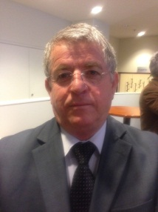 |  | Jani BABI, Vice-Minister of Agriculture, Ministry of Agriculture, Rural Development and Water Management, Tirana  (tel.: +355 42 23 08 66 fax: +355 42 23 08 66 e-mail: jani.babi@bujqesia.gov.al)
 | 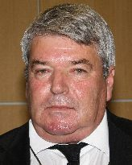 |  | Petrit TOPI, Director, National Seeds and Seedlings Institute, Ministry of Agriculture, Bulevardi "Deshmoret e Kombit" Nr. 2, Tirana  (tel.: +355 4 230324 fax: +355 4 230324 e-mail: topipetrit@yahoo.com)
 | 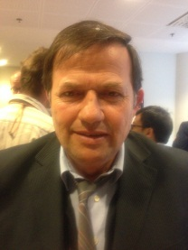 |  | Vlash TIRANA, Head, Department for Variety Testing, Ministry of Agriculture, Rr. Siri Kodra, Tirana  (tel.: +355 4 230 324 fax: +355 4 362 419 e-mail: vlashtirana@yahoo.com)
 | BRAZIL
 | 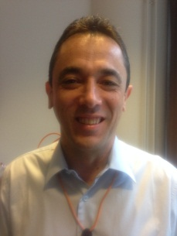 |  | José Antonio FERNANDES HIDALGO, Federal Agricultural Inspector, National Plant Variety Protection Office (SNPC), Ministério da Agricultura, Pecuária e Abastecimento, Esplanada dos Ministérios, Bloco 'D', Anexo A, Sala 250, CEP 70043-900 Brasilia, D.F.  (tel.: +55 61 3218 2915 fax: +55 61 3224 2842 e-mail: jose.hidalgo@agricultura.gov.br)
 | 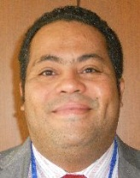 |  | Fabrício SANTANA SANTOS, Coordinator, National Plant Variety Protection Office (SNPC), Ministério da Agricultura, Pecuária e Abastecimento, Esplanada dos Ministerios, Bloco 'D', Anexo A, Sala 250, CEP 70043-900 Brasilia, D.F.  (tel.: +55 61 3218 2923 fax: +55 61 3224 2842  e-mail: fabricio.santos@agricultura.gov.br)
 | CHINA
Zhicheng HUANG, Research Associate, Shanghai Academy of Agricultural Sciences,
No. 888 Yezhuang Road, Fengxian, Shanghai
(tel.: +86 21 57460009 fax: +86 21 57460009 e-mail: hzauhzhch@126.com)
Yang KUN, Agronomist, Division of DUS Testing, Development Center for Science and Technology, Room 707, Nonfeng Building, No. 96 Dong San Huan Nan Lu, Chao Yang District, Beijing
(tel.: 86 10 59199360 fax: 86 10 59199361 e-mail: yang_kunmail@foxmail.com)
 | CZECH REPUBLIC
David HAMPEL, Biometrician, National Plant Variety Office, Central Institute for Supervising and Testing in Agriculture (UKZUZ), Hroznova 2, 656 06 Brno
(tel.: +420 543 548 251 fax: +420 543 212 440 e-mail: david.hampel@ukzuz.cz)
 | fINLAND
Tarja Päivikki HIETARANTA (Mrs.), Senior Officer, Seed Certification Unit, Finnish Food and Safety Authority (Evira), Tampereentie 51, P.O. Box 111, FI-32201 Loimaa
(tel.: +358 50 3443748 e-mail: tarja.hietaranta@evira.fi)
Hanna KORTEMAA (Mrs.), Head of Unit, Seed Certification Unit, Finnish Food Safety Authority (Evira), Tampereentie 51, P.O. Box 111, FI-32201 Loimaa
(tel.: +358 40 833 2486 e-mail: hanna.kortemaa@evira.fi)
Sami MARKKANEN, Senior Officer, Control Department, Finnish Food Safety Authority (Evira), Tampereentie 51, P.O. Box 111, FI-32201 Loimaa
(tel.: +358 40 8294543 fax: +358 29 530 5318 e-mail: sami.markkanen@evira.fi)
Kaarina PAAVILAINEN (Ms.), Senior Officer, Seed Certification, Finnish Food Safety Authority (Evira), Tampereentie 51, P.O. Box 111, FI-32201 Loimaa
(tel.: +358 40 8332480 fax: +358 29 530 5317 e-mail: kaarina.paavilainen@evira.fi)
 | FRANCE
Christophe CHEVALIER, Groupe d'étude et de contrôle des variétés et des semences (GEVES), 25 rue Georges Morel, BP 90024, F-49071 Beaucouze CEDEX
(tel.: +33 2 41 22 8636 fax: +33 2 41 22 8602 e-mail: christophe.chevalier@geves.fr)
 | 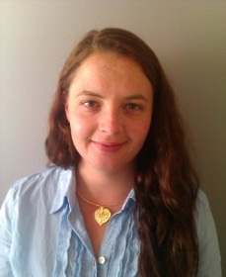 |  | Anne-Lise CORBEL (Mrs.), Responsable DHS colza, crucifères, lin et chanvre, Groupe d'étude et de contrôle des variétés et des semences (GEVES), Domaine de l'Anjouère, F-49370 La Poueze  (tel.: +33 24 122 8705 fax: +33 24 122 8660 e-mail: anne-lise.corbel@geves.fr)
 | GERMANY
Thomas DROBEK, Referat 111,Bundessortenamt, Osterfelddamm 80, D-30627 Hannover
(tel.: +49 511 9566 5688 fax: +49 511 9566 9600
e-mail: thomas.drobek@bundessortenamt.de)
Uwe MEYER, Referatsleiter Informationstechnologie, Referat 111, Bundessortenamt, Osterfelddamm 80, D-30627 Hannover
(tel.: +49 511 9566 5689 fax: +49 511 9566 9689
email: uwe.meyer@bundessortenamt.de)
 | ITALY
Maurizio GIOLO, Senior Scientist, Council for Agricultural Research (CRA SCS) Experimentation and Seed Certification Center, Via Ca' Nova Zampieri, 37-37057, S.G., I-Lupatoto (Verona) 37057
(tel.: +39 045 545 164 fax: +39 045 545 250 e-mail: maurizio.giolo@entecra.it)
 | JAPAN
 | 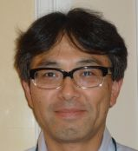 |  | Hiroshi UCHIZAWA, Senior Examiner, Plant Variety Protection Office, New Business & Intellectual Property Division, Food Industry Affairs Bureau, Ministry of Agriculture, Forestry and Fisheries, 1-2-1 Kasumigaseki, Chiyoda-ku, Tokyo 100-8950  (tel.: 81 3 6738 6466 fax: 81 3 3502 6572 e-mail: hiroshi_uchizawa@nm.maff.go.jp)
 | KENYA
 | 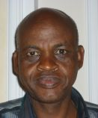 |  | John M. NGENY, Plant Examiner, Plant Variety Rights Office, Kenya Plant Health Inspectorate Service (KEPHIS), P.O. Box 49592-00100, Nairobi  (tel.: +254 20 359 7201 fax: +254 20 353 6175 e-mail: ngenyjma@kephis.org)
 | NETHERLANDS
Raoul HAEGENS, Manager, DUS Vegetable Crops, Naktuinbouw, Sotaweg 22, P.O. Box 40, NL-2371 6D Roelofarendsveen
(tel.: +31 71 332 6207 e-mail: r.haegens@naktuinbouw.nl)
 | POLAND
Wieslaw PILARCZYK, Professor, Research Center for Cultivar Testing (COBORU), PL-63-022 Slupia Wielka
(tel.: +48 61 285 2341 Ext. 238 fax: +48 61 285 3558 e-mail: wpilar@up.poznan.pl)
 | 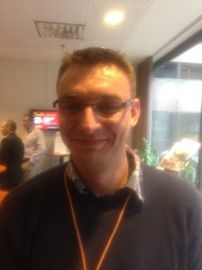 |  | Marcin PRZYSTALSKI, PhD, Research Centre for Cultivar Testing (COBORU), PL-63-022 Stupia Wielka  (tel.: +48 61 28 52 341 fax: +48 61 28 53 558 e-mail: m.przystalski@coboru.pl)
 | REPUBLIC OF KOREA
Man Jae KWON, IT Planning Team Staff, Korea Seed and Variety Service (KSVS), 184, Anyang-ro, Manan-gu, Anyang-si, Gyeonggi-do 430-822
(tel.: +82 31 467 0244 fax: +82 31 467 0116 e-mail: jaekm@korea.kr)
 | 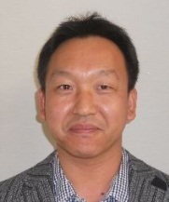 |  | Woo-Gun SHIN, DUS Tester for Plant Variety Protection, Korea Seed and Variety Service (KSVS), Yepyeong-ro 456, Sangnam-myeon, Miryang-si, Gyeongnam, 627-912  (tel.: 82 55 352 9552 fax: 82 55 353 2590 e-mail: swgseed@korea.kr)
 | ROMANIA
 | 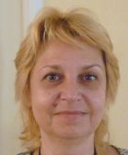 |  | Mihaela CRISTEA, Head of IT Department, State Institute for Variety Testing and Registration (ISTIS), 61 Marasti Avenue, 011464 Bucarest  (tel.: +40 21 318 43 80 fax: +40 21 318 44 08 e-mail: mihaela_cristea@istis.ro)
Cristian Irinel MOCANU, Head of Legal and Administrative Department, State Institute for Variety Testing and Registration, 61 Maratsi Avenue, 011464 Bucharest
(tel.: +40 21 318 43 80 fax: +40 21 318 44 08 e-mail: irinel_mocanu@istis.ro)
 | UNITED KINGDOM
Adrian M.I. ROBERTS, External Development Manager, Biomathematics & Statistics Scotland (BioSS), James Clerk Maxwell Building, The King's Buildings, Edinburgh EH9 3JZ
(tel.: +44 131 650 4893 fax: +44 131 650 4901 e-mail: a.roberts@bioss.ac.uk)
 | II. OFFICER
 |  | Sami MARKKANEN, Chair
 | III. OFFICE OF UPOV
 | 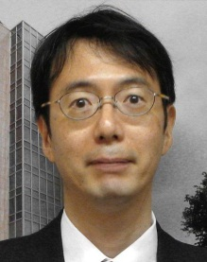 |  | Jun KOIDE, Technical/Regional Officer (Asia), International Union for the Protection of New Varieties of Plants (UPOV), Geneva 1211, Switzerland  (tel.: +41223387442 fax: +41227330336 e-mail: jun.koide@upov.int)
 | 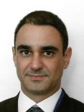 |  | Leontino TAVEIRA, Technical/Regional Officer (Latin America, Caribbean), International Union for the Protection of New Varieties of Plants (UPOV), Geneva 1211, Switzerland  (tel.: +41223389565 fax: +41227330336 e-mail: leontino.taveira@upov.int)

[Annex II follows]

WELCOME ADDRESS BY MRS. RIITTA HEINONEN, DEPUTY DIRECTOR GENERAL,
MINISTRY OF AGRICULTURE AND FORESTRY OF FINLAND

Ladies and Gentlemen,

It is a great pleasure to have you all here in Helsinki today. Finland has been a member of UPOV since 1993 and this is already the second time we will have a UPOV Technical Working Party meeting in Finland, as last time this meeting was held in 1999 in Turku.

As you may know, Finland is the northernmost country in the world with agricultural activities. Finland is a very long country, extending about 1,100 kilometers from the south to the north, which obviously means significant differences in the climate conditions between our regions. Even at its longest the growing season in southern Finland is about 170 days, while in Central Europe it is about 260 and in the south it may be as long as 300 days. In northernmost Finland the growing season is only about 120 days long.

Most of our plant producing farms are in southern Finland, and animal husbandry is practiced mainly in the central, eastern and northern parts of the country. In the very north, in Lapland, reindeer husbandry is a significant livelihood. In 2013 about 36 per cent of the Finnish farms raised livestock and 63 per cent engaged in plant production. Finnish agriculture is still mainly based on family farming, and in our country forest is an essential part of farms. Finland is the most forested country in the EU, with 71 per cent of the land area covered with forest. In total there are about 59,000 farms in Finland.

The main crops grown in Finland include wheat, barley, oats and grasses. Of the cereals mostly spring varieties are cultivated here. Varieties that are suited to our conditions are particularly important for Finland, as they need to be adapted to the long summer days and our special climate and soil conditions. Varieties bred for the Finnish conditions must be capable of taking full advantage of the short and quite cool growing season with abundant daylight.

Finland joined the European Union in 1995, and since then our agriculture has been governed by the common agricultural policy of the EU.

I wish you a pleasant day, and an interesting and productive meeting. Tomorrow you will have field trip and an ideal opportunity to see our countryside during the bus ride to Loimaa. I hope you will enjoy you stay in Finland with our long summer days and abundant daylight.

[Annex III follows]

PLANT VARIETY PROTECTION (PVP) IN FINLAND

Presentation by Mrs. Tarja Hietaranta, Senior Officer, Seed Certification Unit, Finnish Food and Safety Authority.
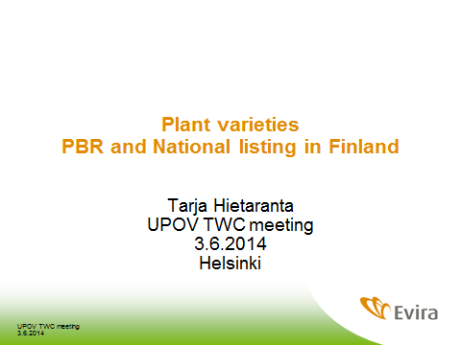

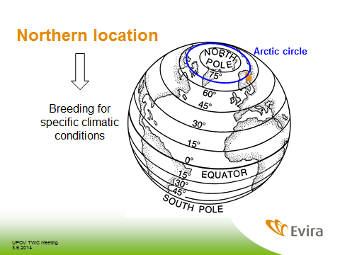

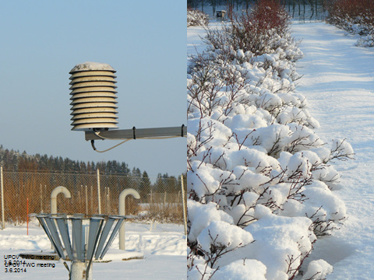

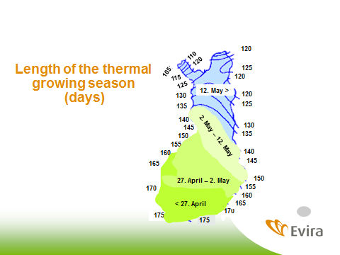

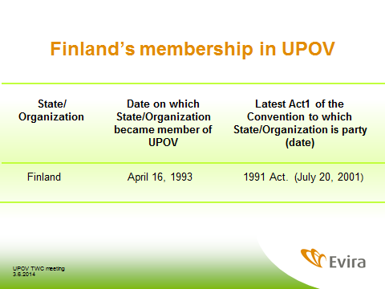

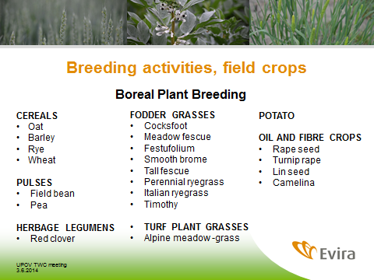

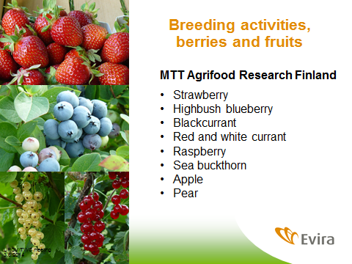

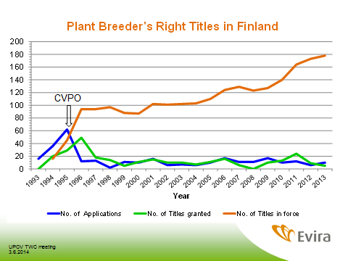

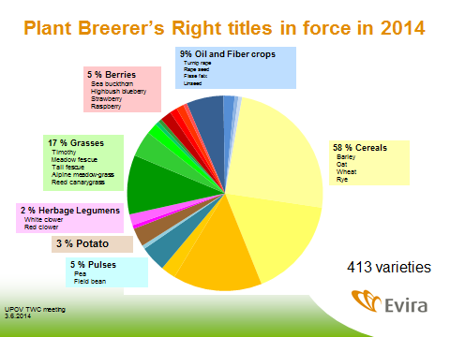

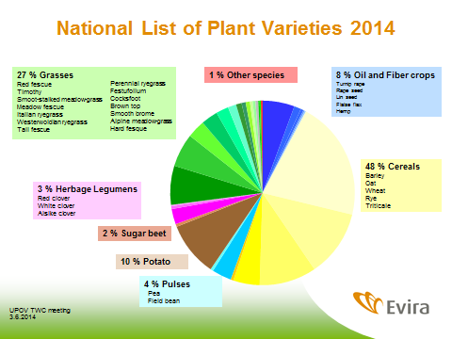

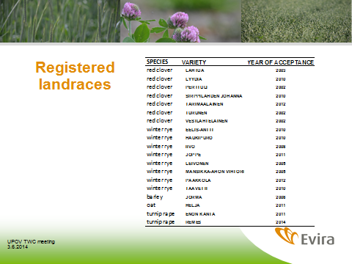

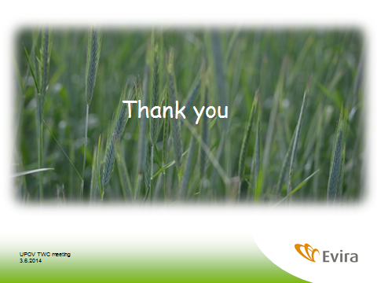

[Annex IV follows]
SEED PRODUCTION AND SEED CERTIFICATION IN FINLAND

Presentation at Technical Visit by Mrs. Hanna Kortemaa, Head of Unit, Seed Certification Unit.
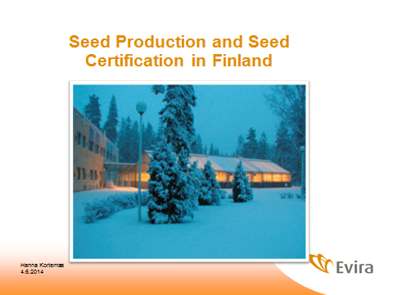

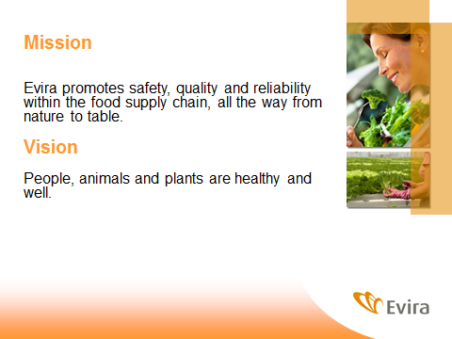

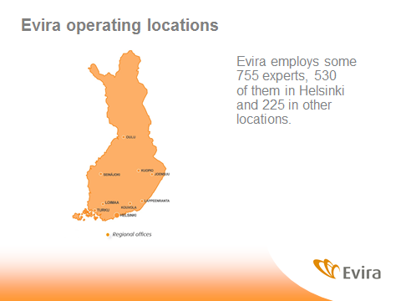

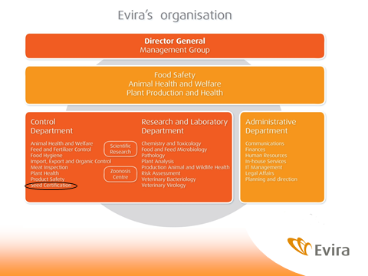

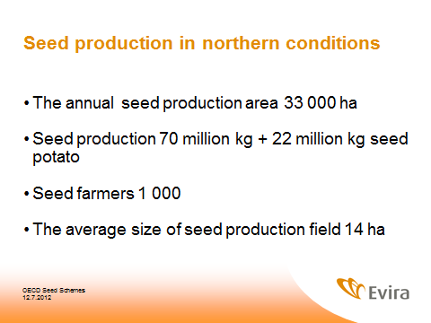

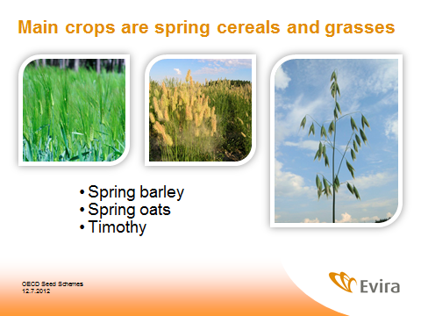

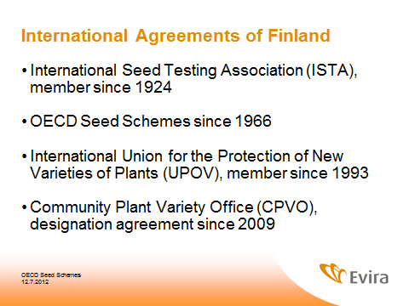

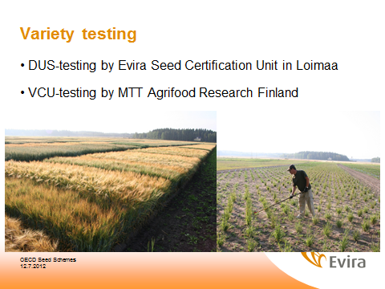

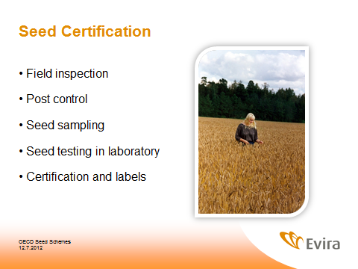

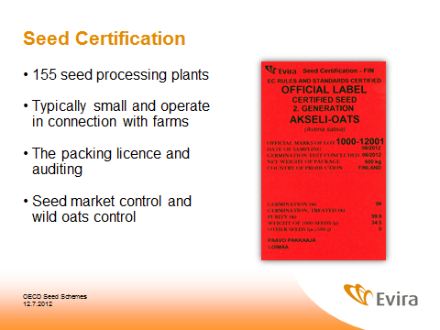

[Annex V follows]
DUS-TESTING IN FINLAND

Presentation at Technical Visit by Ms. Kaarina Paavilainen, Senior Officer, Seed Certification Unit, Evira
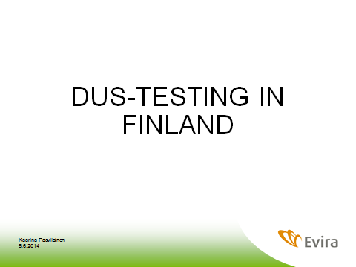

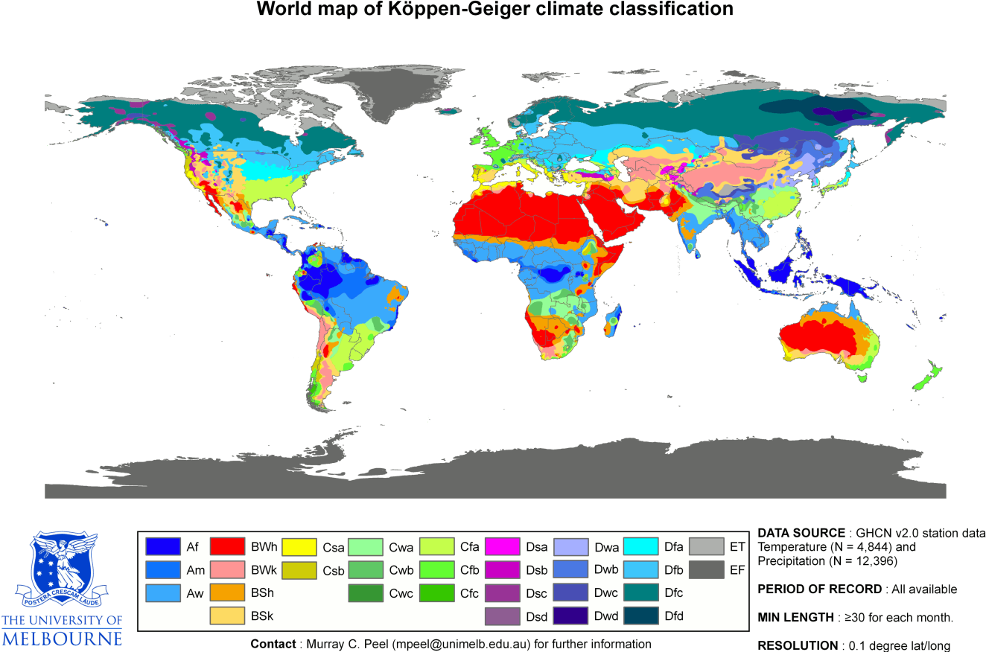

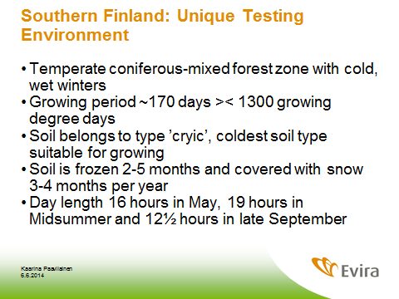

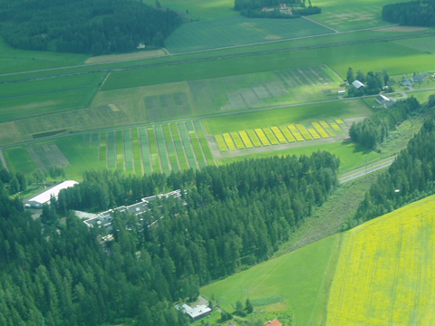

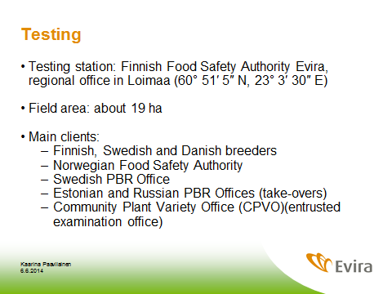

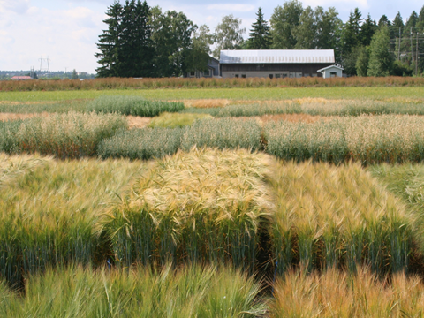

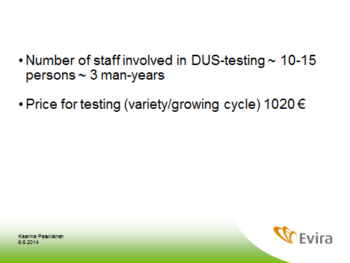

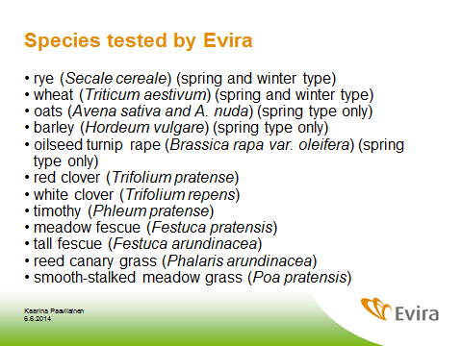

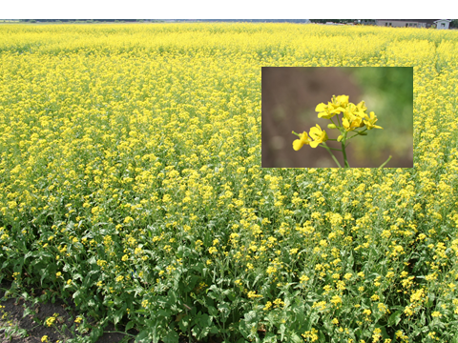

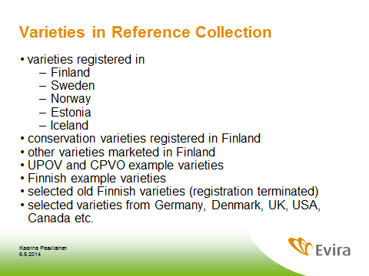

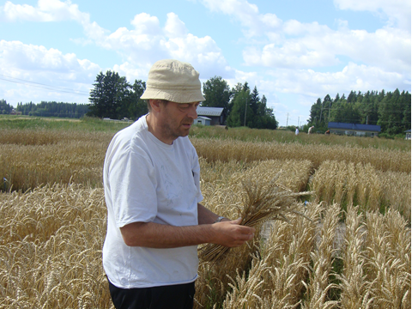

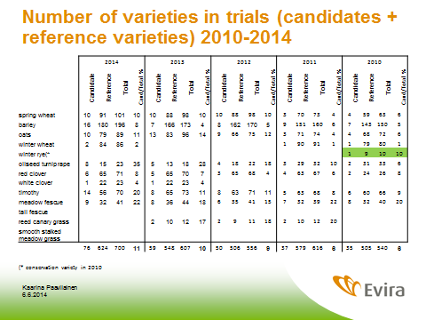

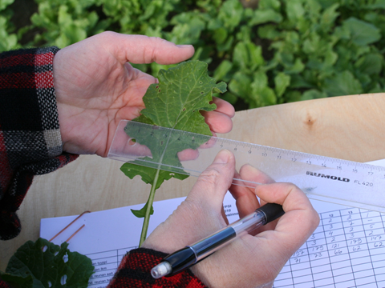

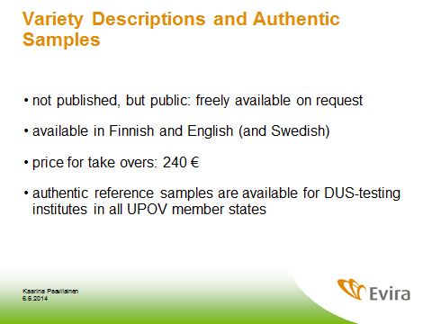

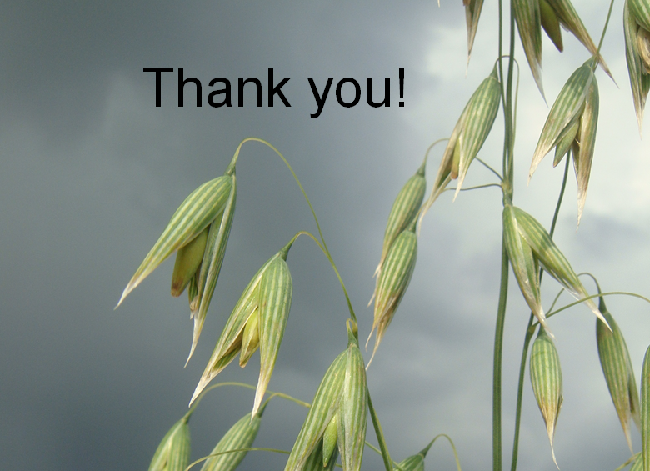

[Annex VI follows]
DUS TESTING FIELD FOR INDIVIDUAL PLANTS

Presentation at Technical Visit by Mr. Sami Markkanen, Senior Officer, Control Department, Evira
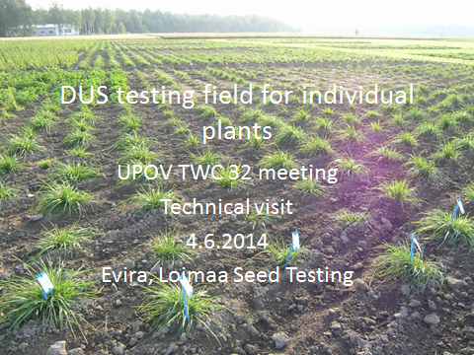

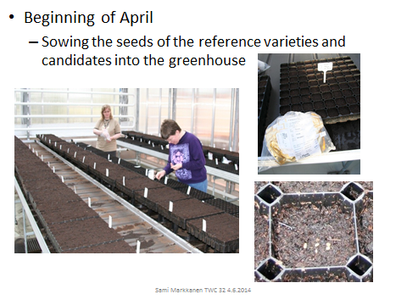

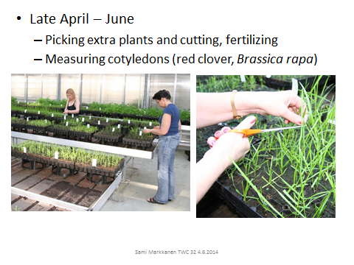

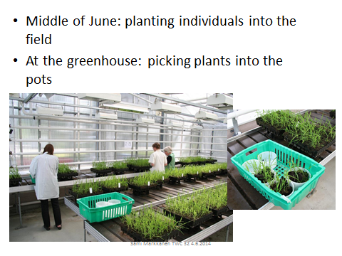

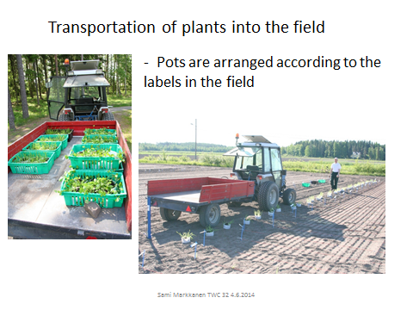

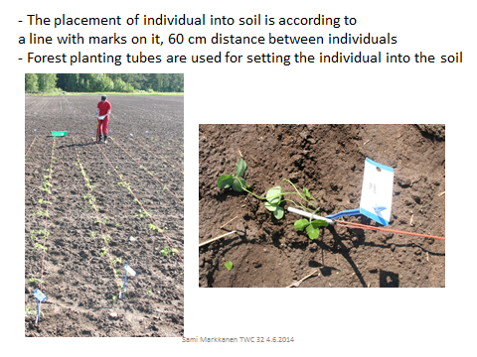

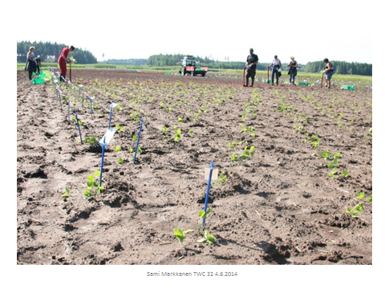

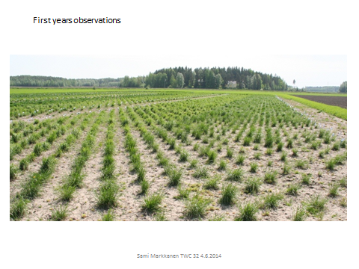

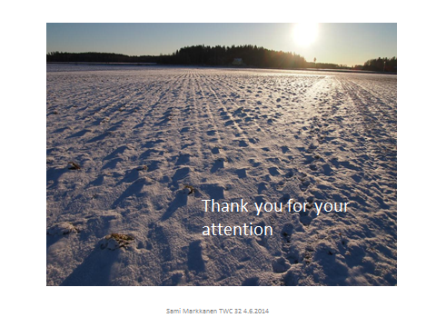

[End of Annexes and of document]

