E
TWC/32/27
ORIGINAL: English
DATE: June 12, 2014
INTERNATIONAL UNION FOR THE PROTECTION OF NEW VARIETIES OF PLANTS
Geneva
Technical working party on automation and computer programs
Thirty-Second Session
Helsinki, Finland, June 3 to 6, 2014
UPDATED SURVEY ON HAND-HELD DATA CAPTURE DEVICES
Document prepared by the Office of the Union
Disclaimer: this document does not represent UPOV policies or guidance

The purpose of this document is to report on developments concerning a survey on hand-held data capture devices.

BACKGROUND

The TWC, at its thirty-first session, held in Seoul, Republic of Korea, from June 4 to 7, 2013, noted the information provided on the updated survey on hand-held data capture devices in the Annex to document TWC/31/28 Rev. as reproduced in Annex I to this document and agreed that a new circular should be issued by the Office of the Union inviting further entries in advance of the thirty-second session of the TWC (see document TWC/31/32 “Report”, paragraph 77).

The Technical Committee (TC), at its fiftieth session, held in Geneva, from April 7 to 9, 2014, requested the Office of the Union to issue a new circular concerning hand-held data capture devices, inviting further entries in advance of the thirty-second session of the TWC. The TC agreed that breeders should also be invited to provide information on the use of hand-held data capture devices (see document TC/50/36 “Report on Conclusions”, paragraph 22).

The TC agreed to propose document UPOV/INF/22 “Software and equipment used by members of the Union” for adoption by the Council at its forty-eighth ordinary session, to be held in Geneva on October 16, 2014, as set out in document TC/50/8, paragraphs 6 to 8 (see document TC/50/36 “Report on Conclusions”, paragraph 110).

On April 29, 2014, the Office of the Union issued circular E_14/113 requesting updates on hand held data capture devices. Annex II to this document presents information on the “Use of hand-held data capture devices in German DUS tests”, prepared by an expert from Germany in reply to the circular.

The TWC is invited to note:

- the summary of information provided by TWC participants on the use of data-loggers for data recording in DUS trials provided in Annex I to this document;

- the information provided by an expert from Germany on the use of data-loggers for data recording in DUS trials in Annex II to this document; and

- that the summary of information provided by TWC participants on the use of data-loggers for data recording in DUS trials will be proposed for inclusion in document UPOV/INF/22 “Software and equipment used by members of the Union” subject to the adoption by the Council.

[Annex I follows]

UPDATED SURVEY ON HAND-HELD DATA CAPTURE DEVICES

Members of the Union | Contact details | Hand-held data capture device used | Type of operating system | Application by user(s)
Belarus | Siamashka Tatsiana, deputy director of DUS testing, State Inspection for varieties testing and protection. Kazintsa str., 90. Minsk 220108. Minsk, Belarus. belsort@mail.ru  Tel. +375 29 1322812.  Fax +375 17 2127451/ | Handheld PC KULON TS-011 (http://www.ts.ru/kulon.html) | Excel / Windows Mobile 5.0 | DUS / VCU
China | Kun YANG, Examiner  Division of DUS Testing, Development Center of Science & Technology, MOA  ROOM 707, Nongfeng Building,  No. 96 Dong San Huan Na Lu,  Chaoyang District, Beijing 100122,  China  Tel: 86-10-5919-9394  Fax: 86-10-5919-9393  Email: yangkunmails@foxmail.com | HP IPAD 4700 | Excel | DUS
Czech Republic | David HAMPEL, Biometrician, Central Institute for Supervising and Testing in Agriculture, (CISTA), National Plant Variety Office, Hroznova 2, 656 06 Brno., Czech Republic tel.: +420 543 548 251 fax: +420 543 212 440 e-mail: david.hampel@ukzuz.cz | PSION Workabout mx | EPOC (Symbian)  OVAL program | DUS
Denmark | Erik Lawaetz, DUS Scientist, The Danish Plant Directorate, Department of Variety Testing, Teglværksvej 10, DK-4230 Skælskør, Denmark | Unitech PA950  Unitech PA600  Unitech PA962 with UMTS network  Datalogic Memor | Excel / Windows Mobile 5.0  Excel / Windows Mobile 5.0  Excel / Windows Mobile 5.0  Excel / Windows Mobile 5.0 | DUS  DUS  DUS / VCU  DUS
France | Christophe CHEVALIER, Groupe d'étude et de contrôle des variétés et des semences (GEVES), rue G. Morel, F-49071 Beaucouze Cedex., France tel. : + 33 2 41 22 86 36 fax : +33 2 41 22 58 01 e-mail: christophe.chevalier@geves.fr | Panasonic Toughbook CF 19  Panasonic Toughbook CF U1 | SIRIUS: Hand data CMP IODR developed by GEVES.  SIRIUS is used in the following crops: Sorghum, sugar beet, maize, wheat, barley, oat, oilseed rape, sunflower, triticale, peas. | DUS / VCU
 |  | ITRONIX
Germany | Thomas DROBEK, Informationstechnologie, Referat 111, Bundessortenamt, Postfach 61 04 40, 30604 Hannover, Germany tel.: +49 511 9566 5688  fax: +49 511 9566 9600  e-mail: thomas.drobek@bundessortenamt.de | PSION Workabout mx  and PSION Workabout mx PRO | EPOC (Symbian)  C- and OPL-programs  Windows Mobil 6.0  C- and Pocket Excel | DUS / VCU
 |  | PNT 1800  Designated replacement in 2012/2013 | WinCE  C-Easy programs | DUS
 |  | ACD M210 Pocket-PC | Visual Studio 2008 – Smart Device Development with Windows CE and Windows Mobile (.NET Compact Framework) | DUS
Israel | Ben-Zion Zaidman, DUS Examiner  Plant Breeders' Rights Unit  Ministry of Agriculture and Rural Development  P.O. Box 30, Bet-Dagan 50250, Israel  Tel: 972-3-9485833; Fax: 972-3-9485839  E-Mail: benzionz@moag.gov.il | Motorola MC55A0 Enterprise Digital Assistant | Windows Mobil 6.5 | DUS
Netherlands | Jan Kees Schipper, DUS expert, Naktuinbouw, Variety Testing Department, P.O. Box 20, 2370 AA Roelofarendsveen  Visiting address, Binnenhaven 1, 6709PD  Wageningen, Netherlands  Tel. +31 (0)6 46713133  Fax +31 (0)317 411721  e-mail: j.k.schipper@naktuinbouw.nl | Itronics Gobook Q.100  Getac PS535F  Leica Disto tm Plus (distance laser-meter)  used in sugar beets | Excel / Pocket PC  2L field(Linx Mobile Solutions)/  Windows Mobile 6.5 | DUS  DUS / VCU  DUS / VCU
 | Gerrit van de Wardt, DUS expert, Naktuinbouw  Variety Testing Department, P.O. Box 20,  2370 AA Roelofarendsveen  Visiting address: Sotaweg 22, 2371 GD  Roelofarendsveen, Netherlands  Tel. +31 (0)6 46713132  Fax +31 (0)71 332 63 63  e-mail: g.vd.wardt@hetnet.nl | Pidion BP 80 | 2L field (Linx mobile solutions)  Windows 7 | DUS
 | Wim van der Kooij, DUS expert, Naktuinbouw,  Variety Testing Department, P.O. Box 20,  2370 AA Roelofarendsveen  Visiting address, Johannes Postweg 1,  8309 PE, Tollebeek, Netherlands  Tel. +31 (0)6 51048483  e-mail: w.vd.kooij@naktuinbouw.nl | LXE-MX7  Ultra sonic distance-meter  used in grass measurements | 2L field(Linx Mobile Solutions)/  Windows Mobile 6.5 | DUS
New Zealand | Jenny Jebson, PVR examiner – Agricultural, Plant Variety Rights Office of NZ, PO Box 9241, Marion Square, Wellington 6141, New Zealand. tel: +64 4 9786322 fax: +64 4 9783691. e-mail: jennifer.jebson@pvr.govt.nz | HP iPAQ pocket PC h6300 series | Microsoft Windows Mobile software | DUS
Poland | Wieslaw PILARCZYK, Expert Statistician, Research Center for Cultivar Testing (COBORU), PL-63-022 Slupia Wielka, Poland tel.: +48 61 285 2341 Ext. 224 fax: +48 61 285 35 58,  e mail: wpilar@au.poznan.pl | PSION Workabout mx | EPOC  OPL-programs | DUS / VCU
 |  | Palmtop PC/ Tablet PC | Windows CE
Republic of Korea | Mi-Hee Yang, Examiner, Senior Researcher, Korea Seed & Variety Service, MIFAFF, Republic of Korea  e-mail: mh730@seed.go.kr | Fujitsu P Series Lifebook with wireless network system of HSDPA
Sweden | Torbjörn Leuchovius, Unit if Applied Field Research (Fältforsk), Swedish University of Agricultural Sciences (SLU), VPE Box 7043, SE-75007 Uppsala, Sweden Tel +46-18-671825 e-mail Torbjorn.Leuchovius@slu.se | Husky Fex21 (old equipment), Psion Workabout PRO, Portable Windows 7 computers like HP Elitebook 2540 etc, Windows XP Tablet PC computers | Windows Pocket PC 4 (old equipment), Windows Mobile 6+, Windows XP tablet PC, Windows 7 | VCU

[Annex II follows]

USE OF HAND-HELD DATA CAPTURE DEVICES IN GERMAN DUS TESTS
Document prepared by an expert from Germany

In German DUS tests experts are using different hand-held data capture devices depending on type of data.

For measurements the 12 years old equipment “PNT1800” from German company “Infos” were replaced by new devices “M210” from German company “ACD” in 2013 (see for reference). The data entry program was developed by our own programmers using programming language “Visual Basic.Net” (Microsoft). The advantage is that we are able to react on questions of our users regarding to mistakes, changes and extensions faster than in the past and without cost for external service.

The new device consists of touch-sensitive screen with handling by pen. An internal scanner is available. Windows CE 5.0 is used as operation system. Data are stored in a database named “SQL Server Compact” (Microsoft).

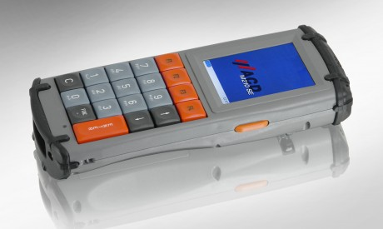 Figure 1: Hand-held device “ACD-M210”

Handling of new devices is more comfortable than by using of previous programs on older devices. Big keys are available on “M210” of the same size as on “PNT1800” to facilitate data entry of measurements.
USB-standard is using to exchange data between hand-held devices and personal computer and is faster than previous serial procedure.

There are now 40 new hand-held devices using for measurements in DUS tests on trial stations. In 2013 more than 5 million measurements on single plants for more than 80 species were captured at 11 locations on 1,000 characteristics with up to 3 replications (plots) and 20 single plants.

Examples:
Species | Number of  Characteristics | Number of Replications | Number of Varieties | Number of Plants | Number of Measurements
Rye grass | 18 | 3 | 753 | 20 | about 813,000
Pelargonium | 10 | 1 | 89 | 10 | 8,900
Berseem Clover | 7 | 3 | 9 | 20 | 3.780
Begonia | 3 | 1 | 8 | 10 | 240

For other characteristics (visual observed characteristics) in German DUS tests hand-held data logger “PSION Workabout mx” and “PSION Workabout mx pro” are using. The advantage of these devices is the ability of data entry by one hand so that the second hand is free for other work in the field.

Figure 2: Hand-held device “PSION-Workabout mx”

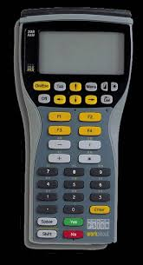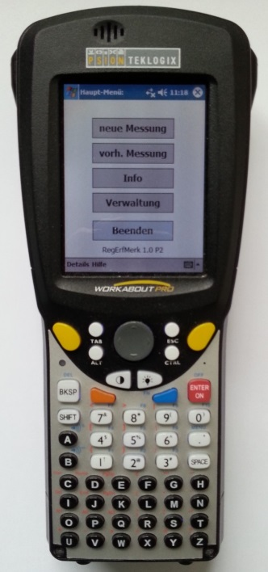

Figure 3: Hand-held device “PSION-Workabout mx pro”

References:
ACD:
http://www.acd-gruppe.de/en/produkte/mobiles-terminal-m210se/
PSION:
http://www.pulster.de/info/psion/workabout/psion-teklogix-workabout-mx-faq-pulster.htm

[End of Annexes and of document]

