E
TWC/32/26
ORIGINAL: English
DATE: June 13, 2014
INTERNATIONAL UNION FOR THE PROTECTION OF NEW VARIETIES OF PLANTS
Geneva
Technical working party ON AUTOMATION AND COMPUTER PROGRAMS
Thirty-Second Session
Helsinki, Finland, June 3 to 6, 2014
Reports on development in plant variety protection
from members and observers
Document prepared by the Office of the Union
Disclaimer: this document does not represent UPOV policies or guidance

The Technical Committee (TC), at its forty-seventh session held in Geneva, from April 4 to 6, 2011, agreed to request the Office of the Union to invite experts to submit written reports to the Office of the Union in advance of the Technical Working Party (TWP) sessions in order that a document containing those reports could be prepared by the Office of the Union. The TC noted that TWP experts would be invited to make a brief oral summary of their written report at the session and would also be encouraged to make reports under the agenda item “Experiences with new types and species”, as appropriate. The TC also noted that TWP experts would have an opportunity to raise questions concerning matters of interest (see document TC/47/26 “Report on the Conclusions”, paragraphs 9 and 10).

Written reports were requested by the Office of the Union in Circular E14/087. The following reports were received (in alphabetical order):

Members of the Union: Annexes I to VII: France, Italy, Japan, Netherlands, Republic of Korea, South Africa, United Kingdom

[Annexes follow]

FRANCE

Sharing the online application of the Community Plant Variety Office of the European Union (CPVO)
The aim of this project is that national examination offices share the Community Plant Variety Office of the European Union (CPVO)’s online application system for their own applications (PVR and/or National list).
The system should include the management of: Application form, DUS TQ and VCU TQ.
Two country pilots were identified for this project: France and Netherlands.
The current
For France, We have finalized the application form and the TQ on two species Maize and Lettuce.
We’ve got a meeting on the last 27th of February with CPVO, NAKT and GEVES to sum up the feedback from clients during the test phase performed last November/December.end of June or July.

Electronic Exchange platform with the CPVO
The aim of this project is to exchange electronic documents between several partners (the CPVO and its examination offices) via an exchange platform hosted on a dedicated server.
There are currently 2 examination offices that have already developed a B2B interface to the platform and are today in a position to send and receive documents from and to their local electronic management of document systems
The CPVO developed recently a ‘CPVO Box’ web page to access to the platform without having to develop a B2B system. Documents can be dropped to a web page and sent to the CPVO. This solution is particularly adapted to examination offices not willing to develop a B2B system because they do not have the resources or because the flow of documents with the CPVO does not justify it.
The aim for the CPVO is to:
- stop sending documents to all EOs in paper format by July 2015
- no longer accept documents in paper format from all EOs by January 2016
The French, Dutch and Spanish partners did not see any impediment to stop exchanging paper with the CPVO. The German and United Kingdom experts considered that the development of an xml format in order to exchange all information included in pdf documents was a pre-condition before abandoning paper.
It was concluded that the exchange platform was a workable tool. All the partners wish to continue to use the exchange platform and wish to extend the use of the platform to all the EO.
The CPVO will reconsider its vision taking into account the comments addressed by partners during this meeting and will organise a mailing with some milestone proposals to all examination offices in order to collect a feedback before a conclusion is drawn and possibly presented to the general meeting with examination offices in December 2014.

CPVO web services
As we have done with the CPOV web service ‘CPVO Variety Finder Denomination’ to manage the test of denomination, we are going to use the new web service developed by CPVO called ‘CPOV Variety Finder Search’. The Web service runs a SQL command to search the trademark into the CPVO database taking into account the input criteria perimeter and specie code.
In return, the user is receiving the list of the denomination returned by the searching tool.
Nothing is recorded into the CPVO database, this web service is the equivalent to the searching tool of the CPVO variety finder web site.
The number of lines returned by the SQL statement is limited to 50 000 lines.
This web service is going to be the starting point of new process “Management of the reference collection’ that we are going to develop in the next month. This process should centralize and harmonize the way that DUS expert define their own theoretical reference collection.

[Annex II follows]

ITALY

In Italy, from May 2013 the CRA SCS (Council for Agricultural Research - Experimentation and Seed Certification Center) is the body responsible for the coordination of official trials of registry and plant protection on behalf of the Ministries.

It is the Ministry of Economic Development that grants plants variety rights in collaboration with the Ministry of Agriculture and Forest.

The situation of the Italian Property Rights (national protection) is as follows:

- during the year 2013, 2 applications for variety protection were filed: 1 for agricultural crops, 1 for fruit crops. None application were approved during 2013.

The situation of Community Plant Variety Right (EU protection) is as follows:

- the total number of applications sent from Italy to the Community Plant Variety Office (CPVO) of the European Union in 2013 was 62: 18 for agricultural crops, 17 for fruit crops, 20 for ornamental plants, 5 for forest trees and 2 for vegetables. The total number of applications requested by Italian companies and approved by CPVO during 2013 was 7 (agricultural crops).

[Annex III follows]

JAPAN

1. Number of application and granted in 2013
Number of application
year | No. of Applications | (2013/2012)
1978 to 2013 | 29,029 | -
2012  2013 | 1,110  1,054 | (95%)

Number of granted
Year | No. of PBR Granted | (2013/2012)
1978 to 2013 | 22,919 | -
2012  2013 | 881  752 | （85%）

2. Average duration of the examination procedure (from application to registration)
2012 | 2013 | 2014 (target)
2.34 year | 2.48 year | 2.3 year

Web-site: http://www.hinsyu.maff.go.jp/en/en_top.html

[Annex IV follows]

NETHERLANDS

Number of applications received
In 2013 1904 applications were received for testing for the first year for national listing and national and European Plant breeders rights. (In brackets the difference with 2012):
Ornamentals 972 (+11%)
Agriculture 144 (+10%)
Vegetables 788 (+20%)
Total 1904 (+15%)
This is an important increase and an all-time record high number of applications. The number of applications received in 2014 up till now, still shows a further increase, except for Ornamentals.

Registration
- The online version of the Netherlands Register of plant varieties (NRR) was included in the thoroughly revised website of the Dutch Board for Plant Varieties RvP (www.raadvoorplantenrassen.nl).
- The use of the i-portal for DUS-applications at Naktuinbouw has increased. Also the electronic exchange of application forms and reports with CPVO vice versa has been started in the beginning of 2014.
- Variety Denominations
In 2013 the CPVO published a new version of the explanatory notes for the checking of the suitability of variety denominations. The CPVO has explained the contents of these notes in a meeting with the Dutch breeding companies. The contacts between CPVO and Dutch Board for Plant Varieties/Naktuinbouw are strengthened in the field of exchanging visions on the suitability of variety denominations.
- Registration of fruit varieties
In the framework of the new Fruit species directive of the European Union, Naktuinbouw made an inventory of those fruit varieties that are being marketed in the Netherlands. As foreseen in the directive a distinction has been made in those varieties that were tested on the DUS principles for Plant Breeders’ Rights, and can thus be certified, and other varieties. In 2014 descriptions of more than 1200 fruit varieties will have to be finished. We try to cooperate with other European (fruit) partners to exchange information.
For membership of the TWF, Gerard Bolscher (who will retire in May 2014) has been replaced by his successor Marco Hoffman.
- Developments in VCU
VCU testing of agricultural crops has been collectively financed by breeders and farmers in The Netherlands for a long time already. Due to reorganization of some public institutions there is no collective farmer’s contribution anymore. From 2014 onwards VCU will be 100% financed by the breeders only.

Quality System
- The second CPVO-audit according to the standards for CPVO entrustment of all ca. 950 species was carried out in 2013. The renewed entrustment was formalized by the decision of the CPVO Administrative Council in March 2014.
- Updating common knowledge Vegetables. In 2013 Naktuinbouw started a project to update information of disease resistance characteristics from varieties of common knowledge. Another project is ongoing in cooperation with GEVES. In tomato, pea and lettuce GEVES and Naktuinbouw developed combined databases.

Training in DUS related activities
The sharing of knowledge is important in order to work on a global, harmonized and strong Plant Breeders Right system for the benefit of society. Naktuinbouw contributes to this principle on different levels.
- Naktuinbouw is involved in bilateral projects to exchange knowledge and to train staff of countries that are working in or on Plant Breeders Rights systems. Besides ongoing projects in China and India in 2013 the following projects started :
  - In Ghana, where the Ghanaean authorities asked assistance in the setting up of a system now the PBR law was accepted by UPOV,
  - in Rwanda, where advise was given on the agricultural policy including the necessity to provide for a good system of variety protection to promote in influx of better varieties,
  - in Ukraine and:
  - in the United Republic of Tanzania where an adjusted form of the Wageningen PVP course will be given on location in the framework of capacity building in this new UPOV member.
- Annually, Naktuinbouw, with the help of UPOV and CPVO, is organising the PVP course in Wageningen, under coordination and supervision of Mrs. Laura Piñán González. In 2013 31 participants from 19 countries participated in this two week training.
- Four colleagues will follow in 2014 the tutor-education of the new UPOV distance learning course DL-305 “Examination of Applications for Plant Breeders’ Rights” (a joint effort of UPOV, Naktuinbouw and experts of other UPOV countries).
- In 2013 Naktuinbouw, in the framework of the internship programme received again 4 colleagues from the UPOV office (1), Zimbabwe (1) and the Republic of Korea (2). The colleagues work together with Naktuinbouw colleagues and thus learn the details of the DUS test work as it is performed in the Netherlands. The use of the Naktuinbouw helpdesk stabilised. Colleagues from all over the world find this opportunity to ask DUS related questions.
- Recently Naktuinbouw published a book; “framework for the Introduction of Plant Breeders’ Rights”. This book, written by Arnold van Wijk and Niels Louwaars is a guidance for practical implementation of a Plant Breeders’ Rights system in a country. We hope with this book, that contains lots of explanations and examples, to offer support to those colleagues who work in countries that recently started, or will start a (UPOV based) Plant Breeders’ Rights system.

Research projects (highlights).
- Handhelds-project: The description for the DUS tests made in field conditions was made on paper for ornamental and vegetable crops in the past. In 2013 Naktuinbouw changed this procedure and now uses handhelds for this purpose. In 2014 the project continues in order to be able to also use handhelds for the comparison between applications and comparing varieties in the field trials.
- Harmonization of disease resistance tests within the EU. In 2013 several tests were carried on within this CPVO project. Results are expected in 2014.
- Ongoing projects: 1-project on change of crop management (from outdoor to indoor) for DUS in Helleborus, together with CPVO; 2-origin of chimera-like structures in Lily and a number of projects to study the possible effect on the DUS work of a change in growing media from soil to artificial media.
Other:
- CIOPORA has contacted CPVO and Naktuinbouw about the setup of a new DNA-project in Rose together with BSA and NIAB. Discussion about a draft will be continued in 2014.

International Cooperation
With GEVES:
The on-going cooperation with GEVES was evaluated in the beginning of 2014. Activities will be intensified in joint data bases of vegetable varieties, joint resistance tests, dbases for photographs and descriptions of ornamental varieties (GEMMA), standardized color description techniques (AIM).
Projects in the CPVO R&D system
Naktuinbouw participates in a number of CPVO co-funded projects:
- The Harmores project; harmonization of disease resistance testing between a number of Examination Offices
- The potato Ringtest project to harmonize the testing of potato between the European Examination Offices
- Development of a European Potato database (containing molecular and morphological data) as a centralized collection of varieties of common knowledge.
- A project to study the possible effect of seed treatment on the DUS test in vegetables

Infringement cases
The use of the DUS sample and DNA data of the DUS samples for infringement purposes is under discussion in the Netherlands between the authorities and the industry. Also the question on ownership of the DUS sample itself plays a role in this discussion.

Miscellaneous
- The oldest part of our greenhouses was renewed and enlarged are ready for use since March 2014.

[Annex V follows]

REPUBLIC OF KOREA

Current status of plant variety protection in the Republic of Korea

1. Plant Breeder's Right
Total number of application as of April 30, 2014 has been reached 7,138 and among them, 5,018 varieties were registered and 797 varieties were rejected or cancelled since implementation of PVP system in 1998.

2. Integrated Information System of PVP Examination in KSVS
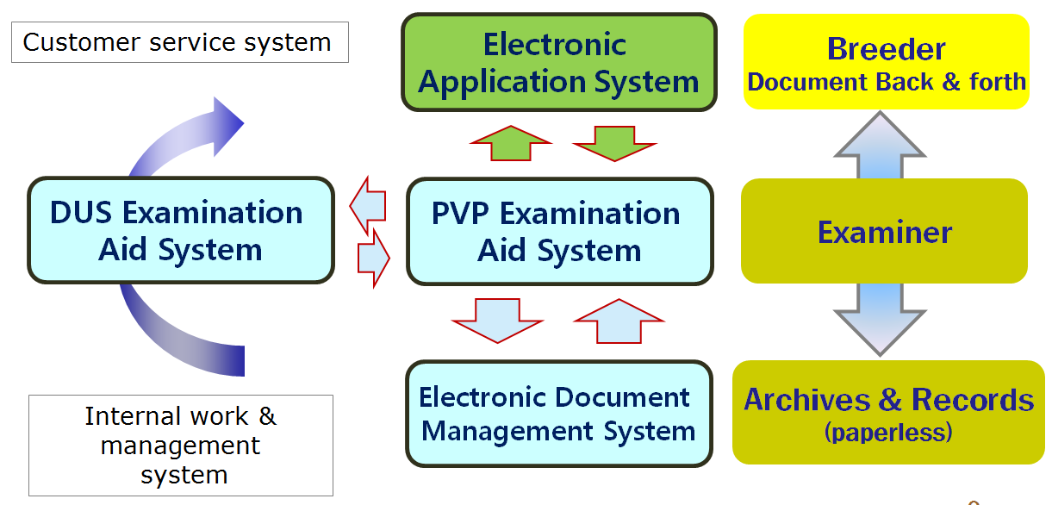
① Electronic Application System
- Internet, URL : http://www.seednet.go.kr
- Applicant can fill in and file up application form and pay application fee
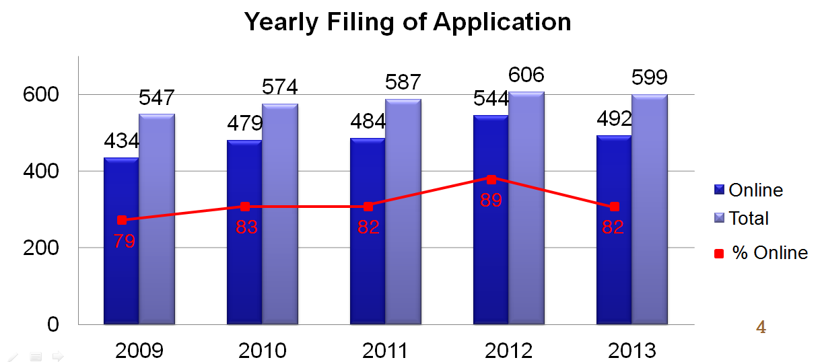
② PVP Examination Aid System
- Intranet, URL : http://portal.seed.go.kr
- Operation staff receives electronic application form and manages PVPR
- Examiner inspects PVP application and decides whether he/she grants PVPR or rejects application
③ DUS Examination Aid System
- Intranet, URL : http://portal.seed.go.kr
- DUS Examiner enters DUS trial data and practices statistical processing and then writes DUS trial report
④ Electronic Document Management System(EDMS)
- Intranet, URL : http://portal.seed.go.kr
- Application form and all documents related to Examination are converted to PDF file format and transferred to EDMS for storage, search and reference

3. Variety Characteristic Search System
① Objective
- PBR judge or examiner for DUS trial is easy to select comparing variety by searching plant variety characteristics
② Database
- applied variety, reference variety and so on (since 1998)
- stored variety number : 13,318 (216 crops)
(as of April. 30. 2014)
Total | Red pepper | Rose | chrysanthemum | Rice | Chinese cabbage | Others
13,318 | 1250 | 961 | 710 | 584 | 531 | 9,282

③ Development course
- To store various image of variety in PV Database
- Number of stored variety image : 11,957(181 crops/4,816 varieties)
4. Plant Variety Protection Law
In the Republic of Korea, Plant variety protection was enforced by Seed Industry Law since 1997. Recently, new Plant Variety Protection Law was enacted in 2 June last year for reinforcing its effectiveness. Thereafter, its decree and regulations also will be enacted.

5. Molecular Techniques
Recently, our country is actively applying DNA analysis to seed circulation management of several crops. The representative example is analyzed about comparison of DNA profiles between registered seed and marketing seed. In addition, we are utilizing molecular markers in genetic purity assessment of national list of varieties of rice, barley and soybean.

6. International Cooperation
KSVS provides PVP training course for the 16 experts from Asian and African countries for 3 weeks in June 2014, supported by KOICA financially.
KSVS is scheduled to host the UPOV Working Group on Biochemical and Molecular Techniques, and DNA-Profiling in Particular (BMT). This session will be held on 9-13 November 2014, in Seoul.

[Annex VI follows]

SOUTH AFRICA

With regards to applications and valid Plant Breeders’ Rights for 2013 the following is reported:
- An additional 29 taxa have been declared in terms of the Plant Breeders’ Rights Act during 2013.
- 309 PBR applications were received of which 30% were for Agricultural crops, 39% for Ornamental crops, 27% for Fruit crops and 4% for Vegetable crops.
- As of December 2013, a total of 2607 varieties had valid plant breeder’s rights in South Africa, of which 34% were for Ornamental crops, 34% for Agricultural crops, 23% for Fruit crops and 9% for Vegetable crops. The top three crops for each crop are:

FRUIT CROPS
1. Prunus persica (L.) Batsch var.
nucipersica Schneid. (105)
2. Vitis L. (71)
3. Prunus persica (L.) Batsch (105)

AGRIC CROPS
1. Solanum tuberosum L. (93)

2. Triticum L. (83)

3. Zea mays L. (352)

ORNAMENTAL CROPS
1. Aloe L. (46)

2. Chrysanthemum L. (65)

3. Rosa L. (341)

VEGETABLE CROPS
- Allium cepa (34)

- Phaseolus vulgaris L. (36)

- Solanum lycopersicum L. (49)

White CONV 86
PBR’s granted in 2013 only are as follows: White open pollinated 6 White GMO 73
Agricultural crops: 101 Yellow CONV 69
Vegetable crops: 16 Yellow GMO 118
Fruit crops: 66
Ornamental crops: 71

[Annex VII follows]

UNITED KINGDOM

Progress/developments of a statistical nature in the United Kingdom include the following:
- A uniformity-testing module is being developed in the DUST software which uses the modified methodology for COYU. This will permit the next stage in the evaluation of the methodology, which is for countries to use the software on their data, to compare the results with their existing methodology, to consider appropriate probability levels for its usage in uniformity testing with different crops, and to report back to the TWC.
- We are continuing to work on methodology for prediction COYD results after the first year. This is to be used to identify thresholds for elimination of reference varieties, potentially for use with methods such as GAIA, and was previously reported in TWC/28/30. We are currently looking at extending the current approach to accommodate heterogeneity in variety-by-cycle variability.

[End of Annexes and of document]

