E
TWC/32/25
ORIGINAL: English
DATE: May 23, 2014
INTERNATIONAL UNION FOR THE PROTECTION OF NEW VARIETIES OF PLANTS
Geneva
Technical working party ON AUTOMATION AND COMPUTER PROGRAMS
Thirty-Second Session
Helsinki, Finland, June 3 to 6, 2014
implementation of a document management system for variety files
Document prepared by an expert form Germany
Disclaimer: this document does not represent UPOV policies or guidance
The purpose of this document is to report on implementation of a document management system for variety files.

Introduction
The Bundessortenamt started in 2007 to use a new electronic system to file applications for national listing and plant breeder's rights. The electronic filing system is based on a new form server system (see document TWC/26/22).

In a second step in 2012, an electronic document management system was introduced to handle the variety files for maize, spring barley, ryegrass and sugar beet which was expanded to 12 further species in 2013. Now there are electronic files for 4,100 varieties. The system will be used for another 30 species in 2014.

Following functions are available:
- Fully automatic generation of variety files in an electronic file system controlled by the database for administrative data using files in xml-format
- Fully automatic generation of lists for new application sorted by species and year
- Use of electronic postboxes for users and groups of users for sending of variety files to other users
- Use of electronic desktop for daily work with documents, processes and variety files
- Different search functions (full text, search for administrative data)
- Addition of a subset or fraction of a variety file (protection, national listing, other)
- Addition of a separate set of documents (for example: disagreement of applicant)
- Addition of new documents received from applicant or sending to them
- Possibility to use reminders
A variety file is always a set of documents and generally not a single document. Two levels of sub files can be used.

Description of the variety file system
A separate client program was developed (see Figure 1). The translation of function names is part of Table 1 (Legend of Fig.1). The rough structure consists of a file cabinet, lists of new applications, a postbox and a desk for temporarily deposition of variety files.
Legend number: 5 6 7 8

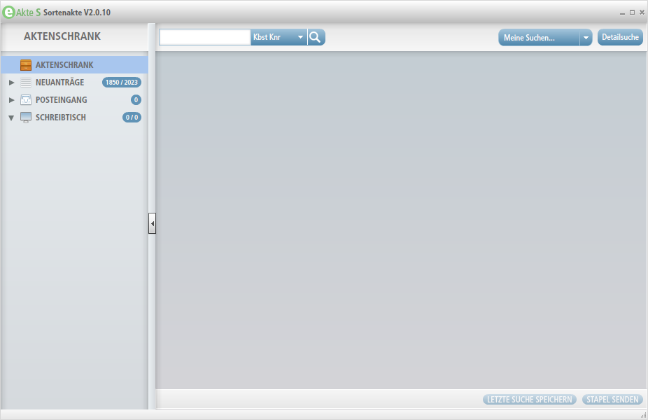
1
2
3
4
9 10
Figure 1: electronic variety file client program

Table 1: Legend of Fig. 1
Number | German description | English description
1 | AKTENSCHRANK | file cabinet
2 | NEUANTRÄGE | Lists of new applications
3 | POSTEINGANG | post inbox
4 | SCHREIBTISCH | desk
5 |  | input field for simple searches
6 | Kbst Knr | Standard option for search condition  shortcut of species and variety number
7 | Meine Suchen | My own searches which I had stored before
8 | Detailsuche | Search option for detailed searches
9 | Letzte Suche speichern | Store last search
10 | Stapel senden | Sending a pack of variety files

Searching for a variety in the file cabinet (for example maize variety with application number 13856) leads to the following screen where information about the variety is available using stored metadata (see Figure 2). Translation of information names is part of Table 2 (Legend of Figure 2).

Legend number: 11 12 13 14 15 16 17

Figure 2: information on metadata of a single variety

Table 2: Legend of Fig. 2
Number | German description /pictogram | English description
11 | M | M is the abbreviation for species maize
12 | 13856 | Application number
13 | UH 010  725  Hohnheim  6830 | Breeders reference  Number of applicant  Applicant name  Number of Agent or representative
14 | Antrag Schutz  31.01.2013  Erteilung Schutz  Löschung Schutz  Antrag Zulassung  Eintragung Zulassung  Löschung Zulassung | Date of application for protection  31st of January 2013  Date of protection  Date of termination  Date of application for National List  Date of addition to National List  Date of deletion from National List
15 |  | Abbreviation and sign for protection procedure (in German: Schutz)
16 |  | Push button to get metadata as tip text
17 |  | Button to delete variety from search list (not in file cabinet)

Looking into the variety file information (protection or national listing), document names and first page of newest or chosen document in an Adobe Reader frame are available (see Figure 3). All documents are stored in pdf/A-Format (long term format for storing documents) with the possibility of optical character recognition (OCR) which is necessary for full-text search. Translation of information names is part of Table 3 (Legend of Figure 3).
Legend number: 18 19 20 21
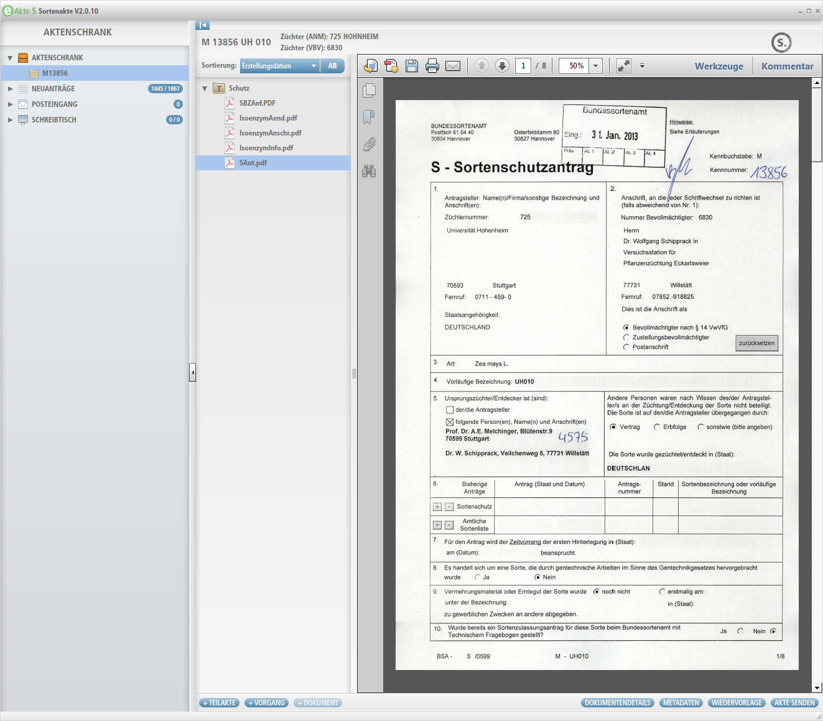
22 23 24 25 26 27 28

Figure 3: First view into a variety file
Table 3: Legend of Fig. 3
Number | German description / pictogram | English description
18 |  | Sub-file (Teilakte) of variety file for protection procedure
19 |  | pdf-document of application form (protection)
20 |  | Documents are sorted descending by date of creation, other sort sequences are available
21 |  | Standard functions of Adobe Reader
22 | + Teilakte | Add a new subset of variety file documents for addition to national list for example (first level)
23 | + Vorgang | Add a new subset of variety file documents within the same procedure (second level)
24 | + Dokument | Add a new document
25 | DOKUMENTENDETAILS | Push button to get more details of document
26 | METADATEN | Push button to get all metadata of variety file
27 | WIEDERVORLAGE | Push button to generate a reminder
28 | AKTE SENDEN | Push button to send a variety file to one or more colleagues with a small comment

The frame in the middle of the screen consists of information about the kind of procedure (protection or national listing) for the variety which is stored in a separate sub-file. The first document in such a sub-file is the application form as a pdf-file including the technical questionnaire and other parts of the application form. All documents are sorted descending by date of creation but other orders of documents can be chosen. There is a possibility to add new sub-files but normally sub-files will be created automatically by using information of the administrative database in XML-Format. These controlling files are stored in a so-called watched folder to interact with the variety file system. Furthermore there are functions to add subsets of documents or individual documents.

With push button it is possible to get information about details of the chosen document like name of the document, date of creation, name of person who had imported the document into the system, date of last change of the document and name of person who changed the document. The push button “METADATEN” provides metadata information about the variety (species, application number, denomination etc.). It is also possible to generate a reminder by using push button “WIEDERVORLAGE”. Another important function is to send a variety file to one or more colleagues (AKTE SENDEN). Here it is possible to add a small comment to inform the addressee.

A very specific function is the list of new application which will be created manually and filled automatically by using controlling files in xml-format which are fully automatically produced by the administrative database (see Figure 4). Translation of information names is part of Table 4 (Legend of Figure 4).

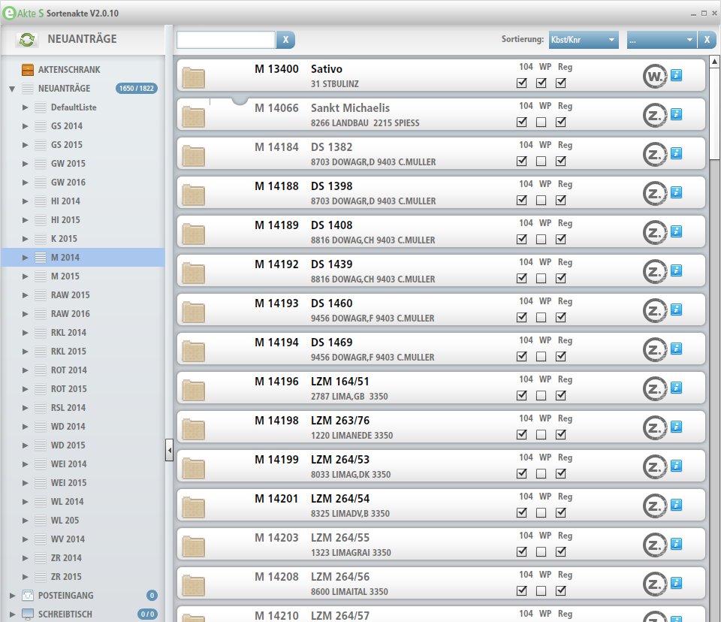
29 30 31

Figure 4: List of new applications (Example: Maize 2014, extract)

Table 4: Legend of Fig. 4
Number | German description / pictogram | English description
29 | 104 - tag | Box to mark a variety as ready in variety registration unit
30 | WP - tag | Box to mark a variety as ready for planning in VCU unit
31 | Reg - tag | Box to mark a variety as ready for planning in DUS unit

New applications are grouped in lists for each species and year. Three units of Bundessortenamt have to mark a variety if the administrative work on the application forms is done.

Additionally there is a possibility to look into two different variety files (M 13856 and 13857 respectively) at the same time (see for Figure 5) if the screen has a diagonal length of 24 inches or more. That is necessary for example if the user has to compare two different technical questionnaires or other documents.
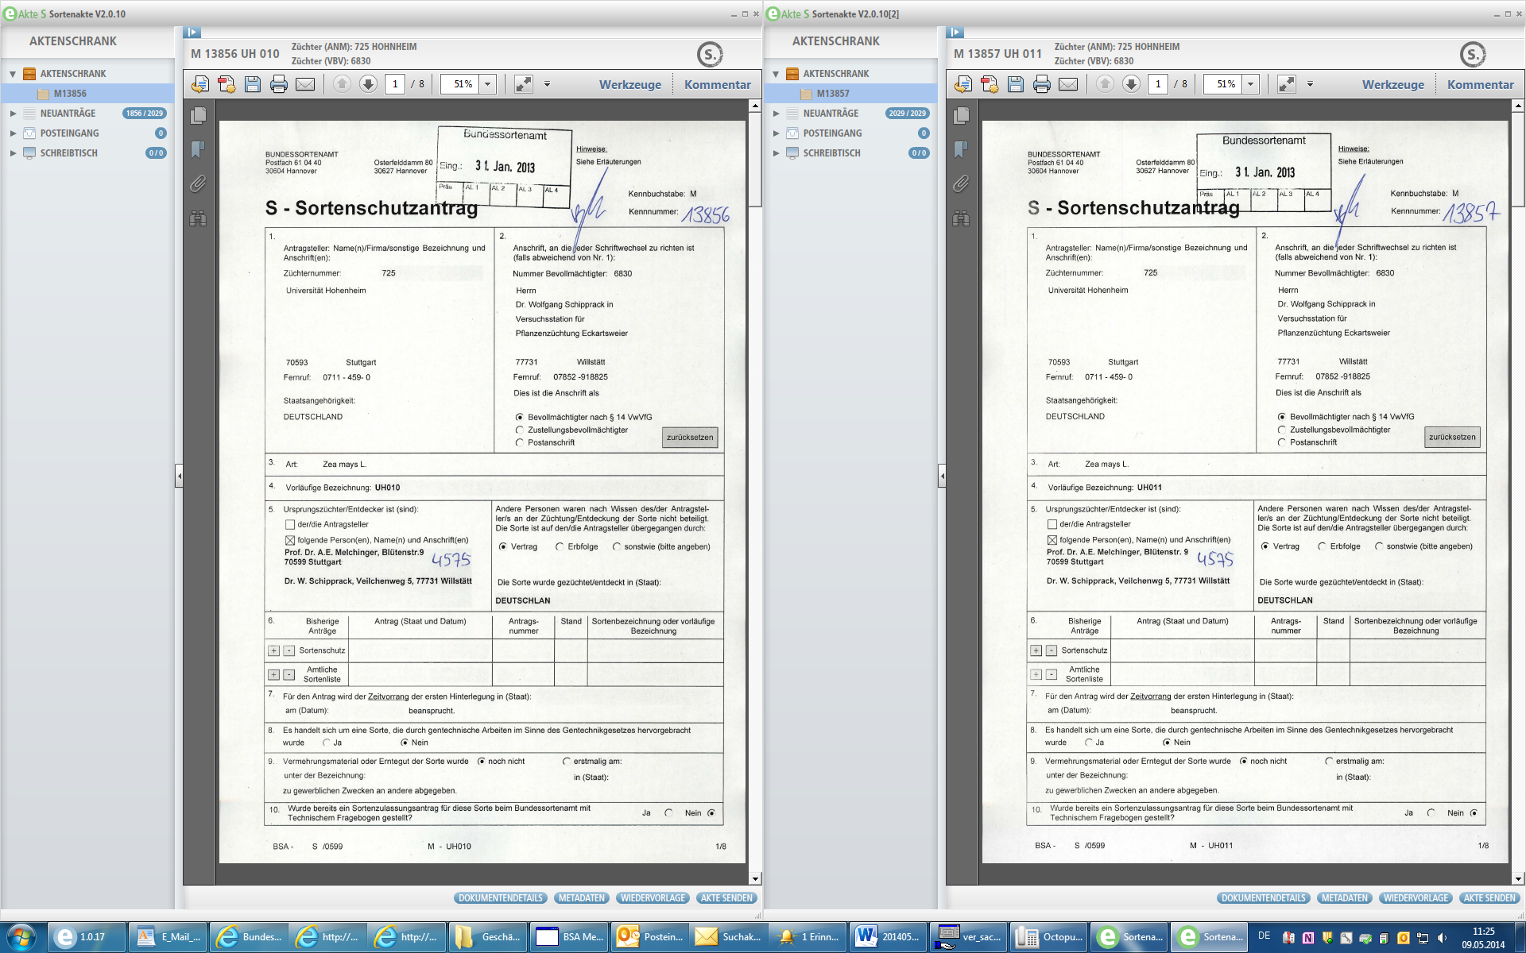
Figure 5: Screen dump for two different variety files on the screen at the same time

All functions are based on server software of company “Adobe” (LiveCycle Workspace, Contentspace and CRX) and a client program (Adobe Air) developed by Bundessortenamt and “Adobe”. The user interface of all own programs are in German language only.

Description of procurement file system and document management system using four-step filing plan
There are two other parts of the project where programs are developed for:
- handling of electronic files for procurement of hardware, software and services of information and communication technology
- daily work with official documents in electronic form by using a four-step filing plan
Currently, both systems are used in the IT unit and the library of the Bundessortenamt only but it is planned to expand them to other units in short time. There were about 450 e-Procurement files in 2013 in electronic workflow system and 780 files from 2010 to 2012. It is expected to grow up in 2014 to 600 new files by including procurement of laboratory unit. It leads to 1,830 files up to the end of 2014 (file = set of documents).

For the daily work with official documents in the IT unit of the Bundessortenamt about 10,000 existing documents were imported in the first quarter of 2013 and about 2,500 new files were added until the end of 2013. There are a lot of possibilities to use workflows and it is planned to join this software with the variety file system by the end of 2014.

The following figure 6 describes connections between the software components of document management system, database, scanning software and client program. It is a mixture of components which are necessary for the variety file system, filing plan system and e-Procurement system.
Figure 6: Description of software components, database, scanner and client program

Cost and benefit
The activities on the document management and workflow systems are quite new. Server software components and support by manpower of external companies are not cheap. Nevertheless there is the possibility to save working hours by own staff and it is planned to get back the money in up to 7 years.

[End of document]

