E
TWC/32/21 Add.
ORIGINAL: English
DATE: June 12, 2014
INTERNATIONAL UNION FOR THE PROTECTION OF NEW VARIETIES OF PLANTS
Geneva
Technical working party ON AUTOMATION AND COMPUTER PROGRAMS
Thirty-Second Session
Helsinki, Finland, June 3 to 6, 2014
ADDENDUM
Revision of document TGP/8: Part II: Selected Techniques Used in DUS Examination, New Section: Statistical Methods for Visually Observed Characteristics
Document prepared by an expert form Finland
Disclaimer: this document does not represent UPOV policies or guidance
The Annex to this document contains a copy of a presentation on a comparison of the results on distinctness decision between the COYD method for ordinal characteristics and χ2-test that will be made at the Technical Working Party on Automation and Computer Programs (TWC), at its thirty-second session.

[Annex follows]

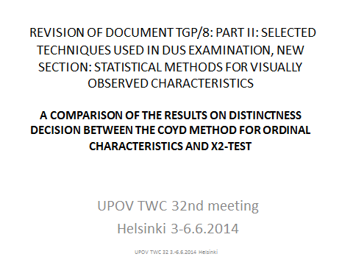

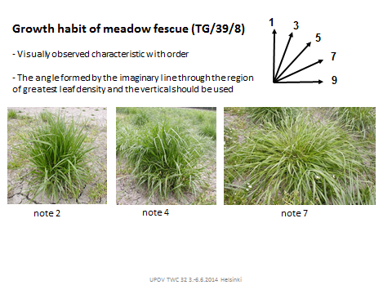

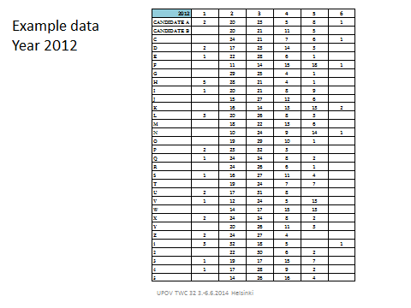

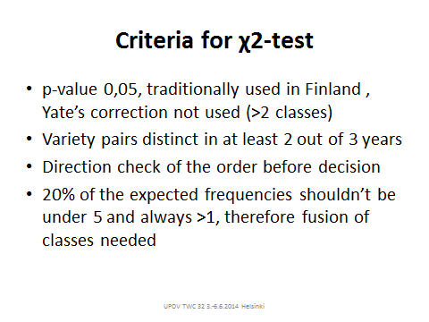

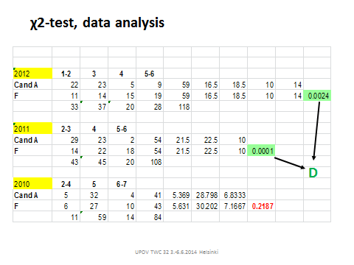

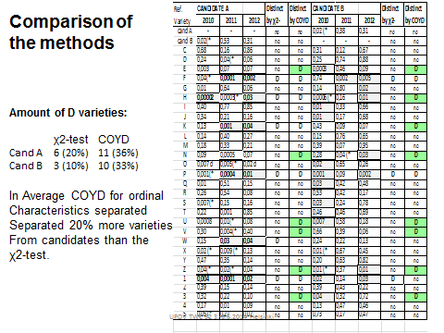

[End of annex and of document]

