E
TWC/32/16 Add.
ORIGINAL: English
DATE: June 12, 2014
INTERNATIONAL UNION FOR THE PROTECTION OF NEW VARIETIES OF PLANTS
Geneva
Technical working party ON AUTOMATION AND COMPUTER PROGRAMS
Thirty-Second Session
Helsinki, Finland, from June 3 to 6, 2014
ADDENDUM
DEVELOPMENT OF THE COMBINED-OVER-YEAR UNIFORMITY CRITERION
Document prepared by Denmark and the United Kingdom
Disclaimer: this document does not represent UPOV policies or guidance
The Annex to this document contains a copy of a presentation on development of the combined-over-year uniformity (COYU) criterion that will be made at the Technical Working Party on Automation and Computer Programs (TWC), at its thirty-second session.

[Annex follows]

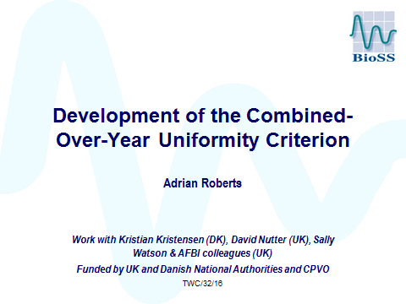

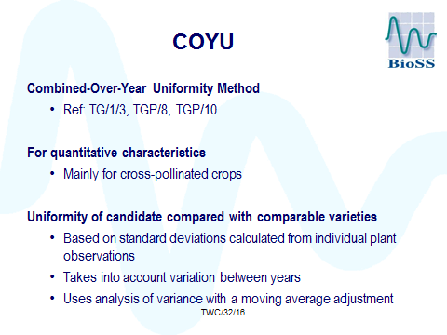

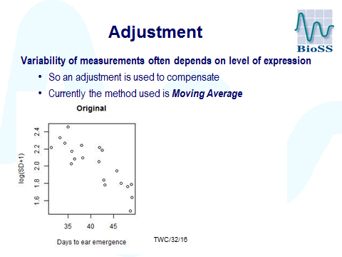

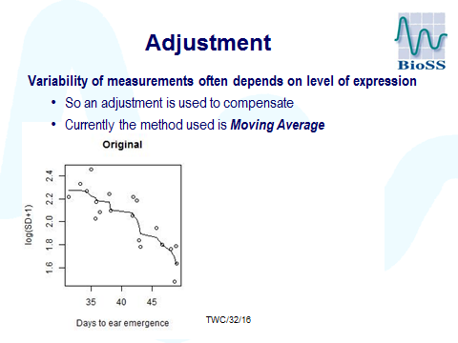

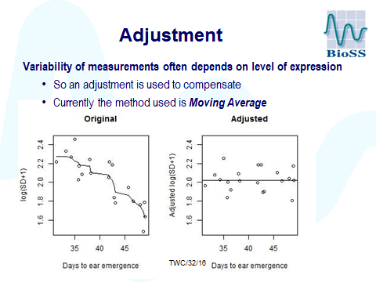

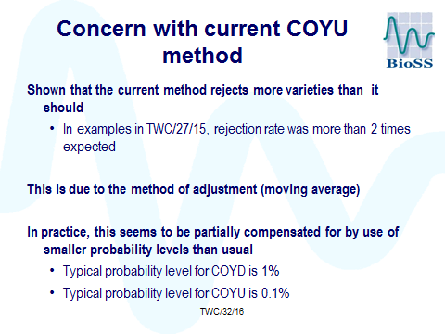

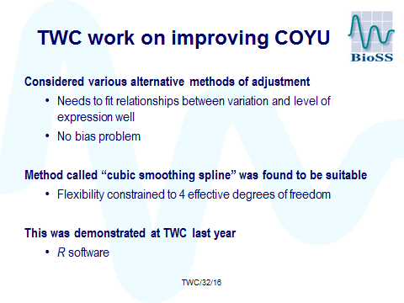

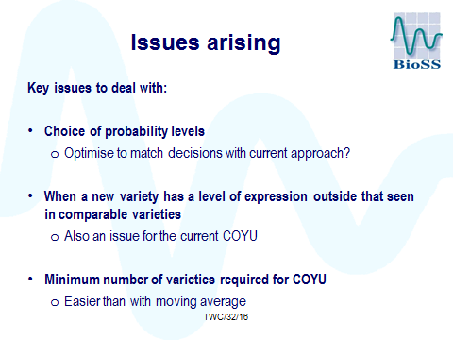

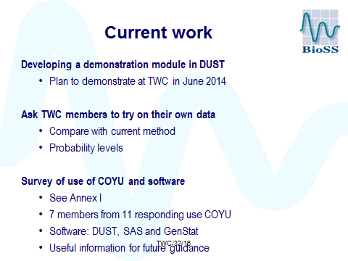

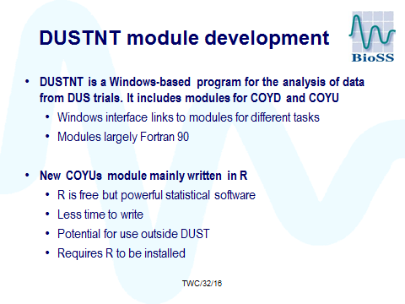

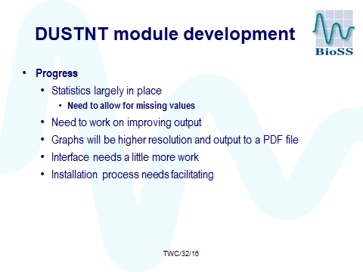

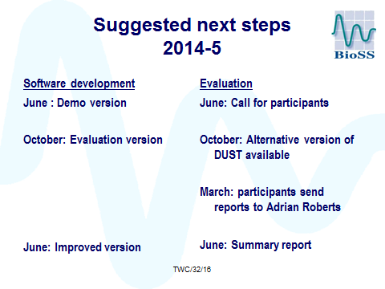

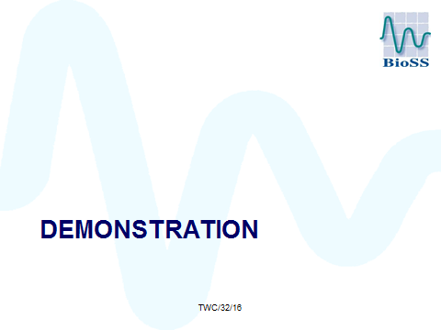

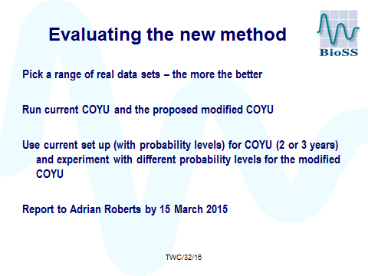

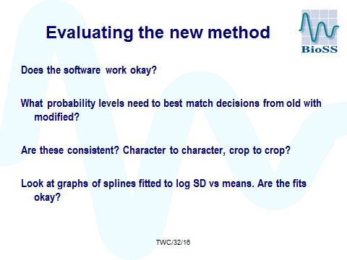

[End of Annexes and of document]

