E
TWC/31/11
ORIGINAL: English
DATE: May 10, 2013
INTERNATIONAL UNION FOR THE PROTECTION OF NEW VARIETIES OF PLANTS
Geneva
Technical working party on automation and computer programs
Thirty-First Session
Seoul, Republic of Korea, June 4 to 7, 2013
REVISION OF DOCUMENT tgp/7: indication of growth stage in test guidElines
Document prepared by the Office of the Union
The purpose of this document is to consider guidance on indicating the growth stage at which to observe characteristics in the Test Guidelines for a future revision of document TGP/7: “Development of Test Guidelines”.

The following abbreviations are used in this document:

TC: Technical Committee
TC-EDC: Enlarged Editorial Committee
TWA: Technical Working Party for Agricultural Crops
TWC: Technical Working Party on Automation and Computer Programs
TWF: Technical Working Party for Fruit Crops
TWO: Technical Working Party for Ornamental Plants and Forest Trees
TWPs: Technical Working Parties
TWV: Technical Working Party for Vegetables

The structure of this document is as follows:

BAcKGROUND 1
Existing GUIDANCE IN DOCUMENT TGP/7 2
TG Template 2
GN 23 3
Chapter 3.3 and GN 9 3
PROPOSALS FOR INDICATING growth stage at which to observe characteristics in the Test Guidelines 4

ANNEX: EXAMPLES OF INDICATIONS OF GROWTH STAGE AT WHICH TO OBSERVE CHARACTERISTICS IN EXISTING TEST GUIDELINES

BAcKGROUND

The Technical Committee (TC), at its forty-ninth session held in Geneva from March 18 to 20, 2013, agreed that clarification should be provided in a future revision of document TGP/7 with regard to the inclusion of growth stage keys in Chapter 8 of the Test Guidelines and requested the Office of the Union to prepare draft guidance for consideration by the TWPs at their sessions in 2013 (see document TC/49/41 “Report on the Conclusions”, paragraph 83).

Existing GUIDANCE IN DOCUMENT TGP/7

TG Template

The TG Template and associated Guidance Note (GN24) provide the following guidance for indicating the growth stage for the observation of characteristics in the Test Guidelines:

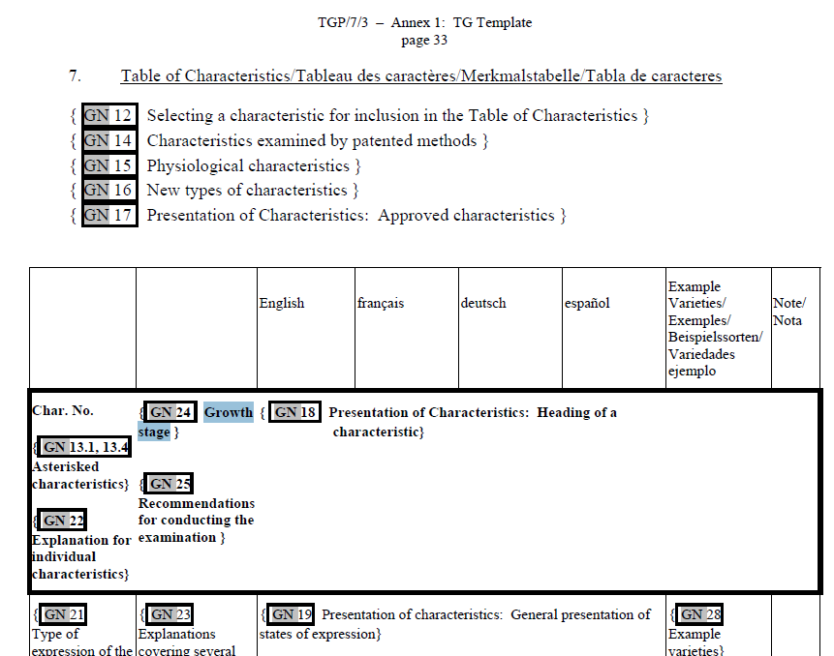

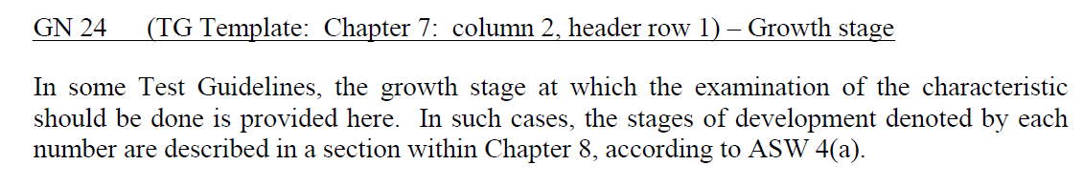

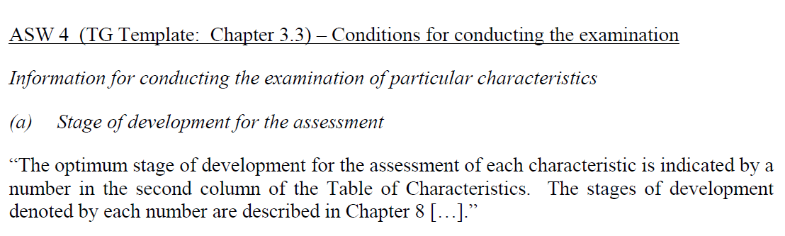

GN 23

Guidance Note GN 23 for drafters of Test Guidelines: “Explanations covering several characteristics”, also states as follows:

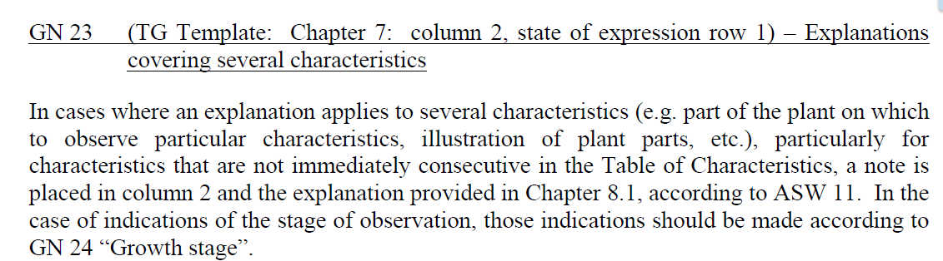

Chapter 3.3 and GN 9

The TG Template and Guidance Note (GN 9) provide further guidance as follows:

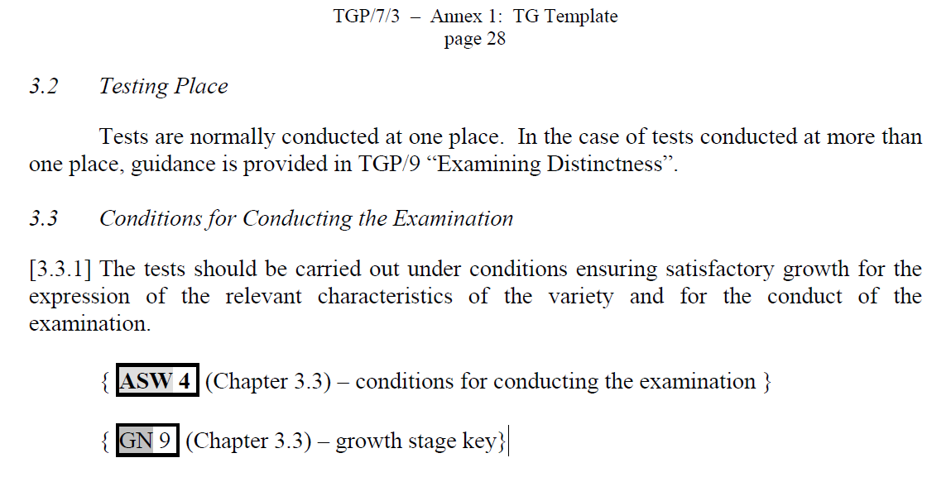

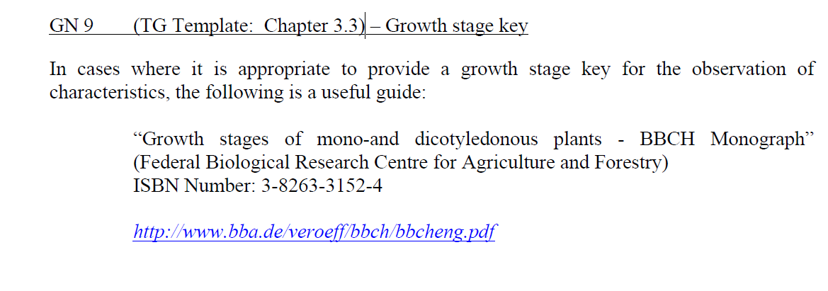

The Annex to this document provides examples of growth stage reference in existing Test Guidelines as follows:
- TG/7/10: Pea
- TG/4/8: Ryegrass
- TG/276/1: Hemp
- TG/PINEAP(proj.12): Pineapple

PROPOSALS FOR INDICATING growth stage at which to observe characteristics in the Test Guidelines

The guidance in document TGP/7 indicating the growth stage at which to observe characteristics in the Test Guidelines clarifies that such indication should be provided in the relevant cell of the Table of Characteristics (see paragraph 5) and accompanied by an explanation of the growth stage key in a separate subchapter of Chapter 8 of the Test Guidelines.

The TWC is invited to consider whether there is a need to amend the existing guidance in document TGP/7 with regard to the indication of growth stage at which to observe characteristics in the Test Guidelines.

[Annex follows]
EXAMPLES OF INDICATIONS OF GROWTH STAGE AT WHICH TO OBSERVE CHARACTERISTICS IN EXISTING TEST GUIDELINES

EXTRACT FROM TG/7/10: PEA

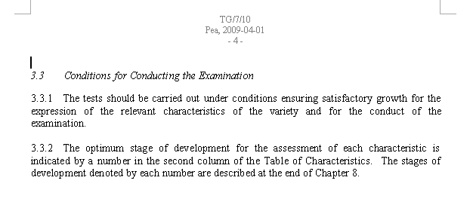

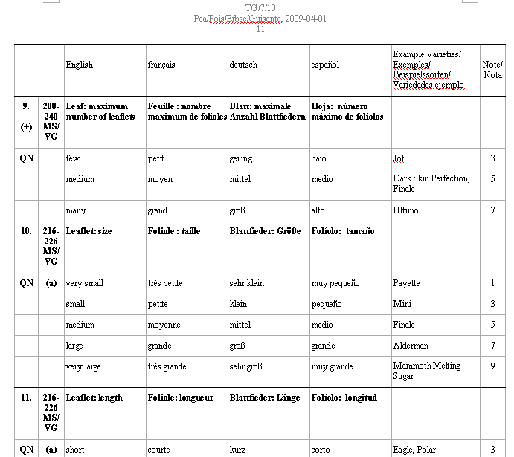

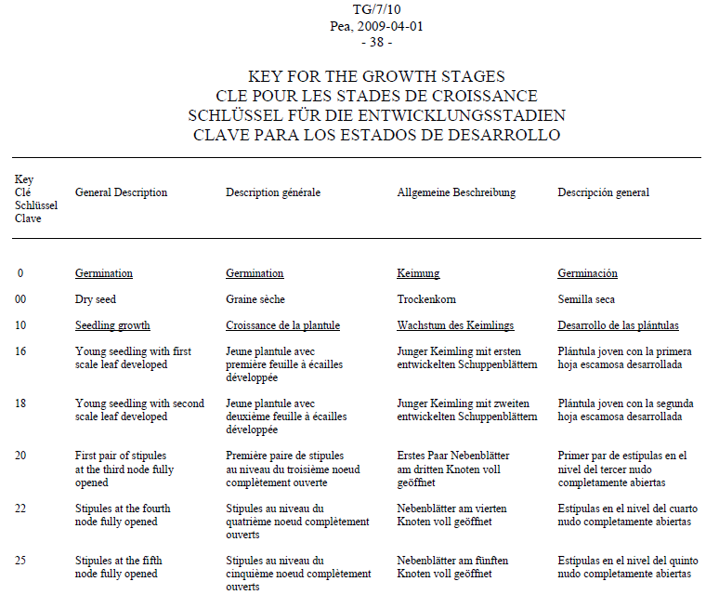

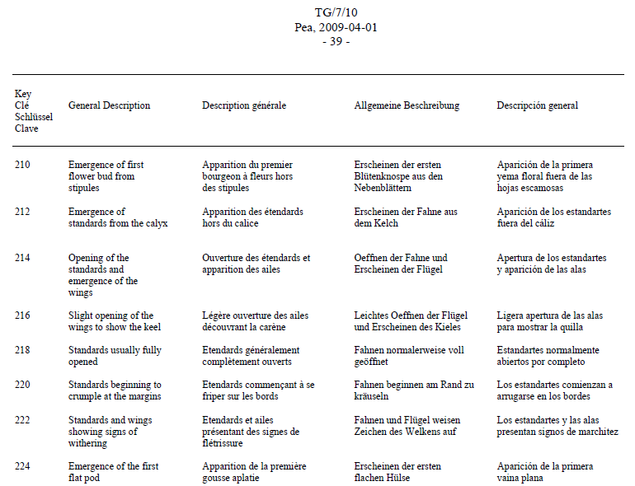
EXTRACT FROM TG/4/8: RYEGRASS

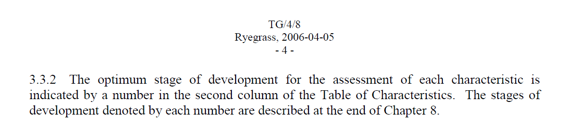

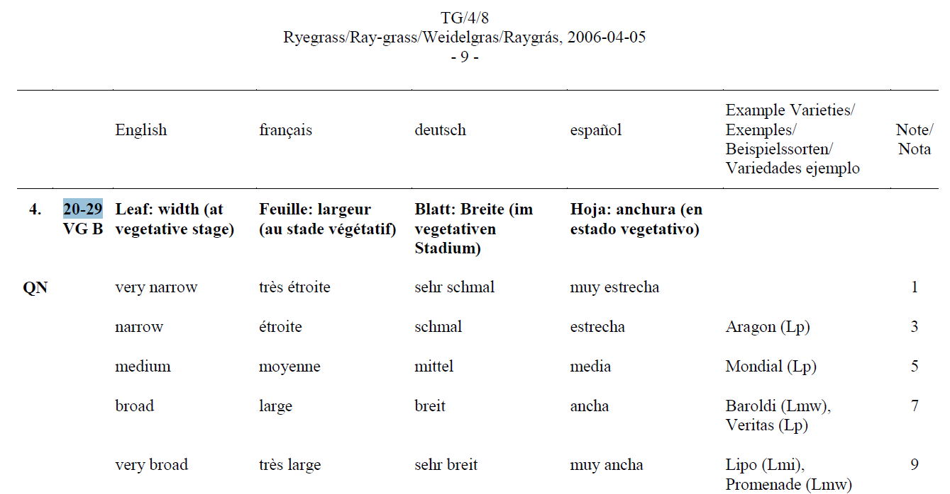

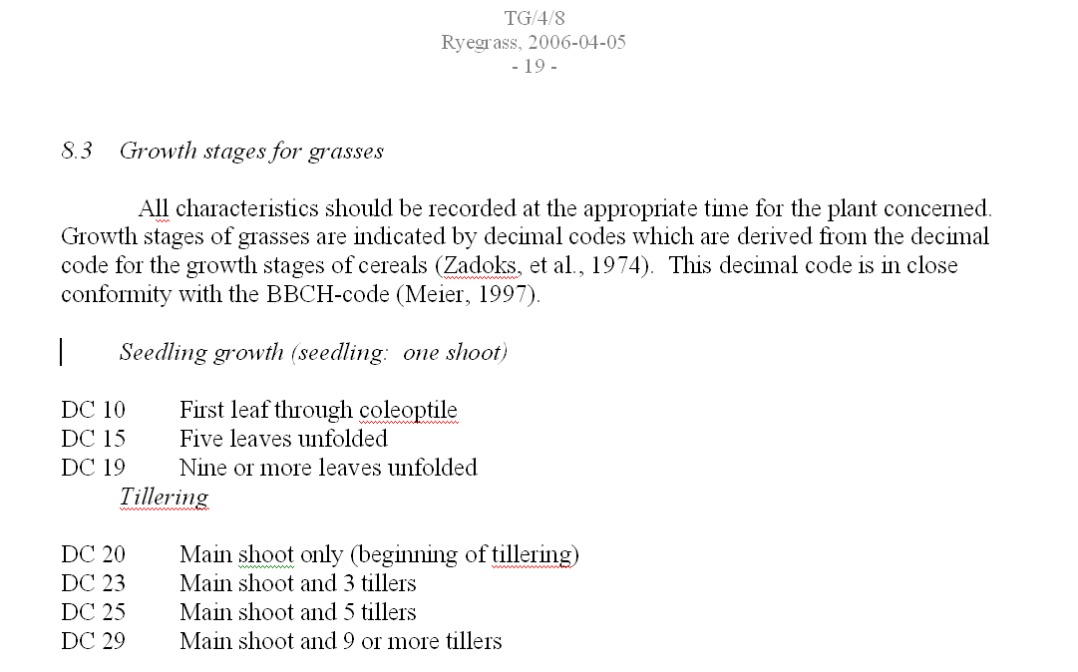
EXTRACT FROM TG/276/1: HEMP

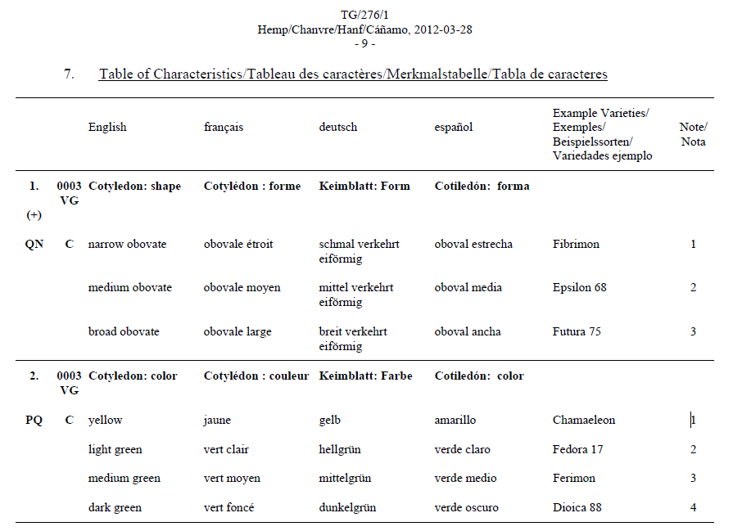

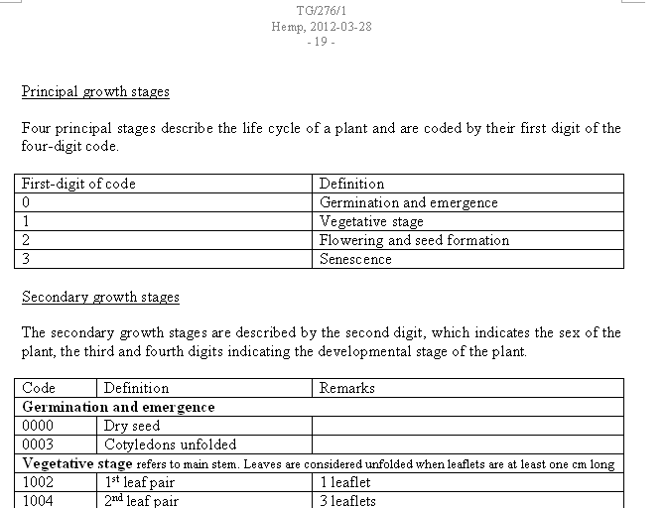

EXTRACT FROM TG/PINEAP(proj.12): PINEAPPLE

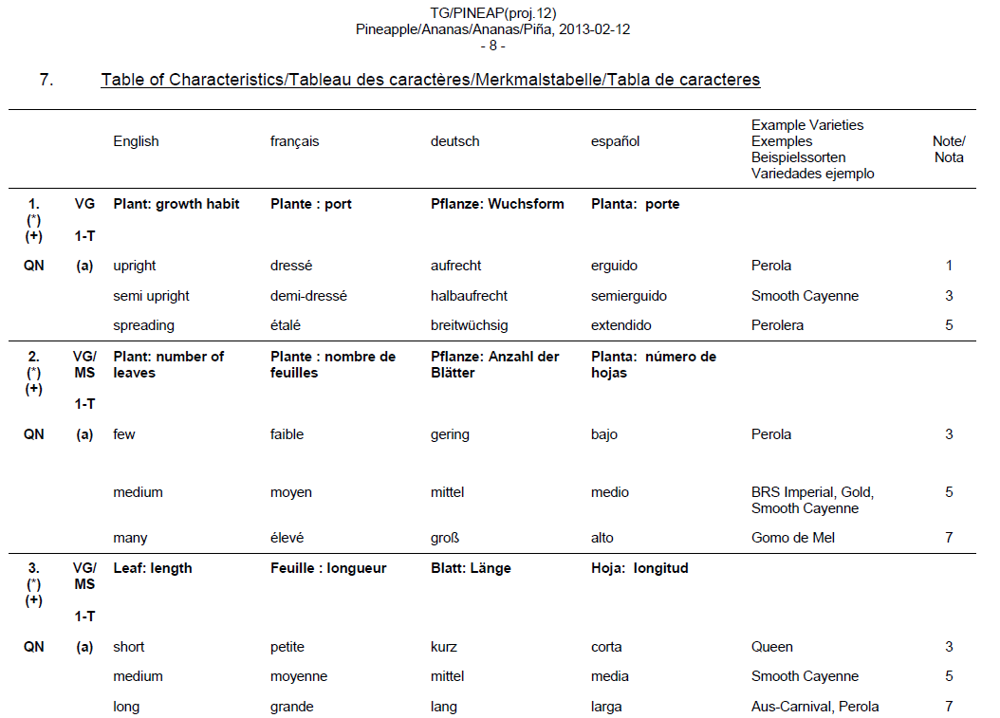

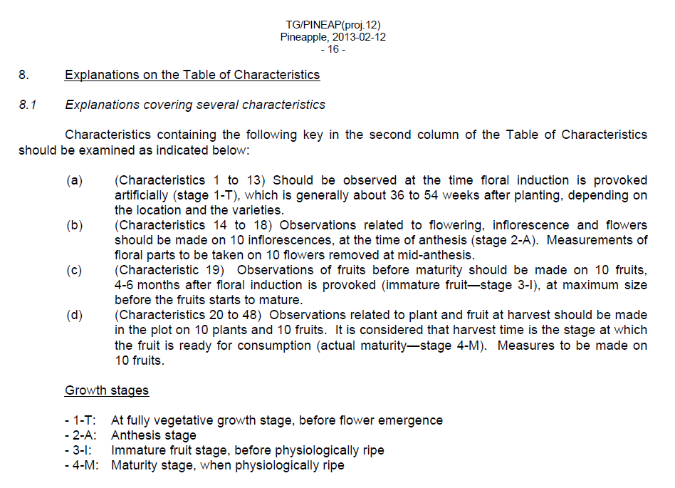
[End of Annex and of document]

