 |  | E  TWC/30/27  ORIGINAL: English  DATE: June 6, 2012
INTERNATIONAL UNION FOR THE PROTECTION OF NEW VARIETIES OF PLANTS
Geneva
Technical working party ON AUTOMATION AND
COMPUTER PROGRAMS
Thirtieth Session
Chisinau, Republic of Moldova, June 26 to 29, 2012

Revision of document TGP/14:
Section 2 : Botanical Terms
Subsection 2: Shapes and Structures
Document prepared by experts from Denmark, Germany, United Kingdom and the Office of the Union
1 The purpose of this document is a report on developments concerning the items approved by the Technical Committee for consideration in the future revision of document TGP/14 “Glossary of Terms Used in UPOV Documents” (document TGP/14/2) (see document TC/48/22 “Report on the conclusions”, paragraphs 70 to 75).

2 The following abbreviations are used in this document:
CAJ: Administrative and Legal Committee
TC: Technical Committee
TC-EDC: Enlarged Editorial Committee
TWA: Technical Working Party for Agricultural Crops
TWC: Technical Working Party on Automation and Computer Programs
TWF: Technical Working Party for Fruit Crops
TWO: Technical Working Party for Ornamental Plants and Forest Trees
TWV: Technical Working Party for Vegetables
TWPs: Technical Working Parties
3 The structure of this document is as follows:

I.REVISIONS ON WHICH THE TECHNICAL COMMITTEE HAS REACHED A CONCLUSION 3
Perspective from which to observe plant shapes 3
Definition for Botanical Terms 3
Components of Shape: states of expression for ratios 3
II.REVISIONS TO BE CONSIDERED BY THE TECHNICAL Working Parties 3
Avoidance of duplication of characteristics 3
Proposal by an expert from Germany presented to the Technical Working Parties in 2010 and the Technical Committee in 2011 3
Comments of the Technical Working Parties in 2010 4
Technical Working Party for Agricultural Crops 4
Technical Working Party on Automation and Computer Programs 4
Technical Working Party for Vegetables 5
Technical Working Party for Ornamental Plants and Forest Trees 5
Technical Working Party for Fruit Crops 5
Conclusions of the Technical Committee in 2011 5
Study presented to the TWPs in 2011 5
Comments of the Technical Working Parties in 2011 6
Technical Working Party for Agricultural Crops 6
Technical Working Party for Vegetables 6
Technical Working Party on Automation and Computer Programs 6
Technical Working Party for Ornamental Plants and Forest Trees 6
Conclusions of the Technical Committee in 2012 6
Proposed text for revision of tgp/14 section 2: subsection 2: shape and structures: I Shape: 2. DEVELOPING SHAPE –RELATED CHARACTERISTICS 1
Proposed text for revision of tgp/14 section 2: subsection 2: shape and structures 1
Proposed text for revision of tgp/14 Supplementsection 2: subsection 2: shape and structures 1
Proposed text for revision of tgp/14 section 2: subsection 2: I shape 1
Components of Shape: states of expression for ratios 1
Chart for Simple Symmetric Plane Shapes 2
2.5 Combination of Full Plane-, Base- and Apex Shape Characteristics 11

annex I: Subsection 2: Shapes and Structure
aNNEX II: Proposed Text for Revision of TGP/14 Section 2: Subsection 2: Shape and Structures
ANNEX III: Proposed Text for Revision of TGP/14 Section 2: Subsection 2: I Shape
annex IV: Examination of the use component and composite characters for determining distinctness
appendix: Relationships between component and composite characteristics in example species
ANNEX V: Use of Composite Characters for Determining Distinctness and Uniformity

I REVISIONS ON WHICH THE TECHNICAL COMMITTEE HAS REACHED A CONCLUSION

Perspective from which to observe plant shapes

4 The Technical Committee (TC), at its forty-eighth session, held in Geneva from March 26 to 28, at its forty-eighth session, recalled that it had agreed to recommend that, where appropriate, an explanation for shape characteristics should provide guidance on the perspective from which to observe the shape(see document TC/48/22 “Report on the Conclusions”, paragraph 71 ). Annex I to this document contains a proposal of guidance on the perspective from which to observe plant shapes.

Definition for Botanical Terms

5 With regard to a future revision of TGP/14 “Glossary of Terms Used in UPOV Documents”, Section 2: Botanical Terms: Subsection 2: Shapes and Structures: I. Shape: II. Structure: Section 2.4, the TC, at its forty-eighth session, recalled that it had agreed that additional definitions for botanical terms, such as for peduncle and petiole, should be added to document TGP/14 where the provision of such definitions would help to avoid confusion. However, it had confirmed that this should not result in a change to the explanation in document TGP/14/1 that “In general, the meaning of botanical terms which are used in the Test Guidelines to indicate the relevant part of the plant to be examined, but which are not themselves used as states of expression (e.g. bract, petal, berry, etc.), do not require a UPOV specific definition and are not included in this document.” Annex II to this document contains the proposed definition for pedicel, peduncle, petiole and petiolule.

6 The TC, at its forty-eighth session, recalled that it had agreed the following definition of “spike” for inclusion in a future revision of document TGP/14/1: Section 2: Botanical Terms: Subsection 2: Shapes and Structures: III. Definitions for Shape and Structure Terms (see document TC/48/22 “Report on the Conclusions”, paragraph 73):

Spike | an indeterminate inflorescence with sessile flowers on an unbranched axis.

Components of Shape: states of expression for ratios

7 With regard to the use of characteristics for ratios, the TC, at its forty-eighth session, agreed that it should be possible to use states such as “high” or “low”, provided that explanations and illustrations were provided to avoid any risk of confusion. It also agreed that it should be possible to use states such as “elongated” and “compressed” for characteristics that were worded as shapes, rather than ratios (see document TC/48/22 “Report on the Conclusions”, paragraph 74). Annex III to this document contain proposals for the revision of document TGP/14/ ”Glossary of Terms Used in UPOV Documents” to reflect that approach.

II. REVISIONS TO BE CONSIDERED BY THE TECHNICAL Working Parties

Avoidance of duplication of characteristics

Proposal by an expert from Germany presented to the Technical Working Parties in 2010 and the Technical Committee in 2011

8 Document TGP/14/1, Section 2: Botanical Terms: Subsection 2: Shapes and Structures: I. SHAPE: 2. “Developing Shape-Related Characteristics”, paragraph 2.1.1, states that:

“Duplication of the same difference in two separate characteristics should be avoided: for example, the use of characteristics for both ratio length/width and for shape should be avoided where states of expression of the characteristic for shape relate to different length/width ratios.”

9 A further example of a duplication is when separate characteristics are included for ratio length/width, length and width, because two of those characteristics would determine the third.

10 The ratio length/width (width/length) is a tool to describe the shape. The absolute measures are indications for the size. It is necessary to decide which are the most appropriate characteristics to describe those two sources of variation (shape and size), i.e. best discrimination between varieties and greatest environmental stability. The aim is to distinguish varieties with the same shape by size and with the same size by shape.

11 Experience has often shown that “width in relation to length” or “length in relation to width” is more stable than the absolute measurements of width and length, because the absolute measures are more influenced by the environment. In such cases, the ratio is better for the description of the shape.

12 If all varieties have the same shape, only one characteristic is necessary to observe the size. In such cases, consideration needs to be given to whether the length or width would be more reliable.

13 If varieties have different shapes and different sizes within the same shape, one absolute dimension (length or width) and the ratio should be used for DUS. Thus, two characteristics should be included in the Test Guidelines:

“length” and “ratio width/length” (or “width in relation to length”)
or
“width” and “ratio length/width (or “length in relation to width”).

14 The inclusion of a third characteristic that is fully determined by the two other characteristics would not provide any additional information for the assessment of DUS and should be avoided.

15 If the duplication of characteristics is avoided, width in relation to length can be described with the states “narrow” to “broad” and length in relation to width with the states “short” to “long”.

16 Document TGP/8/1 “Trial Design and Techniques Used in the Examination of Distinctness, Uniformity and Stability”, Part II, 1. The GAIA Methodology, states the following with regard to correlation between characteristics:
“1.3.1 Weighting of characteristics
“1.3.1.1 It is important to take account of the correlation between characteristics when weighting. If two characteristics are linked (e.g. plant height including panicle; plant height excluding panicle), it is advisable to use only one of them in GAIA, to avoid double weight.”

Comments of the Technical Working Parties in 2010

Technical Working Party for Agricultural Crops

17 At its thirty-ninth session, held in Osijek, Croatia, from May 24 to 28, 2010, the TWA considered document TWA/39/22 (paragraphs 7 to 15 of document TWA/39/22) (see document TWA/39/27 “Report”, paragraphs 68 to 70).

18 The TWA agreed that experts from Denmark, Germany and the United Kingdom should send data on characteristics for length, width and length/width ratio to Mr. Trevor Gilliland for collation. The TWA, at its fortieth session, would consider that data with a view to forming conclusions on any benefits in using all three characteristics in Test Guidelines.

19 The TWA noted that the text of TGP/8/1 Draft 15 “Trial Design and Techniques Used in the Examination of Distinctness, Uniformity and Stability”, Part II, 1. The GAIA Methodology, Section 1.3.1.1, should be amended to clarify that there is an assumption that the length of panicle is used as a characteristic.

Technical Working Party on Automation and Computer Programs

20 The TWC, at its twenty-eighth session, held in Angers, France, from June 29 to July 2, 2010, considered document TWC/28/22 (paragraphs 7 to 15 of document TWC/28/22) (see document TWC/28/36 “Report”, paragraphs 46 and 47).

21 The TWC agreed that the first sentence of paragraph 8 should read “The ratio length/width (width/length) is a tool to describe a component of shape”. It also noted that any characteristics that were considered for distinctness would also need to be examined for uniformity. The TWC agreed that it should consider the results of the analysis of the data on characteristics for length, width and length/width ratio to be considered by the TWA (see paragraph 16, above), at its twenty- ninth session.

Technical Working Party for Vegetables

22 The TWV, at its forty-fourth session, held in Veliko Tarnovo, Bulgaria, from July 5 to 9, 2010, expressed concerns with regard to the proposal in document TWV/44/22 (paragraphs 7 to 15 of document TWV/44/22) that, if varieties have different shapes and different sizes within the same shape, only one absolute dimension (length or width) and the ratio should be used for DUS. In the first instance, it was noted that both length and width would need to be recorded in order to derive the ratio length/width. It also considered that it was often useful to have a separate description for length, width and ratio length/width. With regard to concerns about duplication of characteristics, it was noted that there was a suitable warning in relation to GAIA in document TGP/8/1 Draft 15, Part II, 1. The GAIA Methodology, Section 1.3.1 Weighting of characteristics. It did not anticipate problems for DUS examiners making decisions on DUS where the characteristics length, width and ratio length/width were considered separately and noted that there were correlations between other types of characteristics (see document TWV/44/34 “Report”, paragraphs 59 and 60).

Technical Working Party for Ornamental Plants and Forest Trees

23 The TWO, at its forty-third session, held in Cuernavaca, Morelos State, Mexico, from September 20 to 24, 2010, considered document TWO/43/22. With regard to the proposal in document TWO/43/22 that, if varieties have different shapes and different sizes within the same shape, only one absolute dimension (length or width) and the ratio should be used for DUS, the TWO shared the concerns of the TWV. In the first instance, it was noted that both length and width would need to be recorded in order to derive the ratio length/width. It also considered that it was often useful to have a separate description for length, width and ratio length/width. With regard to concerns about duplication of characteristics, it was noted that there was a suitable warning in relation to GAIA in document TGP/8/1 Draft 15, Part II, 1. The GAIA Methodology, Section 1.3.1 Weighting of characteristics. It did not anticipate problems for DUS examiners making decisions on DUS where the characteristics length, width and ratio length/width were considered separately and noted that there were correlations between other types of characteristics (see document TWO/43/29 Rev. “Revised Report”, paragraphs 50 and 51).

Technical Working Party for Fruit Crops

24 The TWF, at its forty-first session, held in Cuernavaca, Morelos State, Mexico, from September 27 to October 1, 2010, considered document TWF/41/22. With regard to the proposal in document TWF/41/22 that, if varieties have different shapes and different sizes within the same shape, only one absolute dimension (length or width) and the ratio should be used for DUS, the TWF shared the concerns of the TWV. In the first instance, it was noted that both length and width would need to be recorded in order to derive the ratio length/width. It also considered that it was often useful to have a separate description for length, width and ratio length/width. With regard to concerns about duplication of characteristics, it was noted that there was a suitable warning in relation to GAIA in document TGP/8/1 Draft 15, Part II, 1. The GAIA Methodology, Section 1.3.1 Weighting of characteristics. It did not anticipate problems for DUS examiners making decisions on DUS where the characteristics length, width and ratio length/width were considered separately and noted that there were correlations between other types of characteristics (see document TWF/41/30 Rev. “Revised Report”, paragraphs 54 and 55).

Conclusions of the Technical Committee in 2011

25 The TC, at its forty-seventh session held in Geneva from April 4 to 6, 2011, agreed that with regard to a future revision of TGP/14 “Glossary of Terms Used in UPOV Documents”, Section 2: Botanical Terms: Subsection 2: Shapes and Structures: I. Shape: Developing Shape-Related Characteristics, that the avoidance of duplication of characteristics should be considered further by the TWPs (see document TC/47/26 “Report on the Conclusions”, paragraphs 81).

Study presented to the TWPs in 2011

26 At their sessions in 2011, the Technical Working Parties received information on a study concerning “Examination of the use component and composite characters for determining distinctness”, prepared by experts from Denmark, Germany and the United Kingdom as presented in Annex IV to this document.

27 The following bullet points summarize the overall observations and related considerations.
- In direct compliance with the current TGP/14 guidelines, duplication of the same difference in two separate characteristics should be avoided.
- Only ratios describing biologically meaningful plant characteristics should be calculated.
- As composite characteristics are calculated from components that are routinely assessed in trials, workloads and costs are unlikely to be a significant consideration in determining their practical value.
- There were large differences between the species in the discriminating power of the composite character relative to its component characters. In some cases, the composite character was much less discriminating than its individually examined components, in others it was intermediary and in others it was the most discriminating character of all.
- The composite character provided some level of unique variety-pair distinctions in all species, though in some cases this was at a very low frequency.
- Where one of the component characters was only weakly discriminating, the composite character was usually highly correlated to the other component character and had a lower discriminating power.
- The individual component characters were in the majority of cases independent of each other. The exceptions being the cotyledon characteristics in WOSR [Winter Oilseed Rape] and to a lesser degree the fruit characteristics in Apple.
- Composite characters were often very highly correlated with their component characters and in most cases with a significantly higher similarity than that existing between the two component characters.
- The degree of correlation between a component character and its composite character was not a good predictor of their independent discriminating potential. This was also the case between component characters where the level of similarity did not accurately indicate their relative discriminating power.

Comments of the Technical Working Parties in 2011

Technical Working Party for Agricultural Crops

28 The TWA at its fortieth session held in Brasília, Brazil, from May 16 to 20, 2011, received a presentation on a study concerning the “Examination of the use component and composite characters for determining distinctness”, prepared by experts from Denmark, Germany and the United Kingdom and contained in Annex II to document TWA/40/3, a copy of which is reproduced in Annex IV to this document. The TWA stressed the importance of the results of the study. It illustrated the importance to get knowledge on the relationship between composite characteristics and their components in order to be able to decide which characteristics should be included in the Test Guidelines. The TWA proposed to prepare, for the forty-first session of the TWA, specific guidance in that respect, based on the presented study. Furthermore, the TWA invited the other TWPs to consider the results of the aforementioned study at their sessions in 2011 (see document TWA/40/23 “Report, paragraph 39).

Technical Working Party for Vegetables

29 At its forty-seventh session, held in Monterey, United States of America, from July 25 to 29, 2011, the TWV, endorsed the overall observations and related considerations as set out in document TWV/45/3, Annex II, a copy of which is reproduced in Annex IV to this document. In particular, it noted that each case would need to be considered on its merits (see document TWV/45/26 “Report”, paragraph 60).

Technical Working Party on Automation and Computer Programs

30 The TWC at its twenty-ninth session held in Geneva, Switzerland, from June 7 to June 10, 2011, took note of the comments presented in paragraphs 2.10 to 2.17 of Annex I of document TWC/29/3, a copy of which is reproduced in Annex IV to this document (see: document TWC/29/31 “Report, paragraph 41).

Technical Working Party for Ornamental Plants and Forest Trees

31 The TWO, at its forty-fourth session, held in Fukuyama City, Hiroshima Prefecture, Japan, from November 7 to 11, 2011 The TWO endorsed the overall observations and related considerations as set out in document TWO/44/3, Annex II, a copy of which is reproduced in the Annex to this document. In particular, it noted that each case would need to be considered on its merits (see document TWO/ 44/25 “Report”, paragraph 39).

Conclusions of the Technical Committee in 2012

32 The TC, at its forty-eighth session, welcomed the study concerning “Examination of the use component and composite characters for determining distinctness”, prepared by experts from Denmark, Germany and the United Kingdom, as presented in Annex IV to this document. The TC agreed that guidance, based on that study, should be prepared for the TWPs sessions in 2012, by the experts from Germany, Denmark and the United Kingdom (see document TC/48/22 “Report on the Conclusions”, paragraph 75).

33 The Draft of guidance on “Use of Composite Characters for Determining Distinctness and Uniformity” prepared by experts from Denmark, Germany and the United Kingdom is provided in Annex V of this document.

[Annexes follow]
SUBSECTION 2: SHAPES AND STRUCTURES

Proposed text for revision of tgp/14 section 2:
subsection 2: shape and structures: I Shape: 2. DEVELOPING SHAPE –RELATED CHARACTERISTICS

It is proposed to add a new section concerning perspective from which to observe plant shapes in document TGP/14/1, as follows:

2.8 Perspective from which to observe plant shapes

Where appropriate, an explanation of the perspective from which to observe the shape should be included in the Test Guidelines.

[Annex II follows]

Proposed text for revision of tgp/14 section 2:
subsection 2: shape and structures

III. DEFINITIONS FOR SHAPE AND STRUCTURE TERMS

Definition for Botanical Terms

Terms | Definition / comment
Peduncle | A stem supporting an inflorescence or supporting an infructescence after fecundation
Pedicel | A stem which attaches single flowers or fruit to the main stem of the inflorescence or infructescence.
Petiole | A stalk attaching the leaf blade to the stem
Petiolule | A stalk of any of the leaflets making up a compound leaf.

Proposed text for revision of tgp/14 Supplementsection 2:
subsection 2: shape and structures

III. DEFINITIONS FOR SHAPE AND STRUCTURE TERMS

English | Français | Deutsch | Español
Peduncle | Pédoncule | Blütenstandstiel | Pédonculo
Pedicel | Pédicelle | Blütenstiel | Pedicelo
Petiole | Pétiole | Blattstiel | Peciolo
Petiolule | Pétiolule | Kleiner Blattstiel | Peciólulo

[Annex III follows]

Proposed text for revision of tgp/14 section 2: subsection 2: I shape

Components of Shape: states of expression for ratios

Extracts from document TGP/14/1 Section2: Botanical Terms Subsection 2: Shape and Structures:

1.3 The apex (apical or distal part) of an organ or plant part is the end furthest from the point of attachment. The base (proximal part) of a plant part is the end nearest to the point of attachment. However, it should be noted that the illustrations of shapes in the Test Guidelines might not always be orientated with the point of attachment (base) at the bottom if that is not the natural orientation of the organ on the plant.

1.4 The shape of base and shape of apex are considered in Sections 2.3 and 2.4 respectively. The chart below (Chart for Simple Symmetric Plane Shapes) illustrates the other three components for simple symmetric plane shapes (those for which the angle at the base and at the apex does not exceed 180°) as follows:

(a) Ratio length/width (or ratio width/length): the ratio length/width varies from left to right within a row, but is approximately the same within a column;
(b) Position of broadest part: the position of the broadest part varies from row to row, but is approximately the same in each row;
(c) Lateral outline: the shape of the lateral sides varies from set to set, but is approximately the same within a set.

1.5 To ensure that the ratio length/width is clearly understood, it is recommended to use meaningful present the characteristic as a shape with states such as “very elongated“ to “very compressed”, or to present the characteristic as “ratio legth/width” with states such as “very high” to “very low” and to provide an illustration rather than states such as “very high”. To avoid confusion concerning the absolute dimensions, it is recommended to avoid the use of terms such as “narrow“ and “broad“ for ratio length/width, particularly where characteristics for the absolute dimensions are also included for the same plant part. The terms associated with certain length/width ratios used in the Chart for Simple Symmetric Plane Shapes are only intended to illustrate the use of ratio length/width. In the Test Guidelines, the use of terms such as “[very/moderately/slightly] high (elongated)” and “[very/moderately/slightly] low (compressed)“ will need to be determined according to the range of expression for the characteristic concerned.

[…]

Chart for Simple Symmetric Plane Shapes

shape |  |  | very elongated | moderately elongated | slightly elongated | medium | slightly compressed | moderately compressed | very compressed
ratio length/width |  |  | very high | high | high to medium | medium | medium to low | low | very low
Parallel set
oblong | 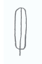 |  | 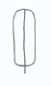 | 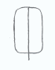 | 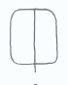 | 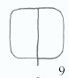 | 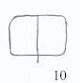 | 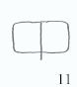 | 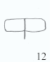
Rounded set
ovate | 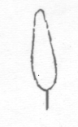 |  | 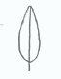 | 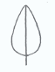 | 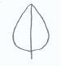 | 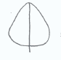 | 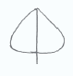 | 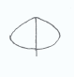 | 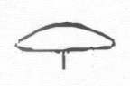
elliptic | 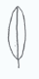 |  | 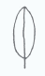 | 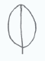 | 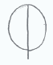 | 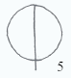 | 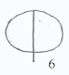 | 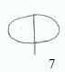 | 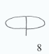
obovate | 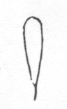 |  | 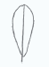 | 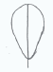 | 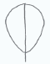 | 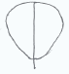 | 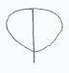 | 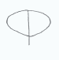 | 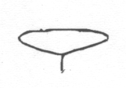
Angular set
triangular | 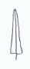 | 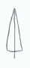 |  | 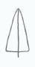 | 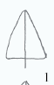 | 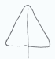 | 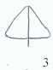 | 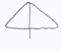 | 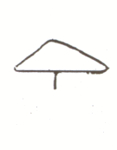
trullate | 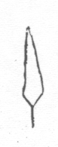 | 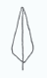 |  | 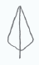 | 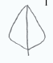 | 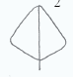 | 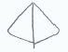 | 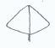 | 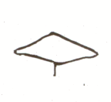
rhombic | 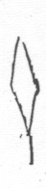 | 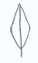 |  | 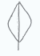 | 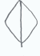 | 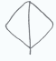 | 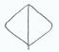 |  | 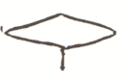
obtrullate | 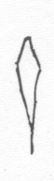 | 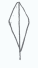 |  | 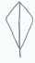 | 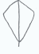 | 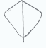 | 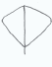 | 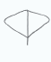 | 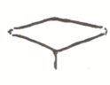
obtriangular | 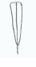 | 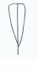 |  | 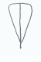 | 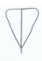 | 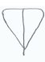 | 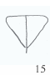 | 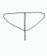 | 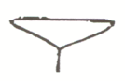

Example 1 (a circle indicates the shape of one or more varieties in the variety collection)

The only variation between varieties is found in the ratio length/width.

Parallel set
oblong
Rounded set
ovate
elliptic
obovate

Possible characteristic(s) (Example 1)

Alternative 1

Plant [part]: ratio length/width (high to low) (QN)

Alternative 2

Plant [part]: shape (narrow obovate (1); medium obovate (2); broad obovate (3)) (QN)
with the following illustration

Note | 1 | 2 | 3
(a) Shape | narrow obovate | medium obovate | broad obovate
(b) Ratio length/width | high | medium | low

Possible characteristic(s) (Example 3)

Alternative 1

(a) Plant [part]: ratio length/width (elongated to compressed high to low) (QN)

(b) Plant [part]: shape of base (acute, obtuse, rounded) (PQ)

(c) Plant [part]: lateral outline (clearly rounded to clearly triangular) (QN)

Alternative 2

Plant [part]: shape (narrow trullate (1); narrow ovate (2); medium trullate (3); medium ovate (4); broad ovate (5)) (PQ)
with the following illustration

 |  | narrow | ←→ | broad
triangular outline
←→ |  | 1  narrow trullate | 3  medium trullate
rounded outline
 |  | 2  narrow ovate | 4  medium ovate | 5  broad ovate

Example 4

There is variation between varieties in the ratio diameter/height, position of broadest part and the lateral outline in the apical half. The lateral outline varies between ovate and trullate.

The base is the end nearest to the point of attachment.

 |  | ratio diameter/height
 | lateral outline in apical half  (Notes) | elongated high  (3) | medium  (5) | compressed low  (7) | position of broadest part  (Notes)
cylindrical waisted | concave (4) | 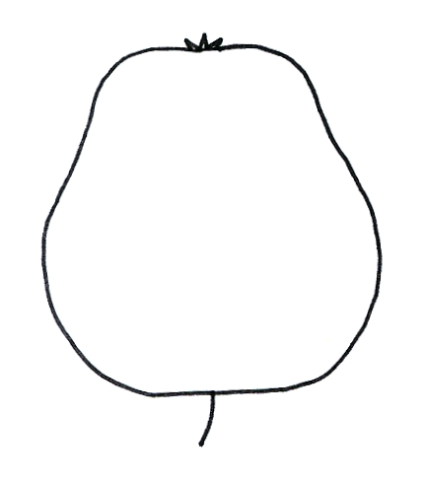 |  |  | at middle (1); moderately towards base (2); or strongly towards base (3)
conic | flat taper (3) | 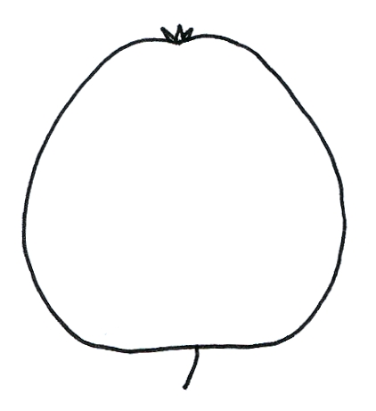 |  |  | at middle (1); moderately towards base (2); or strongly towards base (3)
ovoid | rounded (1) | 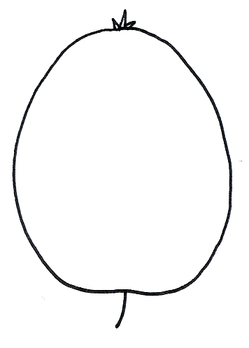 |  |  | moderately towards base (2); or strongly towards base (3)
cylindrical | parallel (2) | 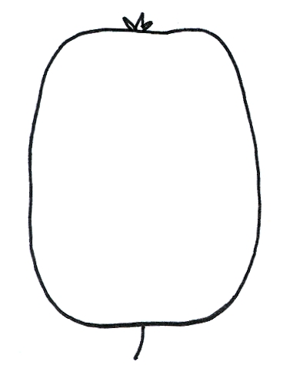 |  |  | at middle (1)
ellipsoid | rounded (1) | 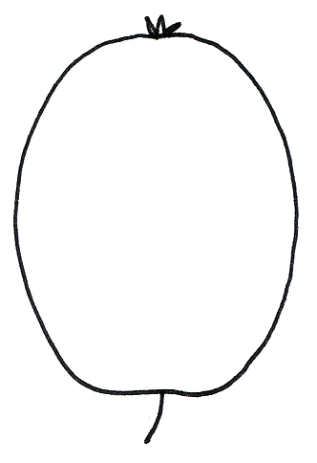  (elliptic) | 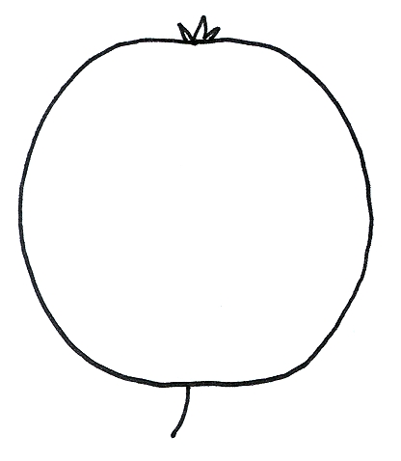  (round) | 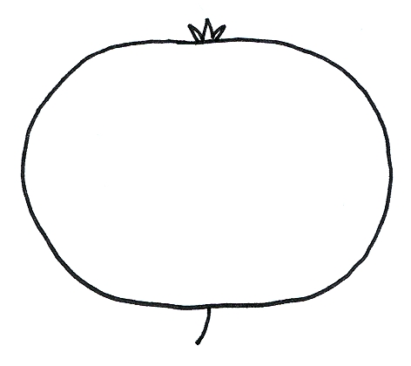  (oblate) | at middle (1)

Possible characteristic(s) (Example 4)

Alternative 1

(a) ratio diameter/height (QN):
e.g. very high (1); high (3); medium (5); low (7); very low (9);
(b) position of broadest part (QN):
e.g. at middle (1); moderately towards base (2); strongly towards base (3);
(c) lateral outline in apical half (PQ):
e.g. rounded (1); parallel (2); flat taper (3); concave (4)

Alternative 2

(a) ratio diameter/height (QN):
e.g. very high (1); high (3); medium (5); low (7); very low (9);

(b) general shape (PQ):
e.g. cylindrical waisted (1); conic (2); ovate (3); cylindric (4); elliptic (5)

with the following illustration:

 |  | ← lateral outline in apical half →
 |  | concave | flat tapering | rounded | flat parallel sides
at base ← position of broadest part → at middle |  |  |  | 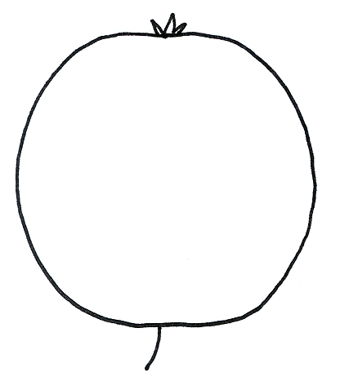  3  ovate
at base ← position of broadest part → at middle |  | 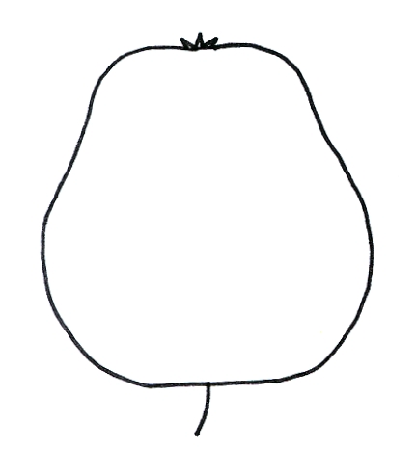 | 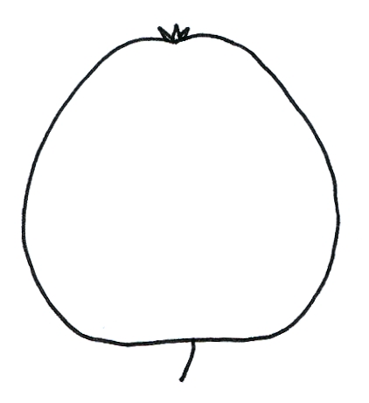
at base ← position of broadest part → at middle |  | 1  cylindrical waisted | 2  conic | 5  elliptic  (includes round and oblate) | 4  cylindric
Example 5

the variation between the range of shapes indicated by the illustrations below:

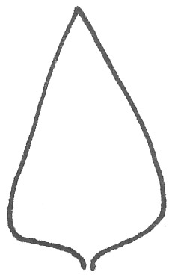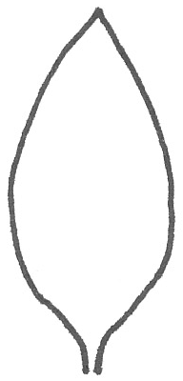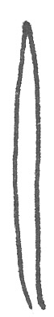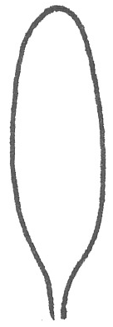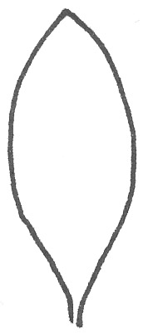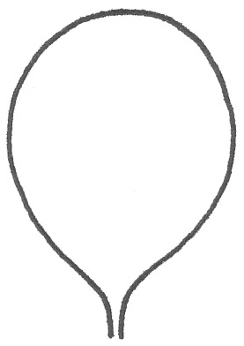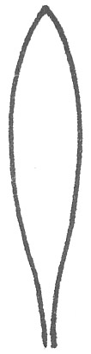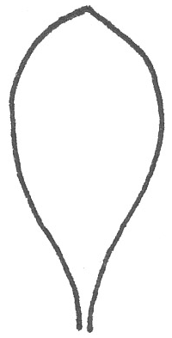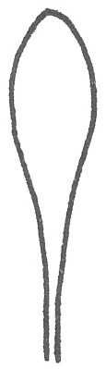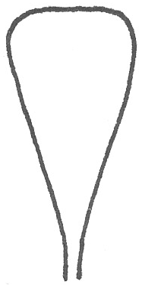

Possible characteristic(s) (Example 5)

Alternative 1

(a) ratio length/width (QN):
e.g. very elongated (1); moderately elongated (3); medium (5); moderately compressed (7); very compressed (9)
e.g. very high (1); high(3); medium (5); low (7), very low (9)
(b) position of broadest part (QN):
e.g. strongly towards base (1); moderately towards base (3); at middle (5); moderately towards apex (7); strongly towards apex (9)
Alternative 2

Shape (PQ): triangular (1); ovate (2); linear (3); oblong (4); elliptic (5); circular (6); oblanceolate (7); obovate (8); spatulate (9); obtriangular (10)

(Note: Where the overall shape is presented as a single pseudo-qualitative characteristic, the order of states should be: primary order, broadest part below middle to broadest part above middle; secondary order, narrow to broad (high to low ratio length/width)).

with the following illustration:

 |  | ← broadest part →
 |  | (below middle) | at middle | (above middle)

broad (low) ← width (ratio length/width) → narrow (high) |  |  |  | 3  linear
broad (low) ← width (ratio length/width) → narrow (high) |  |  |  | 4  oblong | 7  oblanceolate | 9  spatulate
broad (low) ← width (ratio length/width) → narrow (high) |  | 1  triangular | 2  ovate | 5  elliptic | 8  obovate |  | 10 obtriangular
broad (low) ← width (ratio length/width) → narrow (high) |  |  |  | 6  circular

Example 6

the variation between the range of shapes indicated by the illustrations below
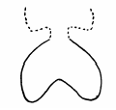 | 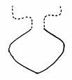 | 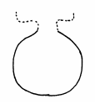 |  | 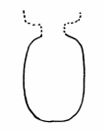

Possible characteristic(s) (Example 6)

Alternative 1

(a) lateral outline (QL)
e.g. reniform (1); rhombic (2); elliptic (3)
(b) ratio length/width (QN):
e.g. elongated high (1); medium (2); compressed low (3)

Alternative 2

Shape (PQ): reniform (1); rhombic (2); elliptic (3); circular (4); transverse elliptic (5)
with the following illustration:

low ← ratio length/width → high |  |  |  | 3  elliptic
low ← ratio length/width → high |  | 1  reniform | 2  rhombic | 4  circular
low ← ratio length/width → high |  |  |  | 5  transverse elliptic

2.5 Combination of Full Plane-, Base- and Apex Shape Characteristics

The following example illustrates how the overall shape of an organ or plant part can be observed in relation to the components of shape explained in Sections 2.2 to 2.4.

Example

the range of shapes covered by the illustrations below

can be observed in relation to:

(ab) ratio length/width (QN):
e.g. very elongated very high (1); moderately elongated high (3); medium (5); moderately compressed low (7); very compressed very low (9)
(bc) position of broadest part (QN):
e.g. at middle (1); moderately towards base (2); strongly towards base (3);
(cd) shape of base (QN/PQ):
e.g. pointed (1); rounded (2); depressed (3)
(de) shape of apex (QN/PQ):
e.g. pointed (1); rounded (2); truncate (3); notched (4)

[Annex IV follows]

Examination of the use component and composite characters for determining distinctness

Information prepared by Experts from Denmark, Germany and the United Kingdom

Background

The key issue in this consideration is defined by document TGP/14/1 draft 11 (see footnote for full reference*). It states that:

“Duplication of the same difference in two separate characteristics should be avoided.”
It further specifically states that:

“...for example, the use of characteristics for both ratio length/width and for shape should be avoided where states of expression of the characteristic for shape relate to different length/width ratios.”

While the latter statement relates specifically to the duplicate assessment of one characteristic by two separate methods (as a shape assessment and as a ratio calculation), the principle of avoiding duplication of the same difference is clearly established in the former statement.

This issue has also been considered in the Technical Committee paper TC-EDC/Jan11/13. Based on the above principles it was questioned whether it was appropriate, for example, to include a length, a width and their ratio in a Test Guideline. The concern was that since the ratio was comprised entirely by the length and width assessments, using all three parameters could be introducing a duplication of the same difference. If so, then in a Test Guideline that included the ratio, only one of the two primary assessments (length or width) should also be included (i.e. ratio + length or ratio + width).

From the above synopsis it is clear that the key issue is to understand the relationship between a composite characteristic and its component characteristics. In practice, it needs to be ascertained whether the same difference is being duplicated. Evidence for this would include how each component distinguishes between large numbers of variety-pairs and specifically whether a high similarity existed in the differences recorded by a composite character and its components. The following report presents evidence and observations on the implications of using individually assessed characters and their calculated composite, for determining distinctness in several agricultural species.

* Section 2 (Botanical Terms), Subsection 2 (Shapes and structures: I), Shape: 2. “Developing Shape-related Characteristics”, para 2.1.1
Possible character combinations

There are several types of character-combinations that can be envisaged. A possible categorization could be as follows:

- Random character combinations
It is possible to calculate a mathematical value for any combination of two characters, for example flowering date divided by leaf length. The issue in this case is not whether the same difference is being duplicated, but that the composite does not describe any biologically occurring or meaningful plant characteristic. It is suggested that it is important to declare in any guideline, that only those calculations that described an actual biological characteristic should be considered for approval as a new distinctness character.

- Relationship characteristics
These calculated characters describe a biologically meaningful relationship between two different plant characteristics. An example would be the ratio between ear length and awn length, whereby candidates are assessed for distinctness on whether the length of awn was significantly longer or shorter for the length of ear to which it was attached (or visa-versa). In theory, this category could also involve non-morphological characteristics such as those based on time or color. A possible example could be a difference in the length of time between flower bud emergence and anthesis, derived by subtracting one date/time from the other. Similarly, a color ratio between two plant parts may differ between varieties and could be assessed.

- Multidimensional characteristics
These calculated characters describe a nonlinear plant feature based on two linear component characters. These could include two-dimensional shape or area characteristics derived from the length and width parameters of leaves, cotyledons, petioles etc. These could also include multidimensional characteristics such as volume, described by the linear characters of height and width, most usefully where the structure is not a perfect sphere.

The demarcation between categories 2 and 3 is to some extent academic, though category 2 includes characteristics that are difficult or impossible to assess without examining the component parts, while category 3 characters are definable structures that could be directly assesses independently of its component parts. In practice, however, the relationships between assessed component and calculated composite characters would not be expected to fundamentally differ and the same question arise regarding inclusion of composite and component characters in the same guideline. The examples provided in this report, therefore, have applicability across both categories.

Dynamics of composite and component characters in example species

Several examples of the discrimination power and relationships between composite characters and their component characters are provided in the Appendix to Annex II. These were produced from DUS trials in Denmark, Germany and the United Kingdom.

In each case the tables examine the capacity of the composite character to distinguish between current varieties by providing a measure of overall discriminating power and the frequency of unique variety-pair separations. The equivalent data for the component characters is also provided, plus the relationship between composite and components measured as correlation/regression analyses. As far as practical the data have been standardized to facilitate across species comparisons.

For overall consideration

There was considerable similarity in the underlying implications of combining individual characters into composites based on the relative discriminating power of each component, and to a lesser degree on the level of similarity and independence between them. There was not, however, sufficiently consistent relationships between composite and component characters in the different species to identify a simple unifying guideline. In some cases the inclusion of composite characters could provide useful additional information, in other cases they appeared to be largely repeating the information available in one or both of their components. Nonetheless, in all species, the composite character did achieve some level of unique variety-pair distinctions.
Determining the appropriate guidance for the future will largely depend on the TWA proposing an expert interpretation of the above observations but it also appears necessary to have specific knowledge of the component/composite dynamics in each species under consideration.

[Appendix follows]
Relationships between component and composite characteristics in example species

The experts provided several distinctness data sets for crop species examined at their research facilities, as follows:

- Awn/Ear Length Ratio in Barley
Component Characters: Ear Length and Awn Length
Composite Character: Awn/Ear Length Ratio

Example A: Discrimination capacity of characteristics for test years 2008 & 2009

UPOV no. | Characteristic | Max. | Min. | LSD | Sig-Each | Sig-Next | Sig-Only
Winter Barley |  |  |  |  | 15576 comparisons
 | Awn: length | 143.97 | 87.47 | 12.00 | 48.0% | 48.0% | 18.4%
16 | Ear: length | 118.80 | 65.65 | 11.80 | 37.0% | 18.8% | 10.3%
17 | Ratio | 2.15 | 0.81 | 0.30 | 33.6% | 0.7% | 0.7%
Spring Barley |  |  |  |  | 46360 comparisons
 | Awn length | 146.27 | 76.92 | 11.47 | 42.7% | 42.7% | 14.1%
16 | Ear length | 97.32 | 61.95 | 8.70 | 29.2% | 16.8% | 7.5%
17 | Ratio | 2.14 | 1.05 | 0.24 | 34.7% | 2.0% | 2.0%

Key: Sig-Each = frequency of variety pairs separated by EACH character independently
Sig-Next = frequency of variety pairs separated by NEXT character when not separated by previous characters
Sig-Only = frequency of variety pairs separated ONLY by that character

Correlations between characters

Winter Barley | 212 varieties in 2008 |  | 213 varieties in 2009
 | Ear Length | Ratio | Ear Length | Ratio
Ratio | -0.76 |  | -0.83
Awn Length | -0.24 | 0.80 | -0.28 | 0.75
Spring Barley | 329 varieties in 2008 |  | 342 varieties in 2009
 | Ear Length | Ratio | Ear Length | Ratio
Ratio | -0.68 |  | -0.70
Awn Length | -0.04 | 0.80 | -0.07 | 0.80

Summary: The composite Ratio had similar discriminating power to Ear Length in Winter Barley and both characters were less powerful than Awn Length (Sig-Each). In Spring Barley the Ratio was more discriminating than Ear Length but again less discriminating that Awn Length. In both species the Ratio separated variety-pairs that were indistinguishable by either component characteristic (Sig-Only). In all data sets, the Ratio was highly positively correlated with Awn Length and highly negatively correlated with Ear Length, while the two component characters were only weakly related.
Example B: Discrimination capacity of characteristics for test years 2006/08, 07/09, 08/10 at two locations each with three growing cycles.

UPOV no. |  | Characteristic | Sig-Each | Sig-Only | Sig-Multi
Winter Barley |  |  | 32,678 comparisons
 | Awn: length |  | 54.3% | 8.9% | 45.4%
16 | Ear: length |  | 65.0% | 10.3% | 54.7%
17 | Ratio |  | 51.6% | 0.6% | 51.1%
Key: as for Example A, plus Sig-Multi = frequency of variety pairs separated by two or all three characters

Correlations between characters (regression coefficient R²)

Winter Barley
 |  |  | Ear: length | Ratio
Ratio |  |  | 0.59
Awn: length |  |  | 0.02 | 0.43
Summary: In agreement with Example A, the calculated Ratio had similar powers of discrimination to one of the component characters, but was weaker than the other (Sig-Each). There were again variety-pairs that were only separated by the Ratio, although in this data set it was in a very small proportion of the comparisons (Sig-Only). The Ratio, therefore, provided little additional discriminating power over its two components. The Ratio was again highly correlated with the component characters which were mutually independent.

- Length/Width Ratios of leaf and fruit in Apple
Component Characters: Leaf Length and Leaf Width;
Fruit Height and Fruit Diameter

Composite Character: Length/Width Ratio
Height/Diameter Ratio

Discrimination capacity of characteristics for test years 2006/07, 07/08, 08/09, 09/10 each with two growing cycles

UPOV no. |  | Characteristic | Sig-Each | Sig-Only | Sig-Multi
Apple (Leaf Characters) |  |  | 13,644 comparisons
14 | Leaf length |  | 52.8% | 9.5% | 43.4%
15 | Leaf Width |  | 43.9% | 3.6% | 40.2%
16 | Ratio |  | 47.1% | 6.9% | 40.2%
Apple (Fruit Characters) |  |  | 13,644 comparisons
14 | Height |  | 52.1% | 4.5% | 47.6%
15 | Diameter |  | 45.5% | 6.9% | 38.6%
16 | Ratio |  | 46.1% | 7.5% | 38.6%
Key: Sig-Each = frequency of variety pairs separated by EACH character independently
Sig-Only = frequency of variety pairs separated ONLY by that character
Sig-Multi = frequency of variety pairs separated by two or all three characters

Correlations between characters (regression coefficient R²)

Apple (Leaf Characters)
 |  | Length |  | Ratio
Ratio |  | 0.19
Width |  | 0.30 |  | 0.26
Apple (Fruit Characters)
 |  | Height |  | Ratio
Ratio |  | 0.25
Diameter |  | 0.52 |  | 0.06
Summary: For leaf characters, the Ratio was slightly more discriminating than Width and slightly less than Length (Sig-Each). Similarly, for fruit characters Diameter and Ratio were similarly discriminating and marginally weaker than Height. In both leaf and fruit examinations the Ratio provided a comparable proportion of unique variety-pair separations to either of its component characters, with the Ratio highest in fruit and second highest in leaf comparisons (Sig-Only). This was probably a consequence of the observed relationships between the characters. In both the leaf and fruit characteristics, the component characters were more closely correlated to each other than to the Ratio, particularly in the fruit.
- Length/Width Ratios of Petals and Cotyledons in Winter Oilseed Rape (WOSR)
Component Characters: Petal Length and Width
Cotyledon Length and Width
Composite Characters: Petal Length/Width Ratio
Cotyledon Length/Width Ratio

WOSR Petal Characteristics |  |  |  |  |  | WOSR Cotyledon Characteristics
Lines 2009 |  |  | Hybrids 2009 |  |  | Lines 2009 |  |  | Hybrids 2009
UPOV No. | Sig-Each | Sig-Next | UPOV No. | Sig-Each | Sig-Next | UPOV No | Sig-Each | Sig-Next | UPOV No. | Sig-Each | Sig-Next
Length 11 | 27.4% | 68.24% | Ratio 54 | 23.7% | 63.01% | Ratio 13 | 21.4% | 60.30% | 74 | 19.4% | 51.15%
Ratio 54 | 24.2% | 19.88% | Length 11 | 21.2% | 20.90% | 72 | 17.5% | 20.47% | Width 3 | 16.2% | 23.07%
16 | 19.2% | 5.93% | 16 | 18.9% | 7.96% | 70 | 13.3% | 8.42% | 75 | 17.7% | 11.29%
18 | 15.8% | 2.71% | 21 | 16.1% | 3.62% | 73 | 13.1% | 4.32% | Ratio 13 | 18.9% | 5.91%
21 | 13.2% | 1.33% | 18 | 15.3% | 1.73% | Width 3 | 10.6% | 3.23% | 70 | 7.6% | 2.86%
15 | 13.3% | 0.81% | 15 | 16.4% | 1.16% | 75 | 17.6% | 1.02% | 78 | 11.6% | 1.47%
17 | 11.2% | 0.40% | 8 | 9.6% | 0.56% | 74 | 19.2% | 0.69% | 73 | 10.8% | 1.42%
4 | 4.0% | 0.23% | 4 | 6.0% | 0.27% | 78 | 12.0% | 0.43% | 72 | 10.8% | 0.88%
19 | 10.9% | 0.17% | 91 | 16.5% | 0.25% | 76 | 14.6% | 0.31% | Length 2 | 13.6% | 0.65%
8 | 4.3% | 0.10% | 19 | 7.5% | 0.14% | Length 2 | 9.8% | 0.27% | 71 | 17.6% | 0.47%
7 | 1.9% | 0.07% | Width 12 | 22.8% | 0.12% | 71 | 18.8% | 0.25% | 76 | 10.3% | 0.30%
Width 12 | 26.2% | 0.06% | 7 | 2.3% | 0.10% | 67 | 11.5% | 0.14% | 67 | 14.8% | 0.26%
91 | 18.6% | 0.03% | 17 | 10.5% | 0.10% | 77 | 2.7% | 0.10% | 66 | 14.6% | 0.12%
9 | 3.3% | 0.03% | 14 | 9.6% | 0.07% | 66 | 8.3% | 0.03% | 69 | 13.6% | 0.07%
14 | 6.6% | 0.01% | 9 | 3.5% | 0.02% | 68 | 9.5% | 0.02% | 77 | 2.4% | 0.05%
Totals | 220286 | 99499 |  | 28887 | 10886 | 69 | 8.7% | 0.01% | 68 | 13.0% | 0.02%
 |  |  |  |  |  | Totals | 254906 | 90437 |  | 24715 | 9368
Key: Sig-Each = frequency of variety pairs separated by EACH character independently as above plus
Sig-Next = frequency of variety pairs separated by NEXT character when not separated by previous characters
Correlations between characters
WOSR |  |  | Lines 2009 |  |  |  | Hybrids 2009
Petal Characteristics |  |  |  | Length | Ratio |  | Length | Ratio
 | Ratio |  |  | 0.52 |  |  | -0.80
 | Width |  |  | -0.20 | 0.74 |  | -0.08 | 0.53
Cotyledon Characteristics |  |  |  | Length | Ratio |  | Length | Ratio
 | Ratio |  |  | -0.38 |  |  | -0.32
 | Width |  |  | 0.72 | 0.37 |  | 0.82 | 0.30
Summary: For both variety types the Length, Width and Ratio petal characters were the three most discriminating of all the characters examined (Sig-Each). The Ratio was the most discriminating character for hybrids and the third most discriminating character for the conventional lines. For cotyledon characters Length, Width and Ratio were not the three most discriminating characters, though Ratio was the most discriminating for conventional lines, and more discriminating than either of its components for both variety types. Overall, therefore, Ratio separated variety-pairs that were not distinct by either of its component characters. Similar to other species, however, Ratio was strongly correlated with both of its components (in one case negatively), while the Length and Width characters were highly independent of each other. In an overall analysis of results from 2010 there was almost perfect correlation between all three characters (data not shown), yet the discriminating power of these three characters was still similar to the 2099 data. This indicated that discrimination power can differ between characters even when they are highly correlated.

- Length/Width Ratios of Flag Leaves in perennial ryegrass

Component Characters: Flag Leaf Length and Flag Leaf Width
Composite Characters: Flag Leaf Length/Width Ratio

Example A: Discrimination capacity of characteristics for test years 2003/05, 05/07, 08/10 each with three growing cycles.

UPOV no. |  | Characteristic | Sig-Each | Sig-Only | Sig-Multi
Ryegrass (fodder diploid) |  |  | 10,598 comparisons
14 | Leaf length |  | 26.2% | 8.6% | 17.6%
15 | Leaf Width |  | 4.7% | 1.5% | 3.2%
16 | Ratio |  | 18.6% | 2.0% | 16.7%
Ryegrass (fodder tetraploid) |  |  | 8,107 comparisons
14 | Leaf length |  | 15.1% | 5.7% | 9.4%
15 | Leaf Width |  | 10.5% | 4.8% | 5.7%
16 | Ratio |  | 11.1% | 1.5% | 9.6%
Ryegrass (turf) |  |  | 10,291 comparisons
14 | Leaf length |  | 23.1% | 13.9% | 9.3%
15 | Leaf Width |  | 10.1% | 4.2% | 5.9%
16 | Ratio |  | 13.6% | 4.9% | 8.7%
Key: Sig-Each = frequency of variety pairs separated by EACH character independently
Sig-Only = frequency of variety pairs separated ONLY by that character
Sig-Multi = frequency of variety pairs separated by two or all three characters
Correlations between characters (regression coefficient R²)

Ryegrass (fodder diploid)
 |  | Length |  | Ratio
Ratio |  | 0.50
Width |  | 0.01 |  | 0.23
Ryegrass (fodder tetraploid)
 |  | Length |  | Ratio
Ratio |  | 0.35
Width |  | 0.16 |  | 0.24
Ryegrass (turf)
 |  | Length |  | Ratio
Ratio |  | 0.26
Width |  | 0.08 |  | 0.61
Summary: Across all three variety types (ploidy and usage) the Ratio was intermediate in overall discriminating power between its component characters (Sig-Each), with Length greatest and Width least powerful. Length uniquely separated the highest proportion of variety-pairs (Sig-Only) with Ratio uniquely separating a similar or lower proportion to Width. Ratio only made a substantial contribution (~5%) of the unique separations in the turf group, which was similar to that achieved by Width. The highest correlation across the fodder diploids was between the Ratio and Length characters. This was most probably due to the low level of variation in Width and this also gave a low correlation between Ratio and Width. In contrast, the closest relationship in the turf types was between Ratio and Width. Overall, however, Length and Width were still highly independent in all three variety types, with the closest relationships involving the Ratio character.

Example B: Final reports on perennial ryegrass candidates 2010

Late Forage Tetraploids - data from 4 years 2006-2010
Candidate: Sures (AFP 13/2185)
Similar Control: Ventoux (AFP 13/1050)

T Values positive if Sures values Larger than Ventoux

 |  |  | MJAR Analysis
 | Character | Stringency | T | Probability | Significance | F3
14 | Length | 0.86 | -2.81 | 0.536 | ** | 1.5 | NS
15 | Width | 0.84 | -1.44 | 15.105 | NS | 0.5 | NS
16 | Ratio | 0.84 | -2.18 | 3.065 | NS (5%) | 1.34 | NS
Late forage diploids - data from 4 years 2006-2010
Candidate: Romark (AFP 13/1480)
Similar Control: Kabota (AFP 13/1398)
If T Values positive Romark values Larger than Kabota
 |  |  | MJAR Analysis
 | Character | Stringency | T | Probability |  | F3
14 | Length | 0.95 | 1.61 | 10.809 | NS | 3.2 | *
15 | Width | 0.89 | 2.62 | 0.947 | ** | 0.8 | NS
16 | Ratio | 0.95 | 2.34 | 2.019 | NS (5%) | 2.1 | NS
Intermediate forage diploids - data from 4 years 2006-2010
Candidate: Perceval (AFP 13/1837)
Similar Control: Merganda (AFP 13/882)
T Values positive if Perceval values Larger than Merganda
 |  |  | MJAR Analysis
 | Character | Stringency | T | Probability |  | F3
14 | Length | 0.82 | 2.50 | 1.282 | NS (5%) | 1.3 | NS
15 | Width | 0.86 | 2.57 | 1.073 | NS (5%) | 0.5 | NS
16 | Ratio | 0.83 | 2.67 | 0.812 | ** | 1.1 | NS
Summary: Example B was constructed from a different data set and a different location to Example A. Despite this the dynamics between the characters was broadly similar, except the overall discriminating power of Width was higher in Example B (data not shown) The three variety distinctness reports provide examples of positive distinctness decisions in 2010 that depended on either Flag Leaf Length, Width or Shape (Ratio). Candidate Sures was passed on a clear difference in Length and as Width had a low non-significant discrimination probability, the calculated difference in Ratio was only at the 5% level. An equivalent result was recorded for Romark, except in this case Width was the essential discriminating character. The third candidate, Percival, was indistinct from Merganda in both component characters (probability levels of only 5%), but their combination in the composite Ratio provided the essential 1% discrimination.

Information provided by the following experts

Beate Ruecker, Germany
Carol Norris, United Kingdom
Erik Lawaetz, Denmark
Trevor Gilliland, United Kingdom (coordinator)
May 6, 2011

[Annex V follows]
Use of Composite Characteristics for Determining Distinctness and Uniformity

Prepared by Experts from Denmark, Germany and United Kingdom

It is possible to derive additional characteristics for comparing between varieties by calculating ‘composite’ characteristics that are mathematical combinations of existing independently examined characteristics. While this can facilitate assessment of important differences between varieties, certain safeguards are necessary to ensure appropriate use. Therefore, composite characteristics should:

- describe a definable plant characteristic.
While it is possible to calculate a mathematical value for any combination of two characteristics (e.g a flowering date divided by a leaf length), only those calculations that describe an actual biological characteristic should be considered for inclusion in procedures.
Permissible examples would be the calculation of a bidimensional characteristic such as area, using linear length and width measurements. Relationship characteristics in morphology can also be derived, such as differences in awn length relative to the length of ear, calculated from the independently measured awn and ear lengths. Similarly, for physiological characteristics a composite can be derived to describe a plant development period for example, by subtracting the timing of flower bud emergence and anthesis. Any other type of composite characteristics that describes a plant feature should be equally suitable.

- be independent of their components
It is important to understand the relationship between a composite characteristic and its components. In compliance with TGP/14 guidelines, it is necessary to ascertain whether or not the same difference is being duplicated. Evidence for this would include comparing how each component distinguishes between a range of variety-pairs and specifically whether a high similarity exists in the variety separations achieved by a composite characteristics and any of its components.

Assessment of uniformity should be conducted in the same manner as for any other characteristics, according to the requirements of TGP/10 (Examining Uniformity) for the characteristics and crop types being examined.

Adoption of any new composite characteristics should, therefore, be considered on an individual species basis and compliance with the above criteria established from evidence of independence from its components and by defining the plant characteristic being examined.

Background note

Document TG/1/3: “General Introduction to the Examination of Distinctness, Uniformity and Stability and the Development of Harmonized Descriptions of New Varieties of Plants” states as follows:

“4.6.3 Combined Characteristics

“4.6.3.1 A combined characteristic is a simple combination of a small number of characteristics. Provided the combination is biologically meaningful, characteristics that are assessed separately may subsequently be combined, for example the ratio of length to width, to produce such a combined characteristic. Combined characteristics must be examined for distinctness, uniformity and stability to the same extent as other characteristics. In some cases, these combined characteristics are examined by means of techniques, such as Image Analysis. In these cases, the methods for appropriate examination of DUS are specified in document TGP/12, “Special Characteristics.”

“4.6.3.2 Combined characteristics are not to be confused with the application of methods, such as “multivariate analysis.” The potential for use of multivariate analysis is considered in document TGP/9, “Examining Distinctness.”

[End of Annex V and of document]

