 | E
International Union for the Protection of New Varieties of Plants

Technical Working Party for Agricultural Crops  Fifty-Fifth Session  Seoul, Republic of Korea, June 15 to 18, 2026 | TWA/55/3 with TWA comments  Original: English  Date: May 13, 2026
Partial revision of the Test Guidelines for Sweet Potato
Document prepared by an expert from Japan
Disclaimer: this document does not represent UPOV policies or guidance
The purpose of this document is to present a proposal for a partial revision of the Test Guidelines for Sweet Potato (document TG/258/1).

The Technical Working Party for Agricultural Crops (TWA), at its fifty-third session, agreed that the Test Guidelines for Sweet Potato (Ipomoea batatas (L.) Lam.) be partially revised and agreed to continue discussions on the inclusion of a new characteristic at the fifty-fifth session of the TWA (see document TWA/54/9 “Report”, paragraph 41 and Annex IV).

The following changes are proposed:

- Addition of a new characteristic and explanation “Leaf blade: anthocyanin coloration of nectary” after characteristic 16 “Young leaf blade: main color on upper side”
- Revision of characteristic and explanation 19 “Storage root: shape”
- Revision of example varieties of characteristic 23 “Storage root: secondary color of skin”
- Revision of characteristic 24 “Storage root: main color of flesh”

The proposed changes are presented below in highlight and underline (insertion) and strikethrough (deletion).

Proposed addition of a new characteristic “Leaf blade: anthocyanin coloration of nectary” after characteristic 16 “Young leaf blade: main color on upper side”

 |  | English | français | deutsch | español | Example Varieties/  Exemples/  Beispielssorten/  Variedades ejemplo | Note/  Nota
17. | VG | Leaf blade: anthocyanin coloration of nectary
QN |  | absent or very weak |  |  |  | Tamayutaka, Koukei14 | 1
 |  | weak |  |  |  | Shiroyutaka | 2
 |  | medium |  |  |  | Suiou | 3
 |  | strong |  |  |  | Beniazuma,  Koganesengan | 4
 |  | very strong |  |  |  |  | 5

Ad. 17: Leaf blade: anthocyanin coloration of nectary

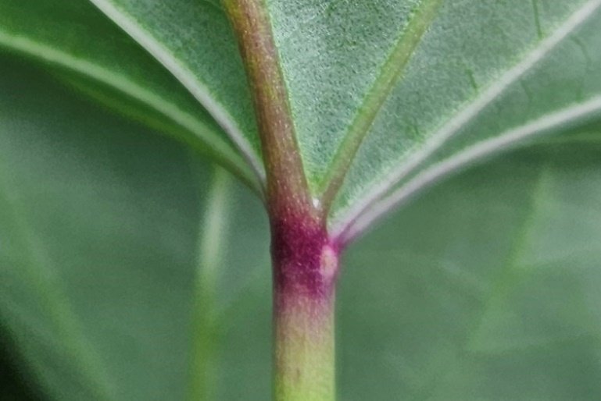

Observations should be made on the nectaries located on the abaxial or underside of the leaf blade at the base. The anthocyanins on the nectaries are independent of the anthocyanins on the veins, and petiole.

Proposed revision of characteristic 19 “Storage root: shape”

Current wording

19.  (*)  (+) | VG | Storage root: shape | Racine de réserve : forme | Speicherwurzel: Form | Raíz tuberosa: forma
PQ | (e) | ovate | ovale | eiförmig | oval |  | 1
 |  | elliptic | elliptique | elliptisch | elíptica |  | 2
 |  | obovate | obovale | verkehrt eiförmig | oboval | Geonmi | 3
 |  | oblong | oblongue | rechteckig | oblonga | Serolane | 4
 |  | irregular | irrégulière | unregelmäßig | irregular | Shinyulmi | 5

Ad. 19: Storage root: shape

 |  | < position of broadest part >
 |  | below middle | at middle | above middle
< lateral outline > | rounded | 1  ovate | 2  elliptic | 3  obovate
< lateral outline > | oblong | 4  oblong
< lateral outline > | irregular | 5  irregular

Proposed new wording

19.  (*)  (+) | VG | Storage root: shape | Racine de réserve : forme | Speicherwurzel: Form | Raíz tuberosa: forma
PQ | (e) | ovate | ovale | eiförmig | oval |  | 1
 |  | circular | circulaire | kreisförmig | circular |  | 2
 |  | elliptic | elliptique | elliptisch | elíptica | Koukei14 | 3
 |  | oblong | oblongue | rechteckig | oblonga | Serolane | 4
 |  | linear | linéaire | linear | lineal | Sweet Caroline Right Green | 5
 |  | obovate | obovale | verkehrt eiförmig | oboval | Geonmi, Koganesengan | 6
 |  | oblong | oblongue | rechteckig | oblonga | Serolane | 7
 |  | irregular | irrégulière | unregelmäßig | irregular | Shinyulmi | 7

Ad. 19: Storage root: shape

 |  | broadest part
 |  | below middle | at middle |  | above middle
relative width | narrow |  |   5  linear
relative width | medium | 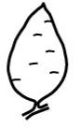  1  ovate | 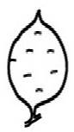  (rounded)  3  elliptic | 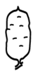  (parallel)  4  oblong | 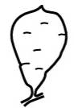  6  obovate
relative width | broad |  | 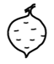  2  circular
irregular |  | 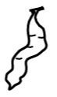  7  irregular

Proposed revision of characteristic 23 “Storage root: secondary color of skin”

Current wording

 |  | English | français | deutsch | español | Example Varieties/  Exemples/  Beispielssorten/  Variedades ejemplo | Note/  Nota
23. | VG | Storage root: secondary color of skin | Racine de réserve : couleur secondaire de la peau | Speicherwurzel: Sekundärfarbe der Schale | Raíz tuberosa: color secundario de la piel
QN |  | absent | absente | fehlend | ausente | Koganesengan | 1
 |  | white | blanche | weiß | blanco | Tamayutaka | 2
 |  | yellow | jaune | gelb | amarillo |  | 3
 |  | orange | orange | orange | anaranjado |  | 4
 |  | pink | rose | rosa | rosa | Koukei 14 | 5
 |  | red | rouge | rot | rojo | Nakamurasaki | 6
 |  | purple | pourpre | purpurn | púrpura | Benikomachi | 7
 |  | brown | brune | braun | marrón | Koganesengan | 8

Proposed new wording

 |  | English | français | deutsch | español | Example Varieties/  Exemples/  Beispielssorten/  Variedades ejemplo | Note/  Nota
23. | VG | Storage root: secondary color of skin | Racine de réserve : couleur secondaire de la peau | Speicherwurzel: Sekundärfarbe der Schale | Raíz tuberosa: color secundario de la piel
PQ |  | absent  none | absente  aucune | fehlend  keine | ausente | Koganesengan, Beniazuma | 1
 |  | white | blanche | weiß | blanco | Tamayutaka | 2
 |  | yellow | jaune | gelb | amarillo |  | 3
 |  | orange | orange | orange | anaranjado |  | 4
 |  | pink | rose | rosa | rosa | Koukei 14 | 5
 |  | red | rouge | rot | rojo | Nakamurasaki | 6
 |  | purple | pourpre | purpurn | púrpura | Benikomachi | 7
 |  | brown | brune | braun | marrón | Koganesengan | 8

Proposed revision of characteristic 24 “Storage root: main color of flesh”

Current wording

24.  (*)  (+) | VG | Storage root: main color of flesh | Racine de réserve : couleur de la chair | Speicherwurzel: Hauptfarbe des Fleisches | Raíz tuberosa: color principal de la pulpa
PQ | (e) | white | blanche | weiß | blanco | Hayanmi,  Shirosengan | 1
 |  | beige | beige | beige | beige | Nakamurasaki, Koukei 14 | 2
 |  | yellow | jaune | gelb | amarillo | Benikomachi, Yulmi | 3
 |  | orange | orange | orange | anaranjado | Benihayato, Hayatoimo,  Juhwangmi | 4
 |  | purple | pourpre | purpurn | púrpura | Ayamurasaki, Borami | 5

Proposed new wording

24.  (*)  (+) | VG | Storage root: main color of flesh | Racine de réserve : couleur de la chair | Speicherwurzel: Hauptfarbe des Fleisches | Raíz tuberosa: color principal de la pulpa
PQ | (e) | white | blanche | weiß | blanco | Hayanmi,  Shirosengan | 1
 |  | beige  light yellow brown | beige  brun-jaune clair | beige  hellgelbbraun | beige  marrón amarillento claro | Nakamurasaki, Koukei 14 | 2
 |  | yellow | jaune | gelb | amarillo | Benikomachi, Yulmi | 3
 |  | orange | orange | orange | anaranjado | Benihayato, Hayatoimo,  Juhwangmi | 4
 |  | pink | rose | rosa | rosa |  | 5
 |  | red | rouge | rot | rojo |  | 6
 |  | purple red | rouge-pourpre | purpurrot | rojo púrpura | Origin Ruby | 7
 |  | purple | pourpre | purpurn | púrpura | Ayamurasaki, Borami | 8

[End of document]

held via electronic means, from May 27 to 30, 2024

