|  |  |  |  |  |  |
| --- | --- | --- | --- | --- | --- |
|  | 75 | | | E  **TG/VIGNA_RAD(proj.3)**  ORIGINAL: English  **DATE**: 2025-04-22 | |
| INTERNATIONAL UNION FOR THE PROTECTION OF NEW VARIETIES OF PLANTS | | | | |
| Geneva | | | | |
| DRAFT |

|  |  |  |
| --- | --- | --- |
|  | MUNG BEAN  UPOV Code(s): VIGNA_RAD  *Vigna radiata* (L.) R. Wilczek | * |

GUIDELINESFOR THE CONDUCT OF TESTS  
FOR DISTINCTNESS, UNIFORMITY AND STABILITY

prepared by an expert from China

to be considered by the

Technical Working Party for Agricultural Crops at its fifty-fourth session,

to be held in Arusha, United Republic of Tanzania, from 2025-05-19 to 2025-05-22

Disclaimer: this document does not represent UPOV policies or guidance

Alternative Names:*

| *Botanical name* | *English* | *French* | *German* | *Spanish* |
| --- | --- | --- | --- | --- |
| *Vigna radiata* (L.) R. Wilczek | Mung Bean | Haricot mungo | Mungbohne, Mungobohne | Frijol mungo |

The purpose of these guidelines (“Test Guidelines”) is to elaborate the principles contained in the General Introduction (document TG/1/3), and its associated TGP documents, into detailed practical guidance for the harmonized examination of distinctness, uniformity and stability (DUS) and, in particular, to identify appropriate characteristics for the examination of DUS and production of harmonized variety descriptions.

**ASSOCIATED DOCUMENTS**

These Test Guidelines should be read in conjunction with the General Introduction and its associated

TGP documents.

TABLE OF CONTENTS PAGE

1. Subject of these Test Guidelines 3

2. Material Required 3

3. Method of Examination 3

3.1  Number of Growing Cycles 3

3.2  Testing Place 3

3.3  Conditions for Conducting the Examination 3

3.4  Test Design 3

3.5  Additional Tests 3

4. Assessment of Distinctness, Uniformity and Stability 4

4.1  Distinctness 4

4.2  Uniformity 5

4.3  Stability 5

5. Grouping of Varieties and Organization of the Growing Trial 5

6. Introduction to the Table of Characteristics 5

6.1  Categories of Characteristics 5

6.2  States of Expression and Corresponding Notes 6

6.3  Types of Expression 6

6.4  Example Varieties 6

6.5  Legend 6

7. Table of Characteristics/Tableau des caracteres/Merkmalstabelle/Tabla de caracteres 7

8. Explanations on the Table of Characteristics 13

8.1  Explanations covering several characteristics 13

8.2  Explanations for individual characteristics 13

8.3  Additional Explanations on the Table of Characteristics 17

9. Literature 18

10. Technical Questionnaire 19

# Subject of these Test Guidelines

These Test Guidelines apply to all varieties of *Vigna radiata* (L.) R. Wilczek.

# Material Required

2.1 The competent authorities decide on the quantity and quality of the plant material required for testing the variety and when and where it is to be delivered. Applicants submitting material from a State other than that in which the testing takes place must ensure that all customs formalities and phytosanitary requirements are complied with.

2.2 The material is to be supplied in the form of seed.

2.3 The minimum quantity of plant material, to be supplied by the applicant, should be:

500 g of seed

The seed should meet the minimum requirements for germination, species and analytical purity, health and moisture content, specified by the competent authority. In cases where the seed is to be stored, the germination capacity should be as high as possible and should, be stated by the applicant.

2.4 The plant material supplied should be visibly healthy, not lacking in vigor, nor affected by any important pest or disease.

2.5 The plant material should not have undergone any treatment which would affect the expression of the characteristics of the variety, unless the competent authorities allow or request such treatment. If it has been treated, full details of the treatment must be given.

# Method of Examination

## 3.1  Number of Growing Cycles

3.1.1 The minimum duration of tests should normally be two independent growing cycles.

3.1.2 The two independent growing cycles should be in the form of two separate plantings.

3.1.3 The testing of a variety may be concluded when the competent authority can determine with certainty the outcome of the test.

## 3.2  Testing Place

Tests are normally conducted at one place. In the case of tests conducted at more than one place, guidance is provided in TGP/9 “Examining Distinctness”.

## 3.3  Conditions for Conducting the Examination

The tests should be carried out under conditions ensuring satisfactory growth for the expression of the relevant characteristics of the variety and for the conduct of the examination.

## 3.4  Test Design

3.4.1 Each test should be designed to result in a total of at least 100 plants which should be divided between at least 2 replicates.

3.4.2 The design of the tests should be such that plants or parts of plants may be removed for measurement or counting without prejudice to the observations which must be made up to the end of the growing cycle.

## 3.5  Additional Tests

Additional tests, for examining relevant characteristics, may be established.

# Assessment of Distinctness, Uniformity and Stability

## 4.1  Distinctness

4.1.1 General Recommendations

It is of particular importance for users of these Test Guidelines to consult the General Introduction prior to making decisions regarding distinctness. However, the following points are provided for elaboration or emphasis in these Test Guidelines.

4.1.2 Consistent Differences

The differences observed between varieties may be so clear that more than one growing cycle is not necessary. In addition, in some circumstances, the influence of the environment is not such that more than a single growing cycle is required to provide assurance that the differences observed between varieties are sufficiently consistent. One means of ensuring that a difference in a characteristic, observed in a growing trial, is sufficiently consistent is to examine the characteristic in at least two independent growing cycles.

4.1.3 Clear Differences

Determining whether a difference between two varieties is clear depends on many factors, and should consider, in particular, the type of expression of the characteristic being examined, i.e. whether it is expressed in a qualitative, quantitative, or pseudo-qualitative manner. Therefore, it is important that users of these Test Guidelines are familiar with the recommendations contained in the General Introduction prior to making decisions regarding distinctness.

4.1.4 Number of Plants or Parts of Plants to be Examined

Unless otherwise indicated, for the purposes of distinctness, all observations on single plants should be made on 20 plants or parts of plants taken from each of 20 plants and any other observations made on all plants in the test, disregarding any off-type plants.

4.1.5 Method of Observation

The recommended method of observing the characteristic for the purposes of distinctness is indicated by the following key in the Table of Characteristics (see document TGP/9 “Examining Distinctness”, Section 4 “Observation of characteristics”):

MG: single measurement of a group of plants or parts of plants

MS: measurement of a number of individual plants or parts of plants

VG: visual assessment by a single observation of a group of plants or parts of plants

VS: visual assessment by observation of individual plants or parts of plants”):

Type of observation: visual (V) or measurement (M)

“Visual” observation (V) is an observation made on the basis of the expert’s judgment. For the purposes of this document, “visual” observation refers to the sensory observations of the experts and, therefore, also includes smell, taste and touch. Visual observation includes observations where the expert uses reference points (e.g. diagrams, example varieties, side-by-side comparison) or non-linear charts (e.g. color charts). Measurement (M) is an objective observation against a calibrated, linear scale e.g. using a ruler, weighing scales, colorimeter, dates, counts, etc.

Type of record: for a group of plants (G) or for single, individual plants (S)

For the purposes of distinctness, observations may be recorded as a single record for a group of plants or parts of plants (G), or may be recorded as records for a number of single, individual plants or parts of plants (S). In most cases, “G” provides a single record per variety and it is not possible or necessary to apply statistical methods in a plant-by-plant analysis for the assessment of distinctness.

In cases where more than one method of observing the characteristic is indicated in the Table of Characteristics (e.g. VG/MG), guidance on selecting an appropriate method is provided in document TGP/9, Section 4.2.

## 4.2  Uniformity

4.2.1 It is of particular importance for users of these Test Guidelines to consult the General Introduction prior to making decisions regarding uniformity. However, the following points are provided for elaboration or emphasis in these Test Guidelines:

4.2.2 These Test Guidelines have been developed for the examination of seed-propagated varieties. For varieties with other types of propagation, the recommendations in the General Introduction and document TGP/13 "Guidance for new types and species" Section 4.5 "Testing Uniformity" should be followed.

4.2.3 For the assessment of uniformity, a population standard of 1% and an acceptance probability of at least 95% should be applied. In the case of a sample size of 100 plants, 3 off-types are allowed.

## 4.3  Stability

4.3.1 In practice, it is not usual to perform tests of stability that produce results as certain as those of the testing of distinctness and uniformity. However, experience has demonstrated that, for many types of variety, when a variety has been shown to be uniform, it can also be considered to be stable.

4.3.2 Where appropriate, or in cases of doubt, stability may be further examined by testing a new seed stock to ensure that it exhibits the same characteristics as those shown by the initial material supplied.

# Grouping of Varieties and Organization of the Growing Trial

5.1 The selection of varieties of common knowledge to be grown in the trial with the candidate varieties and the way in which these varieties are divided into groups to facilitate the assessment of distinctness are aided by the use of grouping characteristics.

5.2 Grouping characteristics are those in which the documented states of expression, even where produced at different locations, can be used, either individually or in combination with other such characteristics: (a) to select varieties of common knowledge that can be excluded from the growing trial used for examination of distinctness; and (b) to organize the growing trial so that similar varieties are grouped together.

5.3 The following have been agreed as useful grouping characteristics:

(a) Hypocotyl: anthocyanin coloration (characteristic 1)

(b) Flower: color of corolla (characteristic 9)

(c) Time of maturity (characteristic 11)

(d) Plant: growth habit (characteristic 12)

(e) Seed: ground color of testa (characteristic 26)

(f) Seed: glossiness (characteristic 27)

5.4 Guidance for the use of grouping characteristics, in the process of examining distinctness, is provided through the General Introduction and document TGP/9 “Examining Distinctness”.

# Introduction to the Table of Characteristics

## 6.1  Categories of Characteristics

6.1.1 Standard Test Guidelines Characteristics

Standard Test Guidelines characteristics are those which are approved by UPOV for examination of DUS and from which members of the Union can select those suitable for their particular circumstances.

6.1.2 Asterisked Characteristics

Asterisked characteristics (denoted by *) are those included in the Test Guidelines which are important for the international harmonization of variety descriptions and should always be examined for DUS and included in the variety description by all members of the Union, except when the state of expression of a preceding characteristic or regional environmental conditions render this inappropriate.

## 6.2  States of Expression and Corresponding Notes

6.2.1 States of expression are given for each characteristic to define the characteristic and to harmonize descriptions. Each state of expression is allocated a corresponding numerical note for ease of recording of data and for the production and exchange of the description.

6.2.2 All relevant states of expression are presented in the characteristic.

6.2.3 Further explanation of the presentation of states of expression and notes is provided in document TGP/7 “Development of Test Guidelines”.

## 6.3  Types of Expression

An explanation of the types of expression of characteristics (qualitative, quantitative and pseudo-qualitative) is provided in the General Introduction.

## 6.4  Example Varieties

Where appropriate, example varieties are provided to clarify the states of expression of each characteristic.

## 

## 6.5  Legend

|  |  |  |  |  |  |  |  |  |  |
| --- | --- | --- | --- | --- | --- | --- | --- | --- | --- |
|  | | English | | français | | deutsch | español | Example Varieties  Exemples  Beispielssorten  Variedades ejemplo | Note/  Nota |
| **1** | **2** | **3** | **4** | **5** | **6** | **7** |  |  |  |
|  |  | **Name of characteristics in English** | | **Nom du caractère en français** | | **Name des Merkmals auf Deutsch** | **Nombre del carácter en español** |  |  |
|  | states of expression | | types d’expression | | Ausprägungsstufen | tipos de expresión |  |  |

1 Characteristic number

2 (*) Asterisked characteristic – see Chapter 6.1.2

3 Type of expression

QL Qualitative characteristic – see Chapter 6.3

QN Quantitative characteristic – see Chapter 6.3

PQ Pseudo-qualitative characteristic – see Chapter 6.3

4 Method of observation (and type of plot, if applicable)

MG, MS, VG, VS – see Chapter 4.1.5

5 (+) See Explanations on the Table of Characteristics in Chapter 8.2

6 (a)-(x) See Explanations on the Table of Characteristics in Chapter 8.1

7 Growth stage key (if applicable) See Explanations on the Table of Characteristics in Chapter 8.3

# Table of Characteristics/Tableau des caracteres/Merkmalstabelle/Tabla de caracteres

|  | | English | | français | | deutsch | español | Example Varieties  Exemples  Beispielssorten  Variedades ejemplo | Note/  Nota |
| --- | --- | --- | --- | --- | --- | --- | --- | --- | --- |
| **1.** | **(*)** | **QL** | **VG** | **(+)** |  | **10** |  |  |  |
|  | | **Hypocotyl: anthocyanin coloration** | |  | |  |  |  |  |
| absent | |  | |  |  | Zhonglv1 C3408 | 1 |
| present | |  | |  |  | Dayinggelv 925 C5786 | 2 |
| **2.** |  | **QN** | **MG** | **(+)** |  | **20** |  |  |  |
|  | | **Time of beginning of flowering** | |  | |  |  |  |  |
| very early | |  | |  |  |  | 1 |
| very early to early | |  | |  |  |  | 2 |
| early | |  | |  |  | Baolv 942 C5636 | 3 |
| early to medium | |  | |  |  |  | 4 |
| medium | |  | |  |  | Zhonglv1 C3408 | 5 |
| medium to late | |  | |  |  |  | 6 |
| late | |  | |  |  | Lvdou C2969 | 7 |
| late to very late | |  | |  |  |  | 8 |
| very late | |  | |  |  |  | 9 |
| **3.** |  | **QN** | **VG** |  | **(a)** | **30** |  |  |  |
|  | | **Stem: anthocyanin coloration** | |  | |  |  |  |  |
| absent or very weak | |  | |  |  |  | 1 |
| weak | |  | |  |  |  | 2 |
| medium | |  | |  |  |  | 3 |
| strong | |  | |  |  |  | 4 |
| very strong | |  | |  |  |  | 5 |
| **4.** |  | **QN** | **VG** | **(+)** | **(a)** | **30** |  |  |  |
|  | | **Stem: hairiness** | |  | |  |  |  |  |
| absent or very weak | |  | |  |  |  | 1 |
| weak | |  | |  |  |  | 2 |
| medium | |  | |  |  |  | 3 |
| strong | |  | |  |  |  | 4 |
| very strong | |  | |  |  |  | 5 |
| **5.** |  | **PQ** | **VG** | **(+)** | **(b)** | **30** |  |  |  |
|  | | **Leaf: shape of lateral leaflet** | |  | |  |  |  |  |
| lanceolate | |  | |  |  |  | 1 |
| medium ovate | |  | |  |  |  | 2 |
| broad ovate | |  | |  |  |  | 3 |
| lobed | |  | |  |  |  | 4 |
| **6.** |  | **QN** | **VG** |  | **(b)** | **30** |  |  |  |
|  | | **Leaf: intensity of green color** | |  | |  |  |  |  |
| light | |  | |  |  |  | 1 |
| medium | |  | |  |  |  | 2 |
| dark | |  | |  |  |  | 3 |
| **7.** |  | **QL** | **VG** |  | **(b)** | **30** |  |  |  |
|  | | **Leaf: anthocyanin coloration at base of leaflets** | |  | |  |  |  |  |
| absent | |  | |  |  | Zhonglv1 C3408 | 1 |
| present | |  | |  |  | Dayinggelv 925 C5786 | 2 |
| **8.** |  | **QN** | **VG** |  | **(b)** |  |  |  |  |
|  | | **Leaf: leaf size** | |  | |  |  |  |  |
| small | |  | |  |  |  | 1 |
| small to medium | |  | |  |  |  | 2 |
| medium | |  | |  |  |  | 3 |
| medium to large | |  | |  |  |  | 4 |
| large | |  | |  |  |  | 5 |
| **9.** | **(*)** | **PQ** | **VG** |  | **(d)** | **30** |  |  |  |
|  | | **Flower: color of corolla** | |  | |  |  |  |  |
| light yellow | |  | |  |  |  | 1 |
| medium yellow | |  | |  |  |  | 2 |
| yellow - purple blend | |  | |  |  |  | 3 |
| **10.** |  | **QL** | **VG** |  | **(d)** | **30** |  |  |  |
|  | | **Flower: anthocyanin coloration of sepal** | |  | |  |  |  |  |
| absent | |  | |  |  |  | 1 |
| present | |  | |  |  |  | 2 |
| **11.** | **(*)** | **QN** | **MG** | **(+)** |  | **40** |  |  |  |
|  | | **Time of maturity** | |  | |  |  |  |  |
| very early | |  | |  |  |  | 1 |
| very early to early | |  | |  |  |  | 2 |
| early | |  | |  |  | Baolv 942 C5636 | 3 |
| early to medium | |  | |  |  |  | 4 |
| medium | |  | |  |  | Zhonglv1 C3408 | 5 |
| medium to late | |  | |  |  |  | 6 |
| late | |  | |  |  | Lvdou C2969 | 7 |
| late to very late | |  | |  |  |  | 8 |
| very late | |  | |  |  |  | 9 |
| **12.** | **(*)** | **PQ** | **VG** | **(+)** |  | **40-50** |  |  |  |
|  | | **Plant: growth habit** | |  | |  |  |  |  |
| determinate | |  | |  |  | Zhonglv1 C3408 | 1 |
| semi-determinate | |  | |  |  | Yinggelvdou C1547 | 2 |
| indeterminate | |  | |  |  | Lanlvdou C4157 | 3 |
| **13.** |  | **QN** | **MS** |  |  | **40-50** |  |  |  |
|  | | **Plant: height** | |  | |  |  |  |  |
| very short | |  | |  |  | Gaoyangxiaolvdou C0229 | 1 |
| very short to short | |  | |  |  |  | 2 |
| short | |  | |  |  | Dayanglvdou C0385 | 3 |
| short to medium | |  | |  |  |  | 4 |
| medium | |  | |  |  | Zhonglv1 C3408 | 5 |
| medium to tall | |  | |  |  |  | 6 |
| tall | |  | |  |  | Quyangxiaolvdou C1819 | 7 |
| tall to very tall | |  | |  |  |  | 8 |
| very tall | |  | |  |  | Hulvdou C1431 | 9 |
| **14.** |  | **QN** | **MS** |  |  | **40-50** |  |  |  |
|  | | **Plant: number of branches** | |  | |  |  |  |  |
| few | |  | |  |  |  | 1 |
| medium | |  | |  |  |  | 2 |
| many | |  | |  |  |  | 3 |
| **15.** |  | **QN** | **VG** | **(+)** |  | **40-50** |  |  |  |
|  | | **Plant: attitude of branches** | |  | |  |  |  |  |
| erect | |  | |  |  |  | 1 |
| erect to semi erect | |  | |  |  |  | 2 |
| semi erect | |  | |  |  |  | 3 |
| semi erect to horizontal | |  | |  |  |  | 4 |
| horizontal | |  | |  |  |  | 5 |
| **16.** |  | **QN** | **MS** |  |  | **50** |  |  |  |
|  | | **Plant:  number of pods** | |  | |  |  |  |  |
| very few | |  | |  |  | Dayanglvdou C0385 | 1 |
| very few to few | |  | |  |  |  | 2 |
| few | |  | |  |  | Gaoyangxiaolvdou C0229 | 3 |
| few to medium | |  | |  |  |  | 4 |
| medium | |  | |  |  | Youlvdou C3247 | 5 |
| medium to many | |  | |  |  |  | 6 |
| many | |  | |  |  | Zhonglv1 C3408 | 7 |
| many to very many | |  | |  |  |  | 8 |
| very many | |  | |  |  | Hulvdou C1431 | 9 |
| **17.** |  | **QN** | **MS** | **(+)** |  | **50** |  |  |  |
|  | | **Stem: number of nodes** | |  | |  |  |  |  |
| few | |  | |  |  |  | 1 |
| medium | |  | |  |  |  | 2 |
| many | |  | |  |  |  | 3 |
| **18.** |  | **QN** | **MS** |  | **(c)** | **50** |  |  |  |
|  | | **Pod:  length** | |  | |  |  |  |  |
| short | |  | |  |  | Hulvdou C2185 | 1 |
| medium | |  | |  |  | Zhonglv1 C3408 | 2 |
| long | |  | |  |  | Dayinggelv 925 C5786 | 3 |
| **19.** |  | **QN** | **MS** | **(+)** | **(c)** | **50** |  |  |  |
|  | | **Pod:  number of seeds** | |  | |  |  |  |  |
| few | |  | |  |  | Fuxinlvdou C3455 | 1 |
| medium | |  | |  |  | Zhonglv1 C3408 | 2 |
| many | |  | |  |  | Dengxianlvdou C2737 | 3 |
| **20.** |  | **PQ** | **VG** | **(+)** | **(c)** | **50** |  |  |  |
|  | | **Pod: curvature** | |  | |  |  |  |  |
| straight | |  | |  |  |  | 1 |
| falcate | |  | |  |  |  | 2 |
| incurved | |  | |  |  |  | 3 |
| **21.** |  | **PQ** | **VG** |  |  | **40** |  |  |  |
|  | | **Stem: shape in cross-section** | |  | |  |  |  |  |
| round | |  | |  |  | Dengxianlvdou C2737 | 1 |
| oblate | |  | |  |  | Zhonglv1 C3408 | 2 |
| **22.** |  | **PQ** | **VG** |  | **(c)** | **50** |  |  |  |
|  | | **Pod: color** | |  | |  |  |  |  |
| yellowish white | |  | |  |  | Hulvdou C2185 | 1 |
| brown | |  | |  |  | Dengxianlvdou C2737 | 2 |
| black | |  | |  |  | Zhonglv1 C3408 | 3 |
| **23.** |  | **QL** | **VG** |  | **(c)** | **50** |  |  |  |
|  | | **Pod: color of hairs** | |  | |  |  |  |  |
| grey | |  | |  |  |  | 1 |
| brown | |  | |  |  |  | 2 |
| **24.** |  | **QN** | **MG** |  |  | **50** |  |  |  |
|  | | **Seed: weight per 100 seeds** | |  | |  |  |  |  |
| low | |  | |  |  |  | 1 |
| low to medium | |  | |  |  |  | 2 |
| medium | |  | |  |  |  | 3 |
| medium to high | |  | |  |  |  | 4 |
| high | |  | |  |  |  | 5 |
| **25.** |  | **PQ** | **VG** | **(+)** |  | **50** |  |  |  |
|  | | **Seed: shape** | |  | |  |  |  |  |
| globose | |  | |  |  | Pinlvyouzi 88-49 C5234 | 1 |
| narrow oblong | |  | |  |  | Dayinggelv 925 C5786 | 2 |
| broad oblong | |  | |  |  | Zhonglv1 C3408 | 3 |
| **26.** | **(*)** | **PQ** | **VG** | **(+)** |  | **50** |  |  |  |
|  | | **Seed: ground color of testa** | |  | |  |  |  |  |
| light green | |  | |  |  |  | 1 |
| medium green | |  | |  |  |  | 2 |
| dark green | |  | |  |  |  | 3 |
| yellow | |  | |  |  |  | 4 |
| brown | |  | |  |  |  | 5 |
| black | |  | |  |  |  | 6 |
| **27.** | **(*)** | **QL** | **VG** |  |  | **50** |  |  |  |
|  | | **Seed: glossiness** | |  | |  |  |  |  |
| absent | |  | |  |  |  | 1 |
| present | |  | |  |  |  | 2 |

# Explanations on the Table of Characteristics

## 8.1  Explanations covering several characteristics

Characteristics containing the following key in the Table of Characteristics should be examined as indicated below:

(a) Observations should be made in the middle and upper part of the main stem.

(b) Observations should be made on lateral leaflets of compound leaves at segments 8 to 10 in the middle and upper parts of the plant.

(c) Measure the pod in the upper part of the plant.

(d) Observations should be made on fresh fully open flowers. Diagram of flower parts:

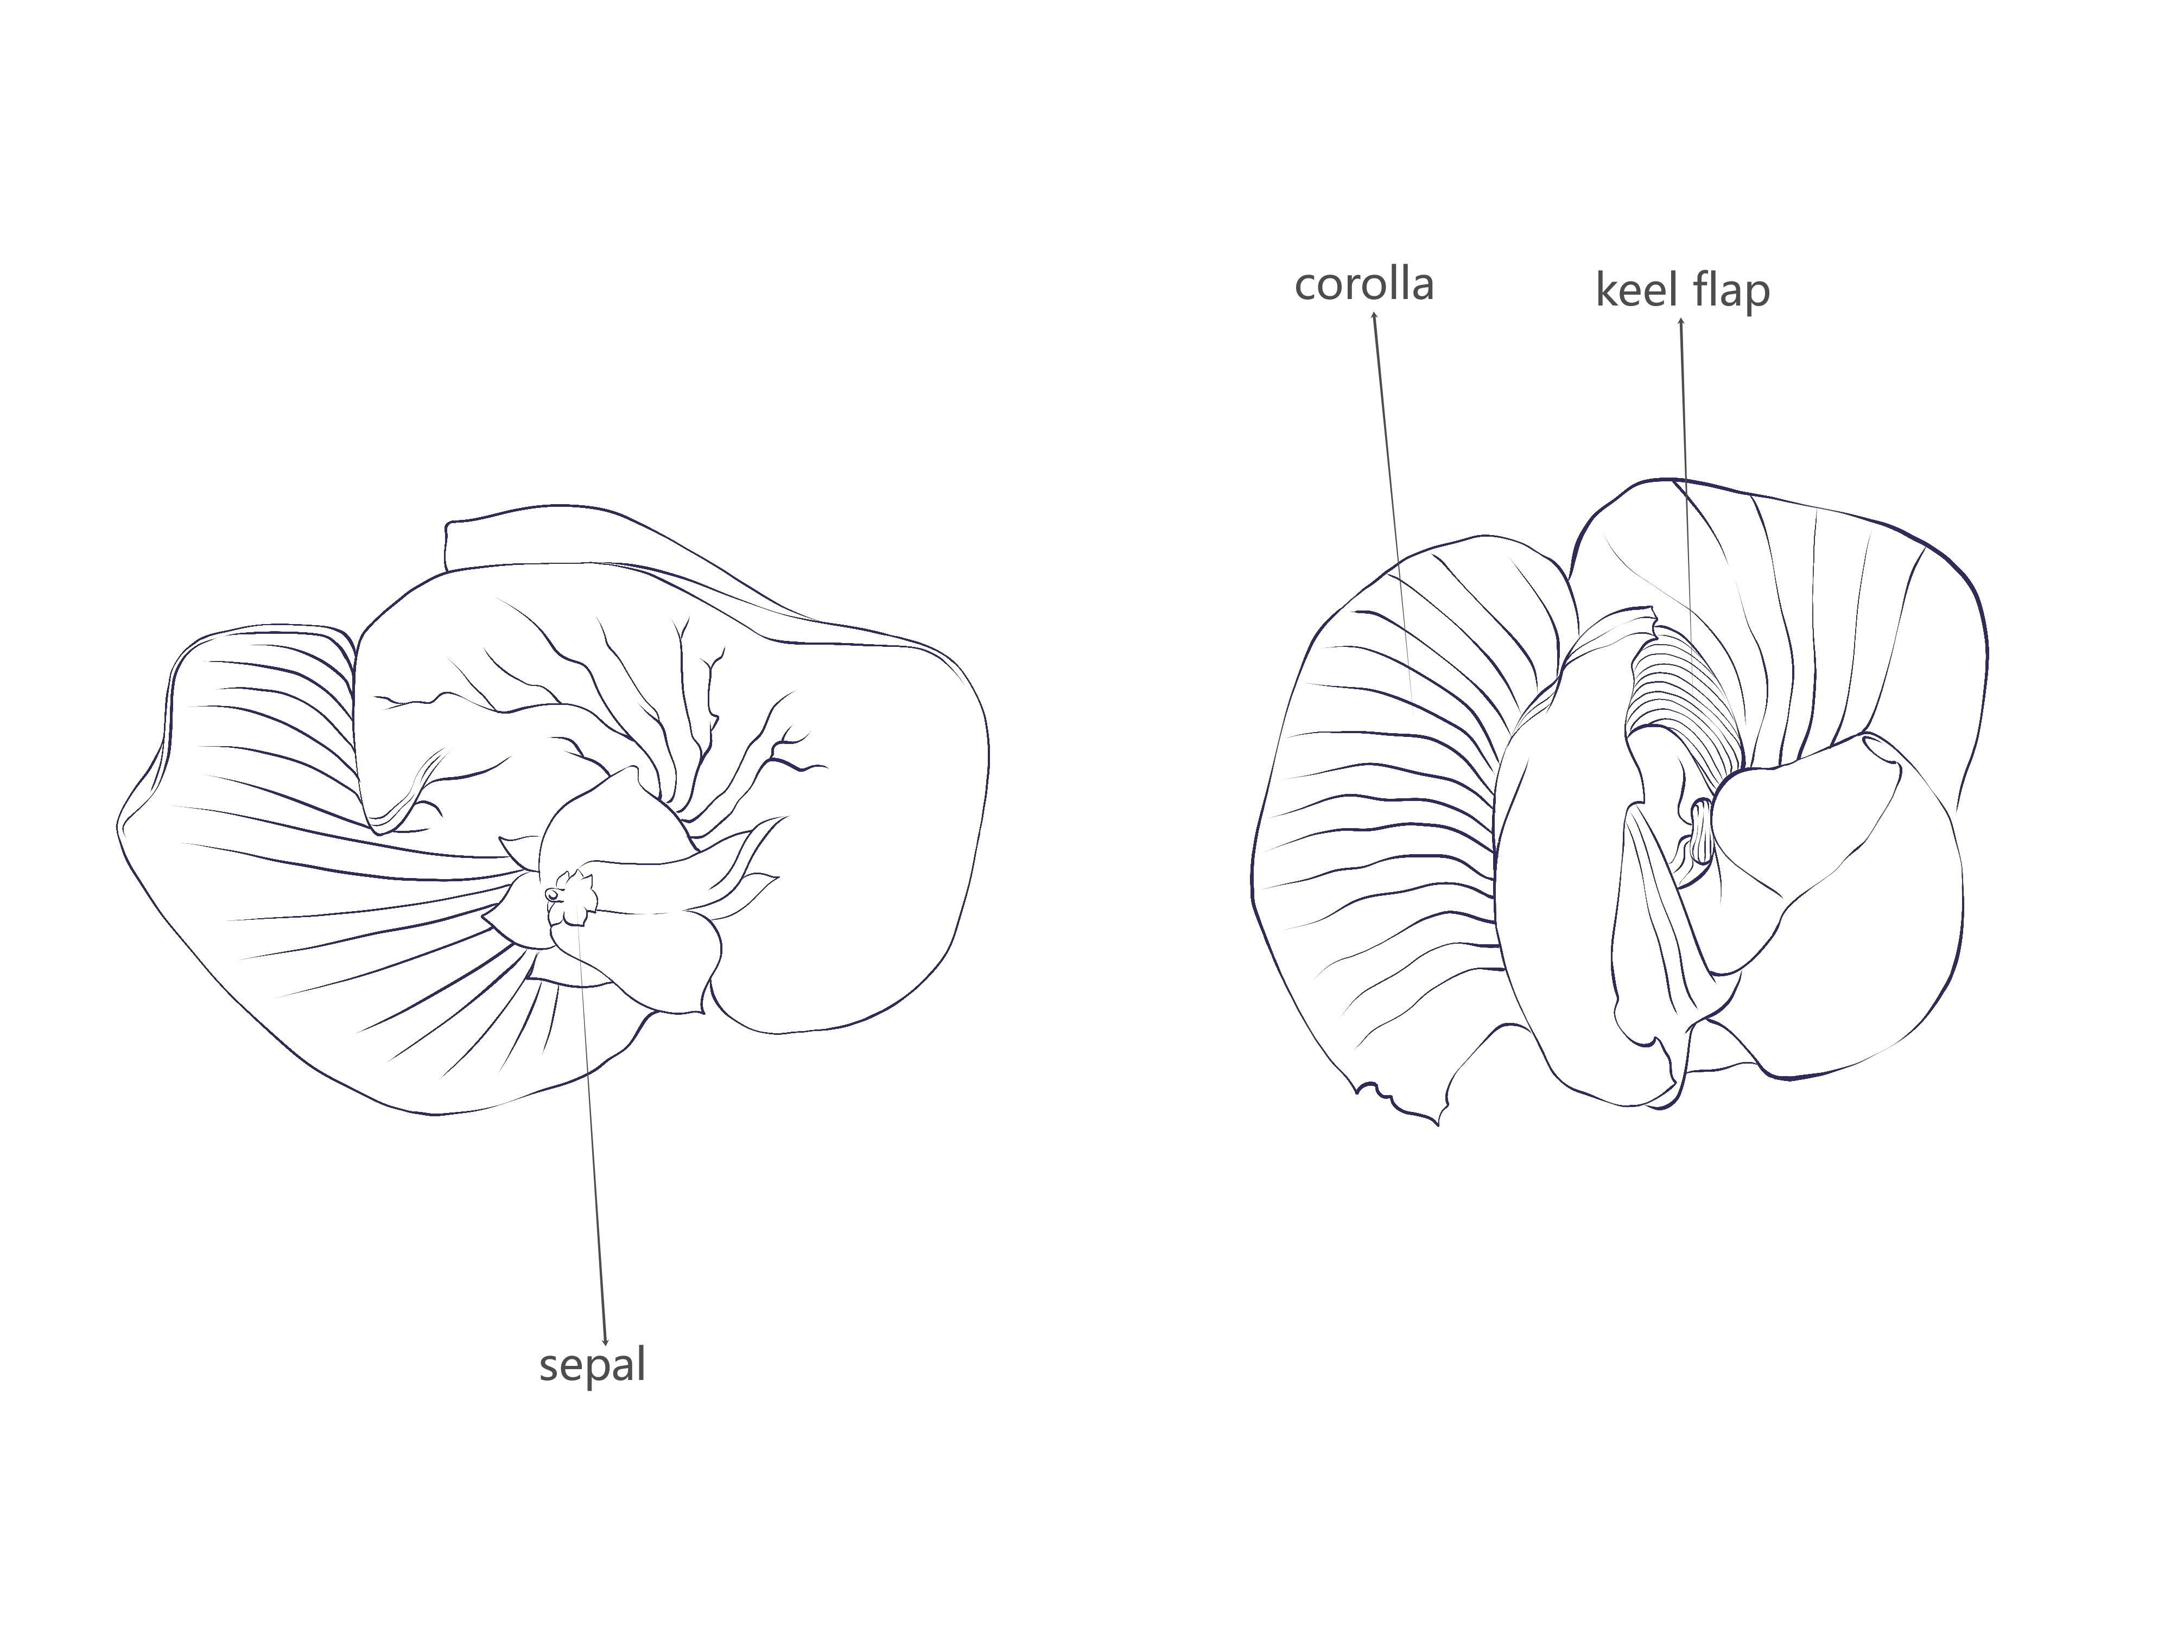

## 8.2  Explanations for individual characteristics

Ad. 1: Hypocotyl: anthocyanin coloration

Germinate 20 seeds in substrate. Seedings should receive at least five hours of intense sunlight after emergence. Seedings should be exposed to artificial lighting at night. Observations should be made three to five days after emergence.

Ad. 2: Time of beginning of flowering

Time of beginning of flowering is reached when 50% of plants show at least one open flower.

Ad. 4: Stem: hairiness

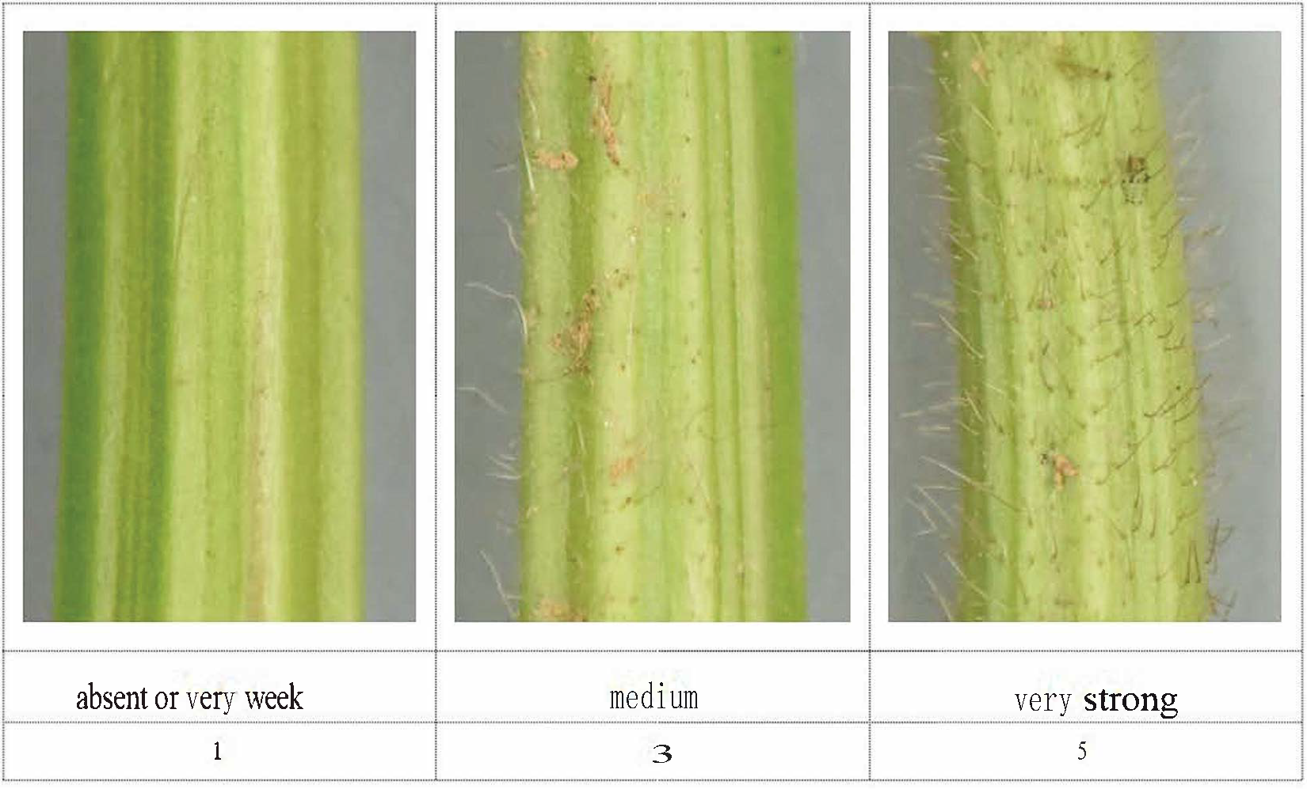

Ad. 5: Leaf: shape of lateral leaflet

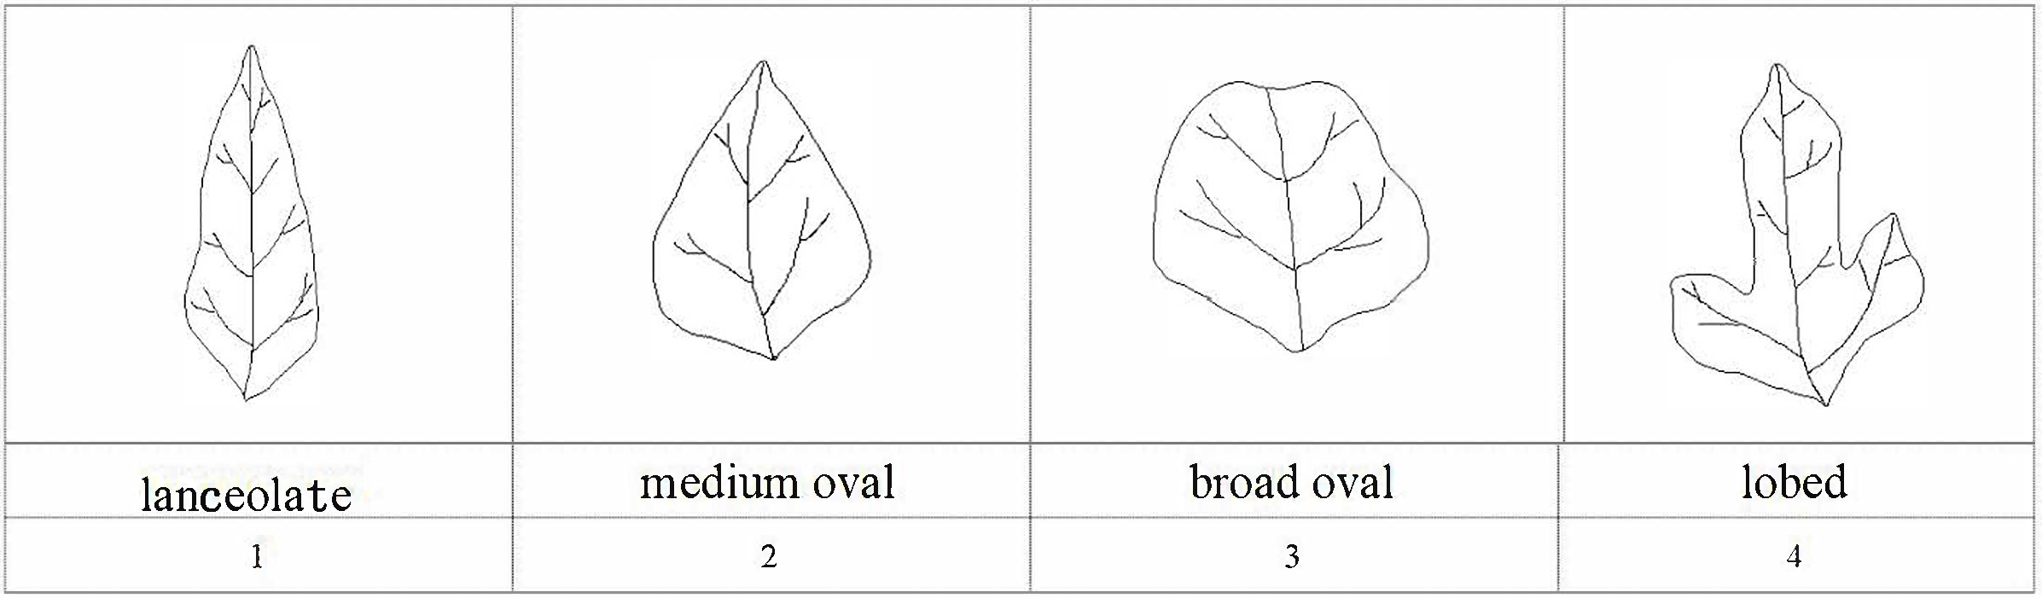

Ad. 11: Time of maturity

The time of maturity is reached when 50% of pods are mature, the pods are mature and the seeds are hard.

Ad. 12: Plant: growth habit

• Test design: Plant growth type should preferably be assessed in a special trial with 2 replicates of 30 plants each with about 9 cm between plants in the rows. Any border effect should be avoided.

• Plant material: Candidate and example varieties should be grown in groups according to their earliness at maturity (characteristic 11).

• Observation: At the beginning of flowering time (1 flower at any level of the main stem), the apex of the plant should be identified with a mark. At maturity (free kernels in the pod), the number of nodes between the mark and the top of the plant is counted. The average number of nodes per variety, in comparison with the example varieties, allows for the appropriate rating of this characteristic.

Determinate varieties:   
• The main stem ends in a floral bud (the terminal cluster is long and with many flowers).

• The growth stops with the flowering of the terminal bud.

• The size of the terminal leaf is the same as the lower leaves in growth stage 60.

Semi-determinate varieties:

• The main stem ends in a floral bud (the terminal cluster is short and with few flowers).

• The growth stops with the flowering of the terminal bud.

• The size of the terminal leaf is smaller than the lower leaves in growth stage 60.

Indeterminate varieties:

• The main stem ends in a vegetative bud.

• The growth continues after flowering.

• The apical meristem remains vegetative and continues to differentiate nodes and leaves when flowers are being differentiated in the rest of the plant.

• The terminal leaf is smaller than the lower leaves in growth stage 60.​

Ad. 15: Plant: attitude of branches

​​

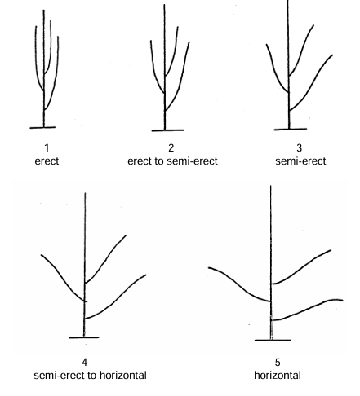

Ad. 17: Stem: number of nodes

Observations should be made from the cotyledon node of the plant to the last node where the compound leaf unfolds at the top of plant.

Ad. 19: Pod:  number of seeds

The number of seeds contained within the structure of the plant pod.

Ad. 20: Pod: curvature

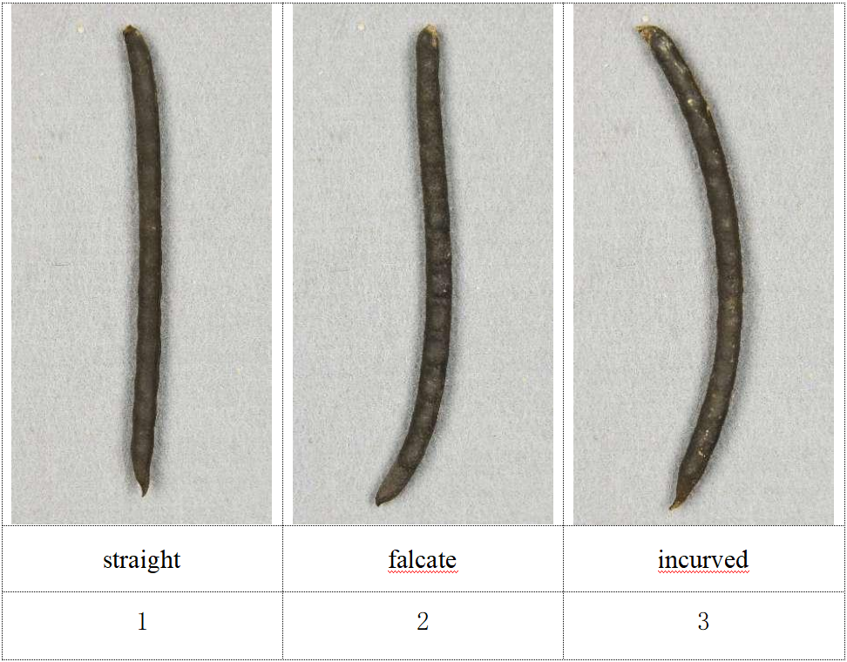

Ad. 25: Seed:  shape

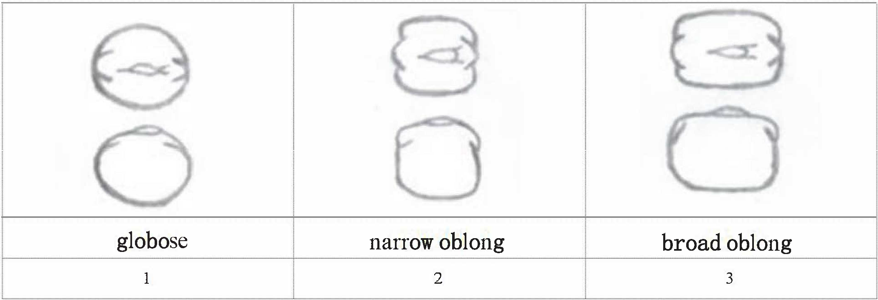

Ad. 26: Seed: ground color of testa

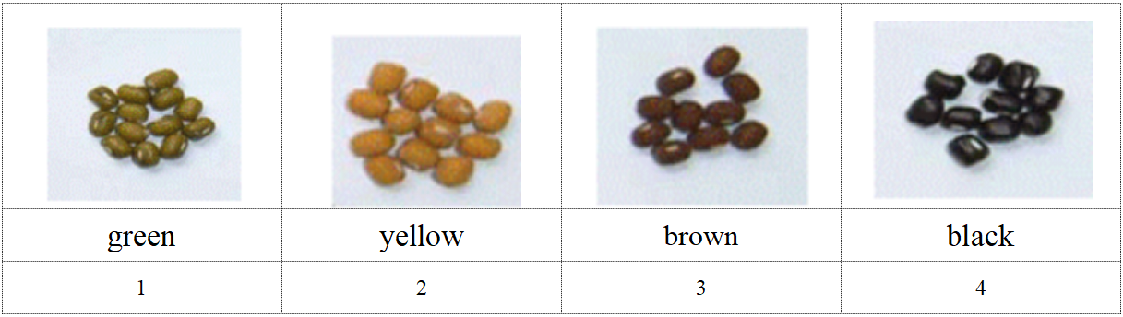

## 

## 8.3  Additional Explanations on the Table of Characteristics

*Decimal Code for the Growth Stages of Vigna radiata*

|  |  |  |
| --- | --- | --- |
| Code | Growth stages | General Description |
| 10 | Seedling stage | Opposite simple leaves fully spread |
| 20 | Initial flowering period | Five percent of the plants in the plot have their first flower |
| 30 | Full-bloom stage | Seventy percent of the plants in the plot are flowering |
| 40 | Maturity stage | 50% of the pods are mature, the pods are mature and the seeds are hard |
| 50 | Ull ripe stage | More than 90% of the pods in the cell were mature, the pods showed mature color, and the beans hardened |

# Literature

2013: Guidelines for the Conduct of Test for Distinctness, Uniformity and Stability of Mungbean (Vigna radiata L. Wilczek). Chinese standard, in Chinese.  
Lixia Wang, et al. 2014: Adaptability and Phenotypic Variation of Agronomic Traits in Mungbean Core Collection under Different Environments in China. Beijing, CN.

# Technical Questionnaire

|  |  |  |  |
| --- | --- | --- | --- |
| TECHNICAL QUESTIONNAIRE | Page {x} of {y} | Reference Number: | |
|  |  |  | |
|  |  | Application date:  (not to be filled in by the applicant) | |
| TECHNICAL QUESTIONNAIRE  to be completed in connection with an application for plant breeders' rights | | | |
| 1. Subject of the Technical Questionnaire | | | |
| 1.1.1 Botanical name | *Vigna radiata* (L.) R. Wilczek | |  |
|  |  | |  |
| 1.1.2 Common name | Mung Bean | |  |
| 2. Applicant | | | |
| Name |  | |  |
|  |  | |  |
| Address |  | |  |
|  |  | |  |
| Telephone No. |  | |  |
|  |  | |  |
| Fax No. |  | |  |
|  |  | |  |
| E-mail address |  | |  |
|  |  | |  |
| Breeder (if different from  applicant) |  | |  |
|  |  | |  |

|  |  |  |  |
| --- | --- | --- | --- |
| TECHNICAL QUESTIONNAIRE | Page {x} of {y} | Reference Number: | |
|  | | | |
| 3. Proposed denomination and breeder's reference | | | |
| Proposed denomination  (if available) |  | |  |
|  |  | |  |
| Breeder's reference |  | |  |

|  |  |  |
| --- | --- | --- |
| TECHNICAL QUESTIONNAIRE | Page {x} of {y} | Reference Number: |

|  |
| --- |
| #4. Information on the breeding scheme and propagation of the variety  4.1 Breeding scheme  Variety resulting from:  4.1.1 Crossing  (a) controlled cross [ ]  (please state parent variety)  (…………………..……………..…) x (……………..…………………..…)  female parent male parent  (b) partially known cross [ ]  (please state parent variety(ies))  (…………………..……………..…) x (……………..…………………..…)  female parent male parent  (c) unknown cross [ ] |
| 4.1.2 Mutation  (please state parent variety) |
| 4.1.3 Discovery and development  (please state where and when discovered and how developed) |
| 4.1.4 Other  (Please provide details) |

|  |  |  |
| --- | --- | --- |
| TECHNICAL QUESTIONNAIRE | Page {x} of {y} | Reference Number: |

|  |
| --- |
| 4.2 Method of propagating the variety  (a) Other (please provide details) [ ]  (a) Other (state method) [ ]  4.2.1 Other  (Please provide details) [ ] |
|  |

|  |  |  |  |  |  |
| --- | --- | --- | --- | --- | --- |
| TECHNICAL QUESTIONNAIRE | | Page {x} of {y} | | Reference Number: | |
|  | | | | | |
| 5. Characteristics of the variety to be indicated (the number in brackets refers to the corresponding characteristic in Test Guidelines; please mark the note which best corresponds). | | | | | |
|  | Characteristics | | Example Varieties | | Note |
| **5.1**  **(5)** | **Leaf: shape of lateral leaflet** | |  | |  |
|  | lanceolate | |  | | 1 [ ] |
|  | medium ovate | |  | | 2 [ ] |
|  | broad ovate | |  | | 3 [ ] |
|  | lobed | |  | | 4 [ ] |
| **5.2**  **(7)** | **Leaf: anthocyanin coloration at base of leaflets** | |  | |  |
|  | absent | | Zhonglv1 C3408 | | 1 [ ] |
|  | present | | Dayinggelv 925 C5786 | | 2 [ ] |
| **5.3**  **(9)** | **Flower: color of corolla** | |  | |  |
|  | light yellow | |  | | 1 [ ] |
|  | medium yellow | |  | | 2 [ ] |
|  | yellow - purple blend | |  | | 3 [ ] |
| **5.4**  **(11)** | **Time of maturity** | |  | |  |
|  | very early | |  | | 1 [ ] |
|  | very early to early | |  | | 2 [ ] |
|  | early | | Baolv 942 C5636 | | 3 [ ] |
|  | early to medium | |  | | 4 [ ] |
|  | medium | | Zhonglv1 C3408 | | 5 [ ] |
|  | medium to late | |  | | 6 [ ] |
|  | late | | Lvdou C2969 | | 7 [ ] |
|  | late to very late | |  | | 8 [ ] |
|  | very late | |  | | 9 [ ] |
| **5.5**  **(12)** | **Plant: growth habit** | |  | |  |
|  | determinate | | Zhonglv1 C3408 | | 1 [ ] |
|  | semi-determinate | | Yinggelvdou C1547 | | 2 [ ] |
|  | indeterminate | | Lanlvdou C4157 | | 3 [ ] |
|  |  | |  | |  |

|  |  |  |  |  |  |
| --- | --- | --- | --- | --- | --- |
| TECHNICAL QUESTIONNAIRE | | Page {x} of {y} | | Reference Number: | |
|  | |  | |  | |
|  | Characteristics | | Example Varieties | | Note |
| **5.6**  **(13)** | **Plant: height** | |  | |  |
|  | very short | | Gaoyangxiaolvdou C0229 | | 1 [ ] |
|  | very short to short | |  | | 2 [ ] |
|  | short | | Dayanglvdou C0385 | | 3 [ ] |
|  | short to medium | |  | | 4 [ ] |
|  | medium | | Zhonglv1 C3408 | | 5 [ ] |
|  | medium to tall | |  | | 6 [ ] |
|  | tall | | Quyangxiaolvdou C1819 | | 7 [ ] |
|  | tall to very tall | |  | | 8 [ ] |
|  | very tall | | Hulvdou C1431 | | 9 [ ] |
| **5.7**  **(20)** | **Pod: curvature** | |  | |  |
|  | straight | |  | | 1 [ ] |
|  | falcate | |  | | 2 [ ] |
|  | incurved | |  | | 3 [ ] |
| **5.8**  **(22)** | **Pod:  color** | |  | |  |
|  | yellowish white | | Hulvdou C2185 | | 1 [ ] |
|  | brown | | Dengxianlvdou C2737 | | 2 [ ] |
|  | black | | Zhonglv1 C3408 | | 3 [ ] |
| **5.9**  **(24)** | **Seed:  weight per 100 seeds** | |  | |  |
|  | low | |  | | 1 [ ] |
|  | low to medium | |  | | 2 [ ] |
|  | medium | |  | | 3 [ ] |
|  | medium to high | |  | | 4 [ ] |
|  | high | |  | | 5 [ ] |
| **5.10**  **(26)** | **Seed: ground color of testa** | |  | |  |
|  | light green | |  | | 1 [ ] |
|  | medium green | |  | | 2 [ ] |
|  | dark green | |  | | 3 [ ] |
|  | yellow | |  | | 4 [ ] |
|  | brown | |  | | 5 [ ] |
|  | black | |  | | 6 [ ] |
|  |  | |  | |  |

|  |  |  |  |  |  |
| --- | --- | --- | --- | --- | --- |
| TECHNICAL QUESTIONNAIRE | | Page {x} of {y} | | Reference Number: | |
|  | |  | |  | |
|  | Characteristics | | Example Varieties | | Note |
| **5.11**  **(27)** | **Seed: glossiness** | |  | |  |
|  | absent | |  | | 1 [ ] |
|  | present | |  | | 2 [ ] |
|  |  | |  | |  |

|  |  |  |  |  |  |
| --- | --- | --- | --- | --- | --- |
| TECHNICAL QUESTIONNAIRE | | Page {x} of {y} | | Reference Number: | |
|  | | | | | | |
| 6. Similar varieties and differences from these varieties  *Please use the following table and box for comments to provide information on how your candidate variety differs from the variety (or varieties) which, to the best of your knowledge, is (or are) most similar. This information may help the examination authority to conduct its examination of distinctness in a more efficient way.* | | | | | | |
| Denomination(s) of variety(ies) similar to your candidate variety | Characteristic(s) in which your candidate variety differs from the similar variety(ies) | | Describe the expression of the characteristic(s) for the **similar** variety(ies) | | Describe the expression of the characteristic(s) for **your** candidate variety |
| *Example* |  | |  | |  |
|  | | | | | | |
|  | | | | | | |
|  | | | | | | |
| Comments | | | | | | |

|  |  |  |
| --- | --- | --- |
| TECHNICAL QUESTIONNAIRE | Page {x} of {y} | Reference Number: |
|  | | | |
| #7. Additional information which may help in the examination of the variety  7.1 In addition to the information provided in sections 5 and 6, are there any additional characteristics which may help to distinguish the variety?  Yes [ ] No [ ]  (If yes, please provide details)  7.2 Are there any special conditions for growing the variety or conducting the examination?  Yes [ ] No [ ]  (If yes, please provide details)  7.3 Other information | | | |

|  |  |  |  |
| --- | --- | --- | --- |
| TECHNICAL QUESTIONNAIRE | Page {x} of {y} | Reference Number: | |
|  | | | |
| 8. Authorization for release  (a) Does the variety require prior authorization for release under legislation concerning the protection of the environment, human and animal health?  Yes [ ] No [ ]  (b) Has such authorization been obtained?  Yes [ ] No [ ]  If the answer to (b) is yes, please attach a copy of the authorization. | | | |
| 9. Information on plant material to be examined or submitted for examination  9.1 The expression of a characteristic or several characteristics of a variety may be affected by factors, such as pests and disease, chemical treatment (e.g. growth retardants or pesticides), effects of tissue culture, different rootstocks, scions taken from different growth phases of a tree, etc.  9.2 The plant material should not have undergone any treatment which would affect the expression of the characteristics of the variety, unless the competent authorities allow or request such treatment. If the plant material has undergone such treatment, full details of the treatment must be given. In this respect, please indicate below, to the best of your knowledge, if the plant material to be examined has been subjected to:  (a) Microorganisms (e.g. virus, bacteria, phytoplasma) Yes [ ] No [ ]  (b) Chemical treatment (e.g. growth retardant, pesticide) Yes [ ] No [ ]  (c) Tissue culture Yes [ ] No [ ]  (d) Other factors Yes [ ] No [ ]  Please provide details for where you have indicated “yes”.  ____________________________________________________________  9.3 Has the plant material to be examined been tested for the presence of virus or other pathogens?  Yes [ ]  (please provide details as specified by the Authority)  No [ ] | | | |
| 10. I hereby declare that, to the best of my knowledge, the information provided in this form is correct: | | | |
| Applicant’s name |  | | |
| Signature |  | Date |  |
|  | [End of document] | | |