 |  |  |  | E  TG/247/2(proj.2)  ORIGINAL: English  DATE: 2025-04-22
INTERNATIONAL UNION FOR THE PROTECTION OF NEW VARIETIES OF PLANTS
Geneva
 |  | DRAFT

 | GRAIN AMARANTH  UPOV Code(s): AMARA  Amaranthus L. | *

GUIDELINES
FOR THE CONDUCT OF TESTS
FOR DISTINCTNESS, UNIFORMITY AND STABILITY

prepared by an expert from Slovakia

to be considered by the

Technical Working Party for Agricultural Crops at its fifty-fourth session,
to be held in Arusha, United Republic of Tanzania, from 2025-05-19 to 2025-05-22

Disclaimer: this document does not represent UPOV policies or guidance

Alternative Names:*

Botanical name | English | French | German | Spanish
Amaranthus L. | Grain Amaranth, Amaranth | Amarante | Amarant, Fuchsschwanz | Amaranto

The purpose of these guidelines (“Test Guidelines”) is to elaborate the principles contained in the General Introduction (document TG/1/3), and its associated TGP documents, into detailed practical guidance for the harmonized examination of distinctness, uniformity and stability (DUS) and, in particular, to identify appropriate characteristics for the examination of DUS and production of harmonized variety descriptions.

ASSOCIATED DOCUMENTS

These Test Guidelines should be read in conjunction with the General Introduction and its associated
TGP documents.

TABLE OF CONTENTS PAGE
1. Subject of these Test Guidelines 3
2. Material Required 3
3. Method of Examination 3
3.1 Number of Growing Cycles 3
3.2 Testing Place 3
3.3 Conditions for Conducting the Examination 3
3.4 Test Design 3
3.5 Additional Tests 4
4. Assessment of Distinctness, Uniformity and Stability 4
4.1 Distinctness 4
4.2 Uniformity 5
4.3 Stability 5
5. Grouping of Varieties and Organization of the Growing Trial 5
6. Introduction to the Table of Characteristics 6
6.1 Categories of Characteristics 6
6.2 States of Expression and Corresponding Notes 6
6.3 Types of Expression 6
6.4 Example Varieties 6
6.5 Legend 7
7. Table of Characteristics/Tableau des caracteres/Merkmalstabelle/Tabla de caracteres 8
8. Explanations on the Table of Characteristics 18
8.1 Explanations covering several characteristics 18
8.2 Explanations for individual characteristics 18
8.3 Additional Explanations on the Table of Characteristics 25
9. Literature 26
10. Technical Questionnaire 27

Subject of these Test Guidelines

These Test Guidelines apply to all varieties of Amaranthus L. and its hybrids, excluding ornamental varieties.

Material Required

2.1 The competent authorities decide on the quantity and quality of the plant material required for testing the variety and when and where it is to be delivered. Applicants submitting material from a State other than that in which the testing takes place must ensure that all customs formalities and phytosanitary requirements are complied with.

2.2 The material is to be supplied in the form of seed.

2.3 The minimum quantity of plant material, to be supplied by the applicant, should be:

100 g of seeds

The seed should meet the minimum requirements for germination, species and analytical purity, health and moisture content, specified by the competent authority. In cases where the seed is to be stored, the germination capacity should be as high as possible and should, be stated by the applicant.

2.4 The plant material supplied should be visibly healthy, not lacking in vigor, nor affected by any important pest or disease.

2.5 The plant material should not have undergone any treatment which would affect the expression of the characteristics of the variety, unless the competent authorities allow or request such treatment. If it has been treated, full details of the treatment must be given.

Method of Examination

3.1 Number of Growing Cycles

3.1.1 The minimum duration of tests should normally be two independent growing cycles.

3.1.2 The two independent growing cycles should be in the form of two separate plantings.

3.1.3 The testing of a variety may be concluded when the competent authority can determine with certainty the outcome of the test.

3.2 Testing Place

Tests are normally conducted at one place. In the case of tests conducted at more than one place, guidance is provided in TGP/9 “Examining Distinctness”.

3.3 Conditions for Conducting the Examination

3.3.1 The tests should be carried out under conditions ensuring satisfactory growth for the expression of the relevant characteristics of the variety and for the conduct of the examination.

3.3.2 The optimum stage of development for the assessment of each characteristic is indicated by a number in the Table of Characteristics. The stages of development denoted by each number are described in Chapter 8.

3.4 Test Design

3.4.1 Each test should be designed to result in a total of at least 100 plants which should be divided between at least 2 replicates.

3.4.2 The design of the tests should be such that plants or parts of plants may be removed for measurement or counting without prejudice to the observations which must be made up to the end of the growing cycle.

3.5 Additional Tests

Additional tests, for examining relevant characteristics, may be established.

Assessment of Distinctness, Uniformity and Stability

4.1 Distinctness

4.1.1 General Recommendations

It is of particular importance for users of these Test Guidelines to consult the General Introduction prior to making decisions regarding distinctness. However, the following points are provided for elaboration or emphasis in these Test Guidelines.

4.1.2 Consistent Differences

The differences observed between varieties may be so clear that more than one growing cycle is not necessary. In addition, in some circumstances, the influence of the environment is not such that more than a single growing cycle is required to provide assurance that the differences observed between varieties are sufficiently consistent. One means of ensuring that a difference in a characteristic, observed in a growing trial, is sufficiently consistent is to examine the characteristic in at least two independent growing cycles.

4.1.3 Clear Differences

Determining whether a difference between two varieties is clear depends on many factors, and should consider, in particular, the type of expression of the characteristic being examined, i.e. whether it is expressed in a qualitative, quantitative, or pseudo-qualitative manner. Therefore, it is important that users of these Test Guidelines are familiar with the recommendations contained in the General Introduction prior to making decisions regarding distinctness.

4.1.4 Number of Plants or Parts of Plants to be Examined

Unless otherwise indicated, for the purposes of distinctness, all observations on single plants should be made on 20 plants or parts of plants taken from each of 20 plants and any other observations made on all plants in the test, disregarding any off-type plants.

In the case of observations of parts taken from single plants, the number of parts to be taken from each of the plants should be 1.

4.1.5 Method of Observation

The recommended method of observing the characteristic for the purposes of distinctness is indicated by the following key in the Table of Characteristics (see document TGP/9 “Examining Distinctness”, Section 4 “Observation of characteristics”):

MG: single measurement of a group of plants or parts of plants
MS: measurement of a number of individual plants or parts of plants
VG: visual assessment by a single observation of a group of plants or parts of plants
VS: visual assessment by observation of individual plants or parts of plants”):

Type of observation: visual (V) or measurement (M)

“Visual” observation (V) is an observation made on the basis of the expert’s judgment. For the purposes of this document, “visual” observation refers to the sensory observations of the experts and, therefore, also includes smell, taste and touch. Visual observation includes observations where the expert uses reference points (e.g. diagrams, example varieties, side-by-side comparison) or non-linear charts (e.g. color charts). Measurement (M) is an objective observation against a calibrated, linear scale e.g. using a ruler, weighing scales, colorimeter, dates, counts, etc.

Type of record: for a group of plants (G) or for single, individual plants (S)

For the purposes of distinctness, observations may be recorded as a single record for a group of plants or parts of plants (G), or may be recorded as records for a number of single, individual plants or parts of plants (S). In most cases, “G” provides a single record per variety and it is not possible or necessary to apply statistical methods in a plant-by-plant analysis for the assessment of distinctness.

In cases where more than one method of observing the characteristic is indicated in the Table of Characteristics (e.g. VG/MG), guidance on selecting an appropriate method is provided in document TGP/9, Section 4.2.

4.2 Uniformity

4.2.1 It is of particular importance for users of these Test Guidelines to consult the General Introduction prior to making decisions regarding uniformity. However, the following points are provided for elaboration or emphasis in these Test Guidelines:

4.2.2 These Test Guidelines have been developed for the examination of seed-propagated varieties. For varieties with other types of propagation, the recommendations in the General Introduction and document TGP/13 "Guidance for new types and species" Section 4.5 "Testing Uniformity" should be followed.

4.2.3 The assessment of uniformity for should be according to the recommendations for cross-pollinated varieties in the General Introduction.

4.2.4 For the assessment of uniformity of self-pollinated varieties a population standard of 5% and an acceptance probability of at least 95% should be applied. In the case of a sample size of 100 plants, 9 off-types are allowed.

4.3 Stability

4.3.1 In practice, it is not usual to perform tests of stability that produce results as certain as those of the testing of distinctness and uniformity. However, experience has demonstrated that, for many types of variety, when a variety has been shown to be uniform, it can also be considered to be stable.

4.3.2 Where appropriate, or in cases of doubt, stability may be further examined by testing a new seed stock to ensure that it exhibits the same characteristics as those shown by the initial material supplied.

Grouping of Varieties and Organization of the Growing Trial

5.1 The selection of varieties of common knowledge to be grown in the trial with the candidate varieties and the way in which these varieties are divided into groups to facilitate the assessment of distinctness are aided by the use of grouping characteristics.

5.2 Grouping characteristics are those in which the documented states of expression, even where produced at different locations, can be used, either individually or in combination with other such characteristics: (a) to select varieties of common knowledge that can be excluded from the growing trial used for examination of distinctness; and (b) to organize the growing trial so that similar varieties are grouped together.

5.3 The following have been agreed as useful grouping characteristics:

(a) Cotyledon: anthocyanin coloration (characteristic 1)
(b) Leaf blade: presence of blotch - to be deleted (characteristic 18)
(c) Leaf blade: shape of blotch - to be deleted (characteristic 21)
(d) Inflorescence: color (characteristic 22)
(e) Inflorescence: type (characteristic 25)
(f) Inflorescence: length of bract relative to utricle (characteristic 26)
(g) Inflorescence: growth type (characteristic 27)
(h) Stem: anthocyanin coloration of base (characteristic 32)
(i) Stem: shape in cross section (characteristic 33)
(j) Seed: color (characteristic 34)
(k) Seed: shape (characteristic 35)
(l) Seed: type (characteristic 36)

5.4 Guidance for the use of grouping characteristics, in the process of examining distinctness, is provided through the General Introduction and document TGP/9 “Examining Distinctness”.

Introduction to the Table of Characteristics

6.1 Categories of Characteristics

6.1.1 Standard Test Guidelines Characteristics

Standard Test Guidelines characteristics are those which are approved by UPOV for examination of DUS and from which members of the Union can select those suitable for their particular circumstances.

6.1.2 Asterisked Characteristics

Asterisked characteristics (denoted by *) are those included in the Test Guidelines which are important for the international harmonization of variety descriptions and should always be examined for DUS and included in the variety description by all members of the Union, except when the state of expression of a preceding characteristic or regional environmental conditions render this inappropriate.

6.2 States of Expression and Corresponding Notes

6.2.1 States of expression are given for each characteristic to define the characteristic and to harmonize descriptions. Each state of expression is allocated a corresponding numerical note for ease of recording of data and for the production and exchange of the description.

6.2.2 All relevant states of expression are presented in the characteristic.

6.2.3 Further explanation of the presentation of states of expression and notes is provided in document TGP/7 “Development of Test Guidelines”.

6.3 Types of Expression

An explanation of the types of expression of characteristics (qualitative, quantitative and pseudo-qualitative) is provided in the General Introduction.

6.4 Example Varieties

Where appropriate, example varieties are provided to clarify the states of expression of each characteristic.

6.5 Legend

 |  | English |  | français |  | deutsch | español | Example Varieties  Exemples  Beispielssorten  Variedades ejemplo | Note/  Nota
1 | 2 | 3 | 4 | 5 | 6 | 7
 |  | Name of characteristics in English |  | Nom du caractère en français |  | Name des Merkmals auf Deutsch | Nombre del carácter en español
 |  | states of expression |  | types d’expression |  | Ausprägungsstufen | tipos de expresión

1 Characteristic number

2 (*) Asterisked characteristic – see Chapter 6.1.2

3 Type of expression
QL Qualitative characteristic – see Chapter 6.3
QN Quantitative characteristic – see Chapter 6.3
PQ Pseudo-qualitative characteristic – see Chapter 6.3

4 Method of observation (and type of plot, if applicable)
MG, MS, VG, VS – see Chapter 4.1.5

5 (+) See Explanations on the Table of Characteristics in Chapter 8.2

6 (a)-(x) See Explanations on the Table of Characteristics in Chapter 8.1

7 Growth stage key (if applicable) See Explanations on the Table of Characteristics in Chapter 8.3

Table of Characteristics/Tableau des caracteres/Merkmalstabelle/Tabla de caracteres

 |  | English |  | français |  | deutsch | español | Example Varieties  Exemples  Beispielssorten  Variedades ejemplo | Note/  Nota
1. | (*) | QL | VG |  |  | 10
 |  | Cotyledon: anthocyanin coloration
 |  | absent |  |  |  |  |  | Revancha, UNIFI6161 | 1
 |  | present |  |  |  |  |  | Amapop, Nutrisol, Rojita | 9
2. |  | QN | VG |  |  | 10
 |  | Hypocotyl: intensity of anthocyanin coloration
 |  | absent or very weak |  |  |  |  |  | UNIFI6161 | 1
 |  | very weak to weak |  |  |  |  |  |  | 2
 |  | weak |  |  |  |  |  | Pribina, Rojita | 3
 |  | weak to medium |  |  |  |  |  |  | 4
 |  | medium |  |  |  |  |  | Zobor | 5
 |  | medium to strong |  |  |  |  |  |  | 6
 |  | strong |  |  |  |  |  | Amapop, Nutrisol | 7
 |  | strong to very strong |  |  |  |  |  |  | 8
 |  | very strong |  |  |  |  |  |  | 9
3. |  | QN | MS |  | (a) | 13
 |  | Leaf: length
 |  | very short |  |  |  |  |  |  | 1
 |  | very short to short |  |  |  |  |  |  | 2
 |  | short |  |  |  |  |  | Mariel | 3
 |  | short to medium |  |  |  |  |  |  | 4
 |  | medium |  |  |  |  |  | Amapop, Rojita | 5
 |  | medium to long |  |  |  |  |  |  | 6
 |  | long |  |  |  |  |  | Nutrisol | 7
 |  | long to very long |  |  |  |  |  |  | 8
 |  | very long |  |  |  |  |  |  | 9
4. |  | QN | MS |  | (a) | 13
 |  | Leaf: width
 |  | very narrow |  |  |  |  |  |  | 1
 |  | very narrow to narrow |  |  |  |  |  |  | 2
 |  | narrow |  |  |  |  |  | Mariel | 3
 |  | narrow to medium |  |  |  |  |  |  | 4
 |  | medium |  |  |  |  |  | Amapop, Nutrisol, Rojita | 5
 |  | medium to broad |  |  |  |  |  |  | 6
 |  | broad |  |  |  |  |  |  | 7
 |  | broad to very broad |  |  |  |  |  |  | 8
 |  | very broad |  |  |  |  |  |  | 9
5. |  | QN | MS/VG |  | (a) | 13
 |  | Leaf: ratio length/width
 |  | very low |  |  |  |  |  |  | 1
 |  | very low to low |  |  |  |  |  |  | 2
 |  | low |  |  |  |  |  | Revancha | 3
 |  | low to medium |  |  |  |  |  |  | 4
 |  | medium |  |  |  |  |  | Amapop | 5
 |  | medium to high |  |  |  |  |  |  | 6
 |  | high |  |  |  |  |  | Pribina | 7
 |  | high to very high |  |  |  |  |  |  | 8
 |  | very high |  |  |  |  |  |  | 9
6. |  | QN | VG | (+) | (a) | 13
 |  | Leaf: position of broadest part
 |  | in middle or slightly towards base |  |  |  |  |  | Aztek | 1
 |  | moderately towards base |  |  |  |  |  | Pribina | 2
 |  | strongly towards base |  |  |  |  |  | Rojita | 3
7. |  | QN | VG |  | (a) | 13
 |  | Leaf: prominence of veins
 |  | weak |  |  |  |  |  | Rojita, Zobor | 1
 |  | medium |  |  |  |  |  | Pribina | 2
 |  | strong |  |  |  |  |  | Nutrisol, Revancha | 3
8. |  | PQ | VG |  | (a) | 13
 |  | Leaf: main color on upper side
 |  | light green |  |  |  |  |  | Revancha, Zobor | 1
 |  | medium green |  |  |  |  |  | Rojita, UNIFI6161 | 2
 |  | dark green |  |  |  |  |  |  | 3
 |  | red |  |  |  |  |  | Nutrisol | 4
 |  | purple |  |  |  |  |  | Amapop | 5
9. |  | PQ | VG | (+) | (a) | 13
 |  | Leaf: distribution of secondary color on upper side
 |  | at basal part |  |  |  |  |  | Pribina, Rojita | 1
 |  | central blotch |  |  |  |  |  | Zobor | 2
 |  | at margin and veins |  |  |  |  |  | UNIFI6161 | 3
10. |  | PQ | VG |  | (a) | 13
 |  | Leaf: color on lower side
 |  | green |  |  |  |  |  | Pribina | 1
 |  | green purple |  |  |  |  |  | Aztek, Zobor | 2
 |  | red |  |  |  |  |  | Nutrisol | 3
 |  | purple |  |  |  |  |  | Amapop | 4
11. |  | QN | MG/MS | (+)
 |  | Time of beginning of inflorescence emergence
 |  | very early |  |  |  |  |  |  | 1
 |  | very early to early |  |  |  |  |  |  | 2
 |  | early |  |  |  |  |  |  | 3
 |  | early to medium |  |  |  |  |  |  | 4
 |  | medium |  |  |  |  |  | Pribina, UNIFI6161 | 5
 |  | medium to late |  |  |  |  |  |  | 6
 |  | late |  |  |  |  |  | Nutrisol | 7
 |  | late to very late |  |  |  |  |  |  | 8
 |  | very late |  |  |  |  |  |  | 9
12. |  | QN | MG | (+)
 |  | Time of flowering
 |  | very early |  |  |  |  |  |  | 1
 |  | very early to early |  |  |  |  |  |  | 2
 |  | early |  |  |  |  |  |  | 3
 |  | early to medium |  |  |  |  |  |  | 4
 |  | medium |  |  |  |  |  | Amapop, Pribina | 5
 |  | medium to late |  |  |  |  |  |  | 6
 |  | late |  |  |  |  |  | Nutrisol, Zobor | 7
 |  | late to very late |  |  |  |  |  |  | 8
 |  | very late |  |  |  |  |  |  | 9
13. |  | PQ | VG |  |  | 65
 |  | Stem: color
 |  | green |  |  |  |  |  | Pribina, Revancha | 1
 |  | yellow |  |  |  |  |  | Mariel | 2
 |  | pink |  |  |  |  |  |  | 3
 |  | red |  |  |  |  |  | Nutrisol | 4
 |  | purple |  |  |  |  |  | Amapop | 5
14. | (*) | QL | VG |  |  | 65
 |  | Stem: presence of stripes
 |  | absent |  |  |  |  |  | Pribina, UNIFI6161 | 1
 |  | present |  |  |  |  |  | Amapop | 9
15. |  | PQ | VG |  |  | 65
 |  | Stem: color of stripes
 |  | red |  |  |  |  |  |  | 1
 |  | red purple |  |  |  |  |  | UNIFI6161 | 2
 |  | purple |  |  |  |  |  | Amapop | 3
16. |  | QN | VG |  | (a) | 65
 |  | Leaf petiole: intensity of anthocyanin coloration
 |  | absent or very weak |  |  |  |  |  | Revancha, Rojita | 1
 |  | very weak to weak |  |  |  |  |  |  | 2
 |  | weak |  |  |  |  |  | Oeschberg | 3
 |  | weak to medium |  |  |  |  |  |  | 4
 |  | medium |  |  |  |  |  | UNIFI6161 | 5
 |  | medium to strong |  |  |  |  |  |  | 6
 |  | strong |  |  |  |  |  | Amapop | 7
 |  | strong to very strong |  |  |  |  |  |  | 8
 |  | very strong |  |  |  |  |  | Nutrisol | 9
17. |  | PQ | VG |  | (a) | 65
 |  | Leaf blade: main color
 |  | light green |  |  |  |  |  | Revancha | 1
 |  | medium green |  |  |  |  |  | Pribina, Rojita | 2
 |  | dark green |  |  |  |  |  | Oeschberg | 3
 |  | red |  |  |  |  |  | Amapop, Gabriela | 4
18. | (*) | QL | VG | (+) | (a) | 65
 |  | Leaf blade: presence of blotch - to be deleted
 |  | absent |  |  |  |  |  | Pribina, Revancha | 1
 |  | present |  |  |  |  |  | Amapop | 9
19. |  | QN | VG | (+) | (a) | 65
 |  | Only for varieties with distribution of secondary color on upper side: central blotch: Leaf blade: size of blotch in relation to blade
 |  | very small |  |  |  |  |  |  | 1
 |  | very small to small |  |  |  |  |  |  | 2
 |  | small |  |  |  |  |  |  | 3
 |  | small to medium |  |  |  |  |  |  | 4
 |  | medium |  |  |  |  |  | Aztek | 5
 |  | medium to large |  |  |  |  |  |  | 6
 |  | large |  |  |  |  |  | Amapop | 7
 |  | large to very large |  |  |  |  |  |  | 8
 |  | very large |  |  |  |  |  |  | 9
20. |  | PQ | VG |  | (a) | 65
 |  | Only for varieties with distribution of secondary color on upper side: central blotch: Leaf blade: color of blotch
 |  | green |  |  |  |  |  | Amapop | 1
 |  | grey |  |  |  |  |  |  | 2
 |  | purple |  |  |  |  |  | Aztek, Gabriela | 3
21. | (*) | QL | VG | (+) | (a) | 65
 |  | Leaf blade: shape of blotch - to be deleted
 |  | ovoid |  |  |  |  |  | Amapop | 1
 |  | “V” shaped |  |  |  |  |  |  | 2
22. | (*) | PQ | VG |  |  | 65
 |  | Inflorescence: color
 |  | yellow |  |  |  |  |  | Mariel | 1
 |  | green |  |  |  |  |  | Revancha | 2
 |  | green purple |  |  |  |  |  | Pribina | 3
 |  | pink |  |  |  |  |  | Aztek | 4
 |  | red |  |  |  |  |  | Rojita, UNIFI6161 | 5
 |  | purple |  |  |  |  |  | Amapop, Nutrisol | 6
 |  | brown |  |  |  |  |  |  | 7
23. |  | QN | VG | (+) |  | 65
 |  | Inflorescence: attitude of lateral branches
 |  | upright |  |  |  |  |  | Nutrisol, Rojita | 1
 |  | semi-upright |  |  |  |  |  | Revancha, UNIFI6161 | 2
 |  | spreading |  |  |  |  |  | Oeschberg, Zobor | 3
24. |  | QN | VG | (+) |  | 65
 |  | Inflorescence: density of glomerules
 |  | very sparse |  |  |  |  |  |  | 1
 |  | very sparse to sparse |  |  |  |  |  |  | 2
 |  | sparse |  |  |  |  |  | Oeschberg | 3
 |  | sparse to medium |  |  |  |  |  |  | 4
 |  | medium |  |  |  |  |  | Amapop, Nutrisol | 5
 |  | medium to dense |  |  |  |  |  |  | 6
 |  | dense |  |  |  |  |  |  | 7
 |  | dense to very dense |  |  |  |  |  |  | 8
 |  | very dense |  |  |  |  |  |  | 9
25. | (*) | QL | VG | (+) |  | 65
 |  | Inflorescence: type
 |  | amarantiform |  |  |  |  |  | Nutrisol, Pribina | 1
 |  | glomerulate |  |  |  |  |  | Revancha, Zobor | 2
26. | (*) | QN | VG | (+) |  | 65
 |  | Inflorescence: length of bract relative to utricle
 |  | shorter |  |  |  |  |  | Amapop, Pribina | 1
 |  | equal |  |  |  |  |  | Revancha, UNIFI6161 | 2
 |  | longer |  |  |  |  |  | Nutrisol, Oeschberg | 3
27. | (*) | QL | VG | (+) |  | 65
 |  | Inflorescence: growth type
 |  | determinate |  |  |  |  |  | Pribina, Revancha | 1
 |  | indeterminate |  |  |  |  |  | Amapop, Nutrisol | 2
28. |  | QN | VG | (+) |  | 65
 |  | Inflorescence: attitude
 |  | upright or weakly recurved |  |  |  |  |  | Nutrisol, Pribina | 1
 |  | moderately recurved |  |  |  |  |  | Amapop | 2
 |  | strongly recurved |  |  |  |  |  |  | 3
29. |  | QN | MS/VG | (+) |  | 65
 |  | Inflorescence: length
 |  | very short |  |  |  |  |  |  | 1
 |  | very short to short |  |  |  |  |  |  | 2
 |  | short |  |  |  |  |  |  | 3
 |  | short to medium |  |  |  |  |  |  | 4
 |  | medium |  |  |  |  |  | Pribina, Revancha | 5
 |  | medium to long |  |  |  |  |  |  | 6
 |  | long |  |  |  |  |  | Nutrisol | 7
 |  | long to very long |  |  |  |  |  |  | 8
 |  | very long |  |  |  |  |  |  | 9
30. |  | QN | MG/MS | (+) |  | 89
 |  | Plant: time of maturity
 |  | very early |  |  |  |  |  |  | 1
 |  | very early to early |  |  |  |  |  |  | 2
 |  | early |  |  |  |  |  |  | 3
 |  | early to medium |  |  |  |  |  |  | 4
 |  | medium |  |  |  |  |  | Pribina, Revancha | 5
 |  | medium to late |  |  |  |  |  |  | 6
 |  | late |  |  |  |  |  | Nutrisol, Zobor | 7
 |  | late to very late |  |  |  |  |  |  | 8
 |  | very late |  |  |  |  |  |  | 9
31. |  | QN | MG/MS | (+) |  | 89
 |  | Plant: length
 |  | very low |  |  |  |  |  | Zobor | 1
 |  | very low to low |  |  |  |  |  |  | 2
 |  | low |  |  |  |  |  |  | 3
 |  | low to medium |  |  |  |  |  |  | 4
 |  | medium |  |  |  |  |  | Revancha | 5
 |  | medium to long |  |  |  |  |  | Pribina | 6
 |  | long |  |  |  |  |  | Nutrisol | 7
 |  | long to very long |  |  |  |  |  |  | 8
 |  | very long |  |  |  |  |  |  | 9
32. | (*) | QL | VG |  |  | 89
 |  | Stem: anthocyanin coloration of base
 |  | absent |  |  |  |  |  | Pribina, Revancha | 1
 |  | present |  |  |  |  |  | Amapop, Nutrisol | 9
33. | (*) | QL | VG | (+) |  | 89
 |  | Stem: shape in cross section
 |  | circular |  |  |  |  |  |  | 1
 |  | undulated |  |  |  |  |  | Revancha | 2
34. | (*) | PQ | VG |  |  | 89
 |  | Seed: color
 |  | white |  |  |  |  |  | Amapop, Revancha | 1
 |  | yellow |  |  |  |  |  |  | 2
 |  | pink |  |  |  |  |  |  | 3
 |  | brown |  |  |  |  |  | Oeschberg | 4
 |  | black |  |  |  |  |  |  | 5
35. | (*) | QL | VG | (+) |  | 89
 |  | Seed: shape
 |  | ellipsoid |  |  |  |  |  | Nutrisol, Revancha | 1
 |  | discoid |  |  |  |  |  | Amapop, Pribina, Rojita | 2
36. | (*) | QL | VG |  |  | 89
 |  | Seed: type
 |  | flint |  |  |  |  |  | Nutrisol, Rojita | 1
 |  | floury |  |  |  |  |  | Amapop, Pribina, Revancha | 2
37. |  | QN | MG | (+) |  | 89
 |  | Seed: weight per 1000 seeds
 |  | very low |  |  |  |  |  |  | 1
 |  | very low to low |  |  |  |  |  |  | 2
 |  | low |  |  |  |  |  |  | 3
 |  | low to medium |  |  |  |  |  | Oeschberg | 4
 |  | medium |  |  |  |  |  |  | 5
 |  | medium to high |  |  |  |  |  | Amapop | 6
 |  | high |  |  |  |  |  |  | 7
 |  | high to very high |  |  |  |  |  | Pribina | 8
 |  | very high |  |  |  |  |  |  | 9

Explanations on the Table of Characteristics

8.1 Explanations covering several characteristics

Characteristics containing the following key in the Table of Characteristics should be examined as indicated below:

(a) Observation should be made on leaves in the middle part of plants.

8.2 Explanations for individual characteristics
Ad. 6: Leaf: position of broadest part
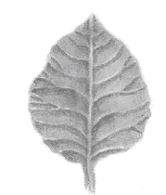 | 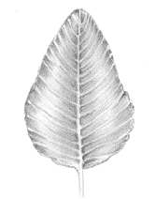 | 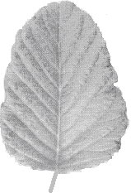
1 | 2 | 3
in middle or slightly towards base | moderately towards base | strongly towards base

Ad. 9: Leaf: distribution of secondary color on upper side
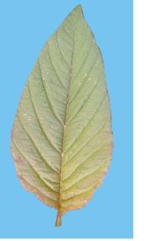 | 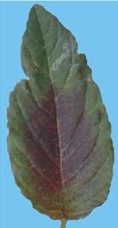 | 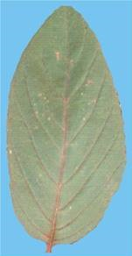
1 | 2 | 3
colored basal area | central blotch | colored margin and veins

Ad. 11: Time of beginning of inflorescence emergence
The time of beginning of inflorescence emergence is reached when 50 % of the plants have an inflorescence of at least 1 cm in length in the apex of the main stem.
Ad. 12: Time of flowering
The time of flowering is reached when 50 % of the plants have a panicle approximately 5 cm long, showing open flowers in its middle parts with separate stamens and with the stigma completely visible.
Ad. 18: Leaf blade: presence of blotch - to be deleted
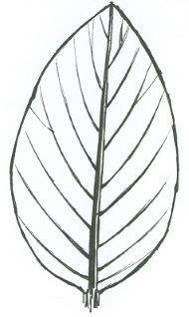 | 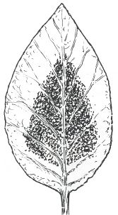
1 | 9
absent | present

Ad. 19: Only for varieties with distribution of secondary color on upper side: central blotch: Leaf blade: size of blotch in relation to blade
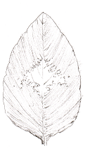 | 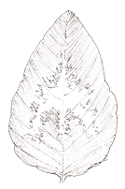 | 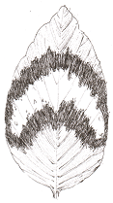
3 | 5 | 7
small | medium | large

Ad. 21: Leaf blade: shape of blotch - to be deleted
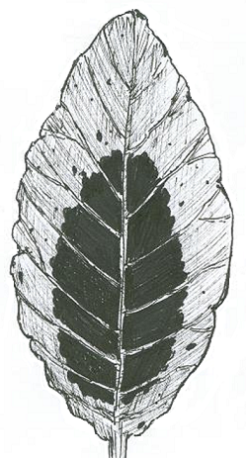 | 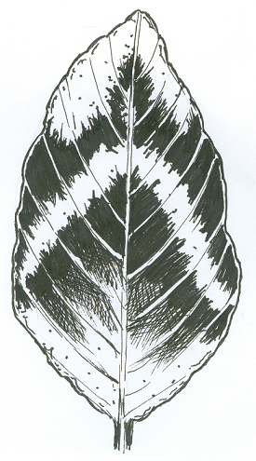
1 | 2
ovoid | "V" shaped

Ad. 23: Inflorescence: attitude of lateral branches
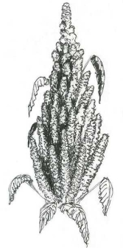 | 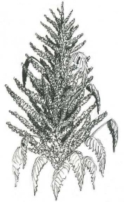 | 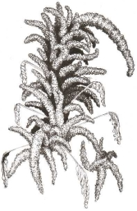
1 | 2 | 3
upright | semi-upright | spreading

Ad. 24: Inflorescence: density of glomerules
The density of glomerules should be observed on the lateral branches of the main inflorescence.
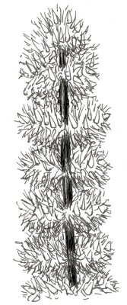 | 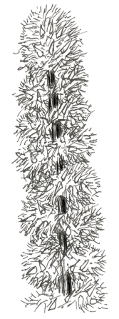 | 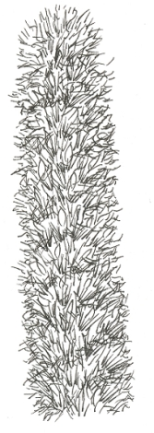
3 | 5 | 7
sparse | medium | dense

Ad. 25: Inflorescence: type
Amarantiform: if the glomerules are inserted in the secondary axes and the glomerules have an extended shape, the inflorescences are ‘amarantiform’.
Glomerulate: if the glomerules are inserted in the primary axes and the glomerules have a spherical shape, the inflorescences are ‘glomerulate’.
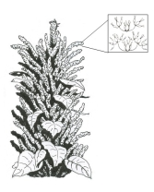 | 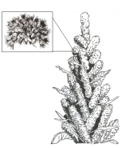
1 | 2
amarantiform | glomerulate

Ad. 26: Inflorescence: length of bract relative to utricle
The observation should be made with a microscope.
Utricle: formed by the mature seed and the opercule (the dehiscent layer which covers the seed).
Bracts: the structures outside the tepals which protect the utricle.
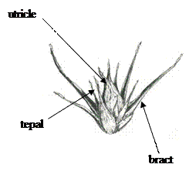

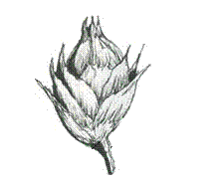 | 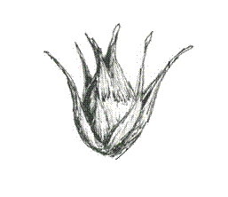 | 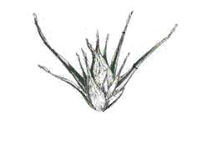
1 | 2 | 3
shorter | equal | longer
a: length of utricle
b: length of bract
Ad. 27: Inflorescence: growth type
Determinate type of inflorescence: The growth of inflorescence stops with the flowering of the terminal bud.
Indeterminate type of inflorescence: The growth of inflorescence continues after beginning of flowering.

Ad. 28: Inflorescence: attitude
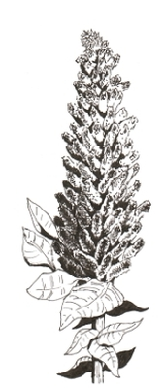 | 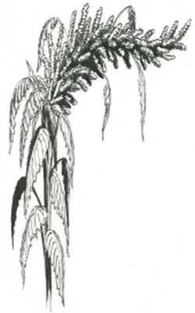 | 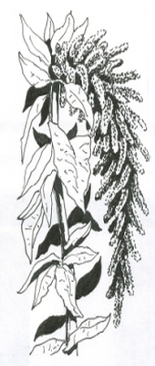
1 | 2 | 3
upright or weakly recurved | moderately recurved | strongly recurved

Ad. 29: Inflorescence: length
The inflorescence should be measured by stretching in horizontal position. The measurement should be taken from the base to the tip of inflorescence.
Ad. 30: Plant: time of maturity
The time of plant maturity is reached when seed taken from the central part of the inflorescence does not change shape when pressed between fingers.
Ad. 31: Plant: length
The plant should be measured from the base of the plant to the tip of the inflorescence.

Ad. 33: Stem: shape in cross section
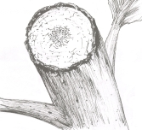 | 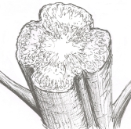
1 | 2
circular | undulated

Ad. 35: Seed: shape
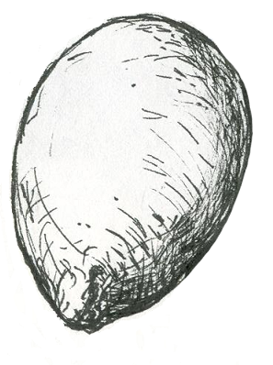 | 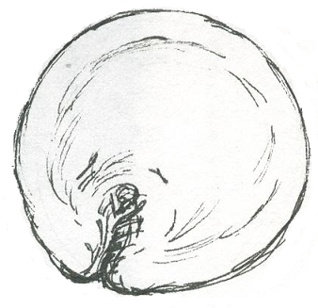
1 | 2
ellipsoid | discoid

Ad. 36: Seed: type
The observation of seed should be made on the glass lid: if the light is transmitted through the seed, it is flint type seed; if the light is not transmitted, it is floury type seed.

8.3 Additional Explanations on the Table of Characteristics

Description of the phenological growth stages of Amaranth sp. according to the BBCH scale
Principal growth stage BBCH | BBCH Code | Description
0: Germination | 00 | Dry seed
 | 01 | Beginning of seed imbibition
 | 03 | Seed imbibition completed
 | 05 | Radicle emerged from seed
 | 06 | Radicle elongated, root hairs and/or side roots visible
 | 08 | Emergence of hypocotyl
 | 09 | Emergence of cotyledons through soil
1: Leaf development | 10 | Cotyledons fully emerged/Opening of cotyledons
 | 11 | First pair of leaves visible
 | 12 | Second pair of leaves visible
 | 13 | Five or six leaves visible
 | 1... | Stages continuous till…
3: Stem elongation |  | The longitudinal growth of the main stem occurs in parallel with the leaf development. That is why the coding of the main stadium 3 is omitted
5: Inflorescence emergence | 50 | Beginning of panicle emergence (panicle still enclosed by leaves)
 | 51 | Leaves surrounding inflorescence separated, inflorescence is visible from above
 | 52 | Panicle visible from the sides (panicle's indeterminate growth habit)
 | 59 | Inflorescence visible, but all flowers are still closed
6: Anthesis and axillary inflorscence | 60 | Beginning of anthesis: main inflorescence flowers with first extruded anthers (acropete flowering)
 | 63 | Staminate and pistillate flowers visible
 | 65 | Full flowering: anthers visible on most panicle
 | 69 | End of flowering: The panicle have completed flowering, but some senesced anthers may remain
7: Fruit and seed development) | 70 | Ovary thickening (development of the fertilized ovule)
 | 71 | Watery ripe: The first visible grains have reached half their final size
 | 73 | Early milk: Immature grains (the grains show a milky consistency)
 | 75 | Medium milk: Grains with a white coloration of opaque tone and a pasty consistency
 | 77 | Late milk: the grain's texture is slightly rough, and their coloration becomes opaque ivory
8: Ripening  Seed ripening | 80 | Milky grain, grain content soft but dry, easily crushed with fingernails
 | 85 | Hard dough: Grain content solid, easily crushed with fingernails
 | 89 | Ripe grain: difficult to crush with fingernails, dry content, the grain has an opaque ivory color on its outside. Ready to harvest.
9: Senescence | 95 | Panicle changes color
 | 97 | Plant dead and collapsing

Literature

Baltensperger, D., 1991: Release of Plainsman (P. I. 538322). Grain Amaranth Legacy 4 (4): 7.
Bressani, R., 1990: Grain amaranth: chemical composition and nutritive value. Proc. National Amaranth, 4th symposium on perspectives on production, University of Minnesota, US, p. 19.
Espitia, R.E., 1986: Caracterización y evaluación preliminar de germoplasma de Amaranthus spp. Tesis Profesional, UAAAN, Saltillo, Coahuila, MX.
Espitia, R.E., 1991a: Revancha: variedad mejorada de amaranto para los valles altos de México. En: Primer Congreso Internacional del Amaranto, Oaxtepec, Morelos, MX, p. 64.
Espitia, R.E., 1991b: Estabilidad del rendimiento en amaranto. In: Primer Congreso Internacional del Amaranto, Oaxtepec, Morelos, MX, p. 65.
Espitia, R.E., 1992: Razas mexicanas de amaranto. XIV Congresos Nacional de Citogenética. Tuxtla Gutiérrez, Chis, MX, p. 669.
Espitia, R.E., 1994: Breeding of grain amaranth. In: O. Paredes López (ed.). Amaranth biology, chemistry and technology. CRC Press, Boca Raton, FL, US, pp. 23-28.
Hauptli, H., 1977: Agronomic potential and breeding amaranth. Proc. First Amaranth Seminar. Emmaus, Pa.
Hauptli, H., Jain, K., 1980: Genetic polymorphisms and yield components in a population of amaranth. The Journal of Heredity 71: pp. 290-292.
Kauffman, C.S., 1986: Observaciones sobre las investigaciones preliminares para el desarrollo de variedades mejoradas de amaranto de grano en cinco países. In: Primer Seminario Nacional del Amaranto. Chapingo, MX, pp. 280-285.
Kauffman, C.S., Weber, L.E., 1990: Grain amaranth. In: J. Janick and J. E. Simon (eds.). Advances in New Crops. Timber Press, Portland OR, US, pp. 127-139.
Kulakow, P.A., Hauptli, H., Jain, S. K., 1985: Genetics of grain amaranths. I. Mendelian analysis of six color characteristics. J. Hered, 76: 27-30.
Kulakow, P.A., Jain, S.K., 1985: The inheritance of flowering. In: Amaranthus species. J. Genet. 64: 85-100.
Kulakow, P.A., 1987: Genetics of grain amaranths II. The inheritance of determinance, panicle orientation, dwarfism, and embryo color. In: A. caudatus. J. Hered. 78: 293-297.
Kulakow, P.A., Jain, S.K., 1987: Genetics of grain amaranths. IV Variation in early generation response to selection. In: Amaranthus cruentus L. Theor. Appl. Gen. 74: 113-120.
National Research Council, 1984: Amaranth, modern Prospects for an Ancient Crop. National Academy Press, Washington, D.C., US, 80 pp.
Sauer, J.D., 1950: The grain amaranthus. A survey of their history and classification. Annuals of the Missouri Botanical garden, US, 37: 561- 632.
Sauer, J.D., 1976: The grain amaranths and their relatives: a revised taxonomic and geographic survey. Annuals of Missouri Botanical Garden, US, 54: 103-137.
Waiker, W.G., Rockwell, W.C., Kohler, G.O., 1970: Preparation and evaluation of popped grains for use. Cereal Chem. 47.
M. Martínez-Núñez, M. Ruiz-Rivas, P.F. Vera-Hernández, R. Bernal-Muñoz, S. Luna-Suárez, F.F. Rosas-Cárdenas, 2019: The phenological growth stages of different amaranth species grown in restricted spaces based in BBCH code. South African Journal of Botany 124: 436-443

Technical Questionnaire

TECHNICAL QUESTIONNAIRE | Page {x} of {y} | Reference Number:
Application date:
(not to be filled in by the applicant)
TECHNICAL QUESTIONNAIRE
to be completed in connection with an application for plant breeders' rights
1. Subject of the Technical Questionnaire

1.1.1 Botanical name | Amaranthus L.
1.1.2 Common name | Grain Amaranth, Amaranth
1.2.1 Botanical name | Amaranthus albus L.
1.2.2 Common name
1.3.1 Botanical name | Amaranthus blitoides S. Watson
1.3.2 Common name
1.4.1 Botanical name | Amaranthus caudatus L.
1.4.2 Common name
1.5.1 Botanical name | Amaranthus crispus (Lesp. et Thévenau) N Terracc.
1.5.2 Common name
1.6.1 Botanical name | Amaranthus cruentus L.
1.6.2 Common name
1.7.1 Botanical name | Amaranthus dubius Mart. ex Thell.
1.7.2 Common name
1.8.1 Botanical name | Amaranthus graecizans L.
1.8.2 Common name

TECHNICAL QUESTIONNAIRE | Page {x} of {y} | Reference Number:
1.9.1 Botanical name | Amaranthus hypocondriacus L. × Amaranthus cruentus L.
1.9.2 Common name
1.10.1 Botanical name | Amaranthus hybridus L. × Amaranthus hypochondriacus L.
1.10.2 Common name
1.11.1 Botanical name | Amaranthus hybridus L.
1.11.2 Common name
1.12.1 Botanical name | Amaranthus hypochondriacus L.
1.12.2 Common name
1.13.1 Botanical name | Amaranthus retroflexus L.
1.13.2 Common name
1.14.1 Botanical name | Amaranthus spinosus L.
1.14.2 Common name
1.15.1 Botanical name | Amaranthus thunbergii Moq.
1.15.2 Common name
1.16.1 Botanical name | Amaranthus tricolor L.
1.16.2 Common name
1.17.1 Botanical name | Amaranthus viridis L.
1.17.2 Common name
2. Applicant

Name
Address
Telephone No.
Fax No.
E-mail address
Breeder (if different from
applicant)
3. Proposed denomination and breeder's reference

Proposed denomination
(if available)
Breeder's reference

TECHNICAL QUESTIONNAIRE | Page {x} of {y} | Reference Number:

#4. Information on the breeding scheme and propagation of the variety

4.1 Breeding scheme

Variety resulting from:

4.1.1 Crossing

(a) controlled cross [ ]

(please state parent variety)

(…………………..……………..…) x (……………..…………………..…)

female parent male parent

(b) partially known cross [ ]

(please state parent variety(ies))

(…………………..……………..…) x (……………..…………………..…)

female parent male parent

(c) unknown cross [ ]

4.1.2 Mutation
(please state parent variety)

4.1.3 Discovery and development
(please state where and when discovered and how developed)

4.1.4 Other
(Please provide details)

TECHNICAL QUESTIONNAIRE | Page {x} of {y} | Reference Number:

4.2 Method of propagating the variety

4.2.1 Seed-propagated varieties

(a) Self-pollination [ ]
(b) Cross-pollination [ ]
(i) Population [ ]
(ii) Synthetic variety [ ]
(c) Hybrid [ ]
(d) Other (please provide details) [ ]

4.2.2 Vegetative propagation

(a) Other (state method) [ ]

4.2.3 Other
(Please provide details) [ ]

TECHNICAL QUESTIONNAIRE |  | Page {x} of {y} |  | Reference Number:
5. Characteristics of the variety to be indicated (the number in brackets refers to the corresponding characteristic in Test Guidelines; please mark the note which best corresponds).

 | Characteristics |  | Example Varieties |  | Note
5.1  (1) | Cotyledon: anthocyanin coloration
 | absent |  | Revancha, UNIFI6161 |  | 1 [ ]
 | present |  | Amapop, Nutrisol, Rojita |  | 9 [ ]
5.2  (18) | Leaf blade: presence of blotch - to be deleted
 | absent |  | Pribina, Revancha |  | 1 [ ]
 | present |  | Amapop |  | 9 [ ]
5.3  (21) | Leaf blade: shape of blotch - to be deleted
 | ovoid |  | Amapop |  | 1 [ ]
 | “V” shaped |  |  |  | 2 [ ]
5.4  (22) | Inflorescence: color
 | yellow |  | Mariel |  | 1 [ ]
 | green |  | Revancha |  | 2 [ ]
 | green purple |  | Pribina |  | 3 [ ]
 | pink |  | Aztek |  | 4 [ ]
 | red |  | Rojita, UNIFI6161 |  | 5 [ ]
 | purple |  | Amapop, Nutrisol |  | 6 [ ]
 | brown |  |  |  | 7 [ ]
5.5  (25) | Inflorescence: type
 | amarantiform |  | Nutrisol, Pribina |  | 1 [ ]
 | glomerulate |  | Revancha, Zobor |  | 2 [ ]
5.6  (26) | Inflorescence: length of bract relative to utricle
 | shorter |  | Amapop, Pribina |  | 1 [ ]
 | equal |  | Revancha, UNIFI6161 |  | 2 [ ]
 | longer |  | Nutrisol, Oeschberg |  | 3 [ ]
5.7  (27) | Inflorescence: growth type
 | determinate |  | Pribina, Revancha |  | 1 [ ]
 | indeterminate |  | Amapop, Nutrisol |  | 2 [ ]
5.8  (32) | Stem: anthocyanin coloration of base
 | absent |  | Pribina, Revancha |  | 1 [ ]
 | present |  | Amapop, Nutrisol |  | 9 [ ]

TECHNICAL QUESTIONNAIRE |  | Page {x} of {y} |  | Reference Number:
 | Characteristics |  | Example Varieties |  | Note
5.9  (33) | Stem: shape in cross section
 | circular |  |  |  | 1 [ ]
 | undulated |  | Revancha |  | 2 [ ]
5.10  (34) | Seed: color
 | white |  | Amapop, Revancha |  | 1 [ ]
 | yellow |  |  |  | 2 [ ]
 | pink |  |  |  | 3 [ ]
 | brown |  | Oeschberg |  | 4 [ ]
 | black |  |  |  | 5 [ ]
5.11  (35) | Seed: shape
 | ellipsoid |  | Nutrisol, Revancha |  | 1 [ ]
 | discoid |  | Amapop, Pribina, Rojita |  | 2 [ ]
5.12  (36) | Seed: type
 | flint |  | Nutrisol, Rojita |  | 1 [ ]
 | floury |  | Amapop, Pribina, Revancha |  | 2 [ ]

TECHNICAL QUESTIONNAIRE |  | Page {x} of {y} |  | Reference Number:
6. Similar varieties and differences from these varieties

Please use the following table and box for comments to provide information on how your candidate variety differs from the variety (or varieties) which, to the best of your knowledge, is (or are) most similar. This information may help the examination authority to conduct its examination of distinctness in a more efficient way.

Denomination(s) of variety(ies) similar to your candidate variety | Characteristic(s) in which your candidate variety differs from the similar variety(ies) |  | Describe the expression of the characteristic(s) for the similar variety(ies) |  | Describe the expression of the characteristic(s) for your candidate variety
Example | Inflorescence: type |  | amarantiform |  | glomerulate
Comments

TECHNICAL QUESTIONNAIRE | Page {x} of {y} | Reference Number:
#7. Additional information which may help in the examination of the variety

7.1 In addition to the information provided in sections 5 and 6, are there any additional characteristics which may help to distinguish the variety?

Yes [ ] No [ ]

(If yes, please provide details)

7.2 Are there any special conditions for growing the variety or conducting the examination?

Yes [ ] No [ ]

(If yes, please provide details)

7.3 Other information

TECHNICAL QUESTIONNAIRE | Page {x} of {y} | Reference Number:
8. Authorization for release

(a) Does the variety require prior authorization for release under legislation concerning the protection of the environment, human and animal health?

Yes [ ] No [ ]

(b) Has such authorization been obtained?

Yes [ ] No [ ]

If the answer to (b) is yes, please attach a copy of the authorization.
9. Information on plant material to be examined or submitted for examination

9.1 The expression of a characteristic or several characteristics of a variety may be affected by factors, such as pests and disease, chemical treatment (e.g. growth retardants or pesticides), effects of tissue culture, different rootstocks, scions taken from different growth phases of a tree, etc.

9.2 The plant material should not have undergone any treatment which would affect the expression of the characteristics of the variety, unless the competent authorities allow or request such treatment. If the plant material has undergone such treatment, full details of the treatment must be given. In this respect, please indicate below, to the best of your knowledge, if the plant material to be examined has been subjected to:

(a) Microorganisms (e.g. virus, bacteria, phytoplasma) Yes [ ] No [ ]

(b) Chemical treatment (e.g. growth retardant, pesticide) Yes [ ] No [ ]

(c) Tissue culture Yes [ ] No [ ]

(d) Other factors Yes [ ] No [ ]

Please provide details for where you have indicated “yes”.

____________________________________________________________

9.3 Has the plant material to be examined been tested for the presence of virus or other pathogens?

Yes [ ]

(please provide details as specified by the Authority)

No [ ]

10. I hereby declare that, to the best of my knowledge, the information provided in this form is correct:

Applicant’s name
Signature |  | Date
 | [End of document]

