E
International Union for the Protection of New Varieties of Plants

Technical Working Party for Agricultural Crops  Fifty-Third Session  Virtual meeting, May 27 to 30, 2024 | TWA/53/4  Original: English  Date: April 29, 2024
Proposal for a revision of document tgp/7 “Development of test guidelines”, Gn 28 – Example varieties
Document prepared by experts from Germany
Disclaimer: this document does not represent UPOV policies or guidance

The TWPs, at their sessions in 2023, discussed possible amendments to document TGP/7, GN 28 “Example Varieties”, as reported in document SESSIONS/2023/2, Annex III, paragraphs 16 to 26 and reproduced in the Annex to this document. The TC, at its fifty-ninth session, noted that the TWA had invited the expert from Germany to draft a proposal to amend the guidance in document TGP/7, GN 28, concerning the situations where illustrations could replace example varieties and their complementary role to clarify the states of expression of a characteristic for consideration at the TWPs, at their sessions in 2024.

2. On the basis of the comments from the TWPs and the TC, at their sessions in 2023, it is proposed to amend document TGP/7, GN 28, as follows (additions indicated with highlighting and underline; and deletions indicated with highlighting and strikethrough):

Proposal

GN 28 (TG Template: Chapter 6.4) – Example varieties

- Purpose of example varieties

The General Introduction (Chapter 4.3) states that “example varieties are provided in the Test Guidelines to clarify the states of expression of a characteristic.” This clarification of the states of expression is required with respect to two aspects:

(a) to illustrate the characteristic and/or

(b) to provide the basis for ascribing the appropriate state of expression to each variety and, thereby, to develop internationally harmonized variety descriptions.

1.1 Illustration of a characteristic
Although eExample varieties have the benefit of enabling examiners to see a characteristic in “real life”. However, in many cases, the illustration of a characteristic by photographs or drawings (to be provided in chapter 8 of the Test Guidelines) may provide a clearer illustration of the characteristic. Furthermore, the difficulty in selecting suitable example varieties, which satisfy all the requirements in Section 4.2 below, means that Therefore, photographs or drawings are an important addition or alternative or addition to example varieties as a means of illustrating characteristics. These are of particular importance when a limited number of example varieties are available which do not fulfill the criteria in Section 3.

1.2 International Harmonization of Variety Descriptions
1.2.1 The main reason why example varieties are used in place of, for example, actual measurements is that expression measurements can be influenced by the environment, i.e. by location and year.

(a) Example varieties in the Test Guidelines

1.2.2 Example varieties are important to adjust the description of the characteristics for the year and location effects, as far as possible. Thus, using the relative scale provided by the example varieties, it can be seen that the example variety Beta measured 10 cm in Country Environment A and 15 cm in Country Environment B, and that but in both environments locations demonstrates the state of expression is “medium”. On this basis, a candidate variety X would be compared to the example variety B and would be considered to have a medium leaf length leaf in both Countries Environments A and B.

 | Example Varieties | Note
Leaf: length of blade
short | Alpha | 3
medium | Beta | 5
long | Gamma | 7

(b) Actual measured values Fixed measurements in the Test Guidelines

1.2.3 If actual measured values absolute measurements were to be indicated in the Test Guidelines and the Test Guidelines were drafted in Country Environment A on the basis of the data from section 1.2.2, the Table of Characteristics would show the following:

 | Length | Note
Leaf: length of blade
short | 5 cm | 3
medium | 10 cm | 5
long | 15 cm | 7

1.2.4 Because there is no “relative scale” provided by the example varieties, the same data would lead to the following descriptions:

 | Country Environment A | Country Environment B
Variety X | 10 cm  (medium: note 5) | 15 cm  (long: note 7)

1.2.5 Thus, if actual measured values absolute measurements were used in the Test Guidelines, variety X, when grown in Country Environment A, would be described as “medium (note 5)”, but if grown in Country Environment B, would be described as “long (note 7)”. This example demonstrates that it could be very misleading to compare descriptions from different test cycles or locations on the basis of actual measured values absolute measurements, without the adjustment for test cycles and/or location effects provided by example varieties.

1.2.6 Example varieties provided in Test Guidelines are of particular importance for international harmonization of variety descriptions. Nevertheless, because of the possibility of particular interactions between the variety genotype and location (e.g. influence of photoperiod or climate), it should not be assumed that descriptions developed in different countries or locations using the same set of example varieties will be the same (see also section 2.2). Guidance on the scope for comparison of varieties on the basis of descriptions produced in different locations is provided in document TGP/9, Examining Distinctness.

2. Deciding where example varieties are needed for a characteristic should be provided
1.1 The General Introduction (Chapter 4.3) states that “example varieties are provided in the Test Guidelines to clarify the states of expression of a characteristic.” This clarification of the states of expression is required with respect to two aspects:

(a) to illustrate the characteristic and/or

(b) to provide the basis for ascribing the appropriate state of expression to each variety and, thereby, to develop internationally harmonized variety descriptions. (Further information on these two aspects is provided in Section 4 “Purpose of Example Varieties”).

1.2 UPOV has, in particular, identified “Asterisked Characteristics” as those which are important for the international harmonization of variety descriptions.

1.3 The decision on whether example varieties are required for a characteristic can be summarized as follows:

(i) If a characteristic is not important for the international harmonization of variety descriptions (non-asterisked characteristic) and example varieties are not necessary for illustration of the characteristic (see Section 3.1), there is no requirement for example varieties to be provided.

(ii) If a characteristic which is important for the international harmonization of variety descriptions (asterisked characteristic) is not influenced by the year or environment (e.g. qualitative characteristics) and example varieties are not necessary for illustration of the characteristic (see Section 1.1), it may not be necessary to provide example varieties.

(iii) If a characteristic is important for the international harmonization of variety descriptions (asterisked characteristics) and is influenced by the environment (most quantitative and pseudo-qualitative characteristics) or example varieties are necessary for illustration of the characteristic (see Section 3.1) it is necessary to provide example varieties.

(iv) If example varieties are considered necessary according to (i) to (iii) above, but it is not appropriate to seek to develop a universal set of example varieties that is applicable for all UPOV members, the development of regional sets of example varieties should be considered.

1.4 The process for deciding if example varieties need to be provided for a characteristic is illustrated in the following Flow Diagram 1. Flow Diagram 2 indicates where example varieties should be provided in the case of regional sets of example varieties (see Section 4).

2.1 Example varieties are required for characteristics when the characteristic is identified as important for international harmonization of variety descriptions (asterisked characteristics) and is influenced by the environment, and a diagram or illustration is not effective in demonstrating the states of expression.

2.2 For characteristics that are important for international harmonization of variety descriptions (asterisked characteristic) and example varieties are not necessary to clarify the states of expression of the characteristic (see Section 1 (a)), for example where the states of expression can be effectively demonstrated by a diagram or illustration, example varieties are not normally required, but should be included if they are considered to be of benefit.

2.3 For characteristics that are less important for international harmonization of variety descriptions (non-asterisked characteristic) and example varieties are not necessary to clarify the states of expression of the characteristic (see Section 1 (a)), example varieties are not normally required, but should be included if they are considered to be of benefit.

2.4 If example varieties are considered necessary according to (i) to (iii) above, but it is not appropriate to seek to develop a universal set of example varieties that is applicable for all UPOV members, then consideration should be given to the development of regional sets of example varieties should be considered.

1.4 The process for deciding if example varieties need to be provided for a characteristic is illustrated in the following Flow Diagram 1. Flow Diagram 2 indicates where example varieties should be provided in the case of regional sets of example varieties (see Section 4).

3. Criteria for Example Varieties

3.1 Availability
Authorities responsible for DUS testing and breeders need to be able to obtain plant material of example varieties and therefore, in general, example varieties should be widely and readily available for the coverage of the Test Guidelines or, in case of regional sets of example varieties, for the region concerned. For this reason, at the point of starting to draft Test Guidelines, drafters are encouraged to seek lists of varieties from interested parties in order to identify example varieties with the widest availability.

3.2 Minimizing the number
3.2.1 “For practical reasons it is recommended to choose the overall set of example varieties for the Test Guidelines in a way that all the desired characteristics and states of expression are covered by the minimum total number of example varieties. This means that, if possible, each example variety should be used for as many characteristics as possible and example varieties should not be used only for one or very few characteristics.

3.2.2 Where appropriate, example varieties which are required according to Section 2.1. should also be used to illustrate characteristics where example varieties may not be compulsory (see Section 2.2 and 2.3).

3.3 Agreement of interested experts
3.3.1 The set of example varieties proposed by the Leading Expert in the preparation of the Test Guidelines should be prepared in cooperation with all the interested experts. If one or more expert(s) consider(s) that certain example varieties are not suitable for their conditions, a new example variety should, if possible, be found (see also Section 3 “Multiple sets of example varieties”).

3.3.2 It is important that the set of example varieties for a particular characteristic is developed by one expert in order to ensure that the set of example varieties for that characteristic represents the same scale. Example varieties proposed by other experts, for the same characteristic, should be known to represent the same scale before they are accepted in Test Guidelines. In cases where it is necessary to develop a separate scale for different types of variety, or different regions, multiple sets of example varieties may need to be developed (see Section 3 “Multiple sets of example varieties”).

3.4 DemonstrationIllustration of the range of expression within the variety collection
3.4.1 The set of example varieties for a given characteristic should provide information on the range of expression of the characteristic in the collection of varieties covered by the Test Guidelines. Thus, in general, it is necessary to provide example varieties for more than one state of expression and in the case of:

Quantitative characteristics:

(i) “1-9” scale: to provide example varieties for at least three states of expression (e.g. (3), (5) and (7)), although, in exceptional cases, example varieties for only two states of expression may be accepted;

(ii) “1-5” / “1-4” / “1-3” scales: to provide example varieties for at least two states of expression.

Pseudo-qualitative characteristics: to provide a set of example varieties to cover the different types of variation within the range of expression of the characteristics.

3.4.2 Consideration should be given to the use of illustrations to demonstrate the range of expression of characteristics where suitable example varieties do not fulfil the criteria in Section 3

4. Regional sets of example varieties
4.1 Basis for regional sets of example varieties

UPOV Test Guidelines need to cover all the different countries, regions and environments where the DUS examinations are conducted and, as far as possible, they provide universal sets of example varieties in order to maximize harmonization of variety descriptions. However, the regional adaptation of varieties in some genera and species may mean that it is inappropriate to seek to harmonize variety descriptions on a global basis and, therefore, inappropriate to seek to develop a universal set of example varieties. Nevertheless, in such cases, regional harmonization is important and is facilitated by providing regional sets of example varieties as summarized in Flow Diagram 2 in section 3.4. The rationale for identifying regional types will be explained in the Test Guidelines and, where appropriate, correlation between the different regional sets of example varieties may be established.

4.2 Procedure for developing regional sets

4.2.1 In cases where the relevant TWP agrees to the development of regional sets of example varieties, the TWP concerned will determine the regions and the contributors of regional lists of varieties.

4.2.2 In cases where it is known by the relevant TWP that regional sets of example varieties are to be developed, this will be stated in the Test Guidelines.

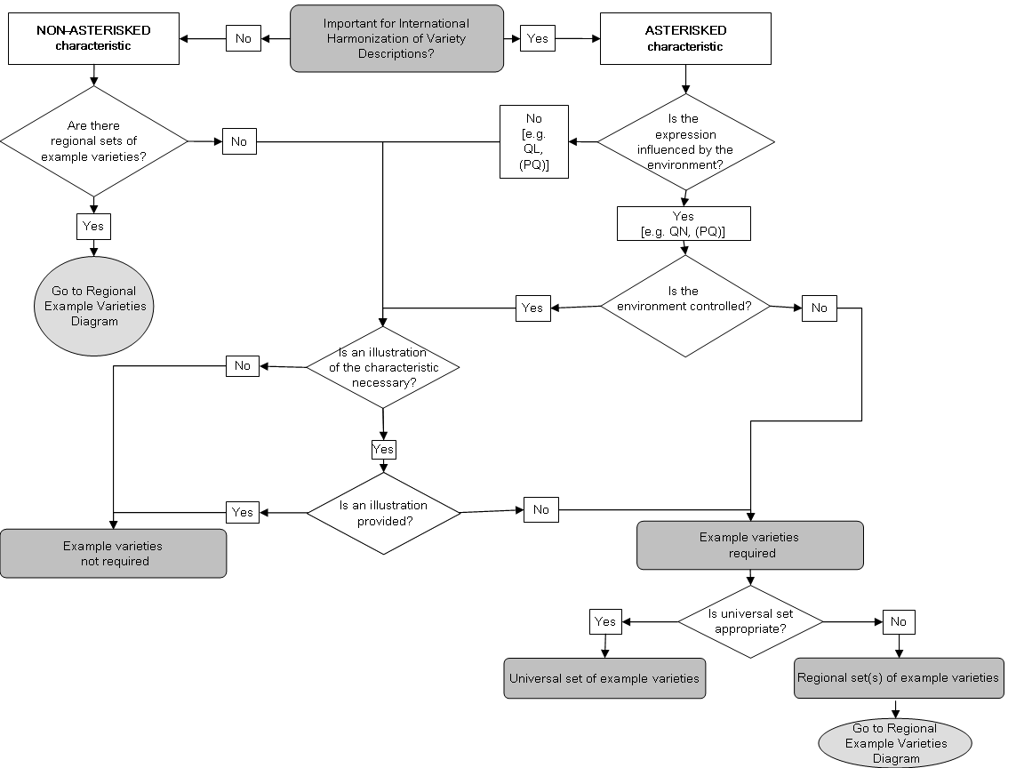
Flow Diagram 1 Deciding if Example Varieties are needed for a characteristic
The Flow diagram does not reflect the complexity of decision elements. In particular, reference to “illustrations” is only used in the sense of illustrations in Section 8 of TGs. Situations where example varieties are needed for illustration (see 1. (a)) is not reflected. In many cases it is very useful to have illustrations in Section 8 in addition to example varieties.

Flow Diagram 2
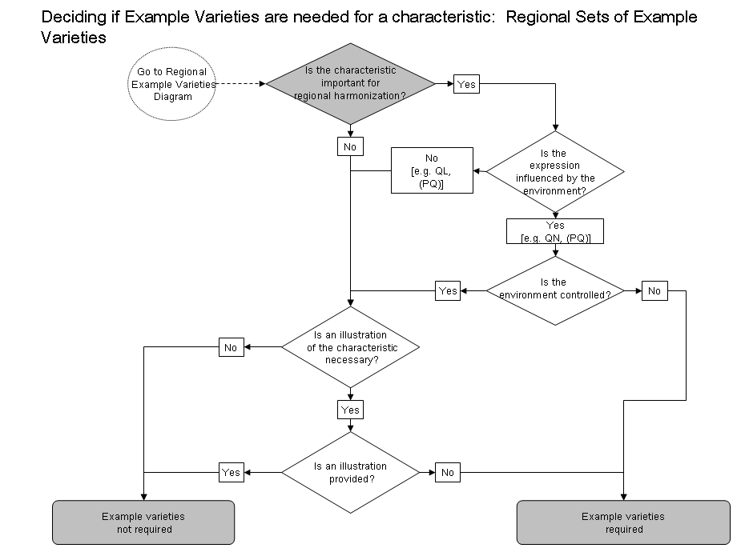
The process for regional sets is the same as for a universal set. It is already covered in Flow Diagram 1 (which should be deleted anyway).

5. Multiple sets of example varieties

5.1 Presentation of Regional Sets of Example Varieties
5.1.1 The existence of multiple sets of example varieties means that, for some or all characteristics, no example varieties are presented in the Table of Characteristics and the multiple sets of example varieties are presented in an annex available on the UPOV Website which is presented as follows:

 | Region A
Example varieties | Ch. 1 | Ch. 2 | Ch. 3 | Ch. 4 | Ch. 5 | etc.
Variety A | 3 | 1 | 3 |  | 3
Variety B | 5 | 2 | 7 | 1 | 1
Variety C | 7 | 3 | 5 | 9 | 2
Variety D |  | 4 |  |  | 4
etc.

 | Region B
Example varieties | Ch. 1 | Ch. 2 | Ch. 3 | Ch. 4 | Ch. 5 | etc.
Variety I | 3 | 4 | 5 |  | 1
Variety II | 5 | 2 | 3 | 1 | 2
Variety III | 7 | 1 | 7 | 9 | 3
Variety IV |  | 3 |  |  | 4
etc.

5.1.2 Even where the “example variety” column is empty (i.e. there are no universal example varieties for any characteristic), the column is retained in the Table of Characteristics to allow users to complete this with the appropriate example varieties.

5.2 Different types of variety
5.2.1 If it is not possible, with a single set of example varieties, to describe all the types of varieties (e.g. winter-types and spring-types) covered by the same Test Guidelines, they may be subdivided to create different sets of example varieties.

5.2.2 Where different sets of example varieties are provided for different types of varieties covered by the same Test Guidelines, they are placed in the Table of Characteristics in the same column as normal. The sets of example varieties (e.g. winter and spring) are separated by a semicolon, and/or indicated by a key which is provided for each set and an explanation for the option chosen should be included in the legend of Chapter 6 of the Test Guidelines.

Example: For certain characteristics, different example varieties are indicated for winter type and spring type varieties. These types are separated by a semicolon, with the winter types placed before the semicolon and prefixed by “(w)” and the spring types placed after the semicolon and prefixed by “(s)”.

 | Stage/  Stade/  Stadium/  Estado | English | français | deutsch | español | Example Varieties/  Exemples/  Beispielssorten/  Variedades ejemplo | Note/  Nota
7.  (*)  (+) | 75-92  MG/MS | Plant: length | Plante: port | Pflanze: Wuchsform | Planta: porte
 |  | short | courte | kurz | corta | (w) Variety A, Variety C; (s) Alpha | 3
 |  | medium | moyenne | mittel | media | (w) Variety B; (s) Beta | 5
 |  | long | longue | lang | larga | (s) Gamma | 7

4. Purpose of example varieties
The General Introduction (Chapter 4.3) states that “example varieties are provided in the Test Guidelines to clarify the states of expression of a characteristic.” This clarification of the states of expression is required with respect to two aspects:

(a) to illustrate the characteristic and/or

(b) to provide the basis for ascribing the appropriate state of expression to each variety and, thereby, to develop internationally harmonized variety descriptions.

4.1 Illustration of a characteristic
Although example varieties have the benefit of enabling examiners to see a characteristic in “real life”, in many cases, the illustration of a characteristic by photographs or drawings (to be provided in chapter 8 of the Test Guidelines) may provide a clearer illustration of the characteristic. Furthermore, the difficulty in selecting suitable example varieties, which satisfy all the requirements in Section 4.2 below, means that photographs or drawings are an important alternative or addition to example varieties as a means of illustrating characteristics.

4.2 International Harmonization of Variety Descriptions
4.2.1 The main reason why example varieties are used in place of, for example, actual measurements is that measurements can be influenced by the environment.

(a) Example varieties in the Test Guidelines

4.2.2 Example varieties are important to adjust the description of the characteristics for the year and location effects, as far as possible. Thus, using the relative scale provided by the example varieties, it can be seen that the example variety Beta measured 10 cm in Country A and 15 cm in Country B, but in both locations demonstrates the state of expression “medium”. On this basis, candidate variety X would be considered to have a medium length leaf in both Countries A and B.

 | Example Varieties | Note
Leaf: length of blade
short | Alpha | 3
medium | Beta | 5
long | Gamma | 7

(b) Fixed measurements in the Test Guidelines

4.2.3 If absolute measurements were to be indicated in the Test Guidelines and the Test Guidelines were drafted in Country A on the basis of the data from section 4.2.2, the Table of Characteristics would show the following:

 | Length | Note
Leaf: length of blade
short | 5 cm | 3
medium | 10 cm | 5
long | 15 cm | 7

4.2.4 Because there is no “relative scale” provided by the example varieties, the same data would lead to the following descriptions:

 | Country A | Country B
Variety X | 10 cm  (medium: note 5) | 15 cm  (long: note 7)

4.2.5 Thus, if absolute measurements were used in the Test Guidelines, variety X, when grown in Country A, would be described as “medium (note 5)”, but if grown in Country B, would be described as “long (note 7)”. This demonstrates that it could be very misleading to compare descriptions from different locations on the basis of absolute measurements, without the adjustment for year or location effects provided by example varieties.

4.2.6 Nevertheless, because of the possibility of particular interactions between the variety genotype and location (e.g. influence of photoperiod), it should not be assumed that descriptions developed in different countries or locations using the same set of example varieties will be the same (see also section 2.2). Guidance on the scope for comparison of varieties on the basis of descriptions produced in different locations is provided in document TGP/9, Examining Distinctness.

[Annex follows]

EXTRACT FROM DOCUMENT SESSIONS/2023/2 “DEVELOPMENT OF GUIDANCE AND DOCUMENTS PROPOSED FOR ADOPTION BY THE COUNCIL

Document TGP/7 Development of Test Guidelines (Revision)

Example varieties for asterisked quantitative characteristics when illustrations are provided

The TC, at its fifty-eighth session⁶, agreed to invite the TWPs, at their sessions in 2023, to consider the situations described by the TWO as the basis to develop guidance on possible exceptions to the requirement to provide example varieties for asterisked quantitative characteristics when illustrations were provided. The TC agreed to invite the TWPs to specify situations where such approach would be applicable (see document TC/58/31 “Report”, paragraphs 23 and 24).

Situations where illustrations could replace example varieties for asterisked quantitative characteristics

The TWV, TWA, TWO and TWF, at their sessions in 2023, considered the situations described by the TWO as the basis to develop guidance on possible exceptions to the requirement to provide example varieties for asterisked quantitative characteristics when illustrations were provided (see documents TWV/57/26 “Report”, paragraphs 11 to 13; TWA/52/11 “Report”, paragraphs 15 to 17, TWO/55/11 “Report”, paragraphs 10 to 13 and TWF/54/13 “Report”, paragraph 13).

The TWV recalled that, at its fifty-sixth session, it had agreed as follows (see document TWV/56/22 “Report”, paragraph 9):

“The TWV agreed that example varieties should continue to be provided for asterisked quantitative characteristics for vegetable crops. The TWV agreed that example varieties could be easily provided for vegetable crops and were useful for harmonizing DUS examination and producing variety descriptions. The TWV recalled that guidance in document TGP/7 required example varieties for three or two states of expression, according to the scale of notes used.”

The TWV agreed that example varieties were important for training for DUS experts and plant breeders using Test Guidelines. The TWV agreed that illustrations should be used to complement example varieties in explanations and whenever plant material of a particular variety was not available.
The TWA agreed that Test Guidelines should provide as much information as possible to clarify the states of expression of a characteristic, such as using illustrations to complement the use of example varieties.

The TWA agreed to invite the experts from Germany in collaboration with Canada, Netherlands and United Kingdom to draft a proposal to amend the guidance in document TGP/7, GN 28 “Example Varieties”, concerning the situations where illustrations could replace example varieties and their complementary role to clarify the states of expression of a characteristic.

The TWO recalled that information on the situations where the approach would be applicable had been provided in document TWP/7/2 “Development of guidance and information materials”, paragraphs 16 and 17 (see document TWO/54/6 “Report”, paragraph 24) as reproduced below:

“16. The TWO, at its fifty-fourth session, noted that Test Guidelines for ornamental plants included many quantitative and pseudo-qualitative floral characteristics, which were not measured and only visually observed (VG). The TWO agreed that the use of illustrations would be suitable to replace example varieties for such characteristics and further facilitate international harmonization. The TWO agreed that the following characteristics could be used as examples of the approach to replace example varieties when illustrations were provided (see document TWO/54/6 ‘Report’, paragraph 24):

- Document TG/336/1 ‘Coreopsis’:
Ad. 24: Ray floret: attitude of basal part (QN)

1 | 2 | 3 | 4
strongly  ascending | moderately ascending | weakly  ascending | horizontal

5 | 6 | 7
weakly  descending | moderately descending | strongly descending

- Document TG/336/1 “Coreopsis”:

“Ad. 29: Ray floret: distribution of main color (PQ)

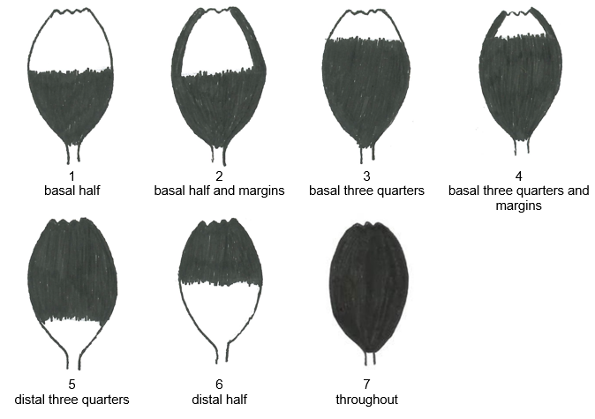

- Document TG/168/3 ‘Statice': Ad. 24: Inflorescence: type (PQ)
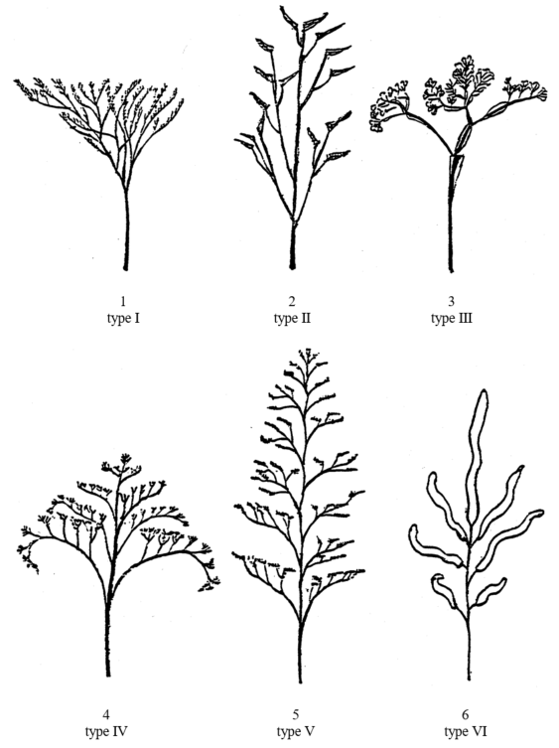

The TWO agreed that such an approach would also be applicable for species with few example varieties and where there was difficulty obtaining plant material of such varieties.

The TWO noted that the TWA, at its fifty-second session, had agreed to invite the experts from Germany in collaboration with Canada, Netherlands and United Kingdom to draft a proposal to amend document TGP/7, GN 28 “Example Varieties”, concerning situations where illustrations could replace example varieties and their complementary role to clarify the states of expression of a characteristic.

The TWO agreed to invite the experts from Canada, European Union, France and the United Kingdom to join the TWA experts to draft a proposal to amend document TGP/7, GN 28.

The TWF, at its fifty-fourth session⁹, agreed that Test Guidelines should provide example varieties and illustrations as far as possible. The TWF noted that there could be difficulty obtaining plant material of certain example varieties not widely available or no longer in cultivation. The TWF noted the expressions of interest of the experts from Australia and Hungary to join the experts from the TWA and TWO drafting a proposal to amend document TGP/7, GN 28 (see document TWF/54/13 “Report”, paragraph 14).

[End of Annex and of document]

TC, fifty-ninth session, held in Geneva on October 23 and 24, 2023
See document TC/59/28 “Report”, paragraph 38
Held via electronic means from April 18 to 22, 2022.

