 |  | E
TG/186/2(proj.5)
ORIGINAL: English
DATE: 2024-05-01

INTERNATIONAL UNION FOR THE PROTECTION OF NEW VARIETIES OF PLANTS
 | Geneva
 | DRAFT
 | SUGARCANE  UPOV Code(s): SACCH  Saccharum L. | *
GUIDELINES
FOR THE CONDUCT OF TESTS
FOR DISTINCTNESS, UNIFORMITY AND STABILITY

prepared by experts from Australia
to be considered by the
Technical Working Party for Agricultural Crops

at its fifty-third session, to be held virtually
from 2024-05-27 to 2024-05-30

Disclaimer: this document does not represent UPOV policies or guidance
Alternative names:*

Botanical name | English | French | German | Spanish
Saccharum L. | Sugarcane | Canne à sucre | Zuckerrohr | Caña de azúcar

The purpose of these guidelines (“Test Guidelines”) is to elaborate the principles contained in the General Introduction (document TG/1/3), and its associated TGP documents, into detailed practical guidance for the harmonized examination of distinctness, uniformity and stability (DUS) and, in particular, to identify appropriate characteristics for the examination of DUS and production of harmonized variety descriptions.
ASSOCIATED DOCUMENTS
These Test Guidelines should be read in conjunction with the General Introduction and its associated TGP documents.

TABLE OF CONTENTS | PAGE
1. | SUBJECT OF THESE TEST GUIDELINES.......................................................................................................... | 3
2. | MATERIAL REQUIRED..................................................................................................................... | 3
3. | METHOD OF EXAMINATION............................................................................................................... | 3
3.1 | Number of Growing Cycles................................................................................................................. | 3
3.2 | Testing Place................................................................................................................... | 3
3.3 | Conditions for Conducting the Examination............................................................................................... | 3
3.4 | Test Design................................................................................................................. | 4
3.5 | Additional Tests................................................................................................................... | 4

4. | ASSESSMENT OF DISTINCTNESS, UNIFORMITY AND STABILITY................................................................. | 4
4.1 | Distinctness.......................................................................................................... | 4
4.2 | Uniformity............................................................................................................ | 5
4.3 | Stability............................................................................................................... | 5

5. | GROUPING OF VARIETIES AND ORGANIZATION OF THE GROWING TRIAL................................................ | 6
6. | INTRODUCTION TO THE TABLE OF CHARACTERISTICS................................................................................ | 6
6.1 | Categories of Characteristics...................................................................................................... | 6
6.2 | States of Expression and Corresponding Notes........................................................................................ | 6
6.3 | Types of Expression............................................................................................................ | 6
6.4 | Example Varieties.............................................................................................................. | 6
6.5 | Legend................................................................................................................. | 8

7. | TABLE OF CHARACTERISTICS/TABLEAU DES CARACTÈRES/MERKMALSTABELLE/TABLA DE CARACTERES.................................................................................................................. | 9
8. | EXPLANATIONS ON THE TABLE OF CHARACTERISTICS............................................................................... | 25
8.1 | Explanations covering several characteristics........................................................................................... | 25
8.2 | Explanations for individual characteristics................................................................................................. | 27

9. | LITERATURE................................................................................................................... | 34
10 | TECHNICAL QUESTIONNAIRE............................................................................................................ | 35

1. | Subject of these Test Guidelines
 | These Test Guidelines apply to all varieties of Saccharum L.

2. | Material Required
2.1 | The competent authorities decide on the quantity and quality of the plant material required for testing the variety and when and where it is to be delivered. Applicants submitting material from a State other than that in which the testing takes place must ensure that all customs formalities and phytosanitary requirements are complied with.
2.2 | The material is to be supplied in the form of vegetative cuttings which are about 6 to 12 months old.
2.3 | The minimum quantity of plant material, to be supplied by the applicant, should be:
 | 12 segments of culm with 3 buds each.
2.4 | The plant material supplied should be visibly healthy, not lacking in vigor, nor affected by any important pest or disease.
2.5 | The plant material should not have undergone any treatment which would affect the expression of the characteristics of the variety, unless the competent authorities allow or request such treatment. If it has been treated, full details of the treatment must be given.

3. | Method of Examination
3.1 | Number of Growing Cycles
3.1.1 | The minimum duration of tests should normally be a single growing cycle.
3.1.2 | The testing of a variety may be concluded when the competent authority can determine with certainty the outcome of the test.
3.2 | Testing Place
 | Tests are normally conducted at one place. In the case of tests conducted at more than one place, guidance is provided in TGP/9 “Examining Distinctness”.
3.3 | Conditions for Conducting the Examination
3.3.1 | The tests should be carried out under conditions ensuring satisfactory growth for the expression of the relevant characteristics of the variety and for the conduct of the examination.
3.3.2 | All characteristics should be observed on plants aged between 10 to 12 months, in the first vegetative cycle of the crop (from planting to the first harvest).

3.4 | Test Design
 | Each test should be designed to result in a total of at least 24 plants, which should be divided between at least 2 replicates.
3.5 | Additional Tests
 | Additional tests, for examining relevant characteristics, may be established.

4. | Assessment of Distinctness, Uniformity and Stability
4.1 | Distinctness
4.1.1 | General Recommendations
 | It is of particular importance for users of these Test Guidelines to consult the General Introduction prior to making decisions regarding distinctness. However, the following points are provided for elaboration or emphasis in these Test Guidelines.
4.1.2 | Consistent Differences
 | The differences observed between varieties may be so clear that more than one growing cycle is not necessary. In addition, in some circumstances, the influence of the environment is not such that more than a single growing cycle is required to provide assurance that the differences observed between varieties are sufficiently consistent. One means of ensuring that a difference in a characteristic, observed in a growing trial, is sufficiently consistent is to examine the characteristic in at least two independent growing cycles.
4.1.3 | Clear Differences
 | Determining whether a difference between two varieties is clear depends on many factors, and should consider, in particular, the type of expression of the characteristic being examined, i.e. whether it is expressed in a qualitative, quantitative, or pseudo-qualitative manner. Therefore, it is important that users of these Test Guidelines are familiar with the recommendations contained in the General Introduction prior to making decisions regarding distinctness.
4.1.4 | Number of Plants or Parts of Plants to be Examined
 | Unless otherwise indicated, for the purposes of distinctness, all observations on single plants should be made on 6 plants or parts of plants taken from each of 6 plants and any other observations made on all plants in the test, disregarding any off-type plants.
 | In the case of observations of parts taken from single plants, the number of parts to be taken from each of the plants should be 23.
 | Unless otherwise indicated, all observations on single culms should be made on 6 culms or parts taken from each of 6 culms.
4.1.5 | Method of Observation
 | The recommended method of observing the characteristic for the purposes of distinctness is indicated by the following key in the Table of Characteristics (see document TGP/9 “Examining Distinctness”, Section 4 “Observation of characteristics”):
MG: single measurement of a group of plants or parts of plants
MS: measurement of a number of individual plants or parts of plants
VG: visual assessment by a single observation of a group of plants or parts of plants
VS: visual assessment by observation of individual plants or parts of plants

 | Type of observation: visual (V) or measurement (M)
 | “Visual” observation (V) is an observation made on the basis of the expert’s judgment. For the purposes of this document, “visual” observation refers to the sensory observations of the experts and, therefore, also includes smell, taste and touch. Visual observation includes observations where the expert uses reference points (e.g. diagrams, example varieties, side-by-side comparison) or non-linear charts (e.g. color charts). Measurement (M) is an objective observation against a calibrated, linear scale e.g. using a ruler, weighing scales, colorimeter, dates, counts, etc.
 | Type of record: for a group of plants (G) or for single, individual plants (S)
 | For the purposes of distinctness, observations may be recorded as a single record for a group of plants or parts of plants (G), or may be recorded as records for a number of single, individual plants or parts of plants (S). In most cases, “G” provides a single record per variety and it is not possible or necessary to apply statistical methods in a plant-by-plant analysis for the assessment of distinctness.
 | In cases where more than one method of observing the characteristic is indicated in the Table of Characteristics (e.g. VG/MG), guidance on selecting an appropriate method is provided in document TGP/9, Section 4.2.
4.2 | Uniformity
4.2.1 | It is of particular importance for users of these Test Guidelines to consult the General Introduction prior to making decisions regarding uniformity. However, the following points are provided for elaboration or emphasis in these Test Guidelines:
4.2.2 | These Test Guidelines have been developed for the examination of vegetatively propagated varieties. For varieties with other types of propagation, the recommendations in the General Introduction and document TGP/13 "Guidance for new types and species" Section 4.5 "Testing Uniformity" should be followed.
4.2.3 | For the assessment of uniformity of vegetatively propagated varieties, a population standard of 1% and an acceptance probability of at least 95% should be applied. In the case of a sample size of 24 plants, 1 off-type is allowed.
4.3 | Stability
4.3.1 | In practice, it is not usual to perform tests of stability that produce results as certain as those of the testing of distinctness and uniformity. However, experience has demonstrated that, for many types of variety, when a variety has been shown to be uniform, it can also be considered to be stable.
4.3.2 | Where appropriate, or in cases of doubt, stability may be further examined by testing a new seed or plant stock to ensure that it exhibits the same characteristics as those shown by the initial material supplied.

5. | Grouping of Varieties and Organization of the Growing Trial
5.1 | The selection of varieties of common knowledge to be grown in the trial with the candidate varieties and the way in which these varieties are divided into groups to facilitate the assessment of distinctness are aided by the use of grouping characteristics.
5.2 | Grouping characteristics are those in which the documented states of expression, even where produced at different locations, can be used, either individually or in combination with other such characteristics: (a) to select varieties of common knowledge that can be excluded from the growing trial used for examination of distinctness; and (b) to organize the growing trial so that similar varieties are grouped together.
5.3 | The following have been agreed as useful grouping characteristics:
(a) |  | Internode: shape in cross section (characteristic 8)
(b) |  | Internode: color where not exposed to sun (characteristic 10)
(c) |  | Node: presence of wing on bud (characteristic 19)
(d) |  | Node: shape of bud (characteristic 20)

5.4 | Guidance for the use of grouping characteristics, in the process of examining distinctness, is provided through the General Introduction and document TGP/9 “Examining Distinctness”.

6. | Introduction to the Table of Characteristics
6.1 | Categories of Characteristics
6.1.1 | Standard Test Guidelines Characteristics
 | Standard Test Guidelines characteristics are those which are approved by UPOV for examination of DUS and from which members of the Union can select those suitable for their particular circumstances.
6.1.2 | Asterisked Characteristics
 | Asterisked characteristics (denoted by *) are those included in the Test Guidelines which are important for the international harmonization of variety descriptions and should always be examined for DUS and included in the variety description by all members of the Union, except when the state of expression of a preceding characteristic or regional environmental conditions render this inappropriate.
6.2 | States of Expression and Corresponding Notes
6.2.1 | States of expression are given for each characteristic to define the characteristic and to harmonize descriptions. Each state of expression is allocated a corresponding numerical note for ease of recording of data and for the production and exchange of the description.
6.2.2 | All relevant states of expression are presented in the characteristic.
6.2.3 | Further explanation of the presentation of states of expression and notes is provided in document TGP/7 “Development of Test Guidelines”.
6.3 | Types of Expression
 | An explanation of the types of expression of characteristics (qualitative, quantitative and pseudo-qualitative) is provided in the General Introduction.

6.4 | Example Varieties
 | Where appropriate, example varieties are provided to clarify the states of expression of each characteristic.

6.5 | Legend
 |  | English |  | français |  | deutsch | español | Example Varieties  Exemples  Beispielssorten  Variedades ejemplo | Note/  Nota
1 | 2 | 3 | 4 | 5 | 6 | 7
 |  | Name of characteristics in English |  | Nom du caractère en français |  | Name des Merkmals auf Deutsch | Nombre del carácter en español
 |  | states of expression |  | types d’expression |  | Ausprägungsstufen | tipos de expresión

1 | Characteristic number
2 | (*) | Asterisked characteristic | – see Chapter 6.1.2
3 | Type of expression
 | QL | Qualitative characteristic | – see Chapter 6.3
 | QN | Quantitative characteristic | – see Chapter 6.3
 | PQ | Pseudo-qualitative characteristic | – see Chapter 6.3
4 | Method of observation (and type of plot, if applicable)
 | MG, MS, VG, VS |  | – see Chapter 4.1.5
5 | (+) | See Explanations on the Table of Characteristics in Chapter 8.2
6 | (a)-(f) | See Explanations on the Table of Characteristics in Chapter 8.1
7 | Not applicable

7. | Table of Characteristics/Tableau des caractères/Merkmalstabelle/Tabla de caracteres

 |  | English |  | français |  | deutsch | español | Example Varieties  Exemples  Beispielssorten  Variedades ejemplo | Note/  Nota
1. |  | QN | VG | (+)
 |  | Plant: growth habit
 |  | erect |  |  |  |  |  | Q121, Q186 | 1
 |  | semi-erect |  |  |  |  |  | Q96, RB72-454 | 2
 |  | intermediate |  |  |  |  |  | Q168 | 3
 |  | semi-prostate |  |  |  |  |  | H56-752 | 4
 |  | prostate |  |  |  |  |  |  | 5
2. | (*) | QN | VG | (+)
 |  | Plant: adherence of leaf sheath
 |  | very weak |  |  |  |  |  |  | 1
 |  | weak |  |  |  |  |  | H56-752, Q96 | 2
 |  | medium |  |  |  |  |  | Q124, Q186 | 3
 |  | strong |  |  |  |  |  | NCo310, Q120, Q201 | 4
 |  | very strong |  |  |  |  |  |  | 5
3. |  | QN | VG
 |  | Plant: number of tillers
 |  | very few |  |  |  |  |  |  | 1
 |  | few |  |  |  |  |  | Q124 | 2
 |  | medium |  |  |  |  |  | RB72-454 | 3
 |  | many |  |  |  |  |  | Q138 | 4
 |  | very many |  |  |  |  |  |  | 5
4. | (*) | QN | MS | (+) | (a)
 |  | Culm: length
 |  | very short |  |  |  |  |  |  | 1
 |  | short |  |  |  |  |  | Q117 | 2
 |  | medium |  |  |  |  |  | Q124, Q138, Q170 | 3
 |  | long |  |  |  |  |  | Q136, RB72-454 | 4
 |  | very long |  |  |  |  |  |  | 5
5. |  | QN | MS |  | (a)
 |  | Internode: length on bud side
 |  | very short |  |  |  |  |  |  | 1
 |  | short |  |  |  |  |  | Q117 | 2
 |  | medium |  |  |  |  |  | Q138, Q170 | 3
 |  | long |  |  |  |  |  | Q124 | 4
 |  | very long |  |  |  |  |  |  | 5
6. | (*) | QN | MS | (+) | (a)
 |  | Internode: diameter
 |  | very small |  |  |  |  |  |  | 1
 |  | small |  |  |  |  |  | Q136 | 2
 |  | medium |  |  |  |  |  | H56-752, Q124, Q170 | 3
 |  | large |  |  |  |  |  | Q117 | 4
 |  | very large |  |  |  |  |  |  | 5
7. | (*) | PQ | VG | (+) | (a)
 |  | Internode: shape
 |  | cylindrical |  |  |  |  |  | Q169, RB72-454 | 1
 |  | tumescent |  |  |  |  |  | Q205 | 2
 |  | bobbin-shaped |  |  |  |  |  | H56-752 | 3
 |  | conoidal |  |  |  |  |  | Q177, Q178 | 4
 |  | obconoidal |  |  |  |  |  | H60-3802 | 5
 |  | concave-convex |  |  |  |  |  | Q115 | 6
8. | (*) | QN | VG | (+) | (a)
 |  | Internode: shape in cross section
 |  | circular |  |  |  |  |  | Q121, RB72-454 | 1
 |  | circular to ovate |  |  |  |  |  |  | 2
 |  | ovate |  |  |  |  |  | Q152, Q186, Q96 | 3
9. | (*) | PQ | VG | (+) | (a)
 |  | Internode: color where exposed to sun
 |  | yellow |  |  |  |  |  | Q230 | 1
 |  | yellow green |  |  |  |  |  | SRA24, SRA25 | 2
 |  | grey yellow |  |  |  |  |  | SRA10 | 3
 |  | green |  |  |  |  |  | Sweet Florida Green | 4
 |  | grey orange |  |  |  |  |  | Q165 | 5
 |  | grey red |  |  |  |  |  | AKOKI | 6
 |  | red |  |  |  |  |  | Hawaii Original | 7
 |  | purple |  |  |  |  |  | RB72-454 | 8
 |  | purple black |  |  |  |  |  | Badila | 9
10 | (*) | PQ | VG | (+) | (a)
 |  | Internode: color where not exposed to sun
 |  | yellow |  |  |  |  |  |  | 1
 |  | yellow green |  |  |  |  |  | SRA24, SRA25 | 2
 |  | grey yellow |  |  |  |  |  | QS01-1078 | 3
 |  | green |  |  |  |  |  | Sweet Florida Green | 4
 |  | grey orange |  |  |  |  |  | Q220 | 5
 |  | grey red |  |  |  |  |  |  | 6
 |  | red |  |  |  |  |  |  | 7
 |  | purple |  |  |  |  |  | SRA9 | 8
 |  | purple black |  |  |  |  |  |  | 9
11 |  | QN | MS/VG | (+) | (a)
 |  | Internode: number of growth cracks
 |  | absent or very few |  |  |  |  |  | H56-752, RB72-454 | 1
 |  | few |  |  |  |  |  | Q124 | 2
 |  | medium |  |  |  |  |  | Q121 | 3
 |  | many |  |  |  |  |  | Q179 | 4
 |  | very many |  |  |  |  |  |  | 5
12 |  | QN | VG | (+) | (a)
 |  | Internode: depth of growth cracks
 |  | very shallow |  |  |  |  |  | RB72-454 | 1
 |  | shallow |  |  |  |  |  | Q124 | 2
 |  | medium |  |  |  |  |  | Q121 | 3
 |  | deep |  |  |  |  |  | Q179 | 4
 |  | very deep |  |  |  |  |  |  | 5
13 | (*) | QN | VG | (+) | (a)
 |  | Internode: degree of zigzag
 |  | absent or weak |  |  |  |  |  | Q124 | 1
 |  | medium |  |  |  |  |  | Q135, Q152 | 2
 |  | strong |  |  |  |  |  | Q117 | 3
14 |  | QN | VG |  | (a)
 |  | Internode: waxiness
 |  | absent or very weak |  |  |  |  |  | Q179 | 1
 |  | weak |  |  |  |  |  | Q138 | 2
 |  | medium |  |  |  |  |  | Q121, RB72-454 | 3
 |  | strong |  |  |  |  |  | H56-752, Q117 | 4
 |  | very strong |  |  |  |  |  |  | 5
15 |  | QN | VG |  | (a)
 |  | Internode: depth of bud groove
 |  | absent or very shallow |  |  |  |  |  | Q117, Q121, Q186 | 1
 |  | shallow |  |  |  |  |  | Q138, Q170, RB72-454 | 2
 |  | medium |  |  |  |  |  | Q179 | 3
 |  | deep |  |  |  |  |  | Q174 | 4
 |  | very deep |  |  |  |  |  |  | 5
16 |  | QN | MS/VG |  | (a)
 |  | Node: width of root band
 |  | very narrow |  |  |  |  |  |  | 1
 |  | narrow |  |  |  |  |  | SRA6 | 2
 |  | medium |  |  |  |  |  |  | 3
 |  | broad |  |  |  |  |  | Q202 | 4
 |  | very broad |  |  |  |  |  |  | 5
17 |  | PQ | VG | (+) | (a)
 |  | Node: shape of root band
 |  | constricted |  |  |  |  |  |  | 1
 |  | conoidal |  |  |  |  |  |  | 2
 |  | obconoidal |  |  |  |  |  |  | 3
18 |  | QN | VG |  | (a)
 |  | Node: width of wax ring
 |  | absent or very narrow |  |  |  |  |  | Q179 | 1
 |  | narrow |  |  |  |  |  | Q180 | 2
 |  | medium |  |  |  |  |  | Q113, Q96, RB72-454 | 3
 |  | broad |  |  |  |  |  | Q115, Q138 | 4
 |  | very broad |  |  |  |  |  | Q195 | 5
19 | (*) | QL | VG |  | (a)
 |  | Node: presence of wing on bud
 |  | absent |  |  |  |  |  |  | 1
 |  | present |  |  |  |  |  |  | 9
20 | (*) | PQ | VG | (+) | (a)
 |  | Node: shape of bud
 |  | triangular-pointed |  |  |  |  |  | RB72-454 | 1
 |  | elliptic |  |  |  |  |  | Q138 | 2
 |  | obovate |  |  |  |  |  | Q202 | 3
 |  | pentagonal |  |  |  |  |  | Q182 | 4
 |  | rhomboid |  |  |  |  |  | Q217 | 5
 |  | round |  |  |  |  |  | Q124, Q179 | 6
 |  | ovate |  |  |  |  |  | Q115, Q170, Q186 | 7
 |  | rectangular |  |  |  |  |  | Q215 | 8
21 |  | QN | MS/VG | (+) | (a)
 |  | Node: length of bud
 |  | very short |  |  |  |  |  | Q178 | 1
 |  | short |  |  |  |  |  |  | 2
 |  | medium |  |  |  |  |  | Q186 | 3
 |  | long |  |  |  |  |  |  | 4
 |  | very long |  |  |  |  |  | Q138 | 5
22 |  | QN | MS | (+) | (a)
 |  | Node: width of bud
 |  | very narrow |  |  |  |  |  | Q186 | 1
 |  | narrow |  |  |  |  |  | Q138 | 2
 |  | medium |  |  |  |  |  | Q178 | 3
 |  | broad |  |  |  |  |  |  | 4
 |  | very broad |  |  |  |  |  |  | 5
23 | (*) | QN | VG | (+) | (a)
 |  | Node: bud prominence
 |  | very weak |  |  |  |  |  | Q152 | 1
 |  | weak |  |  |  |  |  | RB72-454 | 2
 |  | medium |  |  |  |  |  | H56-752, Q121 | 3
 |  | strong |  |  |  |  |  | Q136 | 4
 |  | very strong |  |  |  |  |  |  | 5
24 |  | QN | VG |  | (a)
 |  | Node: position of bud tip in relation to growth ring
 |  | clearly below |  |  |  |  |  | Q171, SRAW18 | 1
 |  | same level |  |  |  |  |  | Q179, RB72-454 | 2
 |  | clearly above |  |  |  |  |  | Q172, SRA9 | 3
25 |  | QN | VG | (+) | (a)
 |  | Node: bud cushion
 |  | absent or very narrow |  |  |  |  |  | Q121, Q186 | 1
 |  | narrow |  |  |  |  |  | Q96 | 2
 |  | medium |  |  |  |  |  | Q181, RB72-454 | 3
 |  | broad |  |  |  |  |  | Q170 | 4
 |  | very broad |  |  |  |  |  |  | 5
26 |  | QN | VG | (+) | (a)
 |  | Node: width of bud wing
 |  | very narrow |  |  |  |  |  | RB72-454 | 1
 |  | narrow |  |  |  |  |  |  | 2
 |  | medium |  |  |  |  |  | Q121 | 3
 |  | broad |  |  |  |  |  |  | 4
 |  | very broad |  |  |  |  |  | BN81-1394 | 5
27 |  | PQ | VG | (+) | (a)
 |  | Node: color of root band where not exposed to sun
 |  | white and green |  |  |  |  |  |  | 1
 |  | yellow and green |  |  |  |  |  |  | 2
 |  | yellow and purple |  |  |  |  |  |  | 3
 |  | green |  |  |  |  |  |  | 4
 |  | green and purple |  |  |  |  |  |  | 5
 |  | purple |  |  |  |  |  |  | 6
28 |  | PQ | VG | (+) | (a)
 |  | Node: color of growth ring where not exposed to sun
 |  | white and green |  |  |  |  |  |  | 1
 |  | yellow and green |  |  |  |  |  |  | 2
 |  | yellow and purple |  |  |  |  |  |  | 3
 |  | green |  |  |  |  |  |  | 4
 |  | green and purple |  |  |  |  |  |  | 5
 |  | purple |  |  |  |  |  |  | 6
29 |  | QN | MS | (+) | (b), (c)
 |  | Leaf sheath: length
 |  | very short |  |  |  |  |  |  | 1
 |  | short |  |  |  |  |  | Q117 | 2
 |  | medium |  |  |  |  |  | Q136, Q170 | 3
 |  | long |  |  |  |  |  | Q121, Q124 | 4
 |  | very long |  |  |  |  |  |  | 5
30 |  | QN | VG |  | (b), (c), (d)
 |  | Leaf sheath: number of hairs
 |  | absent or very few |  |  |  |  |  | Q186, RB72-454 | 1
 |  | few |  |  |  |  |  | Q170 | 2
 |  | medium |  |  |  |  |  | Q117, Q179 | 3
 |  | many |  |  |  |  |  | Q124 | 4
 |  | very many |  |  |  |  |  | Q169 | 5
31 |  | QN | VG | (+) | (b), (c), (d)
 |  | Leaf sheath: length of hairs
 |  | very short |  |  |  |  |  |  | 1
 |  | short |  |  |  |  |  | Q186 | 2
 |  | medium |  |  |  |  |  | Q117, Q138, Q179 | 3
 |  | long |  |  |  |  |  | Q121 | 4
 |  | very long |  |  |  |  |  |  | 5
32 |  | PQ | VG | (+) | (b), (c), (d)
 |  | Leaf sheath: distribution of hairs
 |  | only lateral |  |  |  |  |  | Q138, Q170 | 1
 |  | lateral and dorsal |  |  |  |  |  | SRA5 | 2
 |  | only dorsal |  |  |  |  |  | SRA19 | 3
33 |  | QN | VG | (+) | (b), (c), (d)
 |  | Leaf sheath: length of ligule hairs
 |  | very short |  |  |  |  |  |  | 1
 |  | short |  |  |  |  |  | Q152, Q170, Q96 | 2
 |  | medium |  |  |  |  |  | Q179, RB72-454 | 3
 |  | long |  |  |  |  |  | BN81-1394, Q124 | 4
 |  | very long |  |  |  |  |  |  | 5
34 |  | PQ | VG | (+) | (b), (c)
 |  | Leaf sheath: shape of ligule
 |  | strap-shaped |  |  |  |  |  | Argos | 1
 |  | deltoid |  |  |  |  |  | H56-752, Q170 | 2
 |  | crescent-shaped |  |  |  |  |  | Q121, Q179, Q96 | 3
 |  | bow-shaped |  |  |  |  |  |  | 4
 |  | asymmetrical, steeply sloping |  |  |  |  |  | Vertix 1 Vertix 7 | 5
 |  | asymmetrical, horizontal |  |  |  |  |  | IACSP942094, RB72-454 | 6
35 |  | QN | VG | (+) | (b), (c), (d)
 |  | Leaf sheath: density of ligule hairs
 |  | absent or very sparse |  |  |  |  |  | SRA6 | 1
 |  | sparse |  |  |  |  |  | SRA25 | 2
 |  | medium |  |  |  |  |  | Q152 | 3
 |  | dense |  |  |  |  |  | Q121, RB72-454 | 4
 |  | very dense |  |  |  |  |  | Q179 | 5
36 |  | QN | VG | (+) | (b), (c)
 |  | Leaf sheath: width of ligule
 |  | narrow |  |  |  |  |  | SRAW17 | 1
 |  | medium |  |  |  |  |  | Q115, Q179, Q186 | 2
 |  | broad |  |  |  |  |  | H56-752, Q170 | 3
37 |  | QL | VG | (+) | (b), (c), (f)
 |  | Leaf sheath: underlapping auricle
 |  | absent |  |  |  |  |  |  | 1
 |  | present |  |  |  |  |  | Q186 | 9
38 | (*) | PQ | VG | (+) | (b), (c), (f)
 |  | Leaf sheath: shape of underlapping auricle
 |  | deltoid |  |  |  |  |  | Q186 | 1
 |  | dentoid |  |  |  |  |  | SRA1, SRA2 | 2
 |  | unciform |  |  |  |  |  |  | 3
 |  | calcarifom |  |  |  |  |  | Q196 | 4
 |  | lanceolate |  |  |  |  |  | H56-752, RB72-454 | 5
 |  | falcate |  |  |  |  |  | SRA16 | 6
39 |  | QN | VG |  | (b), (c), (f)
 |  | Leaf sheath: size of underlapping auricle
 |  | very small |  |  |  |  |  |  | 1
 |  | small |  |  |  |  |  | Q96 | 2
 |  | medium |  |  |  |  |  | Q201 | 3
 |  | large |  |  |  |  |  | Q135 | 4
 |  | very large |  |  |  |  |  |  | 5
40 |  | QL | VG | (+) | (b), (c), (f)
 |  | Leaf sheath: overlapping auricle
 |  | absent |  |  |  |  |  |  | 1
 |  | present |  |  |  |  |  | SRA24 | 9
41 | (*) | PQ | VG | (+) | (b), (c), (f)
 |  | Leaf sheath: shape of overlapping auricle
 |  | deltoid |  |  |  |  |  | Q117, RB72-454 | 1
 |  | dentoid |  |  |  |  |  |  | 2
 |  | unciform |  |  |  |  |  |  | 3
 |  | calcariform |  |  |  |  |  |  | 4
 |  | lanceolate |  |  |  |  |  | Q138 | 5
 |  | falcate |  |  |  |  |  |  | 6
42 |  | QN | VG |  | (b), (c), (f)
 |  | Leaf sheath: size of overlapping auricle
 |  | very small |  |  |  |  |  |  | 1
 |  | small |  |  |  |  |  | SRA20, SRA25 | 2
 |  | medium |  |  |  |  |  | Q251, SRA11 | 3
 |  | large |  |  |  |  |  | Q198, Q215 | 4
 |  | very large |  |  |  |  |  |  | 5
43 |  | QN | MS |  | (b)
 |  | Leaf blade: length
 |  | very short |  |  |  |  |  |  | 1
 |  | short |  |  |  |  |  | Q124 | 2
 |  | medium |  |  |  |  |  | Q136 | 3
 |  | long |  |  |  |  |  | Q170 | 4
 |  | very long |  |  |  |  |  |  | 5
44 | (*) | QN | MS |  | (b)
 |  | Leaf blade: width at longitudinal mid-point
 |  | very narrow |  |  |  |  |  |  | 1
 |  | narrow |  |  |  |  |  | Q113, Q186 | 2
 |  | medium |  |  |  |  |  | Q121, Q124 | 3
 |  | broad |  |  |  |  |  | Q138, Q179 | 4
 |  | very broad |  |  |  |  |  |  | 5
45 |  | QN | MS |  | (b)
 |  | Leaf: midrib width at longitudinal mid-point
 |  | very narrow |  |  |  |  |  | Q203 | 1
 |  | narrow |  |  |  |  |  | Q121 | 2
 |  | medium |  |  |  |  |  | Q124, Q170 | 3
 |  | wide |  |  |  |  |  | Q202, SRA5 | 4
 |  | very wide |  |  |  |  |  | Q138 | 5
46 |  | QN | MS |  | (b)
 |  | Leaf: ratio leaf blade width/midrib width
 |  | very low |  |  |  |  |  |  | 1
 |  | low |  |  |  |  |  | SRA5, SRA6 | 2
 |  | medium |  |  |  |  |  | H56-752, Q124 | 3
 |  | high |  |  |  |  |  | Q215, SRA11 | 4
 |  | very high |  |  |  |  |  |  | 5
47 |  | QL | VG | (+) | (d), (e)
 |  | Cane top: shape of cross-section
 |  | Circular |  |  |  |  |  |  | 1
 |  | Ovate |  |  |  |  |  |  | 9
48 |  | QN | MS/VG | (+) | (d), (e)
 |  | Cane top: length
 |  | very short |  |  |  |  |  |  | 1
 |  | short |  |  |  |  |  |  | 2
 |  | medium |  |  |  |  |  |  | 3
 |  | long |  |  |  |  |  |  | 4
 |  | very long |  |  |  |  |  |  | 5
49 |  | QN | VG | (+) | (d), (e)
 |  | Cane top: waxiness
 |  | absent or very weak |  |  |  |  |  |  | 1
 |  | weak |  |  |  |  |  |  | 2
 |  | medium |  |  |  |  |  |  | 3
 |  | strong |  |  |  |  |  |  | 4
 |  | very strong |  |  |  |  |  |  | 5

8. | Explanations on the Table of Characteristics
8.1 | Explanations covering several characteristics
 | Unless otherwise indicated, observations should be made at time of maturity on the middle third of plants aged between 10 to 12 months, in the first vegetative cycle of the crop (from planting to the first harvest).
 | Characteristics containing the following key in the Table of Characteristics should be examined as indicated below:
(a) | Observations on the node and internode should be made on the longest internode of the primary or representative culm.  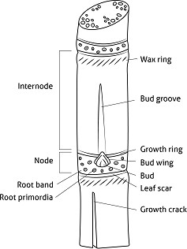
(b) | Observations should be made on the top visible dewlap (TVD) leaf.
(c) | Leaf sheath hairs to be observed on hair groups 57 and 60.  Distribution of hairs is dorsal when only hair group 57 is present. Distribution of hairs is lateral and dorsal when both hair groups 57 and 60 are present.  Distribution of hairs is lateral when only hair group 60 is present.  Leaf sheath ligule hairs to be observed on hair group 61.  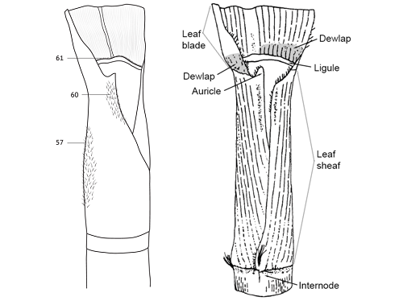
(d) | The cane top is the region between the youngest exposed visible dewlap and the insertion of the fourth youngest fully extended leave (leaf + 4) in the culm.

(e) | The dewlaps are two symmetrical patches at the junction of the leaf blade and the leaf sheath that are different in color and structure from the rest of the leaf.
(f) | The auricles are ear-shaped append­ages located at the upper part of the leaf sheath margin. Not all leaf sheath margins have auricles.

8.2 | Explanations for individual characteristics
Ad. 1: Plant: growth habit

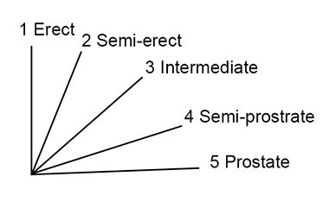

Ad. 2: Plant: adherence of leaf sheath

Observations should be made on the lower half of the stool on the senescing leaves.

Ad. 4: Culm: length

Measurements should be made from the base of the culm at soil level to the base of the Top Visible Dewlap (TVD) leaf.

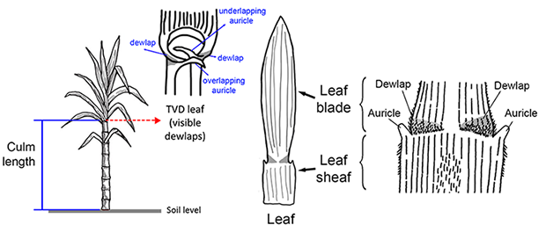

Ad. 6: Internode: diameter

Observations should be made at central part of the internode on the axis going through the bud.

Ad. 7: Internode: shape

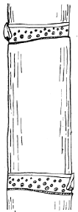 | 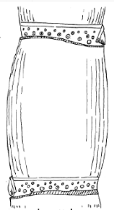 | 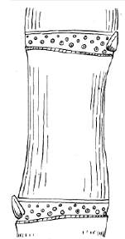
1 | 2 | 3
cylindrical | tumescent | bobbin-shaped

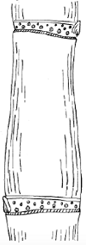 | 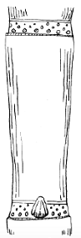 | 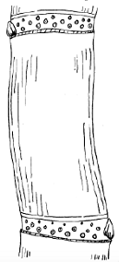
4 | 5 | 6
conoidal | obconoidal | concave-convex

Ad. 8: Internode: shape in cross section

Observations should be made in the central part of the internode.

Ad. 9: Internode: color where exposed to sun

The color covering the largest area should be observed.

Ad. 10: Internode: color where not exposed to sun

Observations should be made on the color covering the largest area and on a culm protected from the sun, from which the wax has been removed.

Ad. 11: Internode: number of growth cracks

Observations should be made across the entire length of the culm.

Ad. 12: Internode: depth of growth cracks

Observations should be made along the whole length of the culm.

Ad. 13: Internode: degree of zigzag

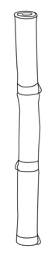 | 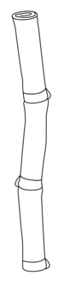 | 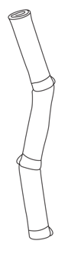
1 | 2 | 3
absent or  weak | medium | strong

Ad. 17: Node: shape of root band

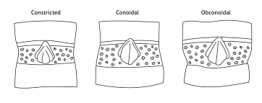

Ad. 20: Node: shape of bud

The bud wings are considered as part of the shape of the bud.

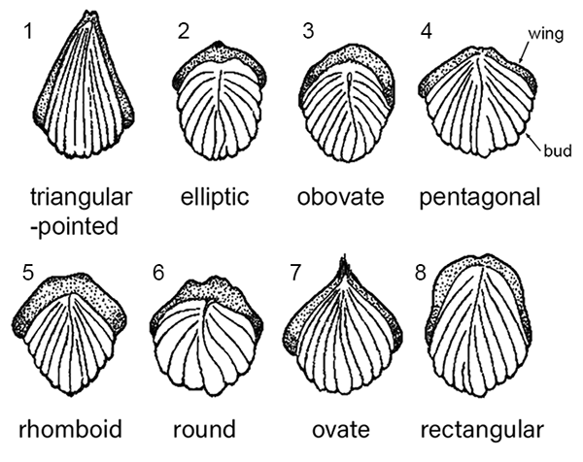

Ad. 21: Node: length of bud

Observations should be made vertically through the bud.

Ad. 22: Node: width of bud

Measurements should be taken horizontally through the bud.

Ad. 23: Node: bud prominence

Observations should be made below the node to which the second senescent leaf from the top was attached.

Ad. 25: Node: bud cushion

To be observed as the space between base of bud and leaf scar.

Ad. 26: Node: width of bud wing

Observations should be made at the broadest part of the wing.

Ad. 27: Node: color of root band where not exposed to sun

The color covering the largest area should be observed.

Ad. 28: Node: color of growth ring where not exposed to sun

The color covering the largest area should be observed.

Ad. 29: Leaf sheath: length

Measurements should be made from the leaf sheath base (point of attachment to the culm) to the dewlap (the junction between the leaf blade and the leaf sheath).

Ad. 31: Leaf sheath: length of hairs

See also 8.1 (c).

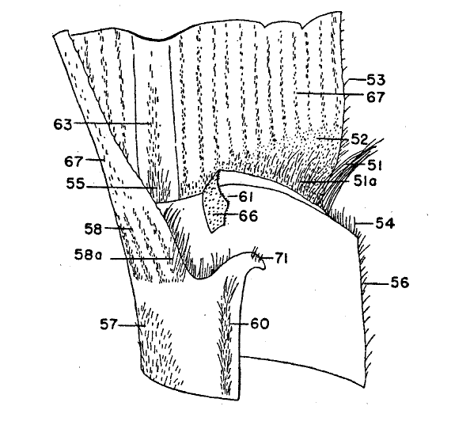

Ad. 32: Leaf sheath: distribution of hairs

See Ad. 31 and 8.1 (c).

Ad. 33: Leaf sheath: length of ligule hairs

See Ad. 31 and 8.1 (c).

Ad. 34: Leaf sheath: shape of ligule

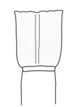 | 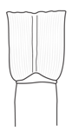 | 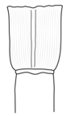
1 | 2 | 3
strap-shaped | deltoid | crescent-shaped

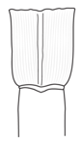 | 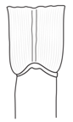 | 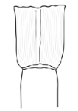
4 | 5 | 6
bow-shaped | asymmetrical,  steeply sloping | asymmetrical,  horizontal

Ad. 35: Leaf sheath: density of ligule hairs

See Ad. 31 and 8.1 (c).

Ad. 36: Leaf sheath: width of ligule

Ligule width is the distance from the point of attachment at the junction of the leaf blade and
the leaf sheath and the upper margin of the ligule at the widest point (middle of ligule).
Observations should be made at the broadest part of the ligule, vertically.

narrow: < 3 mm
medium: 3 – 5 mm
broad: 5 mm

Ad. 37: Leaf sheath: underlapping auricle

See Ad. 4 and Ad. 38. If auricles are not in one of the described shapes, they are to be considered absent.

Ad. 38: Leaf sheath: shape of underlapping auricle

See Ad. 4. Only when underlapping auricles are present (Ad. 37).

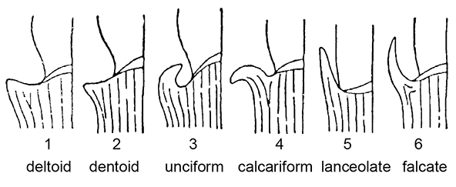

Ad. 40: Leaf sheath: overlapping auricle

See Ad. 4 and Ad. 38. If auricles are not in one of the described shapes, they are to be marked as absent.

Ad. 41: Leaf sheath: shape of overlapping auricle

See Ad. 4 and Ad. 38. Only when overlapping auricles are present (Ad. 40).

Ad. 47: Cane top: shape of cross-section

See 8.1 (d) and Ad. 4. The cross-section cut should be done across the apical meristem within the cane top.

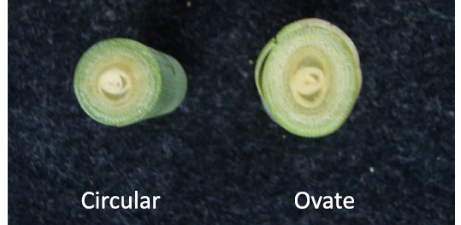

Ad. 48: Cane top: length

See 8.1 (d) and Ad. 4.

Ad. 49: Cane top: waxiness

The waxiness needs to be observed on the leaf sheaths in the cane top.

9. | Literature

Artschwager, E., 1940: Journal of Agricultural Research, v. 60, n. 8, pp. 503-508.

Artschwager, E. 1940: Morphology of the vegetative organs of sugarcane. Journal of Agricultural Research, 60 (8): 503-549.

Artschwager, E. and Brandes, E.W. 1958: Sugarcane (Saccharum officinarum L.). Origin, classification, characteristics and descriptions of representative clones. US Department of Agriculture, Agriculture Handbook. 122: 1-307.

Gallacher, D.J., 1994: Development of a minimum descriptor set for individuals of Saccharum spp. Hybrid germplasm. Thesis submitted for Ph.D., Department of Botany and Tropical Agriculture, James Cook University of North Queensland, AU.

Gallacher, D.J. and Berding, N. 1997: Purpose selection and application of descriptors for sugarcane germplasm. Aust. J. Agric. Res 48: 759-67.

Gallacher, D.J., 1997: Evaluation of sugarcane morphological descriptors using variance components analysis. Aust. J. Agric. Res 48: 769-73.

Gallacher, D.J., 1997: Optimised descriptors recommended for Australian sugarcane germplasm (Saccharum spp. hybrid) Aust. J. Agric. Res 48: 775-79.

Portz G., do Amaral, L.R. and Molin, J.P. 2012: Measuring sugarcane height in complement to biomass sensor for nitrogen management. 11th International Conference on Precision Agriculture.

10. | Technical Questionnaire

TECHNICAL QUESTIONNAIRE | Page {x} of {y} | Reference Number:

Application date:
(not to be filled in by the applicant)
TECHNICAL QUESTIONNAIRE
to be completed in connection with an application for plant breeders' rights

1. | Subject of the Technical Questionnaire
 | 1.1 | Botanical name | Saccharum L.
 | 1.2 | Common name | Sugarcane

2. | Applicant
 | Name
 | Address
 | Telephone No.
 | Fax No.
 | E-mail address
 | Breeder (if different from
 | applicant)

3. | Proposed denomination and breeder's reference
 | Proposed denomination
 | (if available)
 | Breeder's reference

TECHNICAL QUESTIONNAIRE |  |  | Page {x} of {y} | Reference Number:
#4. | Information on the breeding scheme and propagation of the variety
 | 4.1 | Breeding scheme
 | Variety resulting from:
4.1.1 | Crossing
(a) | controlled cross | [ ]
(please state parent variety)

(…………………..……………..…) x (……………..…………………..…)

female parent male parent

(b) | partially known cross | [ ]
(please state known parent variety(ies))

(…………………..……………..…) x (……………..…………………..…)

female parent male parent

(c) | unknown cross | [ ]
4.1.2 | Mutation  (please state parent variety) | [ ]
4.1.3 | Discovery and development  (please state where and when discovered and how developed) | [ ]
4.1.4 | Other  (Please provide details) | [ ]

TECHNICAL QUESTIONNAIRE | Page {x} of {y} | Reference Number:

 | 4.2 | Method of propagating the variety
4.2.1 | Vegetative propagation
(a) | Cuttings | [ ]
(b) | Other (state method) | [ ]
4.2.2 | Other  (Please provide details) | [ ]

TECHNICAL QUESTIONNAIRE | Page {x} of {y} | Reference Number:

5. | Characteristics of the variety to be indicated (the number in brackets refers to the corresponding characteristic in Test Guidelines; please mark the note which best corresponds).

 | Characteristics | Example Varieties | Note
5.1  (2) | Plant: adherence of leaf sheath
 | very weak |  | 1 [ ]
 | weak | H56-752, Q96 | 2 [ ]
 | medium | Q124, Q186 | 3 [ ]
 | strong | NCo310, Q120, Q201 | 4 [ ]
 | very strong |  | 5 [ ]
5.2  (7) | Internode: shape
 | cylindrical | Q169, RB72-454 | 1 [ ]
 | tumescent | Q205 | 2 [ ]
 | bobbin-shaped | H56-752 | 3 [ ]
 | conoidal | Q177, Q178 | 4 [ ]
 | obconoidal | H60-3802 | 5 [ ]
 | concave-convex | Q115 | 6 [ ]
5.3  (8) | Internode: shape in cross section
 | circular | Q121, RB72-454 | 1 [ ]
 | circular to ovate |  | 2 [ ]
 | ovate | Q152, Q186, Q96 | 3 [ ]
5.4  (9) | Internode: color where exposed to sun
 | yellow | Q230 | 1 [ ]
 | yellow green | SRA24, SRA25 | 2 [ ]
 | grey yellow | SRA10 | 3 [ ]
 | green | Sweet Florida Green | 4 [ ]
 | grey orange | Q165 | 5 [ ]
 | grey red | AKOKI | 6 [ ]
 | red | Hawaii Original | 7 [ ]
 | purple | RB72-454 | 8 [ ]
 | purple black | Badila | 9 [ ]

 | Characteristics | Example Varieties | Note
5.5  (10) | Internode: color where not exposed to sun
 | yellow |  | 1 [ ]
 | yellow green | SRA24, SRA25 | 2 [ ]
 | grey yellow | QS01-1078 | 3 [ ]
 | green | Sweet Florida Green | 4 [ ]
 | grey orange | Q220 | 5 [ ]
 | grey red |  | 6 [ ]
 | red |  | 7 [ ]
 | purple | SRA9 | 8 [ ]
 | purple black |  | 9 [ ]
5.6  (13) | Internode: degree of zigzag
 | absent or weak | Q124 | 1 [ ]
 | medium | Q135, Q152 | 2 [ ]
 | strong | Q117 | 3 [ ]
5.7  (20) | Node: shape of bud
 | triangular-pointed | RB72-454 | 1 [ ]
 | elliptic | Q138 | 2 [ ]
 | obovate | Q202 | 3 [ ]
 | pentagonal | Q182 | 4 [ ]
 | rhomboid | Q217 | 5 [ ]
 | round | Q124, Q179 | 6 [ ]
 | ovate | Q115, Q170, Q186 | 7 [ ]
 | rectangular | Q215 | 8 [ ]
5.8  (44) | Leaf blade: width at longitudinal mid-point
 | very narrow |  | 1 [ ]
 | narrow | Q113, Q186 | 2 [ ]
 | medium | Q121, Q124 | 3 [ ]
 | broad | Q138, Q179 | 4 [ ]
 | very broad |  | 5 [ ]

TECHNICAL QUESTIONNAIRE | Page {x} of {y} | Reference Number:

6. | Similar varieties and differences from these varieties
Please use the following table and box for comments to provide information on how your candidate variety differs from the variety (or varieties) which, to the best of your knowledge, is (or are) most similar. This information may help the examination authority to conduct its examination of distinctness in a more efficient way.

Denomination(s) of variety(ies) similar to your candidate variety | Characteristic(s) in which your candidate variety differs from the similar variety(ies) | Describe the expression of the characteristic(s) for the similar variety(ies) | Describe the expression of the characteristic(s) for your candidate variety

Example | Node: shape of bud | round | oval

 | Comments:

TECHNICAL QUESTIONNAIRE | Page {x} of {y} | Reference Number:

#7. | Additional information which may help in the examination of the variety
7.1 | In addition to the information provided in sections 5 and 6, are there any additional characteristics which may help to distinguish the variety?
 | Yes | [ ] | No | [ ]
 | (If yes, please provide details)
7.2 | Are there any special conditions for growing the variety or conducting the examination?
 | Yes | [ ] | No | [ ]
 | (If yes, please provide details)
7.3 | Other information

TECHNICAL QUESTIONNAIRE | Page {x} of {y} | Reference Number:

8. | Authorization for release
 | (a) | Does the variety require prior authorization for release under legislation concerning the protection of the environment, human and animal health?
 |  | Yes | [ ] | No | [ ]
 | (b) | Has such authorization been obtained?
 |  | Yes | [ ] | No | [ ]
 | If the answer to (b) is yes, please attach a copy of the authorization.

9. Information on plant material to be examined or submitted for examination

9.1 The expression of a characteristic or several characteristics of a variety may be affected by factors, such as pests and disease, chemical treatment (e.g. growth retardants or pesticides), effects of tissue culture, different rootstocks, scions taken from different growth phases of a tree, etc.
9.2 The plant material should not have undergone any treatment which would affect the expression of the characteristics of the variety, unless the competent authorities allow or request such treatment. If the plant material has undergone such treatment, full details of the treatment must be given. In this respect, please indicate below, to the best of your knowledge, if the plant material to be examined has been subjected to:

 | (a) | Microorganisms (e.g. virus, bacteria, phytoplasma) | Yes [ ] | No [ ]
 | (b) | Chemical treatment (e.g. growth retardant, pesticide) | Yes [ ] | No [ ]
 | (c) | Tissue culture | Yes [ ] | No [ ]
 | (d) | Other factors | Yes [ ] | No [ ]
 | Please provide details for where you have indicated “yes”.

10. | I hereby declare that, to the best of my knowledge, the information provided in this form is correct:
 | Applicant’s name
 | Signature |  | Date

[End of document]

