 |  | E
TG/23/7(proj.3)
ORIGINAL: English
DATE: 2022-04-08

INTERNATIONAL UNION FOR THE PROTECTION OF NEW VARIETIES OF PLANTS
 | Geneva
 | DRAFT
 | POTATO  UPOV Code(s): SOLAN_TUB  Solanum tuberosum L. | *
GUIDELINES
FOR THE CONDUCT OF TESTS
FOR DISTINCTNESS, UNIFORMITY AND STABILITY

prepared by experts from Germany
to be considered by the
Technical Working Party for Agricultural Crops

at its fifty-first session, to be held in Cambridge, United Kingdom,
from 2022-05-23 to 2022-05-27

Disclaimer: this document does not represent UPOV policies or guidance
Alternative names:*

Botanical name | English | French | German | Spanish
Solanum tuberosum L. | Potato | Pomme de terre | Kartoffel | Papa, Patata

The purpose of these guidelines (“Test Guidelines”) is to elaborate the principles contained in the General Introduction (document TG/1/3), and its associated TGP documents, into detailed practical guidance for the harmonized examination of distinctness, uniformity and stability (DUS) and, in particular, to identify appropriate characteristics for the examination of DUS and production of harmonized variety descriptions.
ASSOCIATED DOCUMENTS
These Test Guidelines should be read in conjunction with the General Introduction and its associated TGP documents.

TABLE OF CONTENTS | PAGE
1. | SUBJECT OF THESE TEST GUIDELINES.......................................................................................................... | 3
2. | MATERIAL REQUIRED..................................................................................................................... | 3
3. | METHOD OF EXAMINATION............................................................................................................... | 3
3.1 | Number of Growing Cycles................................................................................................................. | 3
3.2 | Testing Place................................................................................................................... | 3
3.3 | Conditions for Conducting the Examination............................................................................................... | 3
3.4 | Test Design................................................................................................................. | 4
3.5 | Additional Tests................................................................................................................... | 4

4. | ASSESSMENT OF DISTINCTNESS, UNIFORMITY AND STABILITY................................................................. | 4
4.1 | Distinctness.......................................................................................................... | 4
4.2 | Uniformity............................................................................................................ | 5
4.3 | Stability............................................................................................................... | 5

5. | GROUPING OF VARIETIES AND ORGANIZATION OF THE GROWING TRIAL................................................ | 6
6. | INTRODUCTION TO THE TABLE OF CHARACTERISTICS................................................................................ | 6
6.1 | Categories of Characteristics...................................................................................................... | 6
6.2 | States of Expression and Corresponding Notes........................................................................................ | 6
6.3 | Types of Expression............................................................................................................ | 6
6.4 | Example Varieties.............................................................................................................. | 7
6.5 | Legend................................................................................................................. | 8

7. | TABLE OF CHARACTERISTICS/TABLEAU DES CARACTÈRES/MERKMALSTABELLE/TABLA DE CARACTERES.................................................................................................................. | 9
8. | EXPLANATIONS ON THE TABLE OF CHARACTERISTICS............................................................................... | 26
8.1 | Explanations covering several characteristics........................................................................................... | 26
8.2 | Explanations for individual characteristics................................................................................................. | 28

9. | LITERATURE................................................................................................................... | 38
10 | TECHNICAL QUESTIONNAIRE............................................................................................................ | 39

1. | Subject of these Test Guidelines
 | These Test Guidelines apply to all varieties of Solanum tuberosum L.

2. | Material Required
2.1 | The competent authorities decide on the quantity and quality of the plant material required for testing the variety and when and where it is to be delivered. Applicants submitting material from a State other than that in which the testing takes place must ensure that all customs formalities and phytosanitary requirements are complied with.
2.2 | The material is to be supplied in the form of tubers.
2.3 | The minimum quantity of plant material, to be supplied by the applicant, should be:
 | 100 tubers for each growing cycle
2.4 | The plant material supplied should be visibly healthy, not lacking in vigor, nor affected by any important pest or disease.
2.5 | The plant material should not have undergone any treatment which would affect the expression of the characteristics of the variety, unless the competent authorities allow or request such treatment. If it has been treated, full details of the treatment must be given.

3. | Method of Examination
3.1 | Number of Growing Cycles
3.1.1 | The minimum duration of tests should normally be two independent growing cycles.
3.1.2 | The two independent growing cycles should be in the form of two separate plantings.
3.1.3 | The testing of a variety may be concluded when the competent authority can determine with certainty the outcome of the test.
3.2 | Testing Place
 | Tests are normally conducted at one place. In the case of tests conducted at more than one place, guidance is provided in TGP/9 “Examining Distinctness”.
3.3 | Conditions for Conducting the Examination
3.3.1 | The tests should be carried out under conditions ensuring satisfactory growth for the expression of the relevant characteristics of the variety and for the conduct of the examination.
3.3.2 | The optimum stage of development for the assessment of each characteristic is indicated by a number in the Table of Characteristics. The stages of development denoted by each number are described in Chapter 8.

3.4 | Test Design
3.4.1 | Each test should be designed to result in a total of at least 60 plants, which should be divided between at least 2 replicates.
3.4.2 | The design of the tests should be such that plants or parts of plants may be removed for measurement or counting without prejudice to the observations which must be made up to the end of the growing cycle.
3.4.3 | The assessment of lightsprout characteristics should be carried out on at least 5 tubers.
3.5 | Additional Tests
 | Additional tests, for examining relevant characteristics, may be established.

4. | Assessment of Distinctness, Uniformity and Stability
4.1 | Distinctness
4.1.1 | General Recommendations
 | It is of particular importance for users of these Test Guidelines to consult the General Introduction prior to making decisions regarding distinctness. However, the following points are provided for elaboration or emphasis in these Test Guidelines.
4.1.2 | Consistent Differences
 | The differences observed between varieties may be so clear that more than one growing cycle is not necessary. In addition, in some circumstances, the influence of the environment is not such that more than a single growing cycle is required to provide assurance that the differences observed between varieties are sufficiently consistent. One means of ensuring that a difference in a characteristic, observed in a growing trial, is sufficiently consistent is to examine the characteristic in at least two independent growing cycles.
4.1.3 | Clear Differences
 | Determining whether a difference between two varieties is clear depends on many factors, and should consider, in particular, the type of expression of the characteristic being examined, i.e. whether it is expressed in a qualitative, quantitative, or pseudo-qualitative manner. Therefore, it is important that users of these Test Guidelines are familiar with the recommendations contained in the General Introduction prior to making decisions regarding distinctness.
4.1.4 | Number of Plants or Parts of Plants to be Examined
 | Unless otherwise indicated, for the purposes of distinctness, all observations on single plants should be made on 10 plants or parts of plants taken from each of 10 plants and any other observations made on all plants in the test, disregarding any off-type plants.
 | In the case of observations of parts taken from single plants, the number of parts to be taken from each of the plants should be 1.
4.1.5 | Method of Observation
 | The recommended method of observing the characteristic for the purposes of distinctness is indicated by the following key in the Table of Characteristics (see document TGP/9 “Examining Distinctness”, Section 4 “Observation of characteristics”):

MG: single measurement of a group of plants or parts of plants
MS: measurement of a number of individual plants or parts of plants
VG: visual assessment by a single observation of a group of plants or parts of plants
VS: visual assessment by observation of individual plants or parts of plants

 | Type of observation: visual (V) or measurement (M)
 | “Visual” observation (V) is an observation made on the basis of the expert’s judgment. For the purposes of this document, “visual” observation refers to the sensory observations of the experts and, therefore, also includes smell, taste and touch. Visual observation includes observations where the expert uses reference points (e.g. diagrams, example varieties, side-by-side comparison) or non-linear charts (e.g. color charts). Measurement (M) is an objective observation against a calibrated, linear scale e.g. using a ruler, weighing scales, colorimeter, dates, counts, etc.
 | Type of record: for a group of plants (G) or for single, individual plants (S)
 | For the purposes of distinctness, observations may be recorded as a single record for a group of plants or parts of plants (G), or may be recorded as records for a number of single, individual plants or parts of plants (S). In most cases, “G” provides a single record per variety and it is not possible or necessary to apply statistical methods in a plant-by-plant analysis for the assessment of distinctness.
 | In cases where more than one method of observing the characteristic is indicated in the Table of Characteristics (e.g. VG/MG), guidance on selecting an appropriate method is provided in document TGP/9, Section 4.2.
4.2 | Uniformity
4.2.1 | It is of particular importance for users of these Test Guidelines to consult the General Introduction prior to making decisions regarding uniformity. However, the following points are provided for elaboration or emphasis in these Test Guidelines:
4.2.2 | These Test Guidelines have been developed for the examination of vegetatively propagated varieties. For varieties with other types of propagation, the recommendations in the General Introduction and document TGP/13 "Guidance for new types and species" Section 4.5 "Testing Uniformity" should be followed.
4.2.3 | For the assessment of uniformity, a population standard of 1% and an acceptance probability of at least 95% should be applied. In case of a sample size of 60 plants, 2 off-types are allowed. In case of a sample size of 5 tubers, no off-type is allowed.
4.3 | Stability
4.3.1 | In practice, it is not usual to perform tests of stability that produce results as certain as those of the testing of distinctness and uniformity. However, experience has demonstrated that, for many types of variety, when a variety has been shown to be uniform, it can also be considered to be stable.
4.3.2 | Where appropriate, or in cases of doubt, stability may be further examined by testing a new seed or plant stock to ensure that it exhibits the same characteristics as those shown by the initial material supplied.

5. | Grouping of Varieties and Organization of the Growing Trial
5.1 | The selection of varieties of common knowledge to be grown in the trial with the candidate varieties and the way in which these varieties are divided into groups to facilitate the assessment of distinctness are aided by the use of grouping characteristics.
5.2 | Grouping characteristics are those in which the documented states of expression, even where produced at different locations, can be used, either individually or in combination with other such characteristics: (a) to select varieties of common knowledge that can be excluded from the growing trial used for examination of distinctness; and (b) to organize the growing trial so that similar varieties are grouped together.
5.3 | The following have been agreed as useful grouping characteristics:
(a) |  | Lightsprout: proportion of blue in anthocyanin coloration of base (characteristic 4)
(b) |  | Corolla: intensity of anthocyanin coloration on inner side (characteristic 27)
(c) |  | Corolla: proportion of blue in anthocyanin coloration on inner side (characteristic 28)
(d) |  | Plant: time of maturity (characteristic 31)
(e) |  | Tuber: color of skin (characteristic 34)

5.4 | Guidance for the use of grouping characteristics, in the process of examining distinctness, is provided through the General Introduction and document TGP/9 “Examining Distinctness”.

6. | Introduction to the Table of Characteristics
6.1 | Categories of Characteristics
6.1.1 | Standard Test Guidelines Characteristics
 | Standard Test Guidelines characteristics are those which are approved by UPOV for examination of DUS and from which members of the Union can select those suitable for their particular circumstances.
6.1.2 | Asterisked Characteristics
 | Asterisked characteristics (denoted by *) are those included in the Test Guidelines which are important for the international harmonization of variety descriptions and should always be examined for DUS and included in the variety description by all members of the Union, except when the state of expression of a preceding characteristic or regional environmental conditions render this inappropriate.
6.2 | States of Expression and Corresponding Notes
6.2.1 | States of expression are given for each characteristic to define the characteristic and to harmonize descriptions. Each state of expression is allocated a corresponding numerical note for ease of recording of data and for the production and exchange of the description.
6.2.2 | All relevant states of expression are presented in the characteristic.
6.2.3 | Further explanation of the presentation of states of expression and notes is provided in document TGP/7 “Development of Test Guidelines”.
6.3 | Types of Expression

An explanation of the types of expression of characteristics (qualitative, quantitative and pseudo-qualitative) is provided in the General Introduction.

6.4 | Example Varieties
 | Where appropriate, example varieties are provided to clarify the states of expression of each characteristic.

6.5 | Legend
 |  | English |  | français |  | deutsch | español | Example Varieties  Exemples  Be ejemplo | Note
1 | 2 | 3 | 4 | 5 | 6 | 7
 |  | Name of characteristics in English |  | Nom du caractère en français |  | Name des Merkmals auf Deutsch | Nombre del carácter en español
 |  | states of expression |  | types d’expression |  | Ausprägungsstufen | tipos de expresión

1 | Characteristic number
2 | (*) | Asterisked characteristic | – see Chapter 6.1.2
3 | Type of expression
 | QL | Qualitative characteristic | – see Chapter 6.3
 | QN | Quantitative characteristic | – see Chapter 6.3
 | PQ | Pseudo-qualitative characteristic | – see Chapter 6.3
4 | Method of observation (and type of plot, if applicable)
 | MG, MS, VG, VS |  | – see Chapter 4.1.5
5 | (+) | See Explanations on the Table of Characteristics in Chapter 8.2
6 | (a)-(e) | See Explanations on the Table of Characteristics in Chapter 8.1
7 | Growth stage key See Explanations on the Table of Characteristics in Chapter 8.3

7. | Table of Characteristics/Tableau des caractères/Merkmalstabelle/Tabla de caracteres

 |  | English |  | français |  | deutsch | español | Example Varieties  Exemples  Beispielssorten  Variedades ejemplo | Note/  Nota
1. |  | QN | VG |  | (a)
 |  | Lightsprout: size
 |  | very small |  |  |  |  |  |  | 1
 |  | very small to small |  |  |  |  |  |  | 2
 |  | small |  |  |  |  |  | Laura | 3
 |  | small to medium |  |  |  |  |  |  | 4
 |  | medium |  |  |  |  |  | Diamant, Victoria | 5
 |  | medium to large |  |  |  |  |  |  | 6
 |  | large |  |  |  |  |  | Solist | 7
 |  | large to very large |  |  |  |  |  |  | 8
 |  | very large |  |  |  |  |  |  | 9
2. | (*) | PQ | VG | (+) | (a)
 |  | Lightsprout: shape of base
 |  | spherical |  |  |  |  |  | Albatros | 1
 |  | ovoid |  |  |  |  |  | Laura | 2
 |  | conical |  |  |  |  |  | Bintje, Solist | 3
 |  | broad cylindrical |  |  |  |  |  | Diamant, Innovator | 4
 |  | narrow cylindrical |  |  |  |  |  | Cecile | 5
3. | (*) | QN | VG |  | (a), (b)
 |  | Lightsprout: anthocyanin coloration of base
 |  | absent or very weak |  |  |  |  |  | Estima | 1
 |  | very weak to weak |  |  |  |  |  |  | 2
 |  | weak |  |  |  |  |  | Solist | 3
 |  | weak to medium |  |  |  |  |  |  | 4
 |  | medium |  |  |  |  |  | Arielle | 5
 |  | medium to strong |  |  |  |  |  |  | 6
 |  | strong |  |  |  |  |  | Abbot, Victoria | 7
 |  | strong to very strong |  |  |  |  |  |  | 8
 |  | very strong |  |  |  |  |  | Agria, Red Emmalie | 9

 |  | English |  | français |  | deutsch | español | Example Varieties  Exemples  Beispielssorten  Variedades ejemplo | Note/  Nota
4. | (*) | QN | VG | (+) | (a)
 |  | Lightsprout: proportion of blue in anthocyanin coloration of base
 |  | absent or low |  |  |  |  |  | Arielle, Solist, Victoria | 1
 |  | medium |  |  |  |  |  | Abbot | 2
 |  | high |  |  |  |  |  | Agria, Red Emmalie | 3

5. | (*) | QN | VG | (+) | (a)
 |  | Lightsprout: pubescence of base
 |  | absent or very sparse |  |  |  |  |  | Slaney | 1
 |  | very sparse to sparse |  |  |  |  |  |  | 2
 |  | sparse |  |  |  |  |  | Goldmarie | 3
 |  | sparse to medium |  |  |  |  |  |  | 4
 |  | medium |  |  |  |  |  | Albatros, Laura | 5
 |  | medium to dense |  |  |  |  |  |  | 6
 |  | dense |  |  |  |  |  | Abbot | 7
 |  | dense to very dense |  |  |  |  |  |  | 8
 |  | very dense |  |  |  |  |  | Oxania | 9
6. |  | QN | VG | (+) | (a)
 |  | Lightsprout: size of tip in relation to base
 |  | very small |  |  |  |  |  |  | 1
 |  | very small to small |  |  |  |  |  |  | 2
 |  | small |  |  |  |  |  | Laura | 3
 |  | small to medium |  |  |  |  |  |  | 4
 |  | medium |  |  |  |  |  | Albatros, King Edward | 5
 |  | medium to large |  |  |  |  |  |  | 6
 |  | large |  |  |  |  |  | Abbot | 7
 |  | large to very large |  |  |  |  |  |  | 8
 |  | very large |  |  |  |  |  |  | 9

 |  | English |  | français |  | deutsch | español | Example Varieties  Exemples  Beispielssorten  Variedades ejemplo | Note/  Nota
7. |  | QN | VG | (+) | (a)
 |  | Lightsprout: habit of tip
 |  | closed |  |  |  |  |  | Laura | 1
 |  | closed to intermediate |  |  |  |  |  |  | 2
 |  | intermediate |  |  |  |  |  | Arielle | 3
 |  | intermediate to open |  |  |  |  |  |  | 4
 |  | open |  |  |  |  |  | Diamant, Solist | 5
8. |  | QN | VG |  | (a), (b)
 |  | Lightsprout: anthocyanin coloration of tip
 |  | absent or very weak |  |  |  |  |  | Estima, Innovator | 1
 |  | very weak to weak |  |  |  |  |  |  | 2
 |  | weak |  |  |  |  |  | Solist | 3
 |  | weak to medium |  |  |  |  |  |  | 4
 |  | medium |  |  |  |  |  | Laura, Spunta | 5
 |  | medium to strong |  |  |  |  |  |  | 6
 |  | strong |  |  |  |  |  | Agria | 7
 |  | strong to very strong |  |  |  |  |  |  | 8
 |  | very strong |  |  |  |  |  | Blaue St. Galler | 9
9. |  | QN | VG | (+) | (a)
 |  | Lightsprout: pubescence of tip
 |  | absent or very sparse |  |  |  |  |  | Goldmarie | 1
 |  | very sparse to sparse |  |  |  |  |  |  | 2
 |  | sparse |  |  |  |  |  | Laura | 3
 |  | sparse to medium |  |  |  |  |  |  | 4
 |  | medium |  |  |  |  |  | Albatros | 5
 |  | medium to dense |  |  |  |  |  |  | 6
 |  | dense |  |  |  |  |  | Abbot | 7
 |  | dense to very dense |  |  |  |  |  |  | 8
 |  | very dense |  |  |  |  |  | Camilla | 9

 |  | English |  | français |  | deutsch | español | Example Varieties  Exemples  Beispielssorten  Variedades ejemplo | Note/  Nota
10 | (*) | QN | VG |  | (a)
 |  | Lightsprout: number of root tips
 |  | very few |  |  |  |  |  |  | 1
 |  | very few to few |  |  |  |  |  |  | 2
 |  | few |  |  |  |  |  | Estima, Solist | 3
 |  | few to medium |  |  |  |  |  |  | 4
 |  | medium |  |  |  |  |  | Arielle, Bintje | 5
 |  | medium to many |  |  |  |  |  |  | 6
 |  | many |  |  |  |  |  | Innovator | 7
 |  | many to very many |  |  |  |  |  |  | 8
 |  | very many |  |  |  |  |  |  | 9

11 |  | QN | VG | (+) | (a)
 |  | Lightsprout: length of lateral shoots
 |  | very short |  |  |  |  |  |  | 1
 |  | very short to short |  |  |  |  |  |  | 2
 |  | short |  |  |  |  |  | Laura, Producent | 3
 |  | short to medium |  |  |  |  |  |  | 4
 |  | medium |  |  |  |  |  | Estima, Princess | 5
 |  | medium to long |  |  |  |  |  |  | 6
 |  | long |  |  |  |  |  | Spunta | 7
 |  | long to very long |  |  |  |  |  |  | 8
 |  | very long |  |  |  |  |  |  | 9
12 |  | QN | VG | (+) |  | 51-69
 |  | Plant: foliage structure
 |  | stem type |  |  |  |  |  | Agria, Estima | 1
 |  | intermediate type |  |  |  |  |  | Premiere | 2
 |  | leaf type |  |  |  |  |  | Kennebec | 3
13 | (*) | QN | VG | (+) |  | 51-69
 |  | Plant: growth habit
 |  | upright |  |  |  |  |  | Victoria | 1
 |  | upright to semi-upright |  |  |  |  |  |  | 2
 |  | semi-upright |  |  |  |  |  | Desiree, Secura | 3
 |  | semi-upright to spreading |  |  |  |  |  |  | 4
 |  | spreading |  |  |  |  |  | Solist | 5

 |  | English |  | français |  | deutsch | español | Example Varieties  Exemples  Beispielssorten  Variedades ejemplo | Note/  Nota
14 | (*) | QN | VG | (+) | (b) | 51-69
 |  | Stem: intensity of anthocyanin coloration
 |  | absent or very weak |  |  |  |  |  | Estima | 1
 |  | very weak to weak |  |  |  |  |  |  | 2
 |  | weak |  |  |  |  |  | Victoria | 3
 |  | weak to medium |  |  |  |  |  |  | 4
 |  | medium |  |  |  |  |  | Laura, Saturna | 5
 |  | medium to strong |  |  |  |  |  |  | 6
 |  | strong |  |  |  |  |  | Desiree | 7
 |  | strong to very strong |  |  |  |  |  |  | 8
 |  | very strong |  |  |  |  |  | Blaue St. Galler,  Vitelotte Noir | 9
15 |  | QN | VG |  | (c) | 51-69
 |  | Leaf: outline size
 |  | very small |  |  |  |  |  |  | 1
 |  | very small to small |  |  |  |  |  |  | 2
 |  | small |  |  |  |  |  | King Edward | 3
 |  | small to medium |  |  |  |  |  |  | 4
 |  | medium |  |  |  |  |  | Laura | 5
 |  | medium to large |  |  |  |  |  |  | 6
 |  | large |  |  |  |  |  | Kennebec | 7
 |  | large to very large |  |  |  |  |  |  | 8
 |  | very large |  |  |  |  |  |  | 9
16 |  | QN | VG | (+) | (c) | 51-69
 |  | Leaf: openness
 |  | closed |  |  |  |  |  | Albatros | 1
 |  | closed to intermediate |  |  |  |  |  |  | 2
 |  | intermediate |  |  |  |  |  | Premiere, Solist | 3
 |  | intermediate to open |  |  |  |  |  |  | 4
 |  | open |  |  |  |  |  | Goldmarie | 5

 |  | English |  | français |  | deutsch | español | Example Varieties  Exemples  Beispielssorten  Variedades ejemplo | Note/  Nota
17 |  | QN | VG | (+) | (c) | 51-69
 |  | Leaf: presence of secondary leaflets
 |  | very weak |  |  |  |  |  |  | 1
 |  | very weak to weak |  |  |  |  |  |  | 2
 |  | weak |  |  |  |  |  | Goldmarie | 3
 |  | weak to medium |  |  |  |  |  |  | 4
 |  | medium |  |  |  |  |  | Solist | 5
 |  | medium to strong |  |  |  |  |  |  | 6
 |  | strong |  |  |  |  |  | Victoria | 7
 |  | strong to very strong |  |  |  |  |  |  | 8
 |  | very strong |  |  |  |  |  |  | 9

18 |  | QN | VG | (+) |  | 51-69
 |  | Leaf: green color
 |  | very light |  |  |  |  |  |  | 1
 |  | very light to light |  |  |  |  |  |  | 2
 |  | light |  |  |  |  |  | Solist | 3
 |  | light to medium |  |  |  |  |  |  | 4
 |  | medium |  |  |  |  |  | Kuras, Victoria | 5
 |  | medium to dark |  |  |  |  |  |  | 6
 |  | dark |  |  |  |  |  | Spunta | 7
 |  | dark to very dark |  |  |  |  |  |  | 8
 |  | very dark |  |  |  |  |  |  | 9
19 |  | QN | VG | (+) | (b), (c) | 51-69
 |  | Leaf: intensity of anthocyanin coloration of midrib
 |  | absent or very weak |  |  |  |  |  | Solist | 1
 |  | very weak to weak |  |  |  |  |  |  | 2
 |  | weak |  |  |  |  |  | Russet Burbank | 3
 |  | weak to medium |  |  |  |  |  |  | 4
 |  | medium |  |  |  |  |  | Laura | 5
 |  | medium to strong |  |  |  |  |  |  | 6
 |  | strong |  |  |  |  |  | Romanze | 7
 |  | strong to very strong |  |  |  |  |  |  | 8
 |  | very strong |  |  |  |  |  | Bildtstar , Roseval | 9

 |  | English |  | français |  | deutsch | español | Example Varieties  Exemples  Beispielssorten  Variedades ejemplo | Note/  Nota
20 |  | QN | VG | (+) | (c) | 51-69
 |  | Second pair of lateral leaflets: width in relation to length
 |  | very narrow |  |  |  |  |  |  | 1
 |  | very narrow to narrow |  |  |  |  |  |  | 2
 |  | narrow |  |  |  |  |  | Innovator, Russet Burbank | 3
 |  | narrow to medium |  |  |  |  |  |  | 4
 |  | medium |  |  |  |  |  | Desiree | 5
 |  | medium to broad |  |  |  |  |  |  | 6
 |  | broad |  |  |  |  |  | Cayenne | 7
 |  | broad to very broad |  |  |  |  |  |  | 8
 |  | very broad |  |  |  |  |  |  | 9
21 |  | QN | VG | (+) |  | 51-69
 |  | Terminal and lateral leaflets: frequency of coalescence
 |  | absent or very low |  |  |  |  |  | Courage | 1
 |  | low |  |  |  |  |  |  | 2
 |  | medium |  |  |  |  |  | Goldmarie | 3
 |  | high |  |  |  |  |  |  | 4
 |  | very high |  |  |  |  |  | Cardinia | 5
22 |  | QN | VG | (+) | (b) | 55
 |  | Flower bud: intensity of anthocyanin coloration
 |  | absent or very weak |  |  |  |  |  | Solist | 1
 |  | very weak to weak |  |  |  |  |  |  | 2
 |  | weak |  |  |  |  |  | Pompadour | 3
 |  | weak to medium |  |  |  |  |  |  | 4
 |  | medium |  |  |  |  |  | Victoria | 5
 |  | medium to strong |  |  |  |  |  |  | 6
 |  | strong |  |  |  |  |  | Osprey | 7
 |  | strong to very strong |  |  |  |  |  |  | 8
 |  | very strong |  |  |  |  |  | Blaue St. Galler, Cayenne | 9

 |  | English |  | français |  | deutsch | español | Example Varieties  Exemples  Beispielssorten  Variedades ejemplo | Note/  Nota
23 | (*) | QN | VG | (+) |  | 60-69
 |  | Plant: frequency of inflorescences
 |  | absent or very low |  |  |  |  |  | King Edward | 1
 |  | very low to low |  |  |  |  |  |  | 2
 |  | low |  |  |  |  |  | Arielle | 3
 |  | low to medium |  |  |  |  |  |  | 4
 |  | medium |  |  |  |  |  | Laura | 5
 |  | medium to high |  |  |  |  |  |  | 6
 |  | high |  |  |  |  |  | Agria, Innovator | 7
 |  | high to very high |  |  |  |  |  |  | 8
 |  | very high |  |  |  |  |  | Euroresa | 9

24 |  | QN | VG | (+) | (d) | 60-69
 |  | Inflorescence: size
 |  | very small |  |  |  |  |  |  | 1
 |  | very small to small |  |  |  |  |  |  | 2
 |  | small |  |  |  |  |  | Estima, Solist | 3
 |  | small to medium |  |  |  |  |  |  | 4
 |  | medium |  |  |  |  |  | Goldmarie | 5
 |  | medium to large |  |  |  |  |  |  | 6
 |  | large |  |  |  |  |  | Innovator, Victoria | 7
 |  | large to very large |  |  |  |  |  |  | 8
 |  | very large |  |  |  |  |  |  | 9
25 |  | QN | VG |  | (b), (d) | 60-69
 |  | Peduncle: intensity of anthocyanin coloration
 |  | absent or very weak |  |  |  |  |  | Estima, Solist | 1
 |  | very weak to weak |  |  |  |  |  |  | 2
 |  | weak |  |  |  |  |  | Victoria | 3
 |  | weak to meduim |  |  |  |  |  |  | 4
 |  | medium |  |  |  |  |  | Saturna | 5
 |  | medium to strong |  |  |  |  |  |  | 6
 |  | strong |  |  |  |  |  | Desiree | 7
 |  | strong to very strong |  |  |  |  |  |  | 8
 |  | very strong |  |  |  |  |  | Blaue St. Galler | 9

 |  | English |  | français |  | deutsch | español | Example Varieties  Exemples  Bei ejemplo | Note/
26 |  | QN | VG |  | (d) | 60-69
 |  | Corolla: size
 |  | very small |  |  |  |  |  |  | 1
 |  | very small to small |  |  |  |  |  |  | 2
 |  | small |  |  |  |  |  | Sommergold | 3
 |  | small to medium |  |  |  |  |  |  | 4
 |  | medium |  |  |  |  |  | Laura | 5
 |  | medium to large |  |  |  |  |  |  | 6
 |  | large |  |  |  |  |  | Innovator | 7
 |  | large to very large |  |  |  |  |  |  | 8
 |  | very large |  |  |  |  |  | Roseval | 9
27 | (*) | QN | VG |  | (b), (d) | 60-69
 |  | Corolla: intensity of anthocyanin coloration on inner side
 |  | absent or very weak |  |  |  |  |  | Solist | 1
 |  | very weak to weak |  |  |  |  |  |  | 2
 |  | weak |  |  |  |  |  | Laura, Pirol, Secura | 3
 |  | weak to medium |  |  |  |  |  |  | 4
 |  | medium |  |  |  |  |  | Osprey, Quadriga | 5
 |  | medium to strong |  |  |  |  |  |  | 6
 |  | strong |  |  |  |  |  | Courage | 7
 |  | strong to very strong |  |  |  |  |  |  | 8
 |  | very strong |  |  |  |  |  | Ramona | 9
28 | (*) | QN | VG | (+) | (d) | 60-69
 |  | Corolla: proportion of blue in anthocyanin coloration on inner side
 |  | absent or low |  |  |  |  |  | Laura, Osprey | 1
 |  | medium |  |  |  |  |  | Courage, Secura | 2
 |  | high |  |  |  |  |  | Pirol, Quadriga | 3

 |  | English |  | français |  | deutsch | español | Example Varieties  Exemples  Beispielssorten  Variedades ejemplo | Note/  Nota
29 | (*) | QN | VG |  | (d) | 60-69
 |  | Corolla: extent of anthocyanin coloration on inner side
 |  | absent or very small |  |  |  |  |  | Vitelotte Noir | 1
 |  | very small to small |  |  |  |  |  |  | 2
 |  | small |  |  |  |  |  | Laura | 3
 |  | small to medium |  |  |  |  |  |  | 4
 |  | medium |  |  |  |  |  | Pirol | 5
 |  | medium to large |  |  |  |  |  |  | 6
 |  | large |  |  |  |  |  | Bildtstar | 7
 |  | large to very large |  |  |  |  |  |  | 8
 |  | very large |  |  |  |  |  | Courage | 9
30 |  | QN | VG |  |  | 65-69
 |  | Plant: height
 |  | very short |  |  |  |  |  | Mimi | 1
 |  | short |  |  |  |  |  |  | 2
 |  | medium |  |  |  |  |  | Arielle, Leyla | 3
 |  | tall |  |  |  |  |  |  | 4
 |  | very tall |  |  |  |  |  | Agria, Pirol | 5
31 | (*) | QN | MG | (+) |  | 97
 |  | Plant: time of maturity
 |  | very early |  |  |  |  |  | Leyla, Solist | 1
 |  | very early to early |  |  |  |  |  |  | 2
 |  | early |  |  |  |  |  | Princess | 3
 |  | early to medium |  |  |  |  |  |  | 4
 |  | medium |  |  |  |  |  | Laura | 5
 |  | medium to late |  |  |  |  |  |  | 6
 |  | late |  |  |  |  |  | Euroresa | 7
 |  | late to very late |  |  |  |  |  |  | 8
 |  | very late |  |  |  |  |  | Kuras, Producent | 9

 |  | English |  | français |  | deutsch | español | Example Varieties  Exemples  Beispielssorten  Variedades ejemplo | Note/  Nota
32 | (*) | QN | MS/VG | (+) | (e) | 99
 |  | Tuber: shape
 |  | round |  |  |  |  |  | Kuras | 1
 |  | short-oval |  |  |  |  |  | Courage | 2
 |  | oval |  |  |  |  |  | Diamant, Ramona | 3
 |  | long-oval |  |  |  |  |  | Innovator | 4
 |  | long |  |  |  |  |  | Spunta | 5
 |  | very long |  |  |  |  |  | Pompadour | 6

33 |  | QN | VG |  | (e) | 99
 |  | Tuber: depth of eyes
 |  | very shallow |  |  |  |  |  | Nadine | 1
 |  | very shallow to shallow |  |  |  |  |  |  | 2
 |  | shallow |  |  |  |  |  | Agria, Innovator | 3
 |  | shallow to medium |  |  |  |  |  |  | 4
 |  | medium |  |  |  |  |  | Courage | 5
 |  | medium to deep |  |  |  |  |  |  | 6
 |  | deep |  |  |  |  |  | Kuras, Sommergold | 7
 |  | deep to very deep |  |  |  |  |  |  | 8
 |  | very deep |  |  |  |  |  | Vitelotte Noir | 9
34 | (*) | PQ | VG |  | (e) | 99
 |  | Tuber: color of skin
 |  | light yellow brown |  |  |  |  |  | Nadine | 1
 |  | yellow |  |  |  |  |  | Agria, Solist | 2
 |  | orange brown |  |  |  |  |  | Karo, Velur | 3
 |  | light red |  |  |  |  |  | Bildtstar | 4
 |  | medium red |  |  |  |  |  | Laura | 5
 |  | dark red |  |  |  |  |  | Romanze | 6
 |  | red parti-colored |  |  |  |  |  | Cara | 7
 |  | blue violet |  |  |  |  |  | Blaue St. Galler,  Vitelotte Noir | 8
 |  | blue violet parti-colored |  |  |  |  |  | Catriona, Kestrel | 9

 |  | English |  | français |  | deutsch | español | Example Varieties  Exemples  Beispielssorten  Variedades ejemplo | Note/  Nota
35 |  | QN | VG |  | (e) | 99
 |  | Tuber: texture of skin
 |  | smooth |  |  |  |  |  | Laura | 1
 |  | medium |  |  |  |  |  | Solist | 2
 |  | rough |  |  |  |  |  | Ivory Russet, Russet Burbank | 3
36 | (*) | PQ | VG | (+) | (e) | 99
 |  | Tuber: color of base of eye
 |  | white |  |  |  |  |  | Nadine | 1
 |  | yellow |  |  |  |  |  | Agria, Solist | 2
 |  | red |  |  |  |  |  | Quarta, Romanze | 3
 |  | blue |  |  |  |  |  | Double Fun, Vitelotte Noir | 4
37 | (*) | PQ | VG | (+) | (e) | 99
 |  | Tuber: color of flesh
 |  | white |  |  |  |  |  | Kuras, Russet Burbank | 1
 |  | yellowish white |  |  |  |  |  | Desiree, Estima | 2
 |  | light yellow |  |  |  |  |  | Diamant, Solist | 3
 |  | medium yellow |  |  |  |  |  | Bildtstar , Quarta | 4
 |  | dark yellow |  |  |  |  |  | Laura, Princess | 5
 |  | red |  |  |  |  |  | Red Emmalie | 6
 |  | red parti-colored |  |  |  |  |  | Early Rose | 7
 |  | blue violet |  |  |  |  |  | Purple Majesty | 8
 |  | blue violet parti-colored |  |  |  |  |  | Double Fun | 9

8. | Explanations on the Table of Characteristics
8.1 | Explanations covering several characteristics
 | Characteristics containing the following key in the Table of Characteristics should be examined as indicated below:
(a) | Observations should be made on lightsprouts grown according to the following method:  The spectrum and the intensity of the light source are the most important factors for the expression of lightsprouts characteristics. This spectrum is defined by the type of lamps and the voltage used. When extremes of temperature are avoided, the influence of the temperature on the speed of development is small. A good expression of the characteristics is obtained when the lightsprouts are grown in a light-sealed cabinet at room temperature under continuous light provided by small incandescent bulbs (6V AC/0.05 A) giving an intensity of 7 to 11 lux (approximately 8 bulbs per square meter, 20-30 cm above the tubers).  Observations should be made in a room with indirect day light when the characteristics 7 (habit of tip) and 11 (length of lateral shoots) have reached their maximum differentiation. Example varieties should be used to determine the optimal stage for observations.  The development of lightsprouts depends on the time of test after harvest. Development increases with age of tubers. If the test is started already about 100 days after harvest, the appropriate stage for observations might be reached only after about 14 weeks due to dormancy and/or slow development. If the test is started later, the appropriate stage for observations might be reached after a shorter period.  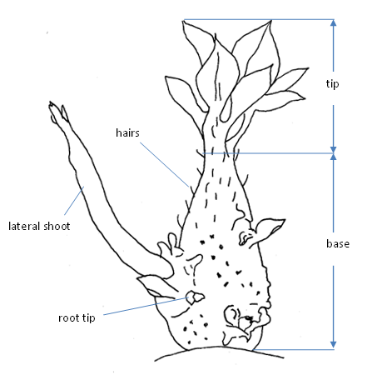
(b) | The intensity of the anthocyanin coloration should be observed. The extent and the distribution should not be considered.

(c) | Observations should be made on fully developed leaves from the center of the plant. One leaf from each of 10 plants should be picked from a main stem midway between the top and the bottom of the plant.
(d) | 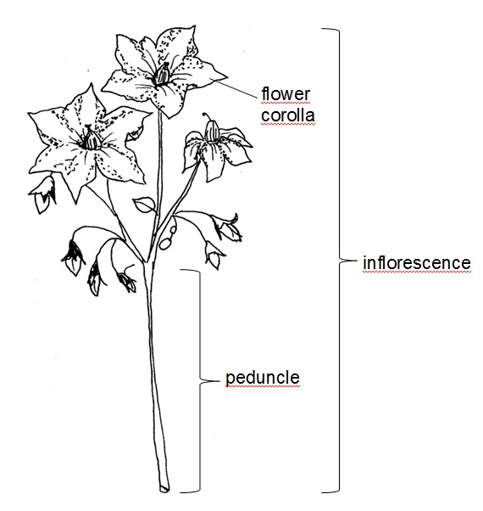  Observations of flower color should be made on the inner side of freshly opened flowers, the best moment is early in the morning.
(e) | Observations should be made within two weeks after harvest. Tubers should be shielded from sunlight as this may have an effect on the color.

8.2 | Explanations for individual characteristics
Ad. 2: Lightsprout: shape of base

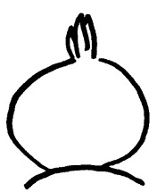 | 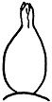 | 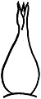 | 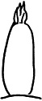 | 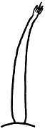
1 | 2 | 3 | 4 | 5
spherical | ovoid | conical | broad cylindrical | narrow cylindrical

Ad. 4: Lightsprout: proportion of blue in anthocyanin coloration of base

The color of anthocyanin results from a red and a blue component. If the proportion of blue is low the anthocyanin appears red-violet. If the proportion of blue is high the anthocyanin appears blue-violet.

Ad. 5: Lightsprout: pubescence of base

It is recommended to use a magnifier.

Pubescence is not always evenly distributed over the lightsprout. The total amount of pubescence of the base should be averaged over the total area of the lightsprout base.

Ad. 6: Lightsprout: size of tip in relation to base

The size of the tip should be examined in relation to the size of the base. The following table provides the note that would correspond to the ratio of the size of tip to size of base.

note | ratio size of tip : size of base
1 | 10:90
2 | 20:80
3 | 30:70
4 | 40:60
5 | 50:50
6 | 60:40
7 | 70:30
8 | 80:20
9 | 90:10

Ad. 7: Lightsprout: habit of tip

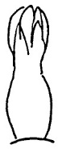 | 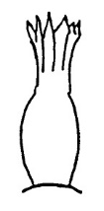 | 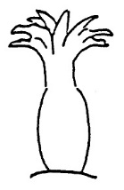
1 | 3 | 5
closed | intermediate | open

Ad. 9: Lightsprout: pubescence of tip

It is recommended to use a magnifier.

Pubescence is not always evenly distributed over the lightsprout. The total amount of pubescence of the tip should be averaged over the total area of the lightsprout tip.

Ad. 11: Lightsprout: length of lateral shoots

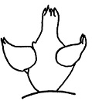 | 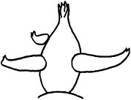 | 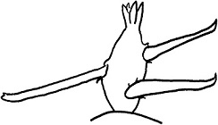
3 | 5 | 7
short | medium | long

Ad. 12: Plant: foliage structure

Stem type: foliage open, stems clearly visible
Intermediate type: foliage half open, stems partly visible
Leaf type: foliage closed, stems not or hardly visible

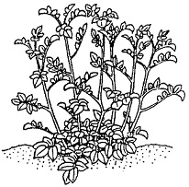 | 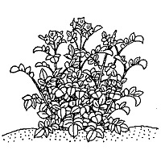 | 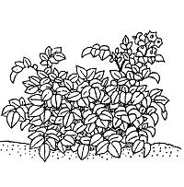
1 | 2 | 3
stem type | intermediate type | leaf type

Ad. 13: Plant: growth habit

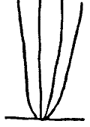 | 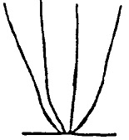 | 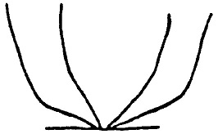
1 | 3 | 5
upright | semi-upright | spreading

Ad. 14: Stem: intensity of anthocyanin coloration

Observations should be made on the lower three quarters of the stems.

Ad. 16: Leaf: openness

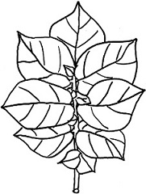 | 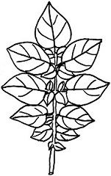 | 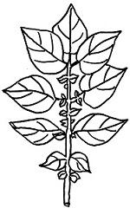
1 | 3 | 5
closed | intermediate | open

Ad. 17: Leaf: presence of secondary leaflets

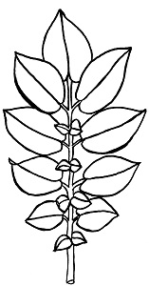 | 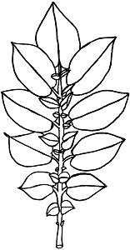 | 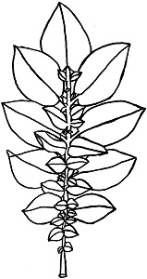
3 | 5 | 7
weak | medium | strong

Ad. 18: Leaf: green color

Observations should be made on fully developed leaves in the center of the plant, preferably not in direct sunlight.

Ad. 19: Leaf: intensity of anthocyanin coloration of midrib

Observations should be made on the upper sider of the leaf.

Ad. 20: Second pair of lateral leaflets: width in relation to length

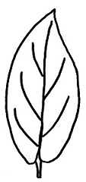 | 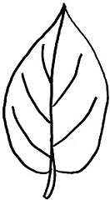 | 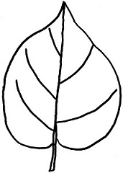
3 | 5 | 7
narrow | medium | broad

Ad. 21: Terminal and lateral leaflets: frequency of coalescence

Observations should be made on fully developed leaves on the whole plant.

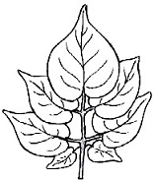 | 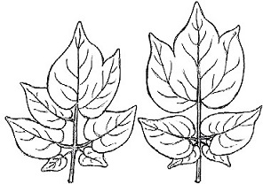
not coalescent | coalescent

Ad. 22: Flower bud: intensity of anthocyanin coloration

The observations should be made on fully developed buds before the corolla is visible.

Ad. 23: Plant: frequency of inflorescences

During the flowering period the plots are observed several times and the frequency is scored. The highest score reached is noted as the final state of expression.

Ad. 24: Inflorescence: size

The general impression of the whole plot is observed.

Ad. 28: Corolla: proportion of blue in anthocyanin coloration on inner side

The color of anthocyanin results from a red and a blue component. If the proportion of blue is low the anthocyanin appears red-violet. If the proportion of blue is high the anthocyanin appears blue-violet.

Ad. 31: Plant: time of maturity

Time of maturity is reached when 80% of the leaves are dead.

Ad. 32: Tuber: shape

The predominant shape should be observed.
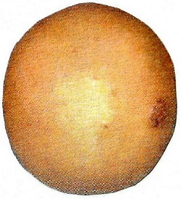 | 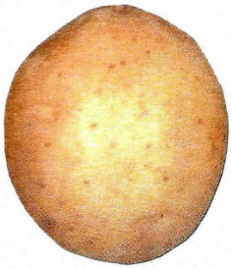 | 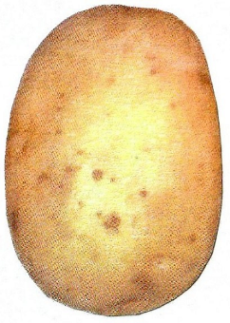 | 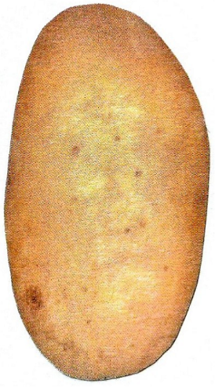 | 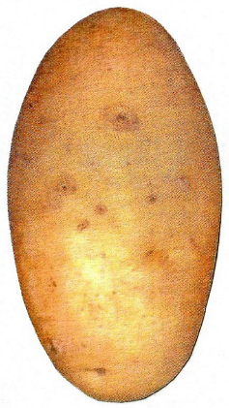 | 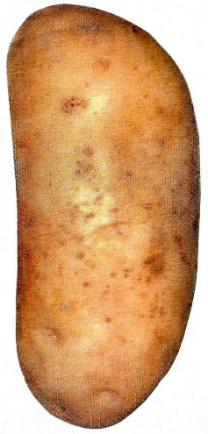
1 | 2 | 3 | 4 | 5 | 6
round | short-oval | oval | long-oval | long | very long

Ad. 36: Tuber: color of base of eye

Not applicable for varieties with particolored skin (note 7 and 9 in characteristic 34: Tuber: color of skin).

Ad. 37: Tuber: color of flesh

Observations should be made on freshly cut tubers. Already a few minutes after cutting the tuber, the flesh may be discolored.

8.3 | Phenological growth stages and BBCH-identification keys of potato (Meier et al., 1997)  Codes Description  2digit 3digit  Principal growth stage 0: Sprouting/Germination  …  Principal growth stage 1: Leaf development  …  Principal growth stage 2: Formation of basal side shoots below and above soil surface  (main stem)  …  Principal growth stage 3: Main stem elongation (crop cover)  …  Principal growth stage 4: Tuber formation  …  Principal growth stage 5: Inflorescence (cyme) emergence  51 501 First individual buds (1–2 mm) of first inflorescence visible (main stem)  55 505 Buds of first inflorescence extended to 5 mm  59 509 First flower petals of first inflorescence visible  …  Principal growth stage 6: Flowering  60 600 First open flowers in population  61 601 Beginning of flowering about 10% of flowers in the first inflorescence open (main stem)  …  65 605 Full flowering: 50% of flowers in the first inflorescence open  …  68 608 80% of flowers in the first inflorescence open  69 609 End of flowering in the first inflorescence  …  Principal growth stage 7: Development of fruit  …  Principal growth stage 8: Ripening of fruit and seed  …  Principal growth stage 9: Senescence  91 901 Beginning of leaf yellowing  93 903 Most of the leaves yellowish  95 905 50% of the leaves brownish  97 907 Leaves and stem dead, stems bleached and dry  99 909 Harvested product

9. | Literature

Meier, U. (ed.), 1997: Growth stages of mono- and dicotyledonous plants / Entwicklungsstadien mono- und dikotyler Pflanzen / Estadios de las plantas mono- y dicotiledóneas / Stades phénologiques des mono- et dicotylédones cultivées: BBCH-Monograph. Blackwell Wissenschaftsverlag, Berlin, Wien.

10. | Technical Questionnaire

TECHNICAL QUESTIONNAIRE | Page {x} of {y} | Reference Number:

Application date:
(not to be filled in by the applicant)
TECHNICAL QUESTIONNAIRE
to be completed in connection with an application for plant breeders' rights

1. | Subject of the Technical Questionnaire
 | 1.1 | Botanical name | Solanum tuberosum L.
 | 1.2 | Common name | Potato

2. | Applicant
 | Name
 | Address
 | Telephone No.
 | Fax No.
 | E-mail address
 | Breeder (if different from
 | applicant)

3. | Proposed denomination and breeder's reference
 | Proposed denomination
 | (if available)
 | Breeder's reference

TECHNICAL QUESTIONNAIRE |  |  | Page {x} of {y} | Reference Number:
#4. | Information on the breeding scheme and propagation of the variety
 | 4.1 | Breeding scheme
 | Variety resulting from:
4.1.1 | Crossing
(a) | controlled cross | [ ]
(please state parent variety)

(…………………..……………..…) x (……………..…………………..…)

female parent male parent

(b) | partially known cross | [ ]
(please state known parent variety(ies))

(…………………..……………..…) x (……………..…………………..…)

female parent male parent

(c) | unknown cross | [ ]
4.1.2 | Mutation  (please state parent variety) | [ ]
4.1.3 | Discovery and development  (please state where and when discovered and how developed) | [ ]
4.1.4 | Other  (Please provide details) | [ ]

TECHNICAL QUESTIONNAIRE | Page {x} of {y} | Reference Number:

 | 4.2 | Method of propagating the variety
4.2.1 | Vegetative propagation
(a) | Tuber | [ ]
(b) | Other (state method) | [ ]
4.2.2 | Other  (Please provide details) | [ ]

TECHNICAL QUESTIONNAIRE | Page {x} of {y} | Reference Number:

5. | Characteristics of the variety to be indicated (the number in brackets refers to the corresponding characteristic in Test Guidelines; please mark the note which best corresponds).

 | Characteristics | Example Varieties | Note
5.1  (4) | Lightsprout: proportion of blue in anthocyanin coloration of base
 | absent or low | Arielle, Solist, Victoria | 1 [ ]
 | medium | Abbot | 2 [ ]
 | high | Agria, Red Emmalie | 3 [ ]
5.2  (23) | Plant: frequency of inflorescences
 | absent or very low | King Edward | 1 [ ]
 | very low to low |  | 2 [ ]
 | low | Arielle | 3 [ ]
 | low to medium |  | 4 [ ]
 | medium | Laura | 5 [ ]
 | medium to high |  | 6 [ ]
 | high | Agria, Innovator | 7 [ ]
 | high to very high |  | 8 [ ]
 | very high | Euroresa | 9 [ ]
5.3  (27) | Corolla: intensity of anthocyanin coloration on inner side
 | absent or very weak | Solist | 1 [ ]
 | very weak to weak |  | 2 [ ]
 | weak | Laura, Pirol, Secura | 3 [ ]
 | weak to medium |  | 4 [ ]
 | medium | Osprey, Quadriga | 5 [ ]
 | medium to strong |  | 6 [ ]
 | strong | Courage | 7 [ ]
 | strong to very strong |  | 8 [ ]
 | very strong | Ramona | 9 [ ]
5.4  (28) | Corolla: proportion of blue in anthocyanin coloration on inner side
 | absent or low | Laura, Osprey | 1 [ ]
 | medium | Courage, Secura | 2 [ ]
 | high | Pirol, Quadriga | 3 [ ]

 | Characteristics | Example Varieties | Note
5.5  (31) | Plant: time of maturity
 | very early | Leyla, Solist | 1 [ ]
 | very early to early |  | 2 [ ]
 | early | Princess | 3 [ ]
 | early to medium |  | 4 [ ]
 | medium | Laura | 5 [ ]
 | medium to late |  | 6 [ ]
 | late | Euroresa | 7 [ ]
 | late to very late |  | 8 [ ]
 | very late | Kuras, Producent | 9 [ ]
5.6  (32) | Tuber: shape
 | round | Kuras | 1 [ ]
 | short-oval | Courage | 2 [ ]
 | oval | Diamant, Ramona | 3 [ ]
 | long-oval | Innovator | 4 [ ]
 | long | Spunta | 5 [ ]
 | very long | Pompadour | 6 [ ]
5.7  (34) | Tuber: color of skin
 | light yellow brown | Nadine | 1 [ ]
 | yellow | Agria, Solist | 2 [ ]
 | orange brown | Karo, Velur | 3 [ ]
 | light red | Bildtstar | 4 [ ]
 | medium red | Laura | 5 [ ]
 | dark red | Romanze | 6 [ ]
 | red parti-colored | Cara | 7 [ ]
 | blue violet | Blaue St. Galler, Vitelotte Noir | 8 [ ]
 | blue violet parti-colored | Catriona, Kestrel | 9 [ ]
5.8  (36) | Tuber: color of base of eye
 | white | Nadine | 1 [ ]
 | yellow | Agria, Solist | 2 [ ]
 | red | Quarta, Romanze | 3 [ ]
 | blue | Double Fun, Vitelotte Noir | 4 [ ]

 | Characteristics | Example Varieties | Note
5.9  (37) | Tuber: color of flesh
 | white | Kuras, Russet Burbank | 1 [ ]
 | yellowish white | Desiree, Estima | 2 [ ]
 | light yellow | Diamant, Solist | 3 [ ]
 | medium yellow | Bildtstar, Quarta | 4 [ ]
 | dark yellow | Laura, Princess | 5 [ ]
 | red | Red Emmalie | 6 [ ]
 | red parti-colored | Early Rose | 7 [ ]
 | blue violet | Purple Majesty | 8 [ ]
 | blue violet parti-colored | Double Fun | 9 [ ]

TECHNICAL QUESTIONNAIRE | Page {x} of {y} | Reference Number:

6. | Similar varieties and differences from these varieties
Please use the following table and box for comments to provide information on how your candidate variety differs from the variety (or varieties) which, to the best of your knowledge, is (or are) most similar. This information may help the examination authority to conduct its examination of distinctness in a more efficient way.

Denomination(s) of variety(ies) similar to your candidate variety | Characteristic(s) in which your candidate variety differs from the similar variety(ies) | Describe the expression of the characteristic(s) for the similar variety(ies) | Describe the expression of the characteristic(s) for your candidate variety

Example | Tuber: shape | short-oval | long-oval

 | Comments:

TECHNICAL QUESTIONNAIRE | Page {x} of {y} | Reference Number:

#7. | Additional information which may help in the examination of the variety
7.1 | In addition to the information provided in sections 5 and 6, are there any additional characteristics which may help to distinguish the variety?
 | Yes | [ ] | No | [ ]
 | (If yes, please provide details)
7.2 | Are there any special conditions for growing the variety or conducting the examination?
 | Yes | [ ] | No | [ ]
 | (If yes, please provide details)
7.3 | Other information

TECHNICAL QUESTIONNAIRE | Page {x} of {y} | Reference Number:

8. | Authorization for release
 | (a) | Does the variety require prior authorization for release under legislation concerning the protection of the environment, human and animal health?
 |  | Yes | [ ] | No | [ ]
 | (b) | Has such authorization been obtained?
 |  | Yes | [ ] | No | [ ]
 | If the answer to (b) is yes, please attach a copy of the authorization.

9. Information on plant material to be examined or submitted for examination

9.1 The expression of a characteristic or several characteristics of a variety may be affected by factors, such as pests and disease, chemical treatment (e.g. growth retardants or pesticides), effects of tissue culture, different rootstocks, scions taken from different growth phases of a tree, etc.
9.2 The plant material should not have undergone any treatment which would affect the expression of the characteristics of the variety, unless the competent authorities allow or request such treatment. If the plant material has undergone such treatment, full details of the treatment must be given. In this respect, please indicate below, to the best of your knowledge, if the plant material to be examined has been subjected to:

 | (a) | Microorganisms (e.g. virus, bacteria, phytoplasma) | Yes [ ] | No [ ]
 | (b) | Chemical treatment (e.g. growth retardant, pesticide) | Yes [ ] | No [ ]
 | (c) | Tissue culture | Yes [ ] | No [ ]
 | (d) | Other factors | Yes [ ] | No [ ]
 | Please provide details for where you have indicated “yes”.

10. | I hereby declare that, to the best of my knowledge, the information provided in this form is correct:
 | Applicant’s name
 | Signature |  | Date

[End of document]

