 |  | E
 | 
  TG/238/2(proj.3)
  ORIGINAL: English
  DATE: 2020-05-07
INTERNATIONAL UNION FOR THE PROTECTION OF NEW VARIETIES OF PLANTS
 | Geneva
  DRAFT
  TEA
  UPOV Code(s): CMLIA_SIN
  Camellia sinensis (L.) Kuntze
  *
GUIDELINES
FOR THE CONDUCT OF TESTS
FOR DISTINCTNESS, UNIFORMITY AND STABILITY

prepared by experts from Kenya
to be considered by the
Technical Working Party for Agricultural Crops

at its forty-ninth session, to be held in Saskatoon, Canada,
from 2020-06-22 to 2020-06-26

Disclaimer: this document does not represent UPOV policies or guidance
Alternative names:*

Botanical name | English | French | German | Spanish
  Camellia sinensis (L.) Kuntze,
  Thea sinensis L.
  Tea
  Théier
  Tee, Teestrauch
  Te, Té

The purpose of these guidelines (“Test Guidelines”) is to elaborate the principles contained in the General Introduction (document TG/1/3), and its associated TGP documents, into detailed practical guidance for the harmonized examination of distinctness, uniformity and stability (DUS) and, in particular, to identify appropriate characteristics for the examination of DUS and production of harmonized variety descriptions.
ASSOCIATED DOCUMENTS
These Test Guidelines should be read in conjunction with the General Introduction and its associated TGP documents.

TABLE OF CONTENTS | PAGE
1. | SUBJECT OF THESE TEST GUIDELINES.......................................................................................................... | 3
2. | MATERIAL REQUIRED......................................................................................................................................... | 3
3. | METHOD OF EXAMINATION................................................................................................................................ | 3
3.1 | Number of Growing Cycles........................................................................................................................ | 3
3.2 | Testing Place............................................................................................................................................. | 3
3.3 | Conditions for Conducting the Examination............................................................................................... | 3
3.4 | Test Design................................................................................................................................................ | 4
3.5 | Additional Tests......................................................................................................................................... | 4

4. | ASSESSMENT OF DISTINCTNESS, UNIFORMITY AND STABILITY................................................................. | 4
4.1 | Distinctness............................................................................................................................................... | 4
4.2 | Uniformity.................................................................................................................................................. | 5
4.3 | Stability...................................................................................................................................................... | 5

5. | GROUPING OF VARIETIES AND ORGANIZATION OF THE GROWING TRIAL................................................ | 7
6. | INTRODUCTION TO THE TABLE OF CHARACTERISTICS................................................................................ | 7
6.1 | Categories of Characteristics..................................................................................................................... | 7
6.2 | States of Expression and Corresponding Notes........................................................................................ | 7
6.3 | Types of Expression.................................................................................................................................. | 8
6.4 | Example Varieties...................................................................................................................................... | 8
6.5 | Legend....................................................................................................................................................... | 9

7. | TABLE OF CHARACTERISTICS/TABLEAU DES CARACTÈRES/MERKMALSTABELLE/TABLA DE CARACTERES...................................................................................................................................................... | 10
8. | EXPLANATIONS ON THE TABLE OF CHARACTERISTICS............................................................................... | 18
8.1 | Explanations covering several characteristics........................................................................................... | 18
 | Explanations for individual characteristics................................................................................................. | 19
  8.2

9. | LITERATURE......................................................................................................................................................... | 25
10. | TECHNICAL QUESTIONNAIRE............................................................................................................................ | 26

1. | Subject of these Test Guidelines
  These Test Guidelines apply to all varieties of Camellia sinensis (L.) Kuntze.

2. | Material Required
2.1
  The competent authorities decide on the quantity and quality of the plant material required for testing the variety and when and where it is to be delivered. Applicants submitting material from a State other than that in which the testing takes place must ensure that all customs formalities and phytosanitary requirements are complied with.
2.2
  The material is to be supplied in the form of one-year-old rooted cuttings.
2.3
  The minimum quantity of plant material, to be supplied by the applicant, should be:
  20 rooted cuttings
2.4
  The plant material supplied should be visibly healthy, not lacking in vigor, nor affected by any important pest or disease.
2.5
  The plant material should not have undergone any treatment which would affect the expression of the characteristics of the variety, unless the competent authorities allow or request such treatment. If it has been treated, full details of the treatment must be given.

3. | Method of Examination
3.1 | Number of Growing Cycles
 | The minimum duration of tests should normally be a single growing cycle.
  3.1.1
 | The testing of a variety may be conducted when the competent authority can determine with certainty the outcome of the test.
  3.1.2
3.2 | Testing Place
 | Tests are normally conducted at one place. In the case of tests conducted at more than one place, guidance is provided in TGP/9 “Examining Distinctness”.
3.3 | Conditions for Conducting the Examination
 | The tests should be carried out under conditions ensuring satisfactory growth for the expression of the relevant characteristics of the variety and for the conduct of the examination.
  3.3.1
3.3.2 | The optimum stage of development for the assessment of each characteristic is indicated by a number in the Table of Characteristics. The stages of development denoted by each number are described in Chapter 8.

3.4 | Test Design
3.4.1
  Each test should be designed to result in a total of at least 10 trees.
  3.4.2
  The design of the tests should be such that plants or parts of plants may be removed for measurement or counting without prejudice to the observations which must be made up to the end of the growing cycle.
3.5 | Additional Tests
 | Additional tests, for examining relevant characteristics, may be established.

4. | Assessment of Distinctness, Uniformity and Stability
4.1 | Distinctness
4.1.1 | General Recommendations
 | It is of particular importance for users of these Test Guidelines to consult the General Introduction prior to making decisions regarding distinctness. However, the following points are provided for elaboration or emphasis in these Test Guidelines.
To assess distinctness of hybrids, the parent lines and the formula may be used according to the following recommendations:
(i) description of parent lines according to the Test Guidelines;
(ii) check of the originality of the parent lines in comparison with the variety collection, based on the characteristics in Chapter 7, in order to identify similar parent lines;
(iii) check of the originality of the hybrid formula in relation to the hybrids in the variety collection, taking into account the most similar lines; and
(iv) assessment of the distinctness at the hybrid level for varieties with a similar formula.
Further guidance is provided in documents TGP/9 "Examining Distinctness" and TGP/8 "Trial Design and Techniques Used in the Examination of Distinctness, Uniformity and Stability".

4.1.2 | Consistent Differences
 | The differences observed between varieties may be so clear that more than one growing cycle is not necessary. In addition, in some circumstances, the influence of the environment is not such that more than a single growing cycle is required to provide assurance that the differences observed between varieties are sufficiently consistent. One means of ensuring that a difference in a characteristic, observed in a growing trial, is sufficiently consistent is to examine the characteristic in at least two independent growing cycles.
4.1.3 | Clear Differences
 | Determining whether a difference between two varieties is clear depends on many factors, and should consider, in particular, the type of expression of the characteristic being examined, i.e. whether it is expressed in a qualitative, quantitative, or pseudo-qualitative manner. Therefore, it is important that users of these Test Guidelines are familiar with the recommendations contained in the General Introduction prior to making decisions regarding distinctness.
4.1.4
  Number of Plants or Parts of Plants to be Examined

  Unless otherwise indicated, for the purposes of distinctness, all observations on single plants should be made on 9 plants or parts of plants taken from each of 9 plants and any other observations made on all plants in the test, disregarding any off-type plants.
  In the case of observations of parts taken from single plants, the number of parts to be taken from each of the plants should be 9.
4.1.5 | Method of Observation
 | The recommended method of observing the characteristic for the purposes of distinctness is indicated by the following key in the Table of Characteristics (see document TGP/9 “Examining Distinctness”, Section 4 “Observation of characteristics”):
MG: single measurement of a group of plants or parts of plants
MS: measurement of a number of individual plants or parts of plants
VG: visual assessment by a single observation of a group of plants or parts of plants
VS: visual assessment by observation of individual plants or parts of plants

 | Type of observation: visual (V) or measurement (M)
 | “Visual” observation (V) is an observation made on the basis of the expert’s judgment. For the purposes of this document, “visual” observation refers to the sensory observations of the experts and, therefore, also includes smell, taste and touch. Visual observation includes observations where the expert uses reference points (e.g. diagrams, example varieties, side-by-side comparison) or non-linear charts (e.g. color charts). Measurement (M) is an objective observation against a calibrated, linear scale e.g. using a ruler, weighing scales, colorimeter, dates, counts, etc.
  Type of record: for a group of plants (G) or for single, individual plants (S)
  For the purposes of distinctness, observations may be recorded as a single record for a group of plants or parts of plants (G), or may be recorded as records for a number of single, individual plants or parts of plants (S). In most cases, “G” provides a single record per variety and it is not possible or necessary to apply statistical methods in a plant-by-plant analysis for the assessment of distinctness.
 | In cases where more than one method of observing the characteristic is indicated in the Table of Characteristics (e.g. VG/MG), guidance on selecting an appropriate method is provided in document TGP/9, Section 4.2.
4.2 | Uniformity
4.2.1 | It is of particular importance for users of these Test Guidelines to consult the General Introduction prior to making decisions regarding uniformity. However, the following points are provided for elaboration or emphasis in these Test Guidelines:
  4.2.2
  These Test Guidelines have been developed for the examination of vegetatively propagated varieties. For varieties with other types of propagation, the recommendations in the General Introduction and document TGP/13 "Guidance for new types and species" Section 4.5 "Testing Uniformity" should be followed.
4.2.3
  For the assessment of uniformity of vegetatively propagated varieties, a population standard of 1% and an acceptance probability of at least 95% should be applied. In the case of a sample size of 10 plants, 1 off-type is allowed.
4.3 | Stability
4.3.1 | In practice, it is not usual to perform tests of stability that produce results as certain as those of the testing of distinctness and uniformity. However, experience has demonstrated that, for many types of variety, when a variety has been shown to be uniform, it can also be considered to be stable.

4.3.2 | Where appropriate, or in cases of doubt, stability may be further examined by testing a new plant stock to ensure that it exhibits the same characteristics as those shown by the initial material supplied.

5. | Grouping of Varieties and Organization of the Growing Trial
5.1 | The selection of varieties of common knowledge to be grown in the trial with the candidate varieties and the way in which these varieties are divided into groups to facilitate the assessment of distinctness are aided by the use of grouping characteristics.
5.2 | Grouping characteristics are those in which the documented states of expression, even where produced at different locations, can be used, either individually or in combination with other such characteristics: (a) to select varieties of common knowledge that can be excluded from the growing trial used for examination of distinctness; and (b) to organize the growing trial so that similar varieties are grouped together.
5.3 | The following have been agreed as useful grouping characteristics:
  (a)
  Plant: type (characteristic 2)
  (b)
  Plant: growth habit (characteristic 3)
  (c)
  Young shoot: density pubescence of bud (characteristic 8)
  (d)
  Leaf blade: color (characteristic 14)
  (e)
  Leaf blade: shape (characteristic 16)

5.4 | Guidance for the use of grouping characteristics, in the process of examining distinctness, is provided through the General Introduction and document TGP/9 “Examining Distinctness”.

6. | Introduction to the Table of Characteristics
6.1 | Categories of Characteristics
6.1.1 | Standard Test Guidelines Characteristics
 | Standard Test Guidelines characteristics are those which are approved by UPOV for examination of DUS and from which members of the Union can select those suitable for their particular circumstances.
6.1.2 | Asterisked Characteristics
 | Asterisked characteristics (denoted by *) are those included in the Test Guidelines which are important for the international harmonization of variety descriptions and should always be examined for DUS and included in the variety description by all members of the Union, except when the state of expression of a preceding characteristic or regional environmental conditions render this inappropriate.
6.2 | States of Expression and Corresponding Notes
6.2.1 | States of expression are given for each characteristic to define the characteristic and to harmonize descriptions. Each state of expression is allocated a corresponding numerical note for ease of recording of data and for the production and exchange of the description.

6.2.2 | In the case of qualitative and pseudo-qualitative characteristics (see Chapter 6.3), all relevant states of expression are presented in the characteristic. However, in the case of quantitative characteristics with 5 or more states, an abbreviated scale may be used to minimize the size of the Table of Characteristics. For example, in the case of a quantitative characteristic with 9 states, the presentation of states of expression in the Test Guidelines may be abbreviated as follows:
State | Note
small | 3
medium | 5
large | 7

 | However, it should be noted that all of the following 9 states of expression exist to describe varieties and should be used as appropriate:
State | Note
very small | 1
very small to small | 2
small | 3
small to medium | 4
medium | 5
medium to large | 6
large | 7
large to very large | 8
very large | 9

6.2.3 | Further explanation of the presentation of states of expression and notes is provided in document TGP/7 “Development of Test Guidelines”.
6.3 | Types of Expression
 | An explanation of the types of expression of characteristics (qualitative, quantitative and pseudo-qualitative) is provided in the General Introduction.
6.4 | Example Varieties
 | Where appropriate, example varieties are provided to clarify the states of expression of each characteristic.

6.5 | Legend
 |  | English |  | français |  | deutsch | español | Example Varieties  Exemples  Beispielssorten  Variedades ejemplo | Note/  Nota
  1
  2
  3
  4
  5
  6
  7
  Name of characteristics in English
  Nom du caractère en français
  Name des Merkmals auf Deutsch
  Nombre del carácter en español
  states of expression
  types d’expression
  Ausprägungsstufen
  tipos de expresión

1 | Characteristic number
2 | (*) | Asterisked characteristic | – see Chapter 6.1.2
3 | Type of expression
 | QL | Qualitative characteristic | – see Chapter 6.3
 | QN | Quantitative characteristic | – see Chapter 6.3
 | PQ | Pseudo-qualitative characteristic | – see Chapter 6.3
4 | Method of observation (and type of plot, if applicable)
 | MG, MS, VG, VS |  | – see Chapter 4.1.5
5
  (+)
  See Explanations on the Table of Characteristics in Chapter 8.2
6
  (a)-(c)
  See Explanations on the Table of Characteristics in Chapter 8.1
7
  Not applicable

7. | Table of Characteristics/Tableau des caractères/Merkmalstabelle/Tabla de caracteres

 |  | English |  | français |  | deutsch | español | Example Varieties  Exemples  Beispielssorten  Variedades ejemplo | Note/  Nota
1. | (*) | QN | VG | (+) | (a)
  Plant: vigor
 |  | weak |  |  |  |  |  | GWEJULUL, TRFK 301/1 | 3
 |  | medium |  |  |  |  |  | TRFK 306 | 5
 |  | strong |  |  |  |  |  | TRFK 301/4, TRFK 371/8 | 7
2. | (*) | PQ | VG | (+) | (a)
  Plant: type
 |  | shrub |  |  |  |  |  | TRFK 536, TRFK 543 | 1
 |  | semi-arbor |  |  |  |  |  | AHP S15/10 | 2
 |  | arbor |  |  |  |  |  | TRFK 56/89 | 3
3. | (*) | PQ | VG | (+) | (a)
  Plant: growth habit
 |  | upright |  |  |  |  |  | TRFK 301/3 | 1
 |  | semi-upright |  |  |  |  |  | AHP S15/10 | 2
 |  | spreading |  |  |  |  |  | TRFK 371/8 | 3
4. |  | QN | VG |  | (a)
  Plant: density of branches
 |  | sparse |  |  |  |  |  | TRFFK 306 | 3
 |  | medium |  |  |  |  |  | EPKD99/10, TRFK 301/4 | 5
 |  | dense |  |  |  |  |  | AHP S15/10,  EPK TN14-3 | 7
5. | (*) | QL | VG | (+) | (a)
  Branch: Zigzag
 |  | absent |  |  |  |  |  | TRFK 31/8 | 1
 |  | present |  |  |  |  |  |  | 9
6. | (*) | QN | MS | (+)
  Young shoot:time of beginning of 'one and abud ' stage
 |  | early |  |  |  |  |  |  | 3
 |  | medium |  |  |  |  |  |  | 5
 |  | late |  |  |  |  |  |  | 7

 |  | English |  | français |  | deutsch | español | Example Varieties  Exemples  Beispielssorten  Variedades ejemplo | Note/  Nota
7. | (*) | PQ | VG |  | (a)
  Young shoot: color of second leaf
 |  | whitish |  |  |  |  |  |  | 1
 |  | light green |  |  |  |  |  | TRFK 301/3 | 2
 |  | medium green |  |  |  |  |  | EPK TN14-3 | 3
 |  | dark green |  |  |  |  |  | NDT TAI, TRFK 306/3 | 4
 |  | yellow green |  |  |  |  |  | TRFK 6/8 | 5
 |  | purple green |  |  |  |  |  | TRFK K-PURPLE | 6
 |  | purple |  |  |  |  |  | TRFK 306 | 7
 |  | brown |  |  |  |  |  |  | 8
 |  | dark brown |  |  |  |  |  |  | 9
8. | (*) | QN | VG |  | (a)
  Young shoot: density pubescence of bud
 |  | absent or very sparse |  |  |  |  |  |  | 1
 |  | very sparse to sparse |  |  |  |  |  |  | 2
 |  | sparse |  |  |  |  |  | TRFK 31/8 | 3
 |  | sparse to medium |  |  |  |  |  |  | 4
 |  | medium |  |  |  |  |  | TRFK 704/2 | 5
 |  | medium to dense |  |  |  |  |  |  | 6
 |  | dense |  |  |  |  |  | AHP S15/10 | 7
 |  | dense to very dense |  |  |  |  |  |  | 8
 |  | very dense |  |  |  |  |  |  | 9
9. |  | QN | VG |  | (a)
  Young shoot :anthocyanin coloration at base of petiole
 |  | absent or very weak |  |  |  |  |  | TRFK 31/8 | 1
 |  | weak |  |  |  |  |  | TRFK 73/1 | 3
 |  | medium |  |  |  |  |  |  | 5
 |  | strong |  |  |  |  |  | TRFK 306 | 7
 |  | very strong |  |  |  |  |  | TRFK K-PURPLE | 9

 |  | English |  | français |  | deutsch | español | Example Varieties  Exemples  Beispielssorten  Variedades ejemplo | Note/  Nota
10. | (*) | QN | MS/VG | (+) | (a)
  Young shoot: length
 |  | short |  |  |  |  |  | K-PURPLE | 3
 |  | medium |  |  |  |  |  | TRFK 704/2 | 5
 |  | long |  |  |  |  |  | BBK 35, TRFK 301/4 | 7
11. | (*) | QN | VG | (+) | (b)
  Leaf blade: attitude
 |  | upwards |  |  |  |  |  | BBK 35, TRFK 56/89 | 1
 |  | outwards |  |  |  |  |  | TRFK 6/8 | 3
 |  | downwards |  |  |  |  |  | TRFK 371/8 | 5
12. | (*) | QN | MS/VG |  | (b)
  Leaf blade: length
 |  | short |  |  |  |  |  | K-PURPLE | 3
 |  | medium |  |  |  |  |  | AHP SC31/37 | 5
 |  | long |  |  |  |  |  | BBK 35, TRFK 301/4 | 7
13. | (*) | QN | MS/VG |  | (b)
  Leaf blade: width
 |  | narrow |  |  |  |  |  | K-PURPLE | 3
 |  | medium |  |  |  |  |  | AHP SC31/37 | 5
 |  | broad |  |  |  |  |  | TRFK 371/8 | 7
14. | (*) | QL | VG |  | (b)
  Leaf blade: color
 |  | green |  |  |  |  |  | TRFK 31/8 | 1
 |  | purple |  |  |  |  |  | TRFK 306 | 2
15. | (*) | QN | VG |  | (b)
  Leaf blade: intensity of color
 |  | light |  |  |  |  |  | AHP SC12/28, TRFK 73/1 | 3
 |  | medium |  |  |  |  |  | TRFK 306, TRFK 31/8 , TRFK56/89 | 5
 |  | dark |  |  |  |  |  | NDT TAI,  TRFK K-PURPLE, TRFK301/6 | 7

 |  | English |  | français |  | deutsch | español | Example Varieties  Exemples  Beispielssorten  Variedades ejemplo | Note/  Nota
16. | (*) | QN | VG | (+) | (b)
  Leaf blade: shape
 |  | very narrow elliptic |  |  |  |  |  | EPK C12, TRFK301/6 | 1
 |  | narrow elliptic |  |  |  |  |  | TRFK 31/8, TRFK 704/2 | 2
 |  | medium elliptic |  |  |  |  |  | AHP S15/10 | 3
 |  | broad elliptic |  |  |  |  |  |  | 4
17. | (*) | PQ | VG | (+) | (b)
  Leaf blade: shape of apex
 |  | obtuse |  |  |  |  |  |  | 1
 |  | acute |  |  |  |  |  | TRFK 108/82 | 2
 |  | acuminate |  |  |  |  |  | AHP S15/10,  TRFCA SF S150, TRFK597/1 | 3
18. | (*) | PQ | VG | (+) | (b)
  Leaf blade: shape of base
 |  | acute |  |  |  |  |  | AHP SC31/37 | 1
 |  | obtuse |  |  |  |  |  | TRFK 704/2 | 2
 |  | truncate |  |  |  |  |  |  | 3
19. |  | PQ | VG
  Leaf blade : shape in cross section
 |  | folded upwards |  |  |  |  |  | TRFK 6/8 | 1
 |  | flat |  |  |  |  |  | TRFK 12/12 | 2
 |  | recurved |  |  |  |  |  |  | 3
20. |  | QN | VG | (+) | (b)
  Leaf blade: undulation of margin
 |  | absent or weak |  |  |  |  |  | EPK TN14-3, TRFK31/8 | 1
 |  | medium |  |  |  |  |  | TRFK 301/3 | 3
 |  | strong |  |  |  |  |  | TRFK 303/577 | 5

 |  | English |  | français |  | deutsch | español | Example Varieties  Exemples  Beispielssorten  Variedades ejemplo | Note/  Nota
21. |  | QN | VG | (+) | (b)
  Leaf blade: serration of margin
 |  | absent or very weak |  |  |  |  |  | TRFFK 306 | 1
 |  | weak |  |  |  |  |  | TRFK 31/8 | 3
 |  | medium |  |  |  |  |  | AHP S15/10 | 5
 |  | strong |  |  |  |  |  | TRFK 301/5, TRFK 597/1 | 7
 |  | very strong |  |  |  |  |  |  | 9
22. |  | QN | VG |  | (b)
  Leaf blade: texture of upper surface
 |  | smooth or weakly rugose |  |  |  |  |  | TRFK 6/8 | 1
 |  | moderately rugose |  |  |  |  |  | EPK TN14-3 | 2
 |  | strongly rugose |  |  |  |  |  | AHP SC31/37 | 3
23. |  | QN | MG | (+) | (c)
  Flower: time of full flowering
 |  | early |  |  |  |  |  |  | 3
 |  | medium |  |  |  |  |  |  | 5
 |  | late |  |  |  |  |  |  | 7
24. |  | QN | MS/VG |  | (c)
  Flower: length of pedicel
 |  | short |  |  |  |  |  | EPK TN14-3 | 3
 |  | medium |  |  |  |  |  | TRFK 6/8, AHP S15/10 | 5
 |  | long |  |  |  |  |  | TRFK 301/5 | 7
25. | (*) | QN | VG |  | (c)
  Flower: anthocyanin coloration on outer side of sepal
 |  | absent or weak |  |  |  |  |  | TRFK 6/8 | 1
 |  | medium |  |  |  |  |  |  | 2
 |  | strong |  |  |  |  |  | TRFK 306 | 3

 |  | English |  | français |  | deutsch | español | Example Varieties  Exemples  Beispielssorten  Variedades ejemplo | Note/  Nota
26. |  | QN | MS |  | (c)
  Flower: diameter
 |  | small |  |  |  |  |  | TRFK 303/577 | 3
 |  | medium |  |  |  |  |  | TRFK 6/8, AHP S15/10 | 5
 |  | large |  |  |  |  |  | TRFK 301/5, TRFK 306 | 7
27. |  | QN | VG |  | (c)
  Flower: density of pubescence of ovary
 |  | sparse |  |  |  |  |  | TRFK 31/8 | 3
 |  | medium |  |  |  |  |  | AHP S15/10 | 5
 |  | dense |  |  |  |  |  | TRFK 6/8 | 7
28. | (*) | QL | VG | (+) | (c)
  Flower: color of inner petals
 |  | greenish |  |  |  |  |  | AHP S15/10 | 1
 |  | white |  |  |  |  |  | TRFK 306 | 2
29. | (*) | QN | VG |  | (c)
  Flower: length of style
 |  | short |  |  |  |  |  | TRFCA SFS150 | 1
 |  | medium |  |  |  |  |  | AHP S15/10 | 2
 |  | long |  |  |  |  |  | TRFK 306 | 3
30. |  | QN | VG | (+) | (c)
  Flower: position of style splitting
 |  | low |  |  |  |  |  | EPK TN14-3 | 1
 |  | medium |  |  |  |  |  | TRFK 306 | 3
 |  | high |  |  |  |  |  | TRFK 6/8 | 5
31. | (*) | QN | VG | (+) | (c)
  Flower: position of stigma relative to stamens
 |  | far below |  |  |  |  |  | TRFK 430/90 | 1
 |  | moderately below |  |  |  |  |  | EPK TN14-3 | 2
 |  | same level |  |  |  |  |  | AHP S15/10 | 3
 |  | moderately above |  |  |  |  |  | EPKD99/10 | 4
 |  | far above |  |  |  |  |  | EPK C12 | 5

8. | Explanations on the Table of Characteristics
8.1 | Explanations covering several characteristics
 | Characteristics containing the following key in the Table of Characteristics should be examined as indicated below:
  (a)
  Observations on the young shoot should be made at least 15 months after transplanting.
  (b)
  Observations on the leaf blade should be made on the third fully developed leaf from previous plucking.
  (c)
  Observations on the flower should be made on fully developed flowers at the blooming stage.

 | Explanations for individual characteristics
  8.2
Ad. 1: Plant: vigor

The vigor of the plant should be considered as the overall abundance of vegetative growth.

Ad. 2: Plant: type
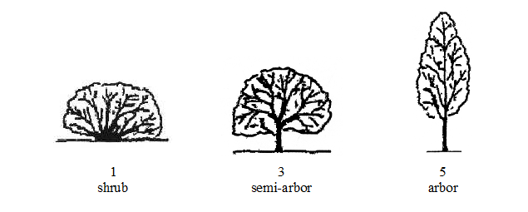

Ad. 3: Plant: growth habit

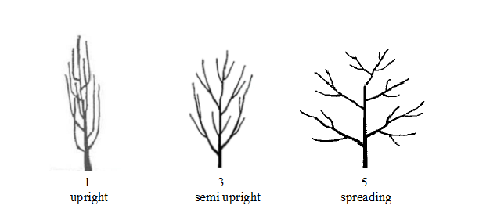

Ad. 5: Branch: Zigzag
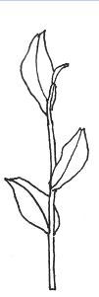 | 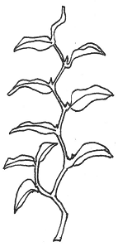
1 | 9
absent | present

Ad. 6: Young shoot:time of beginning of 'one and abud ' stage

The time of beginning of "one and a bud " stage is reached when 30 percent of plants have buds at the "one leaf and a bud " stage.

Ad. 10: Young shoot: length

Observations should be made at" three and a bud stage".

Ad. 11: Leaf blade: attitude
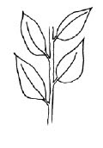 | 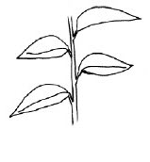 | 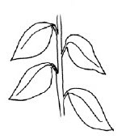
1 | 3 | 5
upwards | outwards | downwards

Ad. 16: Leaf blade: shape

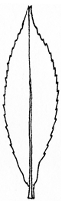 | 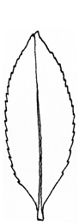 | 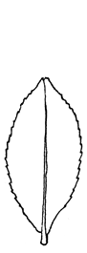 | 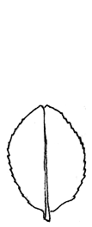
1 | 2 | 3 | 4
very narrow elliptic | narrow elliptic | medium elliptic | broad elliptic

Ad. 17: Leaf blade: shape of apex
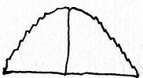 | 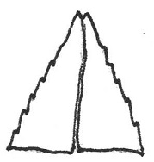 | 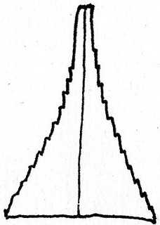
1 | 2 | 3
obtuse | acute | acuminate

Ad. 18: Leaf blade: shape of base

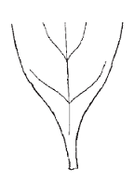 | 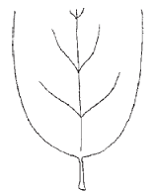 | 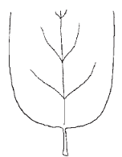
1 | 2 | 3
acute | obtuse | truncate

Ad. 20: Leaf blade: undulation of margin
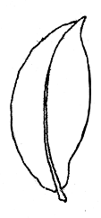 | 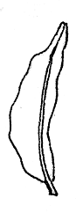 | 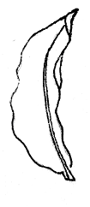
1 | 3 | 5
absent or weak | medium | strong

Ad. 21: Leaf blade: serration of margin

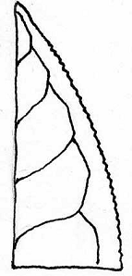 | 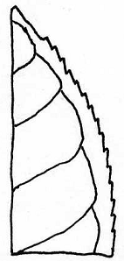 | 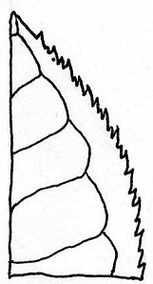
3 | 5 | 7
weak | medium | strong

Ad. 23: Flower: time of full flowering

Time of full flowering is reached when 65% of the plants have 50 % of flowers open.

Ad. 28: Flower: color of inner petals
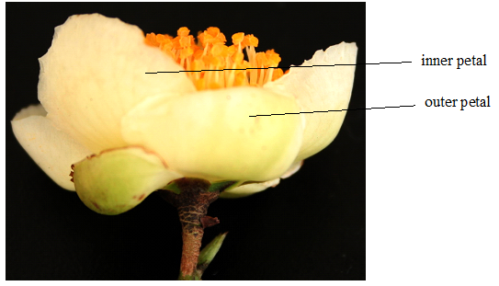

Ad. 30: Flower: position of style splitting

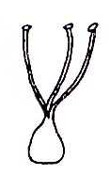 | 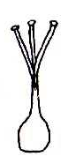 | 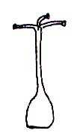
3 | 5 | 7
low | medium | high

Ad. 31: Flower: position of stigma relative to stamens

 |  | 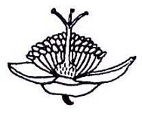
1 | 3 | 5
far below | same level | far above

9.
Literature

Chen, L., Yang, Y.J., Yu, F.L., 2005: Descriptors and data standard for tea (Camellia spp.). China Agricultural Press, Beijing, CN

Chen, L., Yu, F.L., Tong, Q.Q., 2000: Discussions on phylogenetic classification and evolution of section Thea.Journal of Tea Science, 20(2): 89-94

IPGRI, 1997; Descriptor for tea ( Camellia Sinensis ). International Plant Genetic Resources Institute,Rome,IT

Wachira ,F.N.,Kamunya ,S.M.,Chalo,R.,Maritim, T.,Kinyangi,T.,2012:TRFK Clonal Catalogue, (1st Edition) Tea Research Foundation of Kenya (TRFK)

10.
Technical Questionnaire

TECHNICAL QUESTIONNAIRE | Page {x} of {y} | Reference Number:

Application date:
(not to be filled in by the applicant)
TECHNICAL QUESTIONNAIRE
to be completed in connection with an application for plant breeders' rights

1. | Subject of the Technical Questionnaire
 |  | Botanical name
  1.1
  Camellia sinensis (L.) Kuntze
 |  | Common name
  1.2
  Tea

2. | Applicant
 | Name
 | Address
 | Telephone No.
 | Fax No.
 | E-mail address
 | Breeder (if different from
 | applicant)

3. | Proposed denomination and breeder's reference
 | Proposed denomination
 | (if available)
 | Breeder's reference

TECHNICAL QUESTIONNAIRE |  |  | Page {x} of {y} | Reference Number:
 | Information on the breeding scheme and propagation of the variety
  #4.
 | 4.1 | Breeding scheme
 | Variety resulting from:
  4.1.1
  Crossing
 |  | [ ]
  (a)
  controlled cross
(please state parent variety)

(…………………..……………..…) x (……………..…………………..…)

female parent male parent

 |  | [ ]
  (b)
  partially known cross
(please state known parent variety(ies))

(…………………..……………..…) x (……………..…………………..…)

female parent male parent

 |  | [ ]
  (c)
  unknown cross
 |  | [ ]
  4.1.2
  Mutation
  (please state parent variety)
 |  | [ ]
  4.1.3
  Discovery and development
  (please state where and when discovered and how developed)
 | Other  (Please provide details) | [ ]
  4.1.4

TECHNICAL QUESTIONNAIRE  Page {x} of {y} | Reference Number:

 | 4.2 | Method of propagating the variety
  4.2.1
  Vegetative propagation
 |  | [ ]
  (a)
  Cuttings
 |  | [ ]
  (b)
  In vitro propagation
 |  | [ ]
  (c)
  Other (state method)
 | Other  (Please provide details) | [ ]
  4.2.2

TECHNICAL QUESTIONNAIRE | Page {x} of {y} | Reference Number:

5. | Characteristics of the variety to be indicated (the number in brackets refers to the corresponding characteristic in Test Guidelines; please mark the note which best corresponds).

 | Characteristics | Example Varieties | Note
  5.1
  (2)
  Plant: type
  shrub
  TRFK 536, TRFK 543
  1 [ ]
  semi-arbor
  AHP S15/10
  2 [ ]
  arbor
  TRFK 56/89
  3 [ ]
  5.2
  (3)
  Plant: growth habit
  upright
  TRFK 301/3
  1 [ ]
  semi-upright
  AHP S15/10
  2 [ ]
  spreading
  TRFK 371/8
  3 [ ]
  5.3
  (8)
  Young shoot: density pubescence of bud
  absent or very sparse
  1 [ ]
  very sparse to sparse
  2 [ ]
  sparse
  TRFK 31/8
  3 [ ]
  sparse to medium
  4 [ ]
  medium
  TRFK 704/2
  5 [ ]
  medium to dense
  6 [ ]
  dense
  AHP S15/10
  7 [ ]
  dense to very dense
  8 [ ]
  very dense
  9 [ ]
  5.4
  (14)
  Leaf blade: color
  green
  TRFK 31/8
  1 [ ]
  purple
  TRFK 306
  2 [ ]
  5.5
  (16)
  Leaf blade: shape
  very narrow elliptic
  EPK C12, TRFK301/6
  1 [ ]
  narrow elliptic
  TRFK 31/8 , TRFK 704/2
  2 [ ]
  medium elliptic
  AHP S15/10
  3 [ ]
  broad elliptic
  4 [ ]

TECHNICAL QUESTIONNAIRE | Page {x} of {y} | Reference Number:

6. | Similar varieties and differences from these varieties
Please use the following table and box for comments to provide information on how your candidate variety differs from the variety (or varieties) which, to the best of your knowledge, is (or are) most similar. This information may help the examination authority to conduct its examination of distinctness in a more efficient way.

  Denomination(s) of variety(ies) similar to your candidate variety
  Characteristic(s) in which your candidate variety differs from the similar variety(ies)
  Describe the expression of the characteristic(s) for the similar variety(ies)
  Describe the expression of the characteristic(s) for your candidate variety

Example
  Plant: growth habit
  upright
  spreading

 | Comments:

TECHNICAL QUESTIONNAIRE
Page {x} of {y}
Reference Number:

#7. | Additional information which may help in the examination of the variety
7.1 | In addition to the information provided in sections 5 and 6, are there any additional characteristics which may help to distinguish the variety?
 | Yes | [ ] | No | [ ]
 | (If yes, please provide details)
7.2 | Are there any special conditions for growing the variety or conducting the examination?
 | Yes | [ ] | No | [ ]
 | (If yes, please provide details)
7.3 | Other information

TECHNICAL QUESTIONNAIRE
Page {x} of {y} | Reference Number:

8. | Authorization for release
 | (a) | Does the variety require prior authorization for release under legislation concerning the protection of the environment, human and animal health?
 |  | Yes | [ ] | No | [ ]
 | (b) | Has such authorization been obtained?
 |  | Yes | [ ] | No | [ ]
 | If the answer to (b) is yes, please attach a copy of the authorization.

9. Information on plant material to be examined or submitted for examination

9.1 The expression of a characteristic or several characteristics of a variety may be affected by factors, such as pests and disease, chemical treatment (e.g. growth retardants or pesticides), effects of tissue culture, different rootstocks, scions taken from different growth phases of a tree, etc.
9.2 The plant material should not have undergone any treatment which would affect the expression of the characteristics of the variety, unless the competent authorities allow or request such treatment. If the plant material has undergone such treatment, full details of the treatment must be given. In this respect, please indicate below, to the best of your knowledge, if the plant material to be examined has been subjected to:

 | (a) | Microorganisms (e.g. virus, bacteria, phytoplasma) | Yes [ ] | No [ ]
 | (b) | Chemical treatment (e.g. growth retardant, pesticide) | Yes [ ] | No [ ]
 | (c) | Tissue culture | Yes [ ] | No [ ]
 | (d) | Other factors | Yes [ ] | No [ ]
 | Please provide details for where you have indicated “yes”.

10. | I hereby declare that, to the best of my knowledge, the information provided in this form is correct:
 | Applicant’s name
 | Signature |  | Date

[End of document]

