 |  | E
 | 
  TG/58/7(proj.1)
  ORIGINAL: English
  DATE: 2019-07-30
INTERNATIONAL UNION FOR THE PROTECTION OF NEW VARIETIES OF PLANTS
 | Geneva
  DRAFT
  RYE
  UPOV Code(s):
  SECAL_CER
  Secale cereale L.
  *
GUIDELINES
FOR THE CONDUCT OF TESTS
FOR DISTINCTNESS, UNIFORMITY AND STABILITY

prepared by experts from Germany
to be considered by the
Technical Working Party for Agricultural Crops

at its forty-eighth session, to be held in Montevideo, Uruguay,
from 2019-09-16 to 2019-09-20

Disclaimer: this document does not represent UPOV policies or guidance
Alternative names:*

Botanical name | English | French | German | Spanish
  Secale cereale L.
  Rye
  Seigle
  Roggen
  Centeno

The purpose of these guidelines (“Test Guidelines”) is to elaborate the principles contained in the General Introduction (document TG/1/3), and its associated TGP documents, into detailed practical guidance for the harmonized examination of distinctness, uniformity and stability (DUS) and, in particular, to identify appropriate characteristics for the examination of DUS and production of harmonized variety descriptions.
ASSOCIATED DOCUMENTS
These Test Guidelines should be read in conjunction with the General Introduction and its associated TGP documents.

TABLE OF CONTENTS | PAGE
1. | SUBJECT OF THESE TEST GUIDELINES.......................................................................................................... | 3
2. | MATERIAL REQUIRED......................................................................................................................................... | 3
3. | METHOD OF EXAMINATION................................................................................................................................ | 4
3.1 | Number of Growing Cycles........................................................................................................................ | 4
3.2 | Testing Place............................................................................................................................................. | 4
3.3 | Conditions for Conducting the Examination............................................................................................... | 4
3.4 | Test Design................................................................................................................................................ | 4
3.5 | Additional Tests......................................................................................................................................... | 4

4. | ASSESSMENT OF DISTINCTNESS, UNIFORMITY AND STABILITY................................................................. | 6
4.1 | Distinctness............................................................................................................................................... | 6
4.2 | Uniformity.................................................................................................................................................. | 7
4.3 | Stability...................................................................................................................................................... | 7

5. | GROUPING OF VARIETIES AND ORGANIZATION OF THE GROWING TRIAL................................................ | 9
6. | INTRODUCTION TO THE TABLE OF CHARACTERISTICS................................................................................ | 10
6.1 | Categories of Characteristics..................................................................................................................... | 10
6.2 | States of Expression and Corresponding Notes........................................................................................ | 10
6.3 | Types of Expression.................................................................................................................................. | 10
6.4 | Example Varieties...................................................................................................................................... | 10
6.5 | Legend....................................................................................................................................................... | 11

7. | TABLE OF CHARACTERISTICS/TABLEAU DES CARACTÈRES/MERKMALSTABELLE/TABLA DE CARACTERES...................................................................................................................................................... | 12
8. | EXPLANATIONS ON THE TABLE OF CHARACTERISTICS............................................................................... | 19
8.1 | Explanations covering several characteristics........................................................................................... | 19
 | Explanations for individual characteristics................................................................................................. | 20
  8.2

9. | LITERATURE......................................................................................................................................................... | 28
10. | TECHNICAL QUESTIONNAIRE............................................................................................................................ | 29

1. | Subject of these Test Guidelines
  These Test Guidelines apply to all varieties of Secale cereale L..

2. | Material Required
2.1
  The competent authorities decide on the quantity and quality of the plant material required for testing the variety and when and where it is to be delivered. Applicants submitting material from a State other than that in which the testing takes place must ensure that all customs formalities and phytosanitary requirements are complied with.
2.2
  The material is to be supplied in the form of seed.
2.3
  The minimum quantity of plant material, to be supplied by the applicant, should be:
Open-pollinated and hybrid varieties: 5 kg
Parental components: 1.5 kg

 | The seed should meet the minimum requirements for germination, species and analytical purity, health and moisture content, specified by the competent authority. In cases where the seed is to be stored, the germination capacity should be as high as possible and should, be stated by the applicant.
2.4
  The plant material supplied should be visibly healthy, not lacking in vigor, nor affected by any important pest or disease.
2.5
  The plant material should not have undergone any treatment which would affect the expression of the characteristics of the variety, unless the competent authorities allow or request such treatment. If it has been treated, full details of the treatment must be given.

3. | Method of Examination
3.1 | Number of Growing Cycles
 | The minimum duration of tests should normally be two independent growing cycles.
3.2 | Testing Place
 | Tests are normally conducted at one place. In the case of tests conducted at more than one place, guidance is provided in TGP/9 “Examining Distinctness”.
3.3 | Conditions for Conducting the Examination
 | The tests should be carried out under conditions ensuring satisfactory growth for the expression of the relevant characteristics of the variety and for the conduct of the examination.
  3.3.1
3.3.2 | The optimum stage of development for the assessment of each characteristic is indicated by a number in the Table of Characteristics. The stages of development denoted by each number are described in Chapter 8.
 | The recommended type of plot in which to observe the characteristic is indicated by the following key in the Table of Characteristics:
  3.3.3
A:
  Single spaced plants
B:
  Drill plots

  3.3.4
  For characteristics indicated by A, in case of inbred lines and single crosses from inbred lines, uniformity should be assessed on drill plots (see chapter 4.2)

3.4 | Test Design
  3.4.1
  Open pollinated varieties, hybrid varieties and synthetic varieties: Each test should be designed to result in a total of at least 60 single spaced plants (A), which should be divided between at least 2 replicates. In addition, the test should include at least 300 plants in a drill plot (B).
 | Inbred lines and single crosses from inbred lines: Each test should be designed to result in a total of at least 20 single spaced plants (A). In addition, the test should include at least 600 plants in drill plots which should be divided between at least 2 replicates (B).
3.4.2 | The assessment of the characteristic "Seasonal type" should be carried out on at least 300 plants.
3.4.3 | The design of the tests should be such that plants or parts of plants may be removed for measurement or counting without prejudice to the observations which must be made up to the end of the growing cycle.
3.5 | Additional Tests

Additional tests, for examining relevant characteristics, may be established.

4. | Assessment of Distinctness, Uniformity and Stability
4.1 | Distinctness
4.1.1 | General Recommendations
 | It is of particular importance for users of these Test Guidelines to consult the General Introduction prior to making decisions regarding distinctness. However, the following points are provided for elaboration or emphasis in these Test Guidelines.
4.1.2 | Consistent Differences
 | The differences observed between varieties may be so clear that more than one growing cycle is not necessary. In addition, in some circumstances, the influence of the environment is not such that more than a single growing cycle is required to provide assurance that the differences observed between varieties are sufficiently consistent. One means of ensuring that a difference in a characteristic, observed in a growing trial, is sufficiently consistent is to examine the characteristic in at least two independent growing cycles.
4.1.3 | Clear Differences
 | Determining whether a difference between two varieties is clear depends on many factors, and should consider, in particular, the type of expression of the characteristic being examined, i.e. whether it is expressed in a qualitative, quantitative, or pseudo-qualitative manner. Therefore, it is important that users of these Test Guidelines are familiar with the recommendations contained in the General Introduction prior to making decisions regarding distinctness.
4.1.4
  Number of Plants or Parts of Plants to be Examined
Open pollinated varieties, hybrid varieties and synthetic varieties: Unless otherwise indicated, for the purposes of distinctness, all observations on single plants should be made on 60 plants or parts of plants taken from each of 60 plants and any other observations made on all plants in the test. In the case of observations of parts of plants, the number of parts to be taken from each of the plants should be 1.

Inbred lines and single crosses from inbred lines: Unless otherwise indicated, for the purposes of distinctness, all observations on single plants should be made on 10 plants or parts of plants taken from each of 10 plants and any other observations made on all plants in the test, disregarding any off-type plants. In the case of observations of parts of plants, the number of parts to be taken from each of the plants should be 1.

4.1.5 | Method of Observation
 | The recommended method of observing the characteristic for the purposes of distinctness is indicated by the following key in the Table of Characteristics (see document TGP/9 “Examining Distinctness”, Section 4 “Observation of characteristics”):
MG: single measurement of a group of plants or parts of plants
MS: measurement of a number of individual plants or parts of plants
VG: visual assessment by a single observation of a group of plants or parts of plants
VS: visual assessment by observation of individual plants or parts of plants

 | Type of observation: visual (V) or measurement (M)
 | “Visual” observation (V) is an observation made on the basis of the expert’s judgment. For the purposes of this document, “visual” observation refers to the sensory observations of the experts and, therefore, also includes smell, taste and touch. Visual observation includes observations where the expert uses reference points (e.g. diagrams, example varieties, side-by-side comparison) or non-linear charts (e.g. color charts). Measurement (M) is an objective observation against a calibrated, linear scale e.g. using a ruler, weighing scales, colorimeter, dates, counts, etc.
  Type of record: for a group of plants (G) or for single, individual plants (S)

  For the purposes of distinctness, observations may be recorded as a single record for a group of plants or parts of plants (G), or may be recorded as records for a number of single, individual plants or parts of plants (S). In most cases, “G” provides a single record per variety and it is not possible or necessary to apply statistical methods in a plant-by-plant analysis for the assessment of distinctness.
 | In cases where more than one method of observing the characteristic is indicated in the Table of characteristics, observation on a group of plants (MG, VG) always refers to inbred lines and hybrids from inbred line and observation on single plants (MS, VS) refers to open pollinated varieties, hybrid varieties and synthetic varieties.
4.2 | Uniformity
4.2.1 | It is of particular importance for users of these Test Guidelines to consult the General Introduction prior to making decisions regarding uniformity. However, the following points are provided for elaboration or emphasis in these Test Guidelines:
 | These Test Guidelines have been developed for the examination of [to be completed] varieties. For varieties with other types of propagation the recommandation in the General Introduction and document TGP/13 "Guidance for new types and species". Section 4.5 Testing Uniformity should be followed.
  4.2.2
4.2.3
  The assessment of uniformity for open pollinated, hybrid varieties other than single crosses from inbred lines and synthetic varieties should be according to the recommendations for cross-pollinated varieties in the General Introduction.
4.2.4 | For the assessment of uniformity for inbred lines and single crosses from inbred lines a population standard of 0.5 % and an acceptance probability of at least 95% should be applied. In the case of a sample size of 600 plants, 6 off-types are allowed.
4.3 | Stability
4.3.1 | In practice, it is not usual to perform tests of stability that produce results as certain as those of the testing of distinctness and uniformity. However, experience has demonstrated that, for many types of variety, when a variety has been shown to be uniform, it can also be considered to be stable.
4.3.2 | Where appropriate, or in cases of doubt, stability may be further examined by testing a new seed stock to ensure that it exhibits the same characteristics as those shown by the initial material supplied.

4.3.3 | Where appropriate, or in cases of doubt, the stability of a hybrid variety may, in addition to an examination of the hybrid variety itself, also be assessed by examination of the uniformity and stability of its parent lines.

5. | Grouping of Varieties and Organization of the Growing Trial
5.1 | The selection of varieties of common knowledge to be grown in the trial with the candidate varieties and the way in which these varieties are divided into groups to facilitate the assessment of distinctness are aided by the use of grouping characteristics.
5.2 | Grouping characteristics are those in which the documented states of expression, even where produced at different locations, can be used, either individually or in combination with other such characteristics: (a) to select varieties of common knowledge that can be excluded from the growing trial used for examination of distinctness; and (b) to organize the growing trial so that similar varieties are grouped together.
5.3 | The following have been agreed as useful grouping characteristics:
  (a)
  Grain: color of aleurone layer (characteristic 1)
  (b)
  Seasonal type (characteristic 21)

5.4 | Guidance for the use of grouping characteristics, in the process of examining distinctness, is provided through the General Introduction and document TGP/9 “Examining Distinctness”.

6. | Introduction to the Table of Characteristics
6.1 | Categories of Characteristics
6.1.1 | Standard Test Guidelines Characteristics
 | Standard Test Guidelines characteristics are those which are approved by UPOV for examination of DUS and from which members of the Union can select those suitable for their particular circumstances.
6.1.2 | Asterisked Characteristics
 | Asterisked characteristics (denoted by *) are those included in the Test Guidelines which are important for the international harmonization of variety descriptions and should always be examined for DUS and included in the variety description by all members of the Union, except when the state of expression of a preceding characteristic or regional environmental conditions render this inappropriate.
6.2 | States of Expression and Corresponding Notes
6.2.1 | States of expression are given for each characteristic to define the characteristic and to harmonize descriptions. Each state of expression is allocated a corresponding numerical note for ease of recording of data and for the production and exchange of the description.
6.2.2 | In the case of qualitative and pseudo-qualitative characteristics (see Chapter 6.3), all relevant states of expression are presented in the characteristic. However, in the case of quantitative characteristics with 5 or more states, an abbreviated scale may be used to minimize the size of the Table of Characteristics. For example, in the case of a quantitative characteristic with 9 states, the presentation of states of expression in the Test Guidelines may be abbreviated as follows:
State | Note
small | 3
medium | 5
large | 7

 | However, it should be noted that all of the following 9 states of expression exist to describe varieties and should be used as appropriate:
State | Note
very small | 1
very small to small | 2
small | 3
small to medium | 4
medium | 5
medium to large | 6
large | 7
large to very large | 8
very large | 9

6.2.3 | Further explanation of the presentation of states of expression and notes is provided in document TGP/7 “Development of Test Guidelines”.
6.3 | Types of Expression
 | An explanation of the types of expression of characteristics (qualitative, quantitative and pseudo-qualitative) is provided in the General Introduction.
6.4 | Example Varieties
 | Where appropriate, example varieties are provided to clarify the states of expression of each characteristic.

The varieties are indicated as follows:
(s) - spring rye
(w) - winter rye

6.5 | Legend
 |  | English |  | français |  | deutsch | español | Example Varieties  Exemples  Beispielssorten  Variedades ejemplo | Note/  Nota
  1
  2
  3
  4
  5
  6
  7
  Name of characteristics in English
  Nom du caractère en français
  Name des Merkmals auf Deutsch
  Nombre del carácter en español
  states of expression
  types d’expression
  Ausprägungsstufen
  tipos de expresión

1 | Characteristic number
2 | (*) | Asterisked characteristic | – see Chapter 6.1.2
3 | Type of expression
 | QL | Qualitative characteristic | – see Chapter 6.3
 | QN | Quantitative characteristic | – see Chapter 6.3
 | PQ | Pseudo-qualitative characteristic | – see Chapter 6.3
4 | Method of observation (and type of plot, if applicable)
 | MG, MS, VG, VS |  | – see Chapter 4.1.5
5
  (+)
  See Explanations on the Table of Characteristics in Chapter 8.2
6
  (a)
  See Explanations on the Table of Characteristics in Chapter 8.1
7
  Growth stage key See Explanations on the Table of Characteristics in Chapter 8.3

7. | Table of Characteristics/Tableau des caractères/Merkmalstabelle/Tabla de caracteres

 |  | English |  | français |  | deutsch | español | Example Varieties  Exemples  Beispielssorten  Variedades ejemplo | Note/  Nota
1. | (*) | QL | VG | (+) |  | 00
  Grain: color of aleurone layer
 |  | light |  |  |  |  |  | (w) Helltop | 1
 |  | dark |  |  |  |  |  | (s) Arantes, (w) Bonfire | 2
2. |  | QN | VG | (+) |  | 00
  Grain: coloration with phenol
  Grain: coloration au phénol
  Korn: Phenolfärbung
  Grano: coloración al fenol
 |  | absent or very light |  | nulle ou très clair |  | fehlend oder sehr hell | ausente o muy claro |  | 1
 |  | light |  | claire |  | hell | claro |  | 3
 |  | medium |  | moyenne |  | mittel | medio | (s) Tiroler, (w) Gonello | 5
 |  | dark |  | foncée |  | dunkel | oscuro | (s) Arantes, (w) Marcelo | 7
 |  | very dark |  | très foncée |  | sehr dunkel | muy oscuro | (w) SU Stakkato | 9
3. | (*) | QN | VG | (+) |  | 10-11
  Coleoptile: anthocyanin coloration
 |  | absent or very weak |  |  |  |  |  | (w) Helltop | 1
 |  | weak |  |  |  |  |  |  | 3
 |  | medium |  |  |  |  |  | (w) Tonus | 5
 |  | strong |  |  |  |  |  | (s) Ovid, (w) Turbogreen | 7
 |  | very strong |  |  |  |  |  |  | 9
4. |  | QN | MS|A |  | (a) | 12-13
  Coleoptile: length
  Coléoptile: longueur
  Keimscheide: Länge
  Coleóptilo: longitud
 |  | very short |  | très courte |  | sehr kurz | muy corto |  | 1
 |  | short |  | courte |  | kurz | corto | (w) Dukato | 3
 |  | medium |  | moyenne |  | mittel | medio | (s) Arantes, (w) Tonus | 5
 |  | long |  | longue |  | lang | largo | (w) Jobaro | 7
 |  | very long |  | très longue |  | sehr lang | muy largo |  | 9

 |  | English |  | français |  | deutsch | español | Example Varieties  Exemples  Beispielssorten  Variedades ejemplo | Note/  Nota
5. |  | QN | MS|A |  | (a) | 12-13
  First leaf: length of sheath
  Première feuille: longueur de la gaine
  Erstes Blatt: Länge der Blattscheide
  Primera hoja: longitud de la vaina
 |  | very short |  | très courte |  | sehr kurz | muy corta |  | 1
 |  | short |  | courte |  | kurz | corta |  | 3
 |  | medium |  | moyenne |  | mittel | media | (s) Arantes, (w) Marcelo | 5
 |  | long |  | longue |  | lang | larga | (w) Jobaro | 7
 |  | very long |  | très longue |  | sehr lang | muy larga |  | 9
6. |  | QN | MS|A |  | (a) | 12-13
  First leaf: length of blade
  Première feuille: longueur du limbe
  Erstes Blatt: Länge der Blattspreite
  Primera hoja: longitud del limbo
 |  | very short |  | très courte |  | sehr kurz | muy corto |  | 1
 |  | short |  | courte |  | kurz | corto | (w) Guttino | 3
 |  | medium |  | moyenne |  | mittel | medio | (w) Marcelo | 5
 |  | long |  | longue |  | lang | largo | (w) Turbogreen | 7
 |  | very long |  | très longue |  | sehr lang | muy largo |  | 9
7. | (*) | QN | VG|B/VS|A | (+) |  | 25-29
  Plant: growth habit
  Plante: port
  Pflanze: Wuchsform
  Planta: porte
 |  | erect |  | dressé |  | aufrecht | erecto |  | 1
 |  | semi-erect |  | demi-dressé |  | halbaufrecht | semierecto |  | 3
 |  | intermediate |  | demi-dressé à demi-étalé |  | mittel | intermedio | (s) Tiroler, (w) Turbogreen | 5
 |  | semi-prostrate |  | demi-étalé |  | halbliegend | semipostrado | (w) Guttino | 7
 |  | prostrate |  | étalé |  | liegend | postrado |  | 9
8. | (*) | QN | MG|B/MS|A | (+)
  Time of ear emersgence
  Époque d’épiaison
  Zeitpunkt des Ährenschiebens
  Fecha del espigado
 |  | very early |  | très précoce |  | sehr früh | muy precoz | (w) Bonfire | 1
 |  | early |  | précoce |  | früh | precoz | (w) Turbogreen | 3
 |  | medium |  | moyenne |  | mittel | media | (w) Jobaro | 5
 |  | late |  | tardive |  | spät | tardía | (w) Beskyd | 7
 |  | very late |  | très tardive |  | sehr spät | muy tardía | (w) Tonus | 9

 |  | English |  | français |  | deutsch | español | Example Varieties  Exemples  Beispielssorten  Variedades ejemplo | Note/  Nota
9. | (*) | QN | VG|B | (+) |  | 54-58
  Flag leaf: glaucosity of sheath
  Dernière feuille: glaucescence de la gaine
  Oberstes Blatt: Bereifung der Blattscheide
  Ultima hoja: glauescencia de la vaina
 |  | absent or very weak |  | nulle ou très faible |  | fehlend oder sehr gering | ausente o muy baja |  | 1
 |  | weak |  | faible |  | gering | baja | (w) Bonfire | 3
 |  | medium |  | moyenne |  | mittel | media | (w) Helltop | 5
 |  | strong |  | forte |  | stark | alta | (w) SU Stakkato | 7
 |  | very strong |  | très forte |  | sehr stark | muy alta |  | 9

10. |  | QN | MS|A |  |  | 60-69
  Leaf next to flag leaf: length of blade
  Avant-dernière feuille: longueur du limbe
  Zweitoberstes Blatt: Länge der Spreite
  Penúltima hoja: longitud del limbo
 |  | very short |  | très court |  | sehr kurz | muy corta |  | 1
 |  | short |  | court |  | kurz | corta | (w) Guttino | 3
 |  | medium |  | moyen |  | mittel | media | (w) Helltop | 5
 |  | long |  | long |  | lang | larga | (w) Turbogreen | 7
 |  | very long |  | très long |  | sehr lang | muy larga |  | 9
11. |  | QN | MS|A |  |  | 60-69
  Leaf next to flag leaf: width of blade
  Avant-dernière feuille: largeur du limbe
  Zweitoberstes Blatt: Breite der Blattspreite
  Penúltima hoja: anchura del limbo
 |  | very narrow |  | très étroit |  | sehr schmal | muy estrecho |  | 1
 |  | narrow |  | étroit |  | schmal | estrecho | (w) Tonus | 3
 |  | medium |  | moyen |  | mittel | medio | (w) Marcelo | 5
 |  | broad |  | large |  | breit | ancho | (w) Virgiai | 7
 |  | very broad |  | très large |  | sehr breit | muy ancho |  | 9
12. | (*) | QN | VG|B/VS|A |  |  | 69-75
  Ear: glaucosity
  Épi: glaucescence
  Ähre: Bereifung
  Espiga: glauescencia
 |  | absent or very weak |  | nulle ou très faible |  | fehlend oder sehr gering | ausente o muy baja |  | 1
 |  | weak |  | faible |  | gering | baja | (w) Tonus | 3
 |  | medium |  | moyenne |  | mittel | media | (s) Tiroler, (w) Marcelo | 5
 |  | strong |  | forte |  | stark | alta |  | 7
 |  | very strong |  | très forte |  | sehr stark | muy alta |  | 9

 |  | English |  | français |  | deutsch | español | Example Varieties  Exemples  Beispielssorten  Variedades ejemplo | Note/  Nota
13. | (*) | QN | VG|B/VS|A | (+) |  | 70-85
  Stem: hairiness below ear
  Tige: pilosité au-dessous de l’épi
  Halm: Behaarung unterhalb der Ähre
  Tallo: vellosidad bajo la espiga
 |  | absent or very weak |  | nulle ou très faible |  | fehlend oder sehr gering | ausente o muy baja |  | 1
 |  | weak |  | faible |  | gering | baja | (w) Guttino | 3
 |  | medium |  | moyenne |  | mittel | media | (w) Tonus | 5
 |  | strong |  | forte |  | stark | alta | (w) KWS Dolaro | 7
 |  | very strong |  | très forte |  | sehr stark | muy alta |  | 9
14. | (*) | QN | MS|A | (+) |  | 80-92
  Plant: length
 |  | very short |  |  |  |  |  |  | 1
 |  | short |  |  |  |  |  | (w) Guttino | 3
 |  | medium |  |  |  |  |  | (s) Ovid, (w) Marcelo | 5
 |  | long |  |  |  |  |  | (w) Jobaro | 7
 |  | very long |  |  |  |  |  | (w) Bonfire | 9
15. |  | QN | MS|A |  |  | 80-92
  Stem: length between upper node and ear
  Tige: longueur entre le dernier nœud et l’épi
  Halm: Länge zwischen oberstem Knoten und Ähre
  Tallo: longitud entre el nudo superior y la espiga
 |  | very short |  | très court |  | sehr kurz | muy corto |  | 1
 |  | short |  | court |  | kurz | corto | (w) Gonello | 3
 |  | medium |  | moyen |  | mittel | medio | (w) Marcelo | 5
 |  | long |  | long |  | lang | largo | (w) Beskyd | 7
 |  | very long |  | très long |  | sehr lang | muy largo | (w) Turbogreen | 9
16. | (*) | QN | MS|A | (+) |  | 80-92
  Ear: length
 |  | very short |  |  |  |  |  |  | 1
 |  | short |  |  |  |  |  | (s) Arantes, (w) Brandie | 3
 |  | medium |  |  |  |  |  | (w) Turbogreen | 5
 |  | long |  |  |  |  |  | (s) Tiroler, (w) Tonus | 7
 |  | very long |  |  |  |  |  |  | 9

 |  | English |  | français |  | deutsch | español | Example Varieties  Exemples  Beispielssorten  Variedades ejemplo | Note/  Nota
17. | (*) | QN | MS|A | (+) |  | 80-92
  Ear: density
  Épi: compacité
  Ähre: Dichte
  Espiga: densidad
 |  | very lax |  | très lâche |  | sehr locker | muy laxa |  | 1
 |  | lax |  | lâche |  | locker | laxa | (w) Bonfire | 3
 |  | medium |  | demi-lâche à demi-compact |  | mittel | media | (s) Ovid, (w) Gonello | 5
 |  | dense |  | compact |  | dicht | densa | (w) Helltop | 7
 |  | very dense |  | très compact |  | sehr dicht | muy densa |  | 9
18. |  | QN | VG|B/VS|A | (+) |  | 90-92
  Ear: attitude
  Épi: port
  Ähre: Haltung
  Espiga: porte
 |  | erect |  | droit |  | aufrecht | erecto |  | 1
 |  | semi-erect |  | légèrement incurvé |  | geneigt | semierecto |  | 3
 |  | horizontal |  | demi-incurvé |  | waagerecht | horizontal | (w) Beskyd | 5
 |  | semi-recurved |  | incurvé |  | überhängend | colgante | (w) Helltop | 7
 |  | recurved |  | très incurvé |  | stark überhängend | muy colgante |  | 9

19. | (*) | QN | MG|B | (+) |  | 92
  Grain: weight per thousand grains
  Grain: poids de mille grains
  Korn: Tausendkorngewicht
  Grano: peso de mil granos
 |  | very small |  | très faible |  | sehr niedrig | muy bajo |  | 1
 |  | small |  | faible |  | niedrig | bajo | (w) Tonus | 3
 |  | medium |  | moyen |  | mittel | medio | (w) Turbogreen | 5
 |  | large |  | élevé |  | hoch | alto | (w) Jobaro | 7
 |  | very large |  | très élevé |  | sehr hoch | muy alto |  | 9
20. | (*) | QN | MS|B | (+) |  | 92
  Grain: length
  Grain: longueur
  Korn: Länge
  Grano: longitud
 |  | very short |  | très court |  | sehr kurz | muy corto |  | 1
 |  | short |  | court |  | kurz | corto | (w) Tonus | 3
 |  | medium |  | moyen |  | mittel | medio | (s) Arantes, (w) Gonello | 5
 |  | long |  | long |  | lang | largo | (w) Jobaro | 7
 |  | very long |  | très long |  | sehr lang | muy largo |  | 9
21. | (*) | PQ | VG
  Seasonal type
  Type de développement
  Wechselverhalten
  Tipo de desarrollo
 |  | winter |  | hiver |  | Winterform | invierno | (w) SU Stakkato | 1
 |  | alternative |  | alternatif |  | Wechselform | alternativo |  | 2
 |  | spring |  | printemps |  | Sommerform | primavera | (s) Arantes | 3

8. | Explanations on the Table of Characteristics
8.1 | Explanations covering several characteristics
 | Characteristics containing the following key in the Table of Characteristics should be examined as indicated below:
  (a)
  3 x 24 seeds are sown in multipot plates with standard soil in 1 cm sowing depth. The plants are produced in the greenhouse at 20 oC and with additional light for 12 hours per day for 12 days. 20 plants per replicate are measured.

 | Explanations for individual characteristics
  8.2
Ad. 1: Grain: color of aleurone layer

The observation should be made on a sample of 100 seeds.

Ad. 2: Grain: coloration with phenol

Number of grains per test: | 100  The grains should not have been treated chemically
Preparation of grains: | Soak in tap water for 16 to 20 hours, drain and remove surface water, place the grains with crease downwards, cover dish with lid
Concentration of solution: | 1% Phenol-solution (freshly made up)
Amount of solution: | 2 ml in a petri-dish on filter paper
Place: | Laboratory
Light: | Daylight, out of direct sunshine
Temperature: | 18 to 20o C
Time of recording: | 4 hours after adding solution
Scale of recording: | See chapter 7. Table of Characteristics
Note: | At least two of the example varieties should be included as a control

Ad. 3: Coleoptile: anthocyanin coloration
Number of seeds per test: 100
Preparation of seeds: Set up non-dormant seeds on moistened filter paper covered with a Petri dish lid during germination
Place: Laboratory or greenhouse
Temparature and light: When the coleoptiles have reached a length of about 1 cm at 15 to 16 oC in the dark, they are placed in continous light (daylight equivalent) of 13000 to 15000 lux at 18 to 19oCfor 4 days
Time of recording: Coleoptiles fully developed, growth stage 09-11
Note: At least two example varieties should be included as a control
Any alternative method may be used if it gives the same results

Ad. 7: Plant: growth habit
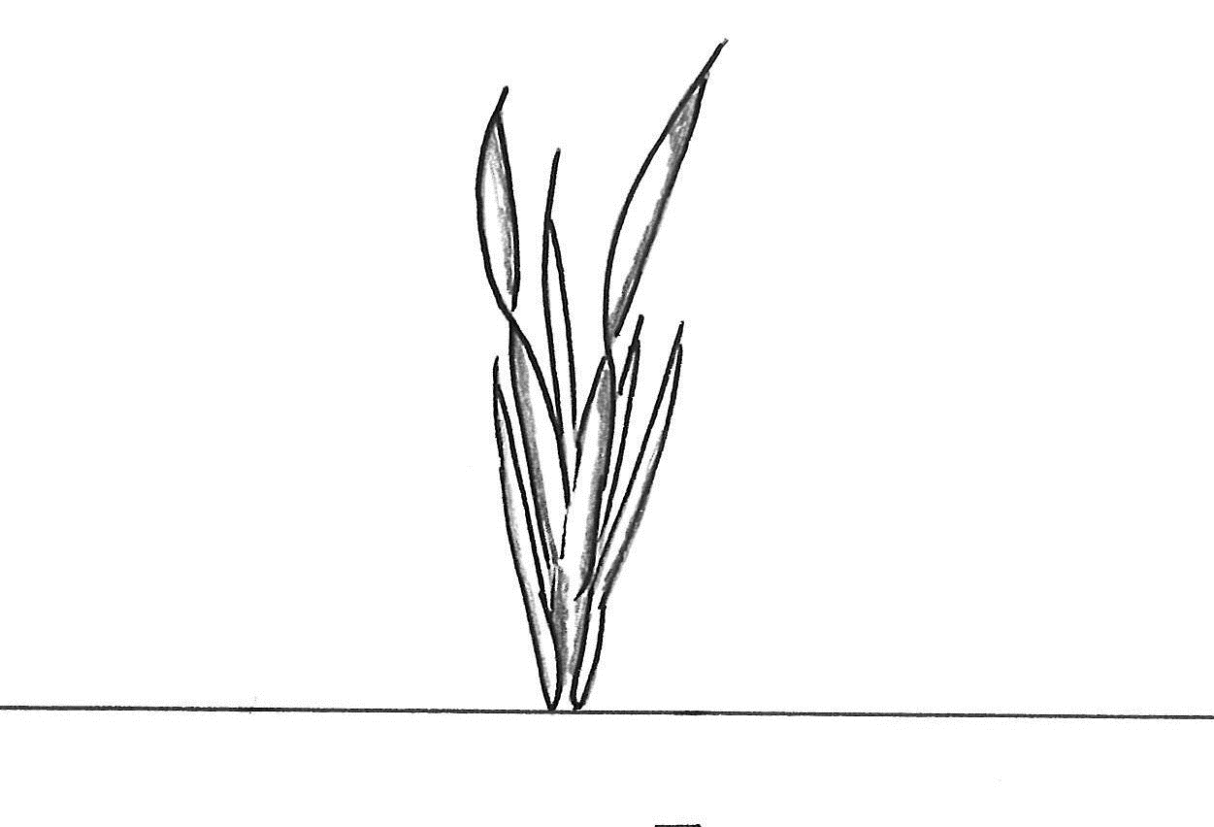 | 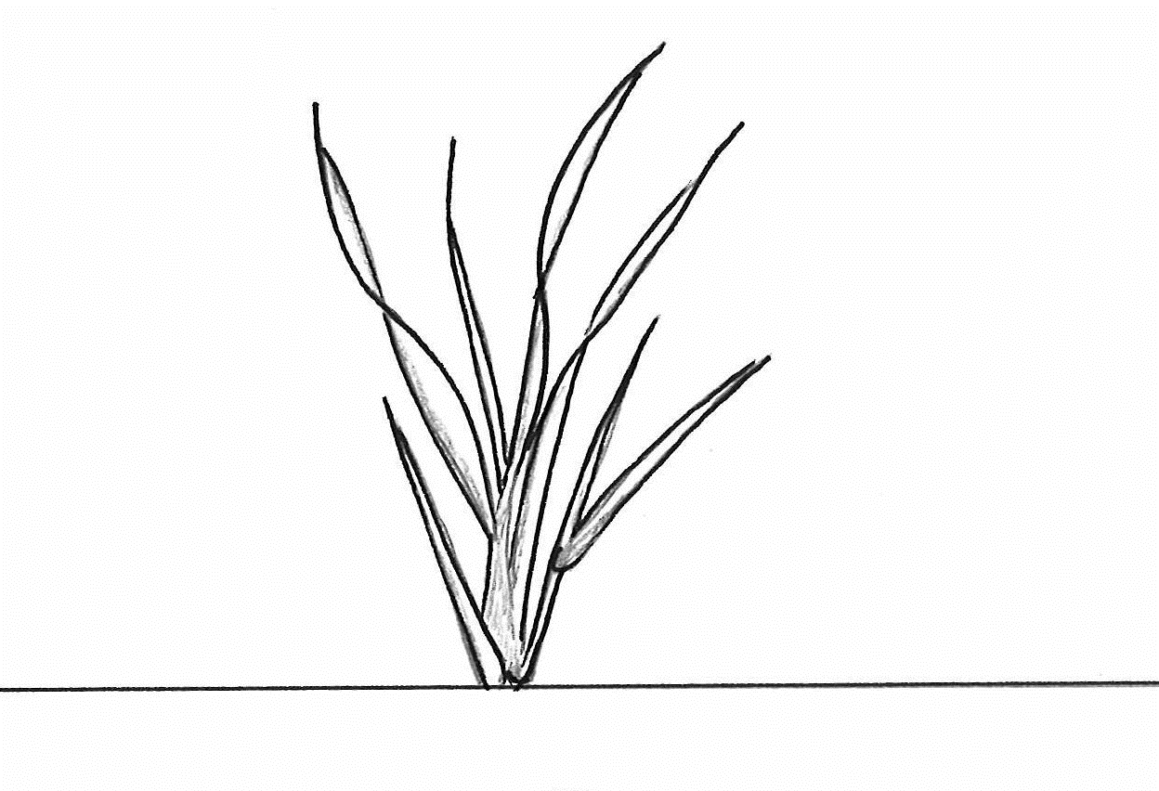 | 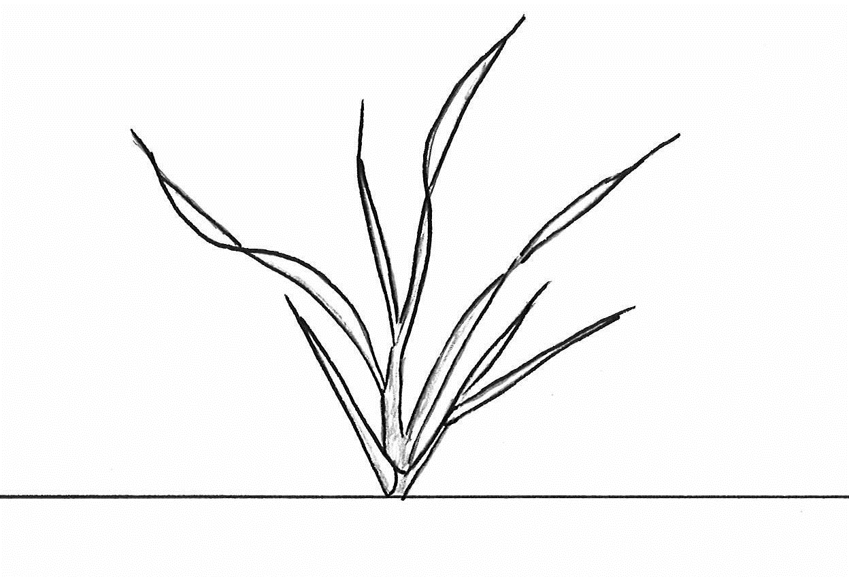 | 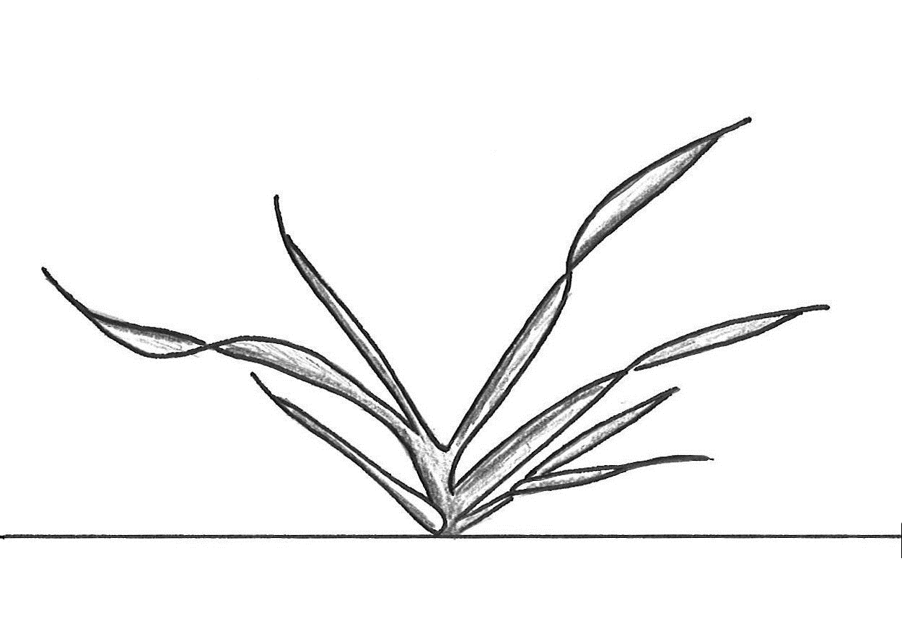 | 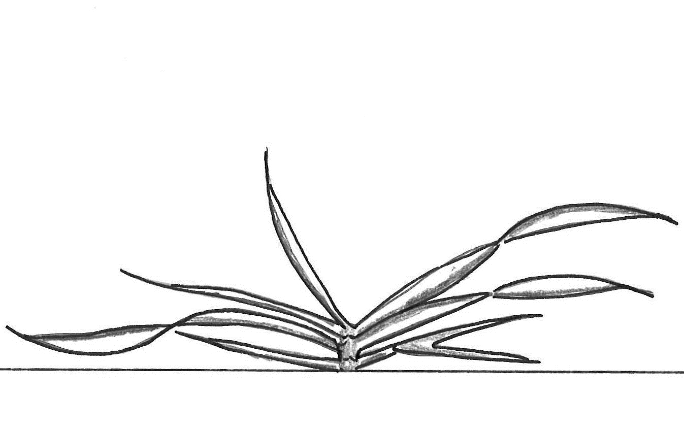
1 | 3 | 5 | 7 | 9
erect | semi-erect | intermediate | semi-prostrate | prostrate

Ad. 8: Time of ear emergence

Open pollinated varieties, hybrid varieties and synthetic varieties (MS/A):
The number of plants which have reached stage 52 of the EUCARPIA Decimal Code for the Growth Stages of Cereals should be recorded at two-day intervals. From these data the average time of ear emergence of the variety should be calculated.

Inbred lines and single crosses from inbred lines (MG/B):
Time of ear emergance is reached when 50 % of the plants have reached stage 52 of the EUCARPIA Decimal Code for the Growth Stages of Cereals.

Ad. 9: Flag leaf: glaucosity of sheath

The observation should be done on the upper third of the sheath.

Ad. 13: Stem: hairiness below ear

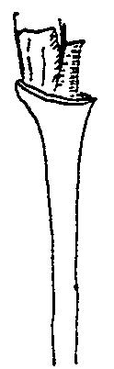 | 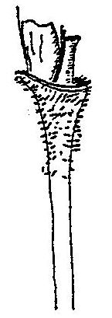 | 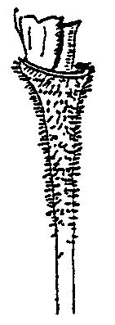 | 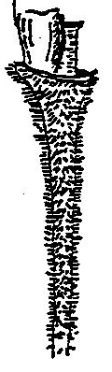 | 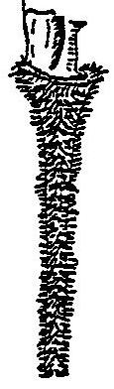
1 | 3 | 5 | 7 | 9
absent or very weak | weak | medium | strong | very strong

Ad. 14: Plant: length

Plant length should be measured including stem, ear and awns.

Ad. 16: Ear: length

Ear length should be measured without awns.

Ad. 17: Ear: density

Ear density is the number of rachis segments devided by length of ear.

Ad. 18: Ear: attitude

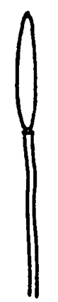 | 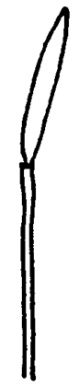 | 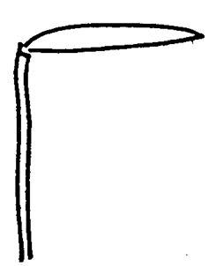 | 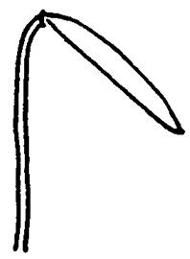 | 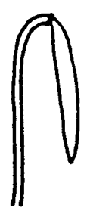
1 | 3 | 5 | 7 | 9
erect | semi-erect | horizontal | semi-recurved | recurved

Ad. 19: Grain: weight per thousand grains

Thousand grain weight and grain length should be assessed in a harvested bunch from a drill plot (about 80 to 100 ears).

Ad. 20: Grain: length

See Ad. 19

  8.3
  Descriptions of the growth stages of the Zadoks decimal code for cereals (ZADOKS et al., 1974)
  Zadoks Decimal code | Description
   | Germination
  00 | Dry seed
  01 | Start of imbibition
  03 | Imbibition complete
  05 | Radicle emerged from seed
  07 | Coleoptile emerged from seed
  09 | Leaf just at coleoptile tip
   | Seedling growth
  10 | First leaf through coleoptile
  11 | First leaf unfolded
  12 | 2 leaves unfolded
  13 | 3 leaves unfolded
  14 | 4 leaves unfolded
  15 | 5 leaves unfolded
  16 | 6 leaves unfolded
  17 | 7 leaves unfolded
  18 | 8 leaves unfolded
  19 | 9 or more leaves unfolded
   | Tillering
  20 | Main shoot only
  21 | Main shoot only and 1 tiller
  22 | Main shoot only and 2 tillers
  23 | Main shoot only and 3 tillers
  24 | Main shoot only and 4 tillers
  25 | Main shoot only and 5 tillers
  26 | Main shoot only and 6 tillers
  27 | Main shoot only and 7 tillers
  28 | Main shoot only and 8 tillers
  29 | Main shoot only and 9 or more tillers
   | Stem elongation
  30 | Pseudo stem erection
  31 | 1st node detectable
  32 | 2nd node detectable
  33 | 3rd node detectable
  34 | 4th node detectable
  35 | 5th node detectable
  36 | 6th node detectable
  37 | Flag leaf just visible
  39 | Flag leaf ligule/collar just visible
   | Booting
  41 | Flag leaf sheath extending
  43 | Boots just visibly swollen
  45 | Boots swollen
  47 | Flag leaf sheath opening
  49 | First awn visible
   | Inflorescence emergence
  51 | First spikelet of inflorescence visible
  52  53 | -  ¼ of inflorescence emerged
  54  55 | -  ½ of inflorescence emerged
  57 | ¾ of inflorescence emerged
  58  59 | -  Emergence of inflorescence completed
   | Anthesis
  60  61 | -  Beginning of anthesis
  65 | Anthesis half-way
  69 | Anthesis completed
   | Milk development
  70  71 | -  Caryopsis watery ripe
  73 | Early milk
  75 | Medium milk
  77 | Late milk
   | Dough development
  80  83 | -  Early dough
  85 | Soft dough
  87 | Hard dough
   | Ripening
  91 | Caryopsis hard (difficult to divide with thumbnail)
  92 | Caryopsis hard (no longer dented with thumbnail)
  93 | Caryopsis loosening in daytime
  94 | Overripe, straw dead and collapsing
  95 | Seed dormant
  96 | Viable seed giving 50% germination
  97 | Seed not dormant
  98 | Secondary dormancy induced
  99 | Secondary dormancy lost

9. | Literature

ZADOKS, J. C., CHANG, T. T. and KONZAK, C. F., 1974. A decimal code for the growth stages of cereals. Weed Research, 14: 415–421.

10. | Technical Questionnaire

TECHNICAL QUESTIONNAIRE | Page {x} of {y} | Reference Number:

Application date:
(not to be filled in by the applicant)
TECHNICAL QUESTIONNAIRE
to be completed in connection with an application for plant breeders' rights

1. | Subject of the Technical Questionnaire
 |  | Botanical name
  1.1
  Secale cereale L.
 |  | Common name
  1.2
  Rye

2. | Applicant
 | Name
 | Address
 | Telephone No.
 | Fax No.
 | E-mail address
 | Breeder (if different from
 | applicant)

3. | Proposed denomination and breeder's reference
 | Proposed denomination
 | (if available)
 | Breeder's reference

TECHNICAL QUESTIONNAIRE |  |  | Page {x} of {y} | Reference Number:
#4. | Information on the breeding scheme and propagation of the variety
 | 4.1 | Breeding scheme
 | Variety resulting from:
  4.1.1
  Crossing
 |  | [ ]
  (a)
  controlled cross
 |  | [ ]
  (b)
  partially known cross
  (please state known parent variety(ies))
 |  | [ ]
  (c)
  unknown cross
 |  | [ ]
  4.1.2
  Mutation
  (please state parent variety)
 |  | [ ]
  4.1.3
  Discovery and development
  (please state where and when discovered and how developed)
 | Other  (Please provide details) | [ ]
  4.1.4

TECHNICAL QUESTIONNAIRE | Page {x} of {y} | Reference Number:

 | 4.2 | Method of propagating the variety
  4.2.1
  Seed-propagated varieties
(a) open pollinated variety [ ]
(b) inbred line [ ]
(c) single hybrid [ ]
(d) three-way hybrid [ ]
(e) double hybrid [ ]
(f) top-cross hybrid [ ]
(g) synthetic variety [ ]
(h) other (please specify) [ ]
......................................................................................................................

 | Other  (Please provide details) | [ ]
  4.2.2

In the case of hybrid varieties the production scheme for the hybrid should be provided on a separate sheet. This should provide details of all the parent lines required for propagating the hybrid e.g.
Single Hybrid
(…………………..……………..…) x (……………..…………………..…)
female parent male parent

Three-Way Hybrid
(…………………..……………..…) x (……………..…………………..…)
female parent male parent

(…………………..……………..…) x (……………..…………………..…)
single hybrid used as female parent male parent

and should identify in particular:
(a) any male sterile lines
(b) maintenance system of male sterile lines.

TECHNICAL QUESTIONNAIRE | Page {x} of {y} | Reference Number:

5. | Characteristics of the variety to be indicated (the number in brackets refers to the corresponding characteristic in Test Guidelines; please mark the note which best corresponds).

 | Characteristics | Example Varieties | Note
  5.1
  (1)
  Grain: color of aleurone layer
  light
  (w) Helltop
  1 [ ]
  dark
  (s) Arantes, (w) Bonfire
  2 [ ]
  5.2
  (3)
  Coleoptile: anthocyanin coloration
  absent or very weak
  (w) Helltop
  1 [ ]
  weak
  3 [ ]
  medium
  (w) Tonus
  5 [ ]
  strong
  (s) Ovid, (w) Turbogreen
  7 [ ]
  very strong
  9 [ ]
  5.3
  (8)
  Time of ear emergence
  very early
  (w) Bonfire
  1 [ ]
  early
  (w) Turbogreen
  3 [ ]
  medium
  (w) Jobaro
  5 [ ]
  late
  (w) Beskyd
  7 [ ]
  very late
  (w) Tonus
  9 [ ]
  5.4
  (13)
  Stem: hairiness below ear
  absent or very weak
  1 [ ]
  weak
  (w) Guttino
  3 [ ]
  medium
  (w) Tonus
  5 [ ]
  strong
  (w) KWS Dolaro
  7 [ ]
  very strong
  9 [ ]
  5.5
  (14)
  Plant: length
  very short
  1 [ ]
  short
  (w) Guttino
  3 [ ]
  medium
  (s) Ovid, (w) Marcelo
  5 [ ]
  long
  (w) Jobaro
  7 [ ]
  very long
  (w) Bonfire
  9 [ ]
  5.6
  (21)
  Seasonal type
  winter
  (w) SU Stakkato
  1 [ ]
  alternative
  2 [ ]
  spring
  (s) Arantes
  3 [ ]

TECHNICAL QUESTIONNAIRE | Page {x} of {y} | Reference Number:

6. | Similar varieties and differences from these varieties
Please use the following table and box for comments to provide information on how your candidate variety differs from the variety (or varieties) which, to the best of your knowledge, is (or are) most similar. This information may help the examination authority to conduct its examination of distinctness in a more efficient way.

  Denomination(s) of variety(ies) similar to your candidate variety
  Characteristic(s) in which your candidate variety differs from the similar variety(ies)
  Describe the expression of the characteristic(s) for the similar variety(ies)
  Describe the expression of the characteristic(s) for your candidate variety

Example
  Time of ear emergence
  4
  7

 | Comments:

TECHNICAL QUESTIONNAIRE | Page {x} of {y} | Reference Number:

#7. | Additional information which may help in the examination of the variety
7.1 | In addition to the information provided in sections 5 and 6, are there any additional characteristics which may help to distinguish the variety?
 | Yes | [ ] | No | [ ]
 | (If yes, please provide details)
7.2 | Are there any special conditions for growing the variety or conducting the examination?
 | Yes | [ ] | No | [ ]
 | (If yes, please provide details)
7.3 | Other information
7.3.1 Ploidie
diploid [ ]
tetraploid [ ]

7.3.2 Other

...................................................................................................................................................

TECHNICAL QUESTIONNAIRE | Page {x} of {y} | Reference Number:

8. | Authorization for release
 | (a) | Does the variety require prior authorization for release under legislation concerning the protection of the environment, human and animal health?
 |  | Yes | [ ] | No | [ ]
 | (b) | Has such authorization been obtained?
 |  | Yes | [ ] | No | [ ]
 | If the answer to (b) is yes, please attach a copy of the authorization.

9. Information on plant material to be examined or submitted for examination

9.1 The expression of a characteristic or several characteristics of a variety may be affected by factors, such as pests and disease, chemical treatment (e.g. growth retardants or pesticides), effects of tissue culture, different rootstocks, scions taken from different growth phases of a tree, etc.
9.2 The plant material should not have undergone any treatment which would affect the expression of the characteristics of the variety, unless the competent authorities allow or request such treatment. If the plant material has undergone such treatment, full details of the treatment must be given. In this respect, please indicate below, to the best of your knowledge, if the plant material to be examined has been subjected to:

 | (a) | Microorganisms (e.g. virus, bacteria, phytoplasma) | Yes [ ] | No [ ]
 | (b) | Chemical treatment (e.g. growth retardant, pesticide) | Yes [ ] | No [ ]
 | (c) | Tissue culture | Yes [ ] | No [ ]
 | (d) | Other factors | Yes [ ] | No [ ]
 | Please provide details for where you have indicated “yes”.

10. | I hereby declare that, to the best of my knowledge, the information provided in this form is correct:
 | Applicant’s name
 | Signature |  | Date

[End of document]

