E
International Union for the Protection of New Varieties of Plants

Technical Working Party for Agricultural Crops  Forty-Seventh Session  Naivasha, Kenya, May 21 to 25, 2018  Technical Working Party on Automation and Computer Programs  Thirty-Sixth Session  Hanover, Germany, July 2 to 6, 2018  Technical Working Party for Vegetables  Fifty-Second Session  Beijing, China, September 17 to 21, 2018  Technical Working Party for Fruit Crops  Forty-Ninth Session  Santiago de Chile, Chile, November 19 to 23, 2018  Technical Working Party for Ornamental Plants and Forest Trees  Fifty-First Session  Christchurch, New Zealand, February 18 to 22, 2019 | TWP/2/8  Original: English  Date: May 9, 2018
Guidance for drafters of Test Guidelines
Document prepared by the Office of the Union
Disclaimer: this document does not represent UPOV policies or guidance

EXECUTIVE Summary

The purpose of this document is to provide guidance for drafters of Test Guidelines and to report developments on the web-based Test Guidelines template (web-based TG template).

The TWPs are invited to note:

(a) the proposals presented by the TWPs, at their sessions in 2017, for further improvements to the web-based TG template, as set out in paragraphs 7 to 12 of this document;

(b) the issues on the web-based TG template addressed during 2017, as set out in paragraphs 13 to 22 of this document;

(c) the issues currently being addressed on the web-based TG template, as set out in paragraph 23 of this document; and

(d) that training on the web-based TG template will be provided to all TWPs, at their sessions in 2018.

The following abbreviations are used in this document:

TC: Technical Committee
TC-EDC: Enlarged Editorial Committee
TG: Test Guidelines
TWA: Technical Working Party for Agricultural Crops
TWC: Technical Working Party on Automation and Computer Programs
TWF: Technical Working Party for Fruit Crops
TWO: Technical Working Party for Ornamental Plants and Forest Trees
TWPs: Technical Working Parties
TWV: Technical Working Party for Vegetables

The structure of this document is as follows:

EXECUTIVE Summary 1
Developments in 2017 2
Comments by the Technical Working Parties 2
Issues addressed on the web-based TG template 3
Revision of the software code 3
Order of UPOV codes and botanical names 3
Order of methods of observation 3
Subsequent explanations covering several characteristics 3
Explanations covering all characteristics 3
Current developments 4
Issues being addressed 4
Training 4
Guidance for users of the web-based TG template 5
ANNEX Features of the Web-based TG Template

Developments in 2017

Comments by the Technical Working Parties

At their sessions in 2017, the TWA, TWC, TWF, TWO and TWV considered document TWP/1/8 “Guidance for drafters of Test Guidelines (see documents TWA/46/10 “Report”, paragraphs 111 to 120, TWC/35/21 “Report”, paragraphs 90 to 94, TWF/48/13 “Report”, paragraphs 54 to 60, TWO/50/14 “Report”, paragraphs 75 to 83 and TWV/51/16 “Report”, paragraphs 50 to 61).

The TWPs noted that the issues addressed on the web-based TG template for inclusion during the second semester of 2017:

- to specify information for more than one method of propagation in Chapter 3.4 “Test Design”;
- addition of new SW paragraph at Chapter 4.2 “Uniformity” to specify type of propagation considered in the Test Guidelines;
- example variety master list: addition of a pop up window with related characteristics before confirming the deletion of a variety from the master list of example varieties;
- improved functionality to move characteristics up and down in the table of characteristics (drag and drop);
- addition of characteristics not contained in the table of characteristics at the end of the Technical Questionnaire (TQ);
- separation of color characteristics in TQ to be indicated as RHS Colour Chart reference or color group;
- addition of a possibility to edit the scope of the Test Guidelines on the cover page (e.g. for excluding species and UPOV Codes).
The TWA agreed to propose the addition of commonly used growth stage keys to the web-based TG Template, such as the BBCH Growth stages of mono-and dicotyledonous plants and the Zadoks’ Decimal code for the growth stages of cereals. The TWA agreed that the growth stage keys should be available in an appropriate format to be adapted and used by Leading Experts of relevant Test Guidelines in the web-based TG Template.

The TWO agreed that explanations covering all characteristics should be able to be displayed before Chapter 8.1 “Explanations covering several characteristics” without a note in the Table of Chars, as set out in document TWP/1/8, paragraphs 28 and 29.

The TWO agreed to propose that practical training on drafting Test Guidelines be offered during the Preparatory Workshops for the TWPs in 2018.

The TWF appreciated the improvement of Version 1 and highlighted the importance of the development of Version 2 of the web-based TG Template for the creation of national Test Guidelines. The TWF agreed that members of the Union should be involved in the development of Version 2 to assure that individual authorities’ needs be taken into account, as far as possible.

The TWV requested the Office to check the possibility to give access to the database containing adopted characteristics also outside the web-based TG Template, for example on the TG drafters’ webpage.

The TWV appreciated the improvement of Version 1 and agreed on the importance of Version 2 of the web-based TG Template for the creation of national Test Guidelines.

Issues addressed on the web-based TG template

Solutions for the following issues raised by users of the web-based TG template were implemented during the second semester of 2017:

- to specify information for more than one method of propagation in Chapter 3.4 “Test Design”;
- addition of new SW paragraph at Chapter 4.2 “Uniformity” to specify type of propagation considered in the Test Guidelines;
- example variety master list: addition of a pop up window with related characteristics before confirming the deletion of a variety from the master list of example varieties;
- improved functionality to move characteristics up and down in the table of characteristics (drag and drop);
- addition of characteristics not contained in the table of characteristics at the end of the Technical Questionnaire (TQ);
- separation of color characteristics in TQ to be indicated as RHS Colour Chart reference or color group;
- addition of a possibility to edit the scope of the Test Guidelines on the cover page (e.g. for excluding species and UPOV Codes).

The following issues agreed by the TC, at its fifty-third session have been implemented (see document TC/53/31 “Report”, paragraphs 129 to 139 and 141):

Revision of the software code

A general revision of the software code has been successfully completed eliminating diverse malfunctioning issues.

Order of UPOV codes and botanical names

The TC agreed that UPOV codes and botanical names in draft Test Guidelines should, in general, be displayed in alphabetical order. However, the TC agreed that the web-based TG Template should allow the Leading Expert to change the order, if appropriate.

Order of methods of observation

The TC agreed that the methods of observation of a characteristic should continue to be presented in alphabetical order, thereby avoiding any indication of order of preference.

Subsequent explanations covering several characteristics

The TC agreed that characteristics with the same explanation could be displayed in Chapter 8.2 “Explanations for individual characteristics” with subsequent explanations being cross-referenced to the first characteristic displaying the appropriate information.

Explanations covering all characteristics

The TC considered whether explanations covering all characteristics should be displayed before Chapter 8.1 “Explanations covering several characteristics” without a note in the Table of Characteristics. The TC agreed to invite the TWPs, at their sessions in 2017, to consider this proposal and report to the TC, at its session in 2018 (see document TC/53/31 “Report”, paragraphs 107 to 110).

The TWA and TWV agreed that explanations covering all characteristics were not used in Test Guidelines for agricultural crops vegetables (see documents TWA/46/10 “Report”, paragraph 116 and TWV/51/16 “Report”, paragraph 55).

The TWO and TWF agreed that explanations covering all characteristics should be able to be displayed before Chapter 8.1 “Explanations covering several characteristics” without a note in the Table of Chars (see documents TWO/50/14 “Report”, paragraph 80 and TWF/48/13 “Report”, paragraph 59).

A link “View/Edit explanation covering all characteristics” will be added on top of the list of characteristics to enable a particular explanation to be displayed before Chapter 8.1. The following screenshot indicates the positioning of the proposed link:

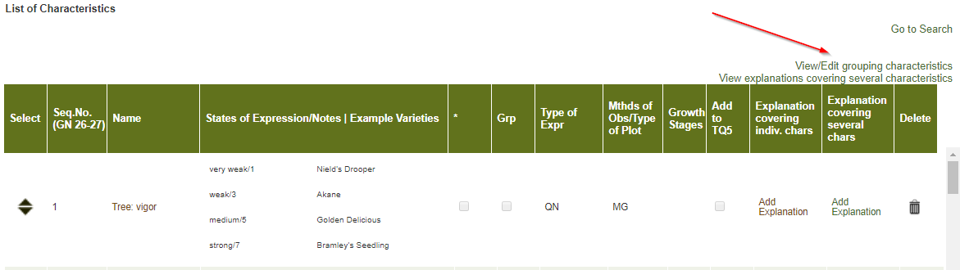

Current developments

Issues being addressed

The following issues on the web-based are currently being addressed:

- concurrent translation of Test Guidelines (first version available by third quarter of 2018) (see Annex)
- national test guidelines: survey on needs of members to be issued by end of 2018
- options to improve the Test Guidelines export files generated by the template
- import and export of tables (e.g. growth stages) and illustrations
- improve reminders (include TG references and name of relevant TWP)
- restrict access to leading experts during the LE drafting and LE checking periods (no links to HTML or word previews for interested experts)
- Improve display of TQ5 to display all rows and buttons in the same window
- Continuous fixing of minor bugs due to deployment of improvements in the template
- Addition of hyperlinks in the exported documents to the symbols indicating that a characteristic has explanations covering individual and/or several characteristics in the Table of Characteristics in order to facilitate electronic navigation in the document;
- Possibility to display large tables in landscape format, such as for indication of growth types;
- Provide the comments by the Office of the Union on draft Test Guidelines in the web-based TG Template.

Training

The TC, at its fifty-third session, agreed that training on the use of the web-based TG template should be offered to the TWPs during the preparatory workshops of the session and/or during the discussions on the agenda item “guidance for drafters’ of Test Guidelines”. The TC agreed that training should also include FAQs and tutorials for users of the web-based TG template (see document TC/53/31 “Report”, paragraph 239).

Training was provided to all TWPs, at their sessions in 2017, under agenda item “guidance for drafters’ of Test Guidelines”. Training will be provided to all TWPs, at their sessions in 2018, under the same agenda item. Bilateral training will also be organized upon request from experts by electronic means.

Users are invited to provide feedback or questions directly via the web-based TG Template by clicking on the link “Feedback”:

Guidance for users of the web-based TG template

Tutorials for the following user roles are available on the web-based TG Template under the link “Tutorials”:

- Leading Expert drafting tutorial
- Interested Expert comments tutorial
- Leading Expert checking tutorial

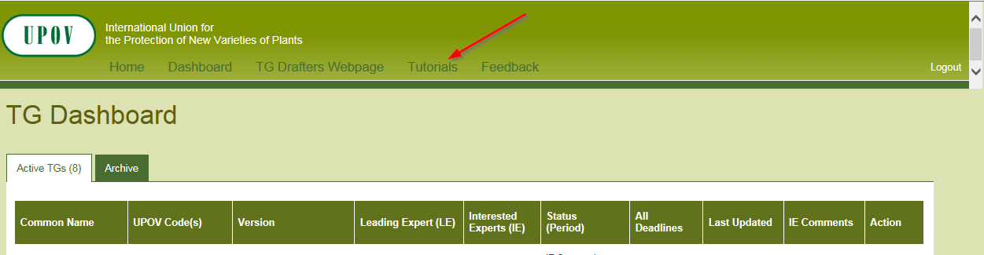

Alternatively, the tutorials are also available for download under the following link: http://upov.int/export/sites/upov/tgp/en/tg_template_tutorial_complete.pdf

The web-based TG template tutorials contain a list of most frequently asked questions for the different user roles.

The TWPs are invited to note:

(a) the proposals presented by the TWPs, at their sessions in 2017, for further improvements to the web-based TG template, as set out in paragraphs 7 to 12 of this document;

(b) the issues on the web-based TG template addressed during 2017, as set out in paragraphs 13 to 22 of this document;

(c) the issues currently being addressed on the web-based TG template, as set out in paragraph 23 of this document; and

(d) that training on the web-based TG template will be provided to all TWPs, at their sessions in 2018.

[Annex follows]

Features of the web-based TG Template

(Extract from document TC/50/10 “Report on developments in UPOV including relevant matters discussed in the last sessions of the Administrative and Legal Committee, the Consultative Committee and the Council”)

The web-based TG Template will be developed in two separate phases in the form of Versions 1 and 2.

Version 1

Version 1 of the web-based TG Template will be fully functional for the development of UPOV Test Guidelines by Leading Experts and will enable Interested Experts to provide comments. Version 1 of the web-based TG Template will be completed in 2016 and a demonstration will be made at the TWPs sessions in 2016.

Features

The main features of Version 1 are as follows:

- Draft Test Guidelines will be prepared by Leading Experts online via the web-based TG Template
- Fixed template containing all universal standard wording which is appropriate for all Test Guidelines (see document TGP/7 “Development of Test Guidelines”, Section 3.1 “The TG Template”)
- Options to add Additional Standard Wording (ASW) (see document TGP/7, Section 3.2 “Additional Standard Wording (ASW) for the TG Template”)
- Links to Guidance Notes (GN) (see document TGP/7, Section 3.3 “Guidance Notes (GN) for the TG Template”)
- A database of characteristics (in English, French, German and Spanish) from Test Guidelines adopted after the adoption of document TGP/7/1 “Development of Test Guidelines” the Collection of Approved Characteristics (adopted in 2004) (see document TGP/7, Annex 4 “Collection of Approved Characteristics”).
The database will contain all information from the Table of Characteristics, including states of expression, notes, example varieties, etc. The database can be searched for relevant characteristics and a relevant characteristic uploaded into draft Test Guidelines with subsequent modification as required.

- Comments boxes for Interested Experts to complete online with a facility to view all comments
- Options to produce output in HTML or Word format.
- English only version
- Translators’ facility for the Table of Characteristics (Chapter 7)

Characteristics uploaded, unchanged, from the database comprising the collection of approved characteristics will be indicated as not requiring translation. For other characteristics, translators will be able to search the database comprising the collection of approved characteristics and input the required translations. The translation of the other chapters of the Test Guidelines will be provided separately for Version 1.

Version 2

Version 2 of the web-based TG Template will provide the two following additional features:

Concurrent translation

In version 2 of the web-based TG Template, the French, German and Spanish language versions of the Test Guidelines will be automatically developed concurrently with the English draft for the standard wording, Additional Standard Wording (ASW) and characteristics uploaded, unchanged, from the database comprising the collection of approved characteristics. Text that has not been automatically translated will be indicated for translation in the language concerned.

Individual authorities’ test guidelines

Version 1 of the web-based TG Template has been designed for the development of Test Guidelines for UPOV. However, it has also been designed such that Version 2 will enable members of the Union to use:

(a) adopted UPOV Test Guidelines as a basis for the development of individual authorities’ test guidelines;

(b) the web-based TG Template and database of characteristics to develop individual authorities’ test guidelines for which there are no UPOV Test Guidelines; and

(c) use individual authorities’ test guidelines, developed using the web-based TG Template, as the basis for draft UPOV Test Guidelines.

Version 2 will have a feature for individual authorities to modify the template wording, within the same structure, to act as a template for their own test guidelines and a feature to allow individual authorities to convert UPOV Test Guidelines into individual authorities’ test guidelines, with necessary modifications.

[End of Annex and of document]

