E
International Union for the Protection of New Varieties of Plants

Technical Working Party for Agricultural Crops  Forty-Seventh Session  Naivasha, Kenya, May 21 to 25, 2018  Technical Working Party on Automation and Computer Programs  Thirty-Sixth Session  Hanover, Germany, July 2 to 6, 2018  Technical Working Party for Vegetables  Fifty-Second Session  Beijing, China, September 17 to 21, 2018  Technical Working Party for Fruit Crops  Forty-Ninth Session  Santiago de Chile, Chile, November 19 to 23, 2018  Technical Working Party for Ornamental Plants and Forest Trees  Fifty-First Session  Christchurch, New Zealand, February 18 to 22, 2019 | TWP/2/7 Rev.  Original: English  Date: May 17, 2018
Molecular techniques
Document prepared by the Office of the Union
Disclaimer: this document does not represent UPOV policies or guidance

Executive summary

The purpose of this document is to report developments concerning molecular techniques in relation to the Technical Working Parties and the Working Group on Biochemical and Molecular Techniques, and DNA-Profiling in Particular.

The TWPs are invited to:

(a) note the report on developments in the TWPs and BMT, as set out in this document; and

(b) note that the Office of the Union plans to invite members of the Union to provide sample database models currently in use as a basis to develop further guidance for document UPOV/INF/17 Section 6 “Databases”, including to assess whether the ST-26 standard would be suitable for UPOV purposes or whether a different model would need to be proposed.

The TWA, the TWV and BMT are invited to consider document TGP/15/2 Draft 1.

The following abbreviations are used in this document:

BMT: Working Group on Biochemical and Molecular Techniques, and DNA-Profiling in Particular
TC: Technical Committee
TWA: Technical Working Party for Agricultural Crops
TWC: Technical Working Party on Automation and Computer Programs
TWF: Technical Working Party for Fruit Crops
TWO: Technical Working Party for Ornamental Plants and Forest Trees
TWPs: Technical Working Parties
TWV: Technical Working Party for Vegetables
OECD: Organization for Economic Co-operation and Development
AOSA: Association of Official Seed Analysts
ISTA: International Seed Testing Association
CIOPORA: International Community of Breeders of Asexually Reproduced Ornamental and Fruit Plants
The structure of this document is as follows:

Executive summary 1
developments at the Technical Working Parties IN 2017 2
developments at the sixteenth session of the Working Group on Biochemical and Molecular Techniques, and DNA-Profiling in Particular 3
Papers presented 3
Reports on developments in UPOV concerning biochemical and molecular techniques 3
Report of work on molecular techniques in relation to DUS examination 3
International guidelines on molecular methodologies including cooperation between the OECD, UPOV, ISTA and ISO 4
Variety description databases including databases containing molecular data 4
The use of molecular techniques in variety identification 4
Proposal to revise document TGP/15 “Guidance on the Use of Biochemical and Molecular Markers in the Examination of Distinctness, Uniformity and Stability (DUS)” 4
The use of molecular markers (SNP) for maize DUS testing in France (2013 to 2016) 4
Genetic selection of similar varieties for the first growing cycle: example French bean 5
Review of document UPOV/INF/17 “Guidelines for DNA-Profiling: Molecular Marker Selection and Database Construction (‘BMT Guidelines’) 5
Working Group on Biochemical and Molecular Techniques, and DNA-Profiling in Particular (BMT) 5
Technical Working Party on Automation and Computer Programs (TWC) 6
Next steps 6
International guidelines on molecular methodologies including cooperation between the OECD, UPOV, ISTA and ISO 6
Coordination session 6
Future program 7
Date and place of next session 7
Program for the seventeenth session 7
3. Possible evolution of model 2: introduction of a molecular threshold for pairs of varieties with a distance of GAIA < 2 2
3.1 Feedback on 4 years of use of model 2 2
3.2 Simulations with different genetic thresholds 3
3.3 Conclusion 3
TGP/15/1 Additional text proposal 1
current procedure 1
PROPOSED procedure 2
BACKGROUND DATA 2

ANNEX I ROLE OF THE WORKING GROUP ON BIOCHEMICAL AND MOLECULAR TECHNIQUES,
AND DNA-PROFILING IN PARTICULAR (BMT)
ANNEX II POSSIBLE EVOLUTION OF MODEL 2: INTRODUCTION OF A MOLECULAR THRESHOLD FOR PAIRS OF VARIETIES WITH A DISTANCE OF GAIA < 2
ANNEX III GENETIC SELECTION OF SIMILAR VARIETIES FOR THE FIRST GROWING CYCLE: EXAMPLE FRENCH BEAN

developments at the Technical Working Parties IN 2017

At their sessions in 2017, the TWA, TWV, TWO, TWF and TWC considered document TWP/1/7 “Molecular Techniques”.

The TWV, at its fifty-first session, held in Roelofarendsveen, Netherlands, from July 3 to 7, 2017, received the following presentations, as reproduced in the Annexes to document TWV/51/2 Rev. (in alphabetical order) (see document TWV/51/16 “Report”, paragraph 151):

(a) “Management of variety collections - How we use molecular techniques in France” presented by an expert from France
(b) “Onion- Managing the variety collection with the use of DNA information” presented by an expert from the Netherlands
(c) “Efficient DUS test in French bean (Phaseolus vulgaris L.) by using molecular data” presented by an expert from the Netherlands

The TWC, at its thirty-fifth session, held in Buenos Aires, Argentina, from November 14 to 17, 2017, received an oral presentation by an expert from Argentina. The TWC noted that Argentina was using molecular marker information for the management of variety collections and planned to integrate this information with the GAIA software (see document TWC/35/21 “Report”, paragraph 71).

developments at the sixteenth session of the Working Group on Biochemical and Molecular Techniques, and DNA-Profiling in Particular

The role of the BMT is reproduced in the Annex I to this document.

The sixteenth session of the BMT was held in La Rochelle, France, from November 7 to 10, 2017, with the preparatory workshop on November 6, 2017. The specific day for the agenda items “The use of molecular techniques in examining essential derivation” and “The use of molecular techniques in variety identification” (the “Breeders’ Day”) was November 8, 2017.

Papers presented

The papers presented under each of the agenda items of the sixteenth session of the BMT were as follows:

Reports on developments in UPOV concerning biochemical and molecular techniques

Reports on developments in UPOV concerning biochemical and molecular techniques (document BMT/16/2)

Report of work on molecular techniques in relation to DUS examination

Genetic Distance-based selection of similar varieties for wheat distinctness test (document BMT/16/6)

Test of the potential use of SNPs markers on oilseed rape varieties (document BMT/16/7)

The use of molecular markers (SNP) for maize DUS testing in France (2013 to 2016) (document BMT/16/8 and BMT/16/8 Add.)

The use of genetic distances as characteristics? Assessment of this approach based on GEVES SNP maize data (document BMT/16/9 Rev.)

The use of molecular markers (SNP) for maize DUS testing: Development and official applications to assess distinctness of hybrids varieties (France) (document BMT/16/10)

An attempt to use molecular markers for winter wheat reference collection management (document BMT/16/11)

Update on the American Seed Trade Association and United States PVP Office Molecular Marker Working Group (document BMT/16/12 and BMT/16/12 Add.)
The use of Reference Variety Similarities in Varietal Distinctness II: Reference Variety Selection
(document BMT/16/14 and BMT/16/14 Add.)

Imoddus proposal: Developing a toolbox to distinguish apple mutants for DUS testing (document BMT/16/15 Rev.)

Use of GBS for Lucerne Variety Distinction (document BMT/16/17)

Genetic selection of similar varieties for the first growing cycle: example French bean (document BMT/16/19 and BMT/16/19 Add.)

SDN-assisted plant breeding and potential impact on DUS testing (document BMT/16/20)

Report on IMODDUS activities in 2017 (document BMT/16/22)

The Tomato project proposal in CPVO IMODDUS program (document BMT/16/27)

International guidelines on molecular methodologies including cooperation between the OECD, UPOV, ISTA and ISO

International guidelines on molecular methodologies including cooperation between the OECD, UPOV, ISTA and ISO (document BMT/16/3)

Practical workshops on DNA techniques and variety identification (document BMT/16/13 BMT/16/3 Add.)

OECD Seed Certification Schemes (document BMT/16/23)

Variety description databases including databases containing molecular data

Integration of molecular data into DUS testing in Durum Wheat: Use of a standardized method for the efficient management of reference collections (document BMT/16/21)

The use of molecular techniques in variety identification

Assessment of reproducibility of 6K SNP genotyping in soybean across laboratories (document BMT/16/16)

Assignment Tests for Genotype Classification (document BMT/16/18 Rev.)

Development on Use of Molecular Technique for PVP in Republic of Korea (document BMT/16/24 and BMT/16/24 Add.)

Determination of purity and quantification of varietal components through NGS (Next Generation Sequencing) (document BMT/16/25)

Determining the parameters to characterize Soybean varieties using single nucleotide polymorphisms (document BMT/16/26)

Confirmation of validation for DNA variety identification technique (document BMT/16/28)

Proposal to revise document TGP/15 “Guidance on the Use of Biochemical and Molecular Markers in the Examination of Distinctness, Uniformity and Stability (DUS)”

The use of molecular markers (SNP) for maize DUS testing in France (2013 to 2016)

The BMT agreed that France should propose a revision to document TGP/15 “Guidance on the Use of Biochemical and Molecular Markers in the Examination of Distinctness, Uniformity and Stability (DUS)”, Annex II, “Example: Parent Lines in Maize”, to reflect the refinements that had been made in France on the basis of its experience in the application of the Model “Combining Phenotypic and Molecular Distances in the Management of Variety Collections”, for consideration by the Technical Committee at its fifty-fourth session (see document BMT/16/29 “Report”, paragraph 9 to 10).

The BMT agreed that it would be advantageous if the draft revision of document TGP/15, to be considered by the TC at its fifty-fourth session, could be published sufficiently before the forty-seventh session of the Technical Working Party for Agricultural Crops (TWA), to be held in Naivasha, Kenya, from May 21 to 25, 2018, and before the seventeenth session of the BMT, in order that any comments of the TWA and BMT on the draft revision could be reported to the TC at its fifty-fourth session.

Document TGP/15/2 Draft 1 incorporates the proposal from France on a revision to document TGP/15.

Annex II to this document provides background information on the proposal from France for the revision of document TGP/15.

Genetic selection of similar varieties for the first growing cycle: example French bean

The BMT agreed that the approach presented in document BMT/16/19 “Genetic selection of similar varieties for the first growing cycle: example French bean” and BMT/16/19 Add. “Addendum to Genetic selection of similar varieties for the first growing cycle: example French bean” was a suitable use of molecular techniques in the examination of DUS and should be proposed for inclusion in document TGP/15. Therefore, it was agreed that the Netherlands should prepare an explanation of the method as a basis for a revision of document TGP/15 to be considered by the Technical Committee at its fifty-fourth session (see document BMT/16/29 “Report”, paragraph 19 to 20).

The BMT agreed that it would be advantageous if the draft revision of document TGP/15, to be considered by the TC at its fifty-fourth session, could be published sufficiently before the fifty-second session of the Technical Working Party for Vegetables (TWV), to be held in Beijing, China, from September 17 to 21,2018, and before the seventeenth session of the BMT, in order that any comments of the TWV and BMT on the draft revision could be reported to the TC at its fifty-fourth session.

Document TGP/15/2 Draft 1 incorporates the proposal from the Netherlands on a revision to document TGP/15.

Annex III to this document provides background information on the proposal from the Netherlands for the revision of document TGP/15.

Review of document UPOV/INF/17 “Guidelines for DNA-Profiling: Molecular Marker Selection and Database Construction (‘BMT Guidelines’)

Working Group on Biochemical and Molecular Techniques, and DNA-Profiling in Particular (BMT)

The BMT considered documents BTM/16/4 and BMT/16/5 and received a presentation by the Office of the Union, on “Standards for databases containing molecular information”, a copy of which is reproduced BMT/16/5 Add (see document BMT/16/29, paragraph 44 and 45).

The BMT agreed to invite members and observers to provide comments on document UPOV/INF/17 “Guidelines for DNA-profiling: Molecular Marker Selection and Database Construction (‘BMT Guidelines’)”. The comments would be compiled by the Office of the Union in a document that would form the basis of a review of document UPOV/INF/17 by the BMT at its seventeenth session. The BMT further agreed to propose to introduce a new chapter concerning cooperation in the exchange of data and construction of databases in document UPOV/INF/17 on the basis of document BMT/16/5.

On February 15, 2018, Circular E-18/004 was issued to designated persons of UPOV members in the Technical Committee and the BMT inviting members and observers of the BMT to provide comments on document UPOV/INF/17 “Guidelines for DNA-profiling: Molecular Marker Selection and Database Construction (‘BMT Guidelines’)” by June 15, 2018.

Technical Working Party on Automation and Computer Programs (TWC)

The TWC received a presentation by the Office of the Union on “Standards for databases containing molecular information”, a copy of which would be provided as document TWC/35/20. The TWC noted the offer for interested members to participate in the test campaigns to develop the ST-26 standard for the presentation of nucleotide and amino acid sequence listings using XML (see document TWC/35/21 “Report”, paragraph 127).

Next steps

The Office of the Union plans to invite members of the Union to provide sample database models currently in use as a basis to develop further guidance for document UPOV/INF/17 Section 6 “Databases”, including to assess whether the ST-26 standard would be suitable for UPOV purposes or whether a different model would need to be proposed.

International guidelines on molecular methodologies including cooperation between the OECD, UPOV, ISTA and ISO

The background to this matter is provided in document TWP/1/7 “Molecular Techniques”, paragraph 15 to 22.

The BMT noted that a Joint OECD/UPOV/ISTA/AOSA Workshop on Biochemical and Molecular Methods had been held in Paris on June 8, 2016, and that the recommendations of the Joint OECD/UPOV/ISTA/AOSA Workshop as reproduced in document BMT/16/3, paragraph 9, were approved by the Annual Meeting of the OECD Seed Schemes, held in Paris on June 9 and 10, 2016; BMT/16/3 page 4 (see document BMT/16/29 “Report”, paragraph 25 to 30).

The BMT noted that the TC, at its fifty-third session, had agreed that possible future collaboration between UPOV, the Organization for Economic Co-operation and Development (OECD) and the International Seed Testing Association (ISTA) might include the harmonization of terms and methodologies used for different crops and the possible development of standards, after agreement by those organizations.

The BMT noted that practical workshops on “DNA Techniques and Variety Identification” had been held in Roelofarendsveen, Netherlands, from May 8 to 10, 2017 and from September 20 to 22, 2017.

The BMT noted that the TC had agreed that UPOV and OECD should consider making progress in the matters reported in this document if ISTA was unable to participate in the near future.

The BMT recalled that the TC, at its fifty-first session, had agreed (see document TC/52/29 Rev. “Revised Report”, paragraph 129):

(a) to develop a joint document explaining the principal features of the systems of the OECD, UPOV and ISTA; and
(b) to develop an inventory on the use of molecular marker techniques, by crop, with a view to developing a joint OECD/UPOV/ISTA document containing that information, in a similar format to UPOV document UPOV/INF/16 “Exchangeable Software”, subject to the approval of the Council and in coordination with OECD and ISTA; and
The BMT agreed that the initiatives above, and consideration of possible harmonization of terms and methodologies used for different crops and the possible development of standards, might be advanced through a further international practical workshop, to be jointly coordinated by OECD, UPOV and ISTA and supported by Naktuinbouw and/or another partner with the relevant facilities.

Coordination session

Discussion groups were formed for: agricultural crops; fruit crops; ornamental plants and forest trees; and vegetables, for BMT participants to exchange information on their work and explore areas for cooperation (see document BMT/16/29, paragraph 48 to 53).

The BMT was informed of the following outcomes of the discussions:

Agricultural Crops

The United Kingdom will compile a list of crops of interest to members of the Union.

Fruit Crops

The following interest in cooperation was identified:

- Apple: Australia, Canada, France, Republic of Korea, United Kingdom, CIOPORA
- Stone fruit: France, Republic of Korea, Spain, United Kingdom
- Berries: Austria, Germany, Netherlands, United Kingdom, CIOPORA
- Nuts: China, Spain

Ornamental Plants and Forest Trees

Opportunities for cooperation on Rose will be explored by the Netherlands (coordinator), China, the United Kingdom and CIOPORA.

Vegetables

The following UPOV members will share their criteria for selecting crops for work in relation to the use of molecular techniques: Canada; China; France; Germany; Netherlands (coordinator); Republic of Korea; United Kingdom.

Future program

Date and place of next session

The BMT welcomed the invitation of Uruguay to hold its seventeenth session in Montevideo, Uruguay, from September 10 to 13, 2018, with the elements of the preparatory workshop included in the session (see document BMT/16/29, paragraph 46).

Program for the seventeenth session

During its seventeenth session, the BMT planned to discuss the following items (see document BMT/16/29, paragraph 54):

1. Opening of the session
2. Adoption of the agenda
3. Reports on developments in UPOV concerning biochemical and molecular techniques (document to be prepared by the Office of the Union)
4. Short presentations on new developments in biochemical and molecular techniques by DUS experts, biochemical and molecular specialists, plant breeders and relevant international organizations (oral reports by participants)
5. Report of work on molecular techniques in relation to DUS examination (papers invited)
6. Cooperation between international organizations (document to be prepared by the Office of the Union)
7. Variety description databases including databases containing molecular data (papers invited)
8. Methods for analysis of molecular data (papers invited)
9. The use of molecular techniques in examining essential derivation (papers invited)
10. The use of molecular techniques in variety identification2 (papers invited)
11. Review of document UPOV/INF/17 “Guidelines for DNA-Profiling: Molecular Marker Selection and Database Construction
12. Revision of document TGP/15 “Guidance on the Use of Biochemical and Molecular Markers in the Examination of Distinctness, Uniformity and Stability (DUS)”
13. Session to facilitate cooperation
14. Date and place of next session
15. Future program
16. Report of the session (if time permits)
17. Closing of the session

The TWPs are invited to:

(a) note the report on developments in the TWPs and BMT, as set out in this document; and

(b) note that the Office of the Union plans to invite members of the Union to provide sample database models currently in use as a basis to develop further guidance for document UPOV/INF/17 Section 6 “Databases”, including to assess whether the ST-26 standard would be suitable for UPOV purposes or whether a different model would need to be proposed.

The TWA, the TWV and BMT are invited to consider document TGP/15/2 Draft 1.

[Annexes follow]

ROLE OF THE WORKING GROUP ON BIOCHEMICAL AND MOLECULAR TECHNIQUES,
AND DNA-PROFILING IN PARTICULAR (BMT)
(as agreed by the Technical Committee at its thirty-eighth session, held in Geneva,
from April 15 to 17, 2002 (see document TC/38/16, paragraph 204))

The BMT is a group open to DUS experts, biochemical and molecular specialists and plant breeders, whose role is to:

- Review general developments in biochemical and molecular techniques;

- Maintain an awareness of relevant applications of biochemical and molecular techniques in plant breeding;

- Consider the possible application of biochemical and molecular techniques in DUS testing and report its considerations to the TC;

- If appropriate, establish guidelines for biochemical and molecular methodologies and their harmonization and, in particular, contribute to the preparation of document TGP/15, “New Types of Characteristics.” These guidelines to be developed in conjunction with the Technical Working Parties;

- Consider initiatives from TWPs, for the establishment of crop specific subgroups, taking into account available information and the need for biochemical and molecular methods;

- Develop guidelines regarding the management and harmonization of databases of biochemical and molecular information, in conjunction with the TWC;

- Receive reports from Crop Subgroups and the BMT Review Group;

- Provide a forum for discussion on the use of biochemical and molecular techniques in the consideration of essential derivation and variety identification.

[Annex II follows]

POSSIBLE EVOLUTION OF MODEL 2: INTRODUCTION OF A MOLECULAR THRESHOLD FOR PAIRS OF VARIETIES WITH A DISTANCE OF GAIA < 2

3. Possible evolution of model 2: introduction of a molecular threshold for pairs of varieties with a distance of GAIA < 2

3.1 Feedback on 4 years of use of model 2

3.1.1 Background Information

Model 2, based on SNP molecular markers, has been applied routinely since 2013 in the management of the maize reference collection in order to optimize the line comparison procedure during the second year of study. This model has resulted in effective reduction of the number of pairs to be put in the field without increasing the risk of not selecting a variety in the variety collection which needs to be compared to the candidate varieties in the field. The table below includes several figures that highlight the efficiency of this tool.

Table 1 – Summary of comparison devices implanted since 2013

 | 2013 | 2014 | 2015 | 2016
No. of candidate varieties (1st year of study) | 280 | 363 | 223 | 208
No. of varieties in 2nd year of study | 181 | 198 | 173 | 148
No. of varieties in reference collection (GEVES) | 3657 | 3702 | 3726 | 3814
No. of total pairs ª | 1 152 760 | 1 547 106 | 918 983 | 867 152
Pairs GAIA < 6 | 7004 | 6365 | 7448 | 5020
Sown Pairs^{b} | 429 | 559 | 504 | 448

ªNo. of total pairs = no. of candidate varieties x (no. of varieties in reference collection + no. of candidate varieties + no. of varieties in 2nd year of study) - no. of candidate varieties
^{b}Pairs with GAIA < 2 + pairs with 2 < GAIA < 6 and DG < 0.2.

3.1.2 Data

Over the last four years, data relating to pairs of varieties with a GAIA weight of less than 6 were compiled in the same graph (Figure 4) then analyzed. The data were obtained by applying the decision rules of the model, described in paragraph 1.4.

Figure 4
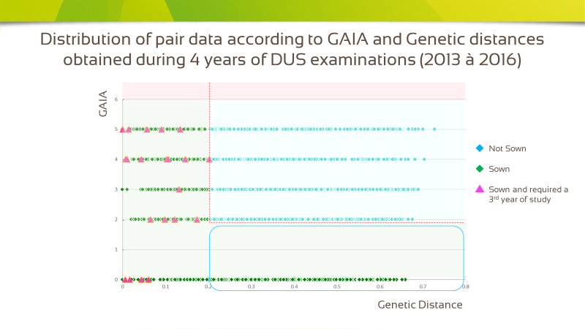

3.1.3 During the side-by-side evaluation process, no pair of varieties belonging to zone GAIA < 2 and DG > 0.2 (encircled in blue in Figure 4) required an extra year of evaluation (purple spots in Figure 4). In other words, all pairs inside this zone appeared to be sufficiently distinct morphologically in the side-by-side comparison process. This result suggests that a threshold could be positioned in zone GAIA < 2 in order to optimize the number of pairs sown in the field, while maintaining the high level of quality of the distinctness assessment.

3.2 Simulations with different genetic thresholds

Several simulations were made in order to verify the gains made by applying the five thresholds which were randomly chosen and regularly distributed in the zone GAIA < 2. Figure 5 presents in histogram form the number of pairs to be sown (in green) and the number of pairs excluded (in blue) each year, along with the average of said data and the average percentage of gains obtained in the field.

Figure 5
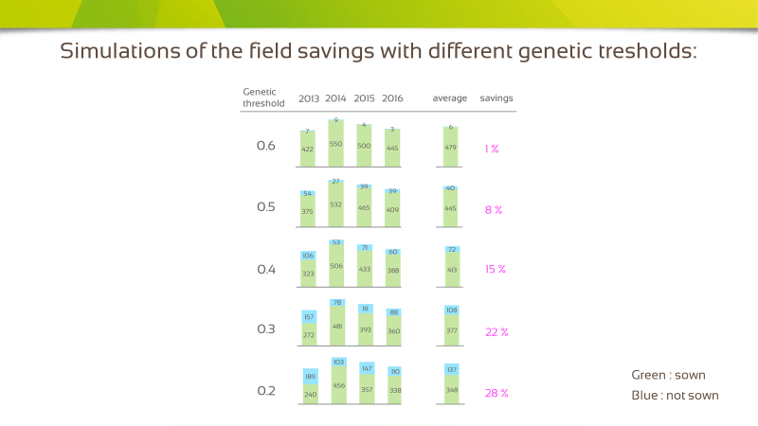

3.2.1 According to the considered threshold between 0.6 and 0.2 the gains are respectively 1% to 28% with similar ratios from one year to another. These results confirm the usefulness of applying such a threshold because it would result in a significant amount of savings in terms of resources and the number of persons usually involved in side-by side comparison work.

3.3 Conclusion

This study provides empirical proof that there is presumably no risk in applying an additional molecular threshold in the zone GAIA < 2. This threshold would reduce significantly the number of pairs to be compared side-by -side in the field and its application would therefore represent:

- An advantage:
- Saving in terms of resources and the number of persons involved in side-by-side comparison work
- No extra cost because molecular data are already available
- Possibly quicker DHS testing

- A constraint:
- The introduction of a parameterization step would be required over a period of several years in order to determine the threshold value.
A safety margin should be maintained when defining this threshold for future routine use, as was the case during implementation of other thresholds mentioned in this document.

[Annex III follows]
Genetic selection of similar varieties for the first growing cycle: example French bean

TGP/15/1 Additional text proposal

2.3 Genetic selection of similar varieties for the first growing cycle (see Annex 3)

2.3.1 In the organisation of a DUS examination it is crucial to be sure that the candidate variety does not already exists in common knowledge.

2.3.2 Key features for the process of selecting similar varieties for the growing trial are the quality of the information on the candidate and the completeness and quality of the variety descriptions of the varieties in the variety collection.

2.3.3 A genotypic approach of the selection process of the most similar varieties from common knowledge not only maximises the chance to discover if the candidate variety already exists (identical genetic fingerprint combined with lack of phenotypical distinctness), but also improves the process of selecting (genetically) similar varieties as it has a more objective basis than the TQ supplied by the applicant.

2.3.4 Based on the provisional conclusion on DUS after the first growing cycle and the variety description made in the first growing cycle, an additional search to select possible phenotypical similar varieties for a second growing cycle can be done.

2.3.5 This approach has the following advantages:
(a) as the collection of genetic information of the varieties of common knowledge is more objective than variety descriptions (no interaction with the environment) it is a more reliable knowledge base, easier to share between authorities and therefore potentially more complete thus minimizing the chance to overlook similar or even identical varieties.

(b) as often the TQ provided by the applicant leads to wrong conclusions, a genotypic approach is more reliable to find the best similar varieties.

(c) as after the first growing cycle a morphological check is performed against the varieties of the variety collection, the final conclusion is still based on morphology.

(d) there is a chance that after the first growing cycle on the basis of morphology a very similar variety is discovered that was not included in the genetic selection and two additional growing cycles are needed. There is also a chance that after the first growing cycle the DUS conclusion is clear and no further similar varieties are discovered on morphology, so the DUS test can be concluded after the first growing cycle.

2.3.6 Annex 3 to this document “Combining Phenotypic and Molecular Distances in the Management of Variety Collections” provides an example of the use of Genetic selection of similar varieties for the first growing cycle.

current procedure

1. A DUS test in French bean (Phaseolus vulgaris L.) normally takes 2 growing cycles according to TG/12/9 Rev. 2. The description of a variety is made using 48 morphological and 4 resistance characteristics.

2. There are nine grouping characteristics. The group “dwarf plant, white flower, round, green pod without string, white seed without secondary color, resistant to BCMNV” contains 350 to 400 varieties. In practice it is not feasible to include these varieties in a field trial and to make side by side comparisons.

3. Based on the information in the TQ of a candidate variety a smaller set is selected from the large group of possible similar varieties. However, the information of the breeder may not be complete and accurate, nor reflecting the morphology of the variety in the environment of the DUS trial, especially in case of quantitative characteristics. Therefore, the information in the TQ must be treated cautiously. In the current DUS procedure the TQ information about morphology and resistances is the only source for selecting similar varieties. For each candidate variety 2 to 3 hours are needed to select a smaller number of similar varieties out of the large group of more than 350 varieties, using expressions for quantitative characteristics.

4. The first growing cycle is used to make a morphological description of the candidate variety and side-by-side comparisons with all selected similar varieties. Afterwards a check is done in the database whether there is any variety to which the candidate appears closer. These can be added in the second growing cycle.

5 The second growing cycle is used to confirm the differences between the closest similar variety and the candidate and to come to a decision on distinctness. Quite often it occurs that in the first growing cycle the closest similar varieties had not been selected, due to inaccurate information in the TQ. This may lead to 3 growing cycles, instead of 2.

PROPOSED procedure

6. The first selection of similar varieties can be performed more efficiently by using genotypic information of the candidate. Only a rather low number of genetically close varieties will be put in the field trial. If one of these genetically close varieties appears in a database check distinct on QL and/or grouping characteristics, it is discarded. Such a database check on QL and/or grouping characteristics takes not more than 20 minutes. A threshold for genetic distance is not known yet.

7. At the end of the first growing cycle a database check is done by comparing the description made in the first growing cycle with all morphological descriptions of known varieties. This second selection takes much less time than the traditional first selection, as one can discard influences caused by deviations from the TQ. This check is important to safeguard that the decision on distinctness is taken on morphology.

8. In the case that the candidate variety is clearly distinct in the first growing cycle, fulfills the uniformity and stability requirements and the database check at the end of the first growing cycle gives no extra similar varieties, the DUS test may be concluded after the first growing cycle.

9. In all other cases a second growing cycle is the performed. The candidate is put in the trial with the closest similar variety from the first year and with all similar varieties from the database check. Distinctness observed in the second growing cycle is supported by the genetic distance. However, a large genetic distance combined with a lack of distinctness on morphological characteristics must not lead to a positive decision on DUS.

BACKGROUND DATA

10. Naktuinbouw has a large DNA database of French bean varieties. It consists of AFLP profiles, by 4 primers giving 78 polymorphic bands. Genetic similarities (distances) between all varieties are calculated (Jaccard). In the near future the AFLP will be replaced by a SNP database. Any validated DNA technique could be used.

11. Application of the ‘genetic selection’ in 2015 and 2016 resulted in a reduction of 60% of the similar varieties to be included in the trial. One of 14 candidates was declared distinct after 1 year of trials. For none of the 14 candidates a 3rd growing cycle was needed. The selection of similar varieties from the morphological database takes about 2 hours less per candidate and the quality of the side-by-side comparison in the field increases having to compare a lower number of varieties.

12. This method of genetic first selection is suitable for any crop with normally two years of testing when a DNA database and a morphological database are available.

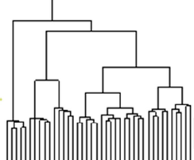
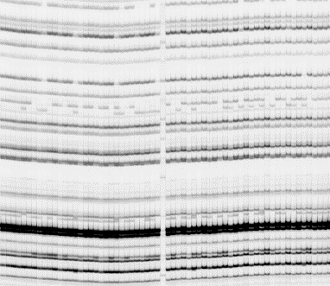
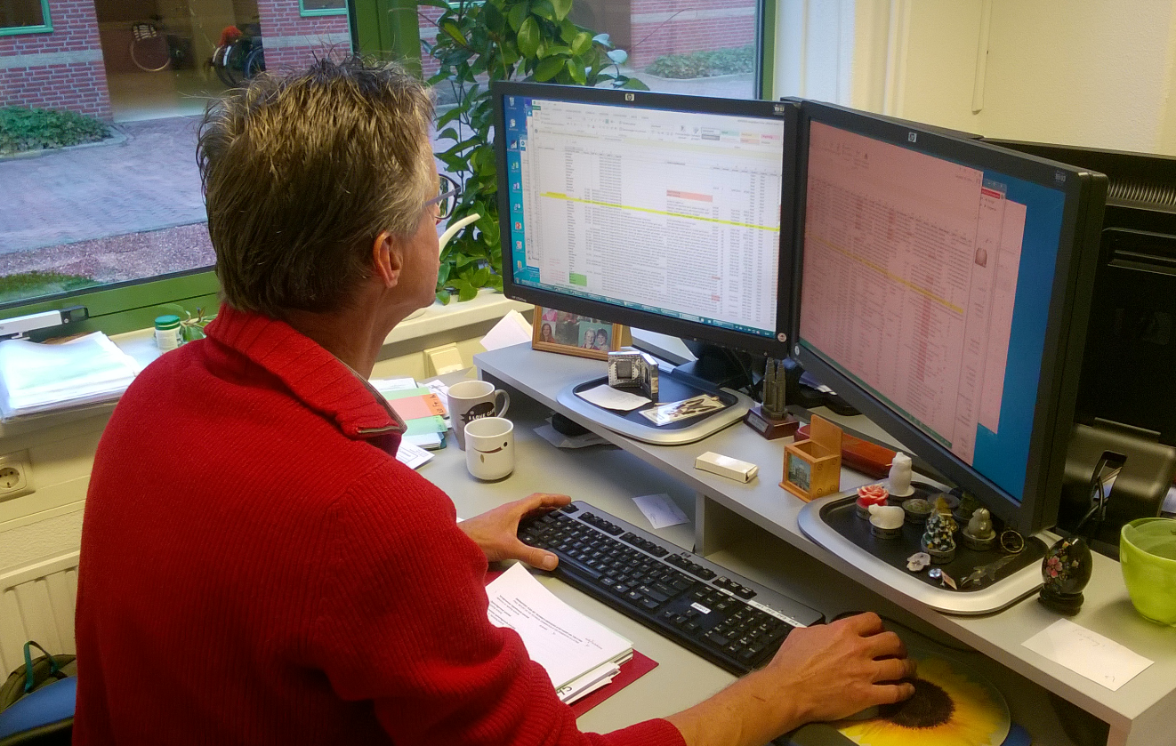
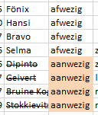
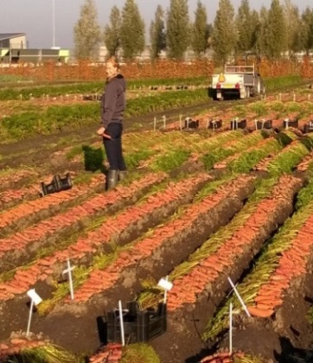
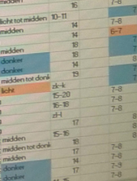
seed
TQ
Start
DNA profiling
DNA similarities
first selection
check morphological database
discard on QL grouping chars only
(short) list of varieties to be put in field trial (1st cycle)
1st growing cycle
Side-by-side comparisons and complete description
‘paper check’ morphological database
discard on all chars
Clearly D and no extra similar varieties: positive conclusion after 1st cycle
Not clearly Distinct and/or extra similar varieties needed: normal 2nd growing cycle
Extra similar varieties needed?

[End of Annex III and of document]

This agenda item was discussed on Wednesday, November 8, 2017 (“Breeders-Day”).
Breeders’ Day

