E
International Union for the Protection of New Varieties of Plants

Technical Working Party for Agricultural Crops  Forty-Seventh Session  Naivasha, Kenya, May 21 to 25, 2018 | TWA/47/6  Original: English  Date: May 12, 2018
Matters to be resolved concerning Test Guidelines adopted by the Technical Committee: Cotton (Gossypium L.) (Revision)
Document prepared by an expert from Spain
Disclaimer: this document does not represent UPOV policies or guidance
The Enlarged Editorial Committee (TC-EDC), at its meeting held in Geneva, from March 26 to 27, 2018, considered document TG/88/7(proj.4) and agreed that the technical issues raised on the draft Test Guidelines for Cotton should be addressed by the TWA (see document TC-ECD/MAR18/11 “Report”, paragraph 57).

The following table presents all the comments made by the TC-EDC on the draft Test Guidelines for Cotton (document TG/88/7(proj.4)), including the technical issues, with the proposed responses by the Leading Expert, Mr. Jesús Mérida (Spain).

4.2.4 | to specify to which type of varieties this paragraph applies to (to check whether 1% population standard applies to all varieties or specific type of varieties)  Leading Expert: for all types of varieties, therefore, paragraph 4.3.3 should be excluded.
Char. 6 | to check whether to delete “clearly”  Leading Expert: Don’t delete because if it’s not clearly below or clearly above must be considered at the same level.
Char. 23 | “Tall” should be “tall”  Leading Expert: agreed
Char. 28 | to read “100 seed weight”  Leading Expert: agreed
Char. 30 to 34 | to clarify how the characteristics are assessed  Leading Expert: The characteristics “Fiber: length (30), strength (31), elongation (32), fineness (micronaire) (33), length uniformity (34)” are evaluated on samples of lint, without seeds. To see explanation Ad.29
Char. 32 | - to add explanation to define the characteristic (meaning of elongation)  - to indicate how it is observed  Leading Expert: Elongation expresses the ability of the fiber to stretch before breaking
Char. 34 | - to review wording of characteristic header (fiber length uniformity)  - to add explanation to define the characteristic (meaning of length uniformity)  - to indicate how it is observed  Leading Expert: According to Classification of Upland Cotton:  Length uniformity is the ratio between the mean length and the upperhalf mean length of the fibers, expressed as a percentage. If all of the fibers in the bale were the same length, the mean length and the upperhalf mean length would be the same, and the uniformity would be 100 percent. However, because of natural variation in the length of cotton fibers, length uniformity will always be less than 100 percent.
8.1 (c) | to check whether to be formatted with bullet points at the same alignment for both “Standard Test Methods” as follows:  “• Standard Test Methods for Measurement of Cotton Fibres by High Volume Instruments (HVI) (Motion Control Fiber Information System). Designation D-4604-95  “• Standard Test Methods for Measurement of Physical Properties of Cotton Fibers by High Volume Instruments (HVI). Designation D-5867-95  “Established by the American Society for Testing and Materials (ASTM)”  Leading Expert: agreed
Ad. 1 | - to improve illustrations (to clarify what clustering is; is clustered the appropriate term?) (density of flowers, distance between flowers?)  - is it really PQ or QN (illustration looks like QN)  Leading Expert: it could be QN; clustered is appropriate because is the international denomination; it refers to distance between flowers. To see new illustrations:

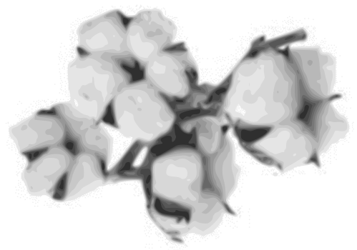 | 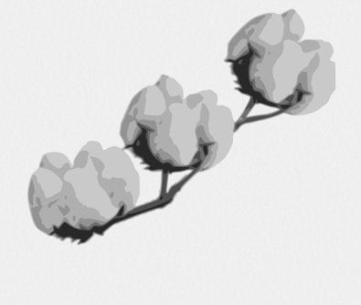 | 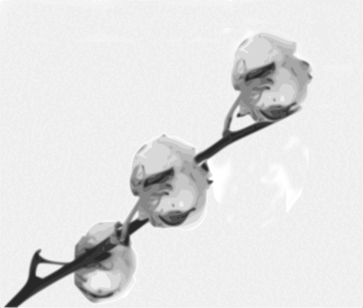
1 | 2 | 3
clustered | semi-clustered | non-clustered

Ad. 6 | to clearly display stigma (magnify plant part to be shown)  Leading Expert: To see new illustrations

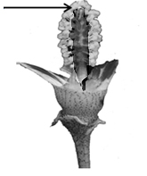 | 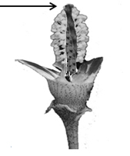 | 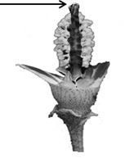
1 | 2 | 3
clearly below | same level | clearly above

Ad. 28 | “... on a sample of delinted seed.”  Leading Expert: agreed
Ad. 29 | to improve explanation (percentage of what?)  Leading Expert: The procedure to be followed is as follows:  - One sample of 500 grams of raw cotton is collected from each repetition. The sample is collected along the plot from capsules located in 1st and 2nd position of the lower fruit branches.  - The lint is separated from the seeds. The content of lint expresses as the percentage of lint in relation to raw cotton.  - The sample of lint, without seed, is sent to the laboratory for the realization of the analysis of length, resistance, elongation, fineness and uniformity.
8.3 | to add literature reference  Leading Expert: Meier U., 1997: Growth stages of mono- and dicotyledonous plants: BBCH-Monograph. Wien Federal Biological Research Center for Agriculture and Forestry, Blackwell Wissenschafts-Verlag, Berlin, DE.
9. | First two references should be amended according the usual way to present literature with all relevant information.  Leading Expert: We propose the literature as in the CVPVO protocol.  9. LITERATURE  American Society for Testing and Materials (ASTM) (1995): Standard Test.  Methods for Measurement of Cotton Fibres by High Volume Instruments (HVI).  (Motion Control Fiber Information System) (Designation: D4604-95).  American Society for Testing and Materials (ASTM) (1995), Standard Test Methods for Measurement of Physical Properties of Cotton Fibers by High Volume Instruments (Designation: D5867-95).  “Cotton”, Ed. R.J. Kohel and C.F. Lewis, no. 24 in the series “Agronomy”, American Society of Agronomy, Inc., Crop Science Society of America, Inc., Soil Science Society of America, Inc., Publishers Madison, Wisconsin, 1984, US.  “Cotton. Origin, History, Technology and Production.” Ed C.W. Smith and J.T. Cothren. Wiley Series in Crop Science. John Wiley & Sons, Inc.. 1999. US.  Manual de Identificación de Variedades de Algodón, Ministerio de Agricultura, Pesca y Alimentación, Secretaria General de Agricultura y Alimentación, 1999, ES.  Meier U., 1997: Growth stages of mono- and dicotyledonous plants: BBCH-Monograph. Wien Federal Biological Research Center for Agriculture and Forestry, Blackwell Wissenschafts-Verlag, Berlin, DE.
TQ 1 | to add box for species as 1.3  Leading Expert: agreed

[End of document]

