|  |  |
| --- | --- |
|  | E |
| International Union for the Protection of New Varieties of Plants |  |

|  |  |
| --- | --- |
| Technical Working Party for Agricultural Crops  Forty-Sixth Session  Hanover, Germany, June 19 to 23, 2017  Technical Working Party for Vegetables  Fifty-First Session  Roelofarendsveen, Netherlands, July 3 to 7, 2017  Technical Working Party for Ornamental Plants and Forest Trees  Fiftieth Session  Victoria, Canada, September 11 to 15, 2017  Technical Working Party for Fruit Crops  Forty-Eighth Session  Kelowna, Canada, September 18 to 22, 2017  Technical Working Party on Automation and Computer Programs  Thirty-Fifth Session  Buenos Aires, Argentina, November 14 to 17, 2017 | TWP/1/18  Original: English  Date: June 9, 2017 |

Illustrations for shape and ratio characteristics

Document prepared by the Office of the Union

Disclaimer: this document does not represent UPOV policies or guidance

# EXECUTIVE SUMMARY

The purpose of this document is to report on developments concerning the revision of guidance available in document TGP/14 on providing illustrations for shape and ratio characteristics.

The Technical Working Parties (TWPs) are invited to consider additional examples that might be provided in document TGP/14 in order to improve guidance on providing illustrations for shape and ratio characteristics.

The structure of this document is as follows:

EXECUTIVE SUMMARY 1

BACKGROUND 2

Guidance on SHAPE CHARACTERISTICS 2

Pseudo-qualitative characteristics 2

Components of shape 2

Illustrating shape characteristics 2

Developing Shape-Related Characteristics 3

Examples of Shape-Related Characteristics 3

Example 1: variation in ratio length/width only. 3

Example 2: variation in position of the broadest part only. 3

Example 3: variation in ratio length/width, shape of base and lateral outline 4

Example 4: variation in ratio height/diameter, position of broadest part and lateral outline in apical half 4

Example 5: variation between the range of shapes indicated by the illustrations: 5

Example 6: variation between range of shapes indicated by the illustrations: 5

additional examples 5

# BACKGROUND

The TC, at its fifty-third session, held in Geneva from April 3 to 5, 2017, agreed to improve guidance available in document TGP/14 on providing illustrations for shape and ratio characteristics by the inclusion of additional examples. The TC agreed to invite the TWPs, at their sessions in 2017, to consider the issue and report to the TC at its session in 2018 (see document TC/53/31 “Report”, paragraph 253).

# Guidance on SHAPE CHARACTERISTICS

## Pseudo-qualitative characteristics

Document TG/1/3 “General Introduction to the Examination of Distinctness, Uniformity and Stability and the Development of Harmonized Descriptions of New Varieties of Plants” (General Introduction) explains that shape can be considered in terms of a pseudo‑qualitative characteristic when each individual state of expression can be identified to adequately describe the range of the characteristic.

Document TGP/9 “Examining Distinctness” explains that the use of pseudo‑qualitative characteristics has limitations due to the difficult to define a general rule on the difference in Notes to establish distinctness within a characteristic.

## Components of shape

Document TGP/14 explains that it can be useful to develop quantitative or qualitative characteristics related to shape, rather than considering shape as a single pseudo qualitative characteristic. In that respect, document TGP/14 defines a plane shape using the following components:

(a) Ratio length/width (or ratio width/length, thickness/length, diameter/length, thickness/width);

(b) Position of broadest part;

(c) Shape of base;

(d) Shape of apex;

(e) Lateral outline.

## Illustrating shape characteristics

To ensure that the ratio length/width is clearly understood, document TGP/14 recommends to present the characteristic as a shape with states such as “very compressed” to “very elongated”, or to present the characteristic as “ratio length/width” with states such as “very low” to “very high” and to provide an illustration. Both alternative characteristics are placed as headers in the following “Chart for simple symmetric plane shapes” (partially reproduced). The position of broadest part is presented in different rows:

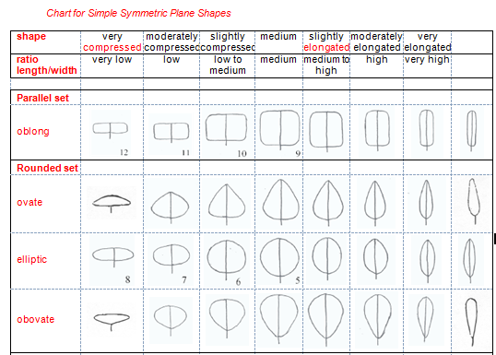

Document TGP/14 proposes the development of charts for other types of plane shapes by describing the ranges for ratio length/width and position of broadest, in a similar way to that shown in the Chart for Simple Symmetric Plane Shapes. The following are shapes used as example in document TGP/14:

|  |  |  |  |  |
| --- | --- | --- | --- | --- |
|  |  |  | New Picture |  |
| auriculiform | hastiform | sagittate | alate | trapezoidal |

## Developing Shape-Related Characteristics

Document TGP/14 explains that “in general, it can be most useful to consider the variation in shape between varieties in the variety collection using the following steps”:

Step 1: Ratio length/width;

Step 2: Position of broadest part;

Step 3: Shape of base;

Step 4: Shape of apex;

Step 5: Lateral outline.

## Examples of Shape-Related Characteristics

Document TGP/14 provide 6 examples of variation in full plane shape components (ratio length/width, position of broadest part and lateral outline) for the development of characteristics, either as characteristics for the individual components or as a single overall shape characteristic:

### Example 1: variation in ratio length/width only.

Alternative 1

Plant [part]: ratio length/width (low to high) (QN)

Alternative 2

Plant [part]: shape (broad obovate (1); medium obovate (2); narrow obovate (3)) (QN)

with the following illustration:

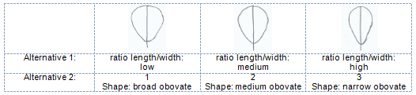

### Example 2: variation in position of the broadest part only.

Alternative 1

Plant [part]: position of broadest part (towards base to towards apex) (QN)

Alternative 2

Plant [part]: shape (ovate (1); elliptic (2); obovate (3)) (QN)

with the following illustration:

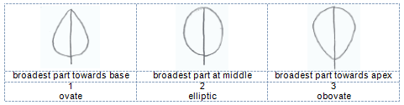

### Example 3: variation in ratio length/width, shape of base and lateral outline

Alternative 1

Plant [part]: ratio length/width (low to high) (QN)

Plant [part]: shape of base (acute, obtuse, rounded) (PQ)

Plant [part]: lateral outline (clearly rounded to clearly triangular) (QN)

Alternative 2

Plant [part]: shape (broad ovate (1); medium ovate (2); medium trullate (3); narrow ovate (4); narrow trullate (5)) (PQ)

with the following illustration:

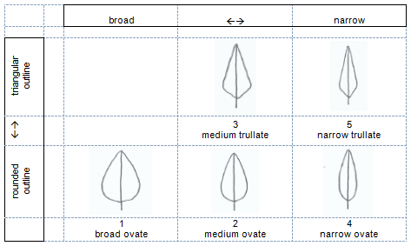

### Example 4: variation in ratio height/diameter, position of broadest part and lateral outline in apical half

Alternative 1

(a) ratio height/diameter (QN): very low (1); low (3); medium (5); high (7); very high (9);

(b) position of broadest part (QN): at middle (1); moderately towards base (2); strongly towards base (3);

(c) lateral outline in apical half (PQ): rounded (1); parallel (2); flat taper (3); concave (4)

Alternative 2

(a) ratio height/diameter (QN): very low (1); low (3); medium (5); high (7); very high (9);

(b) general shape (PQ): cylindrical waisted (1); conic (2); ovate (3); cylindric (4); elliptic (5)

with the following illustration:

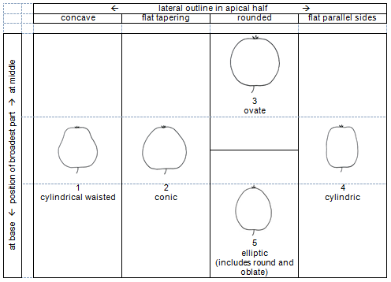

### Example 5: variation between the range of shapes indicated by the illustrations:

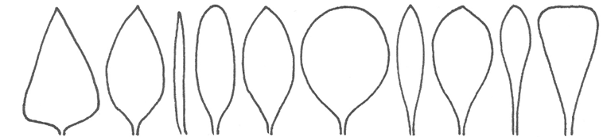

|  |  |
| --- | --- |
| Alternative 1 | with the following illustration: |
| (a) position of broadest part (QN): strongly towards base (1); moderately towards base (3); at middle (5); moderately towards apex (7); strongly towards  apex (9) |  |
| (b) ratio length/width (QN): very low (1); low (3); medium (5); high (7); very high (9); |
| Alternative 2 |
| General shape (PQ): triangular (1); ovate (2); circular (3); elliptic (4); oblong (5); linear (6); obovate (7); oblanceolate (8); spatulate (9); obtriangular (10) |
|  |

### Example 6: variation between range of shapes indicated by the illustrations:

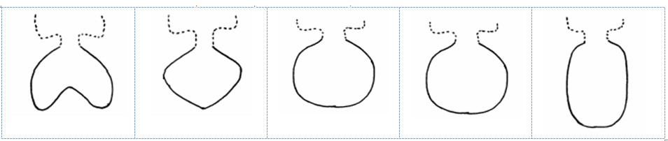

|  |  |
| --- | --- |
| Alternative 1 | with the following illustration: |
| (a) lateral outline (QL): e.g. reniform (1); rhombic (2); elliptic (3) |  |
| (b) ratio length/width (QN): e.g. low (1); medium (2); high (3); |
|  |
| Alternative 2 |
| General shape (PQ): reniform (1); rhombic (2); oblate (3); circular (4); elliptic (5) |
|  |

# additional examples

It is proposed that the TWPs consider additional examples that might be provided in document TGP/14 in order to improve this guidance.

*The TWPs are invited to consider additional examples that might be provided in document TGP/14 in order to improve guidance on providing illustrations for shape and ratio characteristics.*

[End of document]