E
International Union for the Protection of New Varieties of Plants

Technical Working Party for Agricultural Crops  Forty-Sixth Session  Hanover, Germany, June 19 to 23, 2017  Technical Working Party for Vegetables  Fifty-First Session  Roelofarendsveen, Netherlands, July 3 to 7, 2017  Technical Working Party for Ornamental Plants and Forest Trees  Fiftieth Session  Victoria, Canada, September 11 to 15, 2017  Technical Working Party for Fruit Crops  Forty-Eighth Session  Kelowna, Canada, September 18 to 22, 2017  Technical Working Party on Automation and Computer Programs  Thirty-Fifth Session  Buenos Aires, Argentina, November 14 to 17, 2017 | TWP/1/16  Original: English  Date: June 9, 2017
software for statistical analysis in DUS EXAMINATION
Document prepared by the Office of the Union
Disclaimer: this document does not represent UPOV policies or guidance

Executive summary

The purpose of this document is to report on the development of software for statistical analysis in the examination of distinctness, uniformity and stability (DUS).

The TWPs are invited to note the developments concerning software for statistical analysis in DUS examination, as set out in paragraphs 3 to 7 of this document.

background

Statistical methods used in the DUSTC software package

The TWC, at its thirty-fourth session, held in Shanghai, China, from June 7 to 10, 2016, received a presentation by an expert from China on “Statistical methods used in the DUSTC software package”, including a demonstration of the software package that incorporates statistical analysis procedures, including the methods for calculating COYU and COYD (see document TWC/34/32 “Report”, paragraph 89).

A ring-test comparing three different software packages for COYD

The TWC received a presentation by an expert from China on “A ring-test comparing three different software packages for COYD”, a copy of which is reproduced in the Annex to this document. The TWC noted that the same data set was used to compare results generated for the COYD procedure using the statistical packages developed in China (DUSTC), Germany (SAS) and the United Kingdom (DUST). The TWC noted that the three different software packages produced the same result (see document TWC/34/32 “Report”, paragraph 95).

A single tool for DUS computation process

The TWC received a presentation by an expert from France on “A single tool for DUS computation process”, a copy of which is reproduced in the Annex to document TWC/34/29. The TWC noted the integration of new functions in the GAIA software and use of the same interface for different processes, such as COYD and COYU, using the same data set (see document TWC/34/32 “Report”, paragraphs 92 to 94).

The TWC noted the changes to the data structure in the Excel file used to upload data to GAIA with the introduction of information on replicates and number of plants per replicate. The TWC noted that the improvements made would still allow GAIA to be available free of charge.

The TWC agreed to invite France to report on progress in the development of a single tool for DUS computation process at the thirty-fifth session of the TWC.

The TWPs are invited to note the developments concerning software for statistical analysis in DUS examination, as set out in paragraphs 3 to 7 of this document.

[Annex follows]

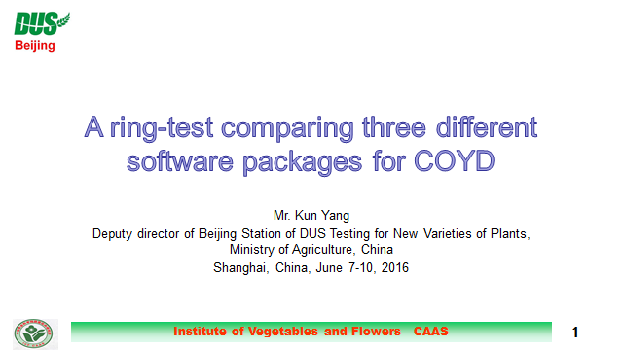

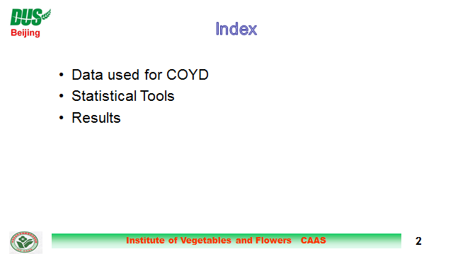

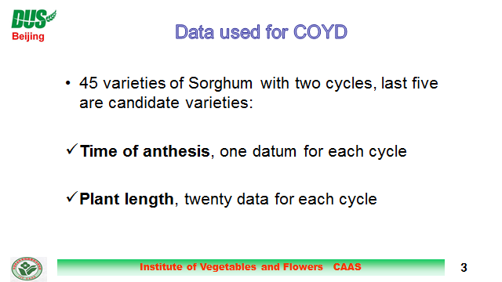

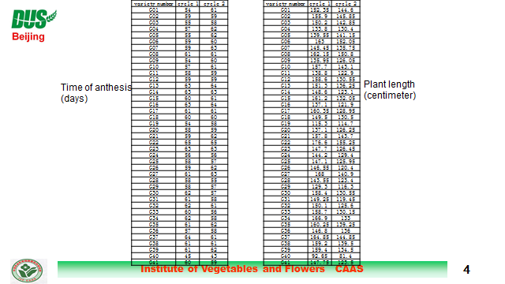

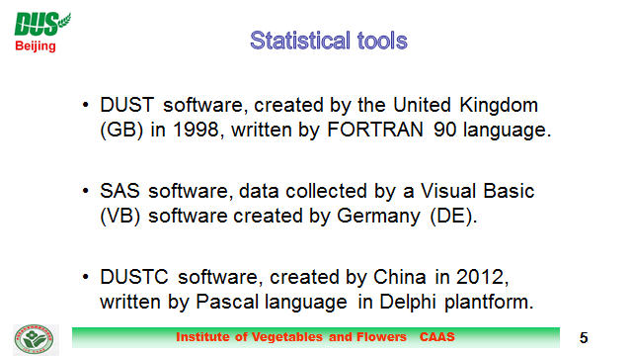

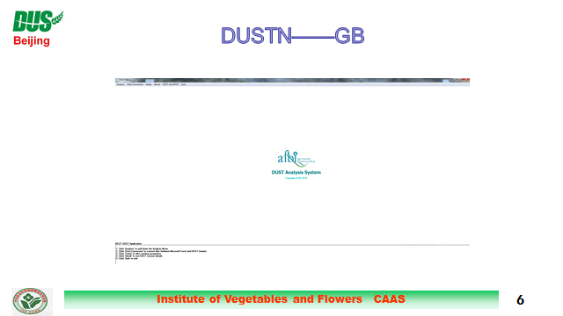

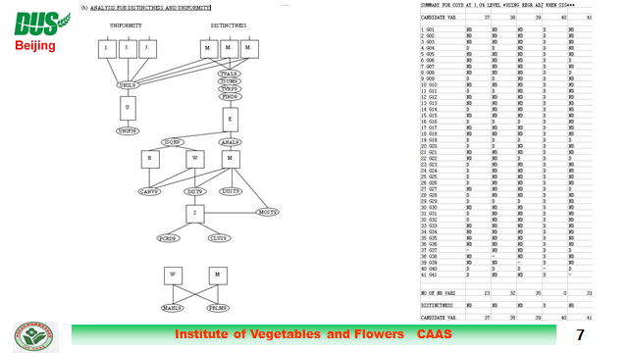

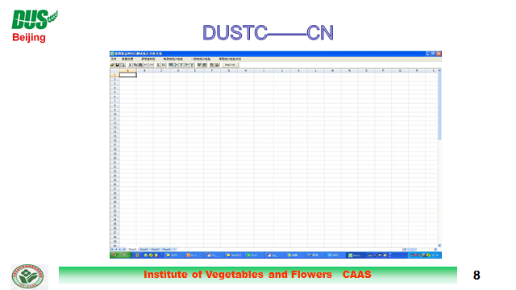

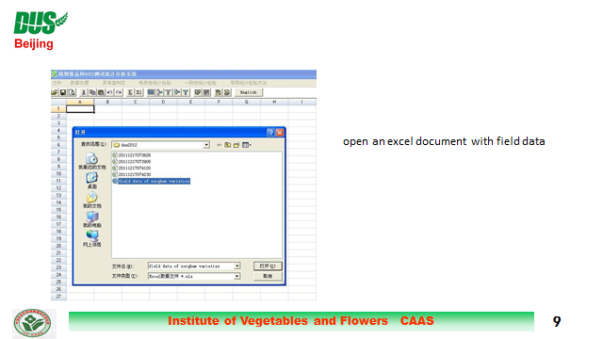

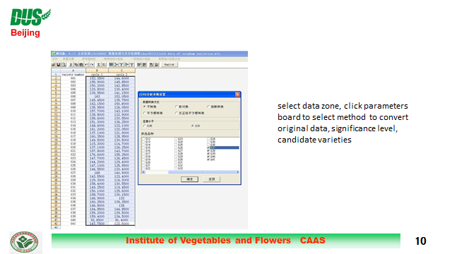

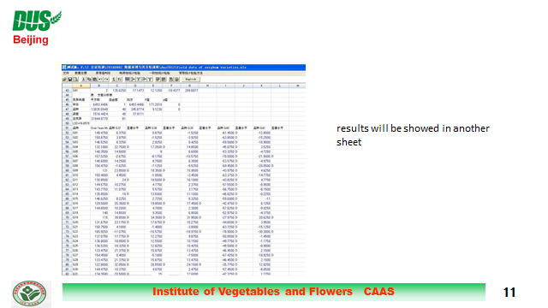

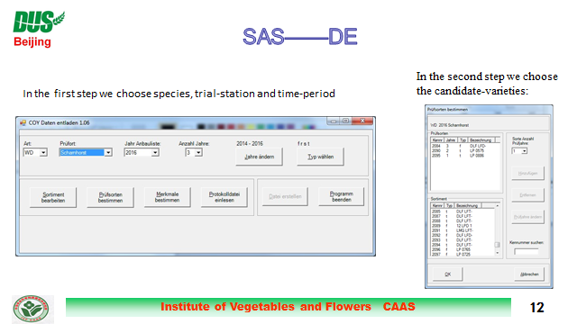

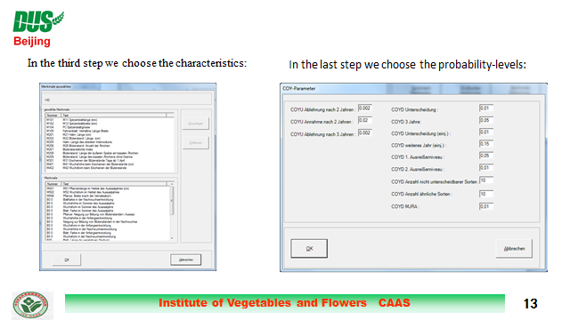

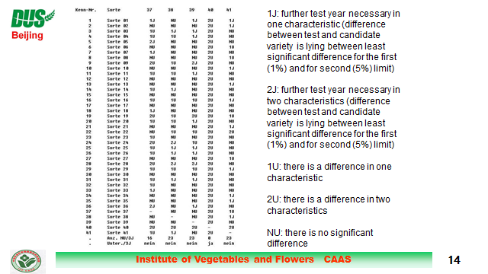

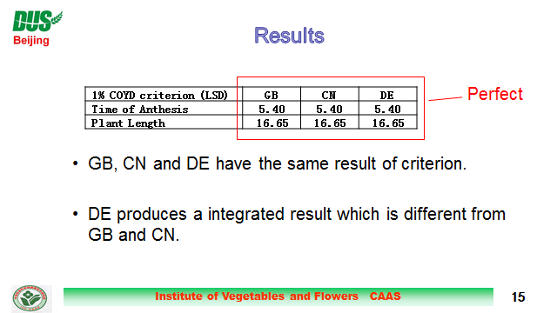

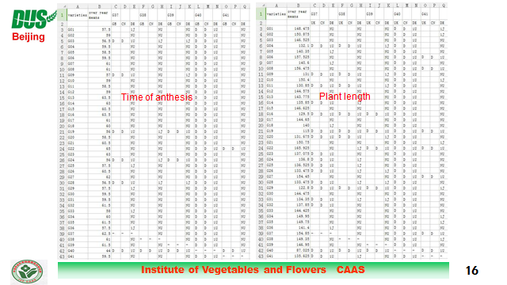

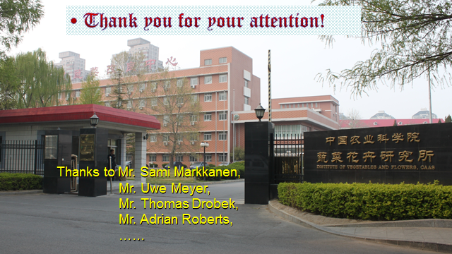

[End of Annex and of document]

