E
International Union for the Protection of New Varieties of Plants

Technical Working Party for Agricultural Crops  Forty-Sixth Session  Hanover, Germany, June 19 to 23, 2017 | TWA/46/8  Original: English  Date: June 7, 2017
Impact of using different numbers of growing cycles on DUS decisions using actual data
Document prepared by the Office of the Union
Disclaimer: this document does not represent UPOV policies or guidance

Executive summary

The purpose of this document is to provide examples on the impact of using different numbers of growing cycles on DUS decisions using actual data.

The TWA is invited to consider the information to be presented at its forty-sixth session on the impact of using different numbers of growing cycles on DUS decisions using actual data, as presented in Annexes I to III to this document.

Background

The background to this document is provided in document TWP/1/21 “Number of growing cycles in DUS examination”.

Information to be presented at the forty-sixth session of the TWA

The Annexes to this document contain the following information to be presented at the forty-sixth session of the TWA:

ANNEX I: “Impact of number of growing cycles on variety descriptions and discrimination power in wheat and barley”, document prepared by an expert from Germany
ANNEX II: “Number of growing cycles in potato varieties - DUS examination of lightsprouts”, presentation prepared by an expert from Poland
ANNEX III: “Number of growing cycles: the impact on cereal variety descriptions”, presentation prepared by an expert from the United Kingdom

The TWA is invited to consider the information to be presented at its forty-sixth session on the impact of using different numbers of growing cycles on DUS decisions using actual data, as presented in Annexes I to III to this document.

[Annexes follow]

TWA/46/8

ANNEX I

IMPACT OF NUMBER OF GROWING CYCLES ON VARIETY DESCRIPTIONS AND
DISCRIMINATION POWER IN WHEAT AND BARLEY

Document prepared by an expert from German

The impact of the number of growing cycles was analyzed for quantitative characteristics in wheat and barley on the basis of data from DUS trials.

Material and methods

Discrimination power of individual characteristics was calculated in three steps:

- ‘1 cycle’: Comparison of all varieties in the growing trial (year 0)
- ‘2 cycles’: For all varieties which were also grown in the year before, distinctness was assessed in both years (year 0 / -1). Two varieties are considered to be distinct if a clear difference in the same direction was observed in both years.
- ‘2 out of 3 cycles’: For all varieties which were also grown the two previous years, distinctness was assessed in all 3 years (year 0 / -1 / -2). Two varieties are considered to be distinct if a clear difference in the same direction was observed in at least 2 out of 3 years.

The German DUS growing trials comprise about 600 varieties in winter wheat and 300 varieties in winter barley. Three year data are available for about 50% of the varieties and two year data for about 70% of the varieties. Every year, the distinctness test includes about 40,000 pairwise 1-cycle-comparisons in wheat and 30,000 in barley (under consideration of some grouping characteristics). About 25,000 2-cycle-comparisons and 15,000 2 out of 3 comparisons were considered in wheat, 15,000 and 6,000 in barley, respectively.

The same analysis was performed for 2014, 2015 and 2016. The discrimination power was calculated in percent pairwise comparisons in which a clear difference was observed. The mean discrimination power over the three years was calculated

A different data set was used to calculate the impact of the number of growing cycles on variety descriptions. DUS observations for 77 winter wheat varieties and 47 winter barley varieties in 6 successive growing cycles were used to establish annual descriptions (year 0). In addition, descriptions over 2 cycles (year 0 / -1) and 3 cycles (year 0 / -1 / -2) were established. The variation of descriptions over one, two and three cycles was calculated.

Results

Discrimination power

The mean discrimination power over the three years is presented in figure 1 and 2. The decision on distinctness was significantly influenced by the number of growing cycles. A clear difference observed in the first cycle was not always confirmed in the second cycle. Consequently, the discrimination power was lower after 2 cycles in most of the characteristics. A clear difference observed in only one of the years may be confirmed in a third year, resulting in a higher discrimination power in 2 out of 3 cycles.

A few characteristics in wheat did not follow this principle, see figure 2: grain coloration with phenol, lower glume beak shape, awns or scurs length and straw pith in cross section. A low 1-cycle-discrimination power was observed for these characteristics. This result may be attributed to the fact that the expression of these characteristics is not evenly distributed in the collection. The low mean discrimination power in 1-cycle comparisons could be caused by a different distribution in the varieties in the first year (about 30% of all varieties). Environmental effects can also have an impact on the discrimination power in some years.

Variety descriptions

The variation of descriptions over one, two and three cycles is illustrated in figures 3 and 4. Annual variety descriptions show a higher variation than descriptions over two and three years for all characteristics in both species. The stability of descriptions is much higher after two cycles and can be further improved by a third cycle.

Conclusion

The study has shown that the number of growing cycles has a significant impact on distinctness decisions and variety descriptions. It confirms the current recommendation in the Test Guidelines for barley and wheat which reads as follows: “The minimum duration of test should normally be two independent growing cycles”.

The recommended minimum duration of test should be followed to establish the official variety description. Reliability and stability of the description is a precondition for enforcement.

Descriptions also play an important role for the management of references collections, in particular when databases with descriptions for varieties of common knowledge are used for the selection of similar varieties for the growing trial. The possible error of descriptions has to be taken into account for any comparison. The exclusion of varieties from the growing trial is a crucial step in the distinctness test. Normally, the error for descriptions of candidate varieties is quite high at the beginning of test. The most important is to limit the error of descriptions of reference varieties by feeding the database with sufficiently stable descriptions. All descriptions in a database should be based at least on the recommended minimum number of growing cycles. Any additional cycle can improve the quality of the description.

Figure 1: Winter barley - Impact of the number of growing cycles on discrimination power

Figure 2: Winter wheat - Impact of the number of growing cycles on discrimination power

Figure 3: Winter barley – variance of variety descriptions over testing periods

Figure 4: Winter wheat – variance of variety descriptions over testing periods

[Annex II follows]

TWA/46/8

ANNEX II

NUMBER OF GROWING CYCLES IN POTATO VARIETIES - DUS EXAMINATION OF LIGHTSPROUTS

Presentation prepared by an expert from Poland

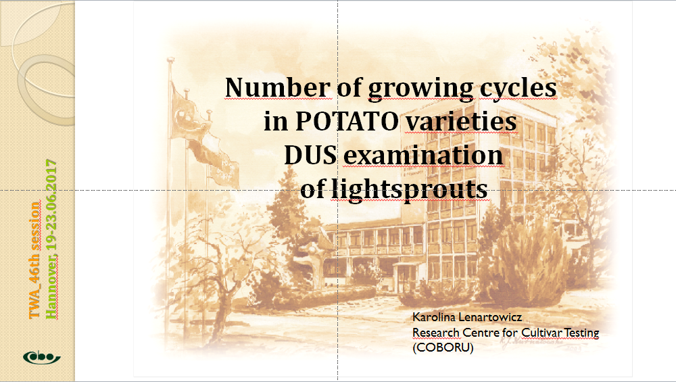

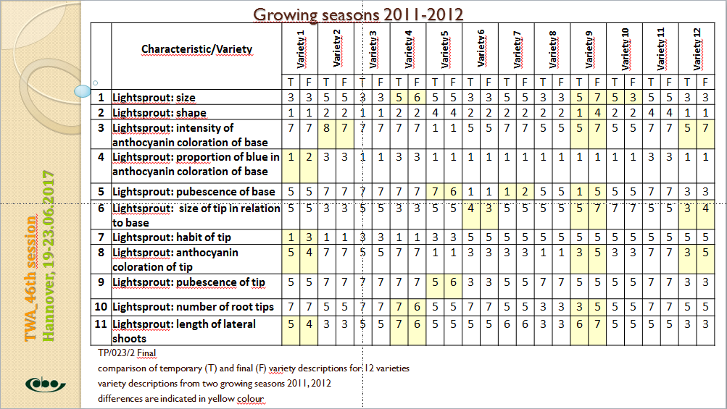

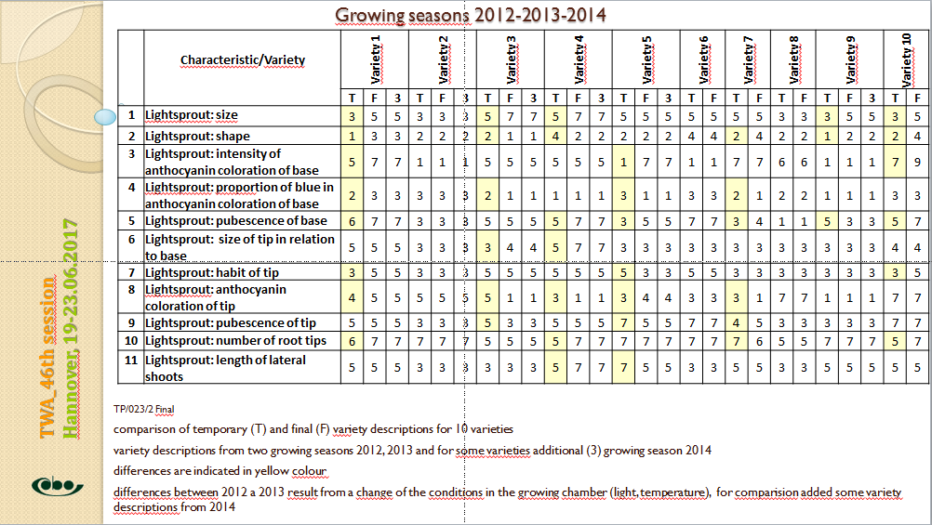

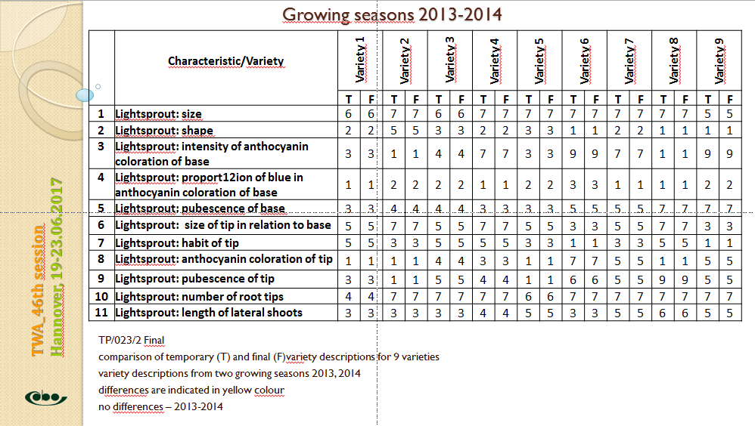

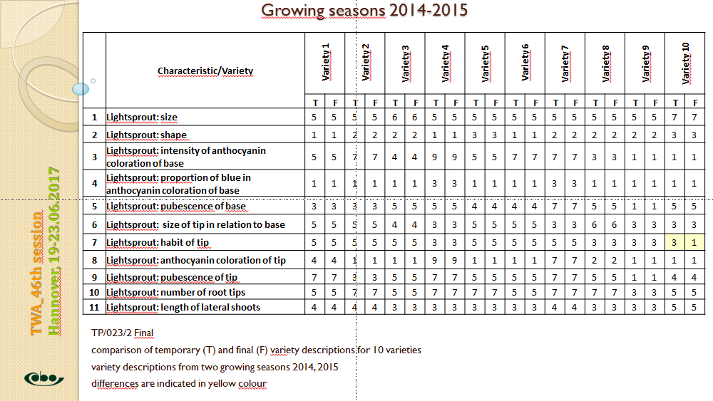

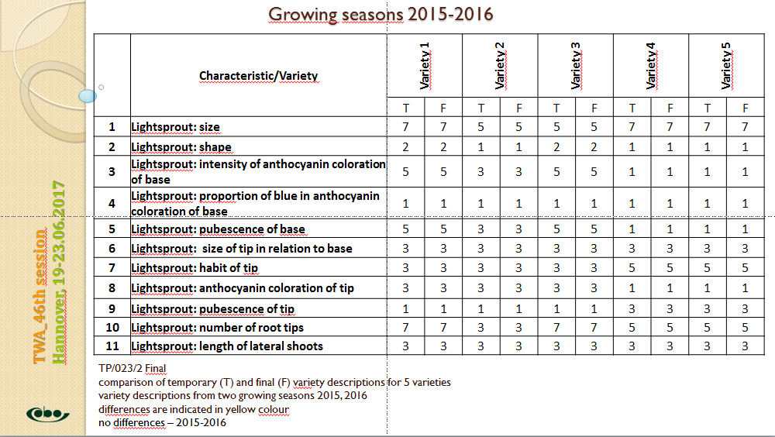

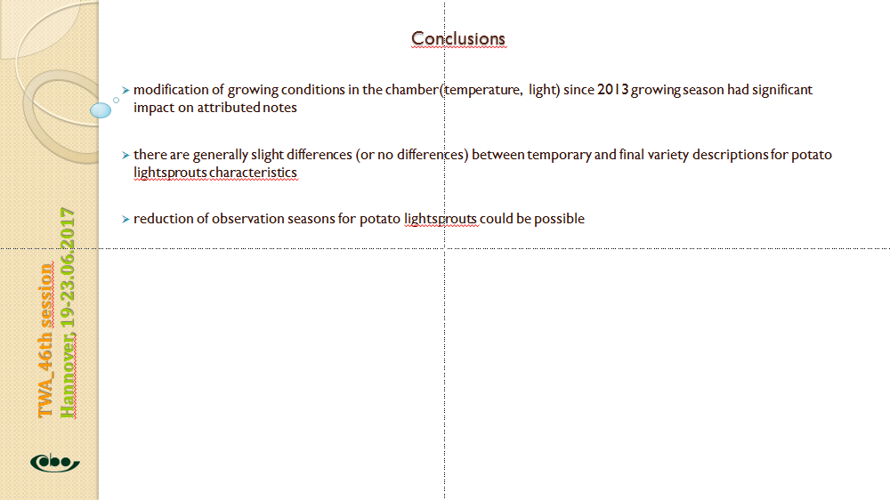

[Annex III follows]

TWA/46/8

ANNEX III

NUMBER OF GROWING CYCLES: THE IMPACT ON CEREAL VARIETY DESCRIPTIONS

Presentation prepared by an expert from the United Kingdom

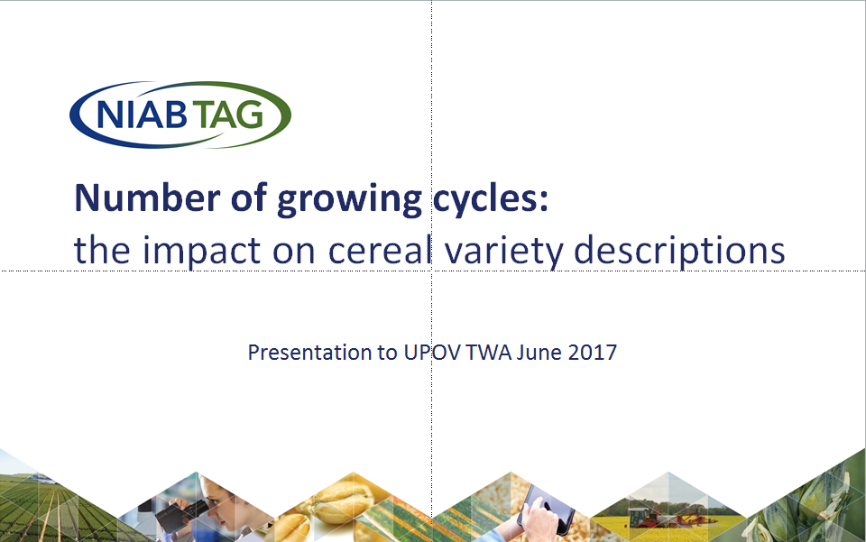

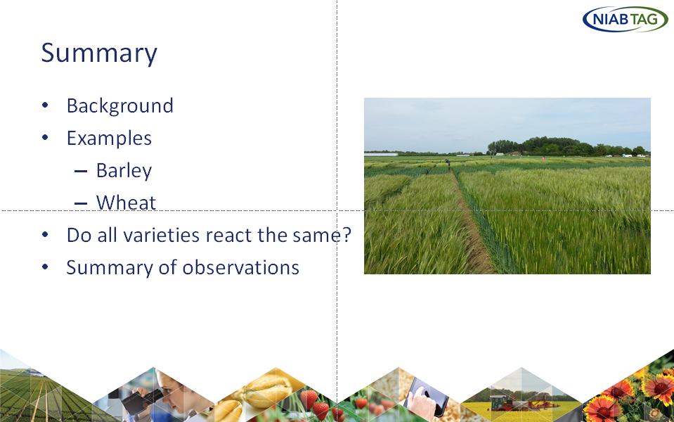

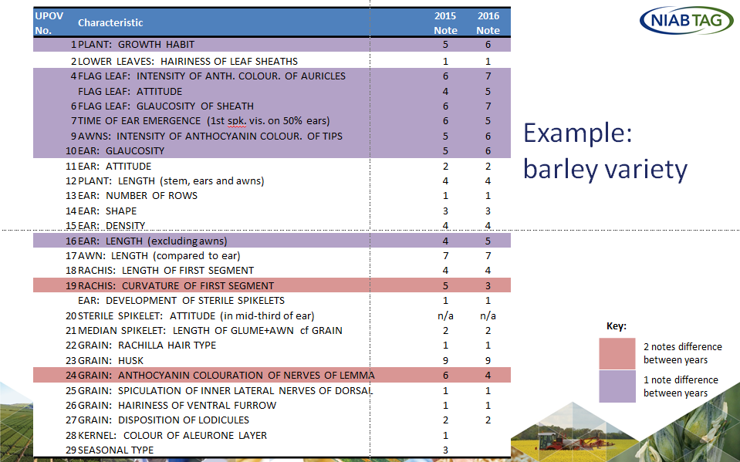

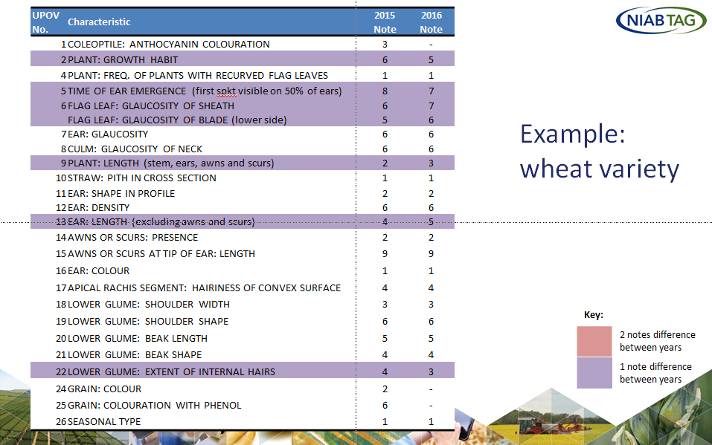

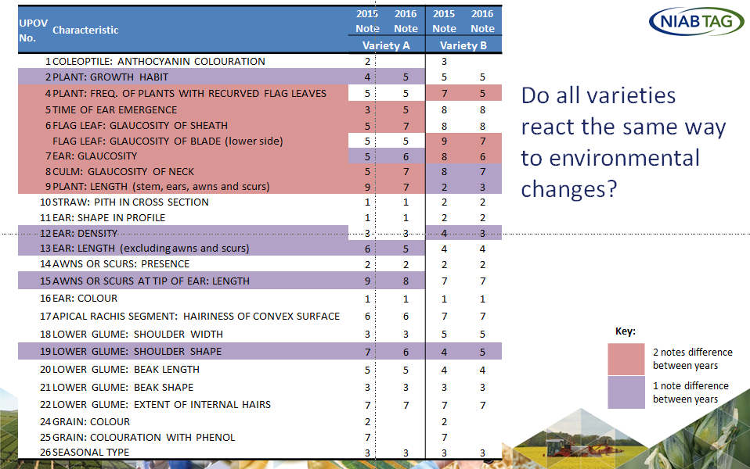

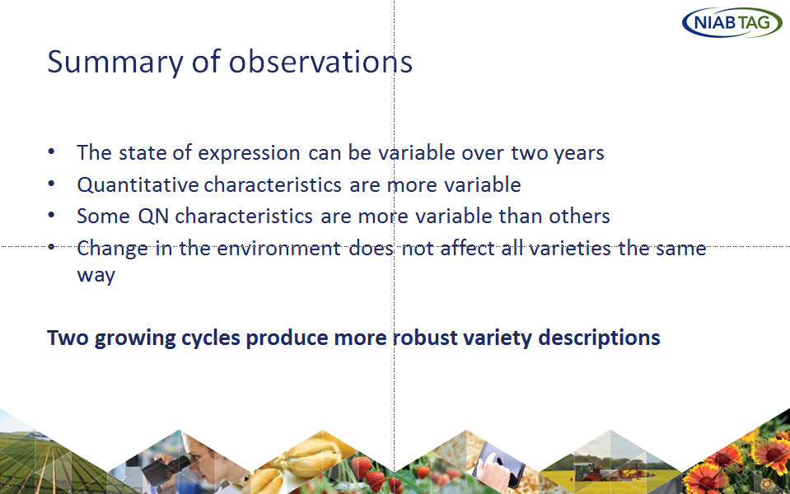

[End of Annex III and of document]

