E
International Union for the Protection of New Varieties of Plants

Technical Working Party for Agricultural Crops  Forty-Sixth Session  Hanover, Germany, June 19 to 23, 2017 | TWA/46/7 Add.  Original: English  Date: July 18, 2017
addendum to
Use of disease and insect resistance characteristics in DUS examination
Document prepared by the Office of the Union
Disclaimer: this document does not represent UPOV policies or guidance
The Annex to this document contains a copy of a presentation on “Use of disease and insect resistance characteristics for Soybean DUS testing”, prepared by an expert from Brazil that was made at the forty-sixth session of the Technical Working Party for Agricultural Crops (TWA).

[Annex follows]

TWA/46/7 Add.

ANNEX

USE OF DISEASE AND INSECT RESISTANCE CHARACTERISTICS FOR SOYBEAN DUS TESTING

Presentation prepared by an expert from Brazil

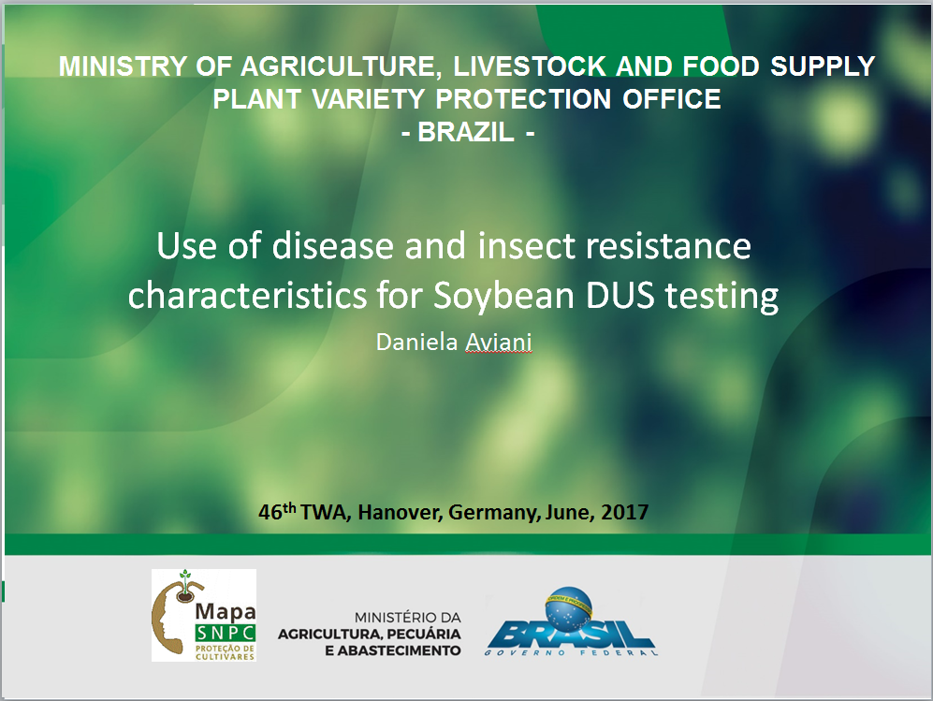

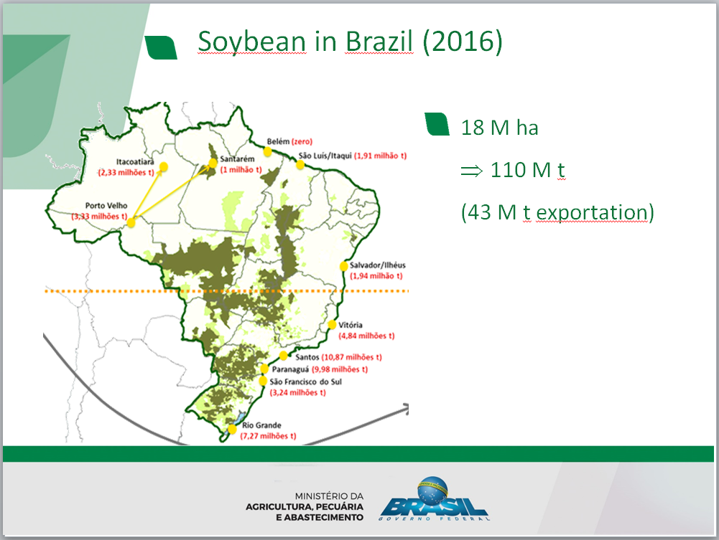

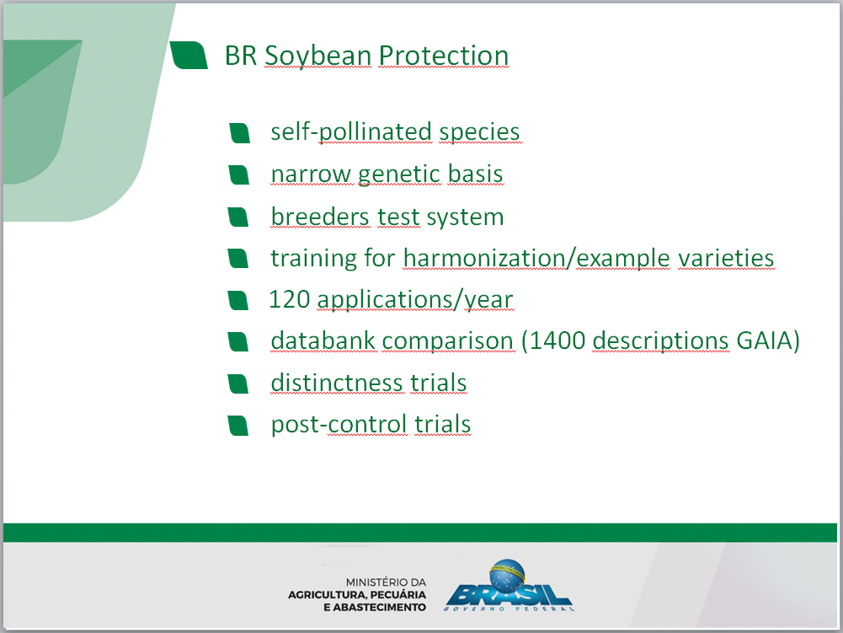

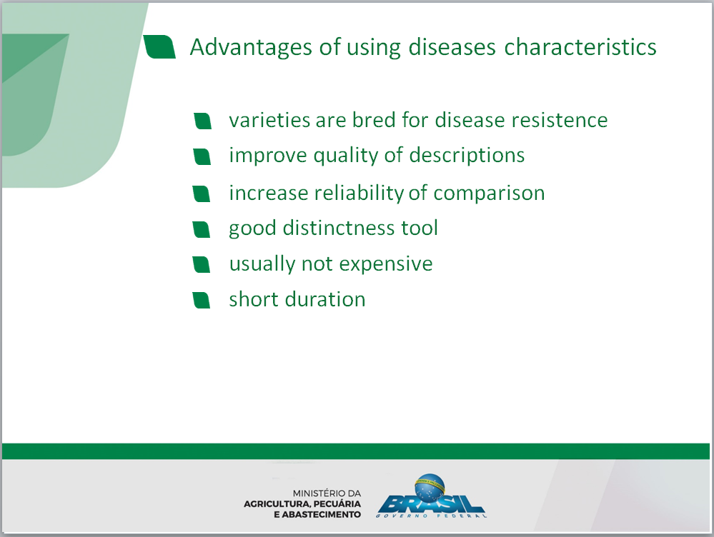

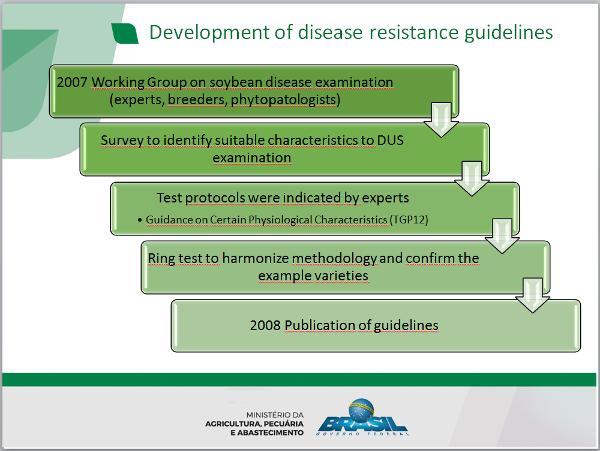

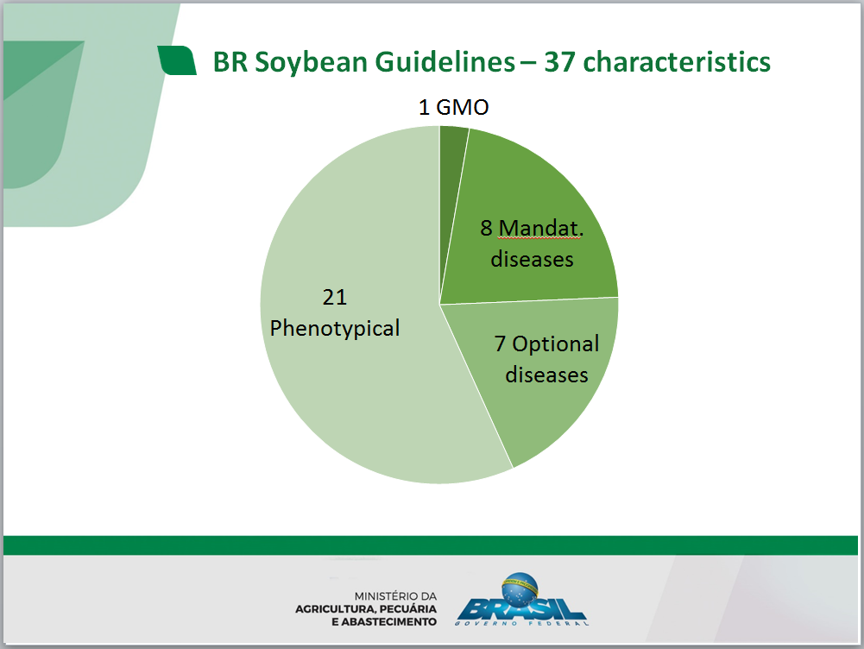

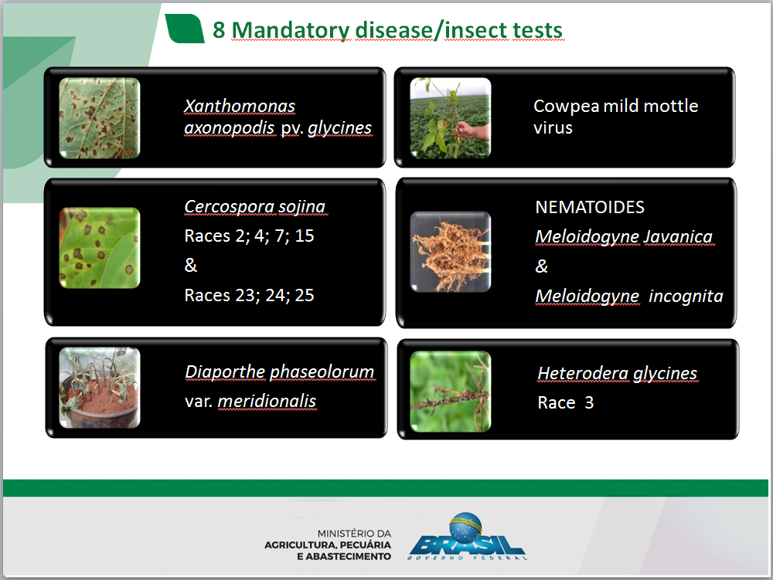

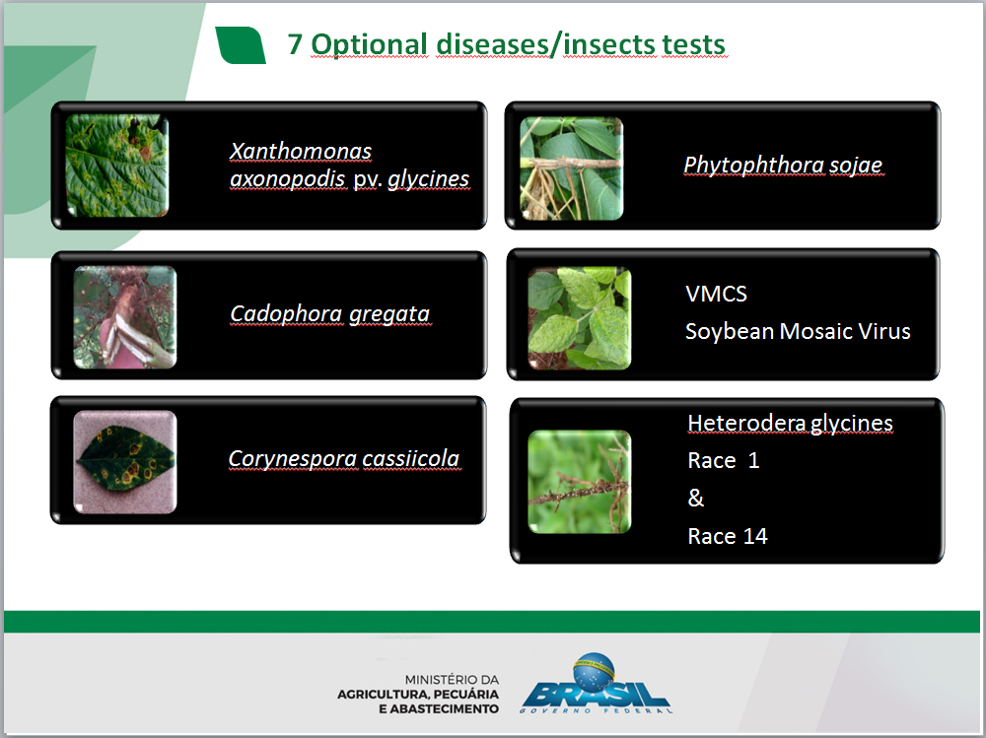

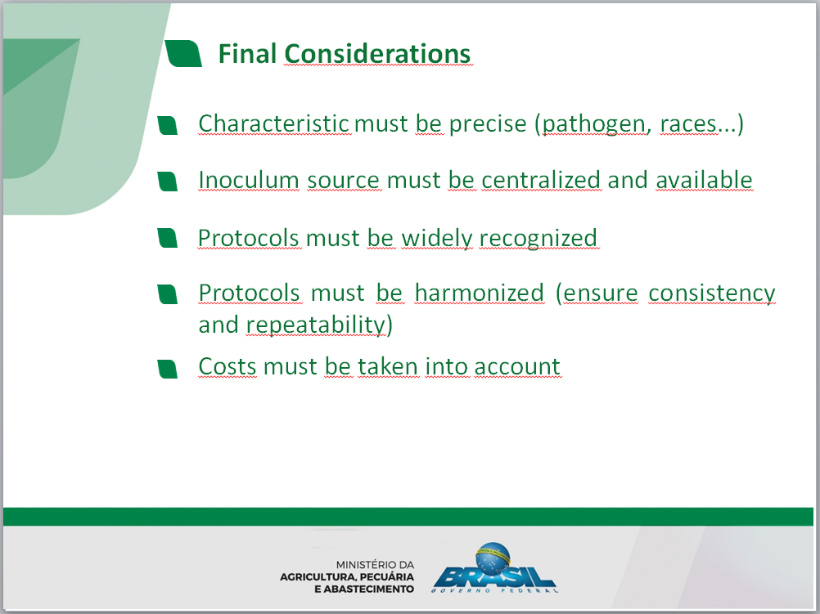

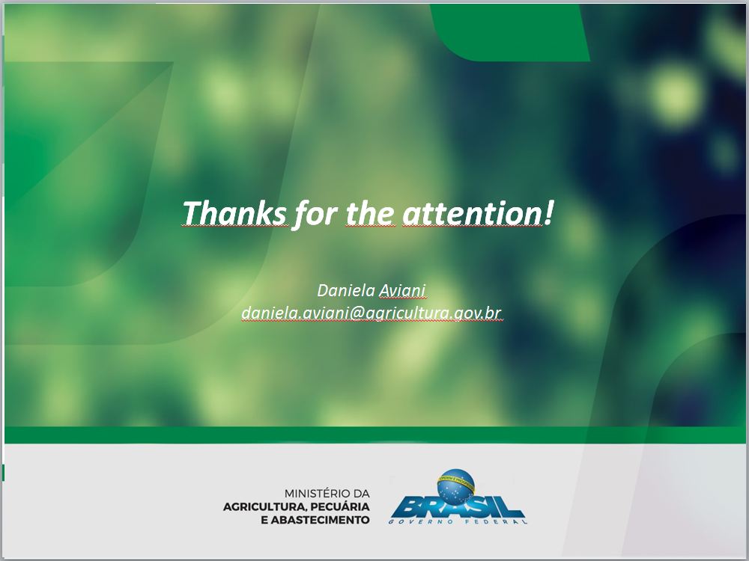

[End of Annex and of document]

