E
International Union for the Protection of New Varieties of Plants

Technical Working Party for Agricultural Crops  Forty-Sixth Session  Hanover, Germany, June 19 to 23, 2017 | TWA/46/7  Original: English  Date: June 7, 2017
Use of disease and insect resistance characteristics in DUS examination
Document prepared by the Office of the Union
Disclaimer: this document does not represent UPOV policies or guidance

Executive summary

The purpose of this document is to report on developments concerning the use of disease and insect resistance characteristics in DUS examination.

The TWA is invited to consider the information to be presented at its forty-sixth session on the use of disease and insect resistance characteristics in DUS examination, as presented in Annexes I to IV to this document.

Background

Technical Working Party for Vegetables

The TWV, at its fiftieth session, held in Brno, Czech Republic, from June 27 to July 1, 2016, considered documents TWV/50/21 and TWV/50/21 Add. Rev. “Use of disease and insect resistance characteristics in DUS examination” (see document TWV/50/25 “Report”, paragraphs 61 to 67).

The TWV noted that the use of a characteristic for DUS purposes did not mean that it would need to become a breeding aim, and vice-versa. The use of a disease or insect resistance characteristic for DUS purposes did not require breeders to select for that characteristic in their breeding programs, but would require them to ensure varieties were uniform and stable for the characteristic, in the same way as for other DUS characteristics.

The TWV noted the approach by the European Union for their Test protocols, and considered the proposal with regard to the idea of phasing-in asterisked characteristics (which lead to obligatory testing in CPVO Protocols over a period of time) in UPOV Test Guidelines, as presented in document TWV/50/21. The TWV agreed that more time was needed for members of the Union to consider if such an approach would be appropriate.

The TWV welcomed the information provided on “MatRef: a national network managing seeds and strains for disease resistance tests”, by the expert from France, and “Harmonization of resistance tests to diseases for DUS testing: Harmores 2”, by the expert from the Community Plant Variety Office of the European Union (CPVO), as reproduced in document TWV/50/21 Add. Rev. It agreed that it would be useful to have an update on those projects at its fifty-first session and also to present information to the Technical Committee (TC), at its fifty-third session, under the discussion item “Use of disease and insect resistance characteristics in DUS examination”.

The TWV noted that the approach presented in document TWV/50/21 Add. Rev. was based on the use of molecular data obtained by the DUS examination office to verify information on disease resistance provided by the applicant in the Technical Questionnaire. If the molecular data was consistent with the information provided by the applicant, the DUS examination would be based on the molecular data but if there was a discrepancy, or the applicants did not test, a bioassay would be used for the DUS examination. The TWV considered that it might be necessary to request confirmation from the applicant that the information provided on disease resistance was based on a bioassay and, if that was not the case, a bioassay would need to be used for the DUS examination. Such an approach could then be proposed for inclusion in the UPOV Test Guidelines.

The TWV noted that the above approach was consistent with the model “Characteristic-Specific Molecular Markers”, as set out in TGP/15 “Guidance on the Use of Biochemical and Molecular Markers in the Examination of Distinctness, Uniformity and Stability (DUS)”. It further noted that the above approach verified the reliability of the link between the molecular marker and the disease resistance characteristic for every candidate variety.

The TWV agreed that it would be valuable for the above approach to be presented to the TC, at its fifty-third session, under the discussion item “Use of disease and insect resistance characteristics in DUS examination”.

Technical Working Party for Agricultural Crops

The TWA, at its forty-fifth session, held in Mexico City, from July 11 to 15, 2016, agreed to invite experts from Brazil, the European Union and France to prepare documents on the use of disease and insect resistance characteristics in DUS examination (see document TWA/45/25 “Report”, paragraph 124).

Technical Committee

The TC, at its fifty-third session, held in Geneva from April 3 to 7, 2017, noted developments in the TWV and TWA concerning the use of disease and insect resistance characteristics in DUS examination (see document TC/53/31 “Report”, paragraph 106).

Information to be presented at the forty-sixth session of the TWA

The Annexes to this document contain the following information to be presented at the forty-sixth session of the TWA:

ANNEX I: “Rust Resistance as DUS Characteristics in Wheat”, presentation prepared by an expert from Australia
ANNEX II: “Use of disease and insect resistance characteristics in DUS examination: experience of Brazil with soybean”, document prepared by an expert from Brazil
ANNEX III: “Harmonization of resistance tests for DUS testing: ‘Harmores 2’”, presentation prepared by an expert from the European Union
ANNEX IV: “Phasing-in period for asterisked disease resistance characteristics in CPVO vegetable technical protocols”, presentation prepared by an expert from the European Union

The TWA is invited to consider the information to be presented at its forty-sixth session on the use of disease and insect resistance characteristics in DUS examination, as presented in Annexes I to IV to this document.

[Annexes follow]

TWA/46/7

ANNEX I

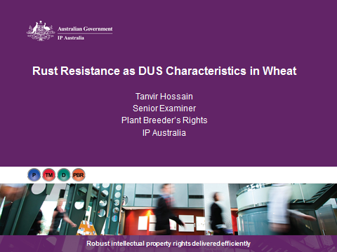

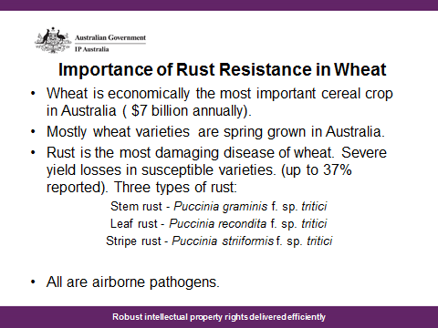

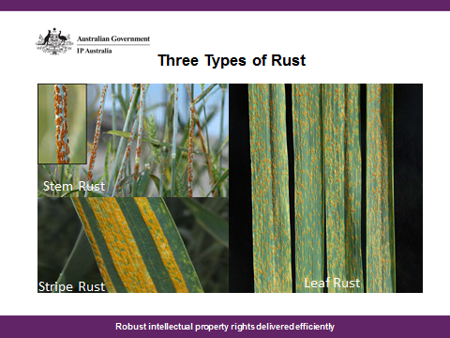

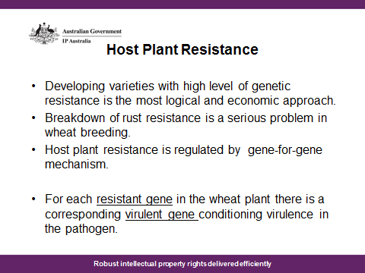

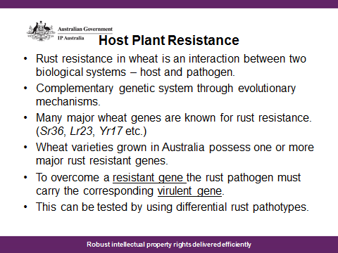

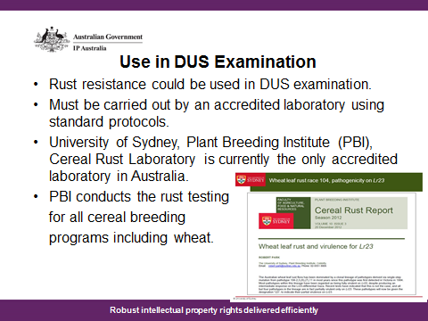

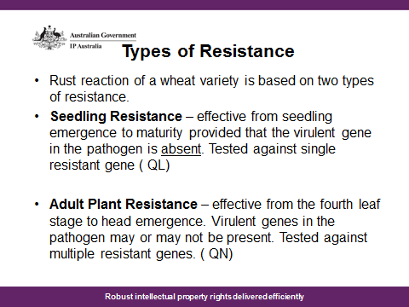

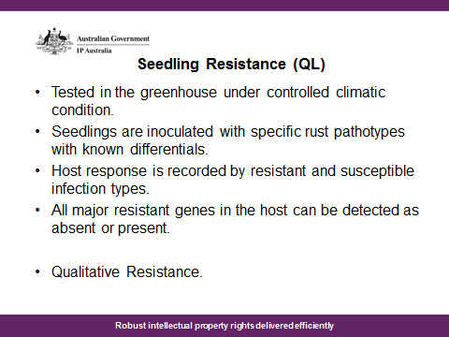

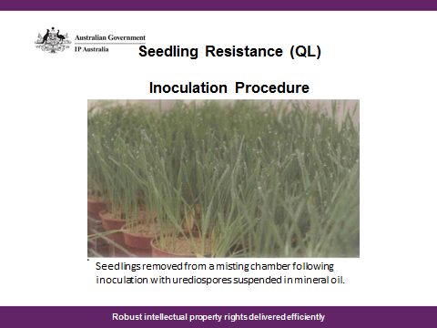

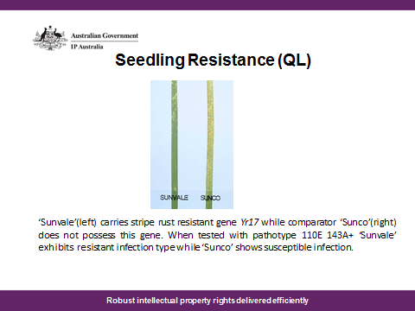

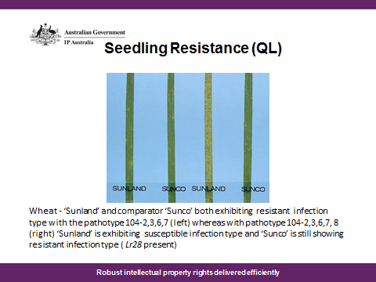

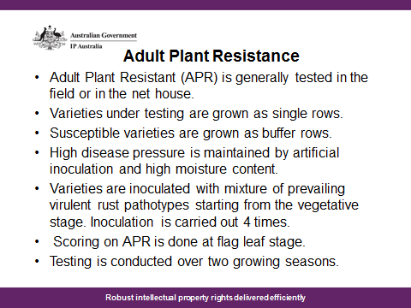

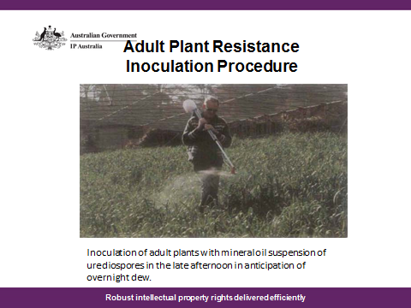

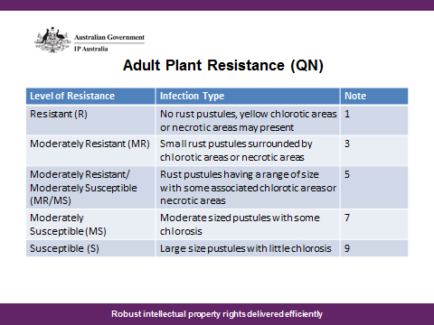

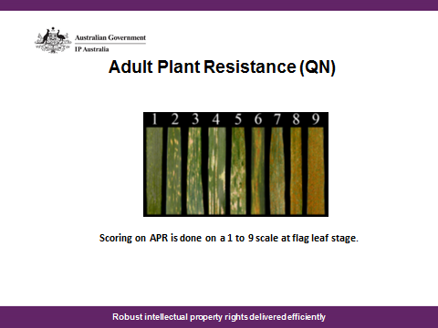

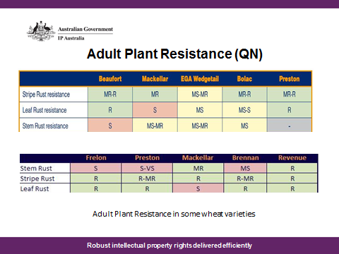

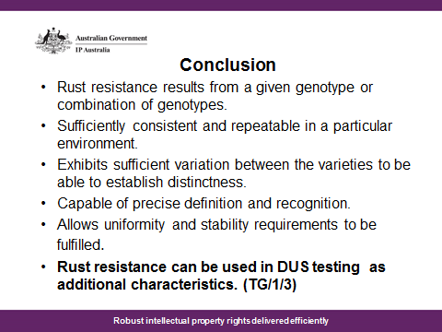

[Annex II follows]

TWA/46/7

ANNEX II

USE OF DISEASE AND INSECT RESISTANCE CHARACTERISTICS IN DUS EXAMINATION:
EXPERIENCE OF BRAZIL WITH SOYBEAN

Document prepared by an expert from Brazil

Disease and insect resistance as a characteristic

Document TG/1/3, chapter 4.6.1 states that characteristics based on the response to external factors, such as living organisms, may be used in DUS tests provided that they fulfil the criteria specified for selection of characteristics. Nevertheless, considering the potential variation in such external factors, it is important for those characteristics to be well defined and have an appropriate method established to ensure consistency in the examination.

Considering these points, the Brazilian PVP Office (SNPC) started in 2007 a workplan in order to define disease resistance characteristics to be used in the DUS tests of soybean (Glycine max (L.) Merrill).

Variety protection of soybean in Brazil

By the end of 2016, the SNPC had received 1346 PVP applications for Soybean varieties.

Despite the high number of applications, the candidate varieties have a narrow genetic basis, because of the low number of ancestors used in the breeding programs. Thus, from 2005, the assessment of distinctness based on morphological characteristics became a problem.

At that time, disease resistance characteristics used in the national test guidelines contained no harmonized protocol for examination.

Considering that disease resistance is one of the main purposes of breeding programs and the need of increasing the number of characteristics to distinguish the new varieties, the SNPC decided to improve the use of such characteristics for DUS examination.

In this regard, through the indication of breeding companies and invitation of the SNPC, a working group of experts consisting of phytopatologists and breeders was established and a schedule of meetings was planned for a year. The objective was to review and suggest disease characteristics to be used on the DUS test guidelines and to define standard protocols to be used. The work was conducted as follows:

- The SNPC carried out a previous research and conducted a survey with the breeders and phytopatologists to identify which disease characteristics would be appropriate for DUS examination;
- The working group of experts decided to distribute the diseases according to the specialty of each member. A protocol for testing would be suggested based on scientific world-wide knowledge, the genetic inheritance of the characteristic and designed according to the recommendations of UPOV, particularly the guidance provided in document TGP/12 “Guidance on Certain Physiological Characteristics”. The example varieties for each level of expression should also be indicated.
- The designated experts circulated the protocol among themselves for improvements and suggestions before being submitted to the approval of the working group.
- A ring test was organized with laboratories and breeders to harmonize the methodology and compare the results amongst different companies, locations and over time.
- The characteristics were classified as mandatory or optional, regarding the fulfillment of the official variety description, according to the reliability of the methodologies to access distinctness, taking into account the repeatability and distribution of occurrence across the country (in the case of field evaluations).
- The working group also identified the critical points that could compromise the performance of the tests when they were carried out by different laboratories or breeders and concluded that once the protocols and example varieties had been defined, the inoculum should be also standardized, by centralizing its source. Thereby, two institutions were recommended as suppliers of the inoculums to be used in DUS testing.
- The working group meetings resulted on the publication, in September 2008, of the new Brazilian DUS test guidelines with 8 mandatory and 7 optional disease resistance characteristics and their specific protocols.
- The characteristics and protocols can be accessed in these two documents (in Portuguese only):
  - http://www.agricultura.gov.br/assuntos/insumos-agropecuarios/insumos-agricolas/protecao-de-cultivar/arquivos-agricolas/soja_formulario_novo_29out2009_p-2.doc; and
  - http://www.agricultura.gov.br/assuntos/insumos-agropecuarios/insumos-agricolas/protecao-de-cultivar/arquivos-agricolas/soja_anexo_ii_-_protocolos_doen-c7as_p.doc.

Conclusion

Considering the work carried out, we can point out that the use of disease resistance characteristics in DUS is an important tool for the authorities, especially considering its usefulness for establishing distinctness and for grouping varieties on DUS trials.

Nevertheless, its establishment must be carefully considered and analyzed particularly regarding the following points:

- The characteristics shall be defined case by case, considering the peculiarities of the pathogen and the species concerned;
- The protocols shall be harmonized and ring tested to ensure consistency and repeatability;
- The inoculum source shall be as centralized as possible (if tests are carried out by different laboratories);
- The test protocols used shall be widely recognized;
- The cost associated with the use of disease resistance characteristics for DUS examination should be considered.

[Annex III follows]

TWA/46/7

ANNEX III

HARMONIZATION OF RESISTANCE TESTS FOR DUS TESTING: “HARMORES 2”

Document prepared by an expert from the European Union

[Annex IV follows]

TWA/46/7

ANNEX IV

PHASING-IN PERIOD FOR ASTERISKED DISEASE RESISTANCE CHARACTERISTICS
IN CPVO VEGETABLE TECHNICAL PROTOCOLS

Document prepared by an expert from the European Union

[End of Annex IV and of document]

