E
International Union for the Protection of New Varieties of Plants

Technical Working Party for Agricultural Crops  Forty-Sixth Session  Hannover, Germany, June 19 to 23, 2017 | TWA/46/6 Add. Rev.  Original: English  Date: July 18, 2017
revised ADDENDUM TO
New Method to Guarantee Minimum Distance between Varieties in Measured Quantitative Characteristics for Distinctness and harmonization between upov members
Document prepared by the Office of the Union

Disclaimer: this document does not represent UPOV policies or guidance
The Annex to this document contains a copy of a presentation on “New method to guarantee minimum distance between varieties in measured quantitative characteristics for distinctness and harmonization between UPOV members”, prepared by an expert from the Republic of Korea that was made at the forty-sixth session of the Technical Working Party for Agricultural Crops (TWA).

[Annex follows]

TWA/46/6 Add. Rev.

ANNEX

NEW METHOD TO GUARANTEE MINIMUM DISTANCE BETWEEN VARIETIES IN
MEASURED QUANTITATIVE CHARACTERISTICS FOR DISTINCTNESS AND HARMONIZATION BETWEEN UPOV MEMBERS”

Presentation prepared by an expert from the Republic of Korea

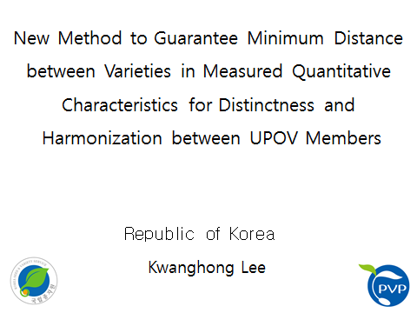

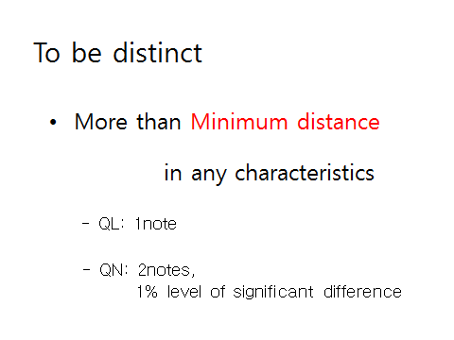

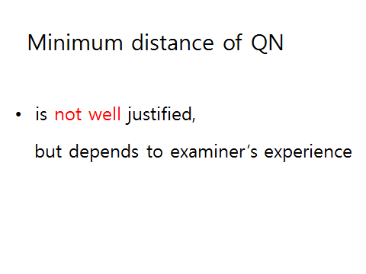

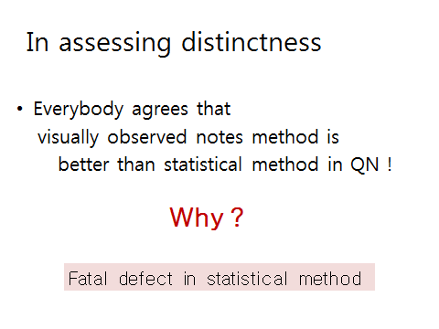

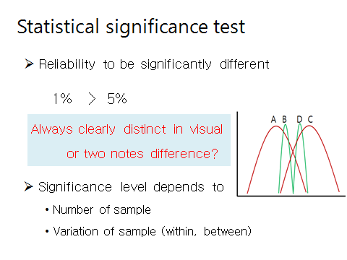

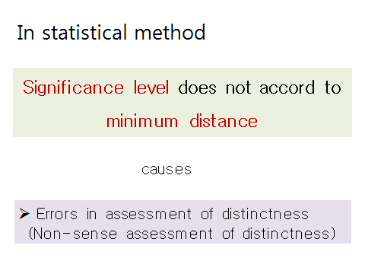

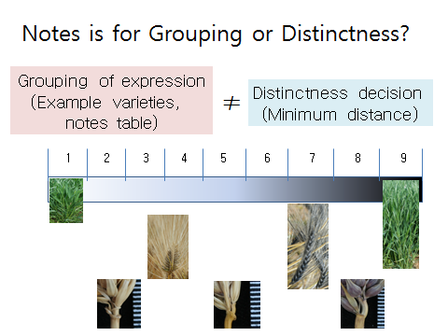

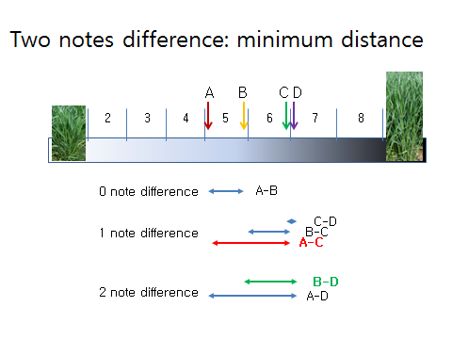

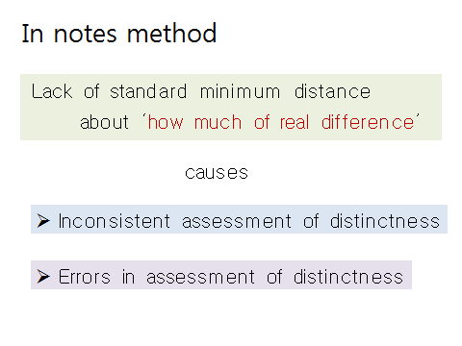

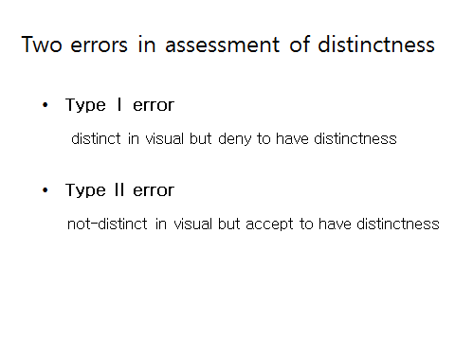

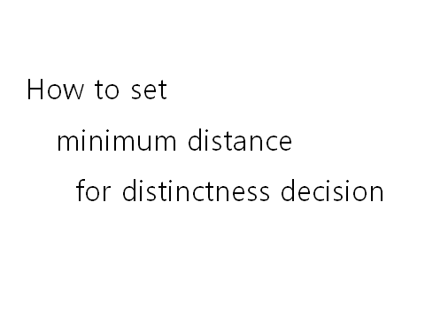

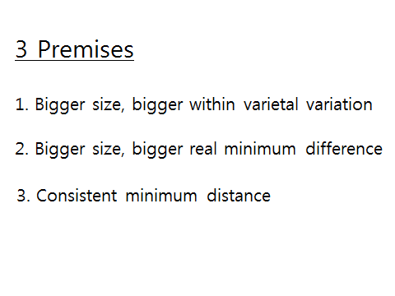

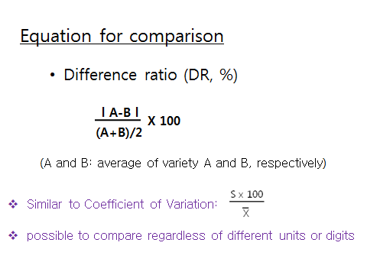

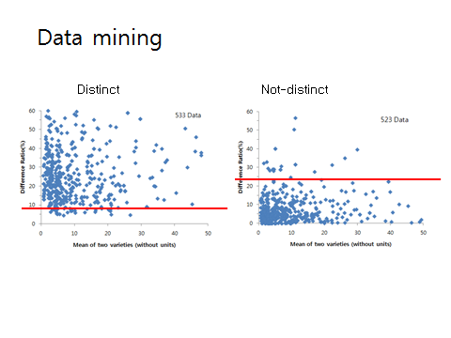

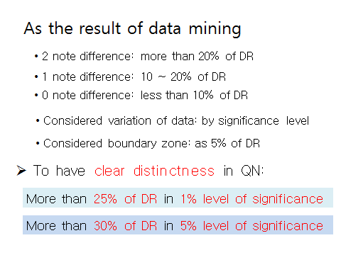

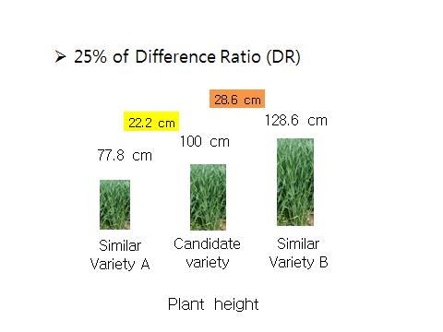

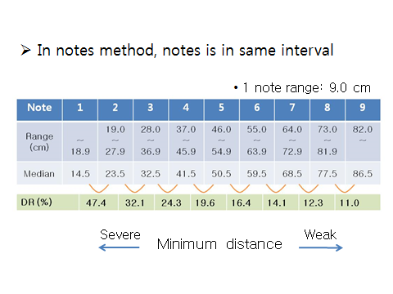

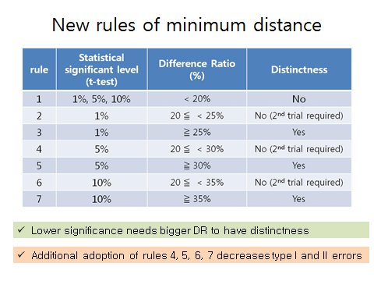

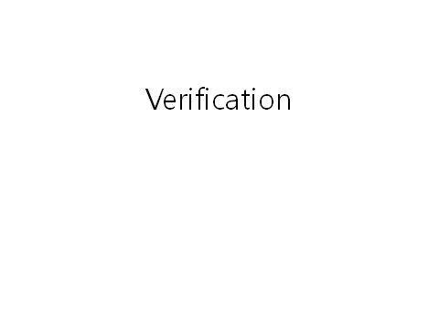

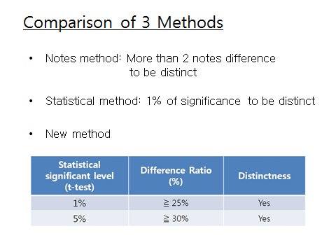

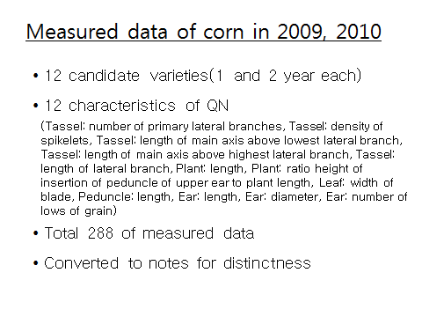

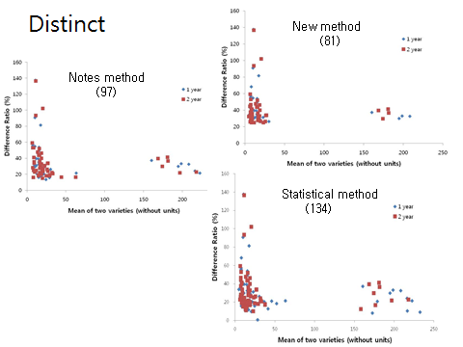

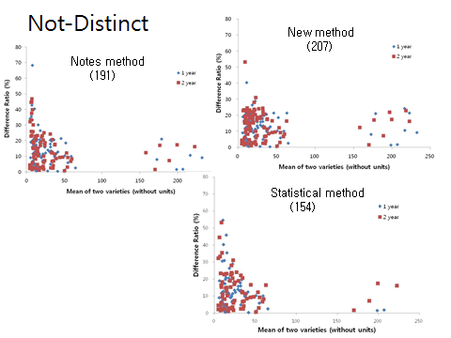

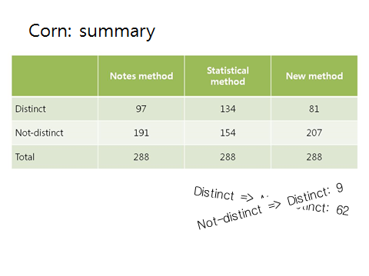

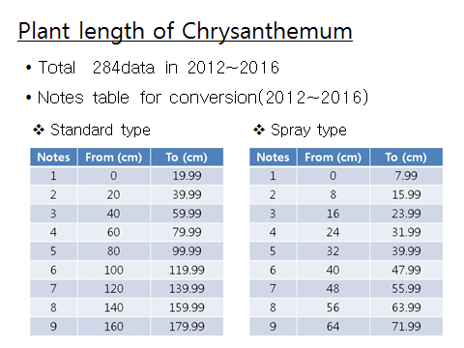

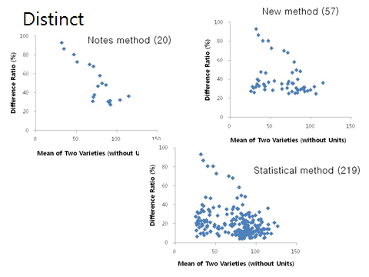

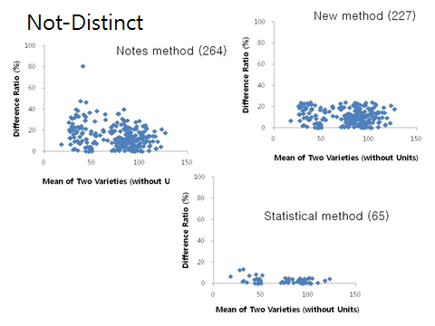

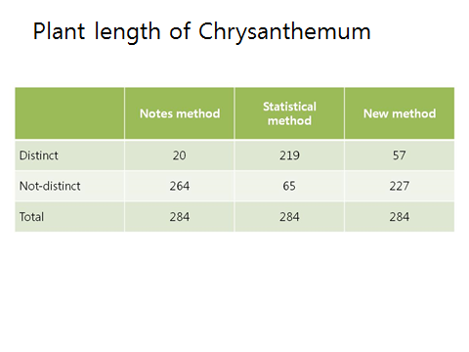

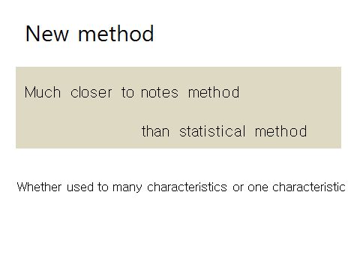

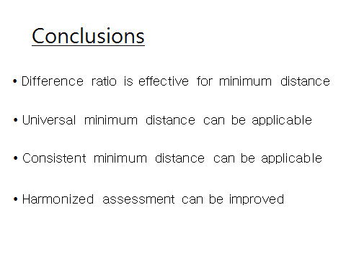

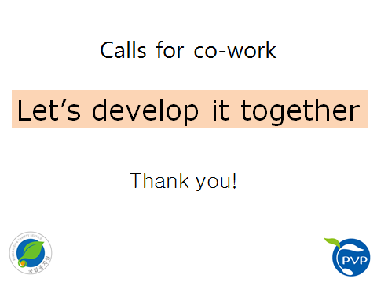

[End of Annex and of document]

