E
International Union for the Protection of New Varieties of Plants

Technical Working Party for Agricultural Crops  Forty-Sixth Session  Hannover, Germany, June 19 to 23, 2017 | TWA/46/6  Original: English  Date: June 7, 2017
New Method to Guarantee Minimum Distance between Varieties in Measured Quantitative Characteristics for Distinctness and harmonization between upov members
Document prepared by an expert from the Republic of Korea

Disclaimer: this document does not represent UPOV policies or guidance

BACKGROUND

The Technical Working Party for Agricultural Crops (TWA), at its forty-fifty session, held in Mexico City from July 11 to 15, 2016, agreed to discuss minimum distance between varieties at its forty-sixth session and invited the European Union and the Republic of Korea to prepare documents (see document TWA/45/25 “Report”, paragraph 124).

Abbreviations used:

- UPOV: International Union for the Protection of New Varieties of Plants
- PVP: Plant variety protection
- DUS: Distinctness, Uniformity and Stability
- QN: Quantitative characteristics
- PQ: Pseudo-qualitative characteristics
- QL: Qualitative characteristics
- DR: Difference ratio between two measured data

1. Obscurity in assessing distinctness of QN

1.1. Minimum distance

A variety should be clearly distinguishable for distinctness (TG/1/3).

To be clearly distinguishable, a candidate variety has to differ more than a minimum distance to any other known varieties in more than one characteristic, theoretically.

Minimum distance is a very important criterion for the determination of distinctness in PVP system. However, the minimum distance in QN and/or PQ is not well justified by objectively comparable method in UPOV, but it is dependent to the experience of each DUS examiners.

The minimum distance for clear difference in QN can be evaluated by following methods:

(a) Notes by visual observation
(b) Conversion of measurements to notes
(c) Statistical significance test of measurements

Here, (a) and (b) will be said notes method, and (c) will be said statistical method.

1.2. Notes method for distinctness

There is always confusion between notes for division of expressions and notes for decision of distinctness. Wide continuous variations of expression in QN are generally divided to notes, a standard scale from 1 to 9, in test guidelines. Notes in test guidelines are not closely based on minimum distance but rough grouping of expressions.

There is no consensus about ‘how much of real difference’ is minimum distance or minimum difference for distinctness in each characteristic. In visual observation, it would be difficult to determine a note value of QN between boundary areas of continuous two notes due to variation.

For QN, difference more than two notes generally represent a clear difference, meaning clear distinctness. Two notes difference in QN has been used like a standard of distinctness. However, there has been no guidance about ‘how much of real difference’ of it.

There are example varieties to each note of characteristics in test guidelines to help DUS examiners’ determination or to prevent discrepancy of DUS examiners. The set of example varieties is like a standard rule in visual assessment of notes.

There are two major problems in example varieties restricting consistent assessment of distinctness in notes method. The one is that all UPOV members cannot use the same set of example varieties in every growing test. Example varieties in test guidelines are not well known to all UPOV members. UPOV members use their own set of example varieties, or partial example varieties, or lack of example varieties. The other is that growing conditions are all different. The growth of an example variety or the range of expression is not all the same if it grows in all UPOV members. Thus, each member has their own different standard rules of minimum distance in QN.

Visual observation is a fast way to survey but relies on subjective determination of DUS examiners who have different experiences. The continuous variations of expression in QN within a variety and among varieties are different even in the same test field and make very difficult to decide visually notes of many varieties in situ. These make DUS examiners rely on measurement, probably. Measured data are converted to notes later at desk or used for statistical methods.

The range of variation in each characteristic is different, so the range of measured values to a note is all different too. The range of measured data to a note in notes table is usually varied by the reflection of variety collection. It is also varied by plant species, DUS examiners and countries. The note value of a variety would be relied on how DUS examiners set the range of measured value to a note in notes table.

The range of measured value to a note would be adjusted according to the note values of example varieties. It occurs to widen/narrow or move the range of measured values. These mean that the same real measured value of a variety could be ranked to different note occasionally. It is doubtful whether those adjustments are proper because the real measured value is the basis of minimum distance for distinctness. It is like an adjustment of the standard rule of distinctness at the DUS examiner’s discretion.

Thus, two notes difference in QN is an elastic minimum distance in distinctness assessment because it could not coincide among DUS examiners throughout the plants unlike in QL. Minimum distance for clear difference should not be adjusted although notes might be adjusted or different by DUS examiners.

1.3. Statistical method for distinctness

There are some recommendations in UPOV documents about statistical methods (documents TG/1/3; TGP/8; TGP/9):

- Least Significant Difference (LSD)
- Combined Over-Years Distinctness Criterion (COYD)
- 2x1% criterion

These statistical methods basically decide clear distinctness if a candidate variety is significantly different in 1% probability level to the similar varieties. In general, a significant difference in 1% level accepts to have distinctness but 5% level or ns (not significant) of it denies to have distinctness. It is not distinct if it is significantly different in 5% level though the difference of means between two varieties (A-C in Fig. 1) is bigger than that in 1% level (B-D in Fig. 1).

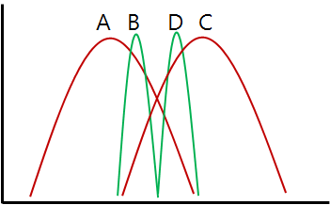

Fig. 1. Importance of distribution of data for statistical significance test.

Statistical significance depends on variation and sample number of data. In case of the same difference of mean, variation (or distribution) of data is a key point of significance level. Although there is a significant difference in 1% level, it does not make sure that it has clear difference visually between compared varieties. Significant difference in 1% level itself does not guarantee that it is visually clearly distinct more than at 5% level. It also does not guarantee that it has more than two notes difference in visual. The level of statistical significance has no correlation to the real difference of measured values. Therefore, 1% level of significant difference could not be a standard rule of minimum distance for distinctness although the statistical significance test itself is objective.

1.4. Errors in assessment of distinctness

There might be two types of error disturbing equity when determining distinctness by statistical method or notes method;
(1) Type I error: visual distinctness between two varieties but distinctness denied due to not-significant difference in 1% level or only one note difference
(2) Type II error: no visual distinction between two varieties but distinctness accepted due to significant difference in 1% level or two notes difference
The possibility of type II error could be increased more by the statistical method than the notes method because the statistical method does not adopt minimum distance when the growth of plants is uniform, especially.

The reason why two types of error occur in the notes method is by the indirect comparison between candidate variety and similar variety. As shown in Fig. 2, varieties in notes 4 and 6 have two notes difference and could be clearly distinct, but the real difference of variety B and D is smaller than that of variety A and C which is one note difference.

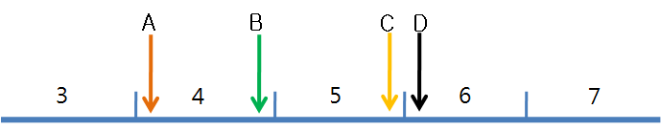

Fig. 2. Possibility of type I and II error in notes method.

Table 1. Example of conversion of measured data to notes and difference ratio (DR) between notes. Difference ratio (DR) is explained later.
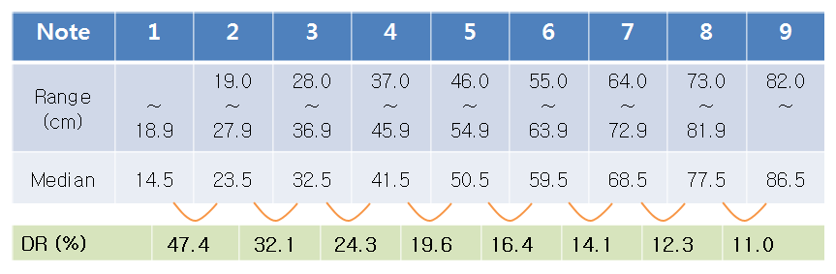
The same interval of measured value between notes is also one of the reasons (Table 1). The possibility of type I error increases at lower notes, and that of type II error increases at higher notes.

2. How to set minimum distance in measured QN?

2.1. Baseline

In QN there is always a variation within varieties responding to environmental conditions which is said normal distribution in statistics. We have to consider the within varietal variation of QN when determining distinctness.

○ premises for further discussion

A. The within varietal variation is generally bigger when the size of plant in a variety is bigger whether it is self- or cross-pollinated.

Example: In plant height of variety A (mean 50cm) and variety B (mean 100cm), if variety A varies mostly between 40 and 60cm (±10cm), variety B would vary more than that.

B. The real minimum difference between candidate and similar variety for clear distinctness in visual assessment should be bigger when the size of a characteristic is bigger.

Example: For a candidate variety of average 50cm of plant height, it might be possible to accept clear distinctness by more than 15cm difference of mean to a similar variety. However, for a candidate variety of plant height 150cm, it might not be enough to accept clear distinctness by that difference because of much bigger within varietal variation.

C. The minimum distance for distinctness should not be elastic by DUS examiners, locations and plant species.

Example: If a maize variety is tested in country A and country B, the growth would be different, the expression of QNs would be different and the notes tables would be different, but the standard rule of minimum distance for distinctness of QNs should not be different between both countries. If one test accepts distinctness with more than 20cm of difference but another test accepts distinctness with more than 10cm of difference at 100cm of plant height of the same plant, it is difficult to believe its authority.

2.2. Equation for the comparison of averages between two varieties
Determination of distinctness is the comparison of candidate variety to many known similar varieties. It has to be compared directly the real difference between a candidate variety and a similar variety assessing minimum distance. It is difficult to compare absolute difference directly between varieties and between characteristics with different units or digits of measurement.

Here, it would be possible to compare the relative difference ratio (DR) between two varieties or between candidate variety A and similar variety B of measured data as follows. It is similar to coefficient of variation in statistics.

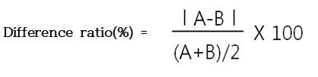

Here, A and B: average of variety A and B, respectively.

Example: Plant length: A is 80cm, B is 100cm, ratio difference between A and B is 22.2%.

2.3. Data mining

It is analysed the data of distinctness assessed by statistical method in measured QN in 2008 and 2009 as partially shown in Fig. 3 and Fig. 4. In the Republic of Korea, one candidate variety is compared to one similar variety generally. Measured QN data of about 80% were determined distinctness by statistical method and the others were converted to notes for distinctness.

A clear minimum distance for distinctness determination from the data was not found. However, most characteristics are denied to distinct by less than 20~30% of difference ratio (DR) in Fig. 3. Most characteristics are accepted to distinct more than 5~10% of DR in Fig. 4.

DR between 10% to 20% can be considered border zone which is difficult to determine distinctness like one note difference. Assuming between 10% to 20% of DR as one note, less than 10% of DR can be considered the same note. More than 20% of DR can be considered about two notes difference or more. For clear difference, about 5% of DR was added as border zone. Therefore, more than 25% of DR can be accepted as clearly distinct. If DR is between 20% and 25%, it would need one more test to confirm the consistency of distinctness.

It is assumed that 25% of DR as minimum distance would be effective for clear difference, and analyzed further.

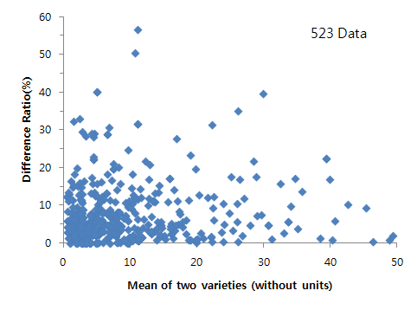
Fig. 3. Analysis of non-distinct measured QN data
(The range of both axes was cut for better presentation.)

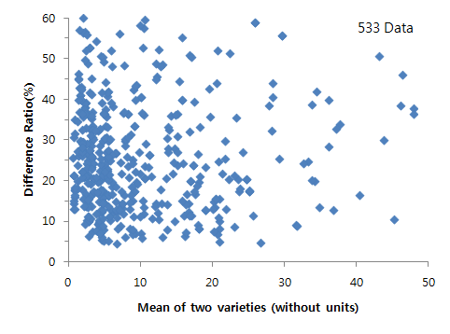
Fig. 4. Analysis of distinct measured QN data .
(The range of both axes was cut for better presentation.)

2.4. New method to determine distinctness

It is important to determine distinctness not only by the difference of averages but also by the distribution or variation of data. The variation of data is related to reliability of data that can be considered by the level of statistical significance test. It is supposed that application of DR with the statistical method can complement the weakness of the statistical method to decide distinctness in QN. The reason is that DR has very similar effect as the notes method for minimum distance. It would significantly reduce type I and II errors in the statistical method. The rule is summarized in table 2.

If DR is below 20%, there is no clear difference between two varieties regardless of significance level.

If there is 1% level of significant difference between two varieties and DR is more than 25%, there is a clear difference between two varieties.

If there is 5% level of significant difference between two varieties and DR is more than 30%, there is a clear difference between two varieties.

If there is 10% level of significant difference between two varieties and DR is more than 35%, there is a clear difference between two varieties.

If DR is between 20% and 25%~35% at each significance level, one more trial is needed to decide distinctness.

Here, the additional adoption of DR 30% and 35% at each 5% and 10% of significance level, respectively, might reduce more chances of the type I and II errors.

Table 2. Combination of difference ratio (DR) and level of statistically significant difference for distinctness.
Statistical  significance level  (t-test) | DR | Distinctness
1%, 5%, 10% | < 20% | No
1% | 20 ≦ < 25% | No (2nd trial required)
1% | ≧ 25% | Yes
5% | 20 ≦ < 30% | No (2nd trial required)
5% | ≧ 30% | Yes
10% | 20 ≦ < 35% | No (2nd trial required)
10% | ≧ 35% | Yes

2.5. Verification

The new method was verified by comparison with measured data converted to notes in corn by a DUS tester. There were 12 candidate varieties, and 12 QNs were measured in 2009 and 2010. There was a total of 288 measured data.

Distinctness of the measured QNs was determined by two notes difference after conversion of measured data to notes. The final decision on distinctness comes from the result of two years’ growing test, but here the data of each year’s distinctness by two notes difference was used. The mean of distinct or not-distinct data of two varieties were compared with DR of them as shown in Fig. 5 (A and B), respectively. A total of 97 data were distinct, and a total of 191 data were not-distinct. In the notes method it would completely depend to how the DUS examiner set the range of measured values to a note.

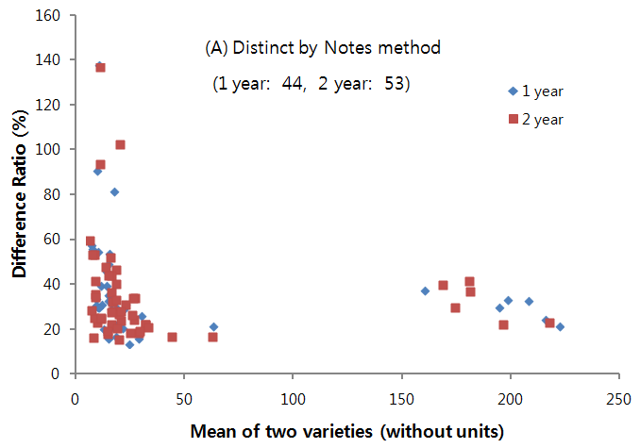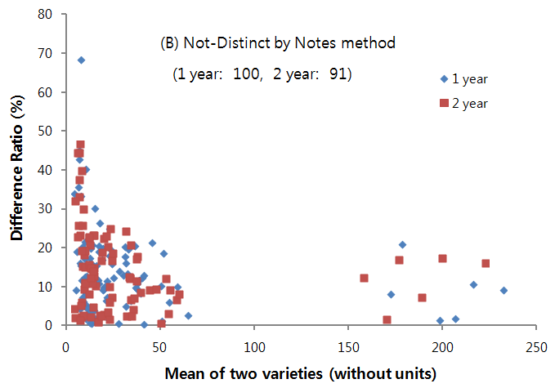
Fig. 5. Analysis of the measured QN data in corn by notes method. (A) distinct data, (B) not-distinct data.

Then, the measured data was analysed by the new method determining distinctness by 25% of DR at 1% level of significance and 30% of DR at 5% level of significance as shown in Fig. 6(A and B). It is possible to determine 1% and 5 % level of significance in our data analysis system. If the data of significance level is ns (not significant), it is decided not-distinct.

A total of 81 data were distinct and a total of 207 data were not-distinct. The number of distinct data is smaller than using the notes method, because the minimum distance as 25% or 30% of DR of the new method is a little higher than the notes method in Fig. 5A .

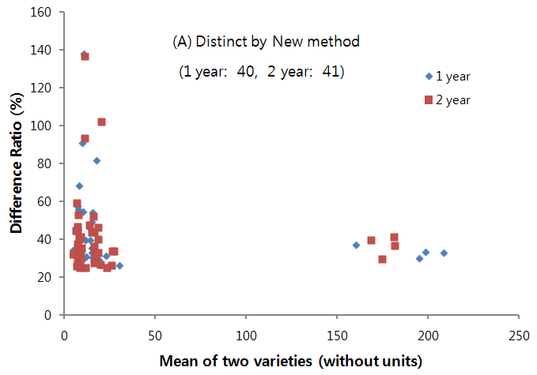
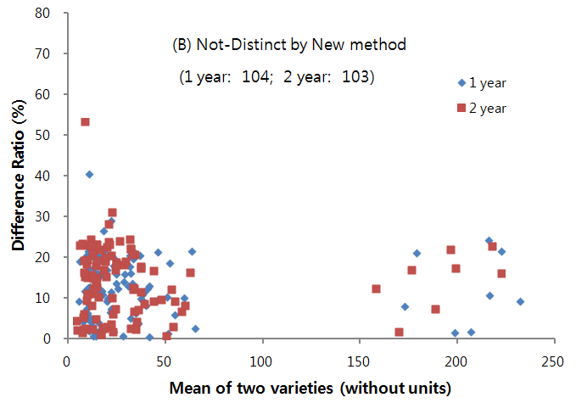
Fig. 6. Analysis of the measured QN data in corn by the new method that use DR and statistical significance test. (A) distinct data, (B) not-distinct data.

The measured data was also analysed by statistical method determining the distinctness by 1% level of significance alone as shown in Fig. 7(A and B). If the data of significance level is 5% or ns (not significant), it is decided not-distinct. A total of 134 data were distinct and a total of 154 data were not-distinct. The number of distinct data is much higher than using the notes method.

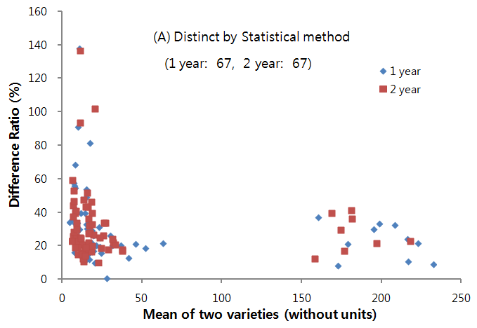
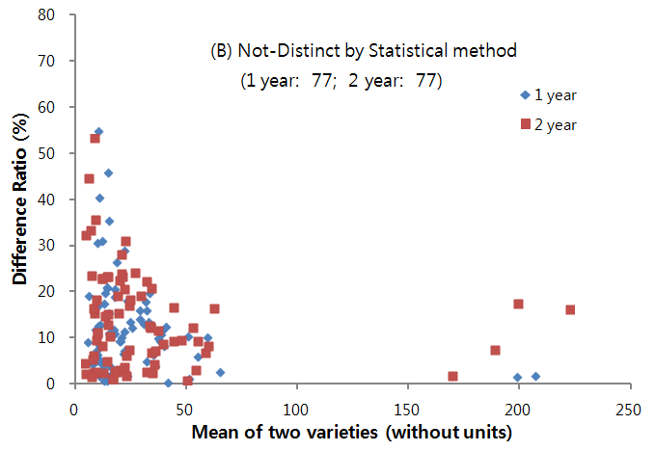
Fig. 7. Analysis of the measured QN data in corn by statistical method that use 1% level of statistical significance test only. (A) distinct data, (B) not-distinct data.

It seems that the new method remarkably decreased the possibility of type II error in the statistical method. The reason would be that DR works like a minimum distance. By the new method, 62 data (21.5% of total) are moved to not-distinct which were distinct in the statistical method.

By applying 30% of DR at 5% level of significance, 9 data (3.1% of total) are moved to distinct from not-distinct in the statistical method. It seems that the possibility of type I error also decreased by the new method.

These results clearly show that DR is effective for minimum distance or minimum difference. Discrepancy of distinctness decisions between the notes method and the statistical method was lessened by setting DR for minimum distance in the new method.

The 25% of DR as minimum distance would be more severe than the notes method in this example of corn. If 20% or 15% of DR is used, the number of distinct data can be increased.

If minimum distance was used as 20% of DR at 1% level of significance and 25% of DR at 5% level of significance in the new method, a total of 28 data (1st year: 16, 2nd year: 12) would be moved from non-distinct to distinct.

However, the change of DR to each QN or to each plant species is not appropriate because universal minimum distance would be more important.

3. Conclusion and calls for co-work

The new method has been discussed in the Republic of Korea since 2009 but it is not accepted officially yet. The strongest contradiction is that the concept of DR is not approved scientifically by UPOV. Some say it is not appropriate because 25%, 30% of DR as a minimum distance is a subjective decision, and it is quite high to set in general. Some say it is not proper to use one DR universally as minimum distance because the minimum distance might be different according to characteristics. Some say it is inevitable to have different minimum distances in regard to characteristics, plant species and DUS examiners, etc. Some say it should be the same result of distinctness with the same difference of measured value in a characteristic regardless of note value whether it is high or low.

The elastic rule of minimum distance would be the main cause of inconsistent assessment of distinctness. Two notes difference has been used as minimum distance in QN. However, the real difference for two notes is dependent on DUS examiners. This causes variation in results of distinctness, and it would be difficult to overcome by training. Adoption of consistent minimum distance would have greater merits than demerits.

It is observed that 25%, 30% of DR as a minimum distance is not so high as shown in table 1. In the notes method, lower notes have higher DR at the same interval of a note range. It would be difficult to insist that this new method is better than the notes method. But, it is obvious that DR is working as minimum distance and adoption of DR in the statistical method could bring results more in line with the notes method at least from this study. This is better fulfilled to UPOV purpose.

It would be possible to set certain % of DR as minimum distance if it is agreed to UPOV-wide or to a nation-wide as shown in table 2 for example. It would be very simple and effective to decrease both type I and II error in the statistical method by adopting DR as minimum distance. It would be helpful to set minimum distance of notes if DR is used to adjust the minimum intervals of measured value between notes. Adoption of DR would also reduce discrepancy between the notes method and the statistical method if DR is used in both methods. It would be useful to consistent results of distinctness. Therefore, certain % of DR could be used as a universal standard rule of minimum distance in measured QN. It would be very powerful to increase harmonized results by different examiners and UPOV members, and to increase confidence to our PVP authority.

It further needs to certify whether the concept of DR is appropriate for a standard rule of minimum distance, and about what % of DR is proper as a minimum distance which everyone can agree clearly distinct.

It would be meaningful to analyse how notes data of measured QN has been assessed. We have not profession in statistics and enough reliable data, so it would be great pleasure if anyone is willing to develop this new method together.

References

- TG/1/3 General introduction to the examination of distinctness, uniformity and stability and the development of harmonized descriptions of new varieties of plants
- TGP/8 Trial design and techniques used in the examination of distinctness, uniformity and stability
- TGP/9 Examining distinctness
- TGP/10 Examining uniformity

※ This method is currently under discussion in the Republic of Korea

[End of document]

