E
International Union for the Protection of New Varieties of Plants

Technical Working Party for Agricultural Crops  Forty-Sixth Session  Hanover, Germany, June 19 to 23, 2017 | TWA/46/4 Add.2  Original: English  Date: July 18, 2017
second addendum to
possible effect on uniformity decisions between Approach 3 and other approaches in document TWP/1/17 “Assessing Uniformity by Off-Types on the Basis of More than One Growing Cycle or on the Basis of Sub-Samples”
Document prepared by the Office of the Union
Disclaimer: this document does not represent UPOV policies or guidance
The Annex to this document contains a copy of a presentation on “Effect of different approaches for the assessment of Uniformity by off-types – examples for Barley”, prepared by an expert from Germany that was made at the forty-sixth session of the Technical Working Party for Agricultural Crops (TWA).

[Annex follows]

EFFECT OF DIFFERENT APPROACHES FOR THE ASSESSMENT OF UNIFORMITY BY OFF-TYPES – EXAMPLES FOR BARLEY

Presentation prepared by an expert from Germany

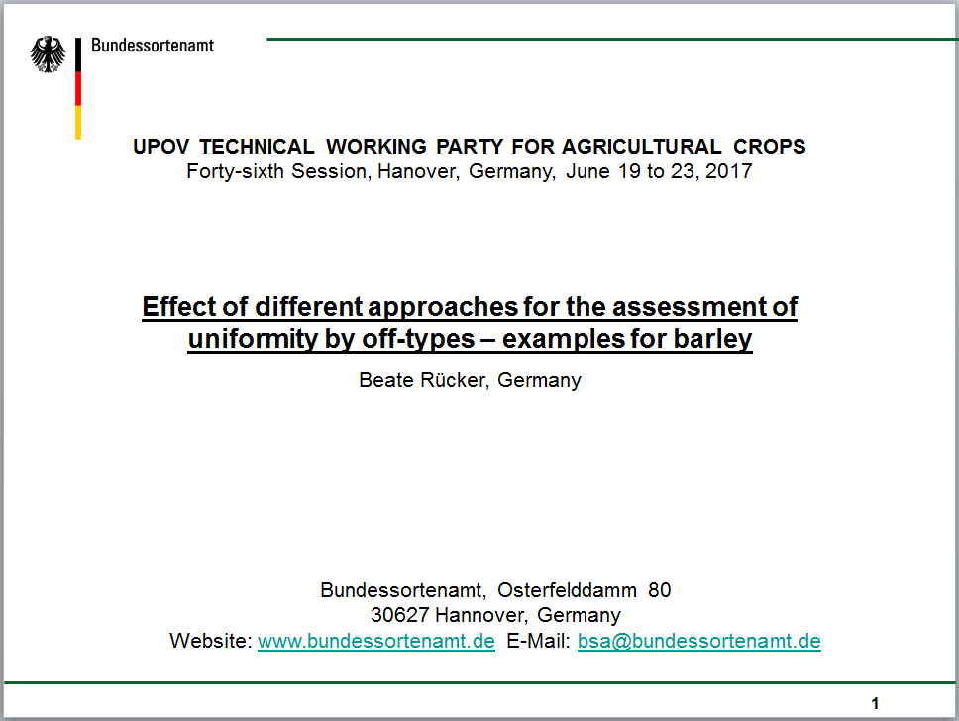

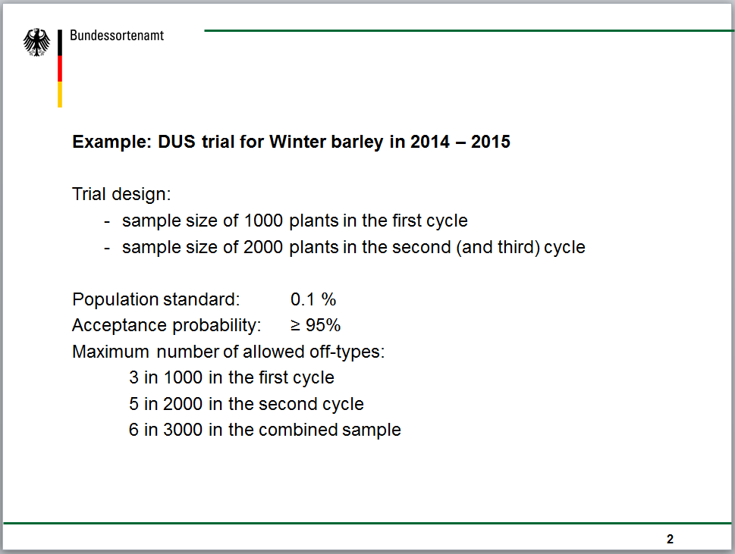

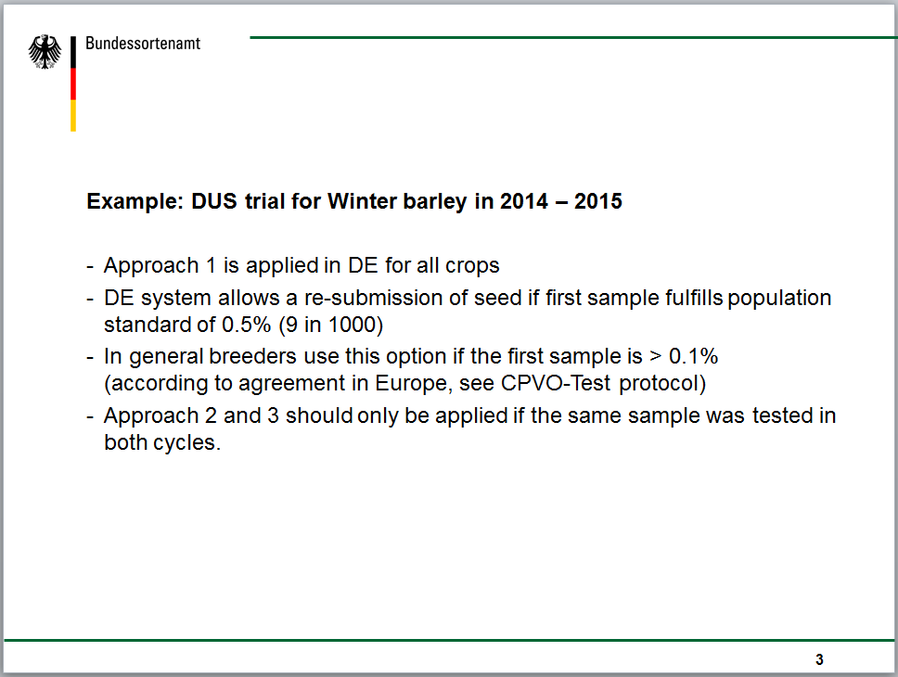

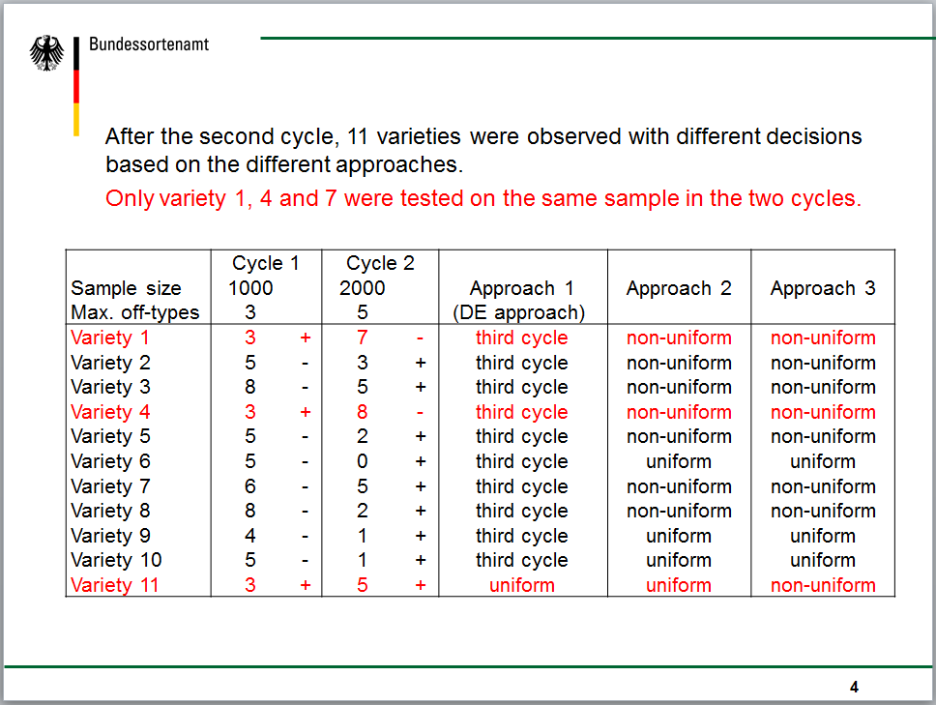

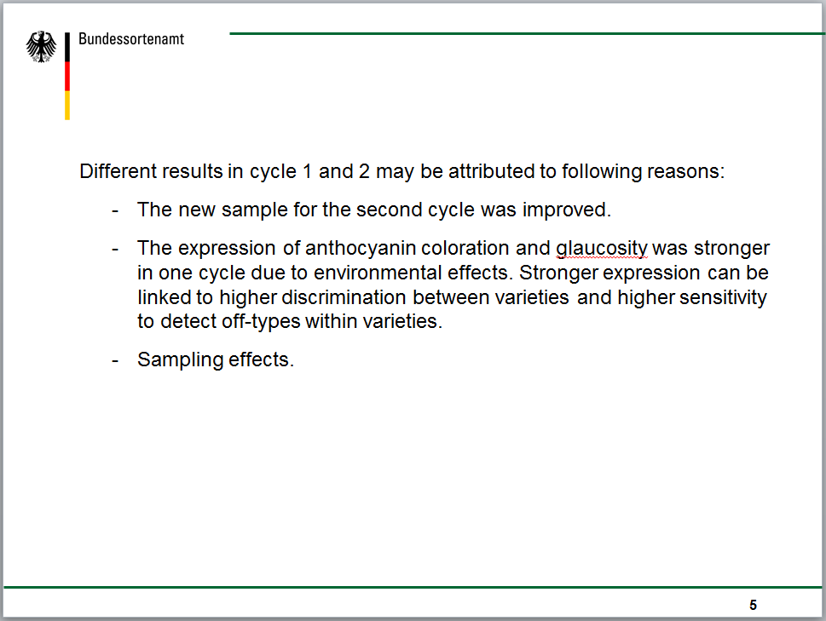

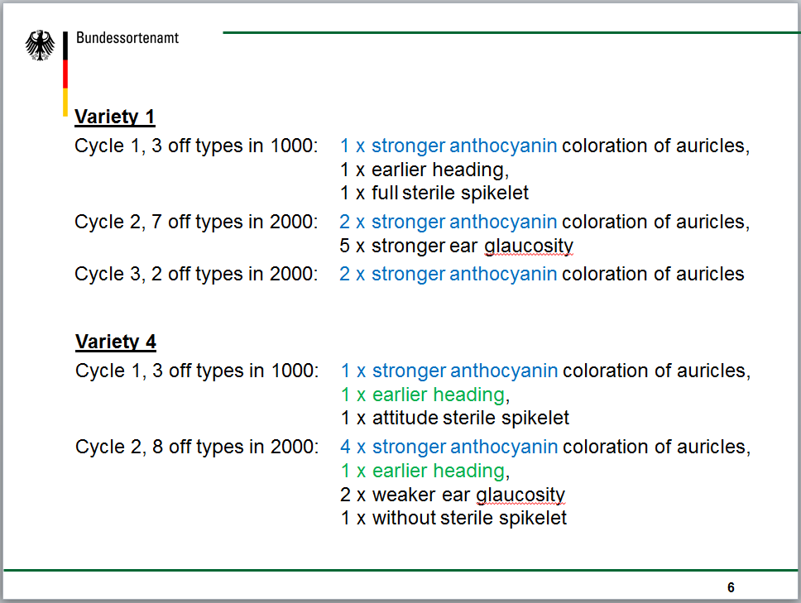

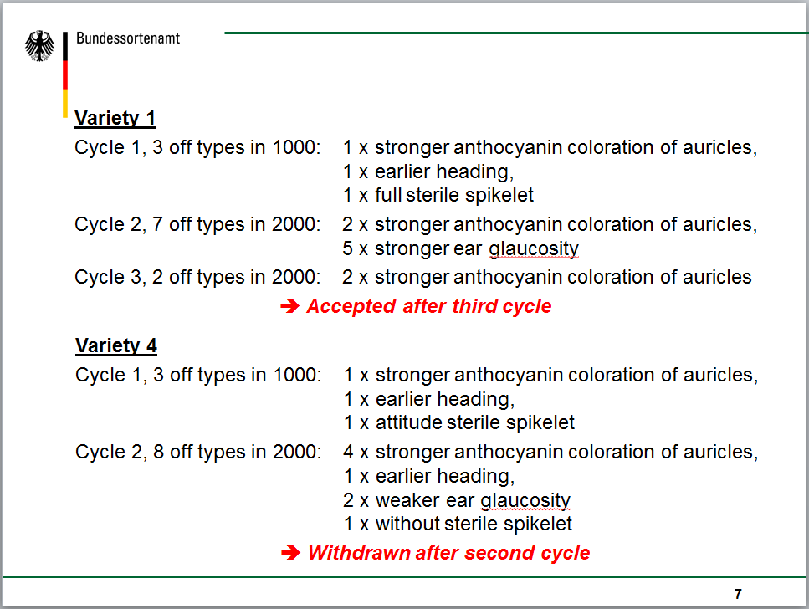

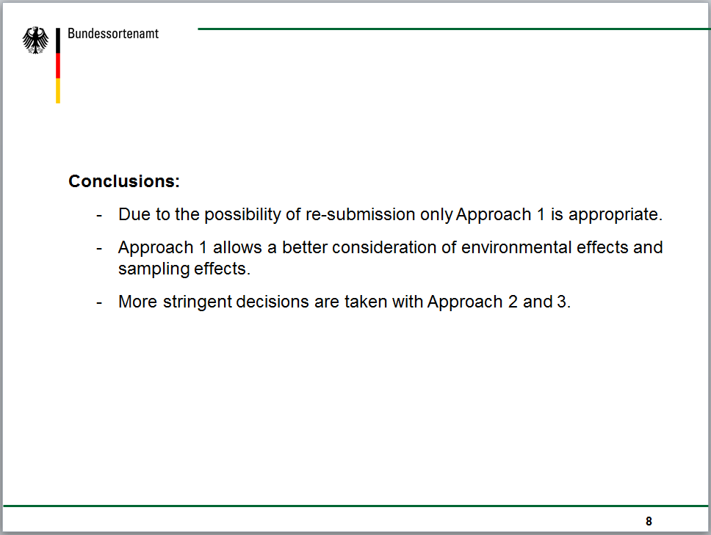

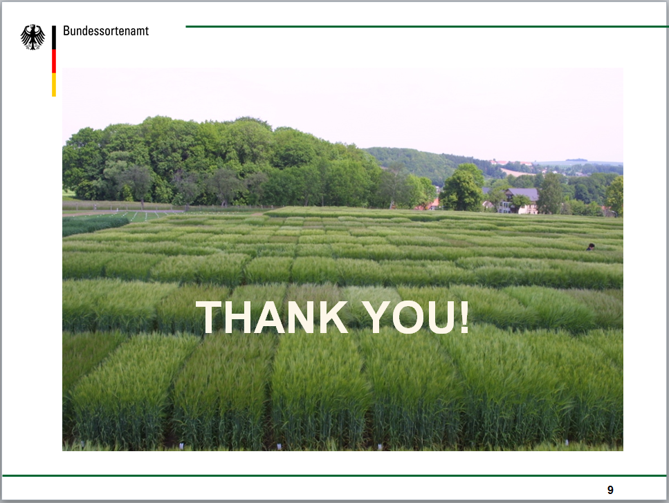

[End of Annex and of document]

