E
International Union for the Protection of New Varieties of Plants

Technical Working Party for Agricultural Crops  Forty-Sixth Session  Hanover, Germany, June 19 to 23, 2017 | TWA/46/4  Original: English  Date: June 2, 2017
possible effect on uniformity decisions between Approach 3 and other approaches in document TWP/1/17 “Assessing Uniformity by Off-Types on the Basis of More than One Growing Cycle or on the Basis of Sub-Samples”
Document prepared by the Office of the Union
Disclaimer: this document does not represent UPOV policies or guidance

Executive summary

The purpose of this document is to provide examples comparing the possible effect on uniformity decisions between Approach 3 and the other approaches presented in document TWP/1/17 “Assessing Uniformity by Off-Types on the Basis of More than One Growing Cycle or on the Basis of Sub-Samples”, to be presented to the TWA, at its forty-sixth session.

The TWA is invited to consider the examples comparing the possible effect on uniformity decisions between Approach 3 and other approaches as presented in the Annexes to this document.

Background

The background to this document is provided in document TWP/1/17 “Assessing Uniformity by Off-Types on the Basis of More than One Growing Cycle or on the Basis of Sub-Samples”.

Examples comparing possible effects on uniformity decisions

The Annexes to this document contain the following presentations to be made at the forty-sixth session of the Technical Working Party for Agricultural Crops (TWA).

ANNEX I “Effect of different approaches for the assessment of uniformity by off-types – examples for Barley”, prepared by an expert from Germany;

ANNEX II “Assessing uniformity by off-types on the basis of more than one growing cycle in wheat” prepared by an expert from Poland

ANNEX III “The United Kingdom’s Experience with Winter Oilseed Rape (WOSR)” prepared by an expert from the United Kingdom;

The TWA is invited to consider the examples comparing the possible effect on uniformity decisions between Approach 3 and other approaches as presented in the Annexes to this document.

[Annexes follow]

Effect of different approaches for the assessment of uniformity by off-types – examples for barley

Document prepared by an expert from Germany

1. The TWC was invited to develop guidance for the assessment of uniformity by off-types for inclusion in document TGP/10 “Examining uniformity”. Different approaches for decisions based on more than one growing cycle were developed. The TWA has considered these proposals and agreed that the guidance should provide parameters for decisions on the most suitable approach based on experience from members (see documents TWA/45/13 “Assessing Uniformity by Off-Types on the basis of more than one Growing Cycle or on the basis of Sub-Samples” and TWA/45/25 “Report”). The TWA agreed to provide examples comparing the possible effect on uniformity decisions between different approaches.

2. The following table summarizes practical examples from the DUS test for winter barley in 2014 and 2015. The growing trials comprise for each variety a sample size of 1000 plants in the first cycle and 2000 plants in the second. In the relevant year, 11 varieties were observed with different decisions based on the different approaches.

3. The following standards were applied:

Population standard: 0.1 %
Acceptance probability: ≥ 95%

Maximum number of allowed off-types:
3 in 1000 in the first cycle
5 in 2000 in the second cycle
6 in 3000 in the combined sample

Examples:

 | Cycle 1 |  | Cycle 2
Sample size | 1000 | Pass(+) / Fail(-) test | 2000 | Pass(+) / Fail(-) test | Approach 1[1] | Approach 2^{[1]} | Approach 3^{[1]}
Max. off-types | 3 |  | 5
Variety 1 | 3 | + | 7 | - | third cycle | non-uniform | non-uniform
Variety 2 | 5 | - | 3 | + | third cycle | non-uniform | non-uniform
Variety 3 | 8 | - | 5 | + | third cycle | non-uniform | non-uniform
Variety 4 | 3 | + | 8 | - | third cycle | non-uniform | non-uniform
Variety 5 | 5 | - | 2 | + | third cycle | non-uniform | non-uniform
Variety 6 | 5 | - | 0 | + | third cycle | uniform | uniform
Variety 7 | 6 | - | 5 | + | third cycle | non-uniform | non-uniform
Variety 8 | 8 | - | 2 | + | third cycle | non-uniform | non-uniform
Variety 9 | 4 | - | 1 | + | third cycle | uniform | uniform
Variety 10 | 5 | - | 1 | + | third cycle | uniform | uniform
Variety 11 | 3 | + | 5 | + | uniform | uniform | non-uniform

4. Approach 1 is applied in the German DUS system for all crops. When Approaches 2 or 3 are applied for this study it has to be taken into account that a re-submission is possible for the second cycle under specific conditions in barley. A new sample may be submitted for the second cycle if the first sample did not exceed a population standard of 0.5 % with an acceptance probability of ≥ 95% (9 in 1000). In general breeders use this possibility if the 0.1 % population standard is exceeded in the first cycle. Only Varieties 1, 4 and 7 were tested on the same sample in the two cycles.
5. More off-types were observed in the first cycle in most examples. This can be attributed to the following reasons:

- The new sample for the second cycle was improved.

- The expression of anthocyanin coloration and glaucosity was stronger in cycle 1 of the concerned testing period due to environmental effects. Stronger expression can be linked to higher discrimination between varieties and higher sensitivity to detect off-types within varieties.

6. Approaches 2 and 3 should only be applied if the same sample was tested in both cycles. This condition is only fulfilled for Varieties 1, 4 and 11. One variety (out of those three) would be accepted after two cycles with Approaches 1 and 2 (Variety 11). All varieties would be rejected with approach 3 (Varieties 1, 4 and 11). Two varieties need a third cycle with approach 1 (Varieties 1 and 4).

7. If it is ignored for the purpose of this study that Approaches 2 and 3 should not be applied in the case of different samples, the examples confirm that Approach 3 is the most stringent one. Variety 11 would be rejected with Approach 3 even if it was within the uniformity standard in both individual cycles. The example of Variety 11 represents the only difference between Approaches 2 and 3.

8. The disadvantage of Approach 1 is a possible prolongation of the test, but a third cycle allows for a better consideration of environmental effects. For example, in Variety 1 the following off-types were observed (same seed sample):
Cycle 1, 3 off-types in 1000: 1 x stronger anthocyanin coloration of auricles,
1 x earlier heading,
1 x full sterile spikelet
Cycle 2, 7 off-types in 2000: 2 x stronger anthocyanin coloration of auricles,
5 x stronger ear glaucosity
Cycle 3, 2 off-types in 2000: 2 x stronger anthocyanin coloration of auricles

9. Finally, the variety was within tolerance in 2 out of 3 cycles and considered to be uniform. Off-types in ear glaucosity have only been observed in the second cycle. Environmental effect cannot be excluded.

10. The following off-types were observed for Variety 4:
Cycle 1, 3 off-types in 1000: 1 x stronger anthocyanin coloration of auricles,
1 x earlier heading,
1 x attitude sterile spikelet
Cycle 2, 8 off-types in 2000: 4 x stronger anthocyanin coloration of auricles,
1 x earlier heading,
2 x weaker ear glaucosity
1 x without sterile spikelet

11. The variety was withdrawn after the second cycle.

12. Only Approach 1 is appropriate for the German DUS system in barley because a re-submission is possible for the second cycle. Approach 1 is also preferred because of a better consideration of possible environmental effects on the expression of some characteristics. Approaches 2 and 3 would not allow for a change of the seed sample. In addition, more stringent decisions are taken with Approaches 2 and 3.

[Annex II follows]

Assessing uniformity by off-types on the basis of more than one growing cycle in wheat

Presentation prepared by an expert from Poland

[Annex III follows]

THE UNITED KINGDOM’S EXPERIENCE WITH WINTER OILSEED RAPE (WOSR)

Presentation by an expert from the United Kingdom

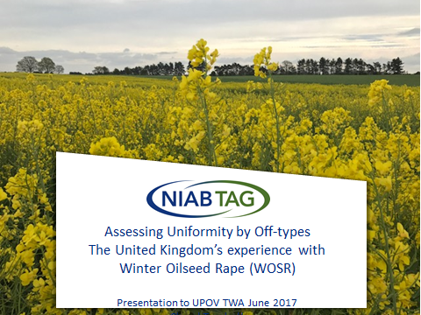

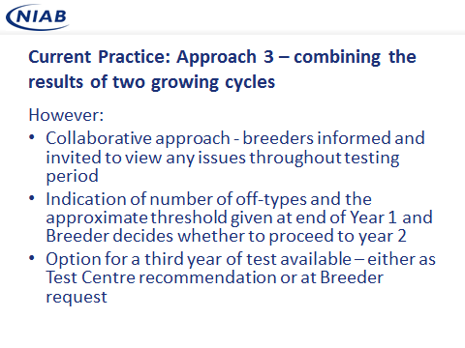

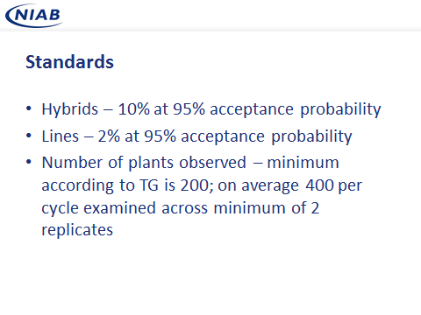

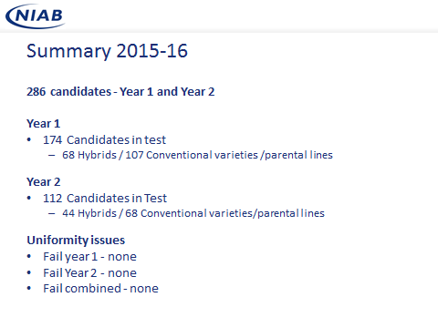

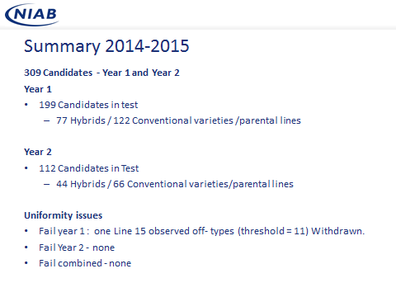

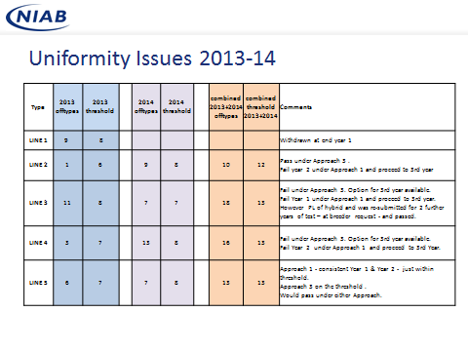
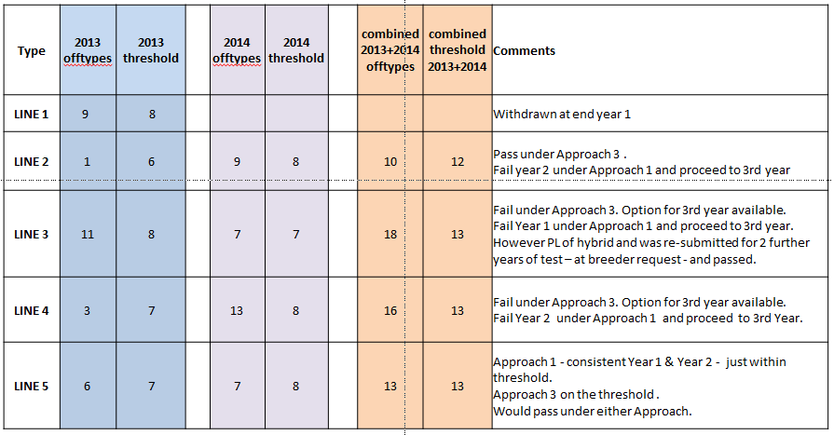

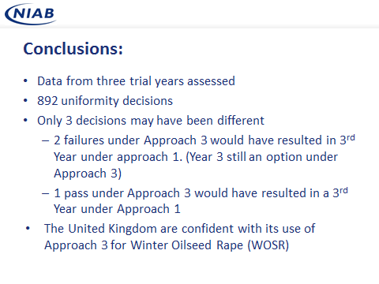

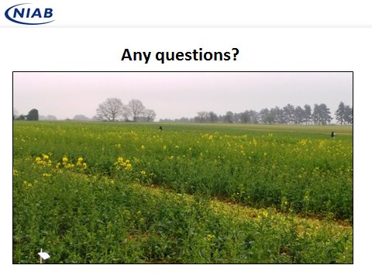

[End of Annex III and of document]

[1] For the description of Approaches 1, 2 and 3 see document TWP/1/17 “Assessing Uniformity by Off-Types on the Basis of More than One Growing Cycle or on the Basis of Sub-Samples”

